Graphical Abstract:
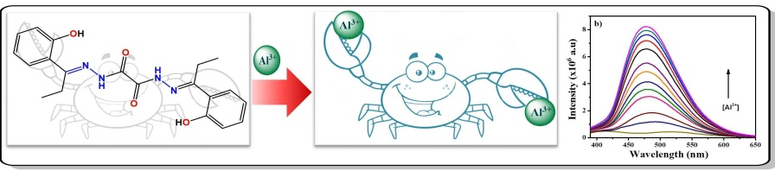
A novel dihydrazone-based fluorescent probe N'1,N'2–bis{1–(2–hydroxyphenyl)propylidene}oxalohydrazide for Al³⁺ is synthesized by simple condensation reaction. The receptor acts as a dibasic hexadentate ligand and interacts with two Al³⁺ ions with a high binding constant K_{B} = 8.99 × 10¹⁰ M⁻¹. The lowest detection limit for the Al³⁺ complex of H₂hpoh was determined to be 7.8 × 10⁻⁵ M.

