Electronic Supplementary Information

A hydroxypropiophenone based fluorescent probe for selective determination of Al³⁺ ions in aqueous ethanol
Divya Pratap Singh^{a,}*^{,1}, Chandani Singh^{b,1}, Sunil Kumar Singh^{b,}*, Romi Dwivedi^{c}, Ashish Kumar Singh^{b,}* and Vinod Prasad Singh^{c}
ªDepartment of Chemistry, Rajkiya Engineering College, Azamgarh-276201 (U.P.) India
^{b}Department of Chemistry, Guru Ghasidas Vishwavidyalaya, Bilaspur-495009, India
^{c}Department of Chemistry, Institute of Science, Banaras Hindu University, Varanasi-221005, India
*Corresponding authors
Email addresses: dpsingh_011@yahoo.co.in; dpsbhu11@gmail.com (D.P. Singh), ashish.bhuchem@gmail.com (A. K. Singh), singh.skumar@gmail.com (S. K. Singh)
¹These authors contributed equally in the manuscript

Fig. S1. IR Spectrum of H₂hpoh

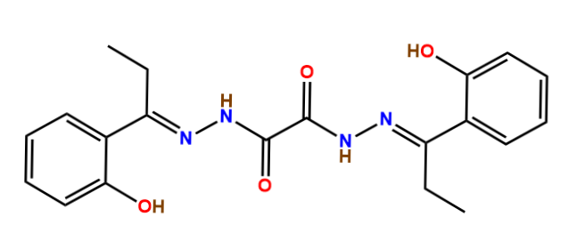
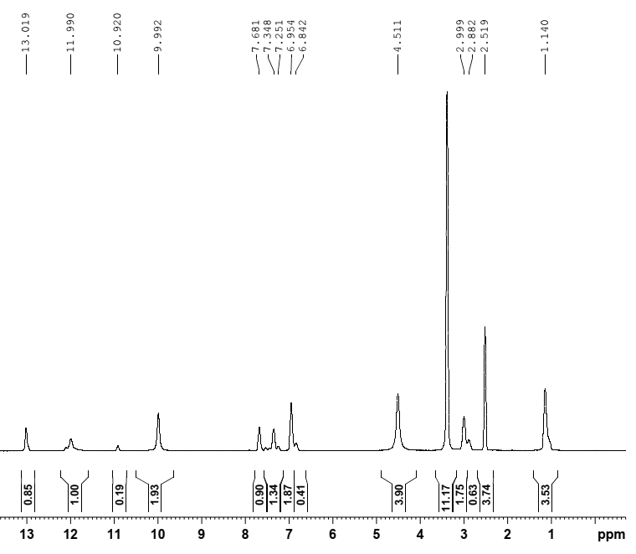
Fig. S2. ¹H NMR spectra of H₂hpoh in DMSO-d₆

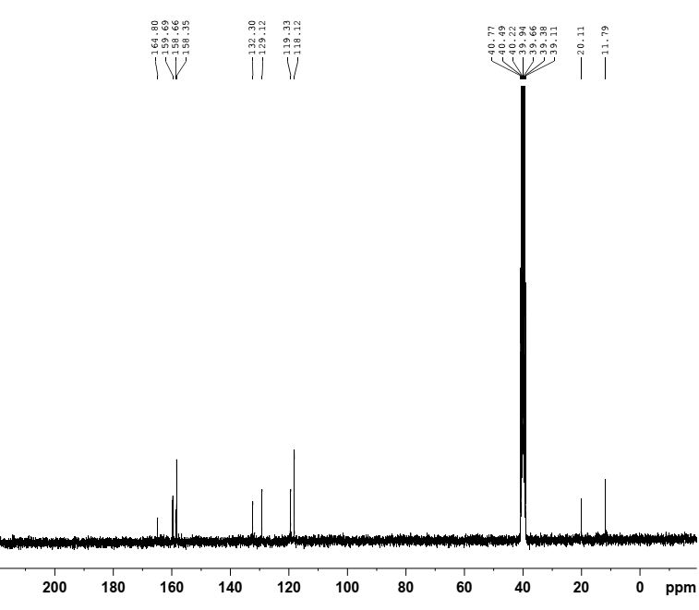

Fig. S3. ¹³C NMR spectra of H₂hpoh in DMSO-d₆

Fig. S4. ESI-MS of H₂hpoh

Table S1. Crystallographic data for H₂hpoh.
Empirical formula | C₂₀ H₂₂ N₄ O₄
Formula weight | 382.42
Temp, K | 298(2) K
λ (Å) | 0.71073 Å
Crystal system | Monoclinic
Space group | P 21/c
a (Å) | 6.0747(15)
b (Å) | 11.621(5)
c (Å) | 13.453(4)
β (º) | 94.61(3)
V (Å³) | 963.8
Z | 2
D_{calc} (g/cm³) | 1.342
μ (mm⁻¹) | 0.096
F(000) | 404
Crystal size (mm3) | 0.24 x 0.22 x 0.20
θ range for data collection (º) | 3.04 to 29.02
No. of reflections collected | 2520
No. of independent reflections (R_{int}) | 2149 (0.0876)
Number of data/restraints/parameters | 2149 / 0 / 131
Goodness-of-fit on F² | 0.997
R₁, wR₂ ^{a,b}[(I>2σ(I))] | 0.0972, 0.1491
R₁, wR₂^{a,b} (all data) | 0.2994, 0.2320
Largest difference in peak and hole (e.Å⁻³) | 0.228 and -0.231
ª R₁ = Σ||F_{o}| – |Fc||Σ|F_{o}|.
^{b} R₂ = [Σw(|F²_{o}| – |F²_{c}|)²/Σw|F²_{o}|²]^{1/2}

Table S2. Selected bond lengths (Å) and angles (º) in the H₂hpoh.
Bond length |  | Bond angle
O(1)-C(1) | 1.208(6) | O(1)-C(1)-N(1) | 126.3(5)
N(2)-C(4) | 1.297(6) | C(1)-N(1)-N(2) | 117.0(5)
N(1)-N(2) | 1.370(6) | C(4)-N(2)-N(1) | 119.9(5)
N(1)-C(1) | 1.344(6) | N(2)-C(4)-C(3) | 119.9(5)
C(4)-C(5) | 1.463(6) | C(3)-C(4)-C(5) | 120.7(5)
C(3)-C(4) | 1.527(7) | O(2)-C(10)-C(9) | 116.2(5)
O(2)-C(10) | 1.346(6) | O(2)-C(10)-C(5) | 124.4(5)

Table S3. Hydrogen bond parameters [Å and º] in the H₂hpoh.
D−H∙∙∙A | D−H | H∙∙∙A | D∙∙∙A | < (DHA)
O(2)−H(2)∙∙∙N(2) | 0.82 | 1.79 | 2.503(6) | 144
N(1)−H(1)∙∙∙O(1) | 0.80(5) | 2.27(6) | 2.673(6) | 111(5)
C(3)−H(3B)∙∙∙N(1) | 0.97 | 2.51 | 2.849(8) | 100
C(6)−H(6)∙∙∙O(2) | 0.93 | 2.43 | 3.325(7) | 161
C(7)−H(7)∙∙∙O(1) | 0.93 | 2.59 | 3.493(7) | 164

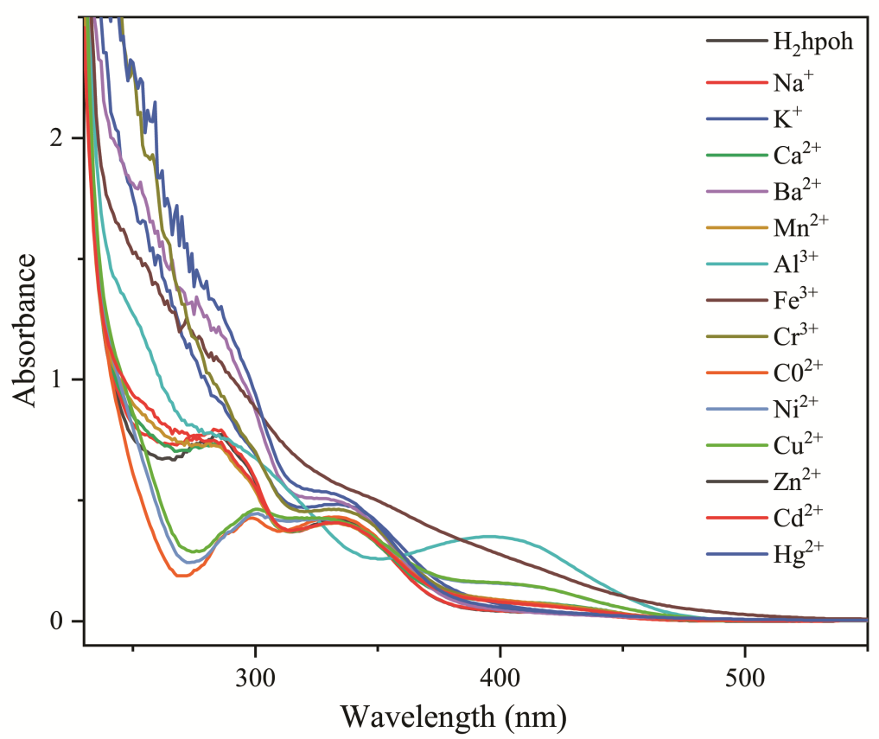

Fig. S5. Effect of addition of various metal ions (2 eq.) on the UV–visible spectra of 50 μM aqueous ethanolic solution of H₂hpoh.

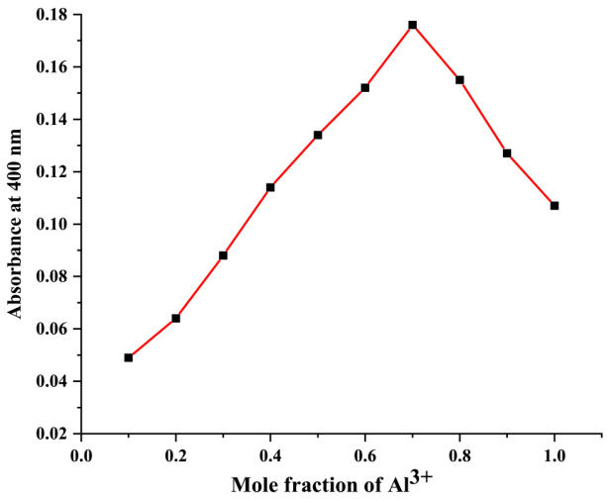

Fig. S6. Job’s plot obtained from UV-visible spectra of solution of H₂hpoh and Al³⁺ ions mixed in varying mole fractions.

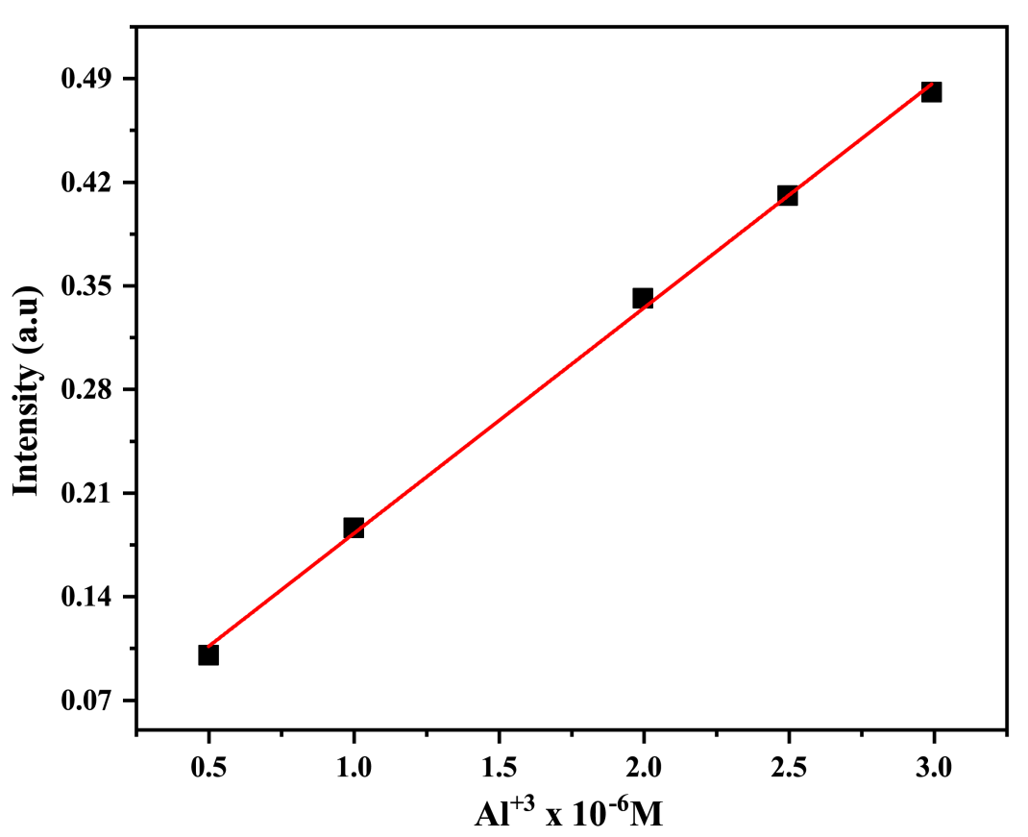

Fig. S7. Emission intensities of H₂hpoh (5 μM) as a function of [Al³⁺] λ_{em}: 478 nm, λ_{ex}: 382 nm. The detection limit is 7.8 × 10⁻⁵ M in the linearity range of 4.99 x10⁻⁷–7.99 x10⁻⁶ M (R² = 0.99824).

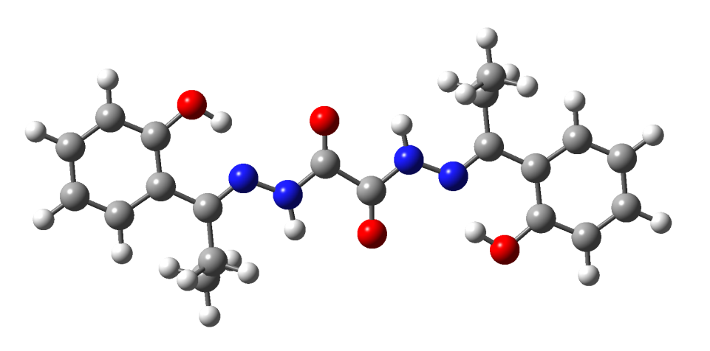
a)

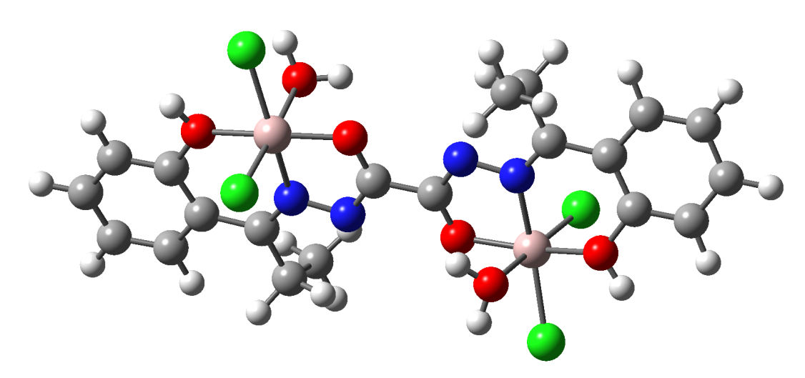
b)

Fig. S8. Optimized structure of a) H₂hpoh and b) its Al³⁺ complex [Al₂Cl₄(hpoh)(H₂O)₂].

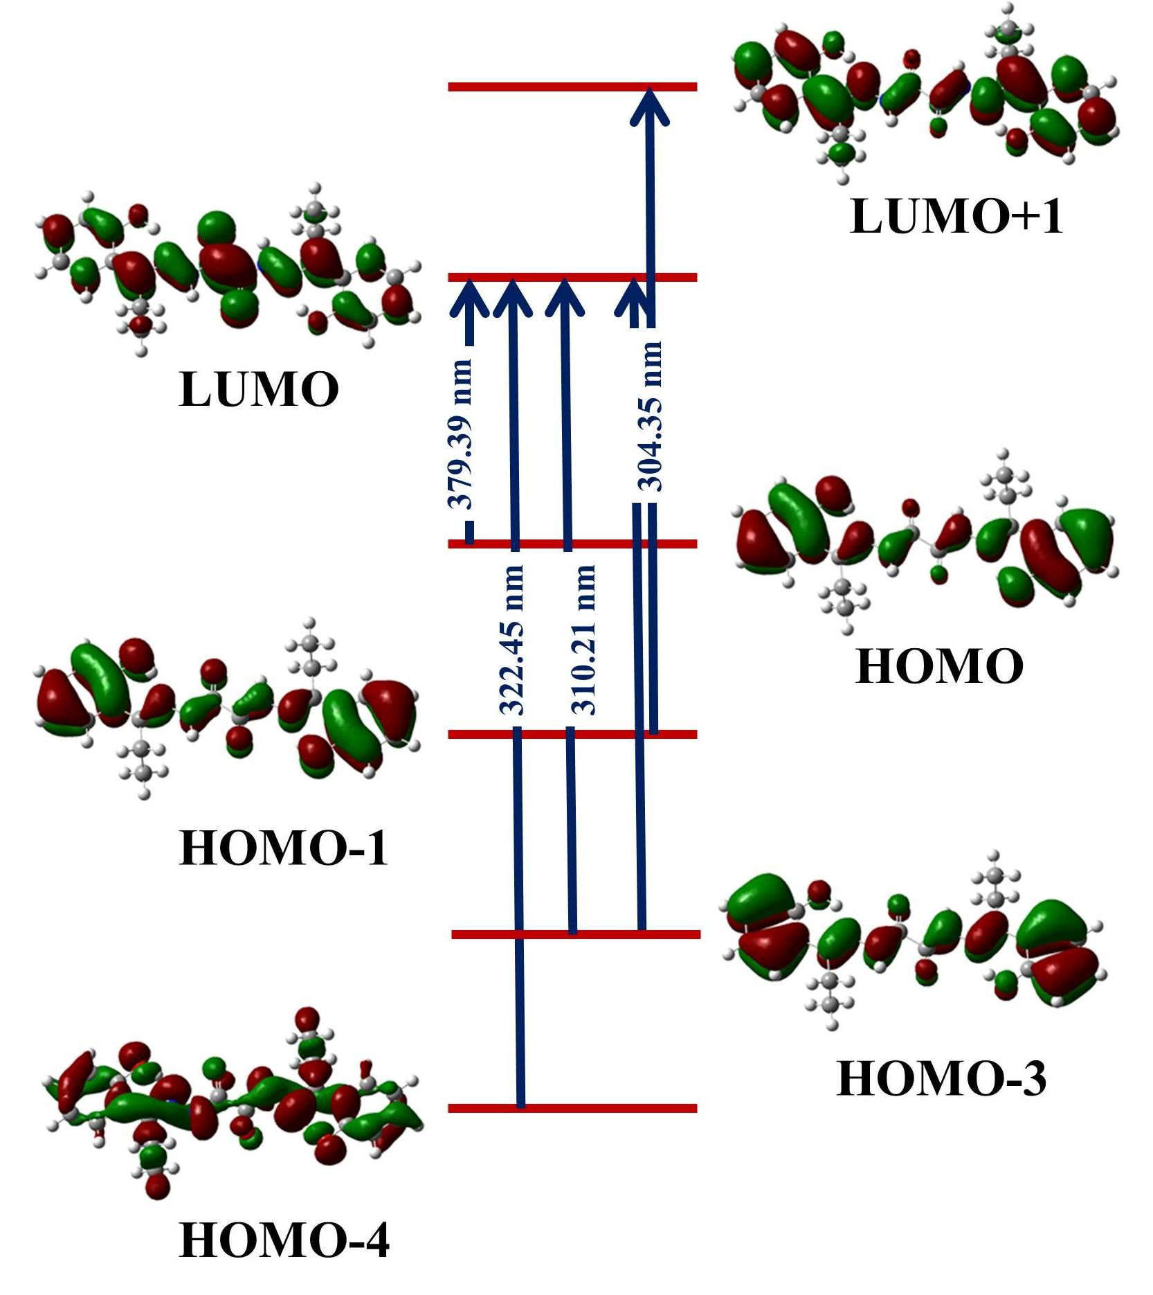

Fig. S9. Energy level diagram for the π molecular orbitals of H₂hpoh.

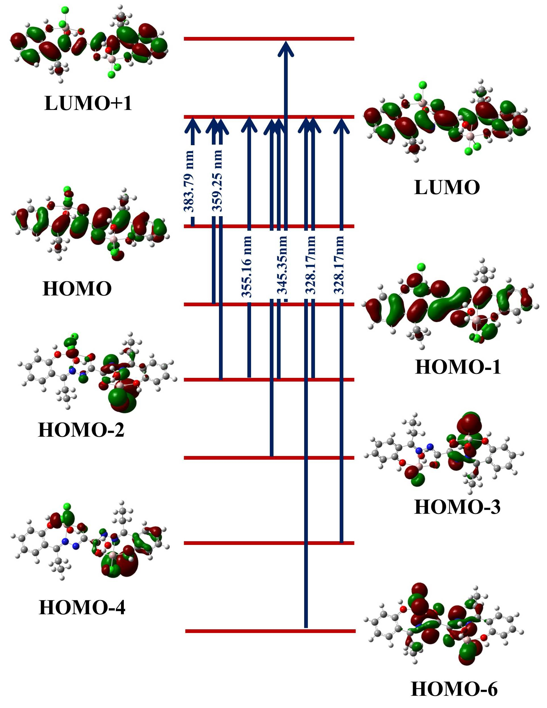
Fig. S10. Energy level diagram for the π molecular orbitals of Al(III) complex [Al₂Cl₄(hpoh)(H₂O)₂]·2H₂O.

