Supplementary Information for
Aligned carbon nanotube integrated circuit downsizing toward a sub-10 nm node
Yanxia Lin^{1,2,†}, Yu Cao^{1,†}, Sujuan Ding³, Lin Xu⁴, Chenchen Liu¹, Qianlan Hu¹, Chuanhong Jin³, Lian-Mao Peng^{1,2,5*}, Zhiyong Zhang^{1,2,5*}
¹ Key Laboratory for the Physics and Chemistry of Nanodevices and Center for Carbon-based Electronics, School of Electronics, Peking University, Beijing 100871, China.
²Academy for Advanced Interdisciplinary Studies, Peking University, Beijing 100871, China.
³State Key Laboratory of Silicon Materials, School of Materials Science and Engineering, Zhejiang University, Hangzhou, 310027, China.
⁴Department of Chemistry, The University of Hong Kong, Pokfulam 999077, China.
⁵Beijing Institute of Carbon-based Integrated Circuits, Beijing, China.
†These authors contributed equally to this work.
*Correspondence to: (L. –M. P.) lmpeng@pku.edu.cn and (Z. Z.) zyzhang@pku.edu.cn

This file includes:
Materials and Methods
Figs S1 to S 13
Tables S1 to S2

Materials and Methods
1. Preparation of high-purity semiconducting CNT array on wafer:
Prepared arc-discharge CNT powder (purchased from Carbon Solution, Inc.) and conjugated poly[9-(1-octylonoyl)-9H-carbazole-2,7-diyl] (PCz) are dissolved in toluene. Then, the mixed solution is dispersed, followed by 2 h centrifugation (Sorvall LYNX6000-Thermo). A dynamic liquid phase filtration process is applied to the as-prepared PCz-wrapped CNT solution, followed by repeated rinsing off in 1,4-epoxybutane (THF). The filtered PCz-wrapped CNTs are redispersed in 1,1,2-trichloroethane target solvent for 5 min at 600 W (Sonics VCX-800). The above dispersion and centrifugation process is repeated to obtain a high-purity CNT solution.
2. Aligning CNT arrays on a 4-inch wafer:
PCz-wrapped CNTs in 1,1,2-trichloroethane are added into a vessel. A 4-inch silicon wafer is clamped by a dip-coating mechanical apparatus and immersed in the as-prepared CNT solvent. Then, 40 μL C₄H₈O₂ (2-butene-1,4-diol) is dropped into the CNT solution to form a binary liquid interface for CNT deposition onto the wafer. Then, the 4-inch silicon wafer is withdrawn at a speed of 10 μm/s. After 3 h, the entire 4-inch wafer is covered with aligned CNT arrays. The aligned CNT films are then repeatedly cleaned by toluene, THF and N, N-dimethylformamide (DMF) for at least 20 min for each solvent. The aligned CNT wafer is finally baked at 180 °C for 30 min.
3. Fabrication and characterization of top-gate A-CNT FETs:
The A-CNT arrays are rinsed in a toluene bath at 60 °C for 1 h, then transferred into an isopropyl bath for 30 s, followed by blow drying in an N₂ stream. Then, the arrays are annealed in a tube furnace in vacuum at a base pressure of 4 × 10⁻⁶ Torr at a temperature of 400 °C for 1 h. And then the A-CNT arrays are used to fabricate FETs. First, markers are patterned by an electron beam lithography (EBL) process and deposition of a 5/45 nm Ti/Au film via electron beam evaporation (EBE) followed by a standard lift-off process. Second, the active channel region is defined by electron beam lithography followed by reactive ion etching (RIE) for 20 s. An additional cleaning process is added before the contact metal deposition to ensure a clean contact interface. The samples are rinsed in a toluene bath at 65 °C for 1 h, and transferred into an isopropyl bath for 30 s followed by blow drying in N₂ stream. Then, p-FET contacts are formed by EBL and deposition of a 20 nm Pd film via EBE. The gate dielectric is patterned by EBL, and HfO₂ film with thickness of 5 nm is deposited by ALD. After patterning the gate metal by EBL, 20/10 nm Ti/Au is deposited on the wafer. Interconnect lines and test pads are patterned by EBL and followed by deposition of 20/60 nm Ti/Au metal via EBE. The devices are measured using a probe station with a semiconductor analyzer (Keithley 4200) in air.
4. The measurements and extraction of interface stated density of A-CNT FETs:
We investigated the Capacitance-voltage (C-V) characteristics and extracted the interface state density (D_{it}) in a metal-oxide-semiconductor capacitor (MOSCAP) with aligned CNTs and an ultra-thin HfO₂ high-k gate dielectric. The C-V measurements are carried out in the Ti/HfO₂/CNT structure in Figure S3A. C-V characteristic of the MOSCAP is measured using Keithley 4200A-SCS analyzer with frequency from 1 MHz to 50 KHz. The interface state density (D_{it}) can be extracted by employing the high-low frequency method based on the difference in the response of the interface states for different frequency. The basic assumption is that during the test, the interface state responds perfectly to the low frequency and does not respond at all to the high frequency. Then it can be assumed that the low-frequency capacitance includes all the trap capacitance generated by the interface trap, while the high-frequency capacitance does not include any trap capacitance. The D_{it} can be extracted by the high-low frequency method through the following equation

where C_{lf} and C_{hf} are the measured capacitance at low and high frequency, respectively. C_{ox} is the oxide capacitance and q is the elementary charge.
5. Design rules for Si-based and A-CNT-based 6T-SRAM cell:
For conventional silicon-based process, 6T-SRAM is commonly based on CMOS FETs (see Figure S4 a, b in supplementary materials). While for A-CNT-based 6T-SRAM in this work, the SRAM is achieved by PMOS FETs. Fig. 2a and Fig. S4 c show the 6T-SRAM cell based on our top-gated A-CNT PMOS FETs. The 6T-SRAM cell is composed of two cross-coupled PMOS-load inverters (P1 & P3 and P2 & P4) which form a latch circuit, and two access transistors (T1 and T2) tied to the two bit-lines (BL, BL’) and one word-line (WL). Unlike conventional silicon and CNT networks, the orientation of A-CNTs must be taken into account when designing the layout. In addition, in order to minimize the cell area, electrodes of various transistors carrying same signals are shared. Moreover, inputs of the 6T-SRAM cell (WL, BL, BL’, V_{DD}, and GND) are placed at the periphery of the cell, enabling easy placement to make large 6T-SRAM arrays. One thing to mention is that the W/L ratio of the pull-down FETs (P3 and P4) must be larger than that of the pull-up FETs (P1 and P2) to ensure enough noise margin, and the size of (W/L)_{3,4} was chosen as three times (W/L)_{1,2} (See Supplementary Fig. S4 for more detail).
6. Fabrication and characterization of A-CNT 6T-SRAM cell:
The active channel region is defined by EBL followed by RIE for 30 s. An additional cleaning process is added before the contact metal deposition to ensure a clean contact interface. The samples are rinsed in a toluene bath at 65 °C for 1 h, and transferred into an isopropyl bath for 20 s followed by blow drying in N₂ stream. Then, source and drain contacts are both formed by EBL and deposition of 20 nm Pd via EBE. Next, the gate dielectric is patterned by EBL, and HfO₂ film with thickness of 5 nm is deposited by ALD. Gate metal and lower-level connection wires are then patterned by EBL and deposition of 20/40 nm Ti/Au via EBE. 20nm of silicon oxide is deposited by EBE as inter layer dielectric. Vias are defined by EBL and inductively coupled plasma (ICP) CF₄ etching for 40s to expose lower-level connection wires. Finally, the upper interconnection lines are formed by EBL and deposition of 10/80 nm Ti/Au via EBE. 6T-SRAM cells are measured using a probe station with a semiconductor analyzer (Keithley 4200) in air.
7. Retrieving A-CNT/metal contact through TLM:
For a group of FETs with the fixed L_{con}, R_{tot} of these devices were measured at the same overdrive voltage (V_{ov} = V_{gs} - V_{th}) of -1 V and V_{ds} of -0.1 V. Since R_{tot} can be expressed as R_{tot}= 2R_{c} + L_{g} × R_{SH}/W_{ch}, where R_{SH} is the square resistance of the A-CNT films and W_{ch} is the width of channel, R_{c} of the A-CNT FETs could be obtained by linear fitting of R_{tot} verus L_{g} and taking the intercept.
8. The proposed process to fabricate double self-aligned A-CNT FETs with CGP below 50 nm.
For transistors based on the full contact structure, it is necessary to ensure that the contact electrode is deposited precisely in the contact area and the gate structure is covered precisely on the A-CNT during the fabrication of small-size transistors. In other words, the three regions of the channel A-CNT, the gate structure and the contact electrode need to be aligned with high precision. Here, a double self-aligned A-CNT FETs with CGP below 50 nm is realized by a double-layer spacer process.
In the first step, aligned CNTs are deposited on the substrate. Before the A-CNT FETs fabrication, the A-CNTs are pretreated by vacuum annealing to obtain the clean surface.
In the second step, the gate dielectric layer and the gate metal are deposited on the aligned CNTs, and the gate stack structure is formed by etching. The gate length can be reduced to 10 nm.
In the third step, a double-layer spacers are deposited on both sides of the gate stack. The spacer near the gate structure is required to be low-k sidewalls, such as SiO₂, and the outer spacer is sacrificial sidewall with unrestricted k values, which can be Al₂O₃, HfO₂, SiN, and other materials different from the inner spacer. The thickness of the inner sidewall is around 3 nm. The thickness of the outer sacrificial sidewall is the contact length, which can be reduced to 15 nm.
In the fourth step, A-CNTs outside the gate structure and double-layer spacers are etched clean by maskless self-alignment etching.
In the fifth step, the outer sacrificial sidewall is etched to expose the A-CNTs in the contact area.
In the sixth step, the contact metal is deposited and etched to form self-aligned Full contact.
According to the above fabrication process, a transistor based on full contact with CGP less than 36 nm can be realized.
9. Retrieving carrier mobility and injection velocity of A-CNT FETs by the VS model.
In the VS model, the drain current can be defined by the product of the mobile charge density and the carrier average velocity along the channel. According to the Gradual channel approximation (1), the channel charge density per area is calculated as
Where C_{g,eff} is the effective gate capacitance, C_{ox} is the insulator capacitance of a single CNT FET, C_{q} is the quantum capacitance of a single CNT in the channel area. Based on the capacitance model(2)
Where ε₀ is the vacuum permittivity, κ_{ox} is the dielectric constant of the gate oxide, t_{ox} is the thickness of the gate oxide and d is the diameter of the CNT. For the aligned CNT FET in this work, gate dielectric HfO₂ κ_{ox} of 11.5, the thickness of HfO₂ t_{ox} of 5 nm, the average diameter d of 1.514 nm and κ_{sub} of 3.9 for silicon substrate are used. Quantum capacitance C_{q} can be calculated based on the non-equilibrium Green’s function formalism (3)
where c_{qa} is 0.087 fF/µm, c_{qb} is 0.16 fF/µm, q is the electron charge, k_{B} is Boltzmann’s constant, bandgap E_{g} is 0.85/d eV, and T is temperature.
All of the above formulas are for a single CNT-based device. Due to the screening effect between CNTs, we cannot simply multiply the single CNT values by the CNT density p_{cnt} for CNT arrays FETs. For C_{ox} and C_{q}, we must make additional adjustments, which were previously outlined in ref. 3. There are two sections to the VS model transport equations⁴. For on-current of the CNT array-based FET, the drain current in the linear region is given by
and in the saturation region is
where V_{GS} and V_{DS} are the gate and drain voltage versus the source, respectively, μ_{CNT} is the apparent carrier mobility, ν_{inj} is the injection velocity. V_{T, LIN} and V_{T, SAT} are the threshold voltage in the linear region and saturation region, respectively. The DIBL effect could also affect the threshold voltage by
where δ is DIBL. The intrinsic bias is calculated by
where R_{S} (R_{D}) is the S/D contact resistance, V_{DS, M} and I_{DS, M} are the measurement results. Then we can extract the carrier mobility μ_{CNT} and injection velocity ν_{sat} by fitting VS model to transfer and output characteristics of our aligned CNT FETs.

References
1. D. J. Frank, Y. Taur, H. S. P. Wong, Generalized scale length for two-dimensional effects in MOSFETs. IEEE Electron Device Lett. 19, 385-387 (1998).
2. D. Jie, H. S. P. Wong, Modeling and Analysis of Planar-Gate Electrostatic Capacitance of 1-D FET With Multiple Cylindrical Conducting Channels. IEEE Transactions on Electron Devices 54, 2377-2385 (2007).
3. A. Majumdar, D. A. Antoniadis, Analysis of Carrier Transport in Short-Channel MOSFETs. IEEE Transactions on Electron Devices 61, 351-358 (2014).

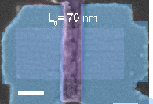
c
b
a
d

Figure S1 | a, Transconductance characteristics of the A-CNT FET in Figure 1d (L_{g}= 85 nm, L_{con}= 80 nm). Open circles represent raw data, and lines represent Savitsky-Golay smoothing fitting. b, Output characteristics of the top-gated A-CNT FET with a CGP of 280 nm, L_{con} of 200 nm, and L_{g} of 70 nm. V_{gs} is varied from -2.2 V to 3.0 V with a step of 0.4 V from top to bottom. The inset shows an SEM image of the FET with full contact. Scale bar: 100 nm. c, Transfer characteristics of the A-CNT FET in Figure S1B (L_{g}= 70 nm, L_{con}= 200 nm). d, Transconductance characteristics of the A-CNT FET in Figure S1b.

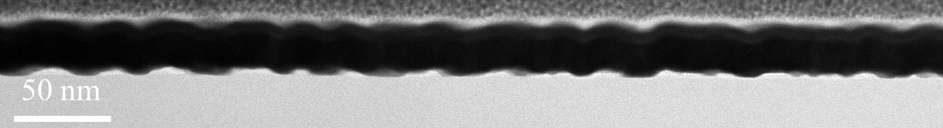
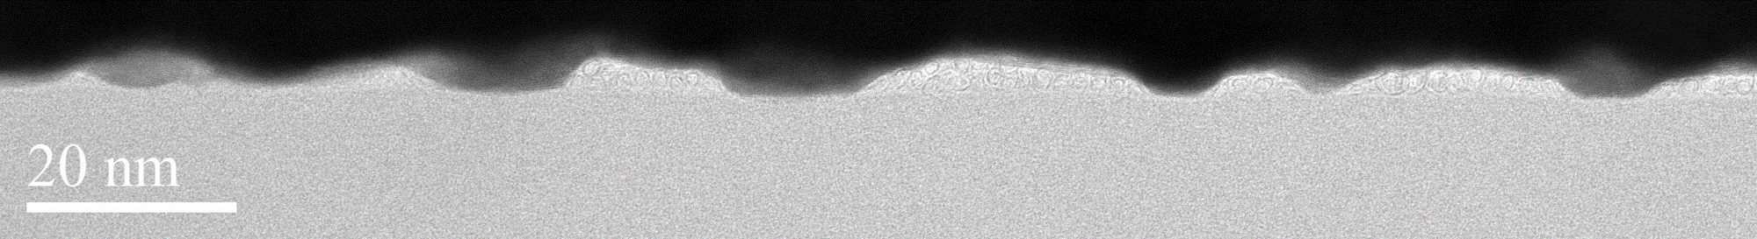

Figure S2| TEM image showing the stacking of A-CNTs in the source and drain contact area of as-fabricated FETs.

b
a
c

Figure S3| Capacitance-Voltage (C-V) characteristics of the MOSCAP with aligned CNTs. a, SEM image for the A-CNT-based capacitor. Scale bar: 5 μm. Inset shows the SEM image of the complete C-V test structure. Scale bar for the inset: 20 μm. b, C-V characterization results for the CNT array-based capacitors at a range of low and high frequencies from 1 MHz to 50 KHz. c, Interface states (D_{it}) distribution extracted with the High-Low Frequency C-V method.

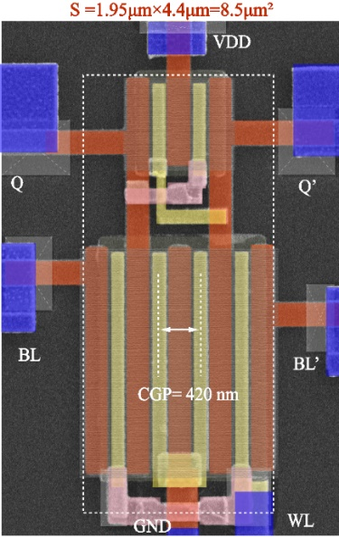
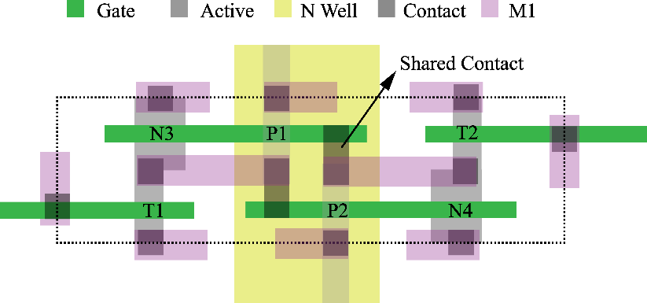
c
b
a
d
e
f

Figure S4| a, Circuit diagram of the 6T-SRAM cell based on Silicon CMOS FETs. b, Layout of the 6T-SRAM cell based on Silicon CMOS FETs. c, Layout of the 6T-SRAM cell based on A-CNT PMOS FETs. d, False-color SEM image of a representative A-CNT based 6T-SRAM cell with CGP of 420 nm and area of 8.58 μm². Scale bar: 500 nm. e, Read margin characterization of the 6T-SRAM cell in d. f, Write margin characterization of the 6T-SRAM cell in d.
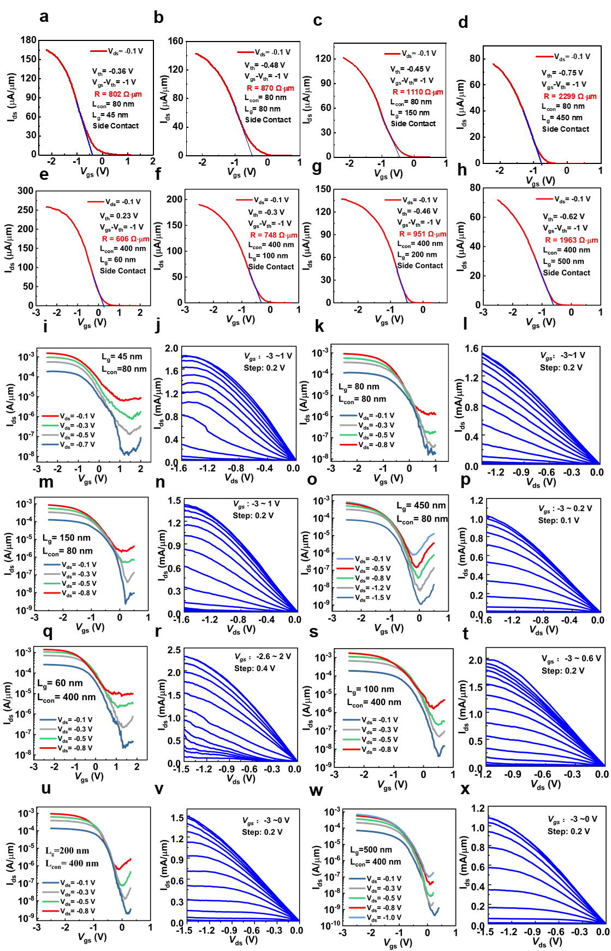

Figure S5| Transfer and output characteristic for top-gated p-type A-CNT FETs
with Side contact structure of different contact length and gate length at V_{ds}= -0.1 V. V_{th} is extracted by the linear extrapolation method.
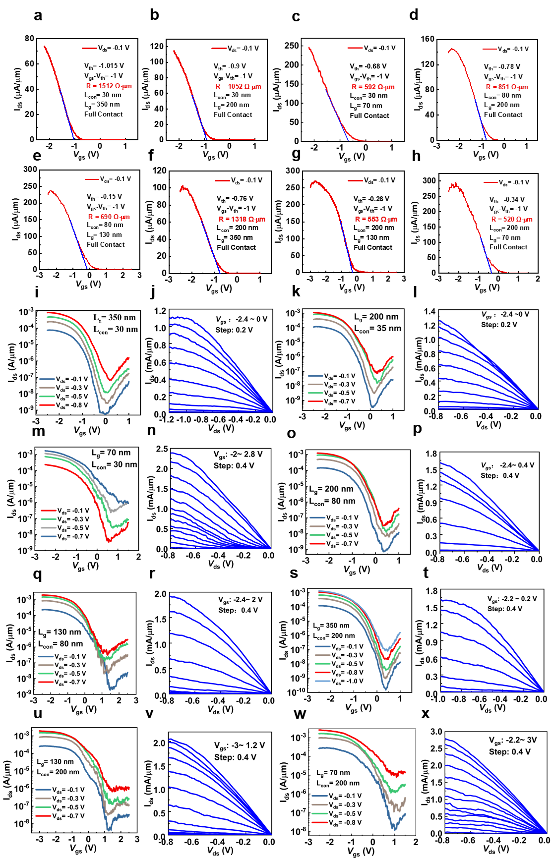

Figure S6| Linear transfer curves for top-gated p-type A-CNT FETs with Full contact structure of different contact length and gate length at V_{ds}= -0.1 V. V_{th} is extracted by the linear extrapolation method.

Figure S7| L_{T} versus L_{con} for both Side Contact structure (blue) and Full Contact structure (red).

c
b

a

Figure S8| a, Output characteristics of the same device with L_{g}= 30 nm, L_{con}= 200 nm in Figure 4a. b, Transconductance of the same device in A. Open circles represent raw data, and lines represent Savitsky-Golay smoothing fitting. c, Transconductance of the device with L_{g}= 35 nm, L_{con}= 16 nm in Figure 4d. Open circles represent raw data, and lines represent Savitsky-Golay smoothing fitting.

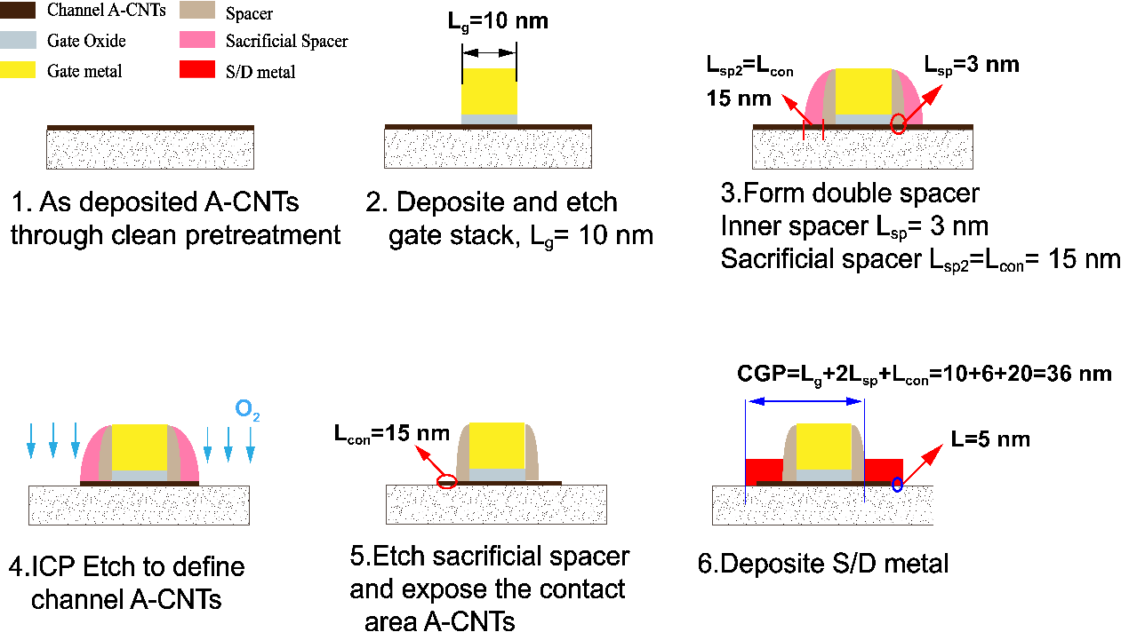

Figure S9| The proposed process flow to fabricate double self-aligned A-CNT FETs with CGP below 50 nm.

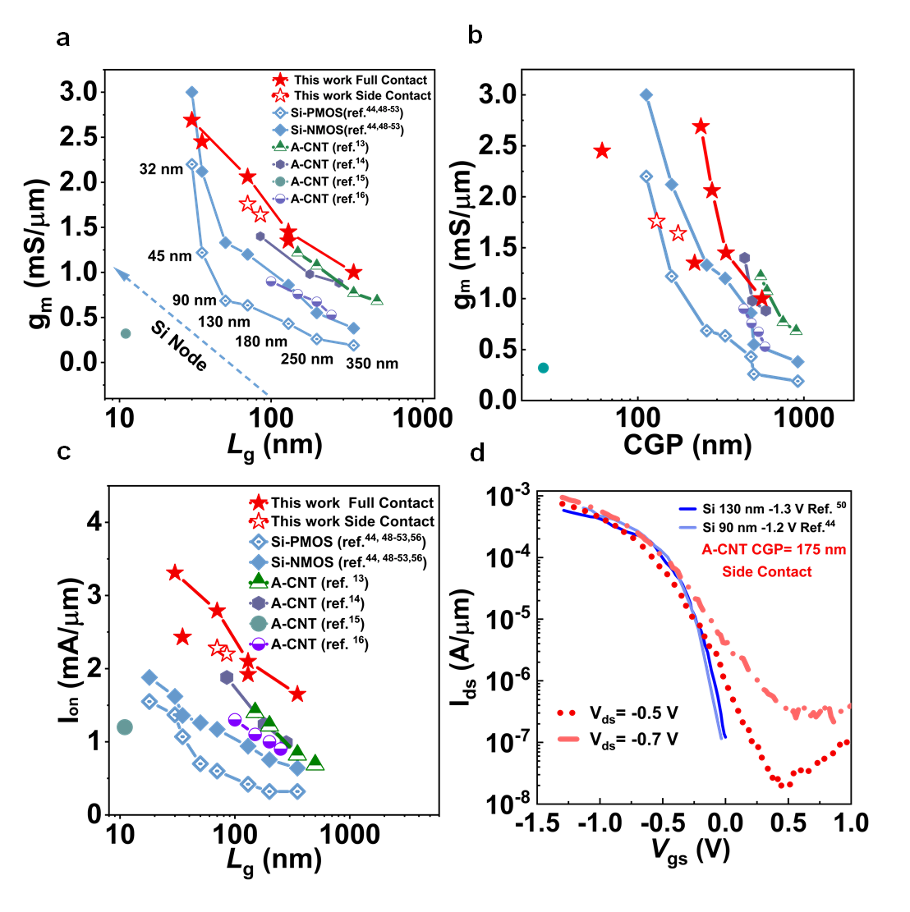

Figure S10| Benchmarking A-CNT FETs. a, Comparison of g_{m} at various L_{g} for A-CNT FETs in this work with other reported A-CNT FETs and silicon technology. b, Comparison of g_{m} at various CGP for A-CNT FETs in this work with other reported A-CNT FETs and silicon technology. c, Benchmarking I_{on} verus 1/L_{g} of the A-CNT FETs and Si FETs with different technology nodes. d, Comparison of transfer characteristics of representative A-CNT FETs in this work with various silicon technology nodes.

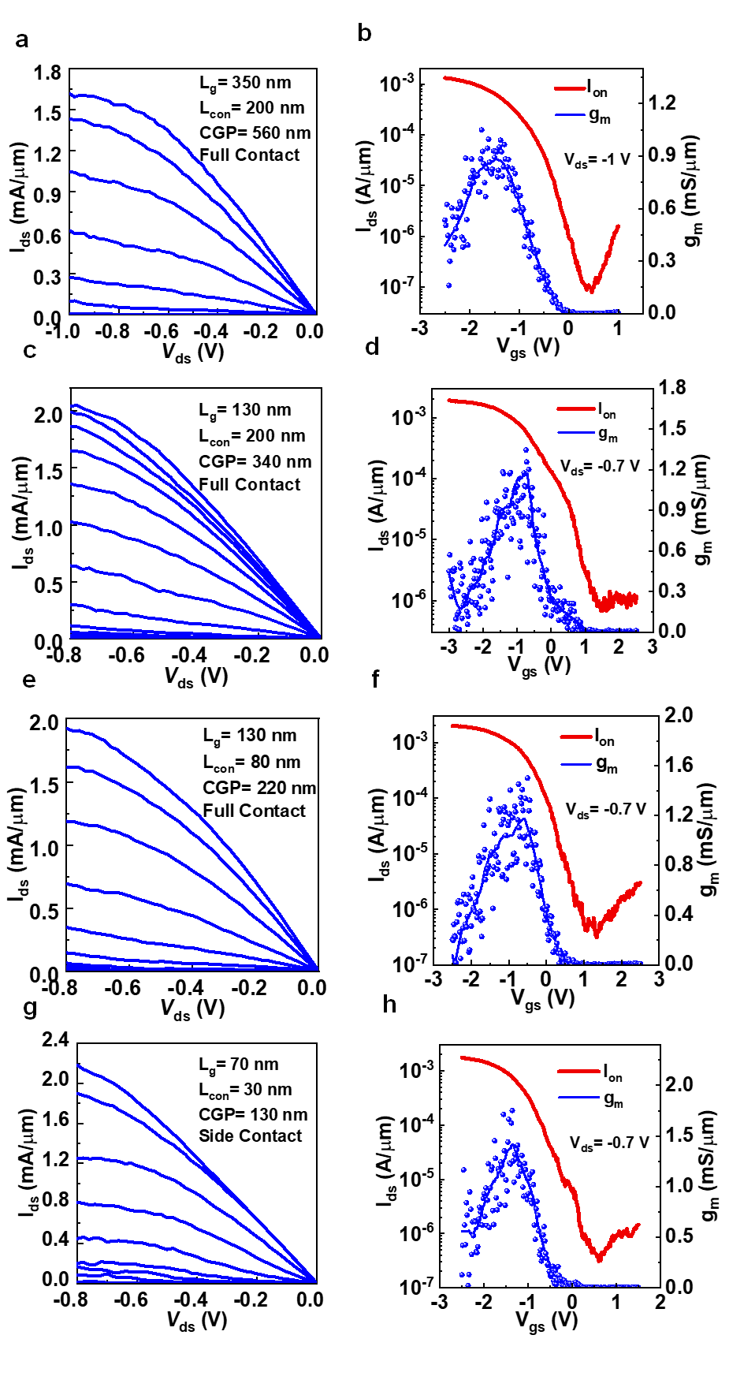

Figure S11| Output and transfer characteristics for top-gated p-type A-CNT FETs with Full contact structure CGP= 560 nm (a, b), CGP= 340 nm (c, d), CGP= 220 nm (e, f), with Side Contact structure CGP= 130 nm (g, h).

b
a

Figure S12| The green lines represent the output curves of CNT FETs in the experiment, and the blue scatters represent the corresponding data simulated with the VS model.

Figure S13 | Benchmarking the carrier mobility of the A-CNT FETs at different gate lengths (all extracted by the virtual source (VS) model) with that of Si FETs with different technology nodes from Intel and IRDS 2020.

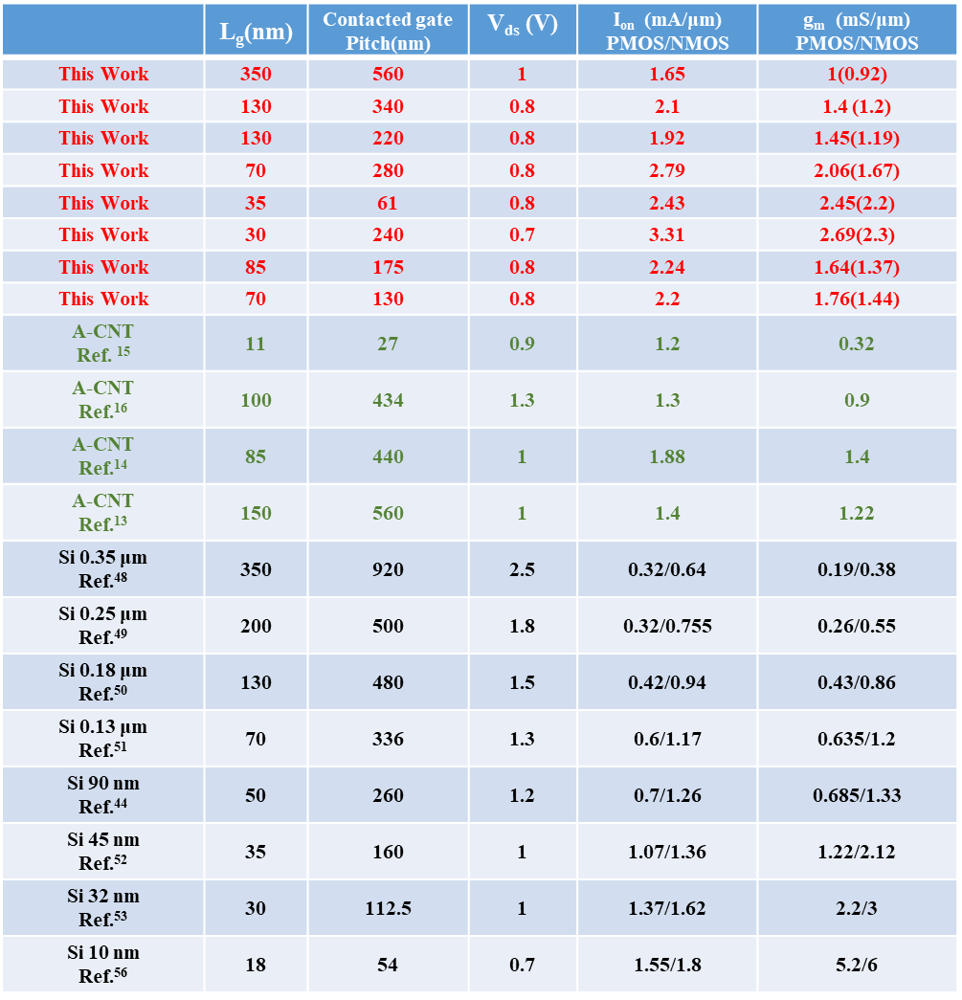

Table S1 | Benchmark A-CNT FETs in this work with other reported A-CNT FETs and silicon technology.

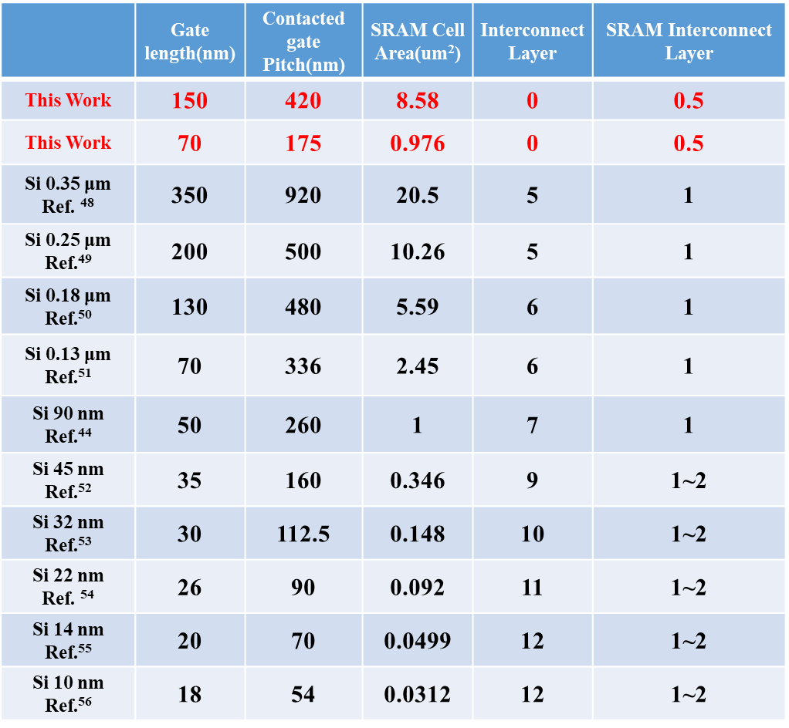

Table S2 | Benchmark state-of-the-art CNT technology reported in this work with silicon technology.

