Supplementary tables
Supplementary Table S1. Differential expression of RNA editing gene families in liver cancer.
Family | No. | Gene | TCGA_LIHC* |  |  | Catholic_mLIHC** |  |  | ICGC_LIRI*** |  |  | GSE77314
Family | No. | Gene | Non-tumor | Tumor | Fold change | Normal | Tumor | Fold change | Non-tumor | Tumor | Fold change | Non-tumor | Tumor | Fold change
Family | No. | Gene | (n=50) | (n=371) | Fold change | (n=15) | (n=56) | Fold change | (n=202) | (n=238) | Fold change | (n=50) | (n=50) | Fold change
ADAR | 1 | ADAR1 | 16.43 | 33.55 | 2.04 | 46.65 | 73.67 | 1.58 | 21.24 | 41.38 | 1.95 | 25.44 | 41.12 | 1.62
ADAR | 2 | ADARB1 | 0.67 | 1.02 | 1.53 | 4.93 | 3.76 | -1.31 | 2.40 | 2.71 | 1.13 | 3.62 | 2.83 | -1.28
ADAR | 3 | ADARB2 | 0.04 | 0.06 | 1.35 | 0.23 | 0.20 | -1.14 | N.E | 0.12 | - | 0.27 | 0.14 | -1.96
APOBEC | 1 | AICDA | N.E | N.E | - | N.E | N.E | - | N.E | N.E | - | N.E | N.E | -
APOBEC | 2 | APOBEC1 | N.E | N.E | - | N.E | N.E | - | N.E | 0.46 | - | N.E | N.E | -
APOBEC | 3 | APOBEC2 | N.E | 0.15 | - | N.E | N.E | - | 0.17 | 0.22 | 1.32 | 0.10 | 0.16 | 1.70
APOBEC | 4 | APOBEC3A | 0.25 | 0.11 | -2.20 | 1.68 | 0.51 | -3.29 | 0.73 | 1.39 | 1.91 | 0.50 | 0.23 | -2.16
APOBEC | 5 | APOBEC3B | 0.41 | 2.27 | 5.52 | 0.23 | 1.27 | 5.43 | 0.49 | 2.14 | 4.39 | 0.30 | 2.48 | 8.26
APOBEC | 6 | APOBEC3C | 2.20 | 3.54 | 1.20 | 1.97 | 2.07 | 1.05 | 3.17 | 3.02 | -1.05 | 3.07 | 2.19 | -1.40
APOBEC | 7 | APOBEC3D | 0.47 | 0.86 | 1.84 | 0.63 | 0.81 | 1.30 | 0.92 | 1.02 | 1.11 | 1.05 | 0.88 | -1.19
APOBEC | 8 | APOBEC3F | 0.96 | 1.36 | 1.43 | 1.27 | 1.40 | 1.10 | 0.84 | 1.06 | 1.26 | 1.36 | 1.55 | 1.14
APOBEC | 9 | APOBEC3G | 0.71 | 1.07 | 1.52 | 2.88 | 2.85 | -1.01 | 3.41 | 3.67 | 1.08 | 4.43 | 3.51 | -1.26
APOBEC | 10 | APOBEC3H | 0.19 | 0.43 | 2.27 | 0.45 | 0.44 | -1.02 | 0.91 | 1.13 | 1.24 | 1.06 | 0.86 | -1.23
APOBEC | 11 | APOBEC4 | N.E | N.E | - | N.E | N.E | - | N.E | N.E | - | N.E | N.E | -
*TCGA_LIHC: The Cancer Genome Atlas_Liver Hepatocellular Carcinoma
**Catholic_mLIHC: Catholic university_multistage Liver Hepatocellular Carcinoma (GSE114564)
***ICGC_LIRI: International Cancer Genome Consortium_Liver Cancer-RIKEN.JP
NE: Non-expression

Table S2. Systematic analysis of mutual exclusivity between ADAR1 amplification and CTNNB1 mutation in various cancers.
No. | Abbreviation | Study | Samples | CTNNB1 | ADAR1 | Both | Neither | p-value | Tendency
1 | LIHC | Liver hepatocellular carcinoma | 366 | 94 | 41 | 5 | 226 | 0.004** | Mutual exclusivity
2 | STAD | Stomach adenocarcinoma | 393 | 27 | 18 | 6 | 342 | 0.01** | Co-occurrence
3 | LUAD | Lung adenocarcinoma | 230 | 5 | 33 | 4 | 188 | 0.039* | Co-occurrence
4 | PRAD | Prostate adenocarcinoma | 492 | 13 | 11 | 2 | 466 | 0.056 | None
5 | SKCM | Skin Cutaneous Melanoma | 287 | 16 | 12 | 3 | 256 | 0.067 | None
6 | UCS | Uterine Carcinosarcoma | 56 | 0 | 4 | 1 | 51 | 0.089 | None
7 | UCEC | Uterine Corpus Endometrial Carcinoma | 242 | 70 | 17 | 3 | 152 | 0.094 | None
8 | OV | Ovarian serous cystadenocarcinoma | 311 | 5 | 26 | 2 | 278 | 0.124 | None
9 | PAAD | Pancreatic adenocarcinoma | 149 | 4 | 8 | 1 | 136 | 0.271 | None
10 | CESC | Cervical squamous cell carcinoma | 191 | 7 | 10 | 1 | 173 | 0.384 | None
11 | ACC | Adrenocortical carcinoma | 88 | 14 | 2 | 1 | 71 | 0.433 | None
12 | ESCA | Esophageal carcinoma | 184 | 10 | 9 | 1 | 164 | 0.469 | None
13 | BRCA | Breast invasive carcinoma | 963 | 5 | 112 | 1 | 845 | 0.528 | None
14 | BLCA | Bladder Urothelial Carcinoma | 127 | 6 | 13 | 1 | 107 | 0.568 | None
15 | COADREAD | Coloreactal adenocarcinoma | 220 | 12 | 7 | 0 | 201 | 0.671 | None
16 | KIRC | Kidney renal clear cell carcinoma | 448 | 51 | 9 | 1 | 387 | 0.673 | None
17 | LUSC | Lung squamous cell carcinoma | 178 | 5 | 11 | 0 | 162 | 0.724 | None
18 | HNSC | Head and Neck squamous cell carcinoma | 504 | 10 | 14 | 0 | 480 | 0.753 | None
19 | SARC | Sarcoma | 243 | 5 | 12 | 0 | 226 | 0.775 | None
20 | PCPG | Pheochromocytoma and Paraganglioma | 162 | 1 | 6 | 0 | 155 | 0.963 | None
21 | LGG | Brain Lower Grade Glioma | 283 | 2 | 4 | 0 | 277 | 0.972 | None
22 | THYM | Thymoma | 123 | 3 | 1 | 0 | 119 | 0.976 | None
23 | KIRP | Kidney renal papillary cell carcinoma | 280 | 2 | 3 | 0 | 275 | 0.979 | None
24 | THCA | Thyroid carcinoma | 399 | 2 | 1 | 0 | 396 | 0.995 | None
25 | LAML | Acute Myeloid Leukemia | 188 | 0 | 0 | 0 | 188 | 1 | None
26 | CHOL | Cholangiocarcinoma | 35 | 0 | 5 | 0 | 30 | 1 | None
27 | GBM | Glioblastoma multiforme | 273 | 0 | 1 | 0 | 272 | 1 | None
28 | KICH | Kidney Chromophobe | 66 | 2 | 0 | 0 | 64 | 1 | None
29 | DLBC | Lymphoid neoplasm | 48 | 0 | 3 | 0 | 45 | 1 | None
30 | MESO | Mesothelioma | 83 | 0 | 4 | 0 | 79 | 1 | None
31 | TGCT | Testicular Germ Cell Tumors | 149 | 0 | 1 | 0 | 148 | 1 | None
32 | UVM | Uveal Melanoma | 80 | 1 | 0 | 0 | 79 | 1 | None
*The genomic alteration and mutation data are acquired from cBioPortal (www.cbioportal.org)

Table S3. Differential expression and fold change of miR-3144-3p and ED_miR-3144(3_A<G) target candidates in liver cancer RNA-seq datasets.
 |  |  | TCGA_LIHC |  |  | Catholic_mLIHC |  |  | ICGC_LIRI
 | No. | Genes | Non-tumor | Tumor | Fold change | Normal | Tumor | Fold change | Non-tumor | Tumor | Fold change
 | No. | Genes | (n=50) | (n=371) | Fold change | (n=15) | (n=56) | Fold change | (n=202) | (n=238) | Fold change
Canonical miR-3144-3p targets | 1 | STXBP4 | 0.12 | 0.43 | 3.48 | 3.49 | 6.61 | 1.89 | 0.37 | 0.89 | 2.37
Canonical miR-3144-3p targets | 2 | SUV39H2 | 0.69 | 1.89 | 2.74 | 2.25 | 5.21 | 2.31 | 1.07 | 2.32 | 2.16
Canonical miR-3144-3p targets | 3 | MSI2 | 0.56 | 1.44 | 2.56 | 14.56 | 25.21 | 1.73 | 1.75 | 3.44 | 1.96
Edited_miR-3144(3_A<G)  targets | 1 | INMT | 9.65 | 2.53 | -3.82 | 26.95 | 9.6 | -2.79 | 11 | 3.5 | -3.14
Edited_miR-3144(3_A<G)  targets | 2 | GHR | 27.20 | 7.56 | -3.60 | 84.66 | 26.75 | -3.17 | 33.28 | 10.33 | -3.22
Edited_miR-3144(3_A<G)  targets | 3 | GLYAT | 58.82 | 21.38 | -2.75 | 153.18 | 37.14 | -4.12 | 100.66 | 44.71 | -2.25
Edited_miR-3144(3_A<G)  targets | 4 | SLC38A4 | 114.84 | 60.33 | -1.90 | 332.43 | 134.61 | -2.47 | 133.36 | 75.11 | -1.78
Edited_miR-3144(3_A<G)  targets | 5 | HMGCS2 | 664.92 | 436.49 | -1.52 | 826.03 | 347.58 | -2.38 | 652.14 | 350.01 | -1.86

Table S4. Differential expression of MSI2 targeting genes in liver cancer.
 |  | Catholic_mLIHC |  |  | TCGA_LIHC |  |  | ICGC_LIRI
No. | Genes | Normal | Tumor | Fold change | Non-tumor | Tumor | Fold change | Non-tumorl | Tumor | Fold change
No. | Genes | (n=15) | (n=56) | Fold change | (n=50) | (n=371) | Fold change | (n=202) | (n=238) | Fold change
1 | HMGA2 | 0.07 | 1.15 | 16.08 | 0.003 | 0.16 | 51.56 | 0.17 | 1.68 | 9.65
2 | MKI67 | 0.70 | 6.69 | 9.53 | 0.20 | 1.57 | 7.81 | 0.39 | 3.29 | 8.36
3 | HOXA9 | 0.03 | 0.13 | 3.68 | 0.008 | 0.07 | 8.24 | 0.05 | 0.19 | 3.50
4 | MET | 37.51 | 73.57 | 1.96 | 3.53 | 3.96 | 1.12 | 10.64 | 19.11 | 1.80
5 | SMAD3 | 8.45 | 11.33 | 1.34 | 1.83 | 2.55 | 1.39 | 7.70 | 12.01 | 1.56
6 | BECN1 | 23.09 | 27.53 | 1.19 | 2.01 | 2.47 | 1.23 | 14.01 | 23.86 | 1.70
7 | TGFBI | 95.44 | 106.02 | 1.11 | 3.82 | 4.58 | 1.20 | 64.99 | 96.52 | 1.49
8 | LFNG | 1.34 | 1.33 | -1.004 | 0.79 | 1.27 | 1.61 | 1.76 | 3.66 | 2.08
9 | NOTCH1 | 1.79 | 1.77 | -1.01 | 1.39 | 1.80 | 1.29 | 2.64 | 3.50 | 1.33
10 | IKZF2 | 3.84 | 3.74 | -1.03 | 0.22 | 0.23 | 1.08 | 0.65 | 0.57 | -1.12
11 | BMPR1A | 6.60 | 6.42 | -1.03 | 0.77 | 1.09 | 1.42 | 2.22 | 3.57 | 1.61
12 | PTEN | 67.91 | 64.41 | -1.05 | 2.69 | 2.72 | 1.01 | 9.94 | 10.65 | 1.07
13 | KRAS | 10.93 | 10.00 | -1.09 | 1.76 | 1.97 | 1.12 | 4.89 | 5.60 | 1.15
14 | BRD4 | 11.79 | 10.10 | -1.17 | 2.34 | 2.79 | 1.20 | 6.65 | 7.97 | 1.20
15 | NUMB | 33.57 | 27.61 | -1.22 | 2.14 | 2.33 | 1.09 | 17.16 | 18.52 | 1.08
16 | LRIG1 | 15.95 | 11.66 | -1.37 | 2.48 | 2.60 | 1.05 | 7.90 | 8.78 | 1.11
17 | AHR | 59.56 | 42.20 | -1.41 | 3.59 | 3.31 | -1.09 | 13.55 | 15.95 | 1.18
18 | FLT3 | 0.50 | 0.34 | -1.45 | 0.21 | 0.15 | -1.48 | 0.38 | 0.27 | -1.39
19 | CDKN1A | 35.99 | 22.39 | -1.61 | 5.33 | 5.18 | -1.03 | 65.02 | 54.62 | -1.19
20 | MYC | 28.82 | 15.19 | -1.90 | 4.40 | 3.60 | -1.22 | 24.54 | 23.86 | -1.03
21 | AR | 29.92 | 13.50 | -2.22 | 3.26 | 2.35 | -1.39 | 5.16 | 3.58 | -1.44
22 | ESR1 | 63.15 | 14.62 | -4.32 | 1.60 | 0.49 | -3.27 | 4.03 | 1.28 | -3.14
23 | LIN28A | 0 | 0.008 | - | 0.001 | 0.04 | 35.46 | 0.03 | 0.51 | 16.56

Table S5. List of siRNA, miRNA mimics and antisense miRNA sequences used in transfection.
siRNA/miRNA | Accession No. | Strand | Nucleotide sequence
Control siRNA |  | Sense | 5'-CCUACGCCACCAAUUUCGU-3'
 |  | Antisense | 5'-ACGAAAUUGGUGGCGUAGG-3'
ADAR1 siRNA | NM_001025107 | Sense | 5'-CACCAAGGGAAGUUGACUA-3'
 |  | Antisense | 5'-UAGUCAACUUCCCUUGGUG-3'
MSI2 siRNA | NM_138962 | Sense | 5'-CAGCCGAAAGAAGUCAUGU-3'
 |  | Antisense | 5'-ACAUGACUUCUUUCGGCUG-3'
SLC38A4 siRNA | NM_018018 | Sense | 5'-CAUUCUUGCUCACUUCUAU-3'
 |  | Antisense | 5'-AUAGAAGUGAGCAAGAAUG-3'
Adar1 siRNA | NM_019655 | Sense | 5'-AGACAGUGGUCAACCAGAA-3'
 |  | Antisense | 5'-UUCUGGUUGACCACUGUCU-3'
Msi2 siRNA | NM_054043 | Sense | 5'-GUUAGAUUCCAAGACGAUU-3'
 |  | Antisense | 5'-AAUCGUCUUGGAAUCUAAC-3'
miR-3144-3p | NR_036098 | Sense | 5’-AUAUACCUGUUCGGUCUCUUUA-3'
AS-miR-3144-3p |  | Antisense | 5’-UAAAGAGACCGAACAGGUAUAU-3'
ED_miR-3144(3_A<G) |  | Sense | 5’-AUGUACCUGUUCGGUCUCUUUA-3'
AS-ED_miR3144(3_A<G) |  | Antisense | 5’-UAAAGAGACCGAACAGGUACAU-3'

Table S6. List of primer sequence used in PCR experiments.
Gene | Accession No. | Primer | Nucleotide sequence
ADAR1 | NM_001025107 | Forward | 5'-TGGCAGCCTCCGGGTG-3'
 |  | Reverse | 5'-TGTCTGTGCTCATAGCCTTG-3'
gADAR1 | NM_001025107 | Forward | 5'-CTTTCCGTCAAGATTTAAATT-3'
 |  | Reverse | 5'-GGGATGATTCTTCTGATTTTC-3'
ADAR1-mutant | NM_001025107 | Forward | 5'-GAGAAACTGTCAATGACTGCTAT  GCAGCAATAATCTCCCGGAGAGGCTT-3'
 |  | Reverse | 5'-AAGCCTCTCCGGGAGATTATTGCTG  CATAGCAGTCATTGACAGTTTCTC-3'
MSI2 | NM_138962 | Forward | 5'-AAAGGAGCGCCAGGGTTAAA-3'
 |  | Reverse | 5'-GTCTGCGAACGTGACGAAAC-3'
STXBP4 | NM_178509 | Forward | 5'-CCGGAGCCAAGTTGAGGTTA-3'
 |  | Reverse | 5'-GGAGTGGATGAGGTCTTTGGG-3'
SUV39H2 | NM_001193424 | Forward | 5'-GAGGCGCGAGGAGCTTG-3'
 |  | Reverse | 5'-GCAGTAACGGGCACTTCAGA-3'
GHR | NM_000153 | Forward | 5'-AGCGCAGACGCGAACC\-3'
 |  | Reverse | 5'-AGGCTCCTTAGAAGAATTTGTCTTT-3'
GLYAT | NM_005834 | Forward | 5'-CTGGCTGCATCAGGGAGAAA-3'
 |  | Reverse | 5'-GTCATATCCTGCTCCTGAGGG-3'
SLC38A4 | NM_018018 | Forward | 5'-TGCAGGAAACTGTGATTTGC-3'
 |  | Reverse | 5'-TTCGAGCCCACCAACTTAAT-3'
HMGCS2 | NM_005518 | Forward | 5'-CCACCTGGTGACACAAACAG-3'
 |  | Reverse | 5'-TATGATTCACGGGGAGAAGC-3'
INMT | NM_006774 | Forward | 5'-GAAACAGCGGCCGATGGGA-3'
 |  | Reverse | 5'-AGGCATCAAGGCTACAGCAG-3'
HMGA2 | NM_003483 | Forward | 5'-TGGGAGGAGCGAAATCTAA-3'
 |  | Reverse | 5'-GGTGAACTCAAGCCGAAG-3'
MET | NM_000245 | Forward | 5'-TGCAGCGCGTTGACTTATTCATGG-3'
 |  | Reverse | 5'-GAAACCACAACCTGCATGAAGCGA-3'
HOXA9 | NM_152839 | Forward | 5'-CCCCATCGATCCCAATAACCC-3'
 |  | Reverse | 5'-GGTGAGGTTGAGCAGTCGAG-3'
MKI67 | NM_002417 | Forward | 5'-TTGGTACTGGGGGAGGGAGA-3'
 |  | Reverse | 5'-TGGGAGGCGAAAAAGTAAAA-3'
mir-3144 | NR_036098 | Forward | 5'-TCATGCAAATGGAAACCAAA-3'
 |  | Reverse | 5'-CGTTCATTGTTAAAGGTCACGA-3'
GAPDH | NM_002046 | Forward | 5'-ACCAGGTGGTCTCCTCTGAC-3'
 |  | Reverse | 5'-TGCTGTAGCCAAATTCGTTG-3'
gGAPDH | NM_002046 | Forward | 5'-ACCCAGAAGACTGTGGATGG-3'
 |  | Reverse | 5'-TTCTAGACGGCAGGTCAGGT-3'
gADAR1, primers for amplifying genomic ADAR1
ADAR1-mutant, primers for generation of deaminase inactivated pcDNA3.1_ADAR1-p110
mir-3144, primers for sanger sequencing of mir-3144
Supplementary figures
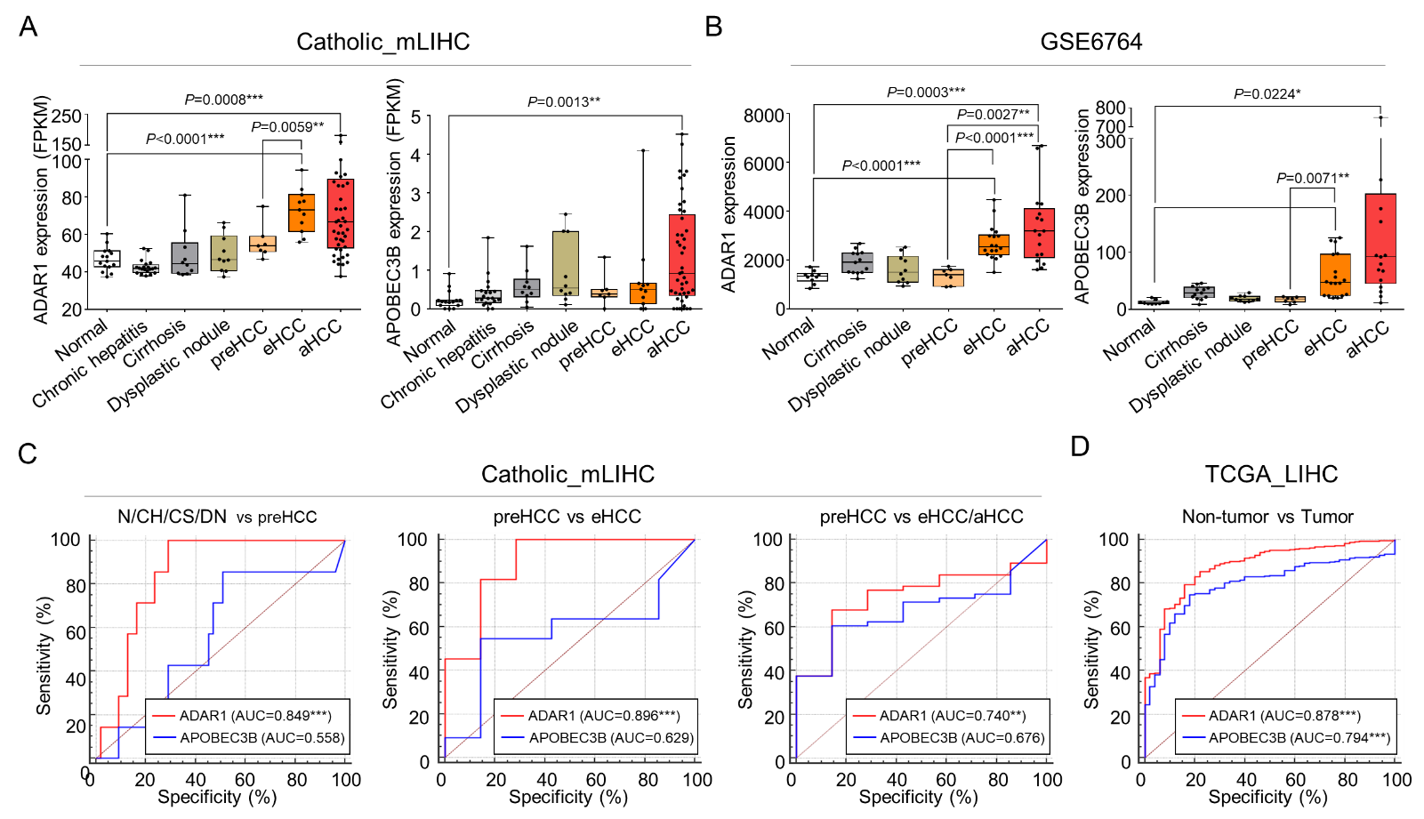
Supplementary Fig. S1. Comparison of ADAR1 and APOBEC3B Expression in Multi-stage liver cancer. ADAR1 and APOBEC3B expression in multi-stage liver cancer. Expression changes of ADAR1 and APOBEC3B in multi-stage liver disease patients of (A) Catholic_mLIHC (n=108) and (B) GSE6764 (n=17). Statistically significant differences were determined using Welch’s t test, P < 0.05*, P < 0.01**, P < 0.0001***. The ROC curve analysis of the ADAR1 and APOBEC3B in liver cancer patients of (C) Catholic_mLIHC and (D) TCGA_LIHC. Statistically significant difference of AUC is compared with reference line (AUC=0.5). N, normal liver. CH, chronic hepatitis B virus infection. DN, dysplastic nodule.

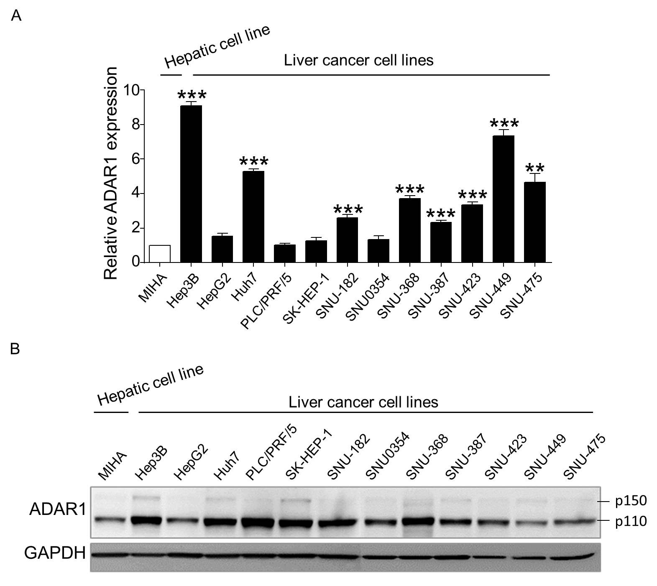
Supplementary Fig. S2. ADAR1 Expression in Liver Cancer Cell Lines. ADAR1 is overexpressed in liver cancer cell lines. Expression of ADAR1 in an immortalized normal hepatic cell line and twelve liver cancer cell lines using qRT-PCR (A) and Western blot analysis (B). *P < 0.05, **P < 0.01, ***P < 0.001; unpaired t-test.
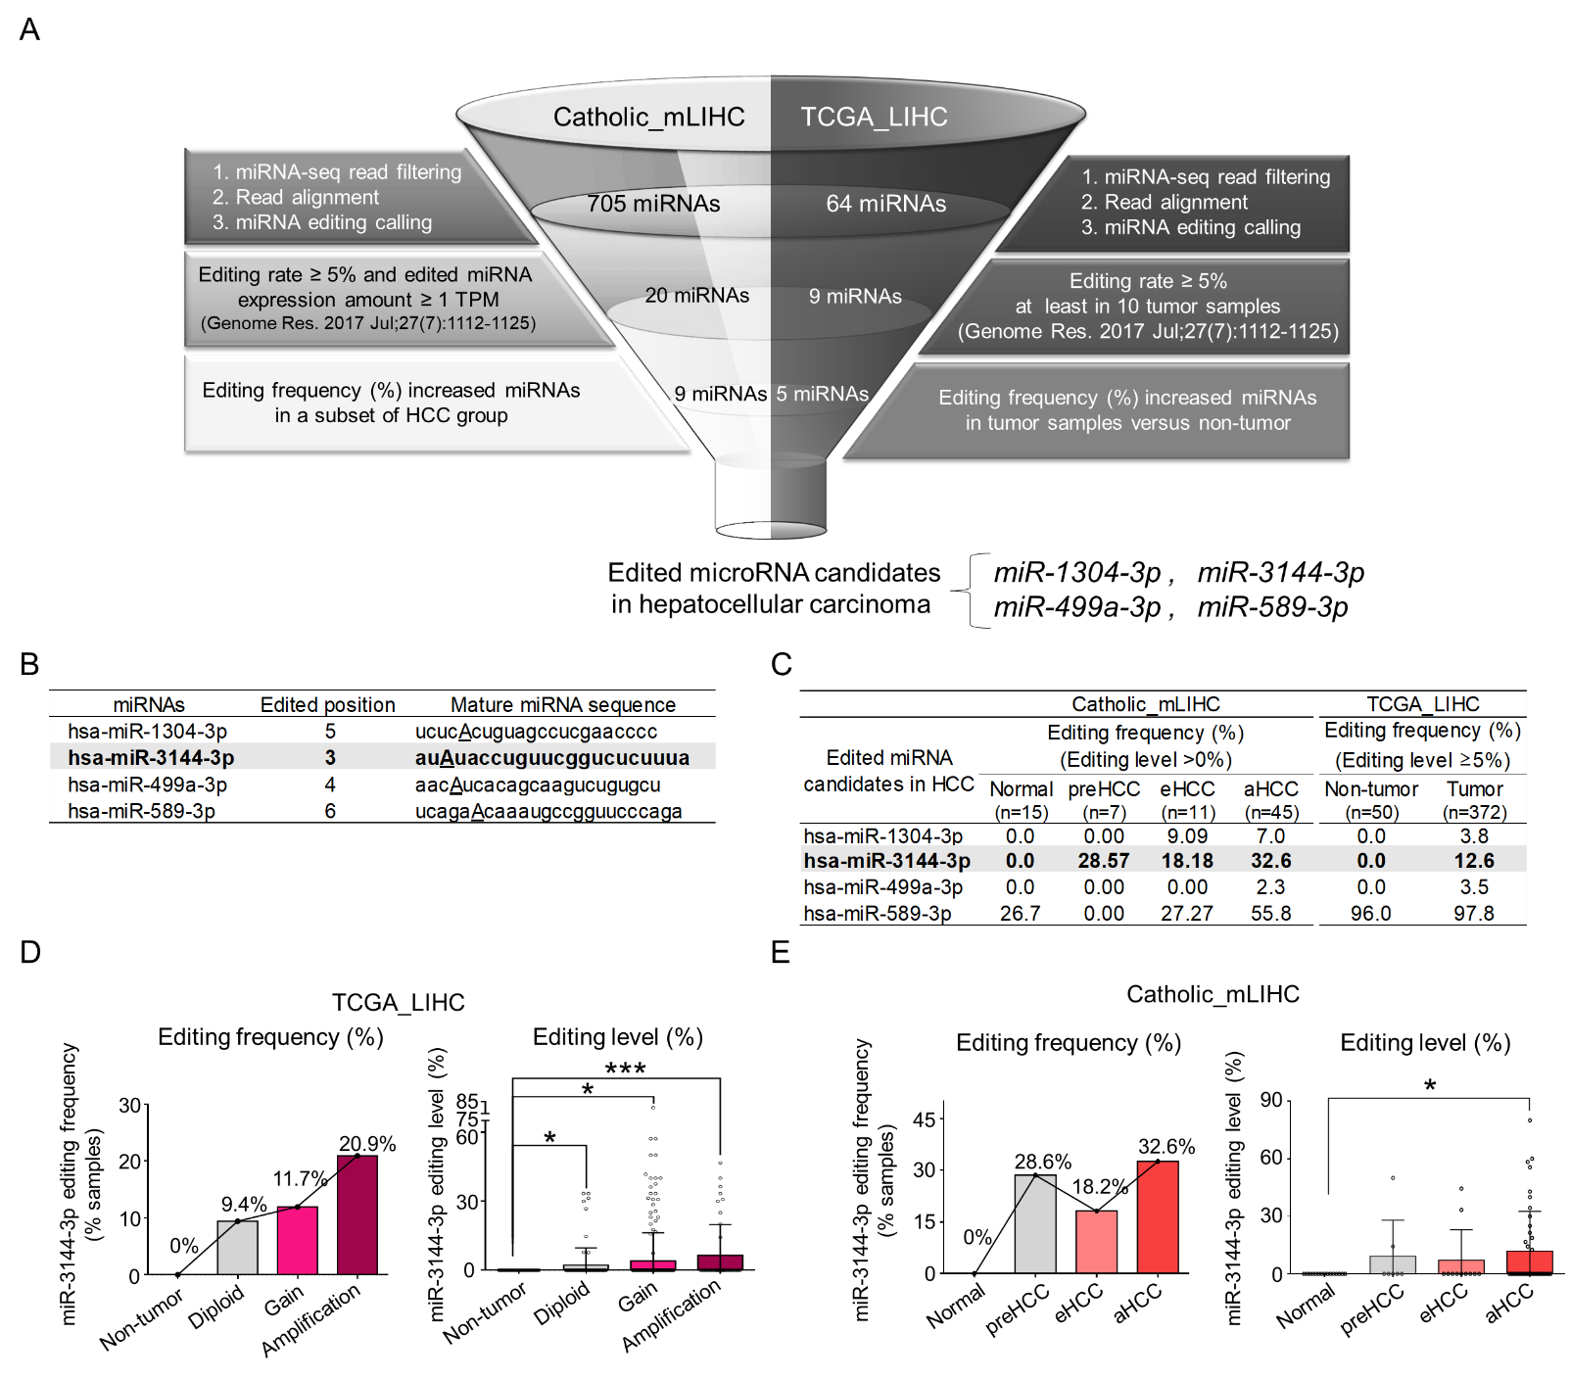 Supplementary Fig. S3. Identification of ADAR1 editing miRNAs in Liver Cancer. Identification of edited miRNA hotspots in liver cancer. (A) Flowchart for the bioinformatic pipeline for identification of edited miRNAs in liver cancer. (B) Editing position summary of the 4 edited miRNAs in liver cancer. (C) The A-to-I editing frequency of the 4 miRNAs analyzed with the two liver cancer small-RNA sequencing datasets of Catholic_mLIHC and TCGA_LIHC. (D) Copy gain and amplification of ADAR1 are associated with increased editing frequency (% samples) of miR-3144-3p compared to normal and diploid groups analyzed with liver cancer TCGA dataset (left panel). Genomic copy number gain (gain and amplification) is related with the increased editing level (%) of miR-3144-3p shown as a boxplot (right panel). (E) The editing frequency (% patient samples) of miR-3144-3p is increased in overt liver cancer (left panel). Differential editing level (%) of miR-3144-3p in multi-stage human liver cancer tissues analyzed with Catholic_LIHC (right panel).
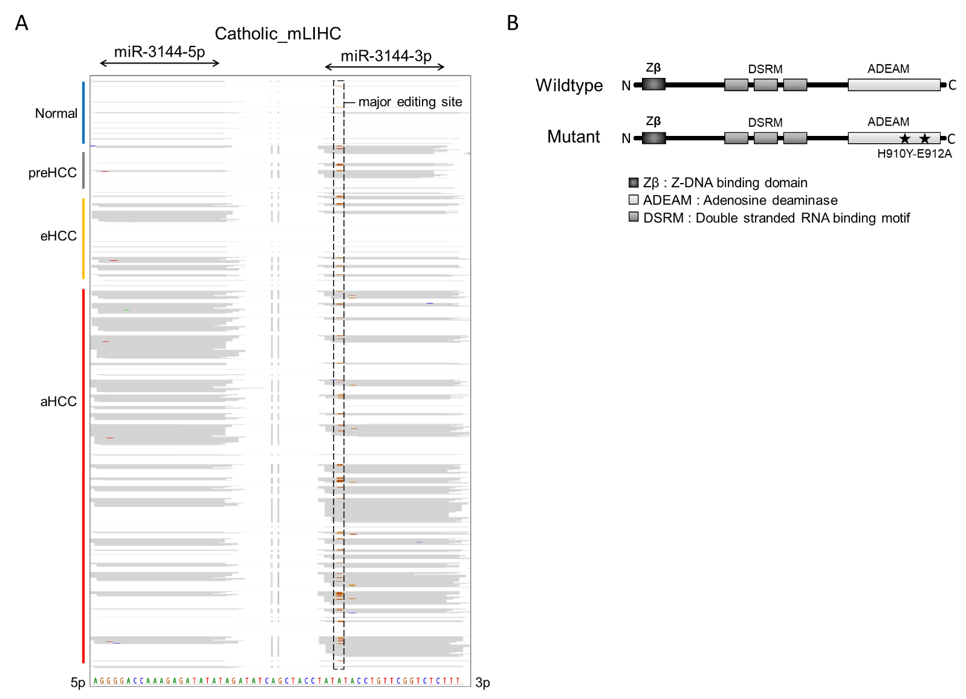
Supplementary Fig. S4. Visualization of miR-3144-3p Editing in silico. Validation of miR-3144-3p editing in silico and in vitro. (A) The A-to-I editing sites of miR-3144-3p seed region are observed in overt liver cancer patient samples visualized by Integrative genomics viewer (IGV). (B) Schematic protein structure diagram of wildtype and adenosine deaminase mutant for of ADAR1-p110.
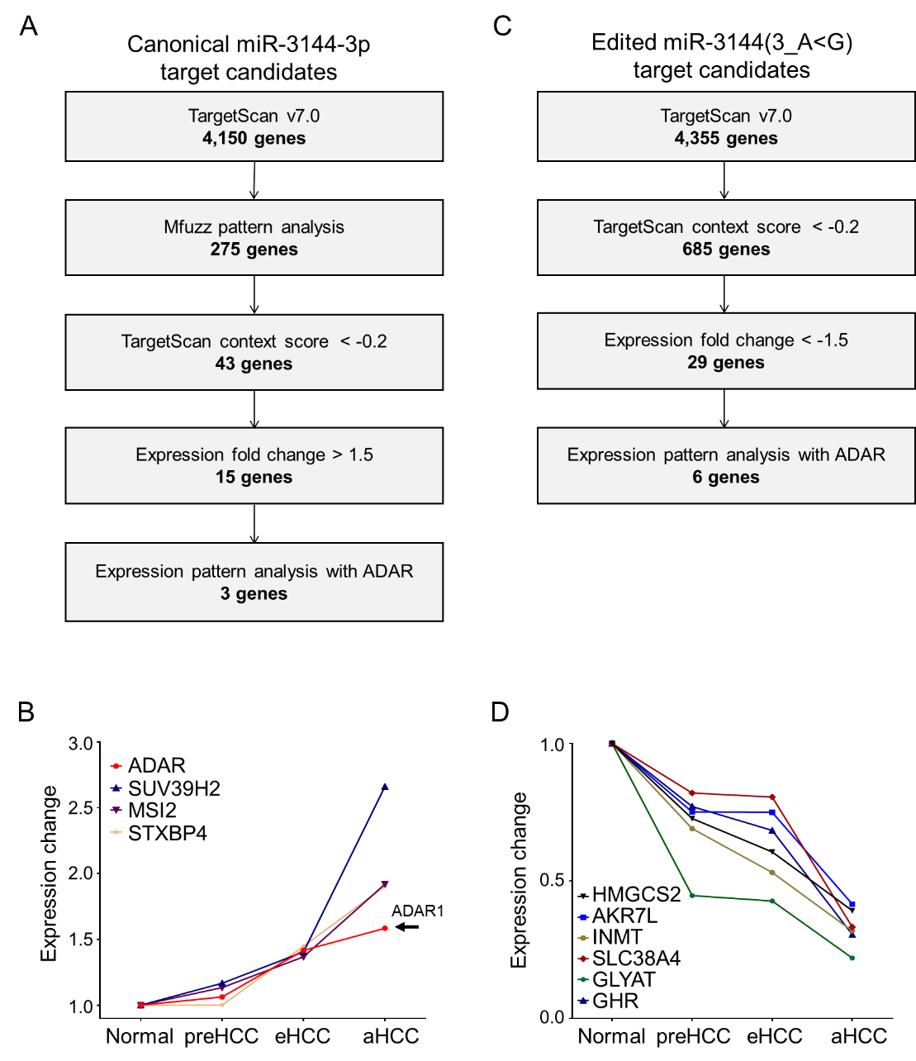
Supplementary Fig. S5. Strategies to Identify Targets of Canonical miR-3144-3p and Edited miR-3144(3_A<G) in Liver Cancer. Strategy to identify miR-3144-3p and ED_miR-3144(3_A<G) target in liver cancer. (A) miR-3144-3p targets are identified with TargetScan v7.0 algorithm and their expressions were analyzed with 3 liver cancer transcriptome sequencing datasets, TCGA_LIHC, Catholic_mLIHC and ICGC_LIRI. (B) The target candidate expression changes of miR-3144-3p in overt liver cancer, Catholic_mLIHC. (C) ED_miR-3144(3_A<G) targets are identified with TargetScan v7.0 algorithm and their expressions were analyzed with 3 liver cancer transcriptome sequencing datasets, TCGA_LIHC, Catholic_mLIHC and ICGC_LIRI. (D) The target candidate expression changes of ED_miR-3144(3_A<G) in overt liver cancer, Catholic_mLIHC.

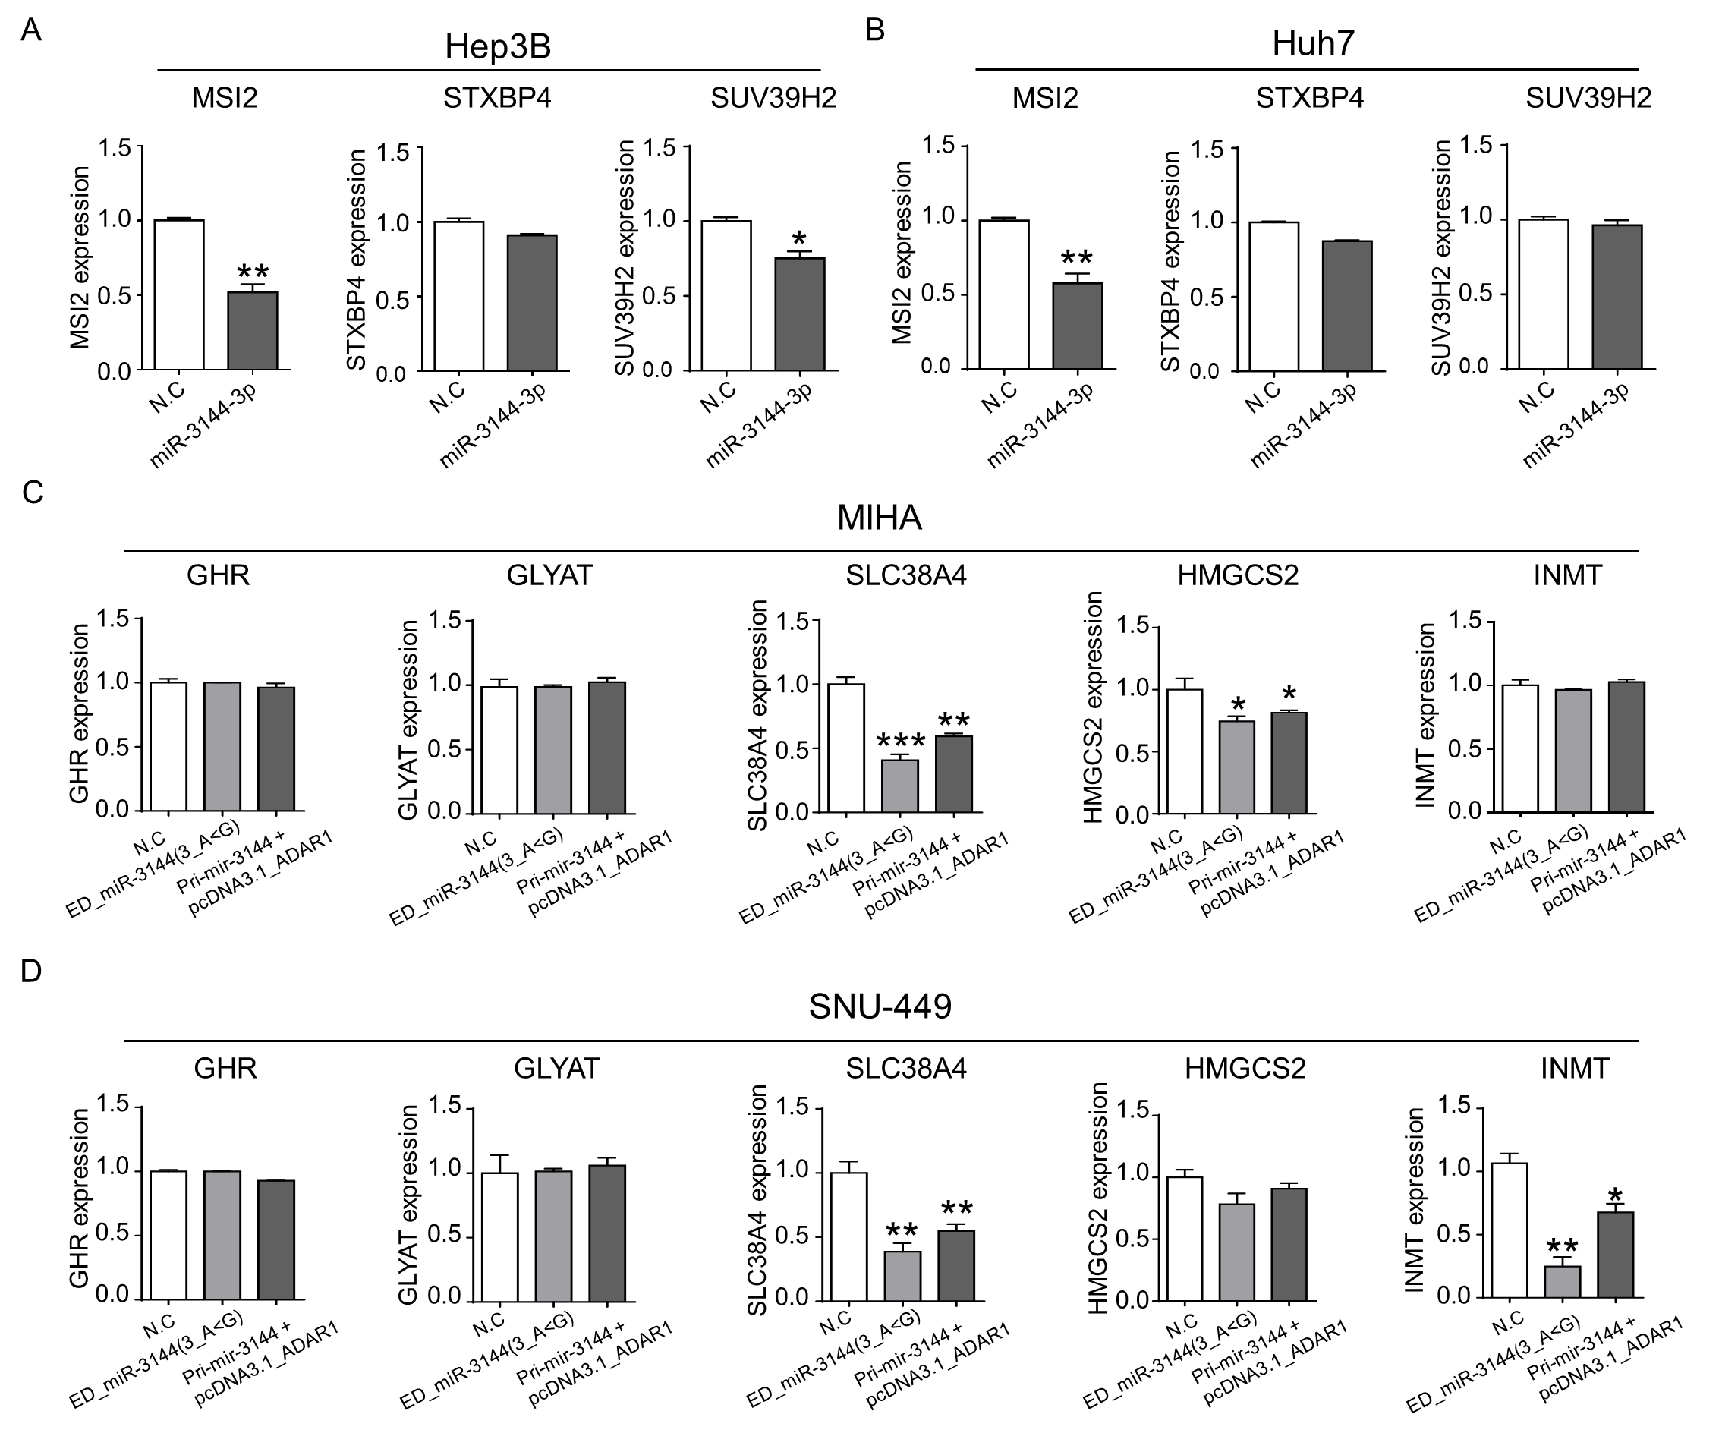
Supplementary Fig. S6. Target validation of canonical miR-3144-3p and ED_miR-3144(3_A<G). Target validation of miR-3144-3p and ED_miR-3144(3_A<G) with qRT-PCR. (A) Hep3B and (B) Huh7 were transfected with negative control (N.C) or miR-3144-3p mimics and the expression of the three target candidates was measured by qRT-PCR. The expression of the five target candidates were analyzed after transfection of ED_miR-3144(3_A<G) or pcDNA3.1_ADAR1-p110 in the background of transfected primary mir-3144 (Pri-mir-3144) in (C) MIHA and (D) SNU-449 cells with qRT-PCR. All data are shown as the mean ± SEM. *P < 0.05, **P < 0.01, ***P < 0.001 by unpaired student’s t test.

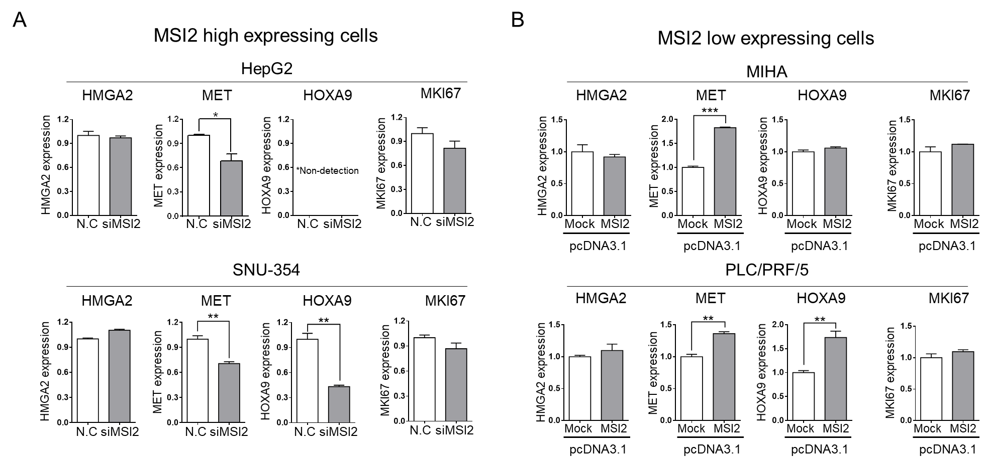
Supplementary Fig. S7. Selective Regulation of MET by MSI2 in Liver Cancer. Expression validation of MSI2 target candidates by qRT-PCR. (A) Negative control siRNA (N.C) or siMSI2 was transfected to two liver cancer cells (HepG2 and SNU-354), the expression was validated by qRT-PCR. (B) MIHA and PLC/PRF/5 cells were transfected with pcDNA3.1_Mock or pcDNA3.1_MSI2 and the expression of the candidate genes were measured with qRT-PCR. All data are shown as the mean ± SEM. *P < 0.05, **P < 0.01, ***P < 0.001 by unpaired student’s t test.

References
[1] Wang AG, Moon HB, Lee MR, Hwang CY, Kwon KS, Yu SL, et al. Gender-dependent hepatic alterations in H-ras12V transgenic mice. J Hepatol 2005;43:836-844.
[2] Futschik ME, Carlisle B. Noise-robust soft clustering of gene expression time-course data. J Bioinform Comput Biol 2005;3:965-988.

