Additional File 1 contains:
Text S1
Tables S1-S3
Figure S1-S5
Test S1. Appendix.
Potential Breeding Habitats of Culex salinarius in Chicago and Decatur, IL
In comparison to the traditionally implicated WNV vectors like Culex pipiens, Culex restuans, Culex tarsalis, and Culex quinquefasciatus, Culex salinarius has been understudied. A few previous studies have estimated that the female flight range is likely ~2 km [65]. To quantify potential larval habitats in locations where Culex salinarius was collected for this study, high-resolution satellite imagery were overlaid by 2 km buffers around each individually collected mosquito. Each individual natural body of freshwater, including locations with evidence of flooding (e.g. ditches, edges of reservoirs), were traced and converted into polygon shapefiles. Results indicate that locations where Culex salinarius was previously collected have plentiful sources of freshwater (at least 0.75 km²), with no mosquito having to travel more than 700 m, a distance well within their average flight range, to reach natural bodies off freshwater (Additional File 1: Figure S5). Additionally, univariate analyses of 40 socio-demographic factors suggests four independent variables may have positive associations with the presence of Culex salinarius: higher % black population (p=0.02), higher % housing built between 1970-1989 (p=0.03), lower median household income (p=0.17), and higher % housing built before WWII (p=0.19) (Additional File 1: Tables S2 & S3).
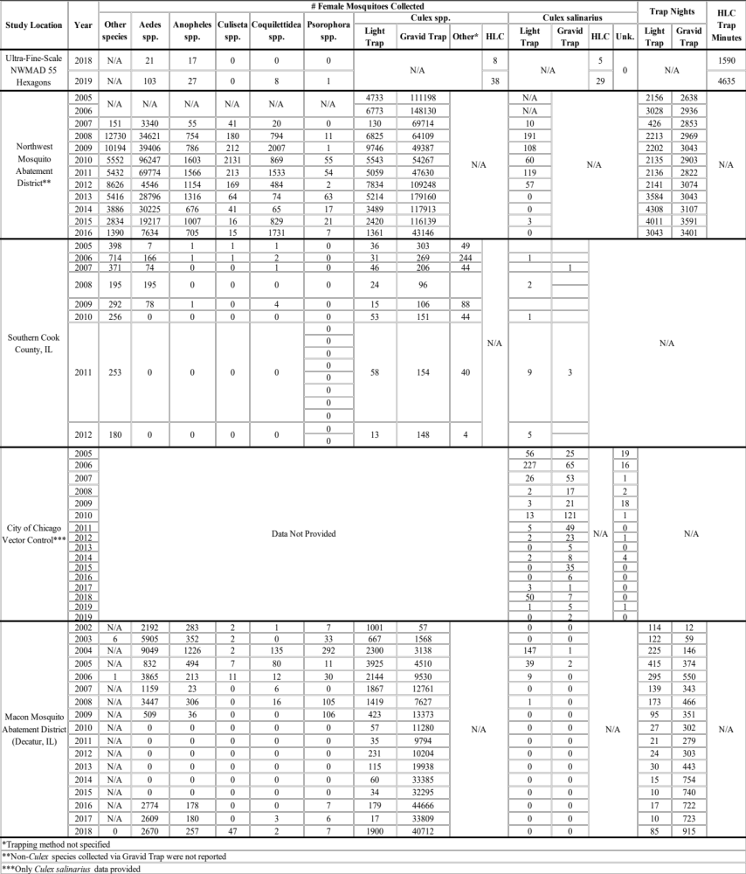
Table S1. Detailed mosquito collection information by genus, trap type, overall trapping effort, and submitting agency.

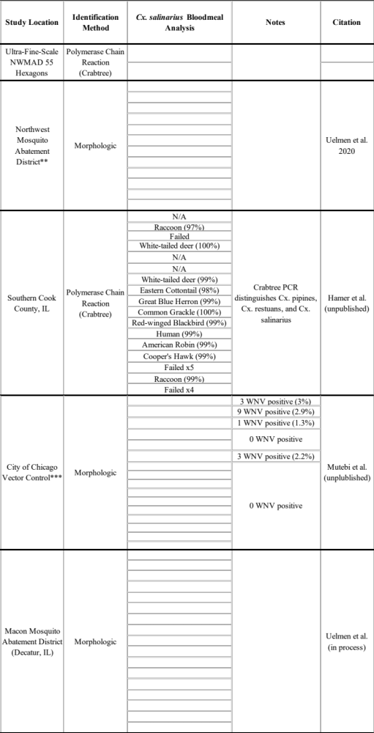
Table S1 (continued).
Independent Variable | Culex salinarius status |  | P
Independent Variable | Present | Absent | P
percentage black | 4.17 | 1.79 | 0.0205
percentage black | (0.9) | (0.42) | 0.0205
percentage housing built between 1970-1989 | 52.36 | 34.72 | 0.0321
percentage housing built between 1970-1989 | (7.25) | (3.42) | 0.0321
median household income | $68221.80 | $80706.20 | 0.169
median household income | ($8098.90) | ($3817.90) | 0.169
percentage housing built before World War II | 3.94 | 9.65 | 0.1867
percentage housing built before World War II | (3.86) | (1.82) | 0.1867
Table S2. Univariate analysis suggests four independent variables may provide unique characteristics in determining the preferred habitat(s) of Culex salinarius within the NWMAD during the summers of 2018 and 2019. Further analysis is not warranted at this time, given the small number of specimens collected. Values in parenthesis indicate one standard error from the mean. No evidence of multicollinearity was present (Table S3).

 | percentage black | percentage housing built between 1970-1989 | median household income | percentage housing built before World War II
percentage black | 1 | 0.374 | -0.244 | -0.436
percentage housing built between 1970-1989 | 0.374 | 1 | -0.535 | -0.158
median household income | -0.244 | -0.535 | 1 | 0.227
percentage housing built before World War II | -0.436 | -0.158 | 0.227 | 1
Table S3. Correlogram testing for multicollinearity among four independent variables associated with Culex salinarius habitat preference within the HLC study regions of NWMAD.

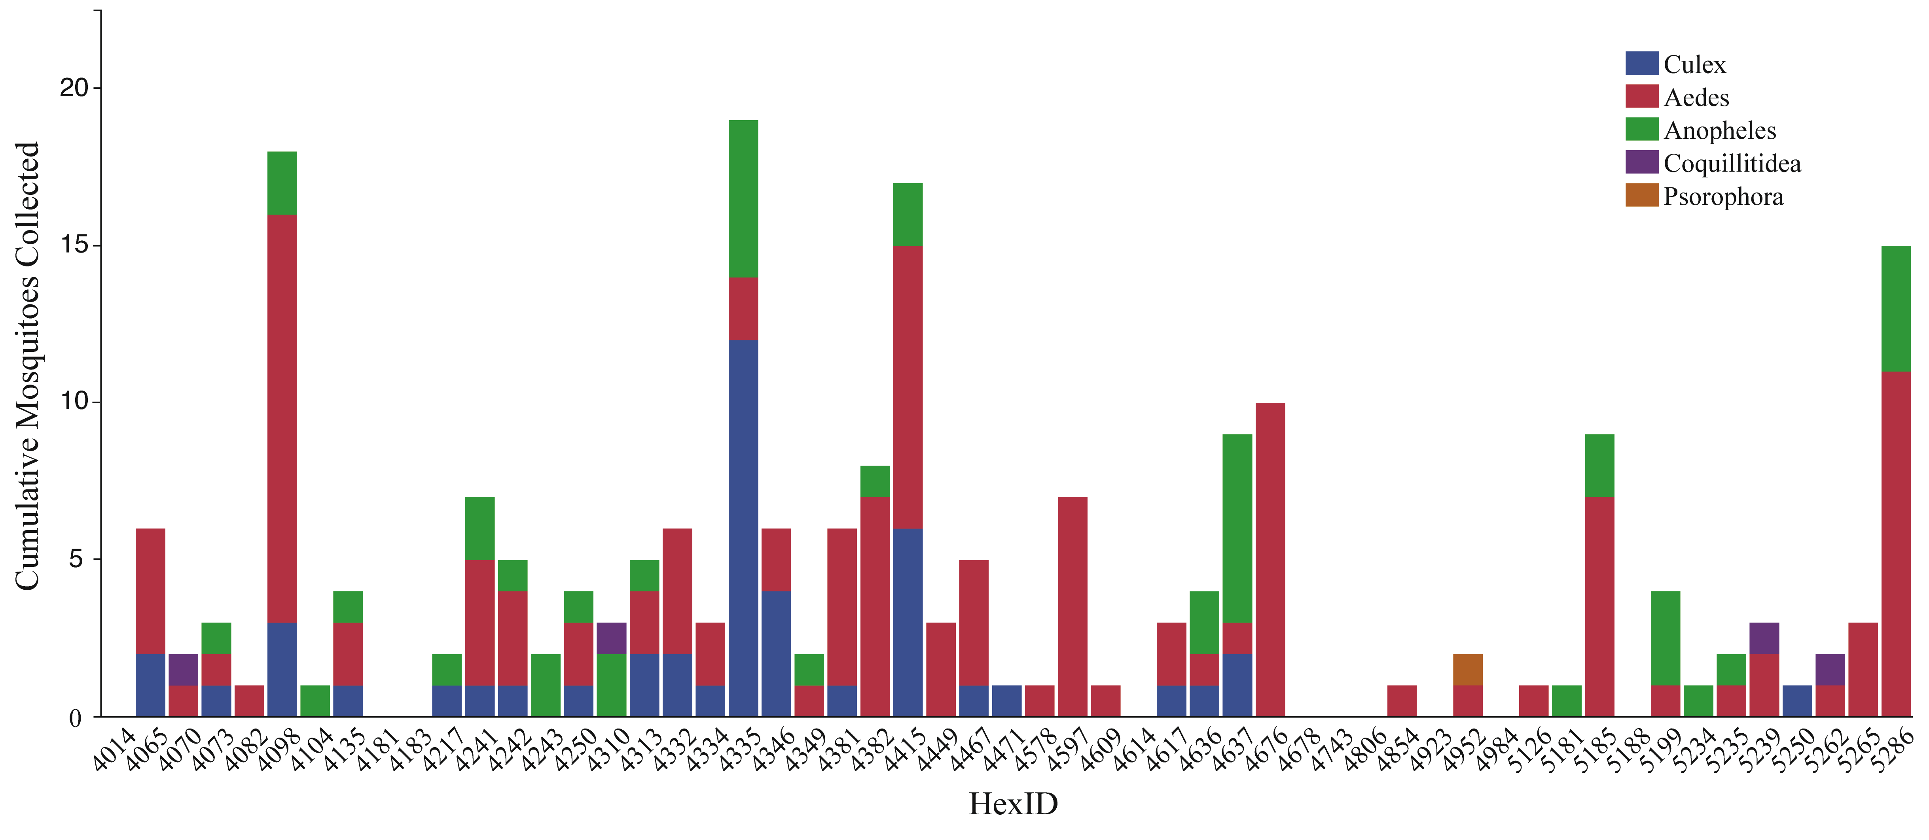
Figure S1. Cumulative HLC collections by mosquito genus for each of the 55 hexagons in the study region.
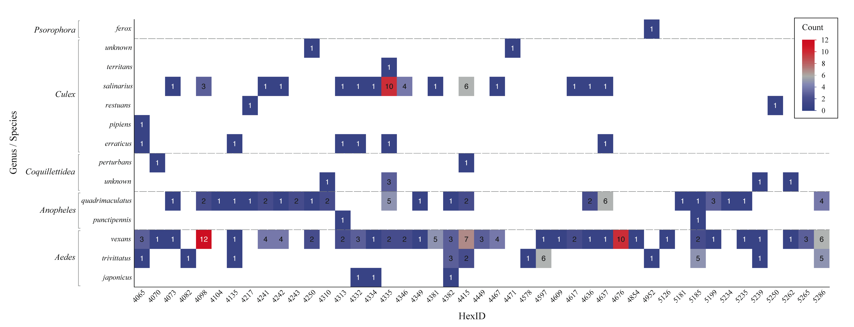
Figure S2. Mosaic plot displaying frequency of genus and species collected by human landing catch by study location (HexID, n=55). For specific coordinates of each mosquito collection location within each HexID, contact the corresponding author.
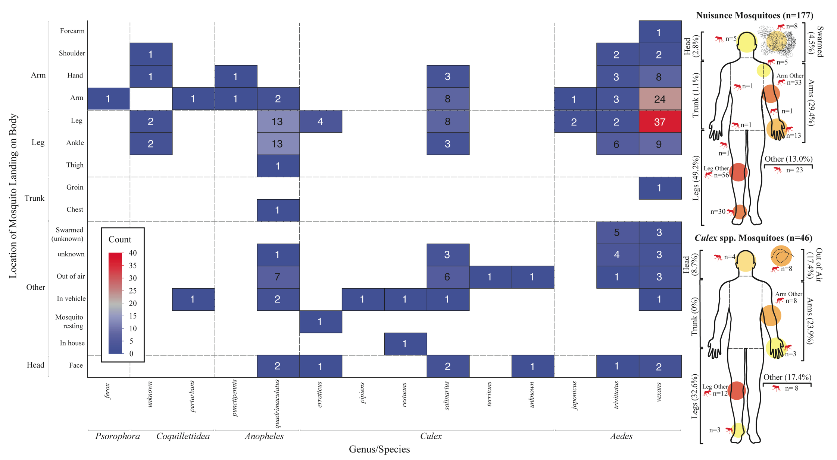
Figure S3. Mosaic plot of frequency of mosquito landing location on body of human collector by genus and species. The diagrams on the far right of the figure display the most common landing locations by nuisance (top) and Culex species (bottom) mosquitoes.
Figure S4. Box plot distribution of average weather factors (temperature, humidity, and wind speed) during human landing catches by genus and species of collected mosquitoes. Temperature and wind speed were recorded by regionally reported value and by a handheld anemometer/thermometer combination device for specific, local values.
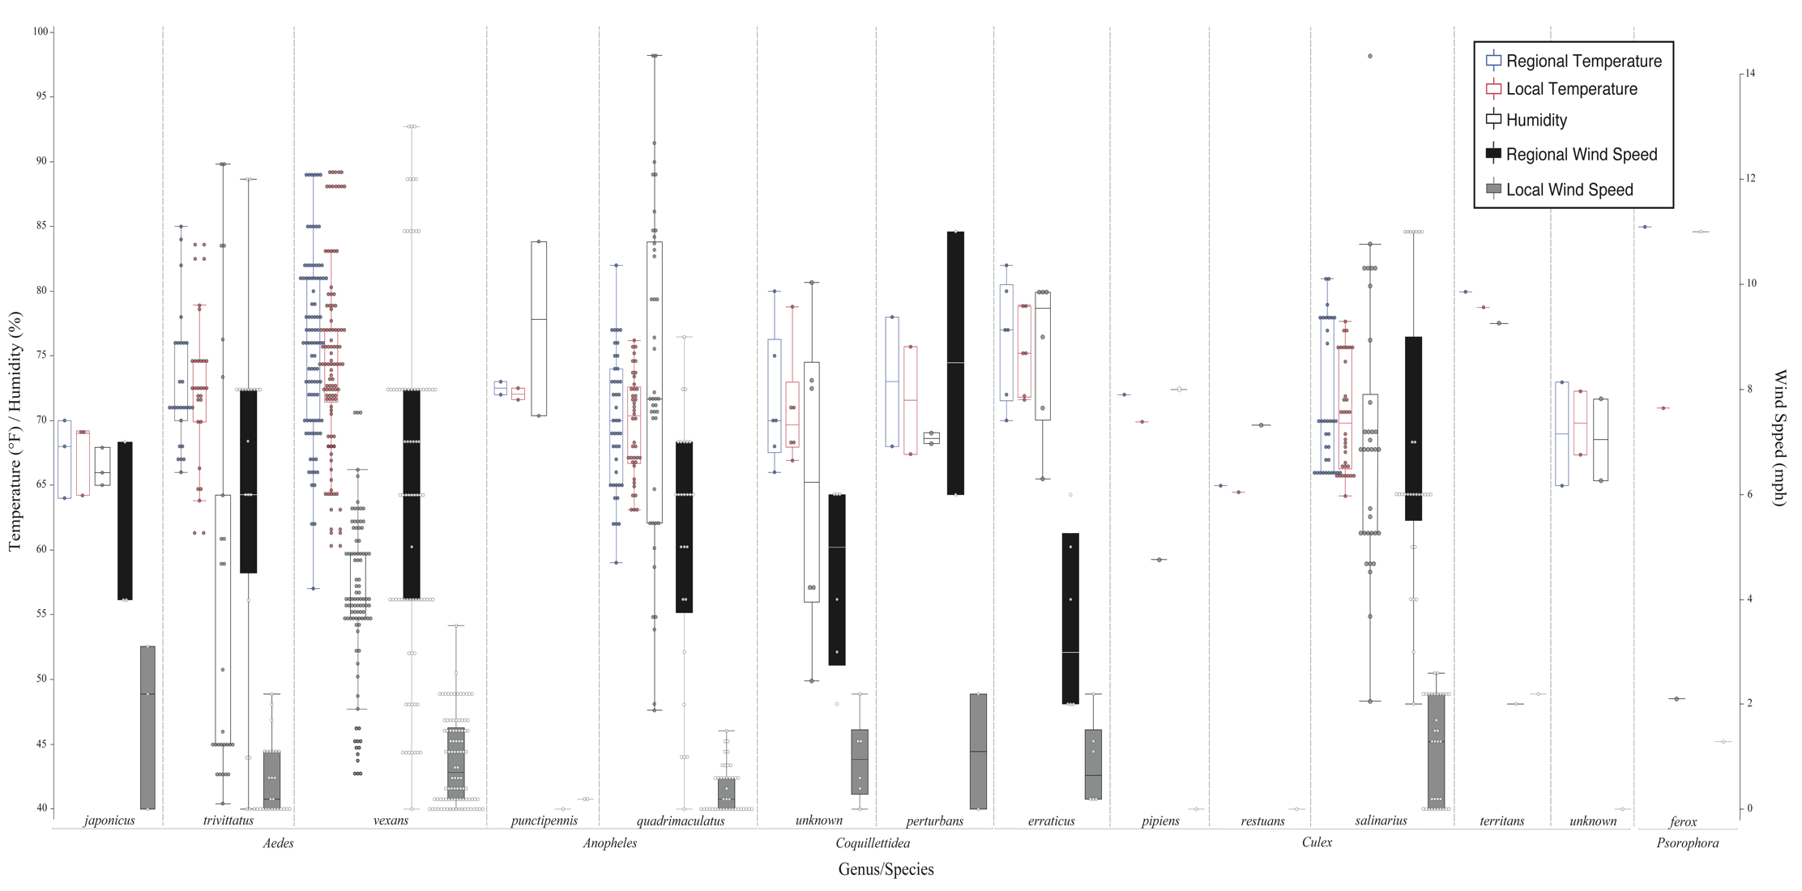
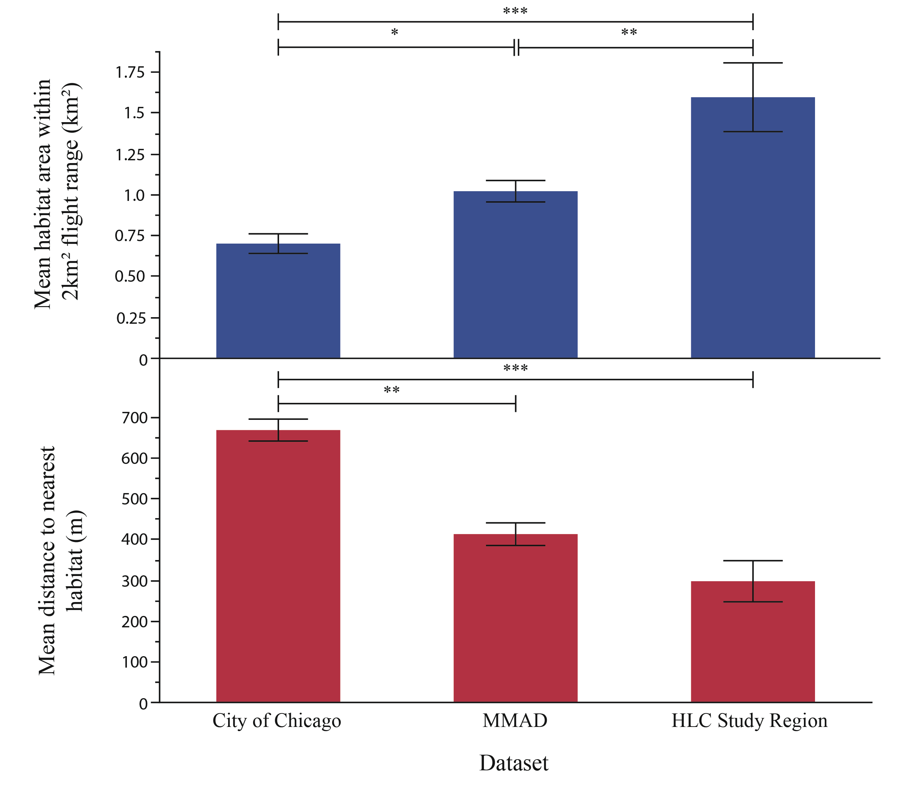
Figure S5. Suitable larval habitats within the average female Culex salinarius flight range (2 km.²) for each collection from the City of Chicago, MMAD, and HLC study regions (55 1-km wide hexagons within the NWMAD).

