SUPPLEMENTAL MATERIALS

Supplemental table 1. The public datasets used in this study.
Data set | Normal (n) | Cancer (n) | Platform | Sample type
TCGA CRC | 45 | 394 | 450k | tissue
GSE48684 | 41 | 64 | 450k | tissue
GSE40279 | 656 |  | 450k | whole blood
GSE122126 | 12 | 3 | 850k | cfDNA

Supplemental table 2. The clinical features of TCGA cohort.
 |  | Normal | CRC
Sex (n, %)
 | male | 24 (53.33) | 211 (53.96)
 | female | 21 (46.67) | 180 (46.04)
 | Na |  | 3
Age (median [Q25-Q75]) |  | 70 [64-77] | 66 (55-74)
Stage (n, %)
 | I |  | 55 (13.96)
 | II |  | 143 (36.29)
 | III |  | 120 (30.46)
 | IV |  | 54 (13.71)
 | Na |  | 22 (5.58%)

Supplemental table 3. The clinical features of GSE48684 cohort.
 |  | Normal | CRC
Sex (n, %)
 | male | 22 (53.66) | 23 (35.94)
 | female | 19 (46.34) | 41 (64.06)
Age (median [Q25-Q75]) |  | Na | Na
Stage (n, %)
 | I |  | 3 (4.69)
 | II |  | 18 (28.13)
 | III |  | 19 (29.69)
 | IV |  | 24 (37.50)

Supplemental table 4. The clinical features of GSE40279 cohort.
 |  | Healthy
Sex (n, %)
 | male | 318 (48.48)
 | female | 338 (51.52)
Age (median [Q25-Q75]) |  | 65 (54-75)

Supplemental table 5. The clinical features of training and validation cohorts used in this study.
 | Training set |  |  |  | Validation set
Sex (n, %) |  | Healthy | Other disease | CRC | Healthy | Interfering disease | Other intestinal disease | Adenoma/Polyps | CRC
 | male | 32 (58.18) | 46 (61.33) | 38 (53.52) | 58 (49.57) | 27 (43.54) | 87 (57.24) | 34 (56.67) | 69 (57.50)
 | female | 23 (41.82) | 29 (38.67) | 33 (46.48) | 59 (54.43) | 35 (56.4) | 65 (42.76) | 26 (43.33) | 51 (42.50)
Age (median [Q25-Q75]) |  | 42 [39-43] | 62 [50-70] | 64 [52-73] | 39 [35-41] | 59 [54-69] | 55 [44-55] | 61 [52-70] | 64 [54-71]
TNM Stage (n, %)
 | I |  |  | 20 (28.17) |  |  |  |  | 17 (14.17)
 | II |  |  | 28 (39.44) |  |  |  |  | 29 (24.17)
 | III |  |  | 21 (29.58) |  |  |  |  | 43 (35.83)
 | IV |  |  | 2 (2.82) |  |  |  |  | 1 (0.83)
 | Na |  |  |  |  |  |  |  | 30 (25.00)

Supplemental table 6. The amplification system of the MethyDT test.
Components | Volume (ul)
20*HA buffer (Ammunition Life-tech, Wuhan) | 2.50
25mM dNTP Mixture (yisheng, Wuhan) | 0.40
High Affinity HotStart Taq(5U/μL) (TianGen, Beijing) | 0.6
TE (Sangon Biotech, Shanghai) | 5.16
Forward primer of ACTB (100μM) | 0.1
Reverse primer of ACTB (100μM) | 0.1
Probe of ACTB (100μM) | 0.1
Forward primer of NTMT1 sense (100μM) | 0.1
Reverse primer of NTMT1 sense (100μM) | 0.1
Probe of NTMT1 sense (100μM) | 0.1
Forward primer of NTMT1 antisense (100μM) | 0.1
Reverse primer of NTMT1 antisense (100μM) | 0.1
Probe of NTMT1 antisense (100μM) | 0.1
Forward primer of MAP3K14-AS1 (100μM) | 0.1
Reverse primer of MAP3K14-AS1 (100μM) | 0.1
Probe 1 of MAP3K14-AS1 (100μM) | 0.12
Probe 2 MAP3K14-AS1 (100μM) | 0.12
Template DNA | 40
Total | 50

Supplemental table 7. The methylated and unmethylated events of all CpG sites in the amplicons of NTMT1 and MAP3K14-AS1 between normal and CRC samples.
 | NTMT1 antisense |  | NTMT1 sense |  | MAP3K14-AS1 antisense
 | normal | cancer | normal | cancer | normal | cancer
Unmethylated | 165 | 9 | 41 | 8 | 149 | 4
Methylated | 75 | 266 | 8 | 82 | 15 | 176

Supplemental table 8. The methylation frequencies of each CpG sites in the amplicons of NTMT1 and MAP3K14-AS1 between normal and CRC samples.
Target |  | normal |  | cancer |  | P value
Target |  | Um | Me | Um | Me | P value
NTMT1 antisense | CpG1 | 9 | 9 | 0 | 25 | < 0.001
NTMT1 antisense | CpG2 | 15 | 8 | 0 | 28 | < 0.001
NTMT1 antisense | CpG3 | 17 | 8 | 0 | 28 | < 0.001
NTMT1 antisense | CpG4 | 17 | 8 | 2 | 26 | < 0.001
NTMT1 antisense | CpG5 | 19 | 6 | 2 | 26 | < 0.001
NTMT1 antisense | CpG6 | 18 | 6 | 1 | 26 | < 0.001
NTMT1 antisense | CpG7 | 18 | 7 | 0 | 28 | < 0.001
NTMT1 antisense | CpG8 | 18 | 7 | 0 | 28 | < 0.001
NTMT1 antisense | CpG9 | 16 | 9 | 1 | 27 | < 0.001
NTMT1 antisense | CpG10 | 18 | 7 | 3 | 24 | < 0.001
NTMT1 sense | CpG1 | 22 | 5 | 8 | 22 | < 0.001
NTMT1 sense | CpG2 | 14 | 3 | 0 | 30 | < 0.001
NTMT1 sense | CpG3 | 5 | 0 | 0 | 30 | < 0.001
MAP3K14-AS1 antisense | CpG1 | 25 | 3 | 0 | 30 | < 0.001
MAP3K14-AS1 antisense | CpG2 | 28 | 1 | 2 | 28 | < 0.001
MAP3K14-AS1 antisense | CpG3 | 26 | 4 | 0 | 30 | < 0.001
MAP3K14-AS1 antisense | CpG4 | 27 | 2 | 1 | 29 | < 0.001
MAP3K14-AS1 antisense | CpG5 | 21 | 4 | 0 | 30 | < 0.001
MAP3K14-AS1 antisense | CpG6 | 22 | 1 | 1 | 29 | < 0.001

Supplemental table 9. ROC curve analysis of the Ct values of NTMT1.
Ct values | Specificity | Sensitivity | Youden index
49.73 | 91.54% | 78.87% | 0.70
48.65 | 91.54% | 77.46% | 0.69
48.30 | 91.54% | 76.06% | 0.68
47.93 | 91.54% | 74.65% | 0.66
47.61 | 92.31% | 74.65% | 0.67
47.57 | 93.08% | 74.65% | 0.68
47.49 | 93.08% | 73.24% | 0.66
47.31 | 93.08% | 71.83% | 0.65
47.18 | 93.08% | 70.42% | 0.63
47.06 | 93.85% | 70.42% | 0.64
46.90 | 93.85% | 69.01% | 0.63
46.84 | 93.85% | 67.61% | 0.61
46.82 | 93.85% | 66.20% | 0.60
46.81 | 93.85% | 64.79% | 0.59
46.80 | 93.85% | 63.38% | 0.57
46.78 | 93.85% | 61.97% | 0.56
46.77 | 93.85% | 60.56% | 0.54
46.76 | 94.62% | 60.56% | 0.55
46.76 | 95.38% | 60.56% | 0.56
46.74 | 95.38% | 59.15% | 0.55
46.72 | 96.15% | 59.15% | 0.55
46.71 | 96.92% | 59.15% | 0.56
46.71 | 97.69% | 59.15% | 0.57
46.69 | 98.46% | 59.15% | 0.58
46.67 | 99.23% | 59.15% | 0.58
46.66 | 99.23% | 57.75% | 0.57
46.65 | 99.23% | 56.34% | 0.56
46.65 | 99.23% | 54.93% | 0.54
46.64 | 99.23% | 53.52% | 0.53
46.63 | 99.23% | 52.11% | 0.51
46.62 | 99.23% | 50.70% | 0.50
46.61 | 99.23% | 49.30% | 0.49
46.61 | 99.23% | 47.89% | 0.47
46.59 | 99.23% | 46.48% | 0.46
46.56 | 99.23% | 45.07% | 0.44
46.55 | 99.23% | 43.66% | 0.43
46.55 | 99.23% | 42.25% | 0.41
46.54 | 99.23% | 40.85% | 0.40
46.54 | 99.23% | 39.44% | 0.39
46.53 | 99.23% | 38.03% | 0.37
46.52 | 99.23% | 36.62% | 0.36
46.51 | 99.23% | 35.21% | 0.34
46.51 | 99.23% | 33.80% | 0.33
46.50 | 99.23% | 32.39% | 0.32
46.49 | 99.23% | 30.99% | 0.30
46.49 | 99.23% | 29.58% | 0.29
46.48 | 99.23% | 28.17% | 0.27
46.48 | 100.00% | 28.17% | 0.28
46.47 | 100.00% | 26.76% | 0.27
46.47 | 100.00% | 25.35% | 0.25
46.46 | 100.00% | 23.94% | 0.24
46.46 | 100.00% | 22.54% | 0.23
46.45 | 100.00% | 21.13% | 0.21
46.44 | 100.00% | 18.31% | 0.18
46.44 | 100.00% | 16.90% | 0.17
46.43 | 100.00% | 15.49% | 0.15
46.43 | 100.00% | 14.08% | 0.14
46.43 | 100.00% | 12.68% | 0.13
46.42 | 100.00% | 11.27% | 0.11
46.41 | 100.00% | 9.86% | 0.10
46.40 | 100.00% | 8.45% | 0.08
46.40 | 100.00% | 7.04% | 0.07
46.40 | 100.00% | 5.63% | 0.06
46.40 | 100.00% | 4.23% | 0.04
46.39 | 100.00% | 2.82% | 0.03
46.38 | 100.00% | 1.41% | 0.01

Supplemental table 10. ROC curve analysis of the Ct values of MAP3K14-AS1.
Ct values | Specificity | Sensitivity | Youden index
49.34 | 97.69% | 54.93% | 0.53
48.46 | 98.46% | 54.93% | 0.53
48.36 | 99.23% | 54.93% | 0.54
48.33 | 99.23% | 53.52% | 0.53
48.27 | 99.23% | 52.11% | 0.51
48.24 | 99.23% | 50.70% | 0.50
48.24 | 99.23% | 49.30% | 0.49
48.24 | 99.23% | 47.89% | 0.47
48.23 | 99.23% | 46.48% | 0.46
48.23 | 99.23% | 45.07% | 0.44
48.22 | 99.23% | 43.66% | 0.43
48.21 | 99.23% | 42.25% | 0.41
48.21 | 99.23% | 40.85% | 0.40
48.20 | 99.23% | 39.44% | 0.39
48.19 | 99.23% | 38.03% | 0.37
48.18 | 99.23% | 36.62% | 0.36
48.18 | 99.23% | 35.21% | 0.34
48.18 | 99.23% | 33.80% | 0.33
48.17 | 99.23% | 32.39% | 0.32
48.17 | 99.23% | 29.58% | 0.29
48.16 | 99.23% | 28.17% | 0.27
48.16 | 99.23% | 26.76% | 0.26
48.16 | 99.23% | 25.35% | 0.25
48.16 | 99.23% | 23.94% | 0.23
48.16 | 100.00% | 23.94% | 0.24
48.15 | 100.00% | 22.54% | 0.23
48.14 | 100.00% | 21.13% | 0.21
48.14 | 100.00% | 19.72% | 0.20
48.13 | 100.00% | 18.31% | 0.18
48.13 | 100.00% | 16.90% | 0.17
48.13 | 100.00% | 15.49% | 0.15
48.12 | 100.00% | 14.08% | 0.14
48.12 | 100.00% | 12.68% | 0.13
48.12 | 100.00% | 11.27% | 0.11
48.12 | 100.00% | 9.86% | 0.10
48.11 | 100.00% | 8.45% | 0.08
48.11 | 100.00% | 7.04% | 0.07
48.11 | 100.00% | 5.63% | 0.06
48.10 | 100.00% | 4.23% | 0.04
48.10 | 100.00% | 2.82% | 0.03
48.09 | 100.00% | 1.41% | 0.01

Supplementary table 11. The positive detection rates and specificities of MethyDT test for non-CRC samples.
Group | Participant (%, n) | Positive detection rate (%, n) | Specificity (%, n)
Adenoma | 7.83 (40) | 30.00 (12) | 70.00 (28)
Polyps | 3.91 (20) | 10.00 (2) | 90.00 (18)
Benign bowel disease | 10.57 (54) | 14.81 (8) | 85.19 (46)
Other disease | 29.75 (152) | 7.24 (11) | 92.76 (141)
Other cancers | 1.57 (8) | 0 (0) | 100 (8)
Healthy | 22.9 (117) | 4.27 (5) | 95.73 (112)

Supplemental table 12. The numbers of single-positive, double-positive and double-negative samples measured by MethyDT test in the training set.
Target | Healthy | Other disease | CRC
me NTMT1 | 2 | 9 | 20
me MAP3K14-AS1 | 0 | 3 | 3
both me | 0 | 0 | 36
both ume | 53 | 63 | 12
Total | 55 | 75 | 71

Supplemental table 13. The numbers of single-positive, double-positive and double-negative samples measured by MethyDT test in the validation set.
Target | Healthy | Adenoma | Polyps | Benign bowel disease | Other disease | Other cancers | CRC
me NTMT1 | 3 | 6 | 2 | 5 | 7 | 0 | 26
me MAP3K14-AS1 | 1 | 3 | 0 | 3 | 0 | 0 | 12
both me | 1 | 3 | 0 | 0 | 4 | 0 | 65
both ume | 112 | 28 | 18 | 46 | 141 | 8 | 17
Total | 117 | 40 | 20 | 54 | 152 | 8 | 120

Supplemental Figures
Supplemental figure 1. Relationship between patient age and methylation levels of cg14015706 (A) and cg08247376 (B). cg14015706 and cg08247376 are located in the first exon of NTMT1 and 200 bp of the upstream MAP3K14-AS1 transcription start site, respectively. The figure shows the Pearson’s correlation coefficient. The solid black line is fitted by linear regression model. The upper and lower bounds correspond to 95% confidence intervals.
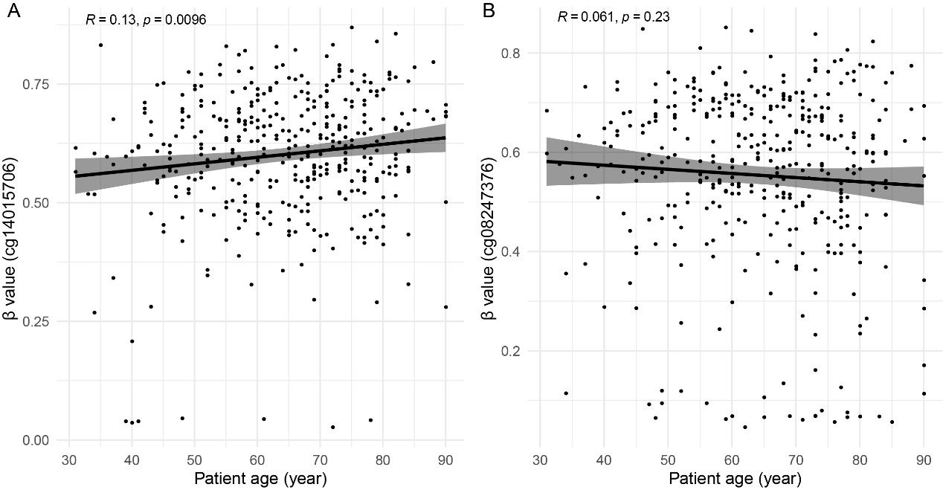

Supplemental figure 2. Ct values of the sense-antisense and dual-MGB probe technique in diluted experiments. A: Boxplot showing the Ct values of sense-, antisense- and sense/antisense strand assays for the detection of different copies of methylated NTMT1 templates. B: Boxplot showing the Ct values of probe1, probe2 and probe1/probe2 assay for the detection of different copies of methylated MAP3K14-AS templates. The error bar of the boxplot indicated the 5%-95% interval of Ct values.
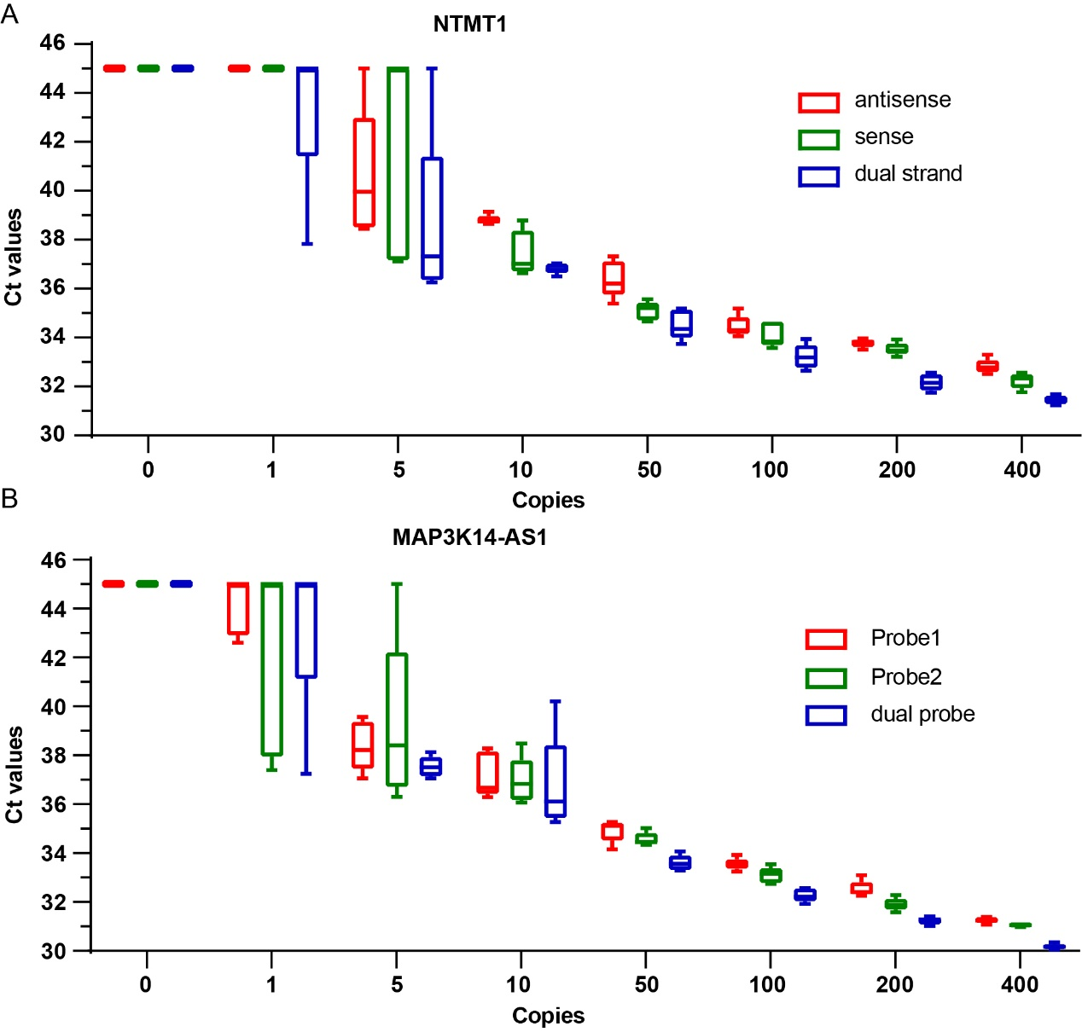

Supplemental figure 3. Standard curves and amplification curves of NTMT1 and MAP3K14-AS1 assays. A and C correspond to the standard curves of the 10-fold dilution experiment of NTMT1 and MAP3K14-AS1 assays, and B and D correspond to the amplification curves of these experiments.
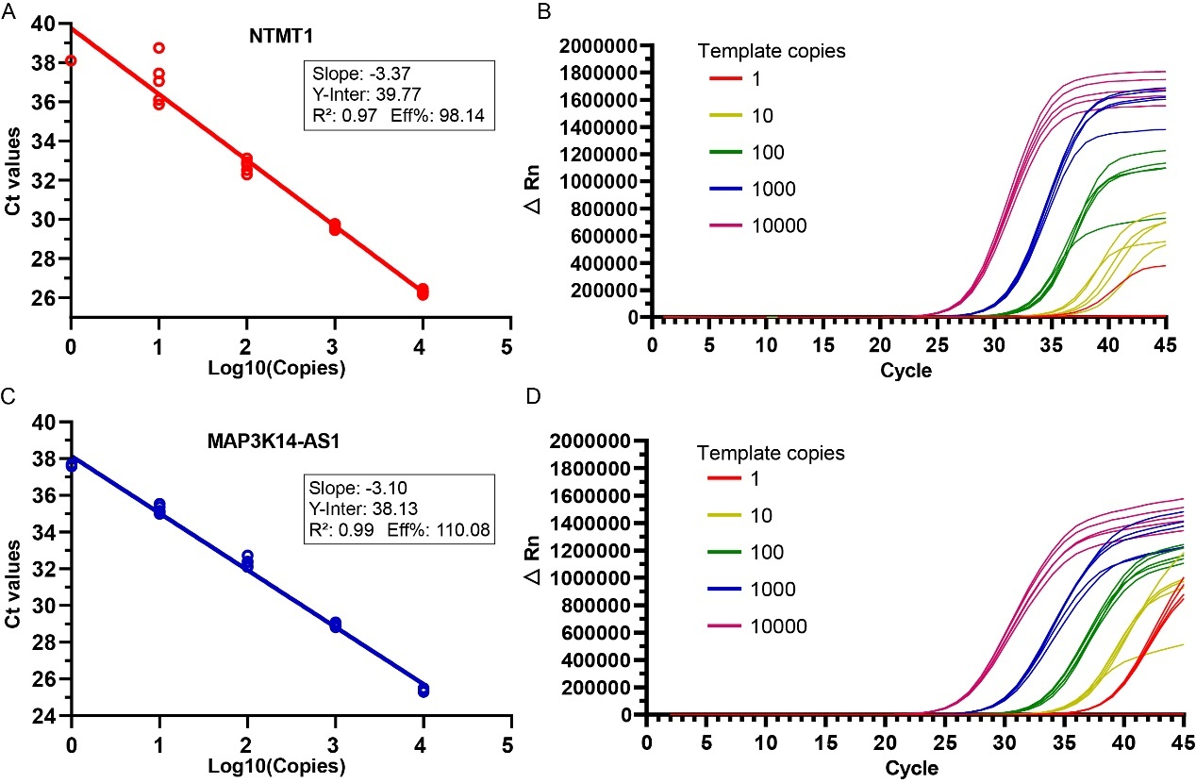

Supplemental figure 4. Standard curves of ACTB, NTMT1 and MAP3K14-AS1 assays in clinical trials. We carried out 6-diluted concentration experiments with each concentration repeated 16 times to assess the cfDNA copies of target genes in clinical samples. A model of Ct~copy number was fitted based on the Ct values and the cfDNA inputs. Using this model, we estimated the copies of each target gene in clinical samples.
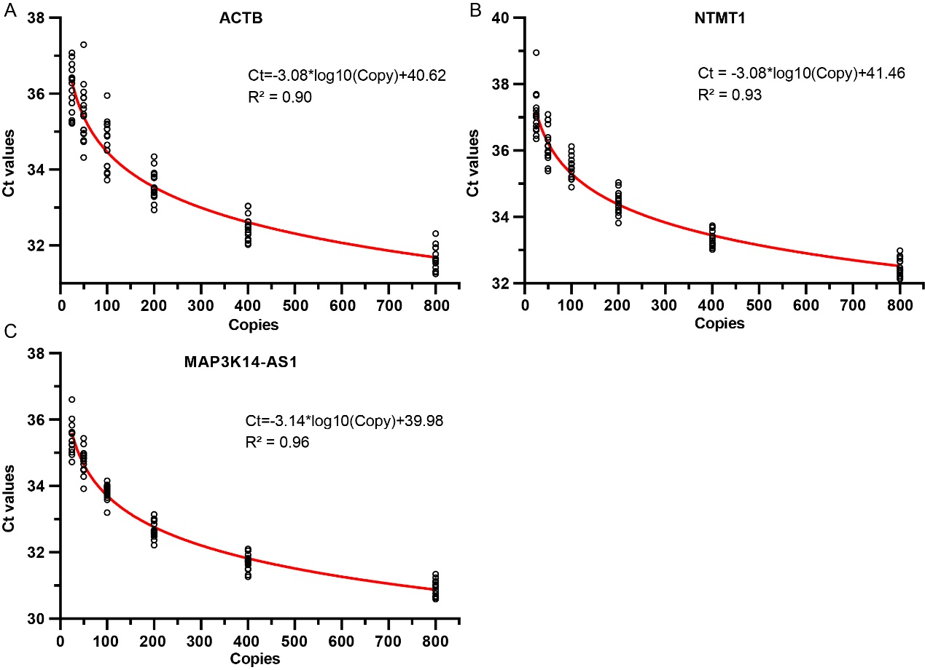

Supplemental figure 5. The cfDNA copies of NTMT1 (A) and MAP3K14-AS1 (B) in non-cancer samples and different stages of CRC samples in training set. Kruskal-Wallis rank sum test was performed for the comparison between four CRC stages. Two-sample Wilcoxon tests was performed for the comparison of non-cancer and stage I groups.
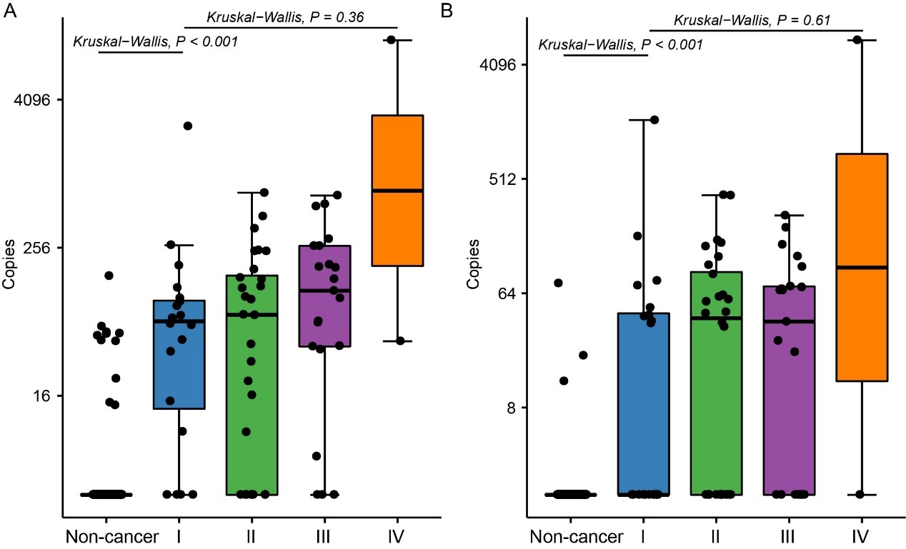

Supplemental figure 6. The cfDNA copies of NTMT1 (A) and MAP3K14-AS1 (B) in different categories of CRC samples in validation set. Boxplot in panel A and B indicated the cfDNA copies of NTMT1 and MAP3K14-AS1 in healthy, CRC and other diseases. Boxplot in panel C and D indicated the cfDNA copies of NTMT1 (C) and MAP3K14-AS1 (D) in non-cancer samples and different stages of CRC samples. Kruskal-Wallis rank sum test was performed for the comparison between four CRC stages. Two-sample Wilcoxon tests was performed for the comparison of non-cancer and stage I groups.
