Full factorial optimization of α-aminophosphonates synthesis using diphenylphosphinic acid as efficient Organocatalyst

Meriem FARREHª, Samia GUEZANE LAKOUD^{a*}, Hacene BENDJEFFAL^{b}, Rym AISSA,ª Mounia MERABET-KHELASSIª, Martial TOFFANO^{c}, Louisa ARIBI-ZOUIOUECHEª

ªEcocompatible Asymmetric Catalysis Laboratory (LCAE) Badji Mokhtar Annaba-University, B.P 12, 23000 Annaba, Algeria
^{b}Research Center in Biotechnology, Ali Mendjli Nouvelle Ville UV 03, BP E73 Constantine, Algeria
^{c} Equipe de Catalyse Moléculaire-ICMMO Bât 420. Université Paris- Saclay.

*Corresponding Author: Samia GUEZANE LAKOUD
Email: samia.guezanelakoud@univ-annaba.dz

Content:

- General ………………………………………………………………………………..3
- General procedure for α-aminophosphonates synthesis……………..………………...3
- ¹H, ¹³C, ³¹P NMR and HRMS data…………………………………………….….3-7
- ¹H, ¹³C, ³¹P NMR and HRMS spectra of α-aminophosphonates compounds….…8-18

1. General
All reagents were purchased from Sigma-Aldrich or Acros Company used without further purification. Reactions were monitored by thin-layer chromatography (TLC) carried out on 0.25-mm Merck silica gel plates (60F-254) using ultraviolet light (254 nm) as the visualizing agent and KMnO₄ solution as developing agents. NMR spectra were recorded with Bruker spectrometers operating at (360MHz, 300 MHz, and 250 MHz for 1H, 90 MHz, 75 MHz, or 63 MHz for ¹³C, and 101 MHz or 121 MHz for ³¹P). The chemical shift of Solvent reference peaks used were CDCl₃ (δ = 7.26 ppm) for 1H and (δ = 77ppm) for ¹³C NMR spectra, while H₃PO₄ was used as external standard for chemical shift references for ³¹P NMR. Couplings constants (J) are given in Hz, with the Following abbreviations multiplicity: s = singlet, d = doublet, t = triplet, q = quartet, m = multiplet, br = broad signal. Mass spectra were taken by a MicrOTOF-Q Bruker spectrometer using electrospray ionization (ESI) analysis. Melting points were measured using Buchi Melting Point B-545.

2. General procedure for the synthesis of α-aminophosphonates 4a-i.
The diphenylphosphinic acid (10 mol%) was added to the reaction mixture of aromatic aldehyde (122.12 mg, 1 mmol), aniline (93 mg, 1 mmol) and diethylphosphite (165 mg, 1.2 mmol) in ethanol (10 mL). The reaction was stirred at 40°C for 30 min. The progress of the reaction was monitored by TLC. The solvent was removed and the resulting residue was treated with HCl (1N) then washed with water (10 mL) and extracted with dichloromethane (10 mL×2). The organic phases were combined and evaporated in vacuum. The crude product was purified by crystallization in hexane. Complete experimental data have been provided (NMR spectra and HRMS).

3. ¹H, ¹³C, ³¹P NMR and HRMS data
3.1. Diethyl[phenyl(phenylamino)methyl]phosphonate (4a)
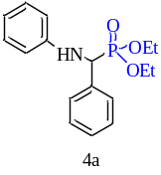
Yield: 92%, as a white crystalline solid; mp 88 °C. ¹H NMR (250 MHz, CDCl₃, 25°C): δ 7.52 -7.29 (m, 6H, ArH), 7.16 -7.10 (t, 1H, J =7.9 Hz, ArH), 6.75-6.69 (t, 1H, , J =7.3 Hz, ArH), 6.64 -6.61 (m, 2H, ArH), 4.84-4.75 (d, 1H, J_{HP}= 24.3 Hz, CHP), 4.18-4.10 (2H, m, -OCH₂- CH₃), 4.01-3.76 (2H, m, -OCH₂-CH₃), 3.74- 3.63 (1H, m, -OCH₂ CH₃), 1.31 (t, 3H, J= 7.1 Hz, -OCH₂-CH₃), 1.14 (t, 3H, J= 7.1 Hz, -OCH₂-CH₃). ¹³C NMR (63 MHz, CDCl₃, 25°C): δ 146.33 (d, J = 14.5 Hz); 136.00, 129.29, 128.74, 128.71, 128.00, 127.03, 118.40, 113.87, 63.27 (d, J²_{CP} = 6.9 Hz), 57.29, 54.90, 16.46, (d, J ³_{CP} = 15.1), 16.37 (d, J ³_{CP} = 5.6 Hz). ³¹P NMR (101 MHz, CDCl₃, 25°C): δ 22.46 ppm. HRMS (ESI) m/z calcd for C₁₇H₂₃NO₃P [M+ H⁺]: 320.1408; Found 320.1410.

3.2 Diethyl [(3-methoxyphenyl)(phenylamino)methyl] phosphonate (4b)
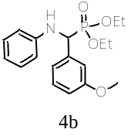
Yield: 98%, as a white crystalline solid; mp103 °C.¹H NMR (300 MHz, CDCl₃, 25 °C) δ 7.36–7.30 (m, 2H, HAr), 7.07–7.13 (m, 2H, HAr), 6.85 (d, J=7.3 Hz, 2H, H Ar), 6.66 (t,
J=16.0 Hz, 1H, HAr), 6.58 (d, 2H, J=8.5Hz, HAr), 4.72 (d, J=24.4 Hz, 1H, CHP), 4.15 (m, 2H, OCH₂-CH₃), 3.91 (m, 1H, -OCH₂-CH₃), 3.77 (s, 3H, -OCH₃), 3.65–3.74 (m,
1H, -OCH₂-CH₃), 1.28 (t, 3H, J=7.0 Hz, -OCH₂-CH₃), 1.14 (t, 3H, J=7.0 Hz, -OCH₂-CH₃). ¹³C NMR (75 MHz, CDCl₃, 25°C): δ 159.40, 143.54
(d, J= 15.4 Hz), 129.24, 129.08, 129.01, 127.77, 127.73, 118.43, 114.16, 114.13,
63.39 (dd, J²_{CP}=6.9, 3.9 Hz), 56.45, 55.33, 54.43, 16.60 (d, J³_{CP}=14.9 Hz), 16.52 (d,
J³_{CP} = 5.9 Hz).³¹P NMR (121 MHz, CDCl₃, 25 °C): δ 23.47 ppm.

3.3. Diethyl [4-nitrophenyl(phenylamino)methyl]phosphonate (4c)
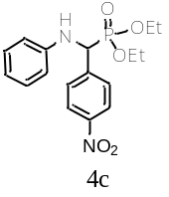
Yield: 90%, as a yellow crystalline solid; mp 89.2°C. ¹H NMR (400 MHz, CDCl₃, 25°C): δ 8.22-8.19 (d, 2H, ArH), 7.68-7.64 (dd, 2H, J_{HP}=8.9, 2.3 Hz, ArH), 7.19-6.95 (m, 2H, ArH), 6.76-6.71 (t, 1H, J=7.4 Hz, ArH), 6.56-6.52 (m, 2H, ArH), 4.88-4.81 (d, 1H, J_{HP}= 25.6 Hz, CHP), 4.25-4.11 (m, 2H, OCH₂-CH₃), 3.99-4.02 (m, 1H, -OCH₂-CH₃), 3. 97-3. 78 (m, 1H, -OCH₂-CH₃), 1.32 (t, 3H, J= 7.1 Hz, -OCH₂-CH₃), 1.21 (t, 3H, J= 7.1Hz, -OCH₂-CH₃). ¹³C NMR (101 MHz, Chloroform-d) δ 147.59, 145.71 (d, J = 16.6 Hz), 143.92 (d, J = 2.5 Hz), 129.35, 128.64 (d, J = 4.7 Hz), 123.75, 119.12, 113.81, 63.63 (dd, J²_{CP} = 27.4, 6.8 Hz), 56.78, 55.31, 16.34 (dd, J³cp = 17.2, 5.5 Hz). ³¹P NMR (162 MHz, Chloroform-d) δ 20.80. HRMS (ESI) m/z calcd for C₁₇H₂₁N₂O₅P [M + Na+]: 387.1094; Found 387.1080.

3.4. Diethyl[1-naphtyl(p-tolylamino)methyl]phosphonate (4d)
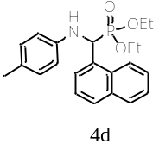
Yield: 90%, as a white crystalline solid; mp 145°C. ¹H NMR (300 MHz, CDCl₃, 25°C): δ 8.27 (d, 1H, J_{HP} = 8.5 Hz, ArH), 7.91 (d, 1H, J = 7.9 Hz ArH), 7.80-7.77 (m, 2H, ArH), 7. 63-7. 48 (m, 2H, ArH), 7.45 (t, 1H, J = 7.7 Hz, ArH), 6.67 (d, 2H, J = 8.48 Hz, ArH), 6.48 (d, 2H, J = 8.4 Hz, ArH), 4.64 (d, 1H, J_{HP} = 24.0 Hz, H_{CP}), 4.23-4.15 (m, 2H, –OCH₂–CH₃), 3.77-3.73 (m, 1H, –OCH₂–CH₃), 3. 28-3.17 (m, 1H, –OCH₂– CH₃), 2.16 (s, 3H, CH₃-Ph), 1.34 (t, 3H, J = 7.1 Hz, –OCH₂–CH₃), 0.75 (t, 3H, J = 7.1 Hz, –OCH₂–CH₃). ¹³C NMR (75 MHz, CDCl₃) δ 143.83 (d, J = 24.8 Hz), 133.81, 131.6 (d, J=19.7 Hz), 129.70, 129.00, 128.40, 127.50, 126.22, 125.64, 125.35 (d, J = 6.0 Hz), 123.00, 113.67, 63.63 (dd, J²_{CP} = 27.4, 6.8 Hz), 20.33, 16.49 (dd, J³cp =5.9, 5.9 Hz). ³¹P NMR (121 MHz, CDCl₃, 25°C): δ 23.07 ppm. HRMS (ESI) m/z calcd for C₂₂H₂₆NO₃P [M ⁺ Na⁺]: 406.1532; Found 406.1542.

3.5. Diethyl [benzo [1,3]dioxol-5-yl( (p-tolylamino) methyl]phosphonate (4e)
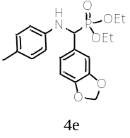
Yield: 91%, as a white crystalline solid; mp 115°C. ¹H NMR (300 MHz, Chloroform-d): δ 7.51 – 7.33 (m, 1H, ArH), 7.00 – 6.89 (m, 4H, ArH), 6.78 (d, J=8.0 Hz, 1H, ArH), 6.53 (d, J=8.5 Hz, 2H, ArH), 5.97 – 5.91 (m, 2H,O-CH₂-O), 4.66 (d, J _{HP} = 24.0 Hz, 1H, H_{CP}), 4.22 – 4.07 (m, 4H,-OCH₂-CH₃), 4.06 – 3.93 (m, 1H, -OCH₂-CH₃), 3.87 – 3.72 (m, 1H, -OCH₂-CH₃), 2.21 (s, 3H, CH₃), 1.31 (t, J = 7.1 Hz, 3H, –OCH₂–CH₃), 1.19 (t, J = 7.1 Hz, 3H, –OCH₂-CH₃). ¹³C NMR (75 MHz, Chloroform-d) δ 147.64 (d, J = 49.1 Hz), 143.78, 129.74 (d, J = 11.6 Hz), 121.35 (d, J = 6.5 Hz), 113.99, 108.21 (d, J = 13.9 Hz), 101.10, 63.84-62.26 (m), 57.01, 54.99, 20.36, 16.37 (dd, J³cp = 12.4, 5.7 Hz). HRMS (ESI) m/z calcd for C₁₉H₂₄NNaO₅P [M ⁺ Na⁺]: 400.128430; Found 400.1273. ³¹P NMR (121 MHz, Chloroform-d) δ 22.72.
3.6. Diethyl [(4-fluorophenyl)(4-tolylamino)methyl] phosphonate (4f)
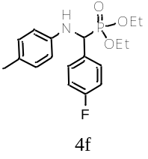
Yield: 88%, as a white crystalline solid; mp 119°C. ¹H NMR (300 MHz, Chloroform-d): δ 7.43 (dd, J = 12.0, 4.0 Hz, 2H, H Ar), 7.26 (m, 2H, HAr), 6.93 (d, 2H, J = 8.2 Hz, HAr), 6.48 (d, 2H, J = 8.5 Hz, HAr), 4.64–4.78 (m, 2H, CH+NH), 4.10–4.17 (m, 2H, -OCH₂-CH₃), 3.97–4.05 (m, 1H, -OCH₂-CH₃), 3.79–3.85 (m, 1H, -OCH₂-CH₃), 2.21 (s, 3H,
CH₃–Ph), 1.31 (t, 3H, J=7.1 Hz, -OCH₂-CH₃), 1.18 (t, 3H,
J = 7.1 Hz, -OCH₂-CH₃). ¹³C NMR: (75 MHz, CDCl₃, 25 °C): δ 143.85 (d,
J = 15.0 Hz), 134.84, 133.80, 133.76, 133.71, 129.83, 129.28, 128.21, 127.89,
127.86, 128.03, 114.06, 63.59 (dd, J²_{cp} = 12.1, 7.0 Hz), 56.89, 54.89, 20.47, 16.59
(d, J³_{cp} = 13.7 Hz), 16.52 (d, J³_{cp} = 5.8 Hz). ³¹P NMR (121 MHz, Chloroform-d) δ 22.69.
HRMS (ESI) m/z calcd for C₁₈H₂₃FNNaO₃P [M ⁺ Na⁺]: 374.1291; Found 374.1275. ³¹P NMR (121 MHz, Chloroform-d) δ 22.72.

3.7. Diethyl [(phenyl)(4-trifluoromethylamino)methyl] phosphonate (4g)
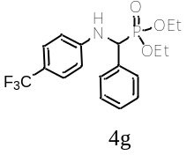
Yield: 88%, as white crystalline solid. mp 140 °C. ¹H NMR (300 MHz, CDCl₃, 25 °C): d = 1.12 (t, 3H, J=7.0 Hz, –OCH₂–CH₃), 1.31 (t, 3H, J = 7.1 Hz, –OCH₂–CH₃), 3.61–3.70
(m, 1H, –OCH₂–CH₃), 3.90–4.08 (dd, J=10.1,7.1Hz, 1H, -OCH₂-CH₃),
4.10–4.20 (m, 2H, –OCH₂–CH₃), 4.79 (dd, 1H, J = 24.2, 7.5 Hz, Ph–CH),
5.16–5.31 (m, 1H, NH), 6.62 (d, 2H, J = 8.5 Hz, H Ar), 7.26–7.40 (m, 5H, HAr),
7.49 (dd, J=7.7, 2.1 Hz, 2H, HAr). ¹³C NMR: (75 MHz, CDCl₃, 25 °C):
d = 148.90 (d, J = 14.4 Hz), 135.13 (d, J = 3.0 Hz), 128.91, 128.87, 128.38,
128.34, 127.90, 127.83, 126.68, 126.63, 113.16, 63.75 (dd, J²_{cp}= 22.9, 7.0 Hz),
56.77, 54.77, 16.59 (d, J³_{cp}=19.0 Hz), 16.51 (d, J³_{cp}= 5.8 Hz). ³¹P NMR:
(121 MHz, CDCl₃, 25°C): δ 22.54 ppm.

3.8. Diethyl [3-phenoxyl(phenylamino)trifluoromethyl]phosphonate (4h)
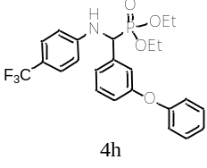
Yield: 78%, as white crystalline solid. mp 155°C. ¹H NMR (360 MHz, Chloroform-d) δ 7.43–7.25 (m, 5H, ArH), 7.20 (d, J = 7.5 Hz, 1H, ArH), 7.13 – 7.05 (m, 3H, ArH), 6.93 (d, J=7.6 Hz, 2H, ArH), 6.59 (d, J = 8.6 Hz, 2H, ArH), 4.74 (d, J = 24.4 Hz, 1H, HC*), 4.20 – 4.06 (m, 2H), 4.05 – 3.93 (m, 1H, –OCH₂–CH₃), 3.84– 3.69 (m, 1H, –OCH₂–CH₃), 1.29 (t, J =7.1 Hz, 3H, –OCH₂–CH₃), 1.16 (t, J =7.1 Hz, 3H, –OCH₂–CH₃). ¹³C NMR (91 MHz, Chloroform-d) δ 157.59, 156.82, 148.74 (d, J=14.3 Hz), 137.26, 129.92 (d, J = 30.6 Hz), 126.55, 123.45, 122.52 (d, J = 5.1 Hz), 120.35, 119.99, 118.83, 118.44, 118.14 (d, J = 5.3 Hz), 113.16, 63.49 (dd, J = 16.8, 6.9 Hz), 56.31, 54.64, 16.42 (d, J³=5.8 Hz), 16.24 (d, J³cp = 5.7 Hz). ³¹P NMR (162 MHz, Chloroform-d) δ 21.54. HRMS (ESI) m/z calcd for C₂₄H₂₅F₃NNaO₄P [M ⁺ Na⁺]: 502.1365; Found 400.1343

3.9. Diethyl [benzo [1,3]dioxol-5-yl( (phenylamino)trifluoromethyl]phosphonate (4i)
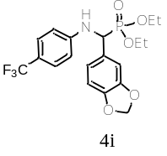
Yield: 87%, as white crystalline solid. mp 148.2 °C. ¹H NMR (400 MHz, Chloroform-d) δ 7.36 (d, J = 8.5 Hz, 2H), 6.97 (s, 1H), 6.95 – 6.90 (m, 1H), 6.80 (d, J = 8.0 Hz, 1H), 6.64 (d, J = 8.5 Hz, 2H), 5.96 (d, J=5.0 Hz, 1H), 5.18 (t, J = 8.4 Hz, 1H), 4.69 (dd, J = 23.9, 6.6 Hz, 1H), 4.15 (dq, J = 14.3, 7.1 Hz, 2H), 4.07 – 3.94 (m, 1H), 3.84 – 3.71 (m, 1H), 1.32 (t, J = 7.1 Hz, 3H), 1.19 (t, J = 7.1 Hz, 3H). ¹³C NMR (101 MHz, Chloroform-d) δ 148.88 (d, J = 34.5 Hz), 126.50, 121.32 (d, J =6.2 Hz), 120.14 (d, J = 34.6 Hz), 113.08, 108.42, 107.98 (d, J =4.2 Hz), 101.25, 63.56 (d, J=7.0 Hz), 63.28 (d, J = 7.0 Hz), 56.14, 54.62, 16.43 (d, J³cp =5.6 Hz), 16.27 (d, J=5.5 Hz). ³¹P NMR (162 MHz, Chloroform-d) δ 21.87. HRMS (ESI) m/z calcd for C₁₉H₂₁F₃NNaO₅P [M ⁺ Na⁺]: 454.1001; Found 454.0991.

4. ¹H, ¹³C, ³¹P NMR and HRMS spectra of all α-aminophosphonates compounds:
¹H, ¹³C, ³¹P NMR and HRMS of diethoxy (phenyl)(phenylamino)methylphosphoryle 4a:

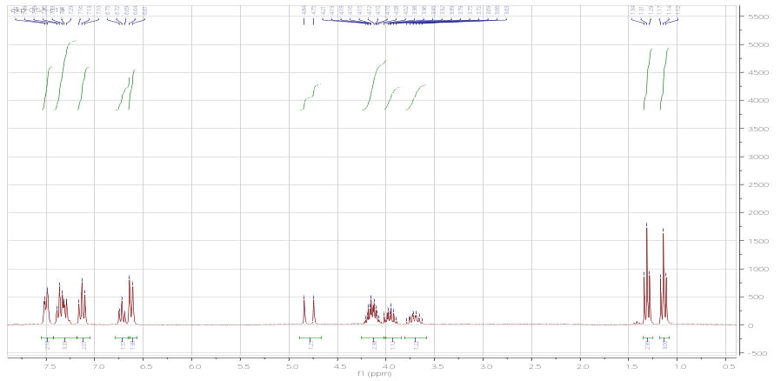
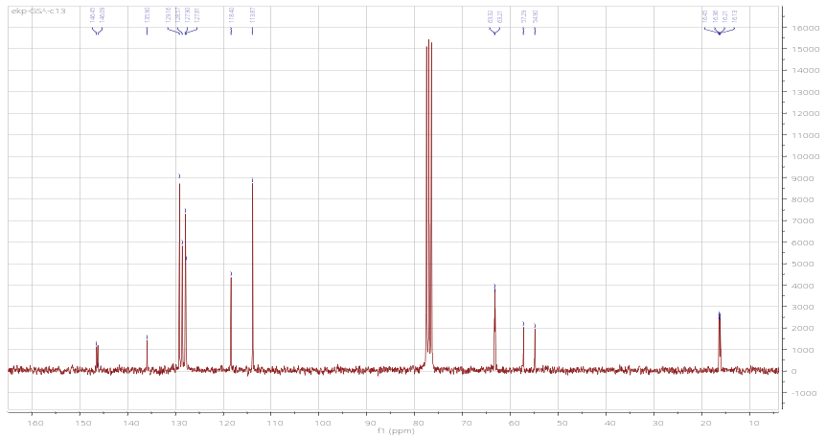
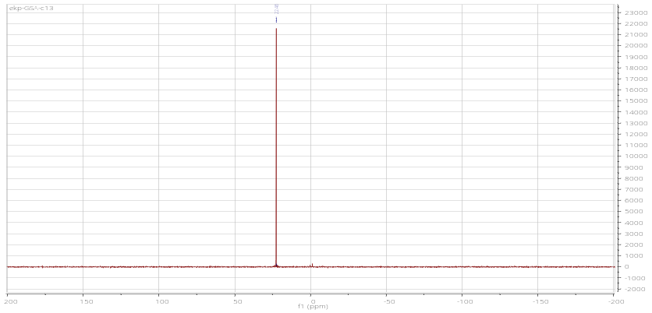
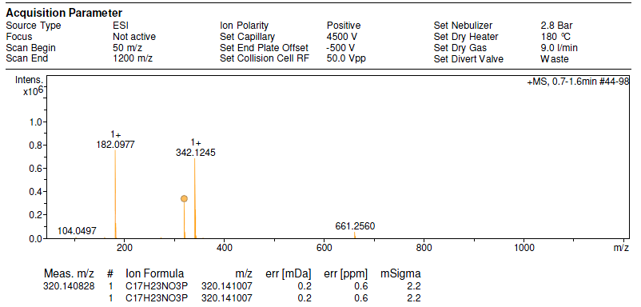
¹H, ¹³C and ³¹P NMR of Diethyl (3-methoxyphenyl) (phenylaminomethyl) phosphonate (4b)
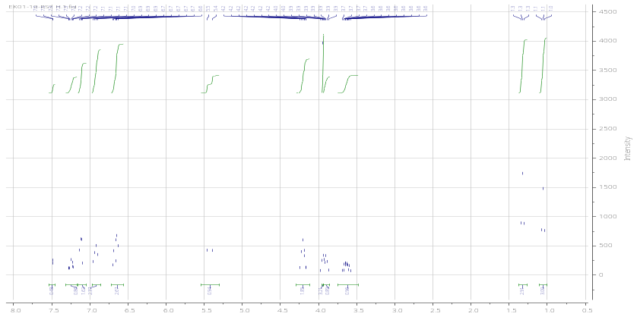
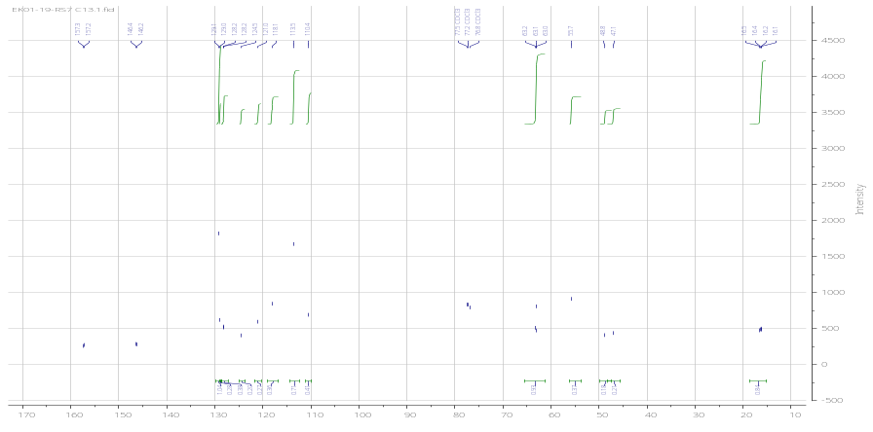
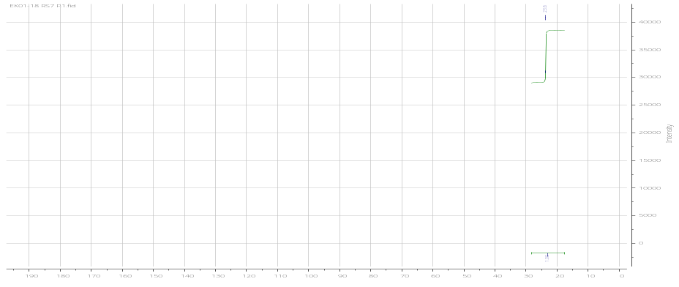
¹H, ¹³C, ³¹P NMR and HRMS of diethyl [4-nitrophenyl(phenylamino)methyl]phosphonate (4c)
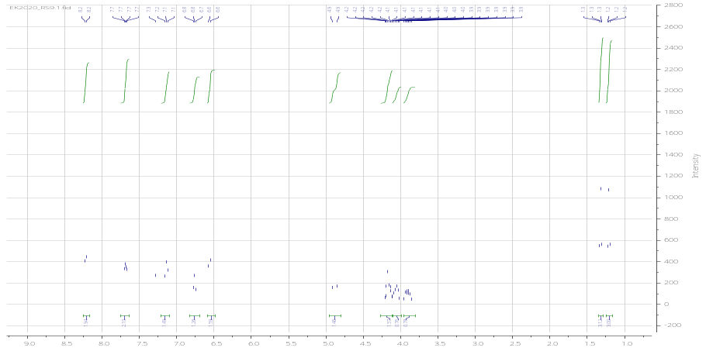
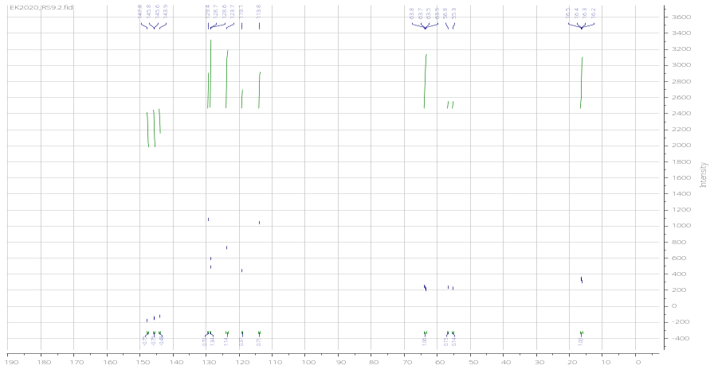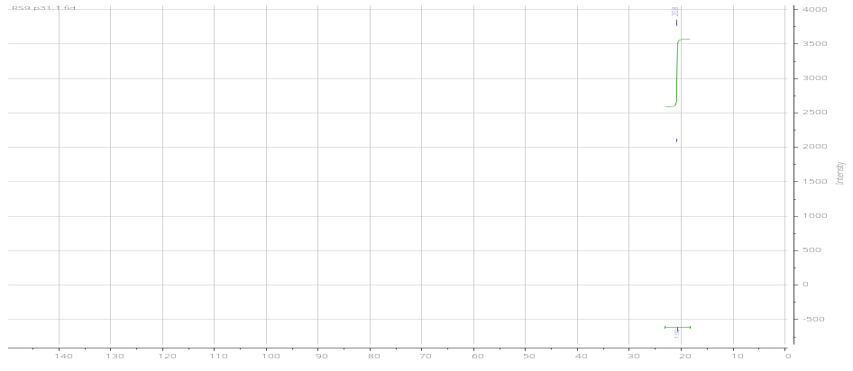

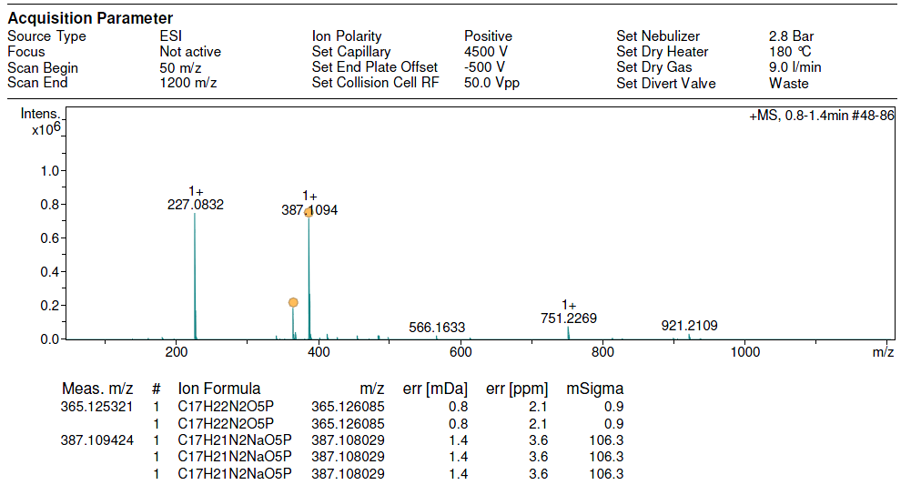
¹H, ¹³C, ³¹P NMR and HRMS of diethyl[1-naphtyl(p-tolylamino)methyl]phosphonate (4d)
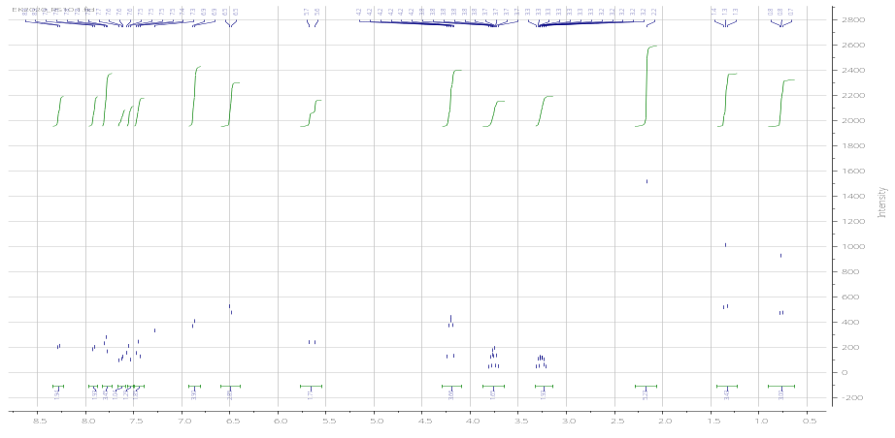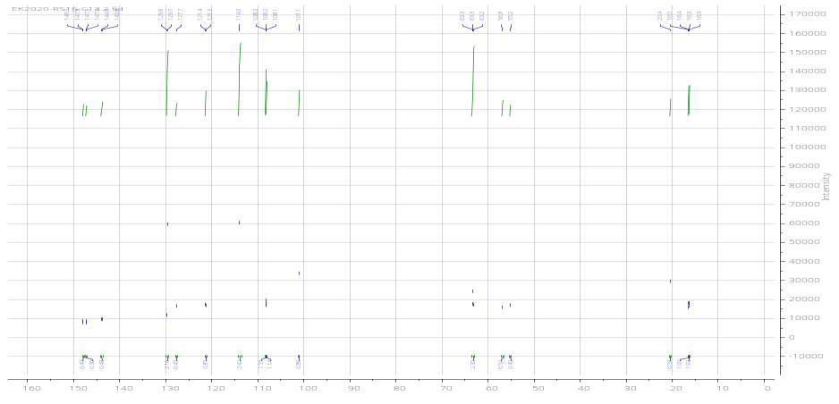
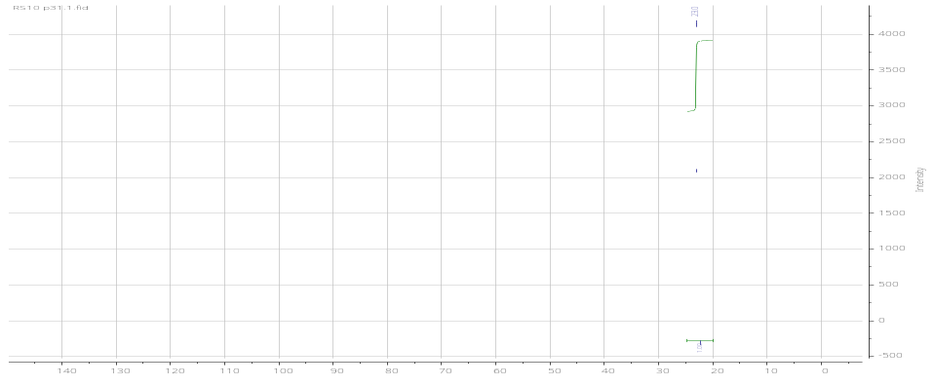
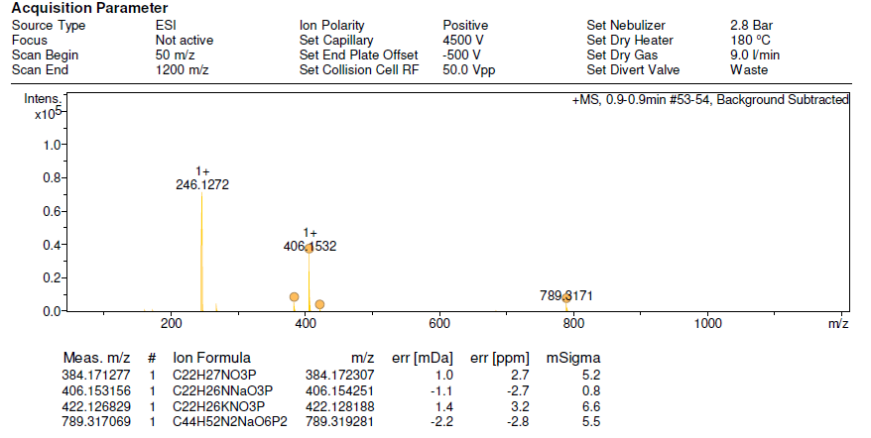
¹H, ¹³C, ³¹P NMR and HRMS of diethyl [benzo [1,3]dioxol-5-yl( (p-tolylamino) methyl]phosphonate (4e)
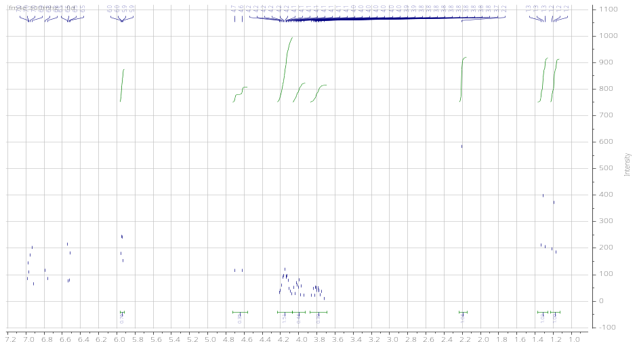
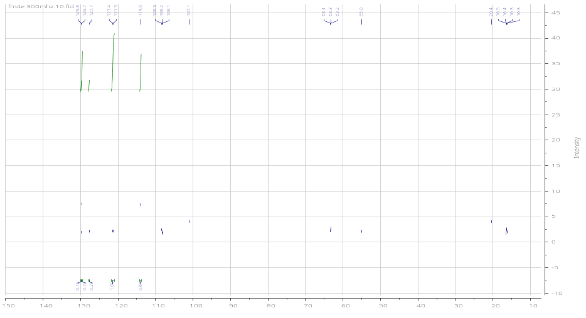

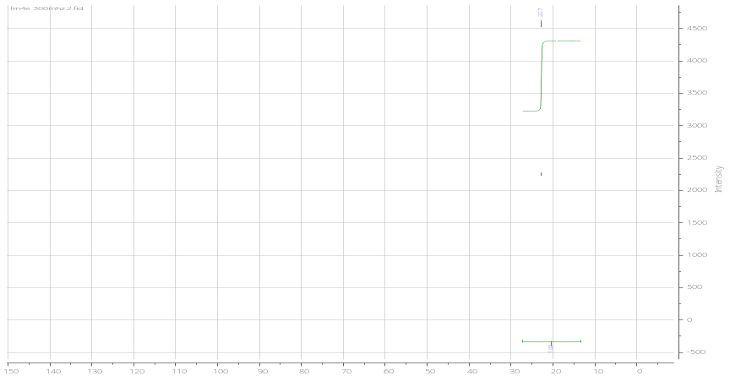
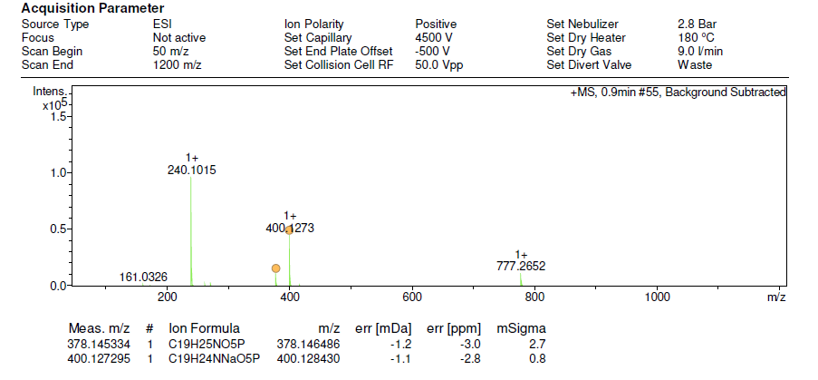
¹H, ¹³C, ³¹P NMR and HRMS of diethyl [(4-fluorophenyl)(4-tolylamino)methyl] phosphonate (4f)
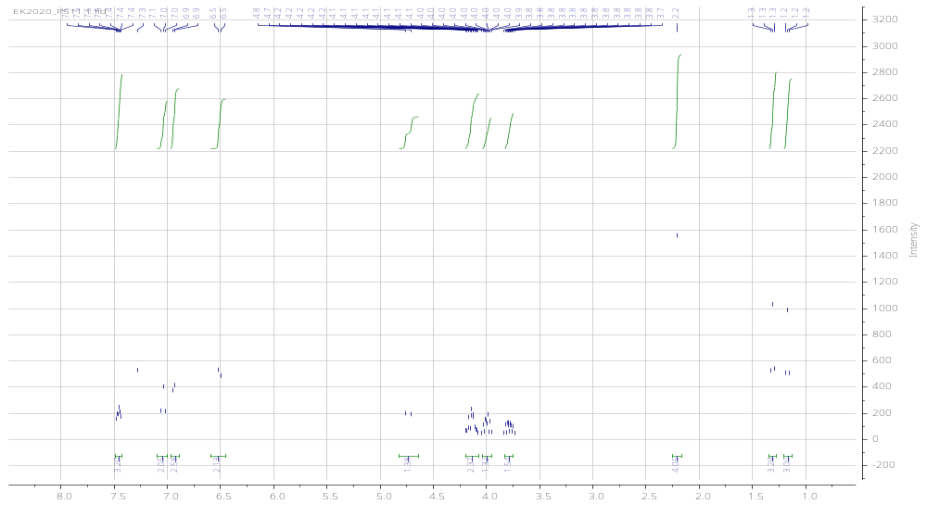
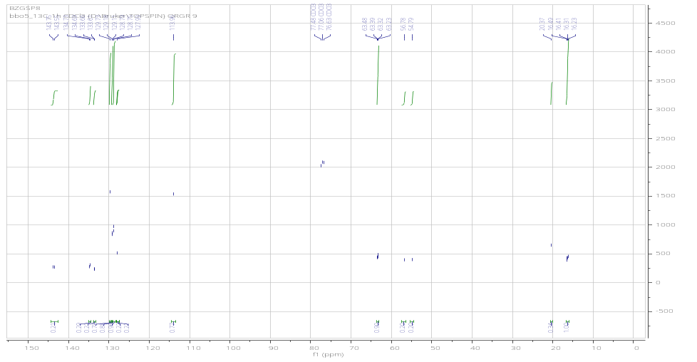
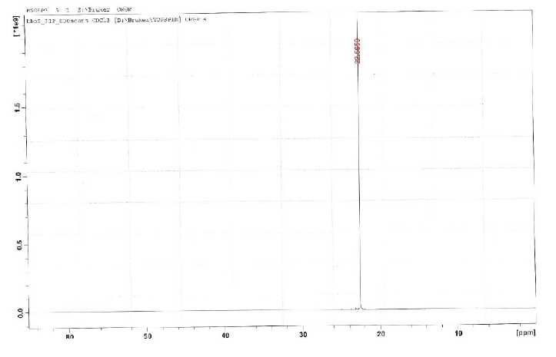
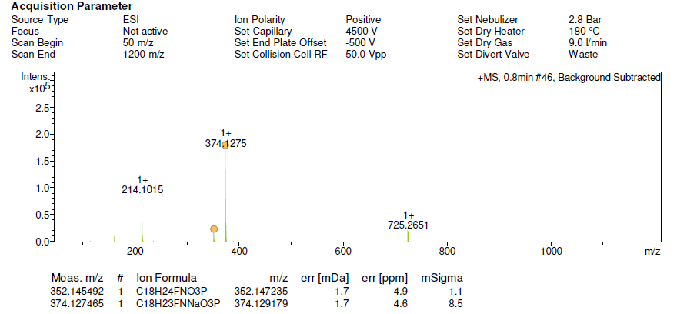

¹H, ¹³C and ³¹P NMR of diethyl [(phenyl)(4-trifluoromethylamino)methyl] phosphonate (4g)

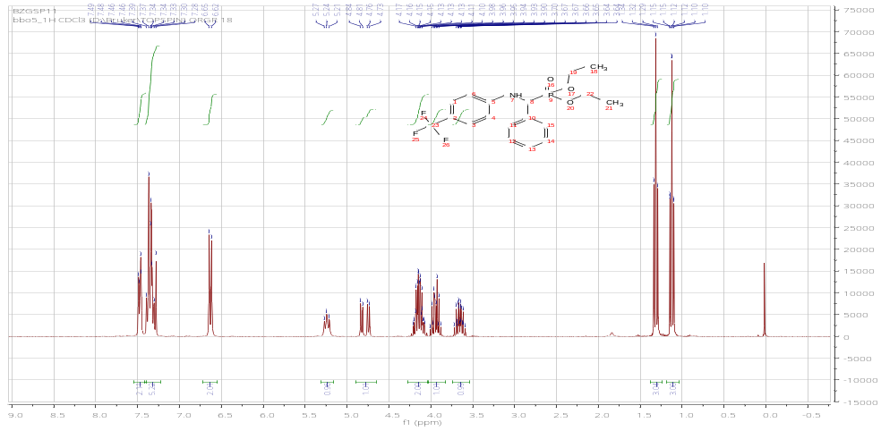
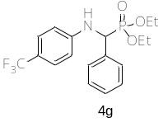
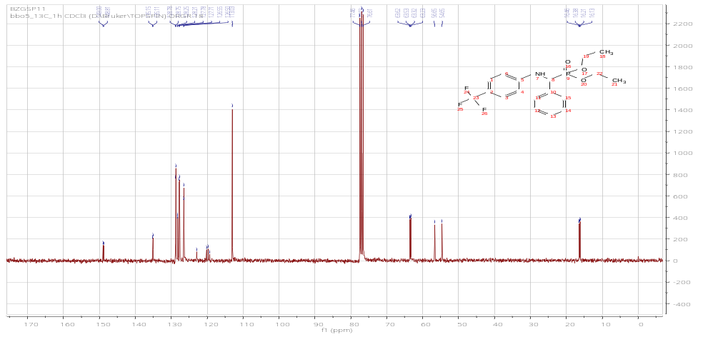
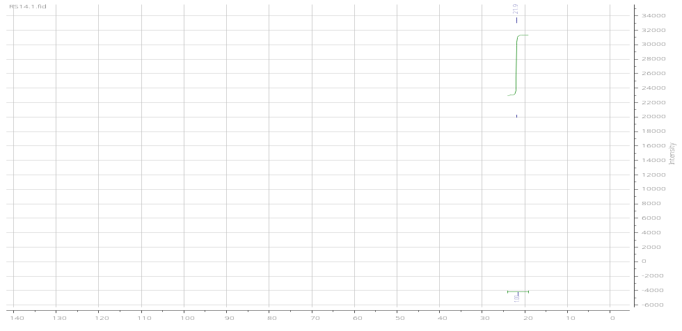

¹H, ¹³C, ³¹P NMR and HRMS of diethyl [3-phenoxyl(phenylamino)trifluoromethyl]phosphonate (4h)
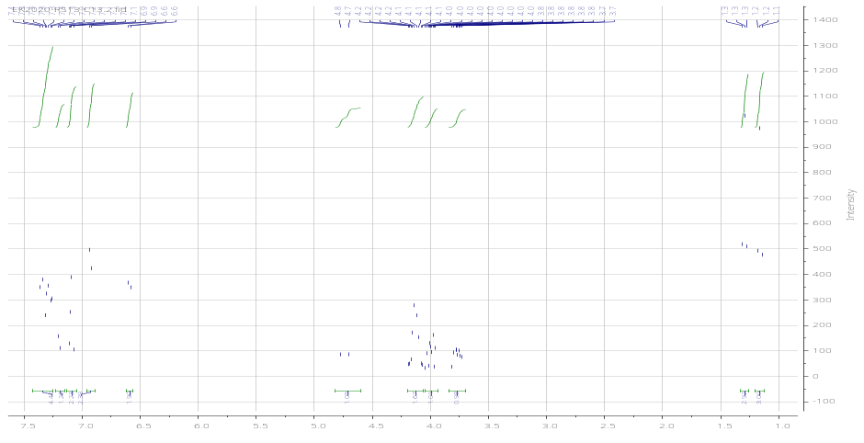
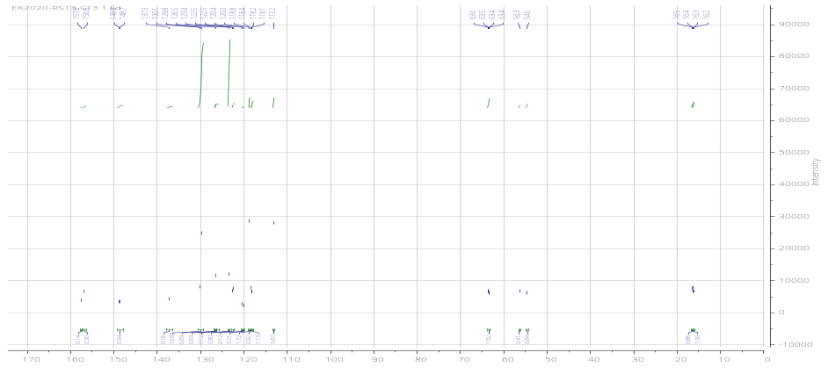
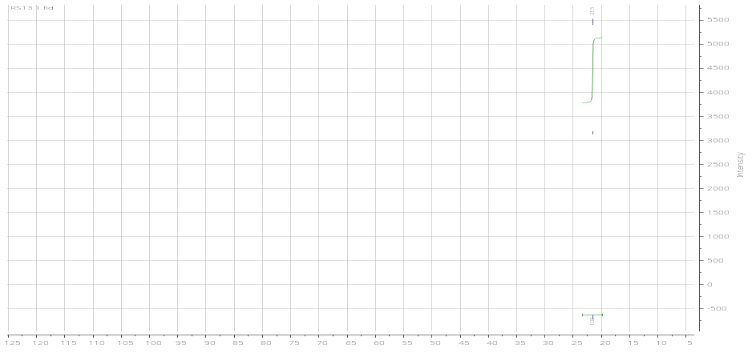
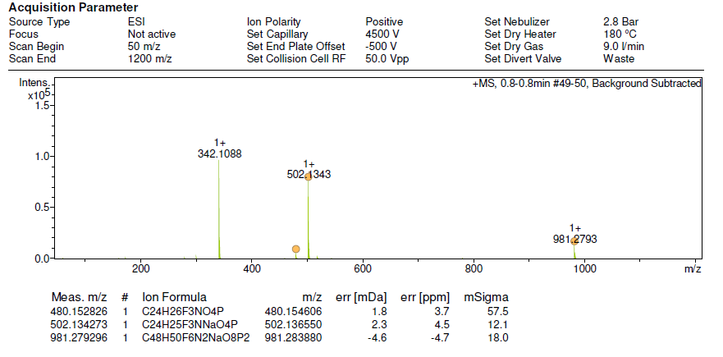

¹H, ¹³C, ³¹P NMR and HRMS of diethyl [benzo [1,3]dioxol-5-yl( (phenylamino)trifluoromethyl]phosphonate (4i)
