Dynamic 18F-Pretomanid PET imaging reveals excellent brain penetration in animal models of TB meningitis and first-in-human studies

Authors: Filipa Mota^{1,2,3†}, Camilo A. Ruiz-Bedoya^{1,2,3†}, Elizabeth W. Tucker^{1,2,4†}, Daniel P. Holt^{5†}, Patricia De Jesus^{1,2,3}, Martin A. Lodge⁵, Clara Erice^{1,2,4}, Xueyi Chen^{1,2,3}, Melissa Bahr^{1,2,3}, Kelly Flavahan^{1,2,3}, John Kim^{1,2,4}, Mary Katherine Brosnan⁵, Alvaro A. Ordonez^{1,2,3}, Charles A. Peloquin⁶, Robert F. Dannals⁵, Sanjay K. Jain^{1,2,3,5*}

Affiliations:
¹Center for Infection and Inflammation Imaging Research, Johns Hopkins University School of Medicine; Baltimore, MD 21287, USA
²Center for Tuberculosis Research, Johns Hopkins University School of Medicine; Baltimore, MD 21287, USA
³Department of Pediatrics, Johns Hopkins University School of Medicine; Baltimore, MD 21287, USA
⁴Department of Anesthesiology and Critical Care Medicine, Johns Hopkins University School of Medicine; Baltimore, MD 21287, USA
⁵Russell H. Morgan Department of Radiology and Radiological Sciences, Johns Hopkins University School of Medicine; Baltimore, MD 21287, USA
⁶Infectious Disease Pharmacokinetics Laboratory, Pharmacotherapy and Translational Research, University of Florida College of Pharmacy; Gainesville, FL 32610, USA

†Authors contributed equally
*Corresponding author. Email: sjain5@jhmi.edu

MATERIALS AND METHODS
General Materials: No unexpected or unusually high safety hazards were encountered. All chemicals and solvents were reagent grade and purchased from a commercial supplier. They were used as received unless otherwise noted. The syntheses of the radiolabeling precursor and intermediates were performed by Axia Chemicals Ltd. (Kent, U.K.). Whenever required, reactions were conducted under a nitrogen atmosphere and anhydrous solvents were utilized. Analytical thin layer chromatography was performed with Merck silica gel 60 F254 plates. Chemical shifts (δ) are reported in parts per million (ppm) relative to residual undeuterated solvent as the internal reference and coupling constants (J) are reported in Hertz (Hz). Splitting patterns are indicated as follows: s = singlet, d = doublet, t = triplet, q = quartet, qn = quintet, dd = doublet of doublet, dt = doublet of triplet, m = multiplet, br = broad peak.

Radiosynthesis of ¹⁸F-pretomanid
Manual synthesis (silver(I)-mediated): Aqueous ¹⁸F-fluoride (2 mL) was trapped on a QMA cartridge pre-equilibrated with Trace-Select Water (10 mL). K¹⁸F was eluted from the cartridge with a solution of potassium oxalate (4 mg, 24 µmol), potassium carbonate (0.2 mg, 1.4 µmol) and dicyclohexano-18-crown-6 (14 mg, 38 µmol) in a mixture of acetonitrile (80%) and water (1 mL) into a Wheaton v-vial. The solution was dried under a constant stream of N₂ for 15 min at 110 °C. K¹⁸F was then dried by azeotropic distillation with acetonitrile (400 µL, twice) at 90 °C and redissolved in methanol (300 µL). The methanol solution was transferred to a Wheaton v-vial charged with silver trifluoromethanesulfonate (20 mg, 40 µmol) and the methanol removed by heating under N₂. The precursor 7 (16 mg, 40 µmol) was dissolved in dichloroethane (300 µL) and added to the vial by syringe. The sealed vial was kept at 60 °C for 20 min, after which the solvent was removed by heating under N₂. Acetonitrile was added (400 µL) and the reaction mixture was filtered through a syringe filter (Puradisc 4mm, 0.2 µm) before injection into a radio-HPLC. The radiotracer was purified using a reverse-phase HPLC column (Phenomenex Luna C18(2) 100Å, 250 x 10 mm) at a flow rate of 3 mL/min, using water and acetonitrile as mobile phases. The following gradient was applied: 40-95% acetonitrile for 20 min; 95% acetonitrile for 5 min; 95-40% acetonitrile for 5 min. ¹⁸F-Pretomanid eluted at 13 min and was diluted in water to a total volume of 50 mL, trapped into a preactivated Sep-Pak C-18 light cartridge, and eluted with ethanol (1 mL) into a vial containing dimethyl sulfoxide (30-50 µL). The ethanol was evaporated under N₂ and the radiotracer was formulated in 10% sulfobutylether-β-cyclodextrin, containing less than 10% dimethylsulfoxide. ¹⁸F-pretomanid was obtained in >95% radiochemical purity and 2-8% radiochemical yield (n.d.c.) from start of synthesis to formulation.

Automated cGMP synthesis: Aqueous ¹⁸F-fluoride (1.8 mL) was trapped on a Chromafix 30-PS-HCO3 anion exchange cartridge and extracted with a solution of potassium bicarbonate (2.1 mg, 21 µmol) and Kryptofix 2.2.2 (6.7 mg, 18 µmol) in a mixture of acetonitrile and water (1 mL, 1:1) into a reaction vial. The solution was dried under a constant stream of N₂ at 110 °C, and azeotropic distillation was performed with acetonitrile (250 µL, twice). The vial was transferred from the thermal heating position to the microwave heating station where it was cooled to room temperature with air. The precursor 7 (5 mg, 14 µmol) was dissolved in dimethylformamide (500 µL) and added to the reaction vial which was then heated under microwave irradiation at 100 watts for 10 min. A maximum temperature of 120 °C was applied. The reaction was quenched with a mixture of acetonitrile and water (2 mL) before purification by preparative-HPLC. The radiotracer was purified using a reverse-phase HPLC column (XBridge C₁₈ 10 µm, 150 x 10 mm) at a flow rate of 10 mL/min, using methanol (50%) and 0.1 M ammonium formate (50%) as mobile phase. ¹⁸F-pretomanid eluted at 8.8 min and was diluted in water to a total volume of 50 mL, trapped into a preactivated Sep-Pak tC18 cartridge, and eluted with ethanol (1 mL) followed by 0.9% sodium chloride (10 mL), via a sterilizing filter (0.22 µm), into a sterile vial containing 0.9% sodium chloride (4 mL). ¹⁸F-pretomanid was obtained in >95% radiochemical purity and 5.7 ± 0.3% n.d.c. yield. The specific activity was measured as 68 ± 2 GBq/µmol (n = 3).

In vitro characterization of ¹⁸F-pretomanid
Calculation of LogD: The LogD_{7.4} of ¹⁸F-pretomanid was determined by a partition method between octanol and PBS at pH 7.4. 1-octanol was pre-saturated with PBS before use. ¹⁸F-pretomanid (1 µL, < 0.1 MBq) was added to a mixture of PBS (200 µL) and 1-octanol (200 µL) in a 1.5 mL Eppendorf vial (n = 6). The mixture was vigorously agitated at room temperature for 5 min and then centrifuged at 3000 g for 10 min. An aliquot (100 µL) from each layer was drawn for measurement in a gamma counter as counts per minute (CPM). The LogD_{oct/PBS} was calculated as follows:
LogD_{oct/PBS} = log [(CPM_{1-octanol} – CPM_{1-octanol blank}) / (CPM_{PBS} – CPM_{PBS blank})]

Serum stability and protein binding: ¹⁸F-Pretomanid (10 µL, < 1 MBq) was added to serum (1 mL) and incubated at 37 °C for 3 h. An aliquot (200 µL) was removed at 10 min, 1 h, and 3 h time points. Serum stability was measured by radio-TLC. Proteins were separated out using a centrifugal filter (Amicon 10 k). The filter tubes were centrifuged at 13,000 RPM for 10 min, washed with PBS and centrifuged again. The filter was removed and the radioactivity in the filter and filtrate was measured by gamma counting to give separate counts per minute (CPM) for each component. The percentage of protein binding was calculated as follows:
% protein binding = CPM_{filter} / (CPM_{filter} + CPM_{filtrate})

Red blood cell (RBC) partition coefficient: ¹⁸F-Pretomanid (1.5 ± 0.6 MBq) was injected into mice (n=3) intravenously. Mice were euthanized 30 min later and blood was drawn into EDTA tubes (BD Microtainer, Fisher Scientific). The amount of ¹⁸F-pretomanid in each sample was quantified as counts per minute (CPM) by gamma counting separately. RBC partition coefficient was calculated as follows:
RBC partition coefficient = CPM_{RBC} / (CPM_{RBC} + CPM_{Plasma})

Blood to plasma correction for imaging analysis
PET blood (PET_{blood}) data were corrected to PET plasma (PET_{plasma}) data to enable tissue/plasma ratio calculations for comparison with mass spectrometry results from plasma. Standard Hct in human subjects was 45% based on standard male and female ranges (36) and standard Hct in animal studies were based on published data for each animal model (34, 35). RBC partition coefficient was based on published literature (37) and results from experiments with radiolabeled-pretomanid. PET_{plasma} was converted from PET_{blood} using the following formula in human studies:
PET_{plasma} = PET_{blood} × [(1 – [RBC partition coefficient × Hct_{subject} / Hct_{standard}]) / (1 – Hct_{subject})]

The following formula was used in animal studies:
PET_{plasma} = PET_{blood} × [(1 – RBC partition coefficient) / (1 – Hct_{standard})]

FIGURES
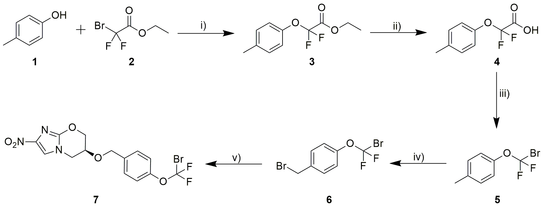
Fig. S1. Precursor synthesis. Precursor synthesis and radiolabeling was performed using the following reagents and conditions: i) NaH, DMF, 10 °C to room temperature (r.t.); ii) NaOH, acetonitrile, r.t., 5 h; iii) (i) DMF, DCM, oxayl chloride, 0 °C to r.t., 3 h, (ii) bromochloromethane, dimethylaminopyridine, 2-mercaptopyridine N-oxide sodium salt, reflux, 2 h; iv) carbon tetrachloride, N-bromosuccinimide, benzoyl peroxide, reflux, 5 h; v) (S)-2-nitro-6,7-dihydro-5H-imidazo[2,1-b][1,3]oxazin-6-ol, DMF, NaH, r.t., 3 h.

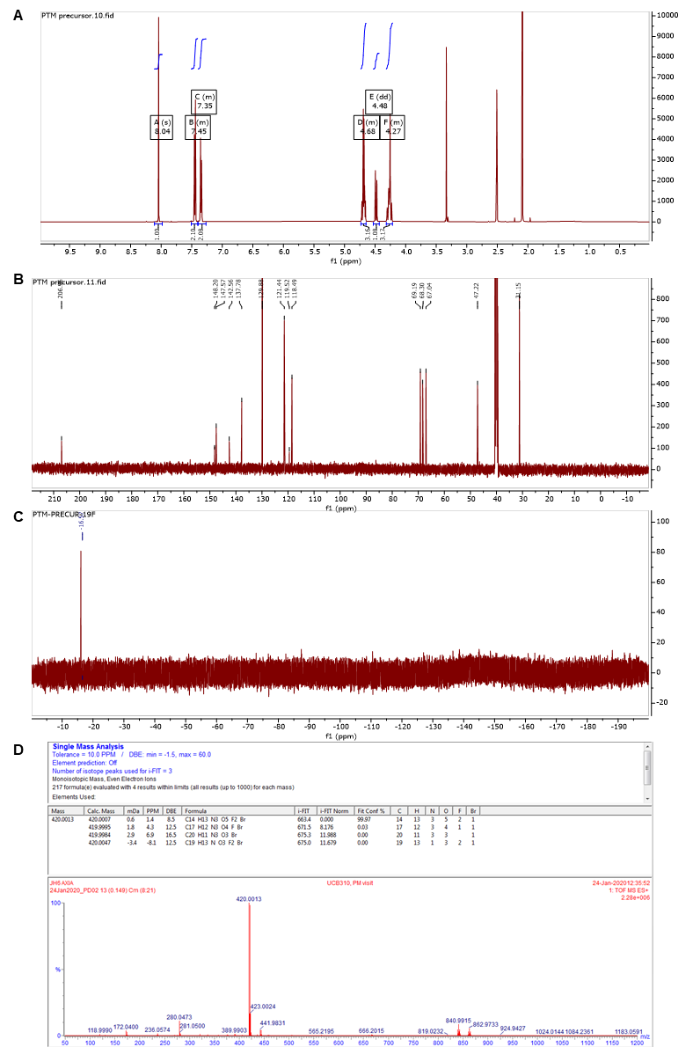
Fig. S2. Structural determination of ¹⁸F-pretomanid precursor 7. (A) ¹H NMR. (B) ¹³C NMR. (C) ¹⁹F NMR. (D) Mass spectrum.

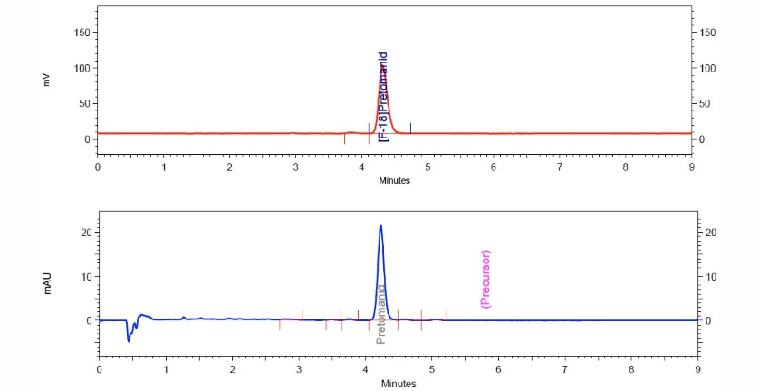
Fig. S3. HPLC chromatograms of purified ¹⁸F-pretomanid. Representative chromatograms of final product solution in the radio-HPLC trace (top red) showing ¹⁸F-pretomanid with >95% purity corresponding to the single peak for pretomanid in the UV trace at 328 nm (bottom blue).

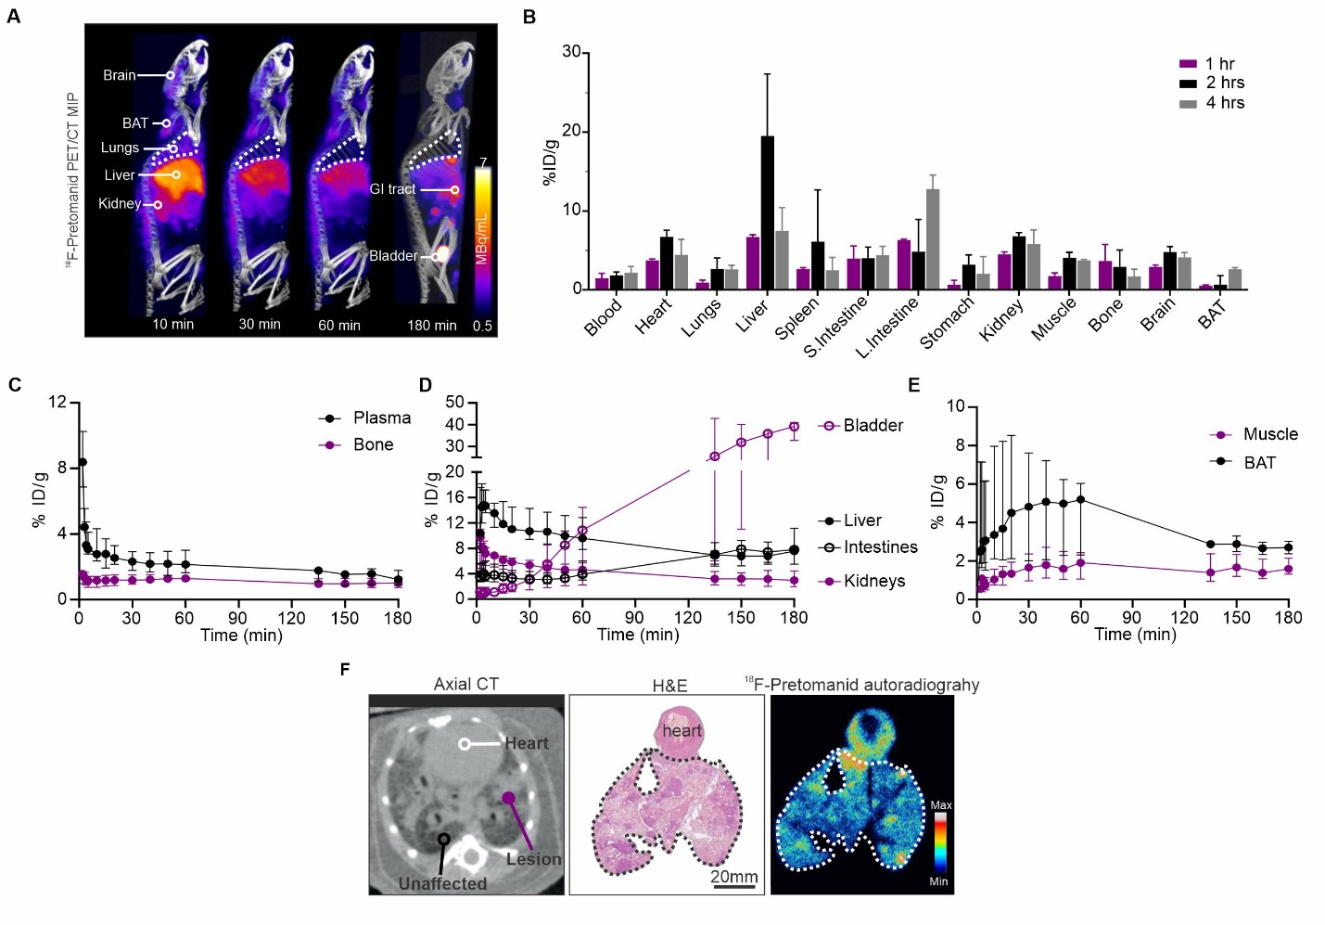
Fig. S4. Validation of ¹⁸F-Pretomanid in the mouse model of pulmonary TB (A) ¹⁸F-Pretomanid PET/CT maximum intensity projections (MIP) at 10, 30, 60 and 180 min post-injection showing the whole-body distribution in a mouse with pulmonary TB. (B) Post-mortem biodistribution of ¹⁸F-pretomanid at 1, 2, and 4 h post-injection. (C) PET-derived ¹⁸F-pretomanid time-activity curves (TACs) from 0 to 180 min in plasma and bone. TAC represented as percentage of injected dose per gram (% ID/g) of tissue over time. (D) TAC from 0 to 180 min in liver, intestines, kidneys, and bladder. (E) TAC in brown adipose tissue (BAT) and muscle. (F) Axial CT scan and coronal histopathology and autoradiography of the same mouse showed lung lesions (e.g., granulomas, pneumonias), unaffected lung, and heart. The lungs are outlined by white and black dotted lines. H&E=hematoxylin and eosin. n = 4 animals. Data are represented as median ± interquartile range (IQR).

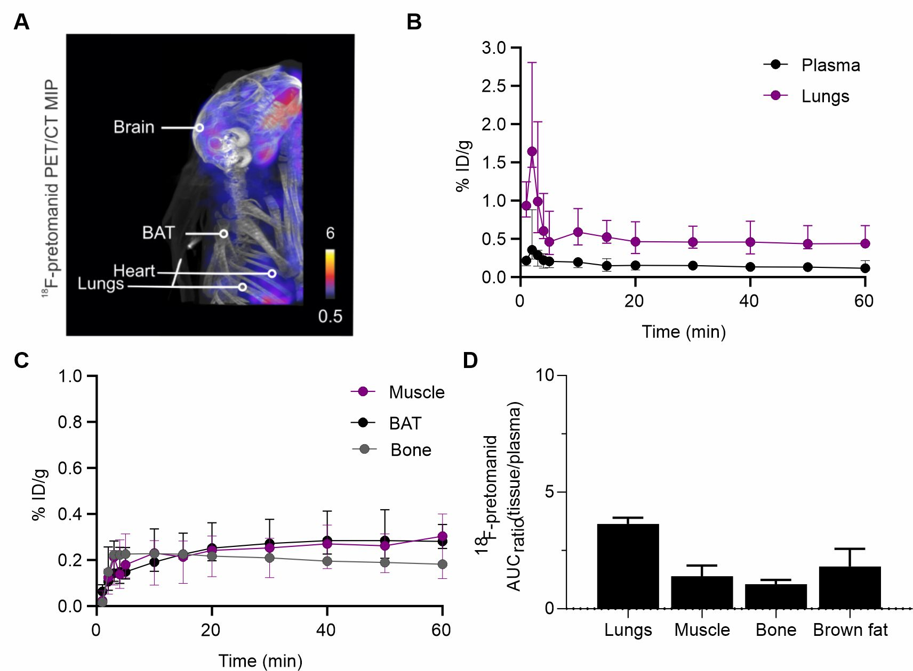
Fig. S5. ¹⁸F-pretomanid PET/CT imaging in the rabbit model of TB meningitis. (A) ¹⁸F-pretomanid PET/computed tomography (CT) maximum intensity projection (MIP) image in a rabbit with TB meningitis. (B) PET-derived ¹⁸F-pretomanid time-activity curves (TACs) from 0 to 60 min in plasma and lungs. (C) PET-derived ¹⁸F-pretomanid TACs from 0 to 60 min in muscle, brown adipose tissue (BAT) and bone. (D) ¹⁸F-pretomanid AUC₃₋₆₀ ratios (tissue/plasma). n = 4 rabbits; one VOI per tissue. Data are represented as median ± IQR.
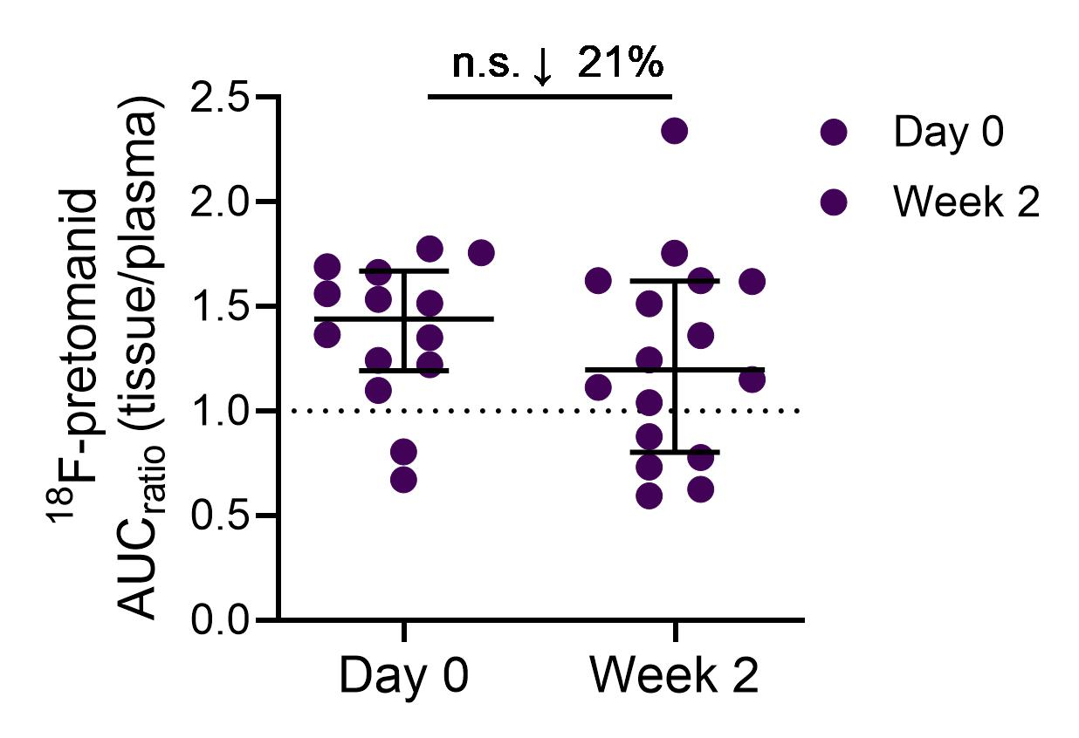
Fig. S6. Pretomanid brain levels in the mouse model of TB meningitis. ¹⁸F-pretomanid AUC ratios (brain/plasma) in mice with TB meningitis before treatment (week 0) and two weeks after initiation of treatment (week 2). Data are represented as median ± IQR. Statistical comparisons were made using two-way ANOVA followed by Bonferroni's test.

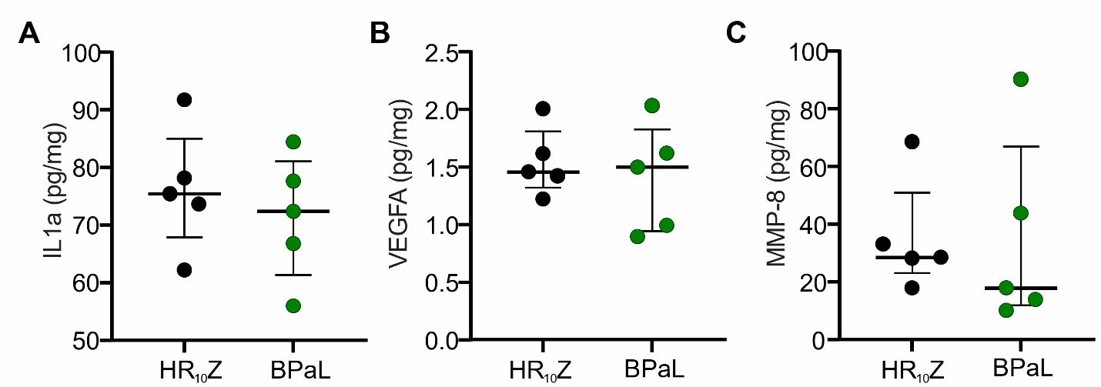
Fig. S7. Cytokines in brain lysates in the mouse model of TB meningitis. (A) IL1α, (B) VEGFA, (C) MMP-8 concentration from brain lysates (n = 5). Data are represented as median ± IQ and statistical comparisons were made using two-tailed Mann-Whitney-Wilcoxon test.

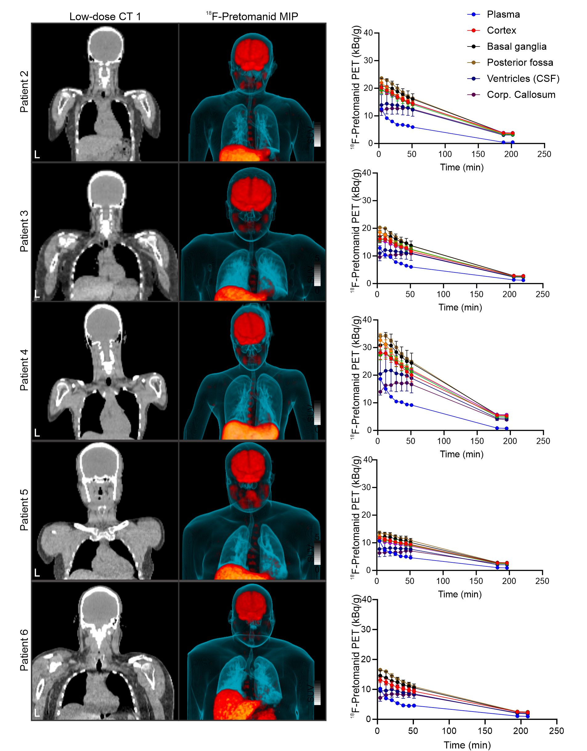
Fig. S8. First-in-human ¹⁸F-Pretomanid PET/CT studies. Coronal CT, coronal maximum-intensity projection (MIP) images, and time-activity curves for the six subjects. Subject 1 is also presented in Fig. 5. Data are represented as median ± IQR.

Tables
Plasma species | % Stability |  |  | % Protein binding
Plasma species | 10 min | 60 min | 180 min | 10 min | 60 min | 180 min
Human | 94 ± 11 | 94 ± 5 | 90 ± 3 | 75 ± 1 | 75 ± 1 | 77 ± 1
Rabbit | 98 ± 4 | 96 ± 6 | 92 ± 1 | 78 ± 1 | 78 ± 1 | 80 ± 1
Rabbit (infected) | 100 ± 0 | 91 ± 13 | 91 ± 0 | 80 ± 1 | 81 ± 0 | 83 ± 1
Mouse | 100 ± 0 | 100 ± 0 | 100 ± 0 | 76 ± 2 | 75 ± 2 | 80 ± 1
Mouse (infected) | 100 ± 0 | 100 ± 0 | 96 ± 6 | 74 ± 0 | 74 ± 2 | 78 ± 0
Table S1. Serum stability and protein binding of ¹⁸F-pretomanid. Data are represented as mean ± standard deviation (SD). n = 3 biological replicates per group.

 | Week 2 |  |  | Week 6
Regimen | CFU(Brain)/g (Log10) (mean) | SD | Log₁₀ reduction | CFU(Brain)/g (Log10) (mean) | SD | Log₁₀ reduction
Untreated | 6.73 | 0.32 | -
HR₁₀Z | 4.34 | 0.16 | 2.39 | 3.21 | 0.19 | 3.52
BPaL | 5.25 | 0.28 | 1.48 | 4.86 | 0.19 | 1.89
Table S2. Brain bacterial burden in the mouse model of TB meningitis. Bacterial burden (log₁₀ CFU) at week 2 and week 6 after initiation of treatment.

Drug | Single dose |  |  |  |  | Two-week treatment
Drug | Plasma median µg/mL (IQR) | Brain median µg/mL (IQR) | CSF median  µg/mL (IQR) | Brain / plasma  median (IQR) | CSF/plasma  median (IQR) | Plasma median µg/mL (IQR) | Brain median µg/mL (IQR) | Brain/plasma  median (IQR)
Pretomanid | 5.42  (3.58-12.17) | 12.26  (10.90-16-47) | 5.42  (4.1-7.0) | 2.56  (1.2-3.59) | 0.05  (0.018-0.14) | 9.09  (7.51-11.08) | 31.04  (24.09-35.52) | 3.39  (3.17-3.60)
Linezolid | 22.98  (15.25-33.0) | 4.44  (2.71-7.93) | 0.38  (0.1-0.76) | 0.16  (0.12-0.28) | 0.24  (0.27-0.31) | 30.36  (25.18-41.49) | 5.76  (4.6-8.12) | 0.19  (0.17-0.20)
Bedaquiline | 0.73  (0.34-1.19) | 0.02  (0.00-0.12) | 0.00  (0.00-0.00)* | 0.015  (0.00-0.16) | 0.00  (0.00-0.00) | 0.89  (0.42-1.19) | 0.05  (0.00-0.19) | 0.07  (0.01-0.13)
M2 | 0.32  (0.14-0.77) | 0.08  (0.04-0.23) | 0.00  (0.00-0.00)* | 0.08  (0.00-0.36) | 0.00  (0.00-0.00) | 1.87  (1.36-2.28) | 0.42  (0.23-1.61) | 0.21  (0.16-0.51)
Table S3. Brain and CSF drug concentrations in TB meningitis mouse model. Concentration of pretomanid, linezolid, bedaquiline, and bedaquiline metabolite (M2) in M. tuberculosis-infected mouse brains following a single dose and two weeks of treatment (10 doses). Data represented as median (IQR). Below limit of detection*
ID | Gender | Age (years) | Weight (kg) | BMI (kg/m²) | ¹⁸F-pretomanid |  | Hematocrit (%) | Albumin (g/dL)
 |  |  |  |  | Dose (MBq) | Specific activity (GBq/µmol) | Hematocrit (%) | Albumin (g/dL)
1 | M | 28 | 84 | 27.5 | 355.2 | 38.7 | 43 | 4.5
2 | F | 20 | 68 | 26.6 | 362.6 | 41.7 | 40 | 4.6
3 | F | 29 | 75 | 28.2 | 358.9 | 23.6 | 39.3 | 4.8
4 | F | 24 | 48 | 18.3 | 358.9 | 40.7 | 38.7 | 4.7
5 | M | 53 | 98 | 31.5 | 362.6 | 62.7 | 41.5 | 4.3
6 | M | 35 | 116 | 37.8 | 358.5 | 34.2 | 43.7 | 4.6

Table S4. First-in-human ¹⁸F-pretomanid PET studies. BMI=body mass index, M=male, F=female.

Mice | RBC/blood | RBC/plasma
M1 | 0.48 | 2.5
M2 | 0.71 | 2.5
M3 | 0.64 | 1.9
Average ±SD | 0.61 ± 0.12 | 2.3 ± 0.4

Table S5. RBC partition coefficient for ¹⁸F-Pretomanid.

