Supporting information for
Genetically-Encoded Discovery of Perfluoroaryl-Macrocycles that Bind to Albumin and Exhibit Extended Circulation in-vivo.

Authors: Jeffrey Y.K. Wong,¹ Steven E. Kirberger², Ryan Qiu¹, Arunika I. Ekanaysake¹, Payam Kelich³, Susmita Sarkar¹, Edgar R. Alvizo-Paez¹, Jiayuan Miao⁴, Shiva Kalhor-Monfared¹, John, J. Dwyer⁵, John M. Nuss⁵, Yu-Shan Lin⁴, Matthew S Macauley,¹ Lela Vukovic³, William C.K. Pomerantz² and Ratmir Derda¹
- Department of Chemistry, University of Alberta, Edmonton, AB T6G 2G2, Canada
- Department of Chemistry, University of Minnesota, Minneapolis, MN 55455, USA
- Department of Chemistry and Biochemistry, University of Texas at El Paso, El Paso, TX 79968, U.S.A.
- Department of Chemistry, Tufts University, Medford, MA 02155, USA
- Ferring Research Institute, San Diego, CA 92121, USA.

Table of contents
1. Biochemistry method 6
2. Preparation of SXCX₃C phage-displayed library 6
3. Panning strategy 1: panning on plate 6
4. Panning strategy 2: panning on plate and in solution 7
5. Panning strategy 3: panning in solution 8
6. General protocol for proteins biotinylation 8
7. PCR amplification protocol for Illumina deep sequencing 9
8. Illumina sequencing of samples before and after panning. 9
Table S1: URL for 1st panning campaign deep sequencing results……………………………..11
Table S2: URL for 2nd panning campaign deep sequencing results…………………………….11
Table S3: URL for 3rd panning campaign deep sequencing results……………………………..11
9. General chemistry method 12
10. Peptide synthesis: 12
11. General protocol for cyclization with pentaflurophenyl-sulfide 12
12. BODIPY fluorescence C-terminus labeling of 5c and 8c 12
13. ¹⁹F NMR binding experiment 13
Table S4: A typical experiment involving titration with HSA………………………………….13
14. Fluorescence polarization binding assay 14
15. Isothermal titration calorimetry (ITC) binding assay 14
16. In vivo pharmacokinetic experiment 14
17. LC–MS analysis for pharmacokinetics 14
18. Docking Calculations 15
Figure S1: First bio-panning campaign of OFS-modified phage-displayed peptide library against the HSA proteins. 16
Figure S2: Second bio-panning campaign of OFS-modified phage-displayed peptide library against the HSA protein. 17
Figure S3: Phage recovered from the second selection campaign of round 3 were bound to different proteins on protein coated plates. 18
Figure S4: PCR amplification protocol for Illumina deep sequencing 19
Figure S5: A heat map is showing of 85 putative hits discovered from the third panning campaign. 20
Figure S6: DFS stapled peptide reacted with GSH over 3 hours 21
Figure S7: Stability of the PFS stapled peptides 22
Figure S8: Ramachandran plot of the cyclic peptide backbone for 5b and 5c 23
Figure S9: Summary of the selected peptide sequences nominated from three panning campaigns. 24
Figure S10: ¹⁹F NMR binding assay 25
Figure S11: Summary of the ¹⁹F NMR binding measurement of the HSA 26
Figure S12: The ¹⁹F NMR titration spectra of 5c and 8c against rat serum albumin. 27
Figure S13: Binding of the selected peptides to HSA monitored by ITC. 28
Figure S14: Binding of the selected peptides to HSA monitored by ITC. 29
Figure S15: Summary of ITC binding assay 30
Figure S16: FP assay for BODIPY labeled 5d titrated against HSA 31
Figure S17: FP assay for BODIPY labeled 5d titrated against fatty acid-free HSA. 32
Figure S18: FP assay for Bodipy labeled RFF-PFS titrated against whole mouse serum 33
Figure S19: The FP binding assay of conjugate 5c with BODIPY installed at N-terminus and C-terminus 34
Figure S20: HSA binding between 5b and 5c 35
Figure S21: ¹⁹F NMR assay of labelled and unlabelled 5c 36
Figure S22: HSA binding sites of ibuprofen and diclofenac ligands in crystal structures. 37
Figure S23: Binding scores of PFS-SICRFFCGGG macrocycle to HSA binding sites of fatty acids, determined in docking calculations. 38
Table S5: Binding scores of RFF macrocycle to HSA fatty acid binding sites from all docking calculation……………………………………………………………………………………..38
Figure S24: Detection of macrocycles using mass spectrometry. 40
19. MATLAB script for DE analysis 41
20. Summary of synthesis 49
Figure S25: Synthesis summary of 1b 49
Figure S26: Synthesis summary of 1c. 50
Figure S27: Synthesis summary of 2b. 51
Figure S28: Synthesis summary of 2c. 52
Figure S29: Synthesis summary of 3b₁. 53
Figure S30: Synthesis summary of 3c₁. 54
Figure S31: Synthesis summary of 3c₂. 55
Figure S32: Synthesis summary of 4b. 56
Figure S33: Synthesis summary of 4c. 57
Figure S34: Synthesis summary of 5b. 58
Figure S35: Synthesis summary of 5c. 59
Figure S36: Synthesis summary of 6b. 60
Figure S37: Synthesis summary of 6c. 61
Figure S38: Synthesis summary of 7b. 62
Figure S39: Synthesis summary of 7c 63
Figure S40: Synthesis summary of 8b. 64
Figure S41: Synthesis summary of 8c. 65
Figure S42: Synthesis summary of C-terminus labeled 5c-BODIPY. 66
Figure S43: Synthesis summary of N-terminus labeled 5d-BODIPY 67
Figure S44: Synthesis summary of N-terminus labeled 5b-BODIPY 68
Figure S45: Synthesis summary of C-terminus labeled 8c-BODIPY. 69
Figure S46: STCHANCGGKKK ¹H NMR Spectra in D₂O, 600 70
Figure S47: STCHDITCGGKKK ¹H NMR Spectra in D₂O, 600 70
Figure S48: STCHYIGCGGKKK ¹H NMR Spectra in D₂O, 600 71
Figure S49: STCHTIYCGGKKK ¹H NMR Spectra in D₂O, 600 71
Figure S50: DFS-STCHANCGGKKK ¹H NMR Spectra in D₂O, 600 72
Figure S51: DFS-STCHDITCGGKKK ¹H NMR Spectra in D₂O, 600 72
Figure S52: DFS-STCHYIGCGGKKK ¹H NMR Spectra in D₂O, 600 73
Figure S53: DFS-STCHTIYCGGKKK ¹H NMR Spectra in D₂O, 600 73
Figure S54: PFS stapled STCHANCGGKKK ¹H NMR Spectra in D₂O, 600 74
Figure S55: PFS-STCHDITCGGKKK ¹H NMR Spectra in D₂O, 600 74
Figure S60: PFS-STCHTIYCGGKKK ¹H NMR Spectra in D₂O, 600 75
Figure S57: PFS stapled STCHYIGCGGKKK ¹H NMR Spectra in D₂O, 600 75
Figure S58: SLCKRECGGG ¹H NMR Spectra in D₂O, 600 76
Figure S59: SICRFFCGGG ¹H NMR Spectra in D₂O, 600 76
Figure S60: STCQGECGGG ¹H NMR Spectra in D₂O, 600 77
Figure S61: PFS stapled SFCPMFCGGG ¹H NMR Spectra in DMSO, 700 77
Figure S62: PFS stapled SLCKRECGGG ¹H NMR Spectra in DMSO, 700 78
Figure S63: PFS stapled SICRFFCGGG ¹H NMR Spectra in DMSO, 700 78
21. References 79

List of abbreviations:
BIA biotin-PEG2-iodoacetamide
Boc tert-butyloxycarbonyl
BODIPY 4,4-difluoro-4-bora-3a,4a-diaza-s-indacene
BSH biotin-thiol
Calc calculated
Da. daltons(s)
DFS
DMF N, N-Dimethylformamide
ESI electrospray ionization
eq. equivalent(s)
EDT 1,2-ethanedithiol
h hour(s)
HSA Human serum albumin
HPLC high performance liquid chromatography
HRMS high-resolution mass spectrometry
LCMS liquid chromatography mass spectrometry
MHz megahertz
MsCl methanesulfonyl chloride
NMR nuclear magnetic resonance
mL milliliter(s)
mM millimolar
min minute(s)
mmol millimoles
PBS phosphate buffered saline
PCR Polymerase chain reaction
PFS pentafluorophenylsulfide
ppm parts per million
rt room temperature
RSA Rat serum albumin
TCEP tris(2-carboxyethyl)phosphine)
TIPS triisopropylsilane
TFA trifluoroacetic acid
Tris tris(hydroxymethyl)aminomethane
v/v volume/volume

Biochemistry method
HSA was purchased from Sigma-Aldrich (cat# A4327-1G), as were Protein A from Sigma-Aldrich (cat# P6031-1MG), and Concanavalin A (cat# C2010-100MG). The proteins were immobilized on a high binding plate (Corning, ref# 3369) with 100 µL of HSA or Protein A (100 µg/mL). The wells were washed 6 times with 200 µL of 1×PBS-T+0.1% tween 20, at pH 7.4 prior to phage incubation. The proteins were biotinylated in section 6. Prior to capture proteins, the magnetic streptavidin beads (Promega, cat# Z5482) were washed with 1 × PBS. All proteins were captures with 20 µL magnetic streptavidin beads.

Preparation of SXCX₃C phage-displayed library

The procedures have been adopted and modified as previously described in two publications that produced the M13-displayed SXCXXXC library⁴⁴ and M13-SDB vector⁶⁸. In short, the vector SB4 QFT*LHQ was digested with Kpn I HF (NEB cat# R3142S) and Eag I HF (NEB cat# R3505S). A primer/template pair consisting of primer 5’-AT GGC GCC CGG CCG AAC CTC CAC C-3’ and template 5’-CC CGG GTA CCT TTC TAT TCT CAC TCT TCT X TGT XXX TGT GGT GGA GGT TCG GCC GGG CGC TTG ATT-3’ with ‘X’ representing a trinucleotide formed by annealing. The primer/template was then extended using Klenow DNA polymerase (NEB) according to the manufacturer’s instructions. The insert fragment was then digested with Kpn1 HF and Eag1 HF, gel purified, and ligated into the cut vector. The ligation products were then transformed into electrocompetent E. coli cells, and the transformants were grown overnight on E. coli TG1 to allow for phage production. Phage cultures were then centrifuged to remove cells and debris, and then the phage was precipitated by PEG precipitation (5% PEG 0.5 M NaCl). Other SDB vectors have been processed identically. We sequenced the naïve libraries by Illumina sequencing, and the naïve library of SXCX_{n}C (n=3-5) composition is publicly available at the following link: https://48hd.cloud/file/1470. SXCX₄C and SXCX₅C libraries were prepared as described in previously reported protocols.³

Panning strategy 1: panning on plate
Round 1-3: The following protocol was repeated 3 times.
In Protein A coated wells, 100 µL of 2×10⁹ PFU/mL DFS modified library or unmodified library was incubated for O/N at 4 ºC to remove unspecific binders. The DFS modified library supernatant was then transferred to wells with HSA and incubated for 1.5 h at RT. In parallel, DFS modified library supernatants were also incubated with Protein A, and unmodified libraries were incubated with HSA and protein A as a negative controls. After panning, all wells were washed 10 times with PBST (Phosphate buffered saline + 0.1% Tween). The phage particles remaining in the wells were eluted with 200 µL of glycine elution buffer (200 mM Glycine-HCl pH 2.2, 0.1% BSA) for 9 min. The elution buffer was transferred into a new 1.7 mL microcentrifuge tube containing 20 µL of neutralization buffer (1 M Tris-HCl, pH 9.1). The recovered phage solution was amplified for the next round of biopanning and PCR amplified for deep sequencing.

Panning strategy 2: panning on plate and in solution
Round 1:
In Protein A coated wells, 100 µL of 2×10⁹ PFU/mL DFS modified library or unmodified library was incubated for O/N at 4 ºC to remove unspecific binders. The DFS modified library supernatant was then transferred to wells with HSA and incubated for 1.5 h at RT. In parallel, DFS modified library supernatants were also incubated with Protein A, and unmodified libraries were incubated with HSA and protein A as a negative controls. After incubation, all wells were washed 10 times with PBST. The phage particles remaining in the wells were eluted with 200 µL of glycine elution buffer (200 mM Glycine-HCl pH 2.2, 0.1% BSA) for 9 min. The elution buffer was transferred into a new 1.7 mL microcentrifuge tube containing 20 µL of neutralization buffer (1 M Tris-HCl, pH 9.1). The recovered phage solution was amplified for the next round of biopanning and PCR amplified for deep sequencing.
Round 2:
A suspension of 50 µL of magnetic streptavidin beads was transferred to a 1.7 mL centrifuge tube and washed with 1 mL of PBST. The beads were then resuspended in 1 mL of blocking buffer (PBS+2% milk) and incubated for 1 h at 4 ºC. In parallel, 200 µL (2×10⁹ PFU/mL) of DFS modified phage and unmodified phage library were incubated for 1 h at RT with pre-blocked beads to remove any beads binders. The beads were immbolized with a magnetic rack and the supernatant was transferred to a new 1.7 mL centrifuge tube for panning. A solution of 100 µL of depleted DFS modified phage library was combined with 10 µg of biotinylated HSA, increased the volume to 200 µL with PBS, and incubated for 1 h at RT. In parallel, 100 µL of the depleted DFS modified phage was combined with 10 µg of biotinylated protein A, increased the volume to 200 µL with 1×PBS and incubated for 1 h at RT. A solution of 100 µL of unmodified phage library that was depleted against Streptavidin beads was combined with 10 µg of biotinylated protein A and HSA, increased the volume to 200 µL with 1×PBS and incubated for 1 hour at RT. After incubation, 50 µL of blocked streptavidin beads were added to the samples. Then, the beads were captured with a magnetic rack and washed 10 times with 1 mL of 1×PBST. The bound phage particles were eluted with 200 µL of glycine elution buffer (200 mM Glycine- HCl pH 2.2, 0.1% BSA) for 9 min. The elution buffer was transferred into a new 1.7 mL microcentrifuge tube and neutralized with 20 µL of 1 M Tris-HCl (pH 9.1). The recovered phage solution was amplified for the next round of biopanning and PCR amplified for deep sequencing.
Round 3:
In Protein A coated wells, 100 µL of 2×10⁹ PFU/mL DFS modified library or unmodified library was incubated for 1 h at 4 ºC to remove unspecific bindings. The DFS modified library supernatant was then transferred to wells with HSA and incubated for 1.5 h at RT. In parallel, depleted DFS modified library supernatants were also incubated with Protein A. Unmodified libraries were incubated with HSA and protein A as negative controls. After incubation, all wells were washed 10 times with 1×PBST. The remaining phage particles were eluted with 200 µL of glycine elution buffer (200 mM Glycine-HCl pH 2.2, 0.1% BSA) for 9 min. The elution buffer was transferred into a new 1.7 mL microcentrifuge containing 20 µL of neutralization buffer (1 M Tris-HCl, pH 9.1). The recovered phage solution was amplified for the next round of biopanning and PCR amplified for deep sequencing.

Panning strategy 3: panning in solution
This strategy was used for one round of panning.
Magnetic streptavidin beads were blocked with blocking phage (note: blocking phage amplifiable with the PCR protocol used for phage libraries) overnight and washed 3 times with 1 mL of 1×PBS. DFS modified phage library (2×10¹¹ pfu/mL) and blocking phage (2×10¹² pfu/mL) were mixed in a 1:10 ratio and incubated with blocked streptavidin beads for 30 mins to deplete beads binders. The depleted DFS modified phage library was incubated with 5 µg of biotinylated HSA and T4GP-His₆ in a total volume 100 µL in 1×PBS with 2% milk for 30 min at RT. In parallel, the depleted DFS modified phage library was incubated with 5 µg of ConA-Bio in a total volume 100 µL in PBS with 2% milk for 30 min at RT. After incubation, 25 µL of blocked magnetic streptavidin beads were added to each mixture and incubated for 20 min at RT. The beads were captured with a magnetic rack and were washed 9 times with 1 mL of 1×PBS. The beads were then resuspended in 1 mL 1×PBS and incubated for 30 mins. The beads were captured with a magnetic rack, the supernatant was discarded, and the beads were resuspended with 60 µL mixture containing 1:1 hexane and DNAse free water and shaken for 15 mins (1500 RPM). The samples were heated to 55 °C for 10 mins or until hexane completely evaporated. The remaining aqueous layer was collected and PCR amplified for deep sequencing by Illumina Next seq.

General protocol for proteins biotinylation
Protein was dissolved to 1 mg/mL in 1×PBS at pH 7.4. 5 molar fold excess of EZ-Link Sulfo-NHS-Biotin (Thermofisher, cat# 21217) were added to the protein solution. The reaction mixture was incubated O/N at 4 ºC. The next day, the protein was dialysis 3 times in 4 L of 1×PBS at pH 7.4. The biotinylated protein was captured with magnetic streptavidin beads to confirm biotinylation. The final concentration was determined with Nano-drop.

PCR amplification protocol for Illumina deep sequencing
Take 25 µL of eluted or amplified phage solution was used as a template for PCR with a total volume of 50 µL.
A Typical 50 µL PCR mixture contained:
- 5× Phusion buffer | 10 μL
- 10 mM dNTPs | 10 μL
- Phusion® High-Fidelity DNA Polymerase (NEB, cat# M0530S) | 0.5 μL
- Forward primer (3’-CAAGCAGAAGACGGCATACGAGATC GGTCTCGGCATTCCTGCTGAACCGCTCTTCCGATCTXXXXCCTTTCTATTCTCACTCT-5’, 10 μM) | 2.5 μL
- Reverse primer (3’-AATGATACGGCGACCACCGAGATCTA CACTCTTTCCCTACACGACGCTCTTCCGATCTXXXXACAGTTTCGGCCGA-5’, 10 μM) | 2.5 μL
- Template solution | 25 μL
- Nuclease free water | 8.5 μL
Thermocycler was preformed using the following setting:
- 95 °C for 30 sec
- 95 °C for 30 sec
- 60.5 °C for 15 sec
- 72 °C for 30 sec
- Repeat step b) to d) 25 times
- 72 °C for 5 min
- hold at 4°C

Illumina sequencing of samples before and after panning.
The PCR products were produced by PCR as described in general PCR amplification protocol for Illumina deep sequencing with one exception: in amplification of libraries before panning (input), the volume of the template (phage solution) was 2 μL. All products were quantified by 2% (w/v) agarose gel in Tris-Borate-EDTA buffer at 100 volts for ~35 min using a low molecular weight DNA ladder as standard (NEB, cat# N3233S). PCR products that contain different indexing barcodes were pooled, allowing 10 ng of each product in the mixture. The mixture was purified by eGel, quantified by quBit and sequenced using the Illumina NextSeq paired-end 500/550 High Output Kit v2.5 (2×75 Cycles). Data were automatically uploaded to BaseSpace™ Sequence Hub. Processing of the data is described in section processing of Illumina data.
Processing of Illumina data
The Gzip compressed FASTQ files were downloaded from BaseSpace™ Sequence Hub. The files were converted into tables of DNA sequences and their counts per experiment. Briefly, FASTQ files were parsed based on unique multiplexing barcodes within the reads discarding any reads that contained a low-quality score. Mapping the forward (F) and reverse (R) barcoding regions, mapping of F and R priming regions allowing no more than one base substitution each and F-R read alignment allowing no mismatches between F and R reads yielded DNA sequences located between the priming regions as described in previous publications.² The files with DNA reads, raw counts, and mapped peptide modifications were uploaded to http://48hd.cloud/ server. Each experiment has a unique alphanumeric name and unique static URL in Tables S1-3.

Table S1: URL for 1st panning campaign deep sequencing results
 | Modification | HSA | Protein A
R1 | DFS | https://48hd.cloud/file/213 | https://48hd.cloud/file/214
R1 | none | https://48hd.cloud/file/217 | https://48hd.cloud/file/218
R2 | DFS | https://48hd.cloud/file/213 | https://48hd.cloud/file/214
R2 | none | https://48hd.cloud/file/217 | https://48hd.cloud/file/218
R3 | DFS | https://48hd.cloud/file/213 | https://48hd.cloud/file/214
R3 | none | https://48hd.cloud/file/217 | https://48hd.cloud/file/218

Table S2: URL for 2nd panning campaign deep sequencing results
 | Modification | HSA | Protein A
R1 | DFS | https://48hd.cloud/file/236 | https://48hd.cloud/file/237
R1 | none | https://48hd.cloud/file/421 | N/A
R2 | DFS | https://48hd.cloud/file/236 | https://48hd.cloud/file/237
R2 | none | https://48hd.cloud/file/421 | N/A
R3 | DFS | https://48hd.cloud/file/236 | https://48hd.cloud/file/237
R3 | none | https://48hd.cloud/file/421 | N/A

Table S3: URL for 3rd panning campaign deep sequencing results
 |  | HSA | T4-GP | ConA
R1 | Input + Modification | https://48hd.cloud/file/799 | https://48hd.cloud/file/799 | https://48hd.cloud/file/799
R1 | Elution | https://48hd.cloud/file/798 | https://48hd.cloud/file/797 | https://48hd.cloud/file/796

General chemistry methods
LC–MS analysis of peptide modifications was obtained on Agilent Technologies 6130 LC–MS. A gradient of solvent A (MQ water) and solvent B (MeCN/H₂O 95/5) was run at a flow rate of 0.5 mL/min (0-4.0 min 5% B; 4.0-5.0 min 5%60% B; 5.0-5.5 min 60%100% B; 5.5-7.5 100% B, 7.5-11 min 100%5% B).

Peptide synthesis:
Peptides were synthesized on a PreludeX peptide synthesizer (Gyros Protein Technolgoes) by standard Fmoc solid chemistry using Rink Amide AM resin. Fmoc-protected amino acids, HBTU, Rink Amide AM resin were purchased from ChemPrep, Wellington FL USA. Peptides were cleaved from the resin by using a TFA/EDT/TIPS/Water (89.9/2.28/4.54/2.28 v/v) then precipitated and washed with ice-cold diethyl ether, and further purified by HPLC and lyophilized into the product.

General protocol for cyclization with decafluorodiphenylsulfone

Procedure was analogous to previously published methods^{42, 43}. In short, linear peptide (10 mM) was dissolved in 50% acetonitrile and Tris buffer (50 mM Tris-HCl, pH 8.5), then 2 equivalents of DFS in 50% acetonitrile and Tris buffer (50 mM Tris-HCl, pH 8.5) was added to the mixture. The mixture was vortexed for 30 sec, incubated for 2 h at room temperature, purified by HPLC and further lyophilized to yield product.

General protocol for cyclization with pentaflurophenyl-sulfide
Procedure was analogous to previously published methods^{42, 43}. In short, linear peptide (10 mM) was dissolved in 50 mM Tris in DMF, then 2 equivalents of PFS was added to the mixture. The mixture was vortexed for 30 sec and allow to react for 1 hour at RT. The reaction mixture was purified by HPLC and lyophilized to yield the product.

BODIPY fluorescence C-terminus labeling of 5c and 8c
N-terminal Fmoc-protected PFS stapled peptides were dissolved in 1×PBS, 50% acetonitrile, then 1.5 equivalents of BODIPY-NHS ester (100 mg/mL DMSO, Anaspec) was added to the solution. The mixture was incubated for O/N at room temperature. Peperdine were add to a final concentration of 20% v/v for 30 mins to deportect the N-terminus Fmoc protecting group. The reaction mixture was purified by HPLC and further lyophilized into the product.

¹⁹F NMR binding experiment

NMR experiments conducted at the University of Minnesota were performed on a Bruker Avance III HD with a Prodigy TCI cryoprobe (2100:1 S/N for ¹⁹F). PFS-peptides were tested as 20 μM solutions in experiments were performed with a fluorinated peptide concentration of 20 μM in 50 mM phosphate, 100 mM NaCl and 26.5 μM 2,2,2-trifluoroethanol, pH 7.4 with varying concentrations of rat or human serum albumin (from 0-160 μM). Parameters used for each experiment are as follows: 750 scans, acquisition time of 0.05 s, relaxation delay of 0.7 s, spectrum centered at -135 ppm with a sweep width of 20 ppm. A reference spectrum observing 2,2,2-trifluoroethanol was acquired for each sample with the following parameters: 16 scans, acquisition time of 0.5 s, relaxation delay of 1 s, spectrum centered at -75 with a sweep width of 10 ppm. The observed chemical shift of the reference was deducted from -77.75 ppm, and this difference was applied to the peptide spectrum.

Table S4: A typical experiment involving titration with HSA
Component | HSA | PFS-peptide | TFE | D₂O | PBS
Stock (µM) | 2000 | 200 | 26.5 | n.a | n.a
 | 0 | 20 | 2 | 25 | 423
 | 2.5 | 20 | 2 | 25 | 420.5
 | 5 | 20 | 2 | 25 | 418
 | 10 | 20 | 2 | 25 | 413
 | 20 | 20 | 2 | 25 | 403
 | 40 | 20 | 2 | 25 | 383
n.a: Not applicable
This series would produce a titration with 20 μM PFS-peptide held constant and the HSA varying in a two-fold fashion: 0, 10, 20, 40, 80,160 μM. TFE refers to 2,2,2-trifluoroethanol as a 1/1000 dilution (approx. 26.5 μM), and PBS components were 50 mM phosphate, 100 mM NaCl, pH 7.4.
NMR experiments conducted at the University of Alberta were performed on an Agilent MR400 with a OneNMRTM Probe (690:1 S/N for ¹⁹F). PFS and OFS peptides were tested as 50uM solutions in 1X PBS, 2.5% DMSO, and 10% D₂O with 100uM HSA. Parameters used for each experiment are as follows: 2048 scans, acquisition time of 0.15s, relaxation delay of 0.85s, spectrum was centered between PFS and OFS fluorine peaks and with a sweep width of 207 ppm. Peptide spectra were referenced to TFA at -76.55 ppm.

Fluorescence polarization binding assay
384 black well plates (PerkinElmer, cat# 6007270) were used to measure all binding assays. The fluorescent-labeled peptides were dissolved to 10 mM in DMSO and diluted to 20 µM in DMSO for use. Each well added with 19 µL of HSA in 1×PBS with the range of final concentration from 190 µM to 15 nM. 1 µL of 20 µM of fluorescence landed peptide added to the wells to a final concentration of 1 µM. Each measuring point was made in duplicate. Before measuring, the plate was spun down with 500×g for 5 mins at RT, incubated for 10 mins, and shaken for 5 mins in the dark. The measurement was performed in Cytation5 Cell Imaging Multi-Mode Reader from BioTek. The data were analyzed and processed in OrginLab.

Isothermal titration calorimetry (ITC) binding assay
Titration experiments were performed using a Microcal VP-ITC instrument. Pepties were discoved in 1×PBS at pH 7.4 to a final concentration of 400 µM . In the case, where ligands have poor solubility in the prepared buffer, up to 5% (v/v) DMF was used. The HAS solution was prepared with the identical buffer as the peptides to a final concentration of 40 µM. All solutions were degassed with MicroCal ThermoVac. All the titration in this studiy carried out at 37 ºC and stirring at 300 rpm. An initial injection of 2 µL follwed by a total of 41 injection of 10 µL peptide solution were added at the interal of 4 mins into the HSA solution. The data were evaluated using the MicroCalTM OriginTM Version 5.0, and the heat signals were fitted to “one set of sites” or “two sets of sites” models to obtain the binding enthalpy, affinity, and stoichiometry estimates.

In vivo pharmacokinetic experiment
All the procedures and experiments involving animals were carried out using a protocol approved by the Health Sciences Laboratory Animal Services (HSLAS), University of Alberta. The protocol was approved as per the Canadian Council on Animal Care (CCAC) guidelines. All mice were maintained in pathogen-free conditions at the University of Alberta breeding facility. Peptide mixtures of 100 µM were prepared in PBS. Mice were administered with 200 µL of the peptide mixture solution with tail veil injection. A series of 6 blood samples were collected at time points from 2 min up to 240 min. Samples were collected in tubes that contained sodium citrate as an anticoagulant and then centrifuged at 5 min at 2,000×g to collect the blood plasma. 10 µL of plasma portion were transferred into a tube containing 40 µL of 8:2 acetonitrile/water to precipitate proteins. The samples were centrifuged at max speed for 10 min at 4 ºC. Supernatants were then transferred to new tubes and subjected to analysis by LC-MS.

LC–MS analysis for pharmacokinetics
LC–MS studies of the stability of peptides in mice were performed in Hewlett Packard 1100 series instrument using a Phenomenex Jupiter C4 protein column (300 Å, 2×50 mm, 0.3 mL/min, A: 0.1% formic acid in water, B: 0.1% formic acid in acetonitrile (0 min 2% B, 010 min 2%70% B, 1015 min 70% B, 1520 min 70%2% B). The amount of peptide remaining was calculated with the area under the curve of SIM (Selected Ion Monitoring) peak in LC–MS.

Docking Calculations

Docking of PFS-SICRFFCGGG macrocycle to the human serum albumin (HSA) protein was performed using five different HSA crystal structures obtained from the RCSB databank (PDB IDs: 1e7e, 1e7f, 1e7g, 1e7h, 1e7i).⁴ In these crystal structures, multiple fatty acids (between six and nine) of different lengths are bound to HSA proteins. The previously characterized binding locations of the fatty acids on the HSA surface⁴ are here called binding sites, labeled by distinct indices. In our calculations, we docked PFS-SICRFFCGGG macrocycles to each of those binding sites. The PFS-SICRFFCGGG structure was constructed with ChemSketch.² Both PFS-SICRFFCGGG and HSA were converted to Autodock Vina⁵ readable format using MGLTools. In docking the PFS-SICRFFCGGG to HSA, the grid box center locations were selected to coincide with the centers of mass of the bound fatty acids. The grid boxes had 2.6 x 2.6 x 2.6 nm² dimensions with a default spacing of 0.0375 nm. The Autodock Vina configuration files and the docking run procedure were generated and ran automatically with a bash script provided by us on Github (https://github.com/vukoviclab/hsa-dock). The docking runs were performed using three different random seeds.

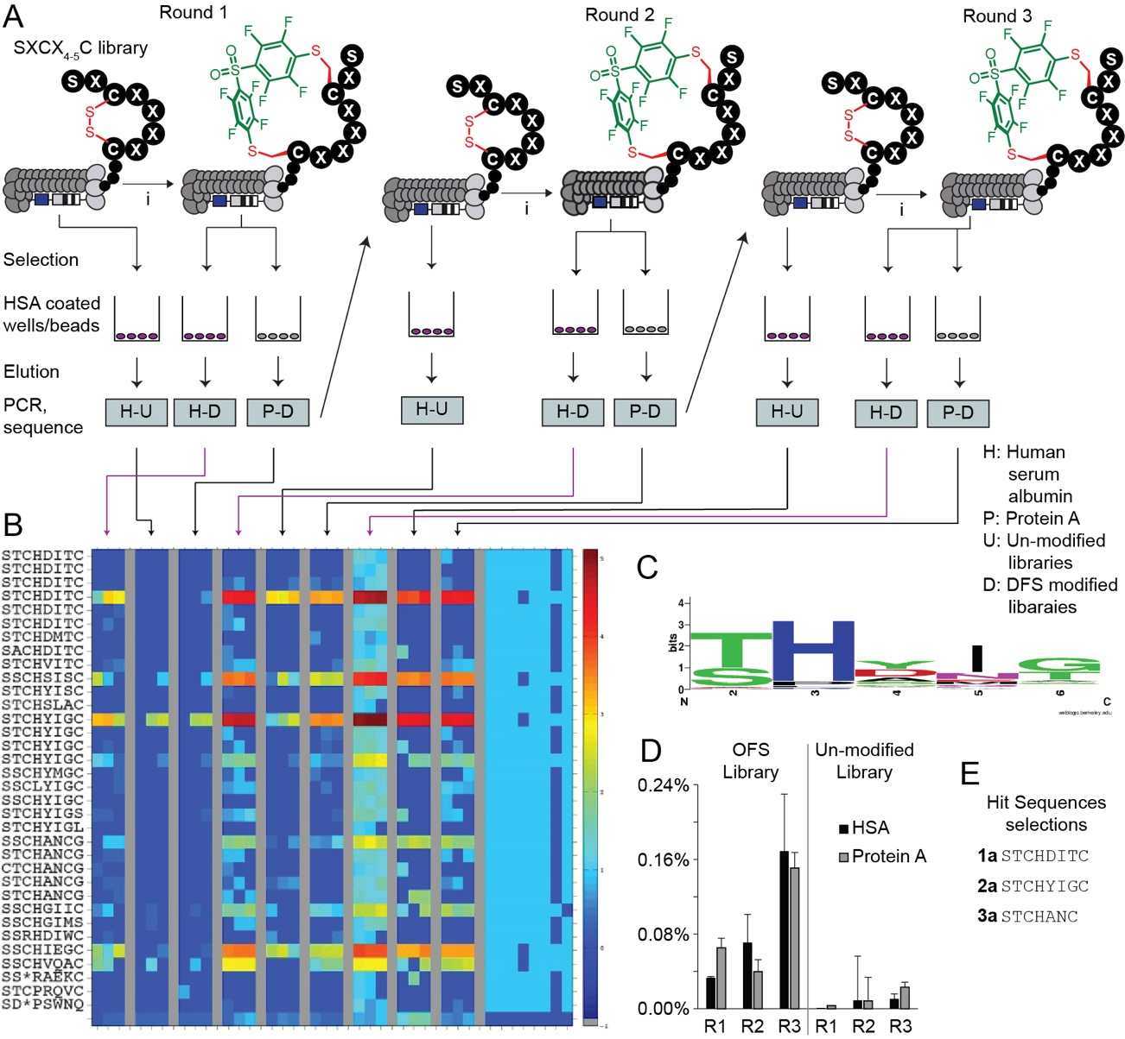
- First bio-panning campaign of OFS-modified phage-displayed peptide library against the HSA proteins.
(A) A scheme of three-rounds panning against HSA and negative controls. (B) The top 39 sequences from differential enrichment results. (C) LOGO analysis plot of the enriched sequences. (D) Percentage of the phage recovery after each round of bio-panning. (E) Selected sequences for chemical synthesis of the macrocycles.

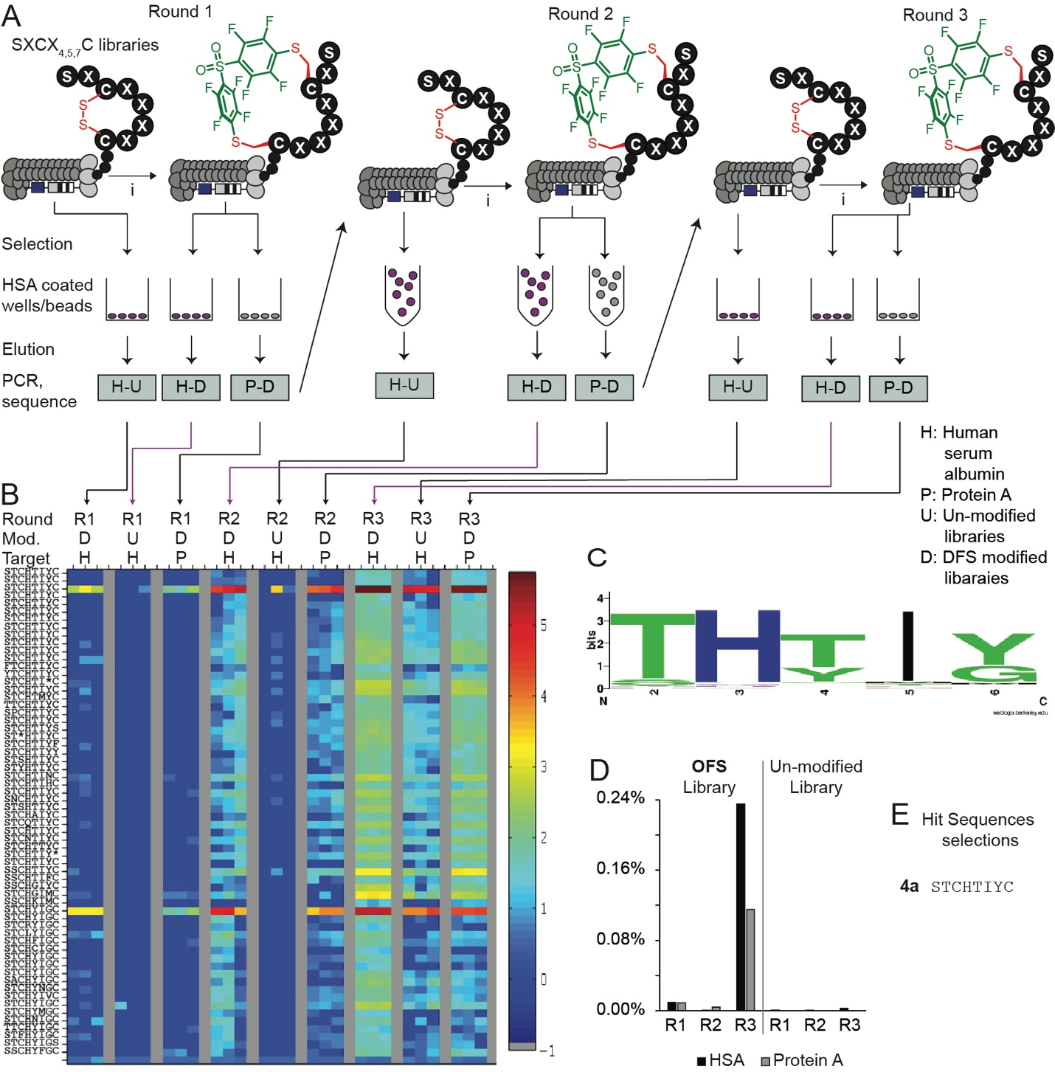
- Second bio-panning campaign of OFS-modified phage-displayed peptide library against the HSA protein.
(A) Scheme of a three-rounds panning against HSA and the negative controls. (B) The top 65 sequences from differential enrichment results. (C) LOGO analysis plot of the enriched sequences. (D) Percentage of the phage recovery after each round of bio-panning. (E) Selected sequences for validation synthesized into macrocycles.

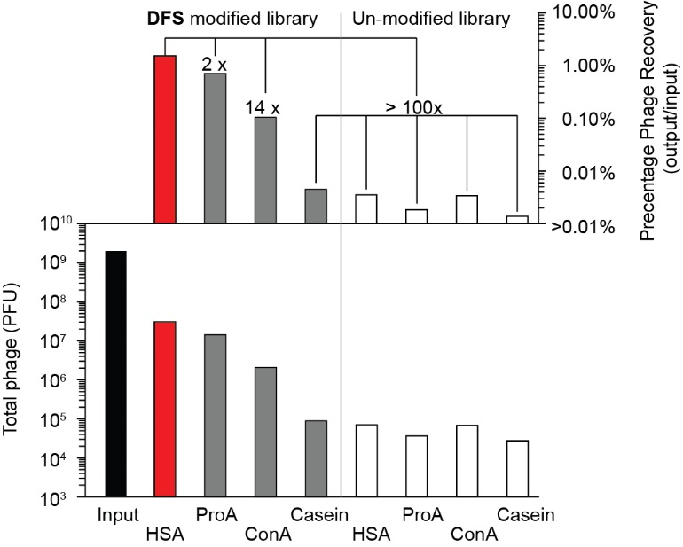
- Phage recovered from the second selection campaign of round 3 were bound to different proteins on protein coated plates.

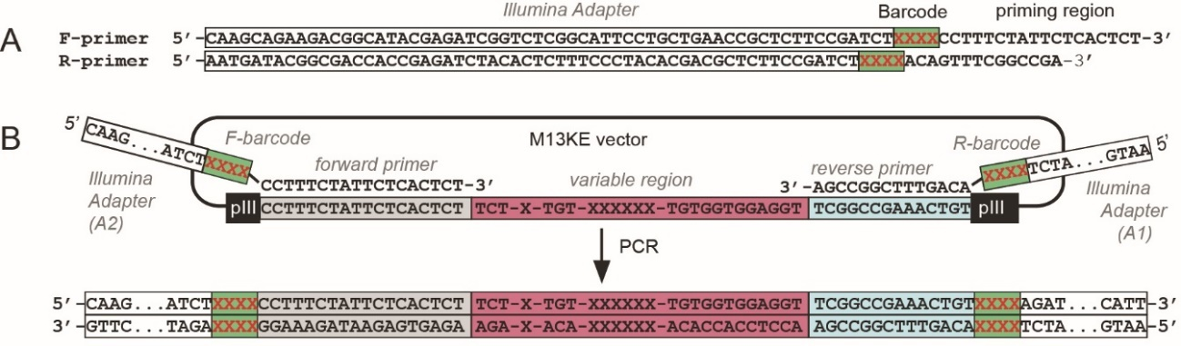
- PCR amplification protocol for Illumina deep sequencing
(A) Primers used for amplifying ligated or naïve oligonucleotide DNA. XXXX denotes 4-nucleotide-long barcodes used to trace multiple samples in an Illumina sequencing experiment. (B) Generation of PCR product. Alignment of forward and reverse primers to 18-bp and 14-bp sequences flanking the variable region at the N-terminus of the pIII gene in M13KE vector, respectively.

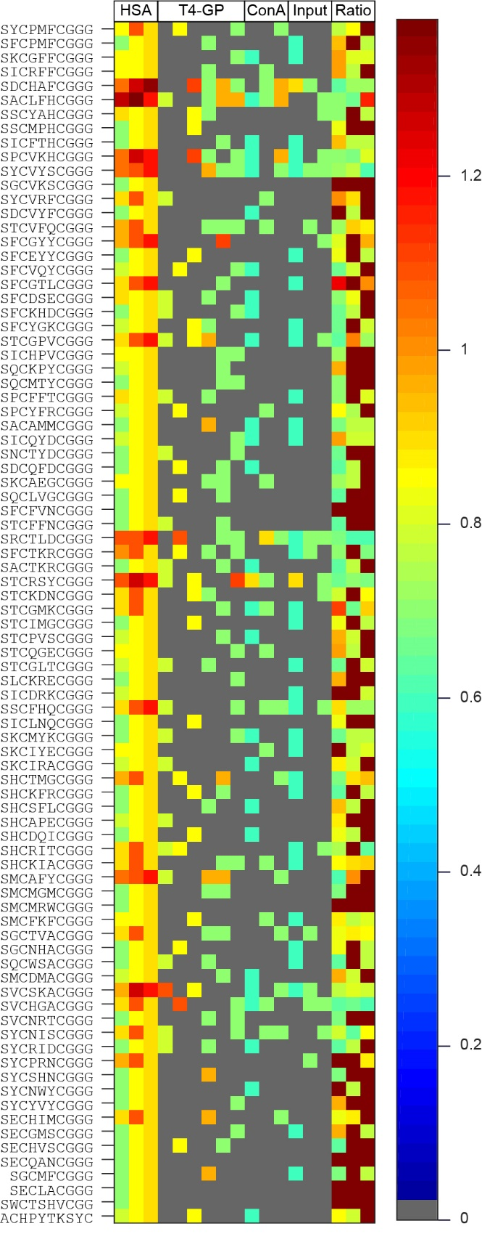
- A heat map is showing of 85 putative hits discovered from the third panning campaign.
The sequences were enriched greater or equal to 4-fold (R>3, p=0.05) when compared to T4-GP and ConA.
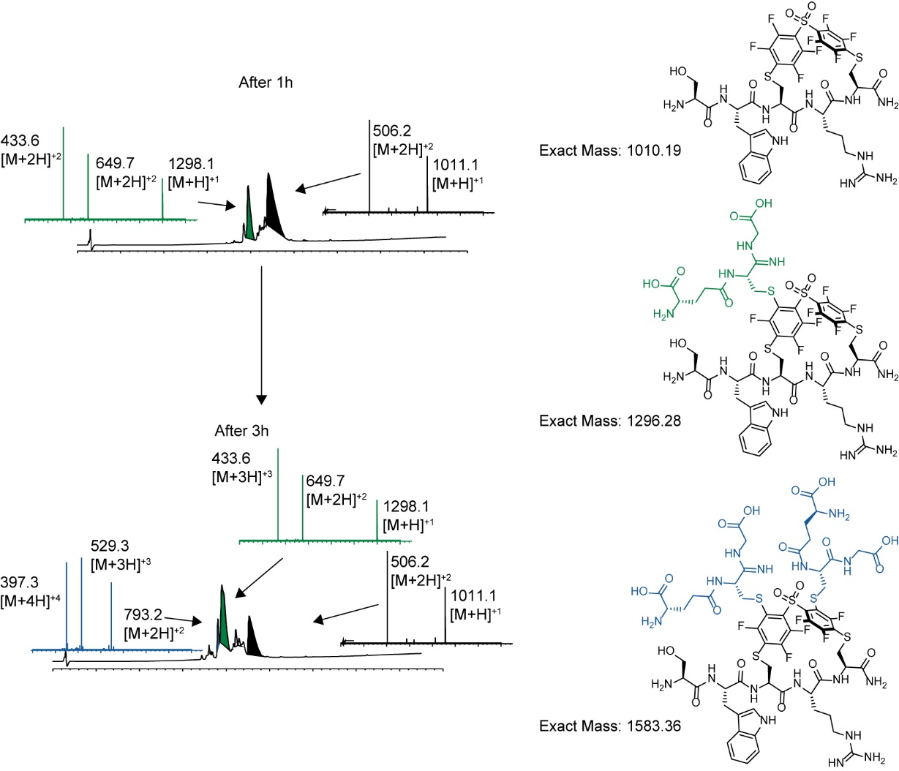
- DFS stapled peptide reacted with GSH over 3 hours
. The DFS-SWCRC peptide was added with one equivalent of GSH in 60% acetonitrile in 50 mM Tris-HCl at pH 8.5. The reaction was monitored by LC–MS.
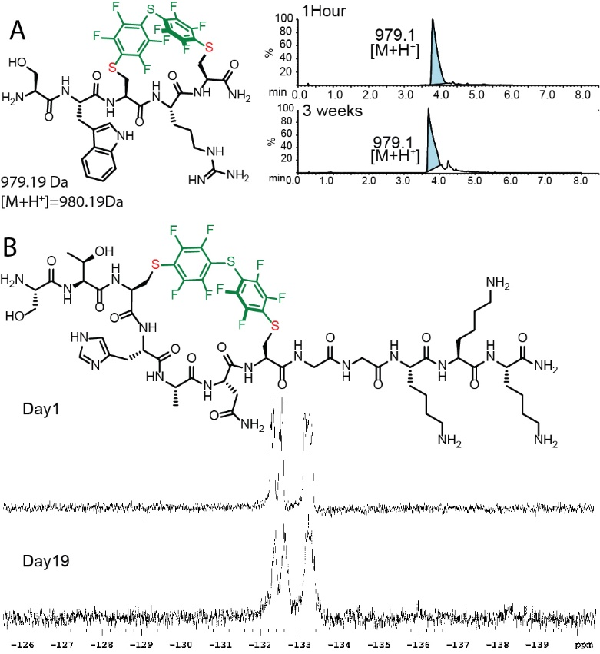
- Stability of the PFS stapled peptides
(A) Results of the PFS-SWCRC mixed with 2-mercaptoethanol and analyzed by LC–MS after 1 hour and 3 weeks. The PFS-SWCRC macrocycle was combined with 1 equivalent of 2-mercaptoethanol in 60% acetonitrile and 50 mM Tris-HCl at pH 8.5. The mixture was monitored by LC–MS. (B) A spectrum of 1 mg of PFS- STCHANCGGKKK mixed with 1 mg of HSA over 19 days in 1×PBS. The mixture was monitored by ¹⁹F NMR in 1×PBS, 10% D₂O
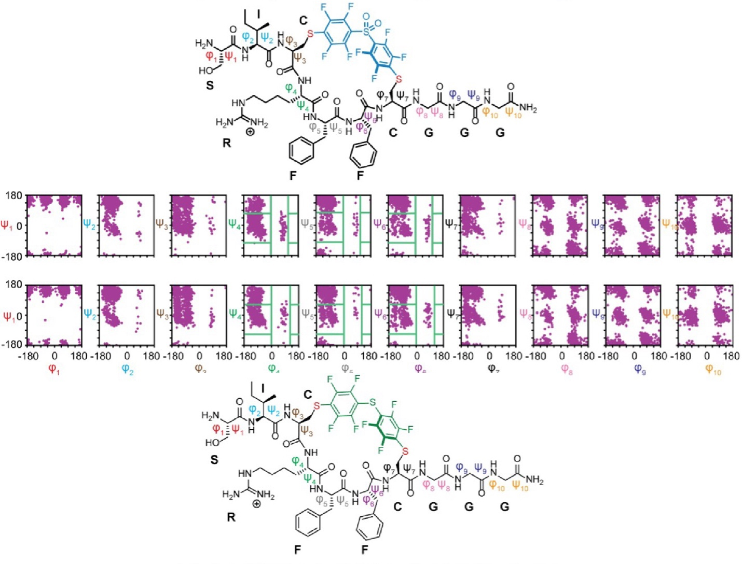
- Ramachandran plot of the cyclic peptide backbone for 5b and 5c
: Green lines indicate the binning boundaries used in the cluster analysis.

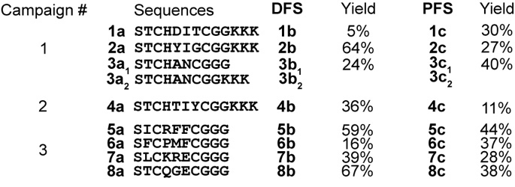
- Summary of the selected peptide sequences nominated from three panning campaigns. The nominated peptides were chemically synthesized and modified with DFS and PFS for validation.
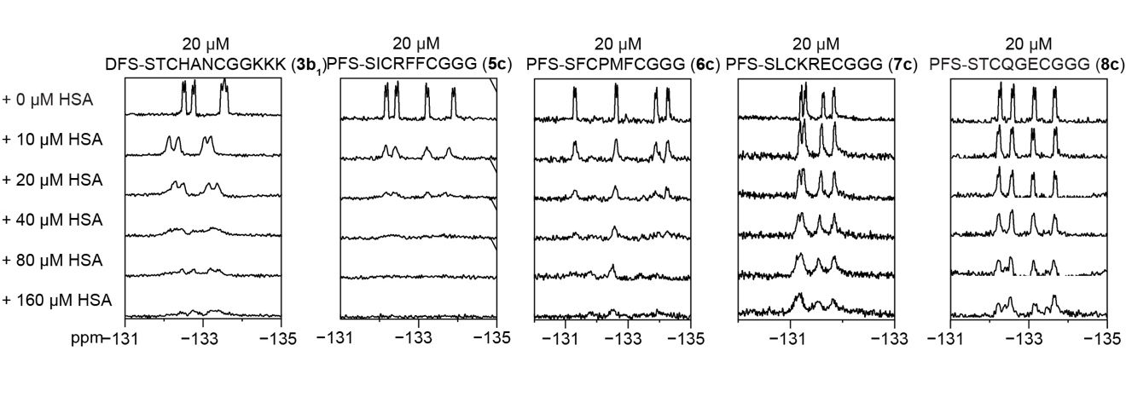
- ¹⁹F NMR binding assay for 3b (PFS-STCHANCGKKK-DFS) 5c (PFS-SICRFFCGGG), 6c (PFS-SFCPMFCGGG), 7c (PFS-SLCKRECGGG), and 8c (PFS-STCQGECGGG) at 20 µM and titrated against various concentrations of HSA.

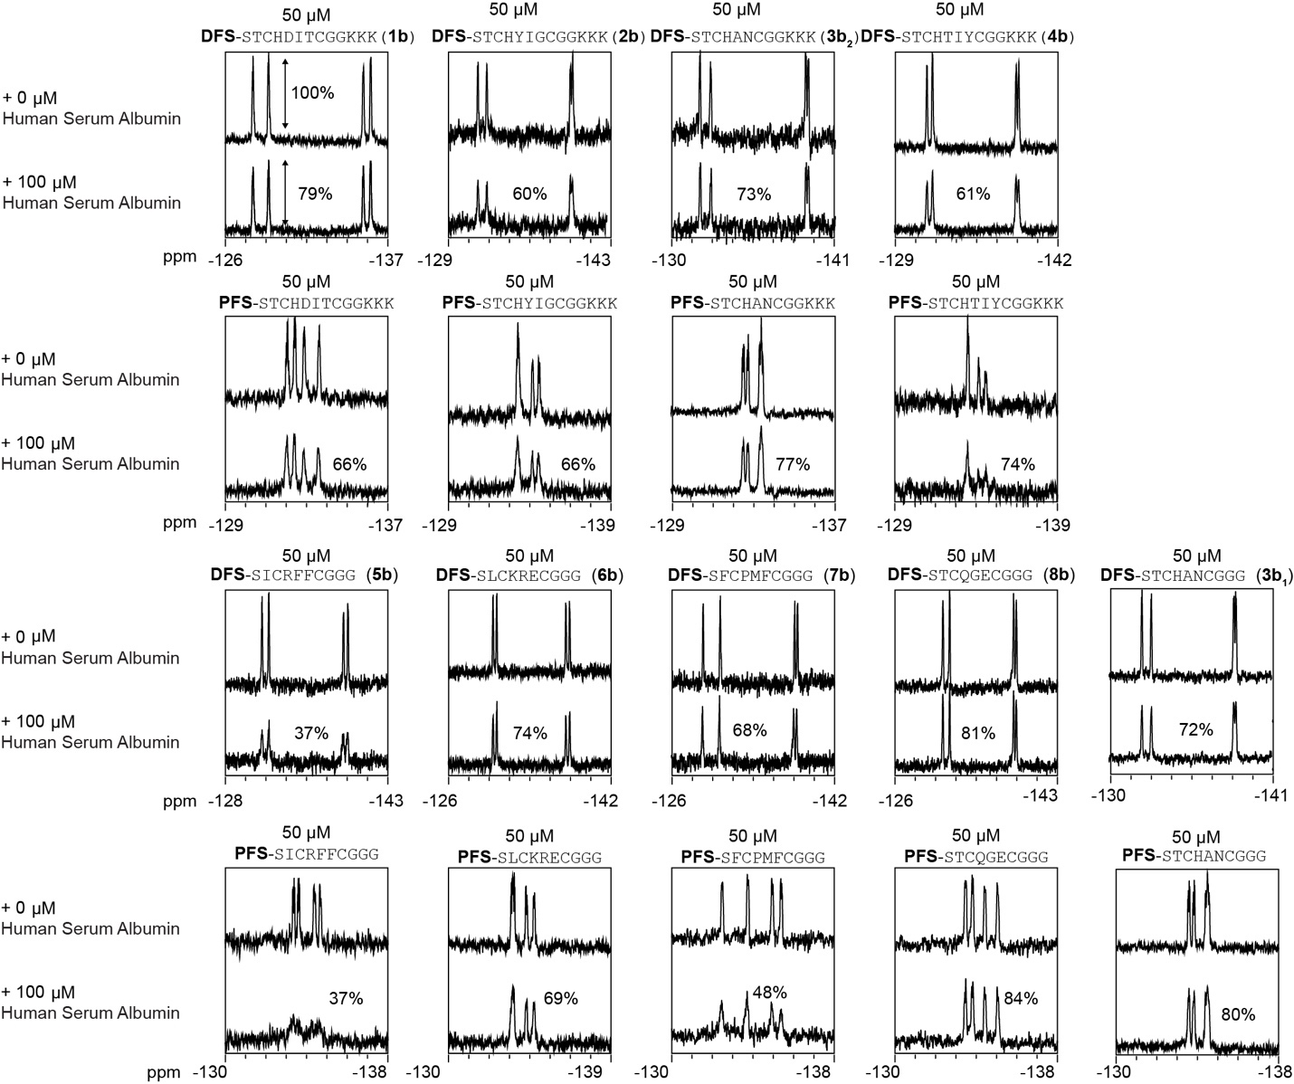

- Summary of the ¹⁹F NMR binding measurement of the HSA
titration spectra of 50 µM of 1b-8b and 1c-8c against 100 µM of HSA. The percentage represents the peak intensity remaining after the addition of HSA.

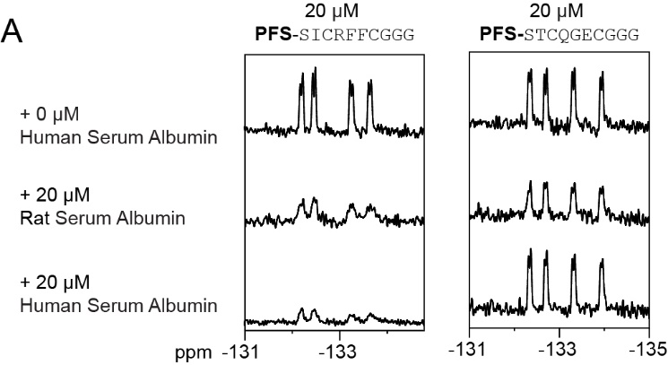
- The ¹⁹F NMR titration spectra of 5c and 8c against rat serum albumin.

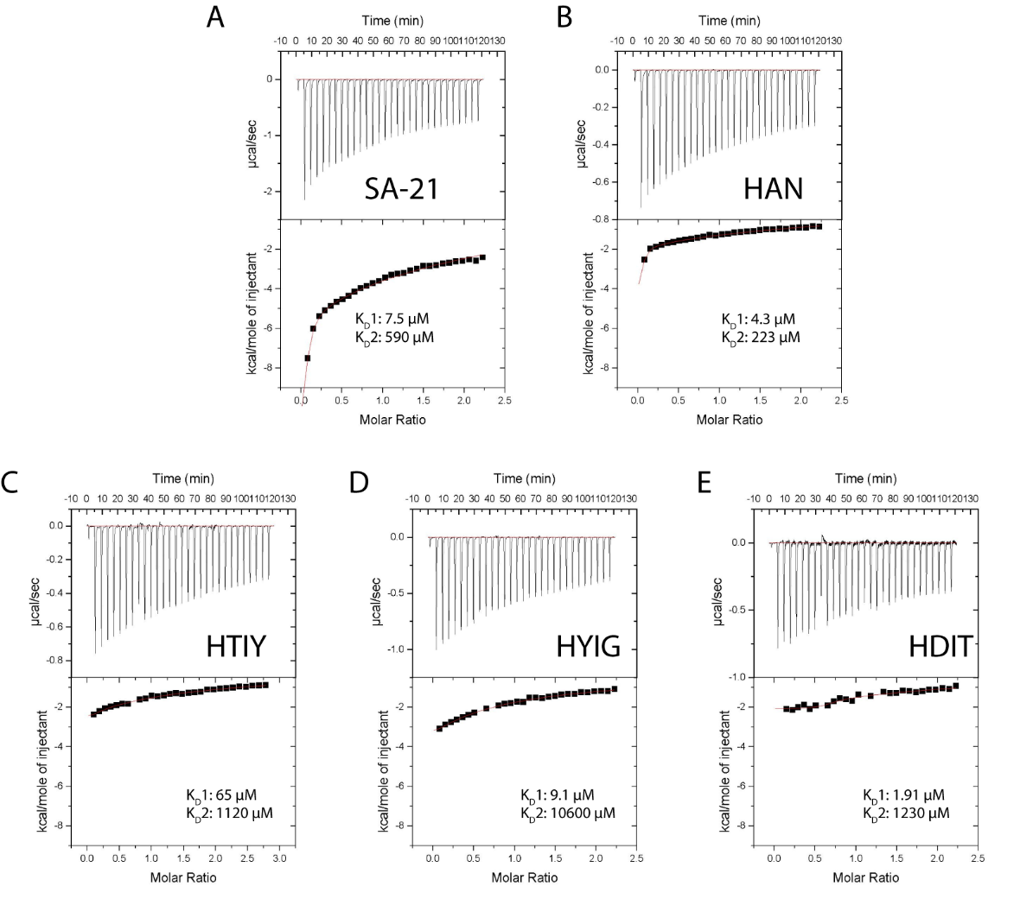
- The first round of equilibrium dissociation constants of the selected peptides on HSA determined by ITC.
The ITC traces and binding isotherms for peptides (A) SA-21 (4 mM), HSA (0.4 mM), (B) DFS-STCHANCGGKKK (4 mM), and HSA (0.4 mM), (C) DFS-STCHTIYCGGKKK (4 mM), HSA (0.4 mM), (D) DFS-STCHYIGCGGKKK (4mM), HSA (0.4 mM) and DFS-STCHDITCGGKKK (4 mM), HSA (0.4 mM) in 1×PBS.

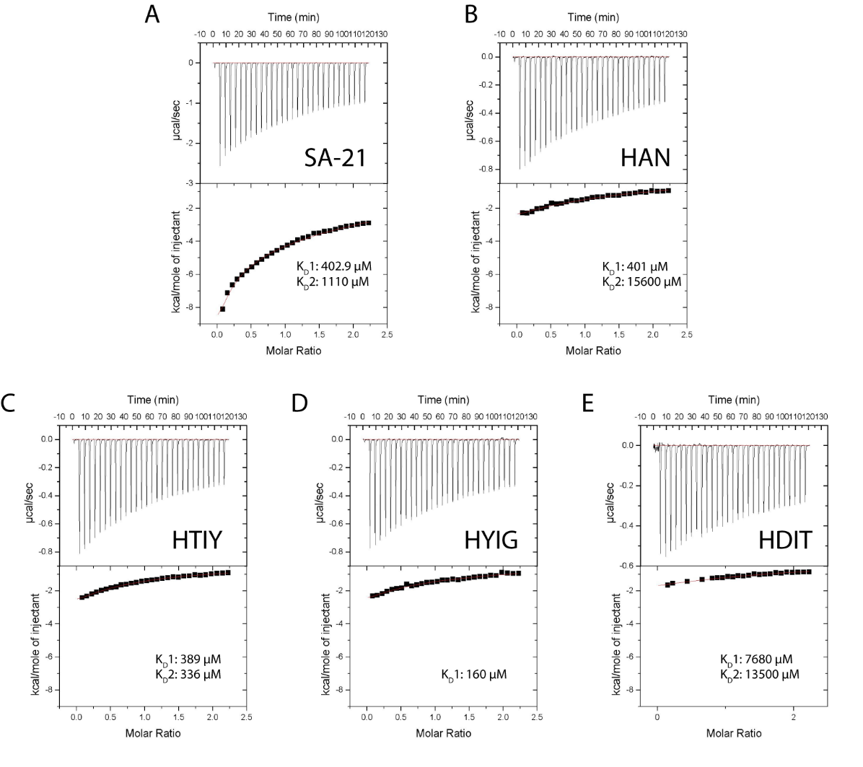
- Second round of equilibrium dissociation constants of the selected peptides on HSA determined by ITC.
The ITC traces and binding isotherms for peptides (A) SA-21 (1 mM), HSA (0.1 mM), (B) DFS-STCHANCGGKKK (1 mM), and HSA (0.1 mM), (C) DFS-STCHTIYCGGKKK (1 mM), HSA (0.1 mM), (D) DFS-STCHYIGCGGKKK (1mM), HSA (0.1 mM) and DFS-STCHDITCGGKKK (1mM), HSA (0.1 mM) in 1×PBS.

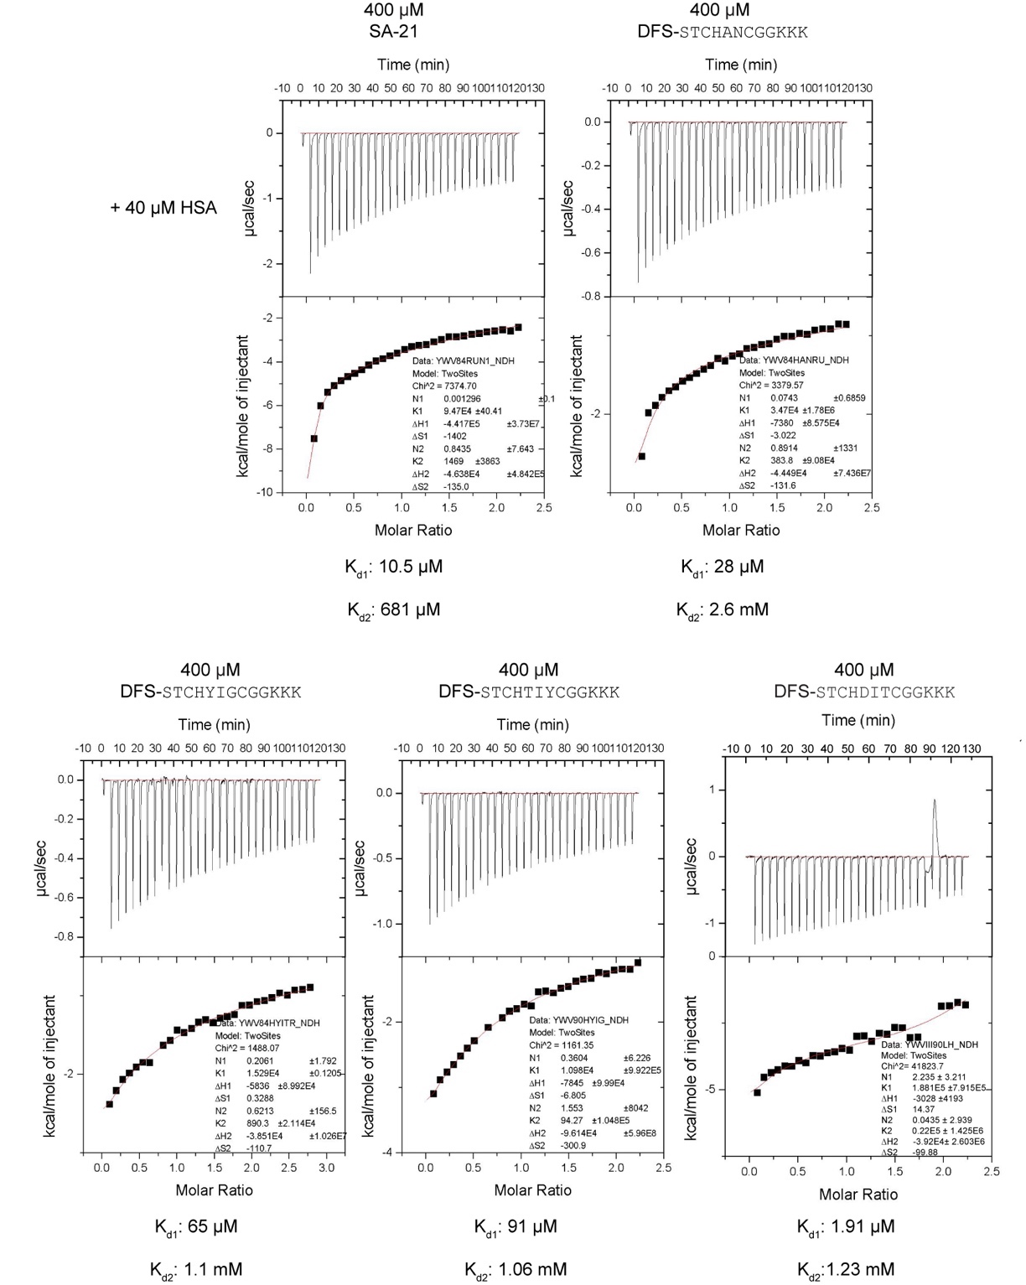
- Summary of ITC binding assay
        - SA-21 and 1b-5b titrated against HSA.

- FP assay for BODIPY labeled 5d titrated against HSA
5d found to have 6 µM binding affinity, 8d (Black) was found to have >82 µM and BODIPY-OH (grey) found to have >320 µM binding affinity.

- FP assay for BODIPY labeled 5d (red) titrated against fatty acid-free HSA.
5d was found to have 4 µM binding affinity, 8d (Black) was found to have >112 µM and BODIPY-OH (grey) was found to have >196 µM binding affinity.
- FP assay for Bodipy labeled RFF-PFS(red) titrated against whole mouse serum
found to have 4 µM binding affinity, QGE-PGS(Black) found to have >100 µM and Bodipy-OH (grey) found to have >80 µM binding affinity.

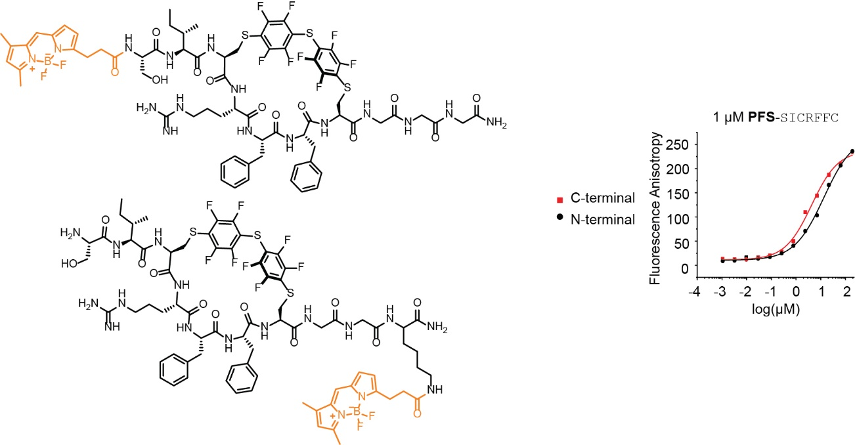
- The FP binding assay of conjugate 5c with BODIPY installed at N-terminus and C-terminus

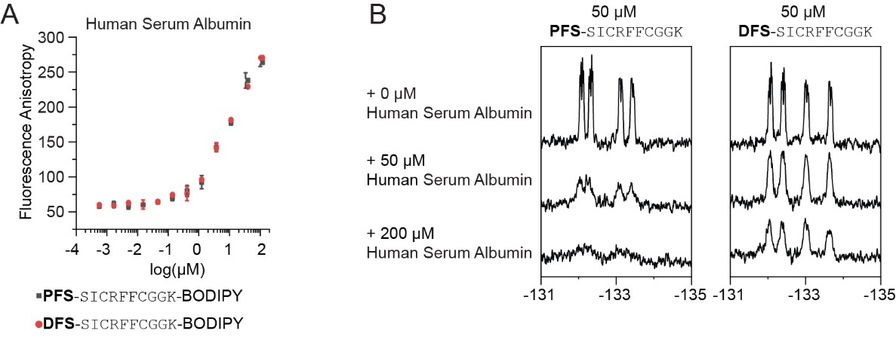
- HSA binding between 5b and 5c
(A) FP binding assay of 5b and 5c. (B) ¹⁹F NMR binding assay of 5b and 5c

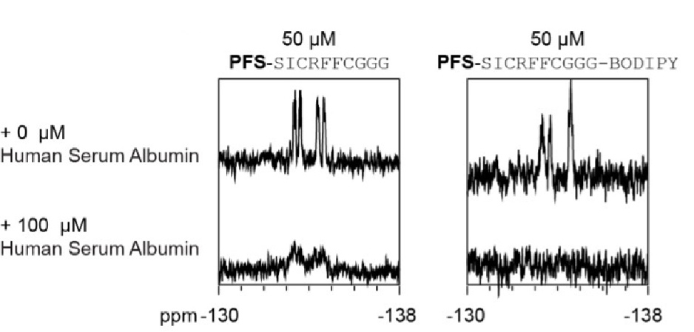
- ¹⁹F NMR comparison of PFS-SICRFFCGGG (5c) and BODIPY labeled 5c.

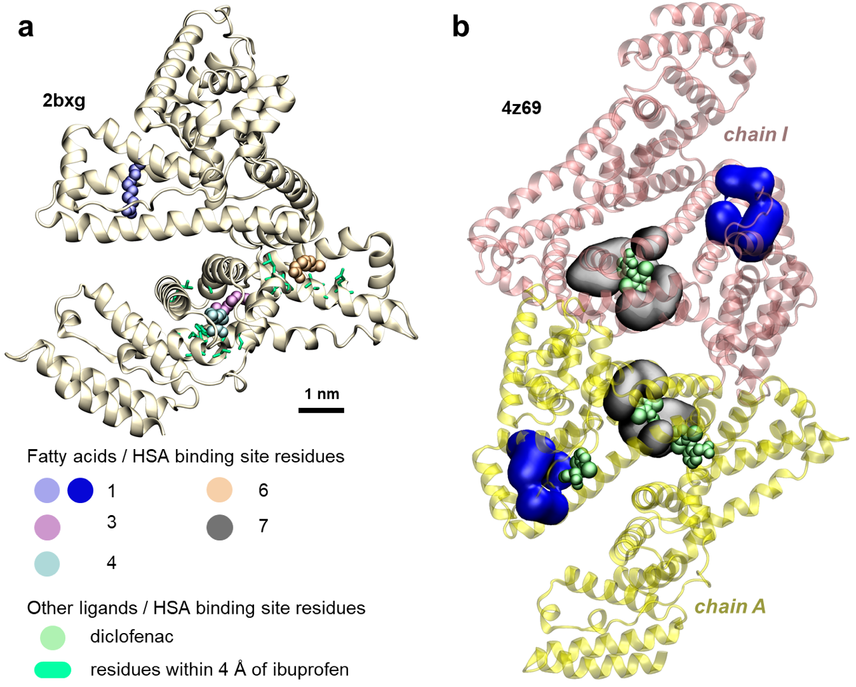
A
B
- HSA binding sites of ibuprofen and diclofenac ligands in crystal structures. a) Structure of HSA in pdb file 2bxg. The atoms in green licorice representation show the HSA residues within 4 Å of the bound ibuprofen molecules, which bind near binding sites 3/4 and 6. Binding site 1, highlighted by the fatty acid shown in blue spheres, is distant from ibuprofen binding sites. b) Structure of two HSA chains and four diclofenac molecules in pdb file 4z69. Grey surfaces show HSA residues forming binding site 7, and blue surfaces show HSA residues forming

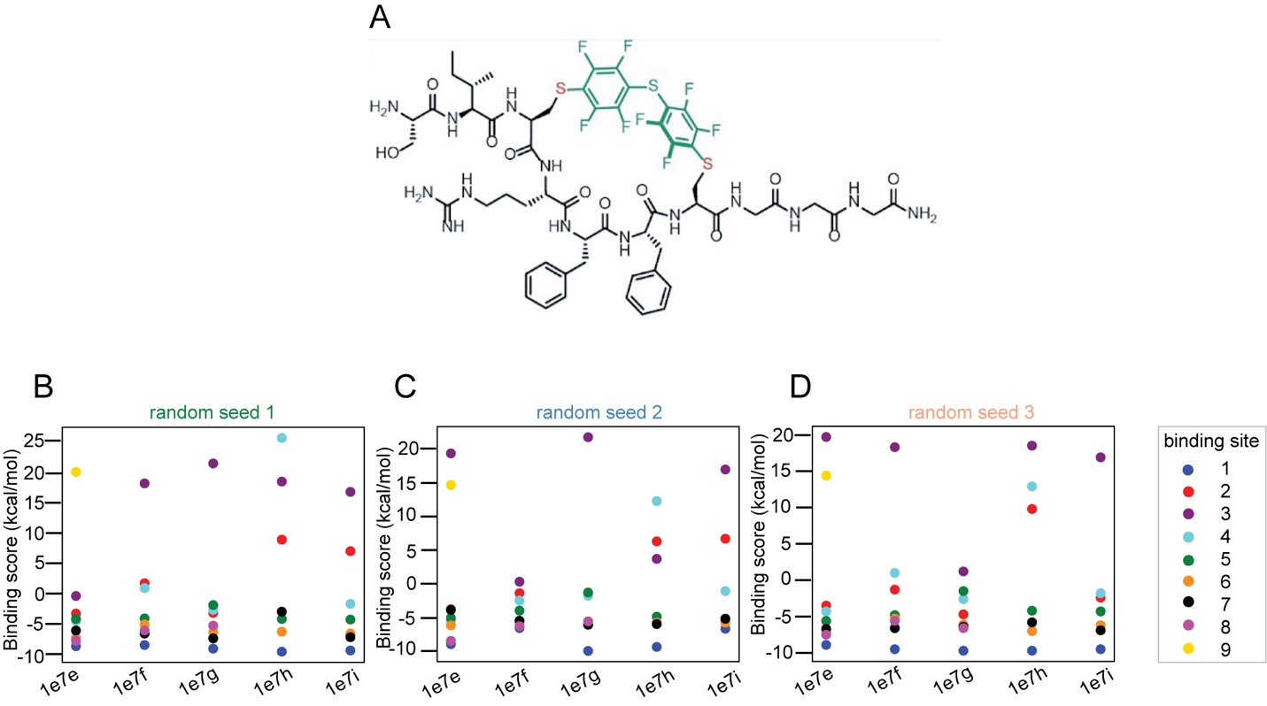
- Binding scores of PFS-SICRFFCGGG macrocycle to HSA binding sites of fatty acids, determined in docking calculations. (A-C) Plots of PFS-SICRFFCGGG-HSA binding scores obtained in docking calculations using three different random seed values. Separate docking calculations were performed for different HSA structures extracted from PDB Databank files with PDB IDs 1e7e, 1e7f, 1e7g, 1e7h, and 1e7i. PFS-SICRFFCGGG macrocycles were docked to previously reported six to nine fatty acid binding sites on HSA surface⁴, each labeled by different color. Some of the HSA fatty acid binding sites and the resulting RFF-HSA binding modes are shown in Figure 6. In each HSA structure, RFF was docked only to the sites occupied by the fatty acids in the pdb file. Therefore, docking was not tested for all the binding sites for every HSA structure, and some scores are missing from the plots.
Table S5: Binding scores of RFF macrocycle to HSA fatty acid binding sites from all docking calculations. In each HSA structure, the RFF was docked only to the sites occupied by fatty acids in the pdb file. Therefore, docking was not tested for all the binding site for every structure, and some scores are thus missing from the table.

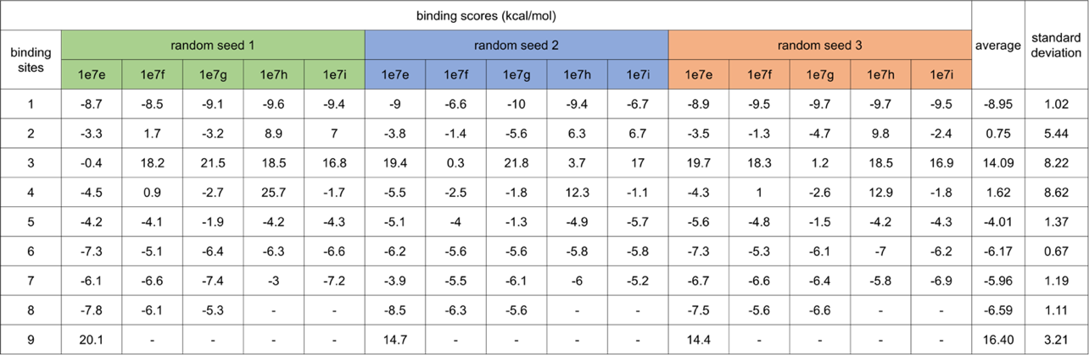

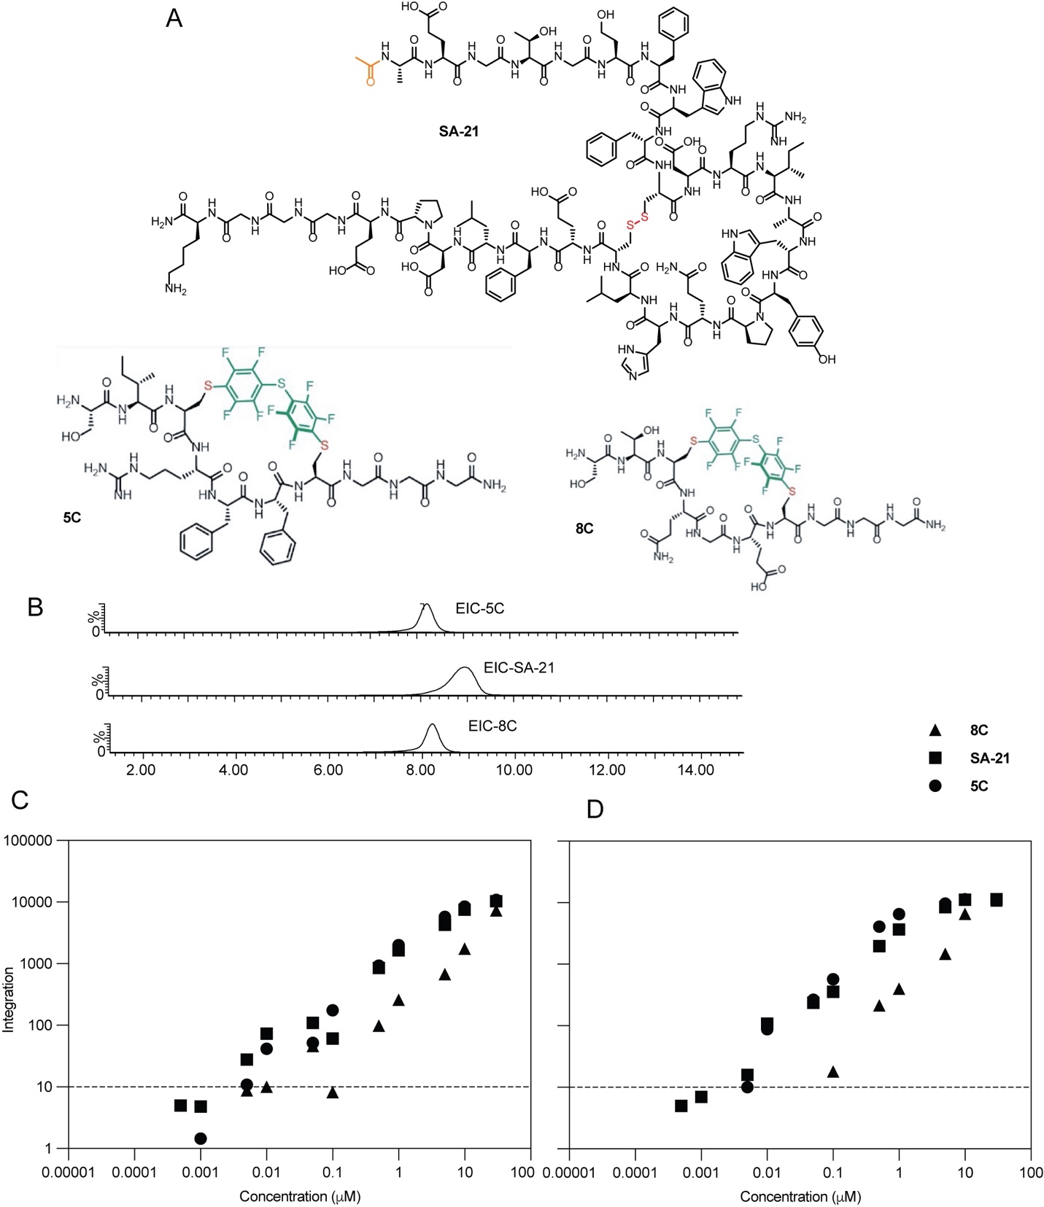
- Detection of macrocycles using mass spectrometry. (A) Total ion chromatograms (TIC) of macrocycles 8c, SA21, and 5c. (B) Standard curve for macrocycles in PBS (C) Standard curve for macrocycles in mice serum

MATLAB script for DE analysis

clear;

Dir='';
File = 'YW_unfiltered_20170829_ed.txt';

SET⁶ = 1:3; % HSA
SET⁷ = 4:9; % T4-GP1
SET⁶ = 10:12; % ConA
SET⁶ = 13:15; % Input

TEST_SET = 1;
TARGET = 'HSA';
CONTROL_SETS = [2 3 4];

REREAD=1; % change to zero if you don’t want to wait for -re-reading of data

close all

OUTPUT='normalized'; % other output_type: 'normalized' 'normalized+1' 'raw'

if REREAD
disp('reading...');
[Nuc, AA, Fr] = readMulticolumn('Dir', Dir, 'File', File, ...
'column', 1:max(cell2mat(SET)),...
'skip', 2, 'output', OUTPUT);
end
%%% To plot Figure S1D chage the variables above to the variables below
% TEST_SET = 9;
% CONTROL_SETS = [10 11];

HITS2DISPLAY = 50; % maximum numer of hits to display
SHOWaminoACIDS = [18 19 20 21 22 23 24 25 26 27];

CLUSTERbyH = 1; % 1 if you want your hits to be clustered by Hamming dist.
PLOT_VOLCANO = 1; % set to 1 if you want to see the actual volcano plot
Sort_CXC_file = 1; % set to 1 if you want to sort the reslt into different CXC files
AA_AXA_Analysis = 1; % set to 1 if you want to see the actual AA_AXA_Analysis

%%%%%%% volcano plot parameters here %%%%%%%%%%%%%%%%%%%%%%%%%%%%%%%%%%%%%%
p_cutoff = 0.05; % p-value cutoff
R_cutoff = 3; % ratio cutoff
MaxX=6; % maximum on the X-scale (if plotting volcano)
vert_cutoff = 0.00001; % maximum on the Y-scale (if plotting volcano)
%%%%%%%%%%%%%%%%%%%%%%%%%%%%%%%%%%%%%%%%%%%%%%%%%%%%%%%%%%%%%%%%%%%%%%%%%%%

%%%%%%%%%%%%%%%%%%%%%% do not change things beyond this point %%%%%%%%%%%%%
%%%%%%%%%%%%%%%%%%%%%% unless you know what you are doing %%%%%%%%%%%%%%%%%

if CLUSTERbyH == 1
disp('Culster on')
else
disp('Culster off')
end

if PLOT_VOLCANO == 1
disp('Volcano Plot on')
else
disp('Volcano plot off')
end

if Sort_CXC_file == 1
disp('Sort CXC on')
else
disp('Sort CXC off')
end

if AA_AXA_Analysis == 1
disp('AA AXA Analysis on')
else
disp('AA AXA Analysis off')
end

SAVEto = [File(1:end-4) TARGET '_'...
OUTPUT...
'CONTR_' num2str(CONTROL_SETS) '_'...
'_P' num2str(p_cutoff)...
'_R' num2str(R_cutoff)...
'.CSV']; % keep blank if don't want to save

% select only the aminoacids you want to see
cAA = char(AA);
sAA=cellstr(cAA(:,SHOWaminoACIDS));
SQUARE=zeros(size(Fr,1),1);

i=0;
disp('calculating p and R...');
IX=zeros(size(Fr,1),numel(CONTROL_SETS));

disp('calculating p and R...');
i=0;
for j=CONTROL_SETS
i=i+1;
ratio(:,i) = mean(Fr(:,SET{TEST_SET}), 2) ./ mean(Fr(:,SET{j}), 2);

[~,confi(:,i)] = ttest2(Fr(:,SET{TEST_SET})',Fr(:,SET{j})',....
p_cutoff,'both','unequal');

IX(:,i) = (confi(:,i) <= p_cutoff) & (ratio(:,i) >= R_cutoff);

SQUARE = SQUARE + ratio(:,i).^2;

if PLOT_VOLCANO
subplot(1,numel(CONTROL_SETS),i);

plot(log2 (ratio(:,i)),...
-log10(confi(:,i)),'d',...
'MarkerSize',4,...
'MarkerFaceColor',0.5*[1 1 1],...
'MarkerEdgeColor',0.5*[1 1 1]); hold on;

plot( log2 (ratio(find(IX(:,i)),i)),...
-log10(confi(find(IX(:,i)),i)),'d',...
'MarkerSize',4,...
'MarkerFaceColor','r',...
'MarkerEdgeColor','r'); hold on;

line([log2(R_cutoff) MaxX],[-log10(p_cutoff) -log10(p_cutoff)]);
line([log2(R_cutoff) log2(R_cutoff)],...
[-log10(p_cutoff) -log10(vert_cutoff)]);

xlim([-MaxX MaxX]);
end
end

R2 = sqrt(SQUARE);

IXall = find( (sum(IX,2)==size(IX,2)) ); % hits that satisfy all criteria

% you can loosen the stringency if necessary
% IXall = find( (sum(IX,2)>=2) ); %hits that satisfy two or more criteria

hits = char(sAA(IXall,:));
Rhits = ratio(IXall,:);
R2hits = R2(IXall);

%%%%%%%%%%%% this is part where hits are clustered by H-dist %%%%%%%%%%%%%%

if CLUSTERbyH
disp('clustering...');
if numel(hits)>3
figure(2)
Y = pdist(hits,'hamming');
Z = linkage(Y,'complete');
[H,T,perm] = dendrogram(Z,0,'colorthreshold',20);
set(H,'LineWidth',2)

for i =1:size(hits,1)
label{i} = i;
end
set(gca,'XTick', 1:1:size(hits,1), 'XTickLabel',label);

hits = hits(perm,:);
Rhits = Rhits(perm,:);
R2hits = R2(perm);
IXall = IXall(perm);
end
end

%%%%%%%%%%%%%%%%%%%display all results as heat map%%%%%%%%%%%%%%%%%%%%%%%%%

figure(3)

if size(IXall,1)>=HITS2DISPLAY
N=HITS2DISPLAY; % display only the first or defined number of hits
else
N=size(IXall,1); %display all
end

FrPPM = round(10^6*Fr); % convert normalized fraction frequency to PPM

imagesc( log10([FrPPM(IXall(1:N),:) ratio(IXall(1:N),:) ]+1) );

set(gca,'YTick', 1:1:N, 'YTickLabel',cellstr(hits(1:N,:)),'TickDir','out',...
'FontName','Courier New','FontSize',14);
set(gca,'XTick', 1:1:size(Fr,2)+4, 'TickDir','out');
jet1=jet;
jet1(1,:)=[0.4 0.4 0.4];
colormap(jet1);
colorbar;

% generate a plain text table for saving or copy from command line
S = char(32*ones(size(hits,1),2));
COM = char(','*ones(size(hits,1),1));

L = [ S(:,1) char(124*ones(size(hits,1),1)) S(:,1)];
if strcmp(OUTPUT,'raw')
F = Fr(IXall,:); % display frequency raw
else
F = FrPPM(IXall,:); % display frequency in ppm
end

toDisp = [hits S ];
toSave = [hits COM ];

for i=1:numel(SET)
for j=1:numel(SET{i})
toDisp = [toDisp num2str(F(:,SET{i}(j))) S];
toSave = [toSave num2str(F(:,SET{i}(j))) COM];
end
toDisp = [toDisp L];
end
toDisp = [toDisp S num2str(round(Rhits)) L];
for i=1:size(Rhits,2)
toSave = [toSave num2str(round(Rhits(:,i))) COM ];
end

disp(toSave);
disp(toDisp);

if ~isempty(SAVEto)

fs = fopen(fullfile(Dir,SAVEto),'w');
RET = char(10*ones(size(toSave,1),1));
fprintf( fs, '%s\r\n', [toSave(:,1:end-1) RET]');
fclose all;
disp('file saved');
end

%%%%%%%%%%%%%%%%%%%%%%%%%%%%%%%%C3C Sorting%%%%%%%%%%%%%%%%%%%%%%%%%%%%%%%%

if Sort_CXC_file

disp('sorting...') ;

%Sorting conditions
C2X = ['S' '\w' 'C' '\w' '\w' 'C' '\w' '\w' '\w'] ;
C3X = ['S' '\w' 'C' '\w' '\w' '\w' 'C' '\w' '\w' '\w'] ;
C4X = ['S' '\w' 'C' '\w' '\w' '\w' '\w' 'C' '\w' '\w'] ;
C5X = ['S' '\w' 'C' '\w' '\w' '\w' '\w' '\w' 'C' '\w'] ;
C7X = ['A' 'C' '\w' '\w' '\w' '\w' '\w' '\w' '\w' 'C'] ;
% Creat sorting array
C2XHits = [];
C3XHits = [];
C4XHits = [];
C5XHits = [];
C7XHits = [];
indexs=[]; %for data puposes not really useful for now
j=0;

% sort C2C
disp('Sorting C2C...')
C2s = regexp(cellstr(hits),C2X);
for i=1:numel(C2s)
if ~isempty(C2s{i})
j=j+1;
C2XHits = [C2XHits; hits(i,:)];
indexs(j) = i;
end
end
%C2Cfound(s) = numel(indexs);

%Sort C3C
disp('Sorting C3C...')
indexs=[];
j=0;
C3s = regexp(cellstr(hits),C3X);
for i=1:numel(C3s)
if ~isempty(C3s{i})
j=j+1;
C3XHits = [C3XHits; hits(i,:)];
indexs(j) = i;
end
end
%C3Cfound(s) = numel(indexs);

%Sort C4C
disp('Sorting C4C...')
indexs=[];
j=0;
C4s = regexp(cellstr(hits),C4X);
for i=1:numel(C4s)
if ~isempty(C4s{i})
j=j+1;
C4XHits = [C4XHits; hits(i,:)];
indexs(j) = i;
end
end
%C4Cfound(s) = numel(indexs);

%Sort C5C
disp('Sorting C5C...')
indexs=[];
j=0;
C5s = regexp(cellstr(hits),C5X);
for i=1:numel(C5s)
if ~isempty(C5s{i})
j=j+1;
C5XHits = [C5XHits; hits(i,:)];
indexs(j) = i;
end
end
%C5Cfound(s) = numel(indexs);

% Sort C7C
disp('Sorting C7C...')
indexs=[];
j=0;
C7s = regexp(cellstr(hits),C7X);
for i=1:numel(C7s)
if ~isempty(C7s{i})
j=j+1;
C7XHits = [C7XHits; hits(i,:)];
indexs(j) = i;
end
end
%C7Cfound(s) = numel(indexs);

end
if ~isempty(C2XHits)
C2 = fopen(fullfile(Dir,['C2C',SAVEto]),'w');
RET = char(10*ones(size(C2XHits,1),1));
fprintf(C2, '%s\r\n',[C2XHits(:,1:end-1) RET]');
fclose all;
disp('C2C saved');
end

if ~isempty(C3XHits)
C3 = fopen(fullfile(Dir,['C3C',SAVEto]),'w');
RET = char(10*ones(size(C3XHits,1),1));
fprintf(C2, '%s\r\n',[C3XHits(:,1:end-1) RET]');
fclose all;
disp('C3C saved');
end

if ~isempty(C4XHits)
C4 = fopen(fullfile(Dir,['C4C',SAVEto]),'w');
RET = char(10*ones(size(C4XHits,1),1));
fprintf(C2, '%s\r\n',[C4XHits(:,1:end-1) RET]');
fclose all;
disp('C4C saved');
end

if ~isempty(C5XHits)
C5 = fopen(fullfile(Dir,['C5C',SAVEto]),'w');
RET = char(10*ones(size(C5XHits,1),1));
fprintf(C2, '%s\r\n',[C5XHits(:,1:end-1) RET]');
fclose all;
disp('C5C saved');
end

if ~isempty(C7XHits)
C7 = fopen(fullfile(Dir,['C7C',SAVEto]),'w');
RET = char(10*ones(size(C7XHits,1),1));
fprintf(C2, '%s\r\n',[C7XHits(:,1:end-1) RET]');
fclose all;
disp('C7C saved');

end

%%%%%%%%%%%%%%%%AA & AxA analysis%%%%%%%%%%%%%%%%%%%%%%%%%%%%%%%%%%%%%%%%%%

if AA_AXA_Analysis
disp('Start AA AXA Analysis...')
figure(100);
AAA = 'ADEFHIKLMNPQRSTVWY';
Y = [];

for i=1:numel(AAA)
Y(i) = numel(find(hits==AAA(i)));
xlabel{i} = AAA(i);
end

plot(1:numel(AAA), Y, 'ok');
set(gca, 'xTick', 1:numel(AAA), 'xTickLabel', xlabel, 'TickDir','out');

%%

Nfound = [];
NfoundS = [];
toSaveIX = [];
toSaveIXS = [];

M = 9;

fs = fopen(fullfile(Dir,['AA' SAVEto]),'w');
fsS = fopen(fullfile(Dir,['AxA' SAVEto]),'w');
fclose all;

fs = fopen(fullfile(Dir,['AA' SAVEto]),'a+');
fsS = fopen(fullfile(Dir,['AxA' SAVEto]),'a+');

for ii = 1:numel(AAA)
%disp(num2str(ii));
for jj= 1:numel(AAA)

phrase = [ AAA(ii) AAA(jj) ] ;
phraseS = [ AAA(ii) '\w' AAA(jj) ] ;

phraseHits = [];
spacedHits = [];
index=[];
j=0;

IX = regexp(cellstr(hits),phrase);
for i=1:numel(IX)
if ~isempty(IX{i})
%check whether his is S**** or A****; if it is, discard
if (phrase(1) =='S' || phrase(1) =='A')
if (numel(IX{i})==1 && IX{i}==1)
continue
end
end

j=j+1;
phraseHits = [phraseHits; hits(i,:)];
index(j) = i;

S1 = char (32*ones(1, M-IX{i}(1)));
S2 = char (32*ones(1, IX{i}(1) ));
spacedHits = [spacedHits; S1 hits(i,:) S2];
end
end
Nfound(ii,jj) = numel(index);

% lets save this with offsets
RET = char(10*ones(size(index,2),1));
fprintf( fs, '%s\r\n', [spacedHits toSave(index,:) RET]');

phraseHits = [];
index=[];
spacedHits = [];
j=0;
clear IX

IX = regexp(cellstr(hits),phraseS);
for i=1:numel(IX)
if ~isempty(IX{i})
%check whether his is S**** or A****; if it is, discard
if (phraseS(1) =='S' || phraseS(1) =='A')
if (numel(IX{i})==1 && IX{i}==1)
continue
end
end

j=j+1;
phraseHits = [phraseHits; hits(i,:)];
index(j) = i;

S1 = char (32*ones(1, M-IX{i}(1)));
S2 = char (32*ones(1, IX{i}(1) ));
spacedHits = [spacedHits; S1 hits(i,:) S2];
end
end
NfoundS(ii,jj) = numel(index);
toSaveIXS = [toSaveIXS index];

% lets save this with offsets
RET = char(10*ones(size(index,2),1));
fprintf( fsS, '%s\r\n', [spacedHits toSave(index,:) RET]');

end
end

figure(200);
subplot(1,2,1);
imagesc(Nfound); colorbar;
set(gca, 'xTick', 1:numel(AAA), 'xTickLabel', xlabel, 'TickDir','out',...
'yTick', 1:numel(AAA), 'yTickLabel', xlabel);

subplot(1,2,2);
imagesc(NfoundS); colorbar;
set(gca, 'xTick', 1:numel(AAA), 'xTickLabel', xlabel, 'TickDir','out',...
'yTick', 1:numel(AAA), 'yTickLabel', xlabel);

fclose all;
fs = fopen(fullfile(Dir,['AA' SAVEto]),'w');
fsS = fopen(fullfile(Dir,['AxA' SAVEto]),'w');
RET = char(10*ones(size(toSaveIX,2),1));
fprintf( fs, '%s\r\n', [toSave(toSaveIX,:) RET]');
disp('AA Saved')

RET = char(10*ones(size(toSaveIXS,2),1));
fprintf( fsS, '%s\r\n', [toSave(toSaveIXS,:) RET]');
disp('AxA Saved')
end

Summary of synthesis
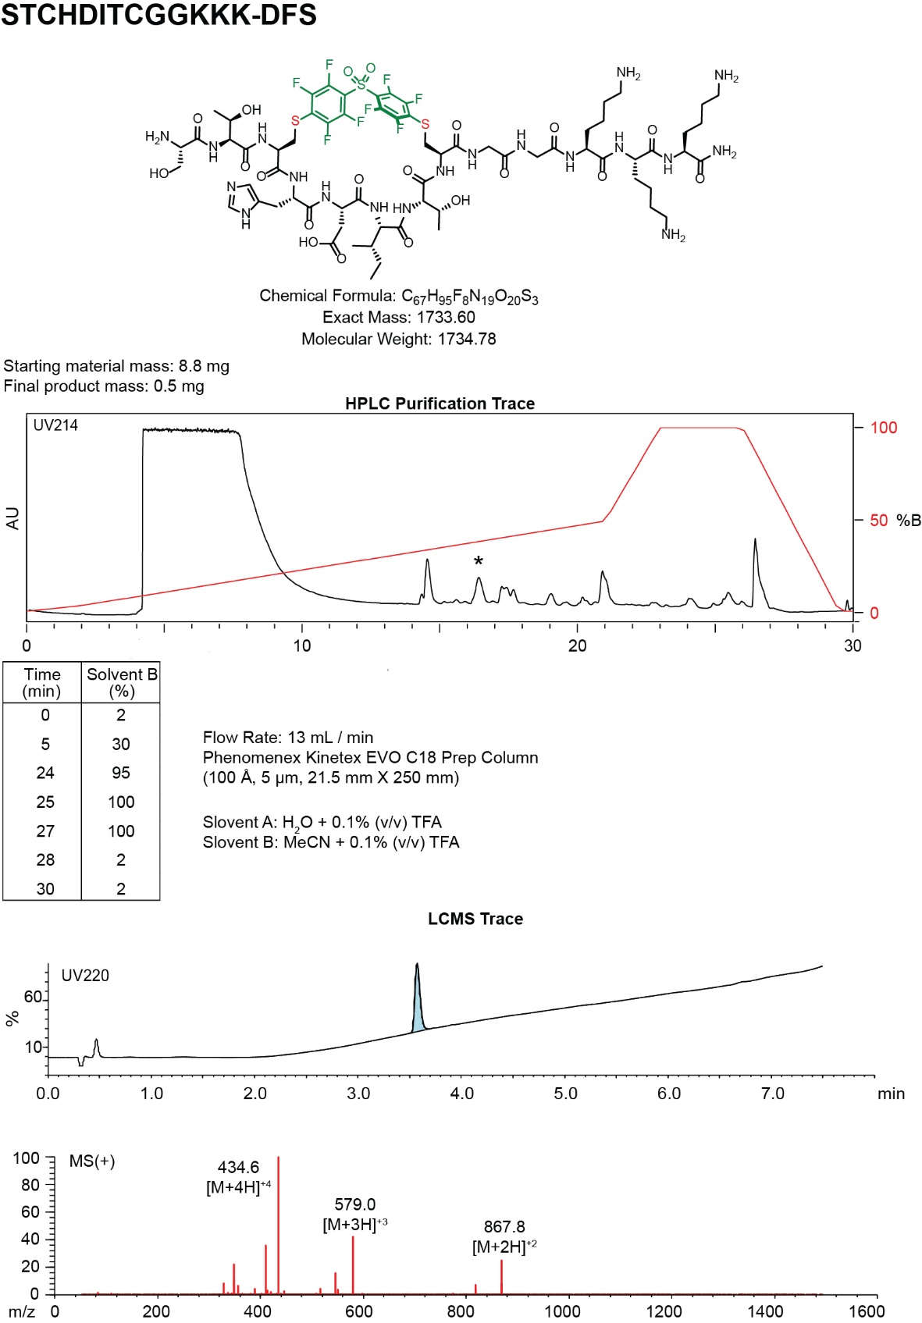
- Synthesis summary of 1b
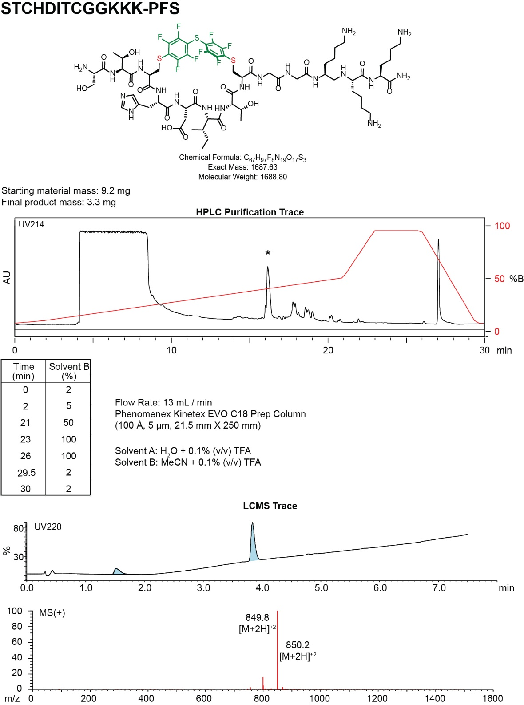
- Synthesis summary of 1c.

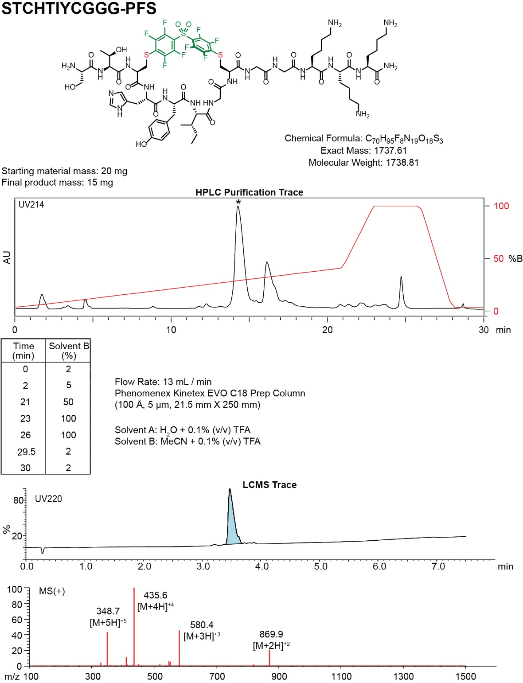
- Synthesis summary of 2b.

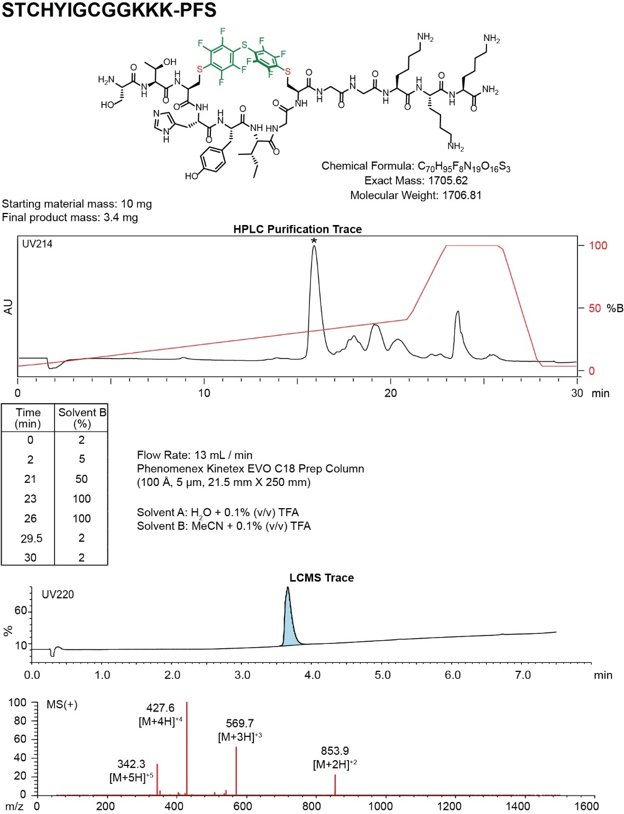
- Synthesis summary of 2c.

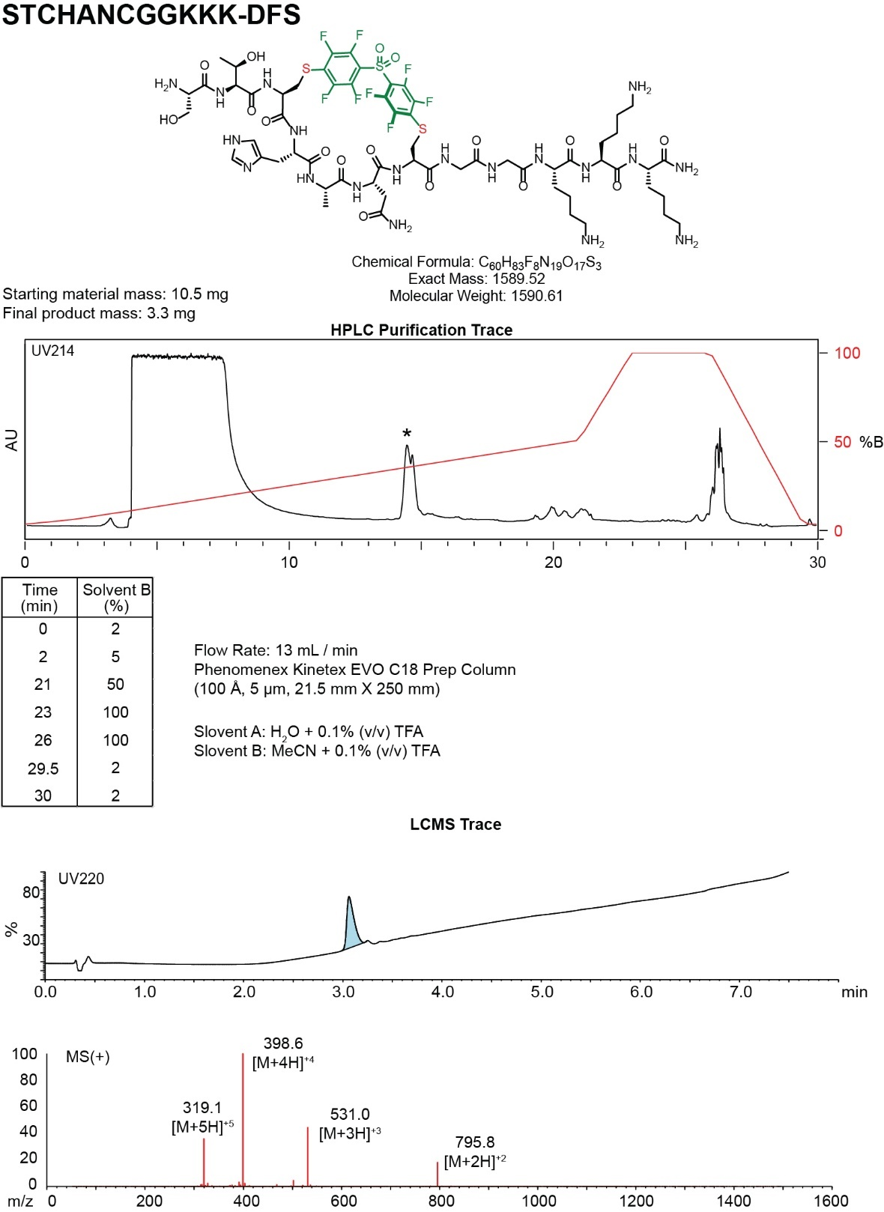
- Synthesis summary of 3b₁.
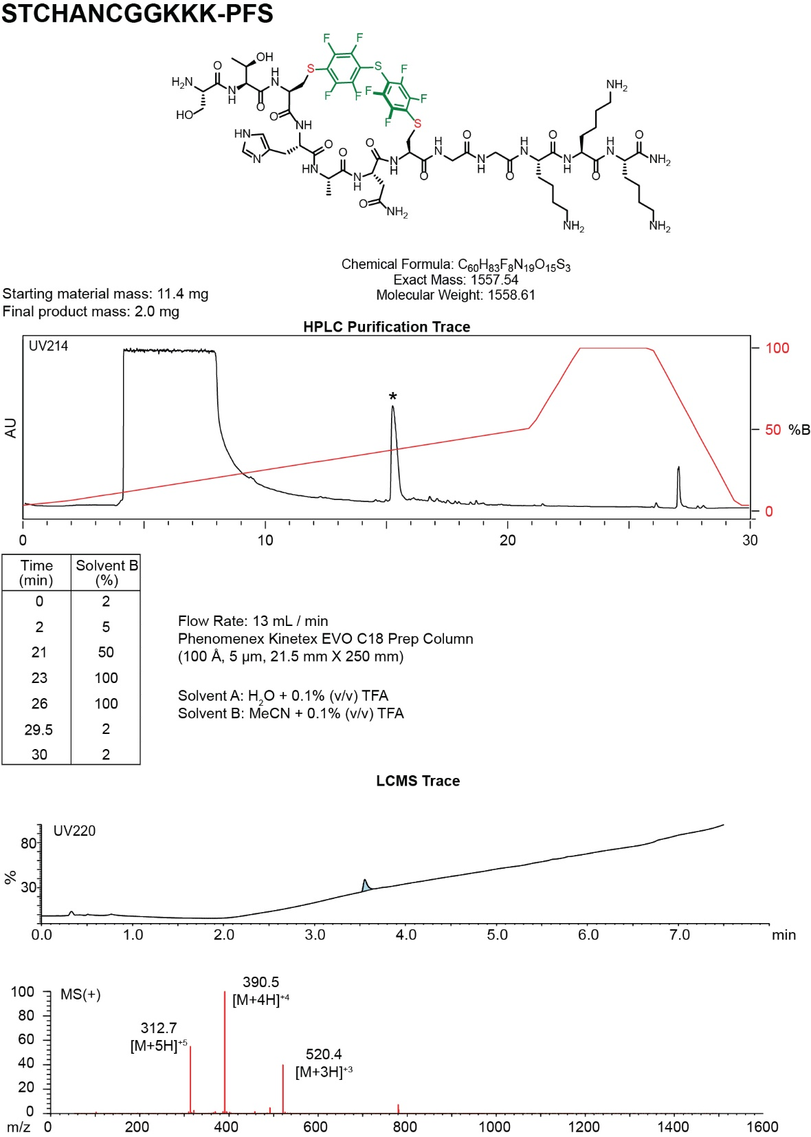
- Synthesis summary of 3c₁.

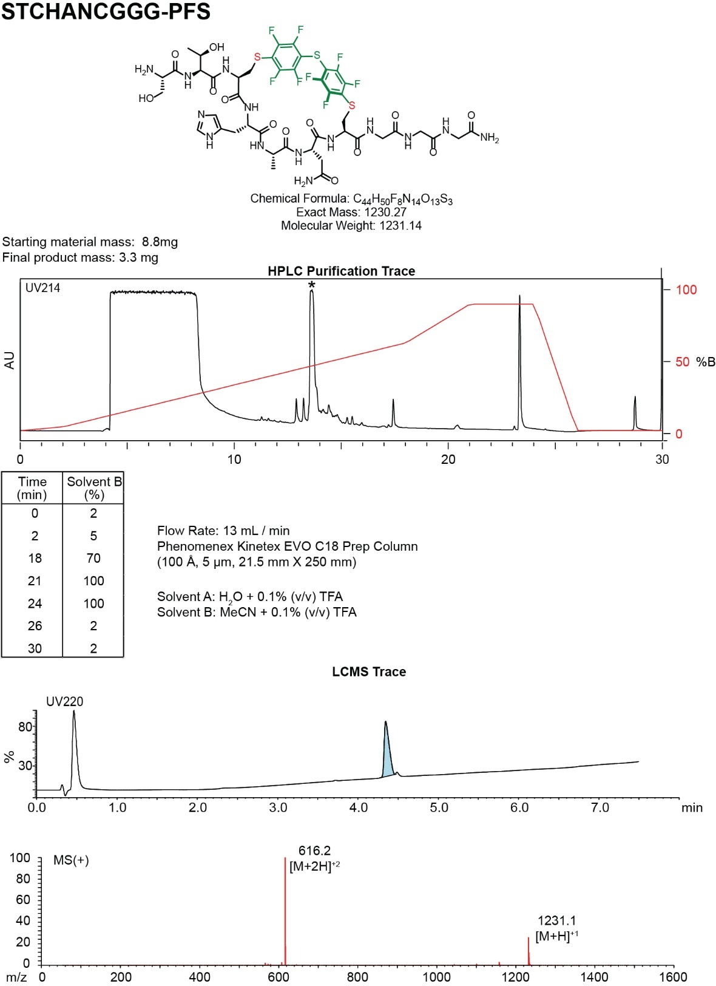
- Synthesis summary of 3c₂.

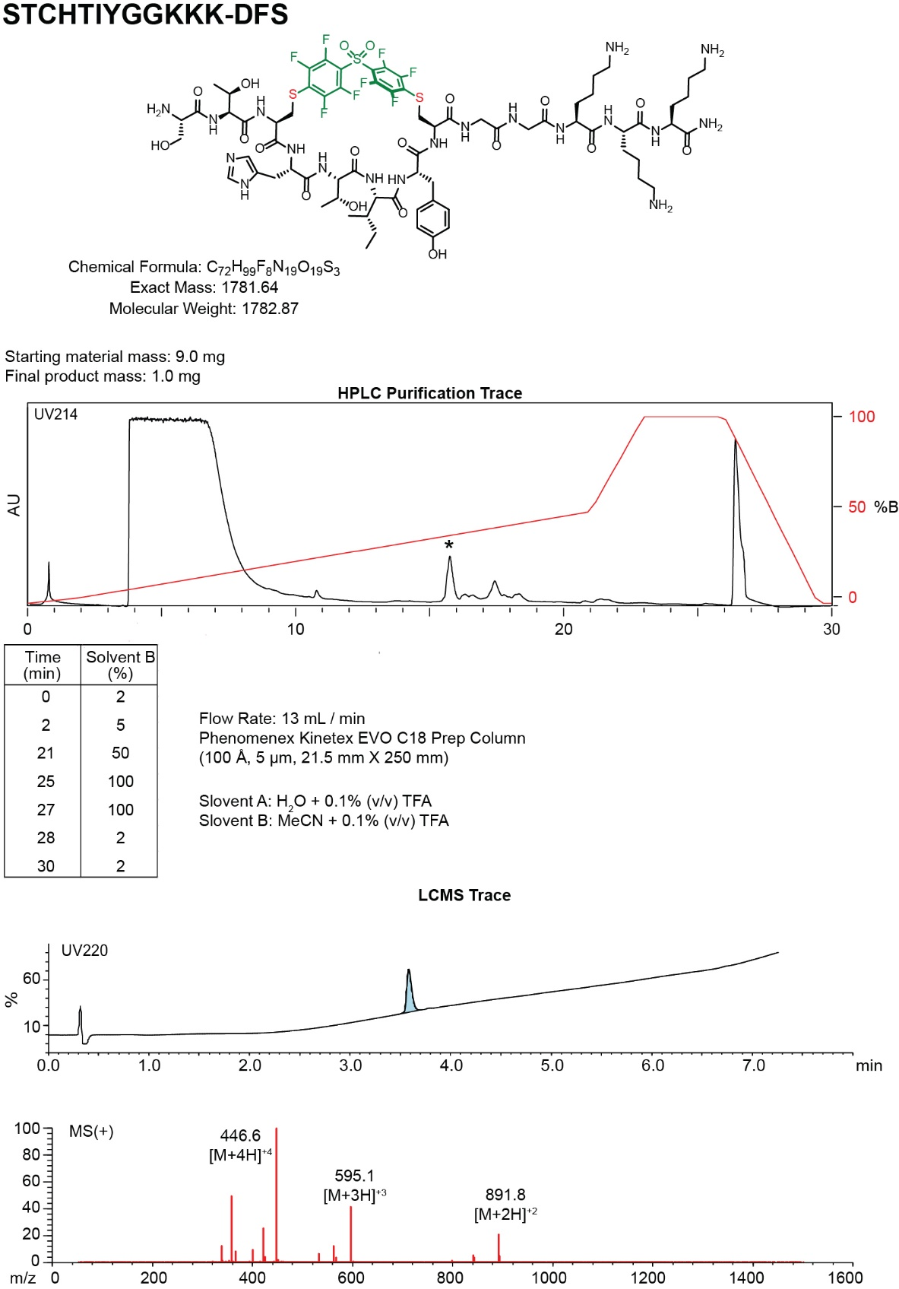
- Synthesis summary of 4b.

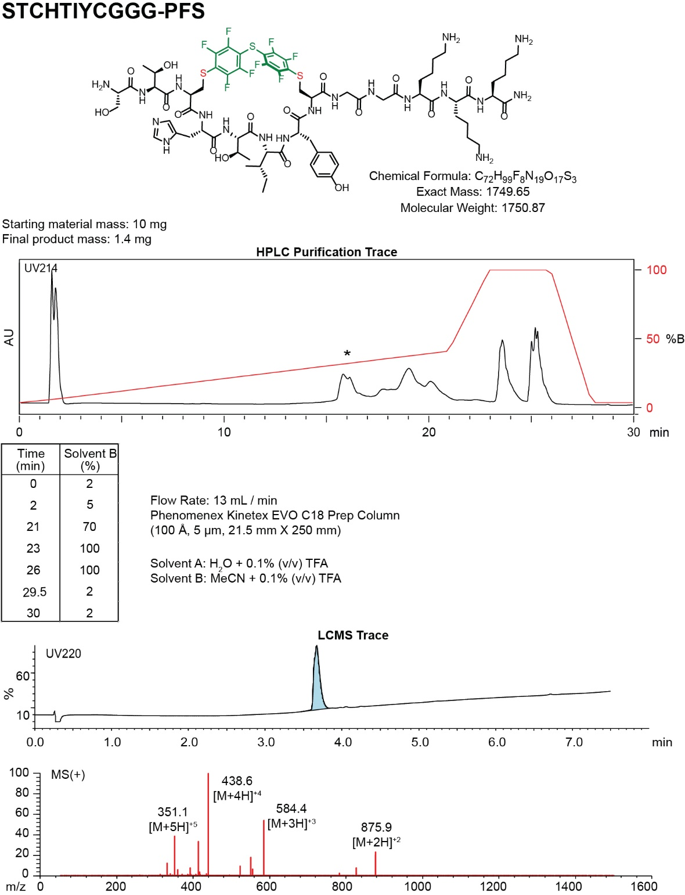
- Synthesis summary of 4c.
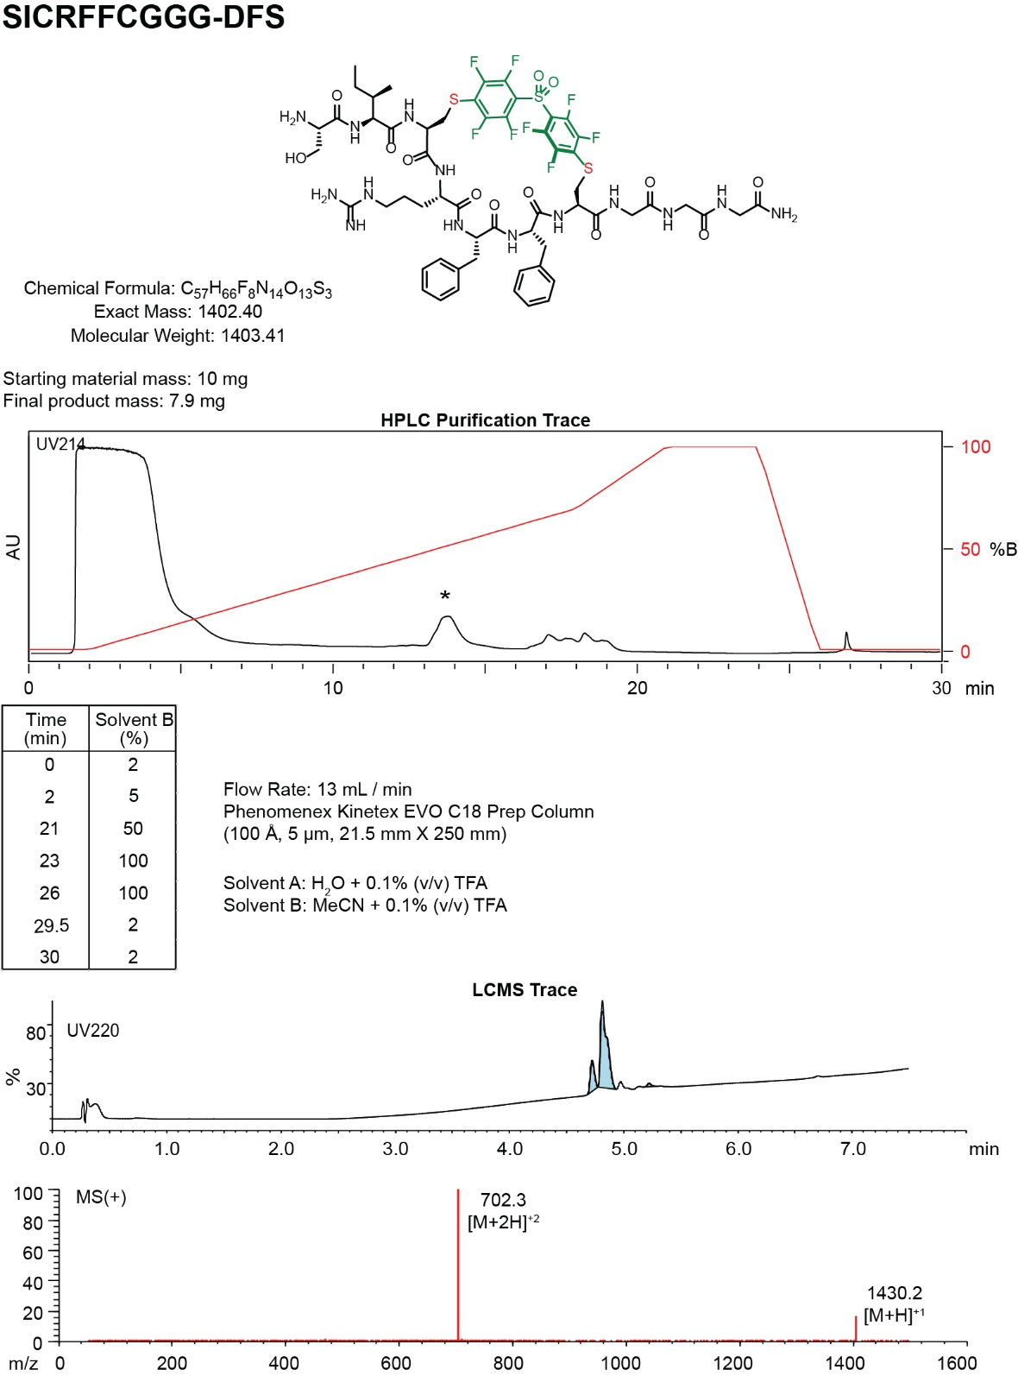
- Synthesis summary of 5b.
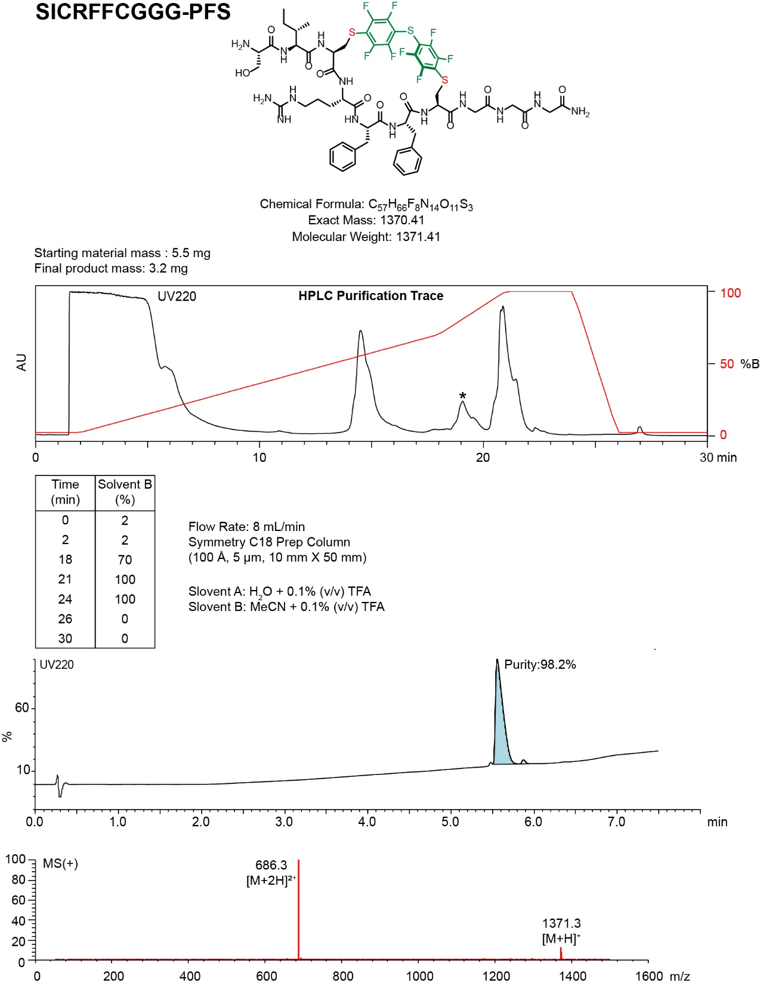
- Synthesis summary of 5c.
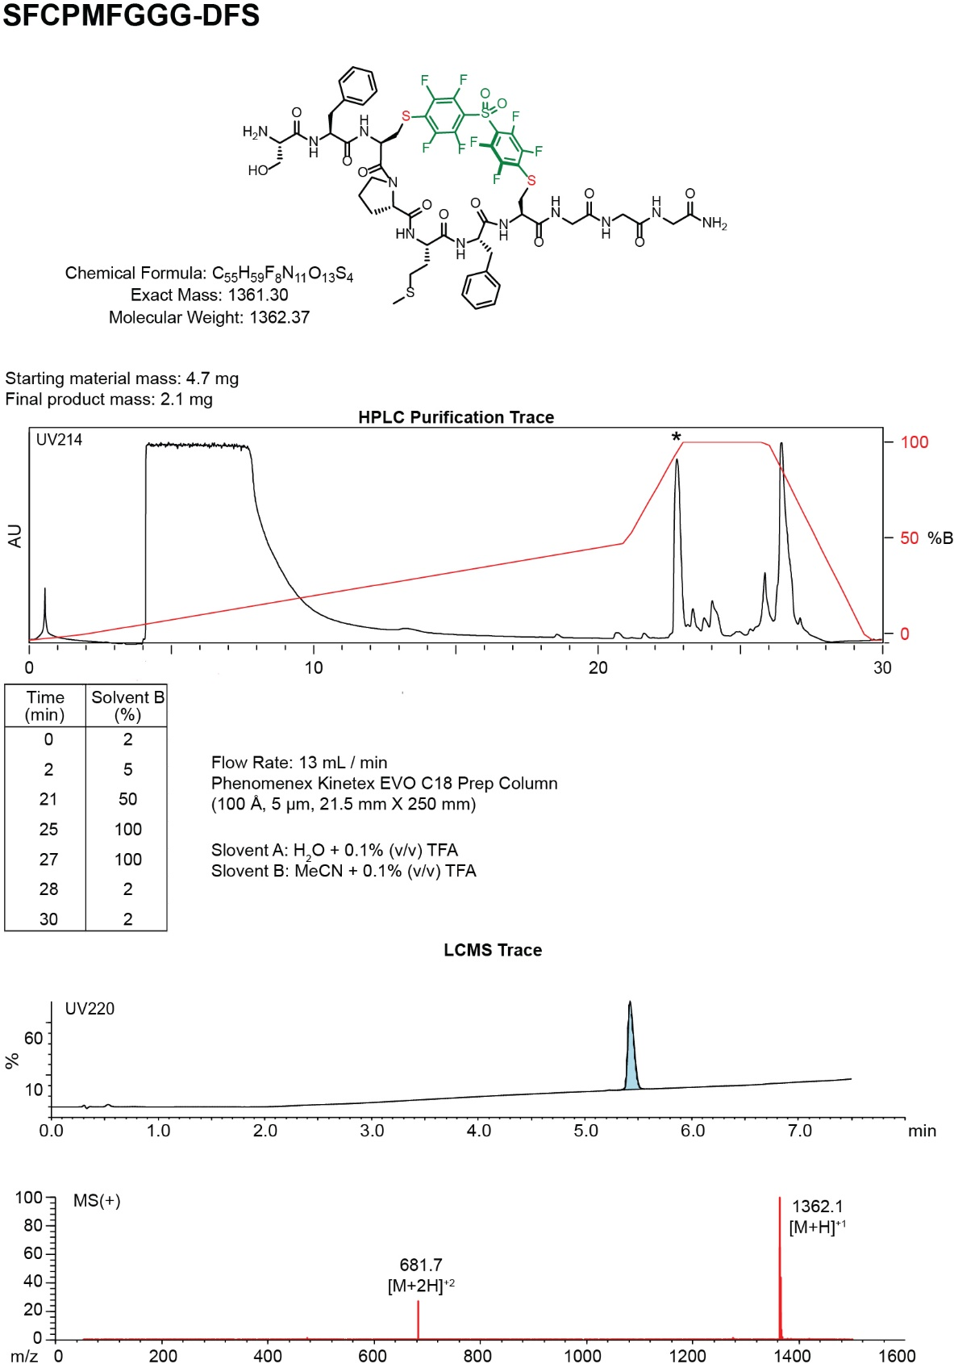
- Synthesis summary of 6b.
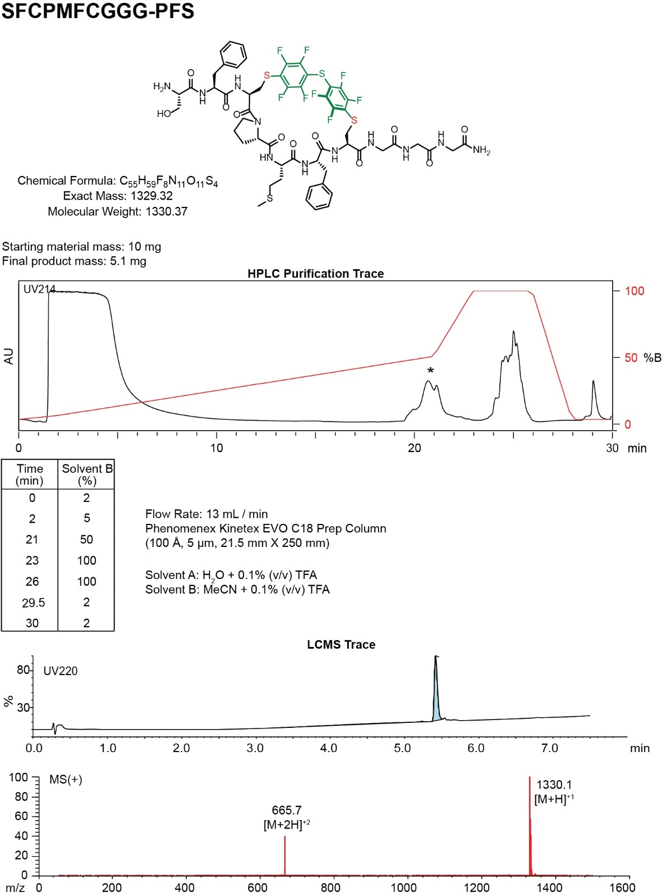
- Synthesis summary of 6c.

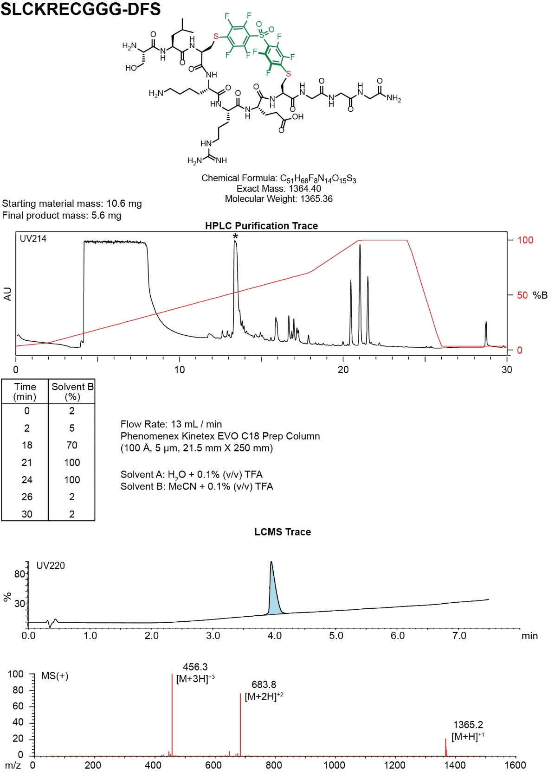
- Synthesis summary of 7b.
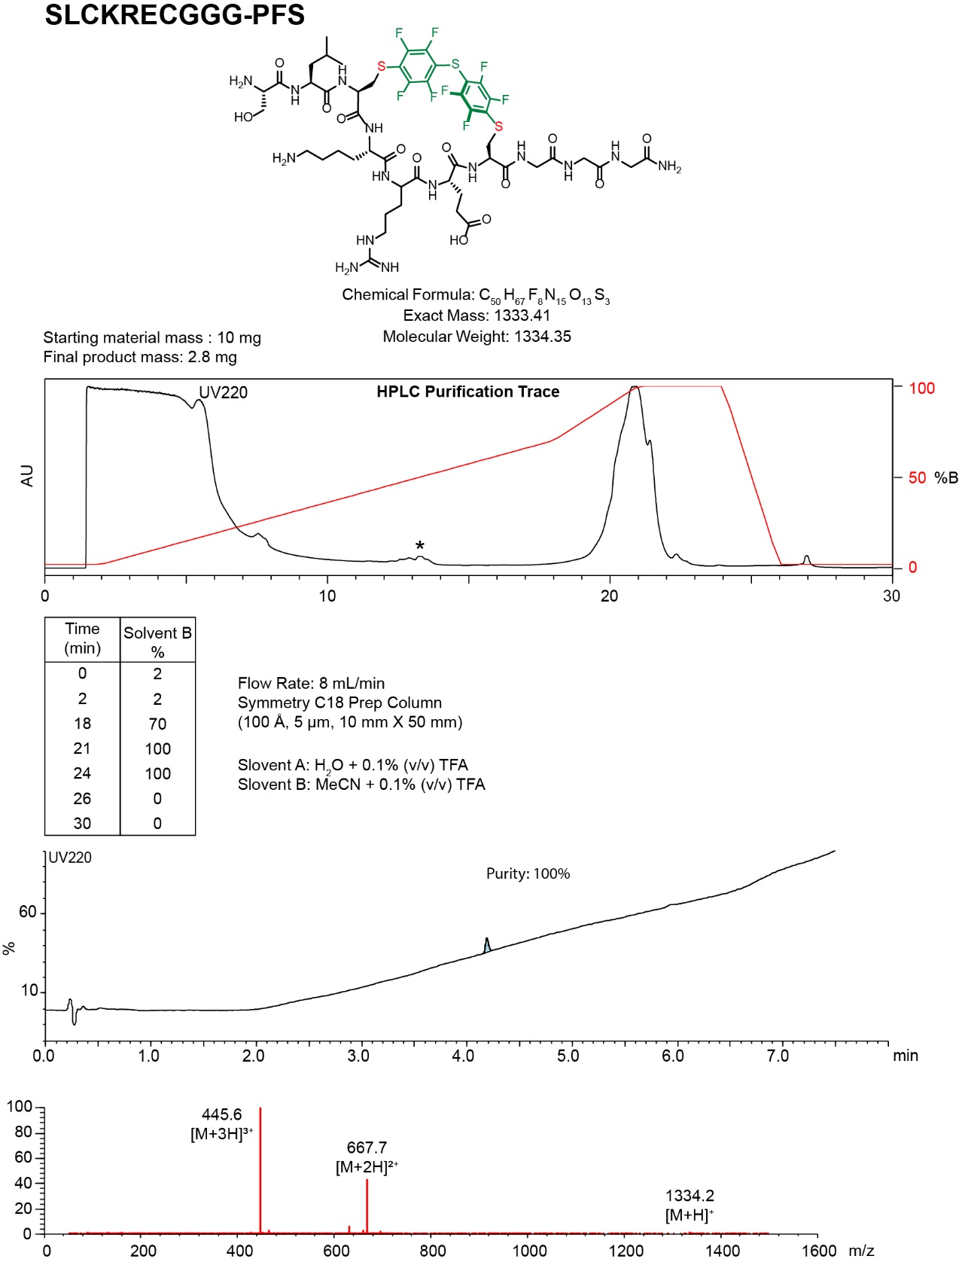
- Synthesis summary of 7c

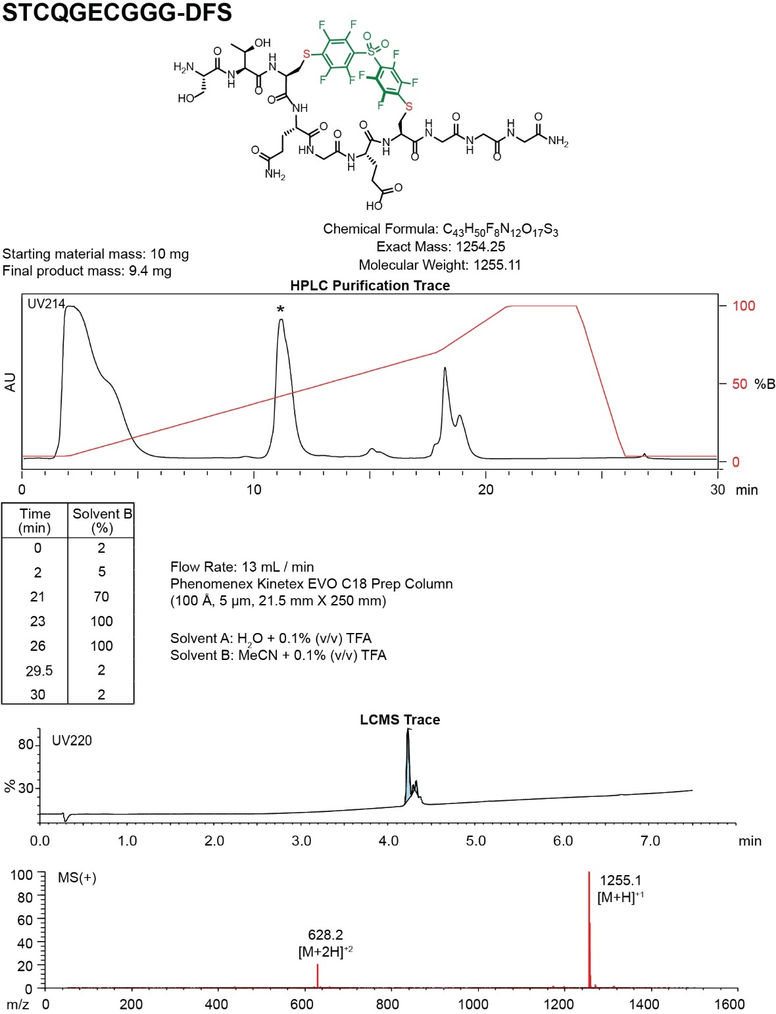
- Synthesis summary of 8b.

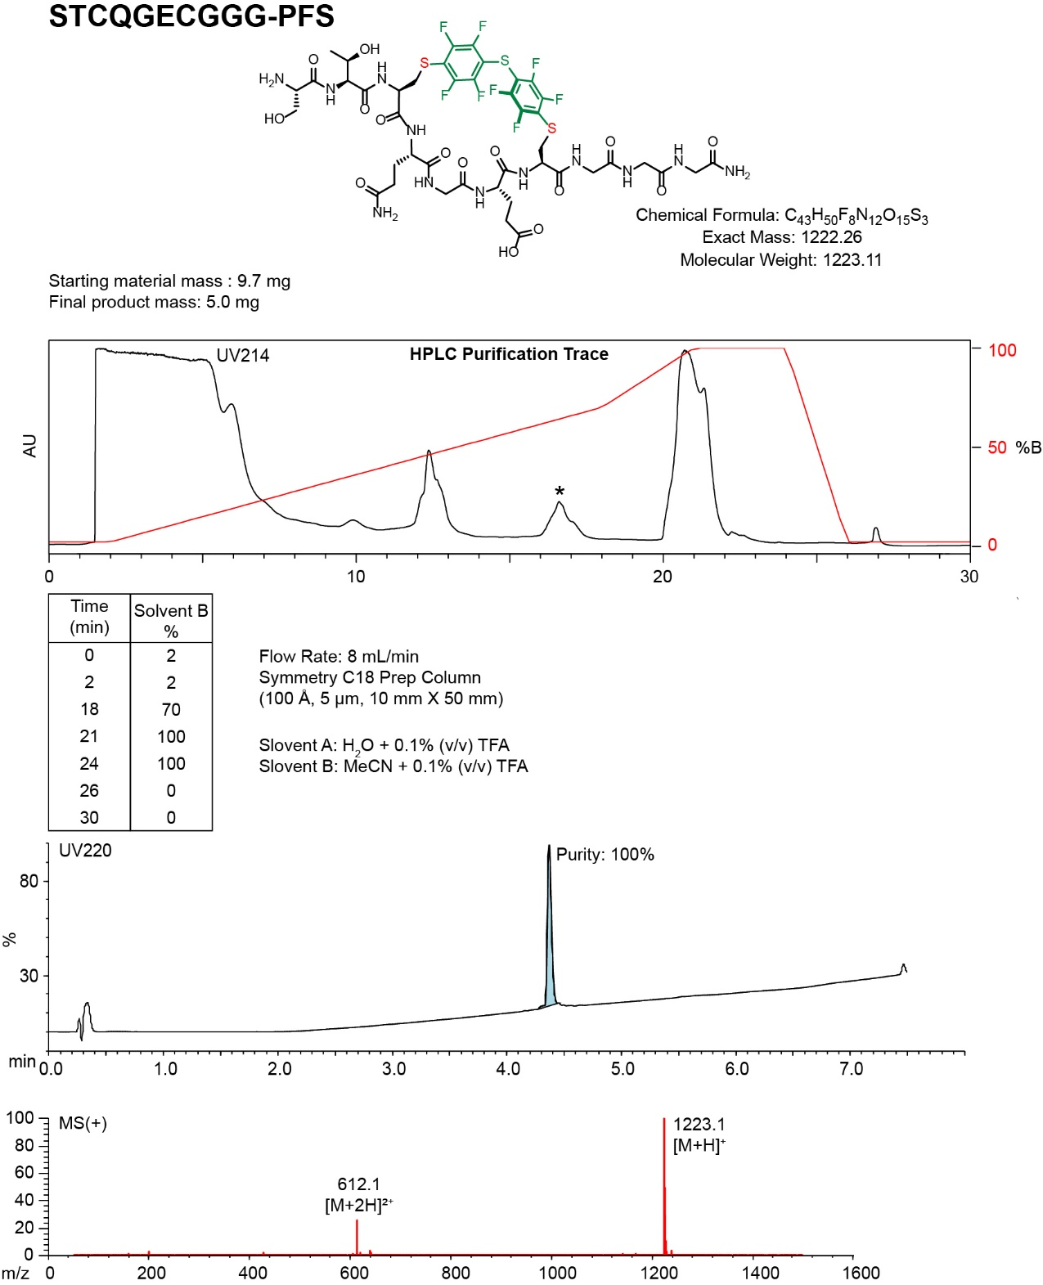
- Synthesis summary of 8c.
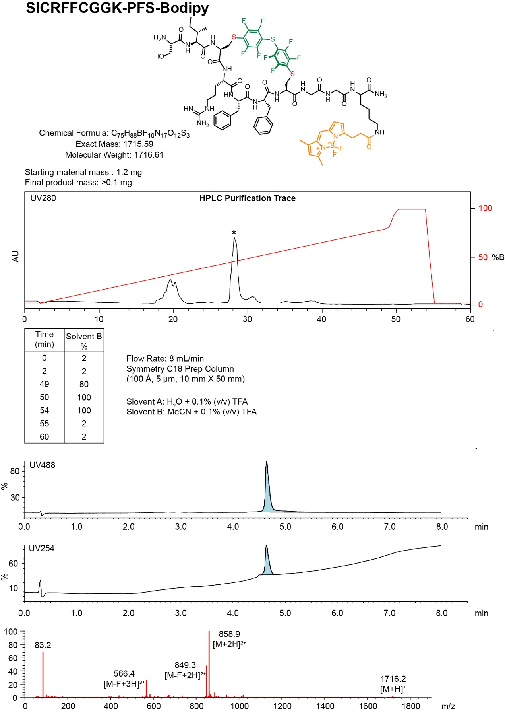
- Synthesis summary of C-terminus labeled 5c-BODIPY.
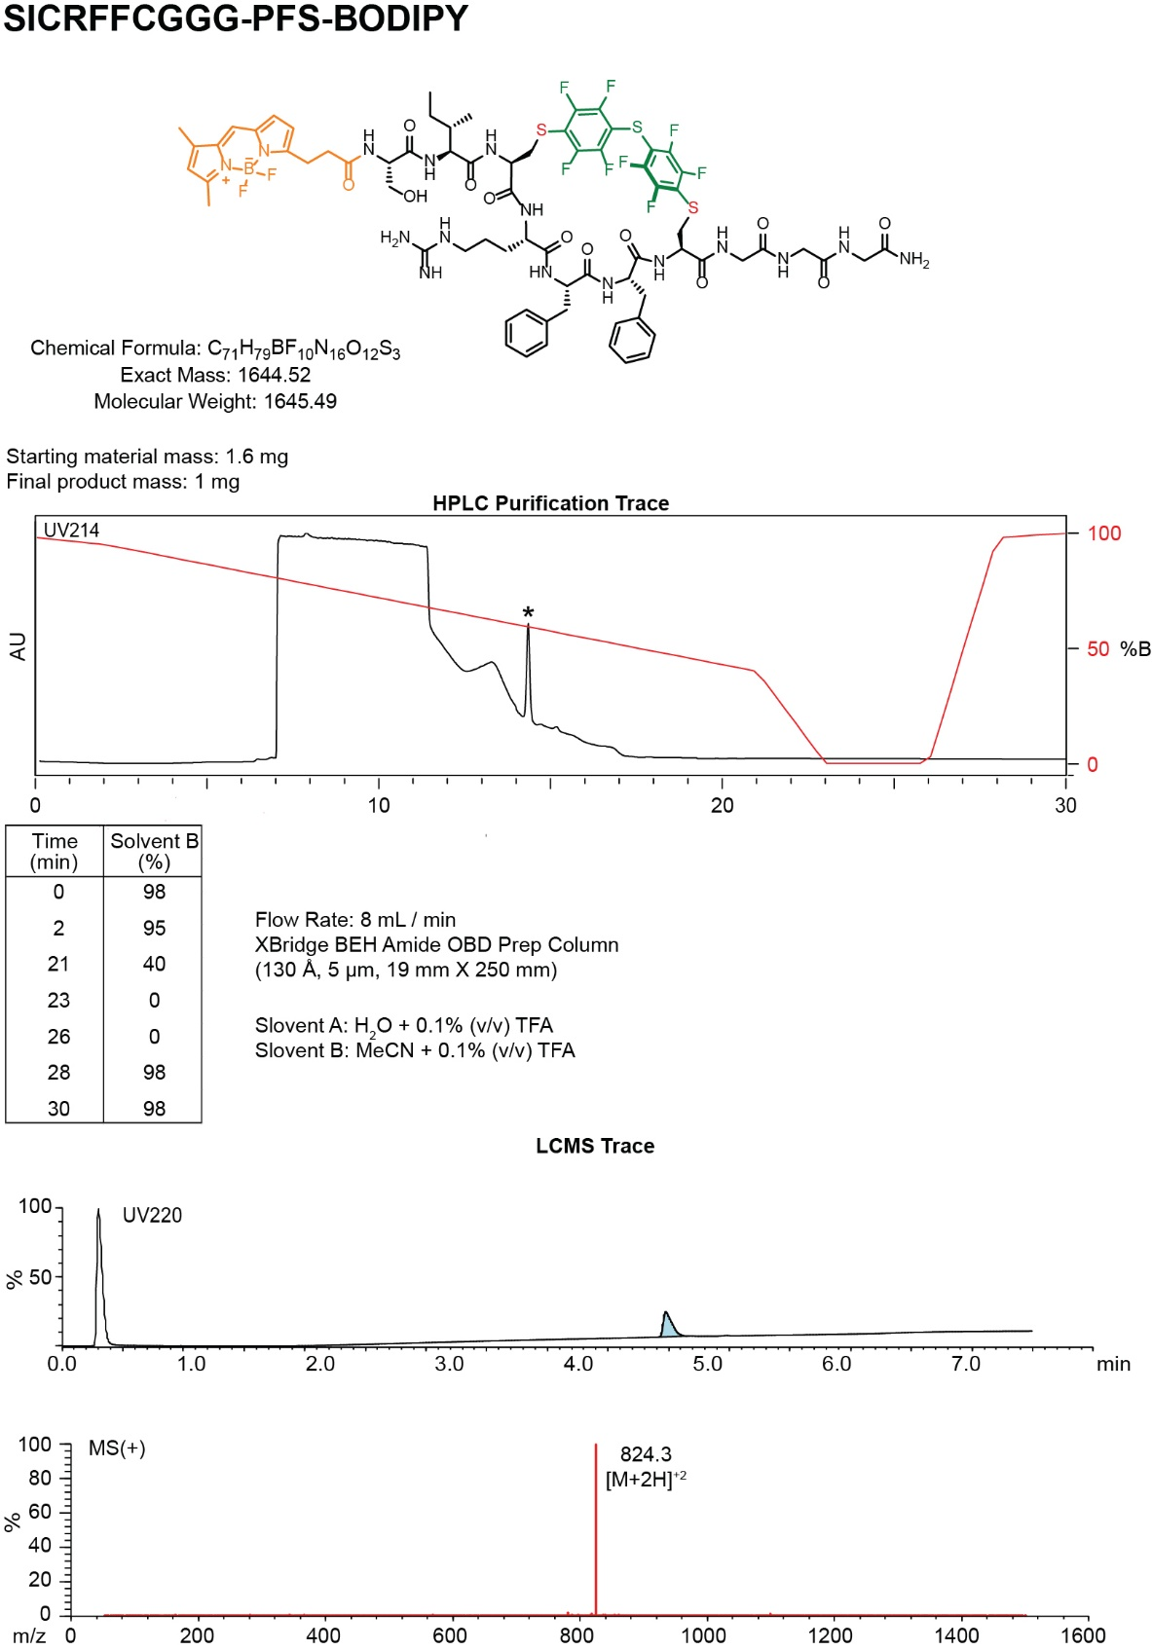
- Synthesis summary of N-terminus labeled 5d-BODIPY
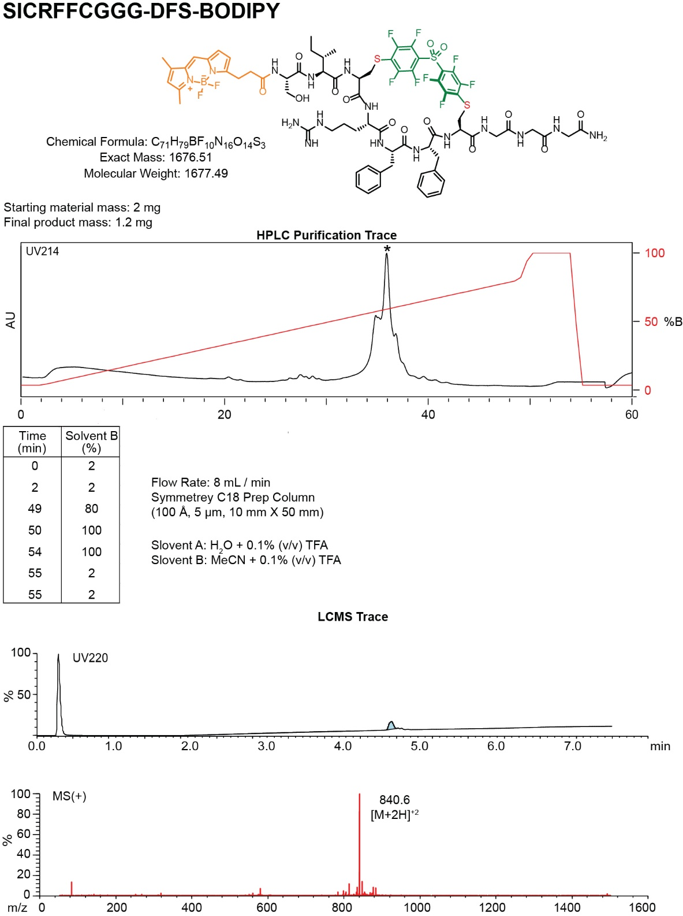
- Synthesis summary of N-terminus labeled 5b-BODIPY

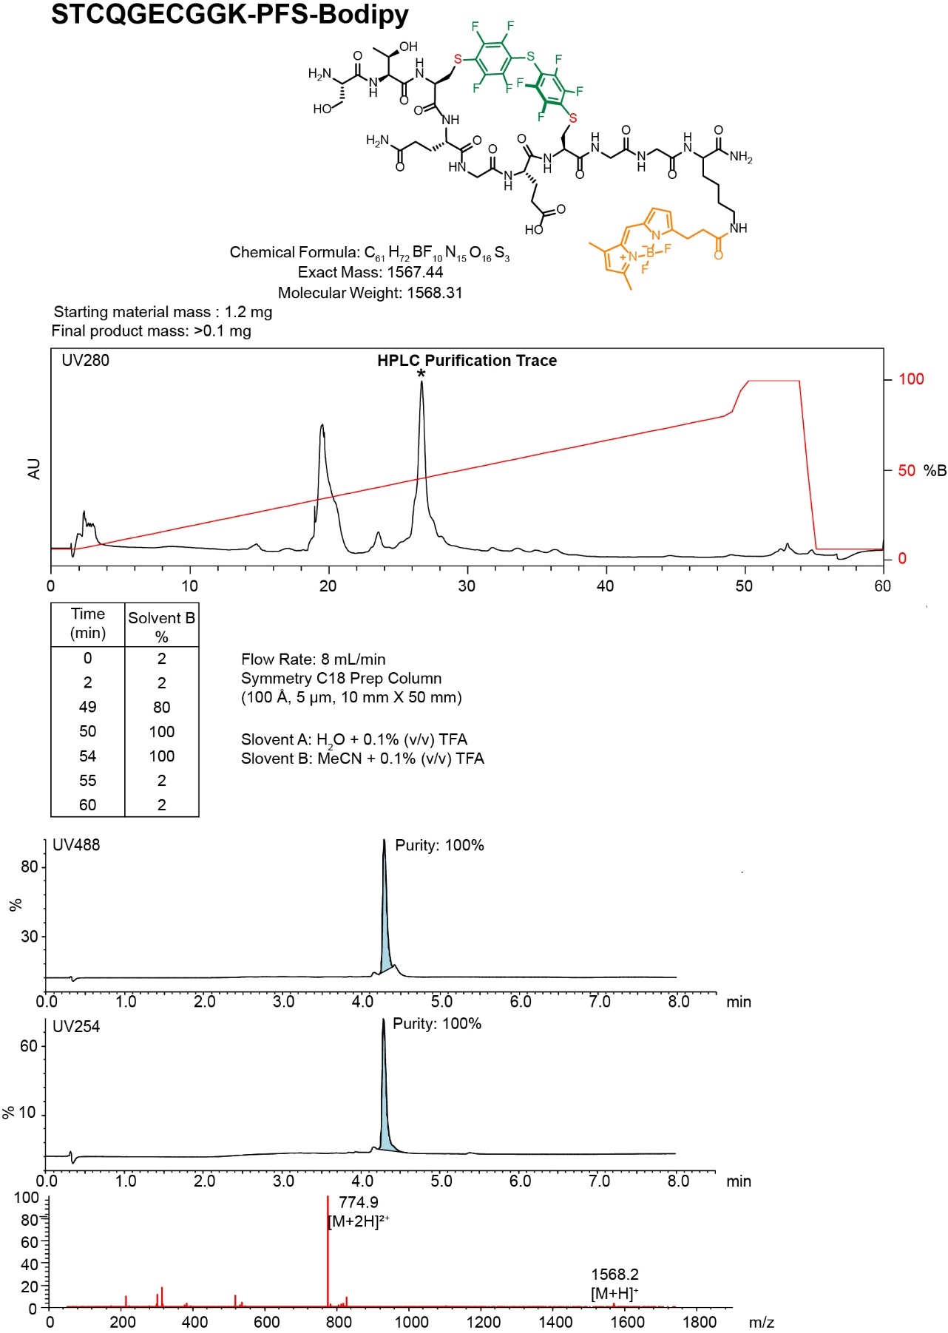
- Synthesis summary of C-terminus labeled 8c-BODIPY.
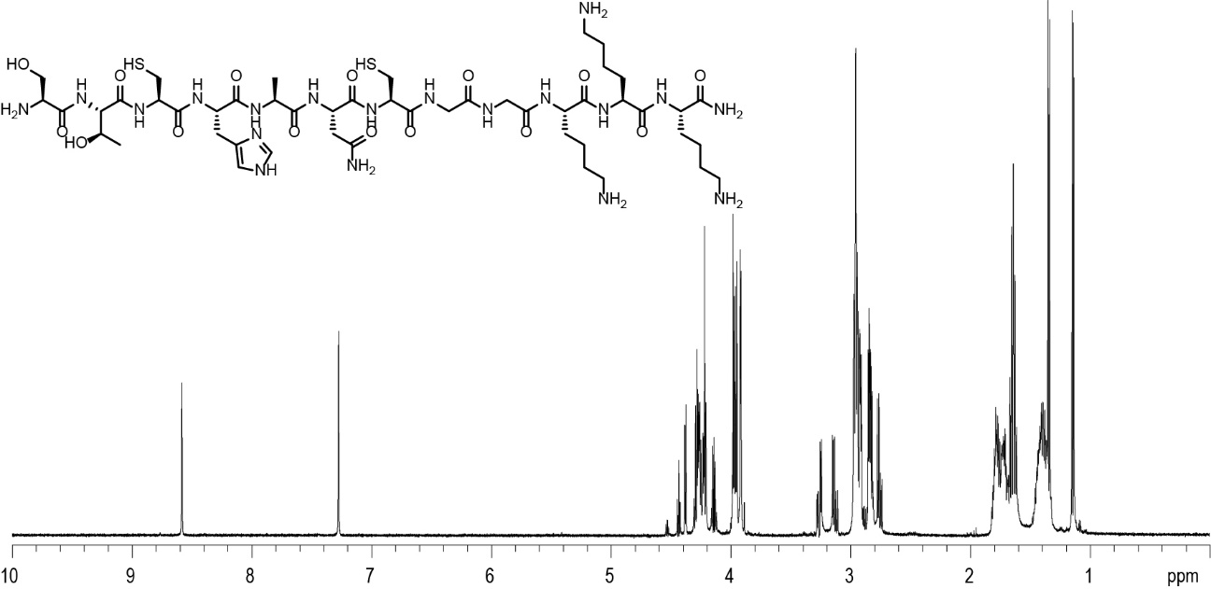
- STCHANCGGKKK ¹H NMR Spectra in D₂O, 600

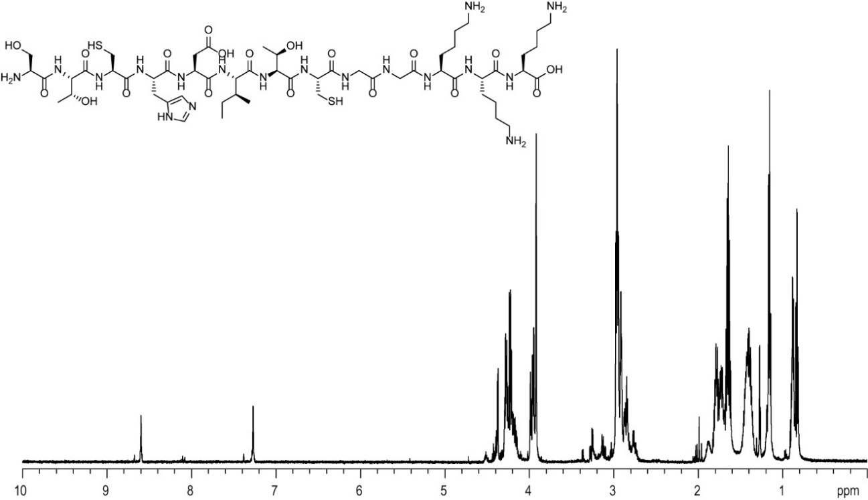
- STCHDITCGGKKK ¹H NMR Spectra in D₂O, 600

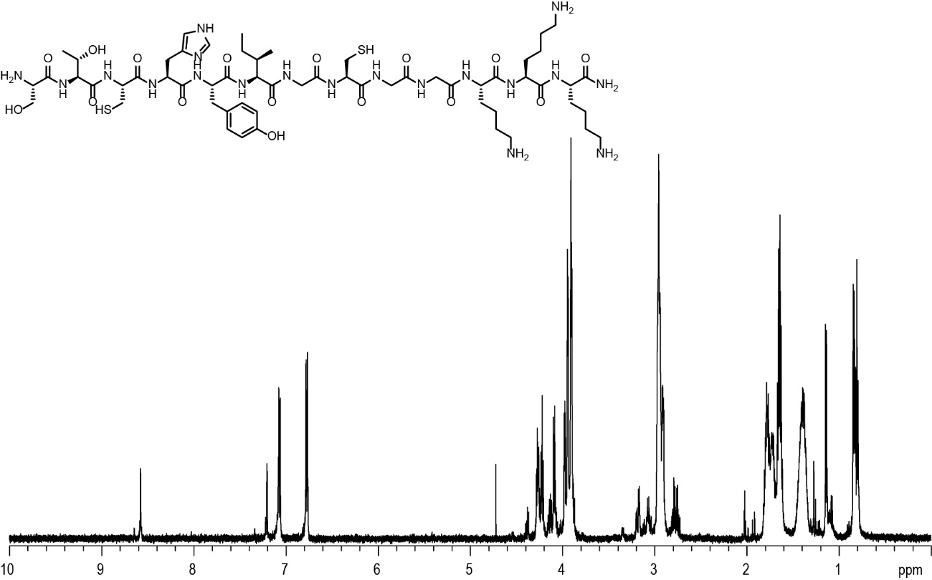
- STCHYIGCGGKKK ¹H NMR Spectra in D₂O, 600

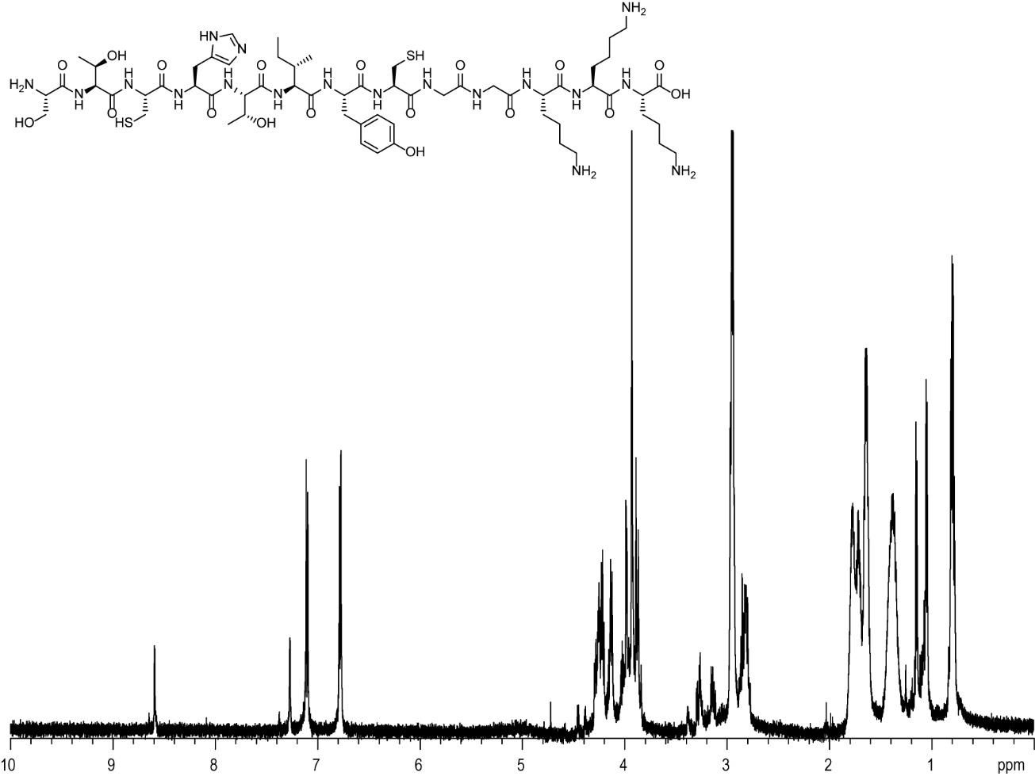
- STCHTIYCGGKKK ¹H NMR Spectra in D₂O, 600
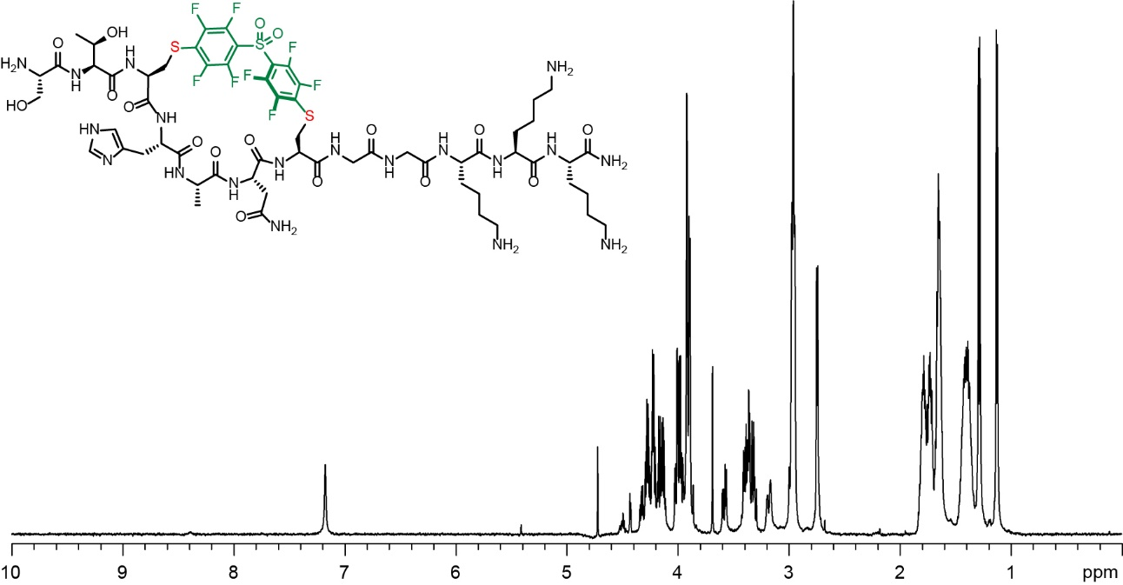
- DFS-STCHANCGGKKK ¹H NMR Spectra in D₂O, 600

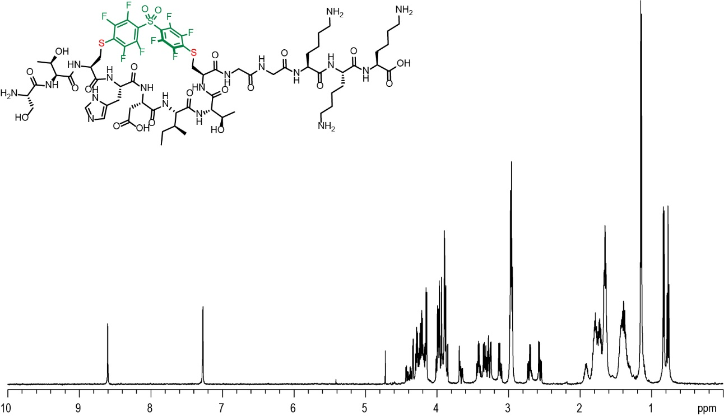
- DFS-STCHDITCGGKKK ¹H NMR Spectra in D₂O, 600
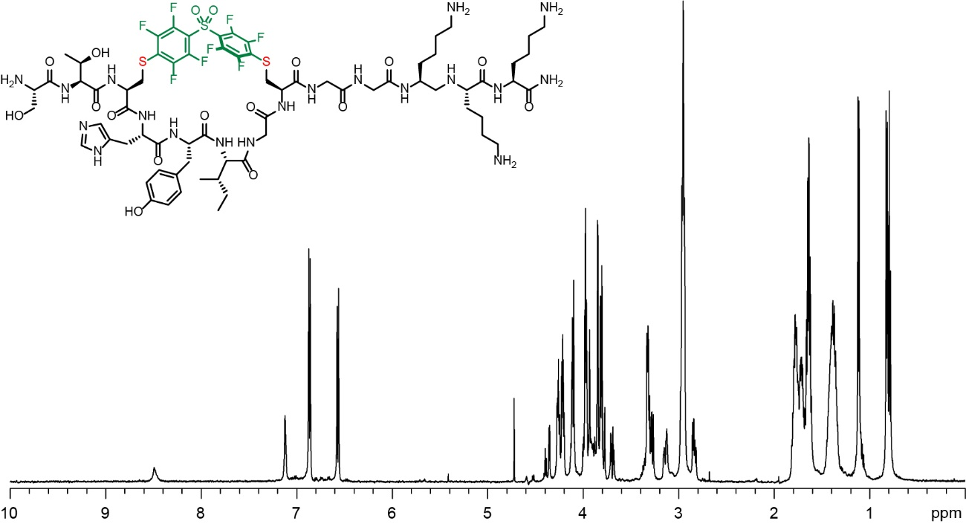
- DFS-STCHYIGCGGKKK ¹H NMR Spectra in D₂O, 600

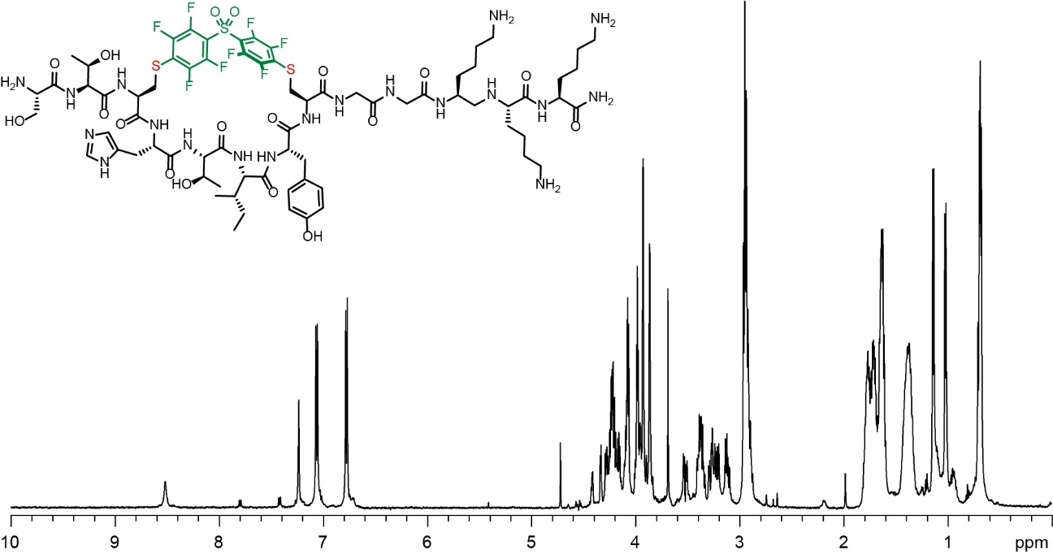
- DFS-STCHTIYCGGKKK ¹H NMR Spectra in D₂O, 600
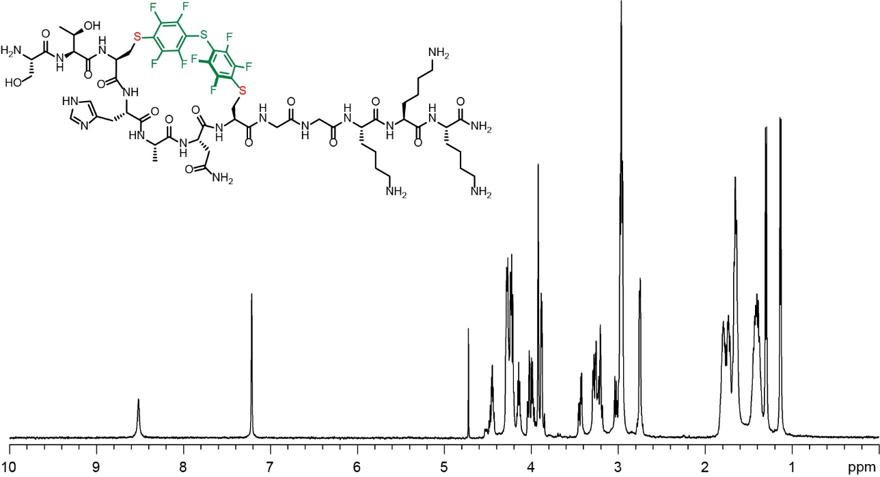
- PFS-STCHANCGGKKK ¹H NMR Spectra in D₂O, 600

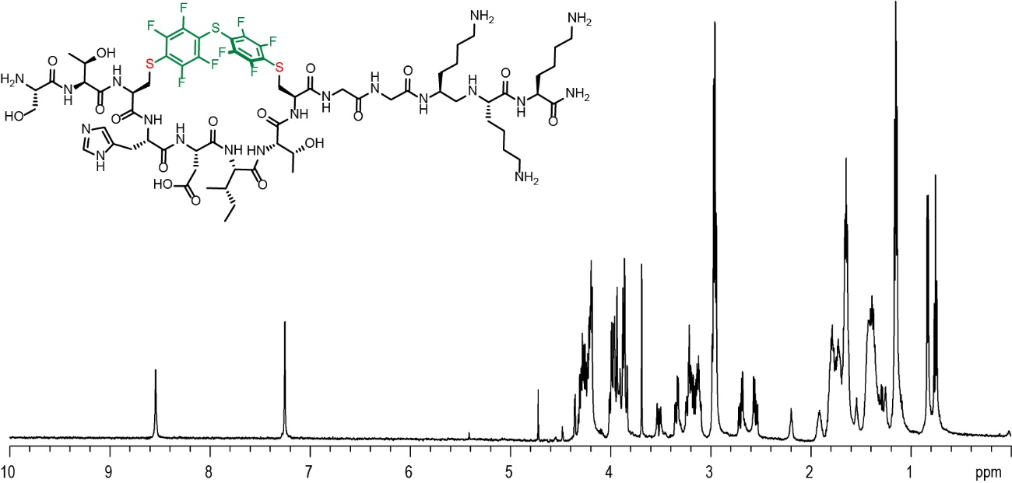
- PFS-STCHDITCGGKKK ¹H NMR Spectra in D₂O, 600

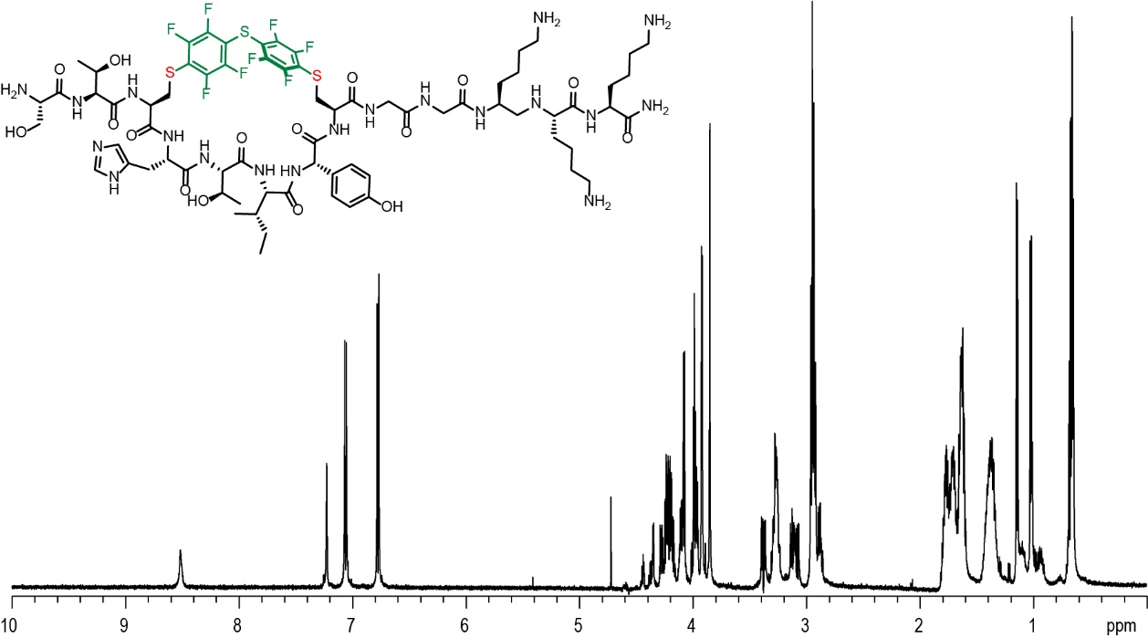
Figure S60: PFS-STCHTIYCGGKKK ¹H NMR Spectra in D₂O, 600

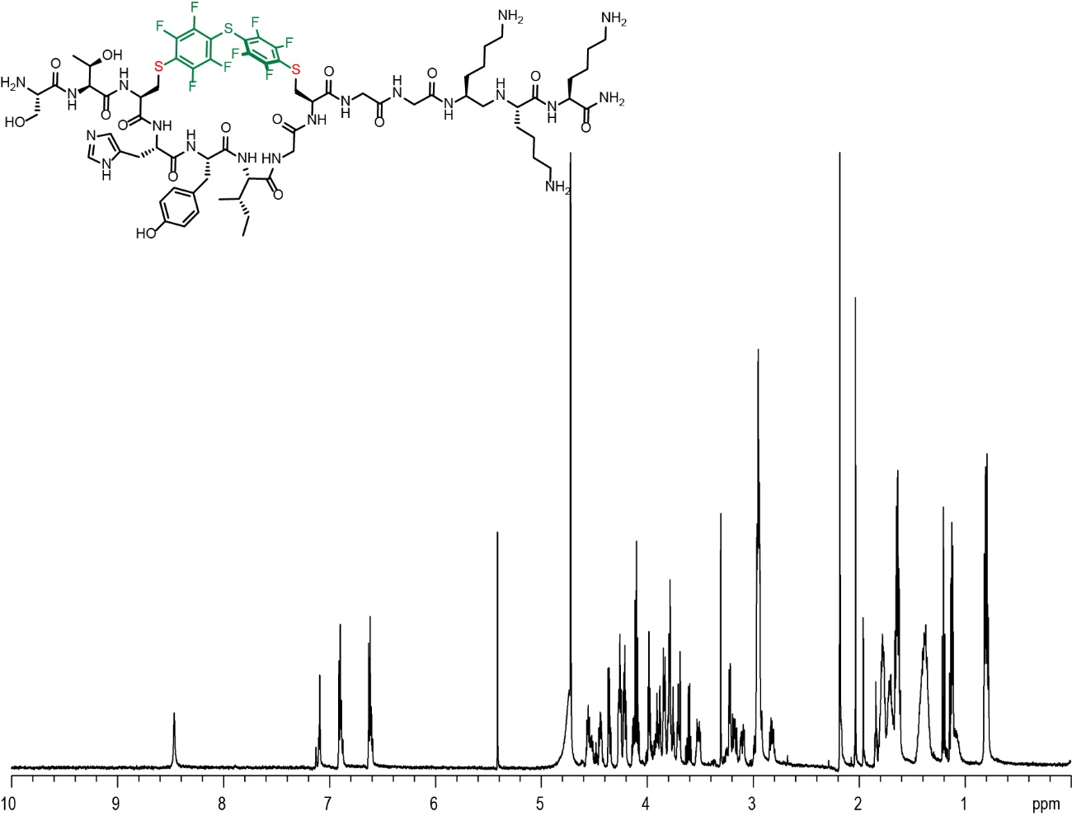
- PFS stapled STCHYIGCGGKKK ¹H NMR Spectra in D₂O, 600

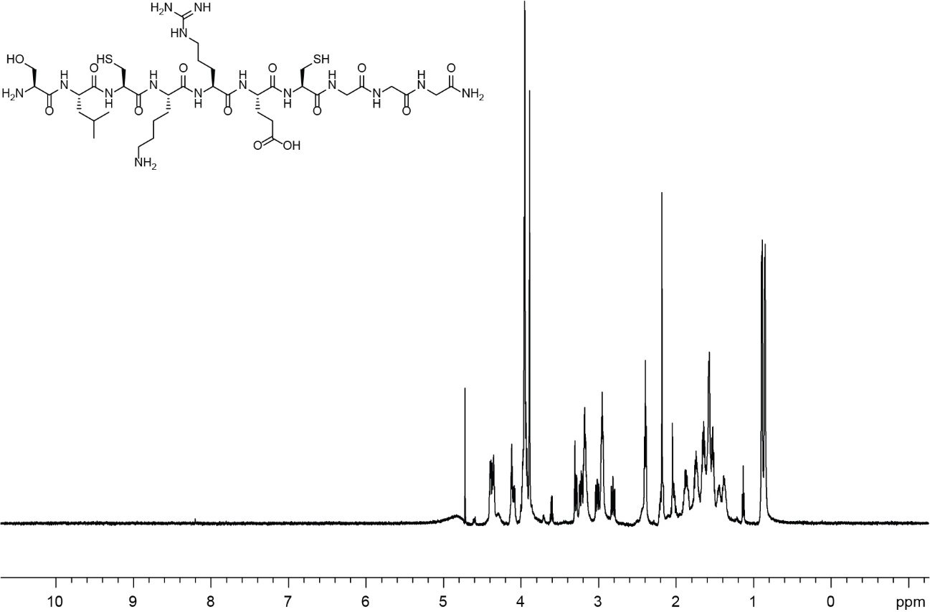
- SLCKRECGGG ¹H NMR Spectra in D₂O, 600

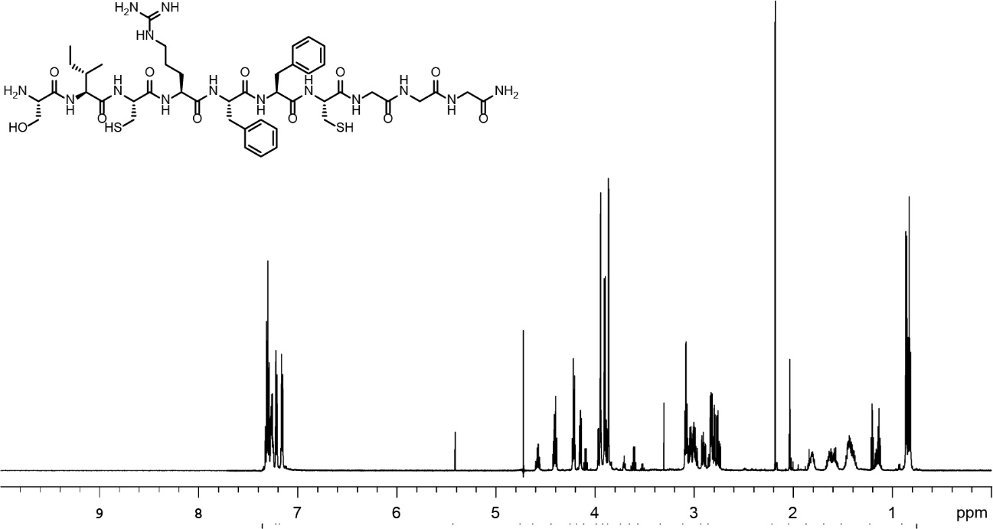
- SICRFFCGGG ¹H NMR Spectra in D₂O, 600

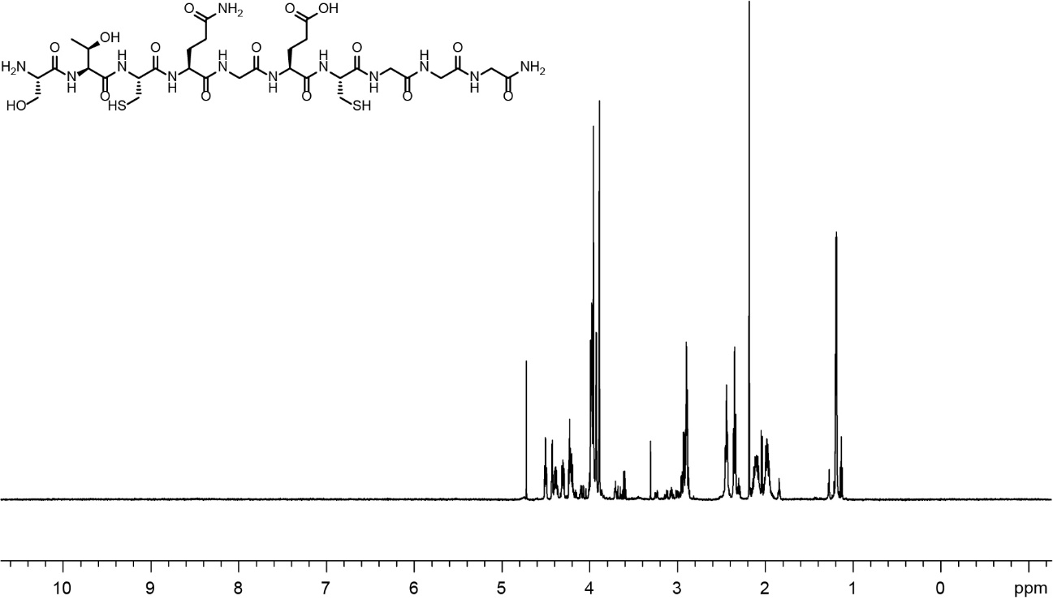
- STCQGECGGG ¹H NMR Spectra in D₂O, 600

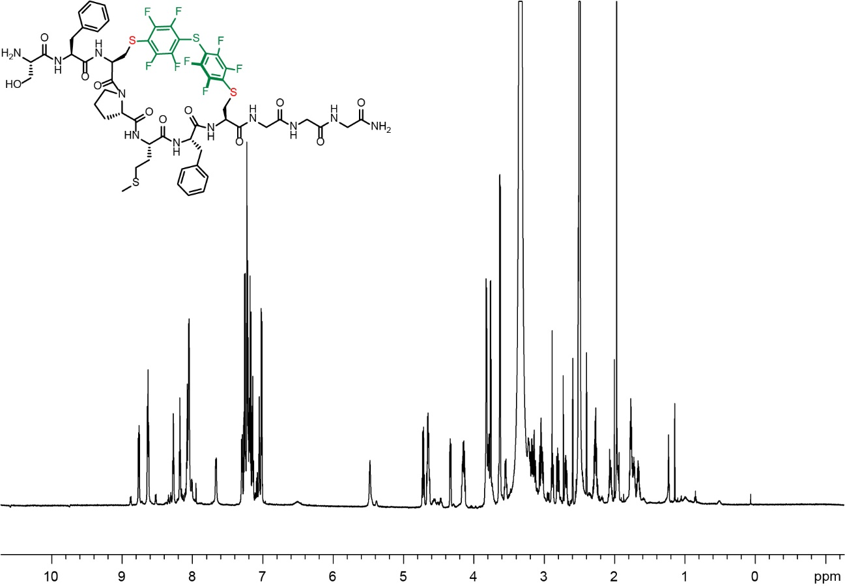
- PFS stapled SFCPMFCGGG ¹H NMR Spectra in DMSO, 700
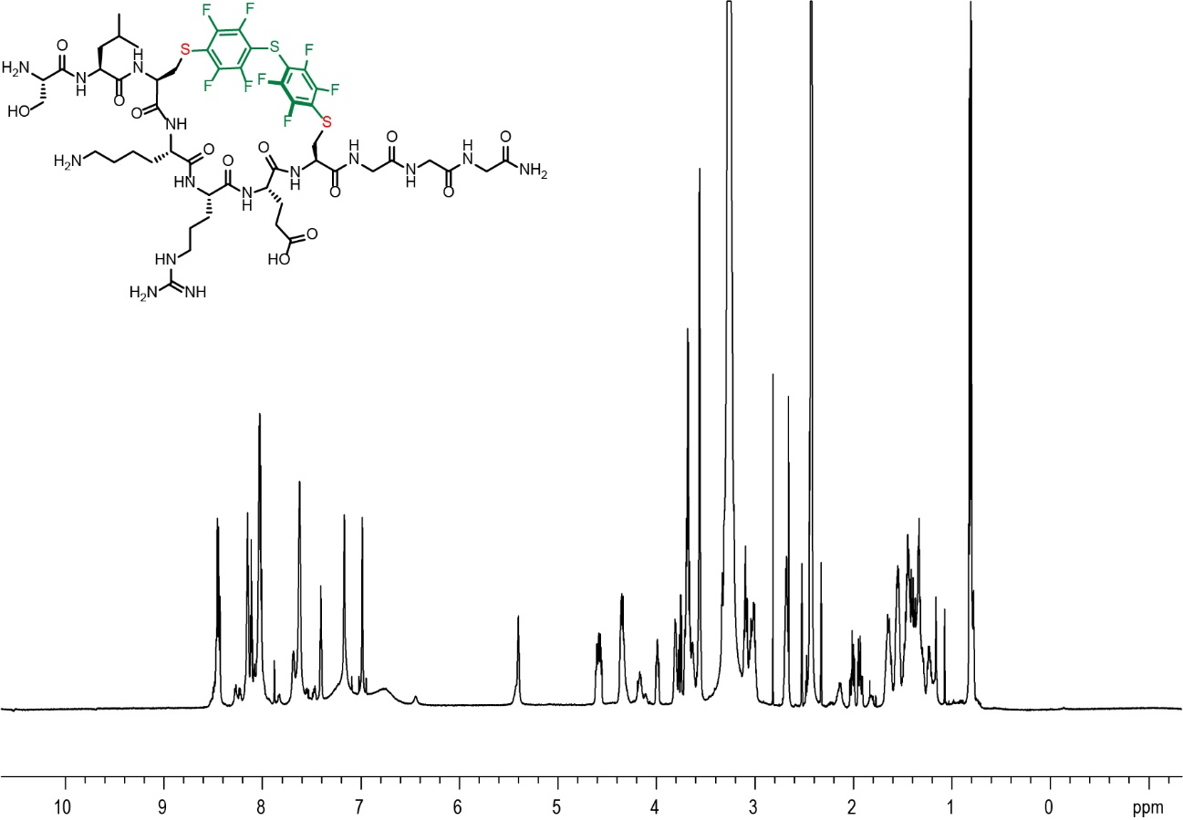
- PFS stapled SLCKRECGGG ¹H NMR Spectra in DMSO, 700

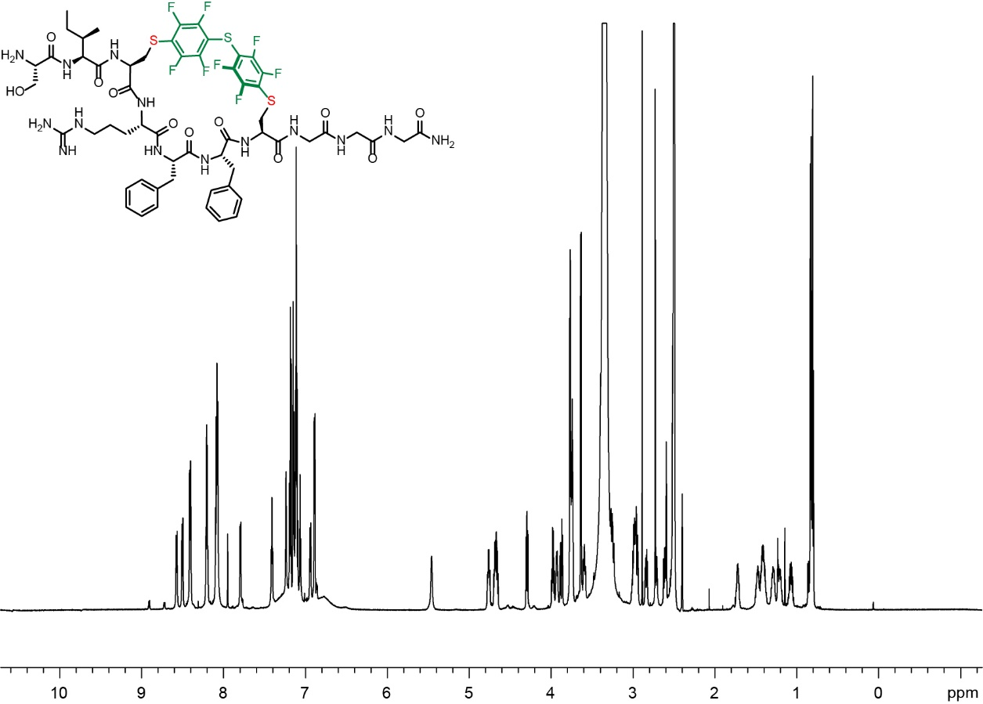
- PFS stapled SICRFFCGGG ¹H NMR Spectra in DMSO, 700

References
1. He, B.; Tjhung, K. F.; Bennett, N. J.; Chou, Y.; Rau, A.; Huang, J.; Derda, R., Compositional Bias in Naive and Chemically-modified Phage-Displayed Libraries uncovered by Paired-end Deep Sequencing. Sci. Rep. 2018, 8 (1), 1214.
2. Sojitra, M.; Sarkar, S.; Maghera, J.; Rodrigues, E.; Carpenter, E. J.; Seth, S.; Ferrer Vinals, D.; Bennett, N. J.; Reddy, R.; Khalil, A.; Xue, X.; Bell, M. R.; Zheng, R. B.; Zhang, P.; Nycholat, C.; Bailey, J. J.; Ling, C.-C.; Lowary, T. L.; Paulson, J. C.; Macauley, M. S.; Derda, R., Genetically encoded multivalent liquid glycan array displayed on M13 bacteriophage. Nat. Chem. Biol. 2021, 17 (7), 806-816.
3. Tjhung, K. F.; Kitov, P. I.; Ng, S.; Kitova, E. N.; Deng, L.; Klassen, J. S.; Derda, R., Silent Encoding of Chemical Post-Translational Modifications in Phage-Displayed Libraries. J. Am. Chem. Soc. 2016, 138 (1), 32-35.
4. Bhattacharya, A. A.; Grune, T.; Curry, S., Crystallographic analysis reveals common modes of binding of medium and long-chain fatty acids to human serum albumin. J. Mol. Biol. 2000, 303 (5), 721-32.
5. Trott, O.; Olson, A. J., AutoDock Vina: improving the speed and accuracy of docking with a new scoring function, efficient optimization, and multithreading. J. Comput. Chem. 2010, 31 (2), 455-61.
6. Andersen, J. T.; Dalhus, B.; Cameron, J.; Daba, M. B.; Plumridge, A.; Evans, L.; Brennan, S. O.; Gunnarsen, K. S.; Bjørås, M.; Sleep, D.; Sandlie, I., Structure-based mutagenesis reveals the albumin-binding site of the neonatal Fc receptor. Nat. Comm. 2012, 3 (1), 610.
7. Staquicini, F. I.; Ozawa, M. G.; Moya, C. A.; Driessen, W. H.; Barbu, E. M.; Nishimori, H.; Soghomonyan, S.; Flores, L. G., 2nd; Liang, X.; Paolillo, V.; Alauddin, M. M.; Basilion, J. P.; Furnari, F. B.; Bogler, O.; Lang, F. F.; Aldape, K. D.; Fuller, G. N.; Hook, M.; Gelovani, J. G.; Sidman, R. L.; Cavenee, W. K.; Pasqualini, R.; Arap, W., Systemic combinatorial peptide selection yields a non-canonical iron-mimicry mechanism for targeting tumors in a mouse model of human glioblastoma. J. Clin. Invest. 2011, 121 (1), 161-73.

