Appendix B

Trait driven or neutral: understanding the change in functional trait expression during early plant succession

Werner Ulrich, Markus Klemens Zaplata

Figure B1. Geographical location of the German Chicken Creek catchment in August 2008 (aerial photograph provided by Vattenfall Europe Mining AG) showing the positions of the 25 m² cells (A). In the cell corners four 1 m² plots form a set (B).

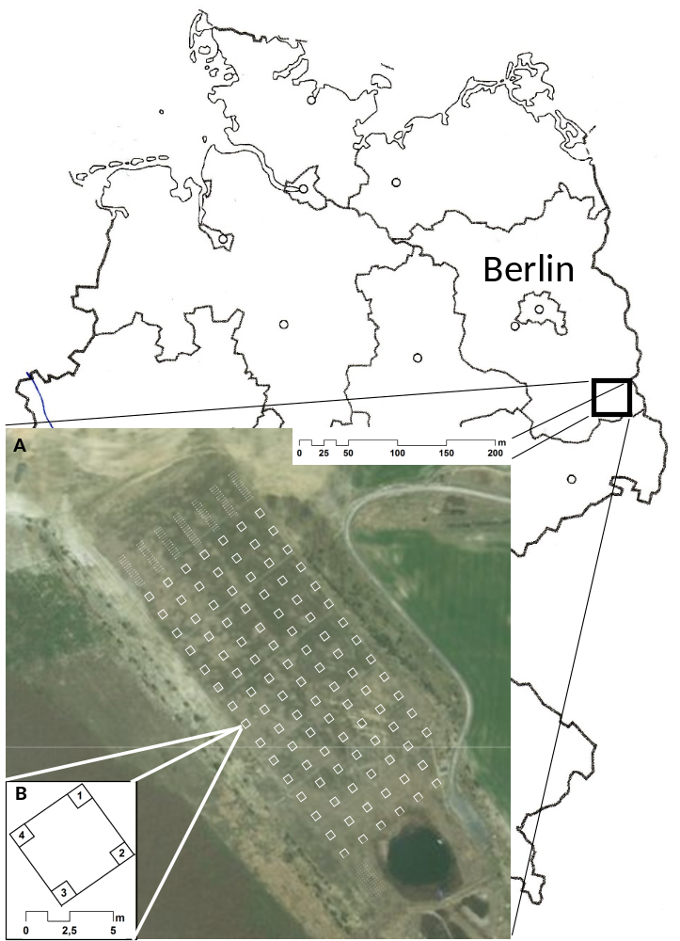
Figure B2. Z-transformed Price partitions for the annual changes in FAD of all 114 study plots. None of the second order polynomial regressions were significant at P < 0.01.

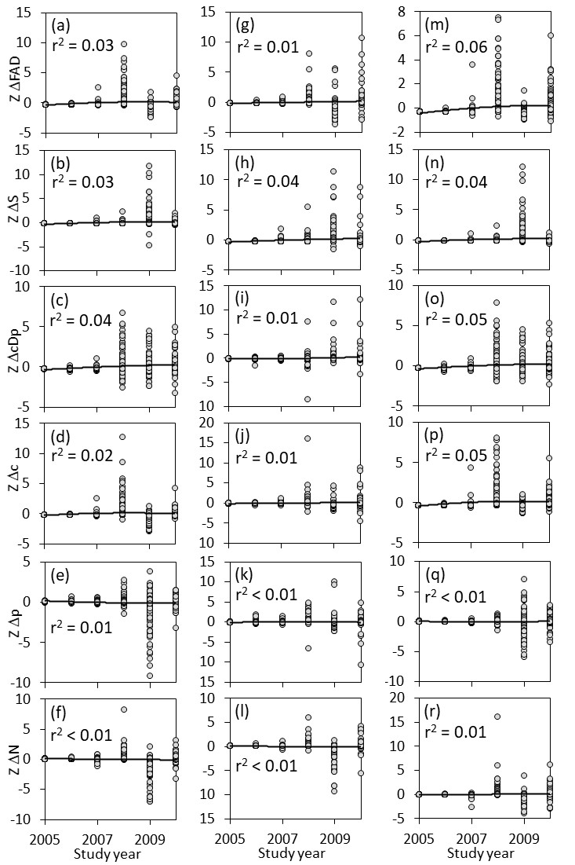

Table B1. Pearson correlation coefficients between environmental variables used in the general linear modelling (Fig.2 of the main text).

Variable | Moisture | Nitrogen | pH | % organic C | % sand
Moisture | 0.01
Nitrogen | -0.01 | 0.38
pH | -0.02 | 0.13 | 0.06
% organic C | -0.04 | 0.09 | 0.04 | 0.09
% sand | -0.09 | -0.04 | -0.12 | -0.15 | -0.63

Table B2. Pearson coefficients of correlations between Price partitions of seed number, seed weight and specific leaf area (SLA). N = 642.

 | Number of seeds
 | ΔS | ΔpΔc | Δc | Δp
ΔpΔc | 0.35
Δc | -0.22 | 0.14
Δp | -0.73 | -0.44 | 0.39
ΔN | -0.58 | 0.02 | 0.42 | 0.42
 | Seed mass
ΔpΔc | 0.12
Δc | -0.17 | 0.04
Δp | 0.03 | 0.07 | 0.03
ΔN | -0.71 | -0.15 | 0.44 | -0.10
 | SLA
ΔpΔc | -0.06
Δc | 0.25 | 0.52
Δp | -0.11 | 0.01 | 0.10
ΔN | 0.03 | 0.18 | 0.41 | -0.04

Table B3. Pearson coefficients of correlations between ΔFAD values of seed number, seed weight and specific leaf area (SLA) among all 107 sample plots.

 | Number of seeds
 | 2005 | 2006 | 2007 | 2008 | 2009
2006 | -0.07
2007 | 0.03 | -0.11
2008 | 0.07 | 0.04 | 0.42
2009 | -0.06 | 0.11 | 0.00 | -0.12
2010 | -0.08 | 0.13 | -0.02 | 0.17 | -0.18
 | Seed mass
2006 | -0.07
2007 | 0.05 | -0.05
2008 | -0.03 | 0.14 | 0.53
2009 | 0.03 | -0.23 | -0.16 | -0.14
2010 | -0.08 | -0.03 | -0.07 | -0.02 | 0.13
 | SLA
2006 | -0.04
2007 | -0.04 | 0.00
2008 | -0.02 | 0.01 | 0.40
2009 | 0.27 | 0.11 | -0.09 | -0.01
2010 | -0.02 | 0.08 | -0.02 | 0.32 | 0.00

