Supplementary Material

In-situ inorganic nano-hybrid strategy to facilely fabricate high flame-safety epoxy resin by inorganic phosphorus/boron-layered double hydroxide complexes
Zhu-Bao Shaoª, Tian-Ci Wangª, Xue-Bao Lin^{b*}, Xiang Songª, Jing Cuiª, Longxiang Zhu^{a*}
ªInstitute of Functional Textiles and Advanced Materials, National Engineering Research Center for Advanced Fire-Safety Materials D & A (Shandong), College of Textiles and Clothing, State Key Laboratory of Bio-Fibers and Eco-Textiles, Qingdao University, Ningxia Road, 308, Qingdao 266071, China
^{b}IMDEA Materials Institu te, C/Eric Kandel, 2, Getafe, Madrid, 28906, Spain

Corresponding authors:
*Xue-Bao Lin, Email: xuebao.lin@imdea.org;
*Longxiang Zhu, Email: lxzhu@qdu.edu.cn;

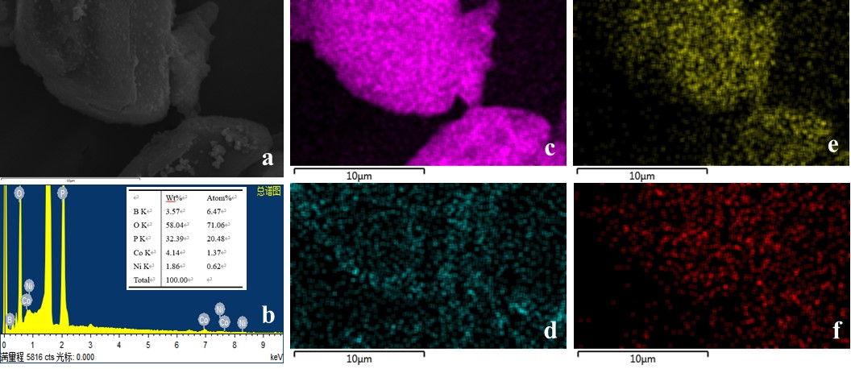
Fig. S1. The morphology of B-LDH@APP (a) and corresponding elements mapping of full (b), P (c), Ni (d), Co (e), and B (f)

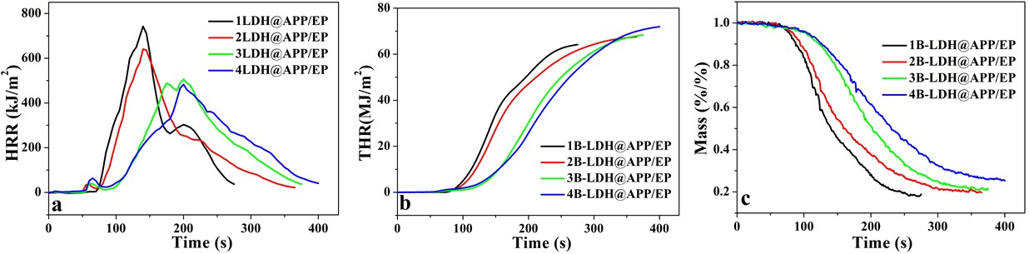
Fig. S2. The heat release rate (a), total heat release (b), and mass loss (c) curves of corresponding B-LDH@APP/EPs.

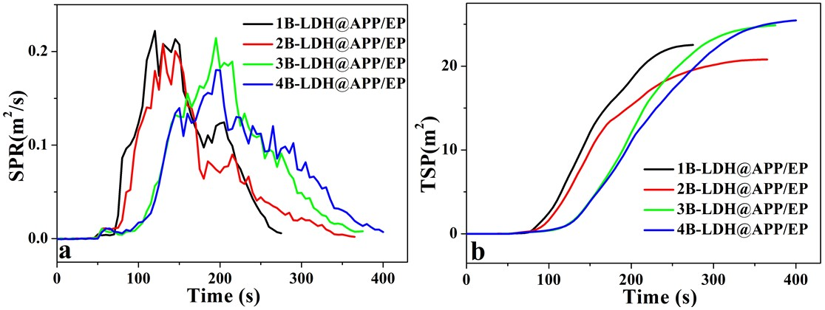
Fig. S3. The smoke production rate (a) and total smoke production (b) curves of corresponding B-LDH@APP/EPs.

Table S1. CC data of corresponding B-LDH@APP/EPs
Sample | 1B-LDH@APP/EP | 2B-LDH@APP/EP | 3B-LDH@APP/EP | 4B-LDH@APP/EP
TTI (s) | 65 | 65 | 64 | 63
Peak HRR (kW/m²) | 742 | 641 | 505 | 482
Time to PHRR (s) | 140 | 142 | 200 | 201
FGR (kW/m².s) | 5.3 | 4.5 | 2.5 | 2.4
THR (MJ/m²) | 64.1 | 67.5 | 68.4 | 71.0
Peak SPR (m²/s) | 0.22 | 0.21 | 0.21 | 0.18
TSP (m²) | 22.5 | 20.8 | 24.8 | 25.4
Residue (%) | 18.9 | 19.7 | 21.0 | 25.3

