Tracing the origin of Korean invasive populations of the spotted lanternfly, Lycorma delicatula (Hemiptera: Fulgoridae)

Hyojoong Kim^{1, †, *}, Sohee Kim^{1, †}, Yerim Lee^{1, *}, Heung-Sik Lee², Seong-Jin Lee², Jong-Ho Lee²
¹Animal Systematics Laboratory., Department of Biology, Kunsan National University 54150, Republic of Korea
²Animal & Plant Quarantine Agency, Gimcheon 39660, Republic of Korea

Supplementary material 1

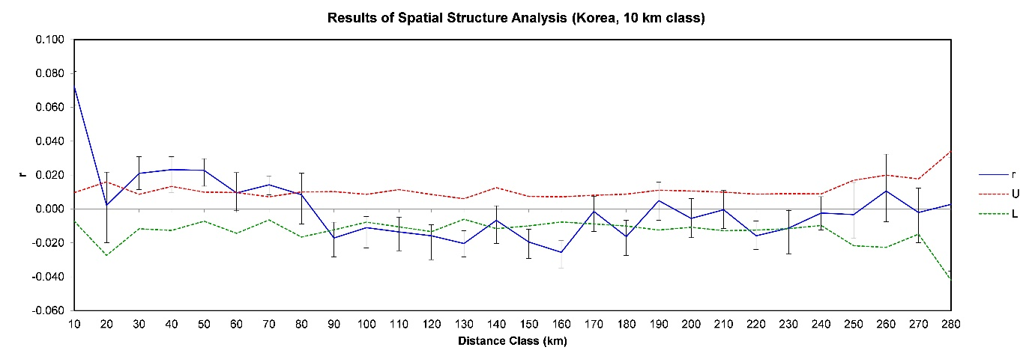
Fig. S1. Spatial autocorrelation analysis at 10 km distance class using Korean pops. r (blue line) means autocorrelation coefficient, U (dashed red) +95% confidence, L (dashed green) -95% confidence

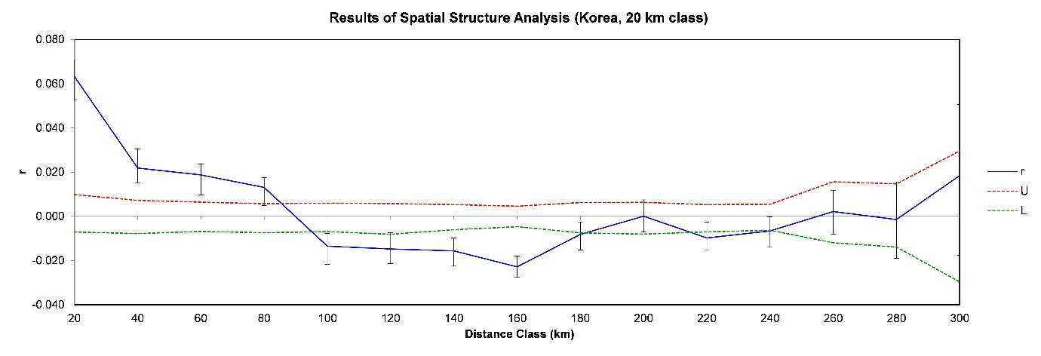
Fig. S2. Spatial autocorrelation analysis at 20 km distance class using Korean pops. r (blue line) means autocorrelation coefficient, U (dashed red) +95% confidence, L (dashed green) -95% confidence

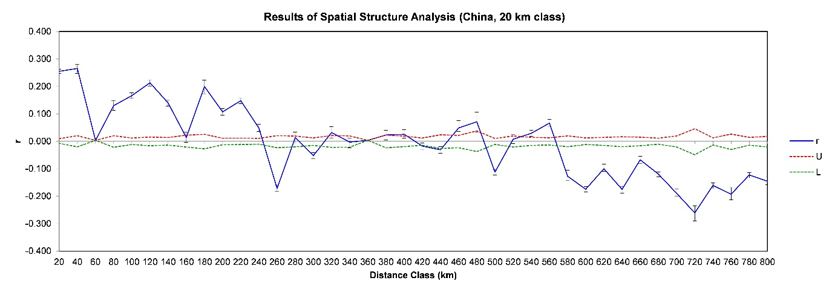
Fig. S3. Spatial autocorrelation analysis at 20 km distance class using Chinese pops. r (blue line) means autocorrelation coefficient, U (dashed red) +95% confidence, L (dashed green) -95% confidence

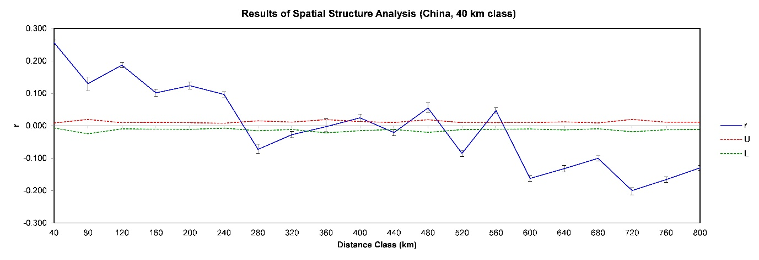
Fig. S4. Spatial autocorrelation analysis at 10 km distance class using Chinese pops. r (blue line) means autocorrelation coefficient, U (dashed red) +95% confidence, L (dashed green) -95% confidence

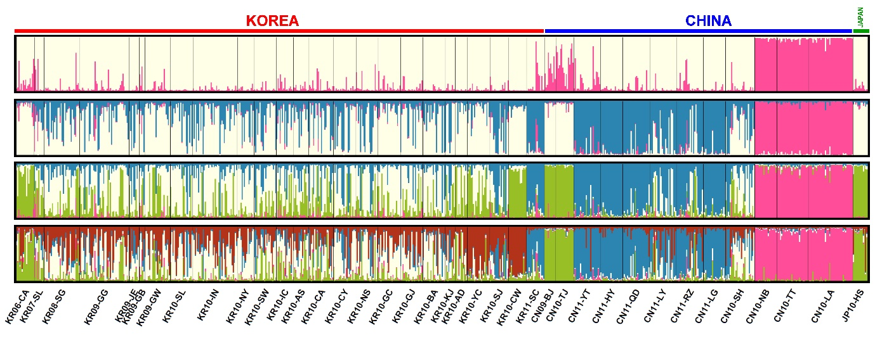
Fig. S5. Genetic structure of L. delicatula for 762 individuals collected from Korea, China and Japan, visualized by individual assignment. In order from the top to the bottom, each genetic structure is shown when K = 2, 3, 4 or 5, respectively.

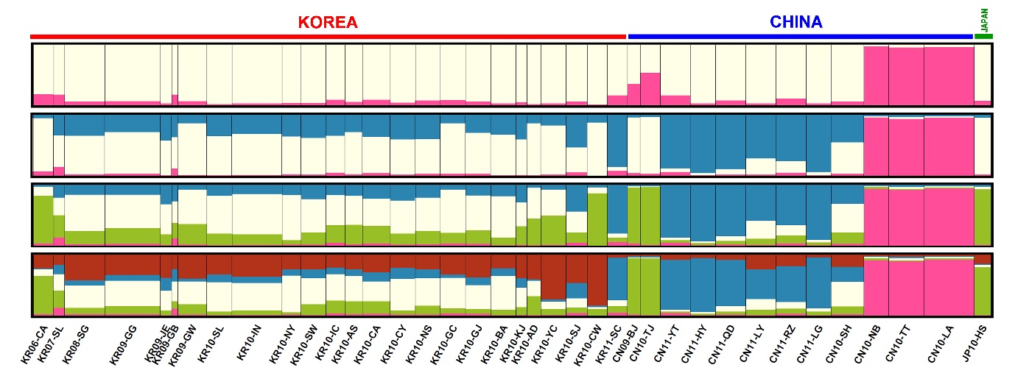
Fig. S6. Genetic structure of L. delicatula for 762 individuals collected from Korea, China and Japan, visualized by group (pop.) assignment. In order from the top to the bottom, each genetic structure is shown when K = 2, 3, 4 or 5, respectively.

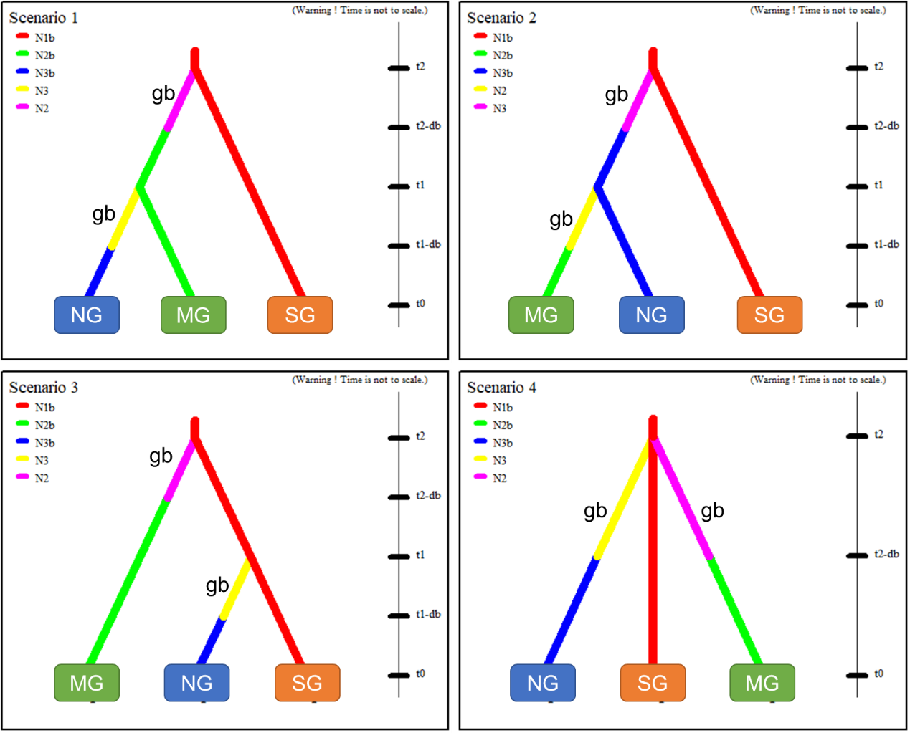

Fig. S7. The four scenarios (1–4) for the DIYABC analyses to infer the invasion route into northern (NG) and/or middle (MG) part of South Korea from Shanghai (SG), China, using a dataset that includes 168 individuals from three subgroups, which consisted of 80 individuals from the ‘NG’ group (KR10-SL, KR10-IN, KR10-SW); 62 from the ‘MG’ group (KR10-CA, KR10-NS, KR10-BA); and 26 from the ‘SG’ group (CN10-SH). ‘gb’ means genetic bottleneck

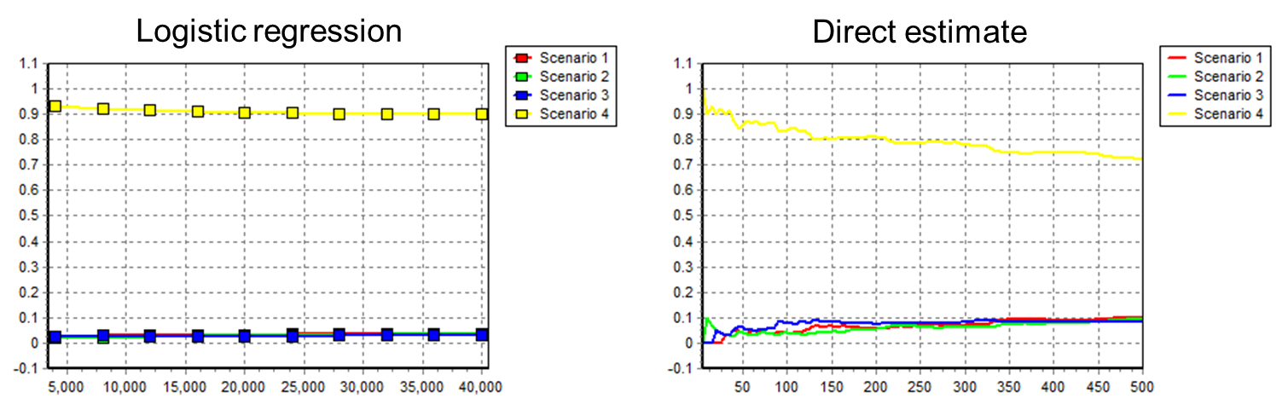

Fig. S8. Plots output by DIYABC showing the posterior probability (y-axis) of the three scenarios through the the logistic regression (left) and direct estimate (right) approaches as output by DIYABC. The x-axis corresponds to the different n_{δ} values used in the computations.

