Table 1: General supply chain management structures and processes at low and high resource availability hospitals in Ghana

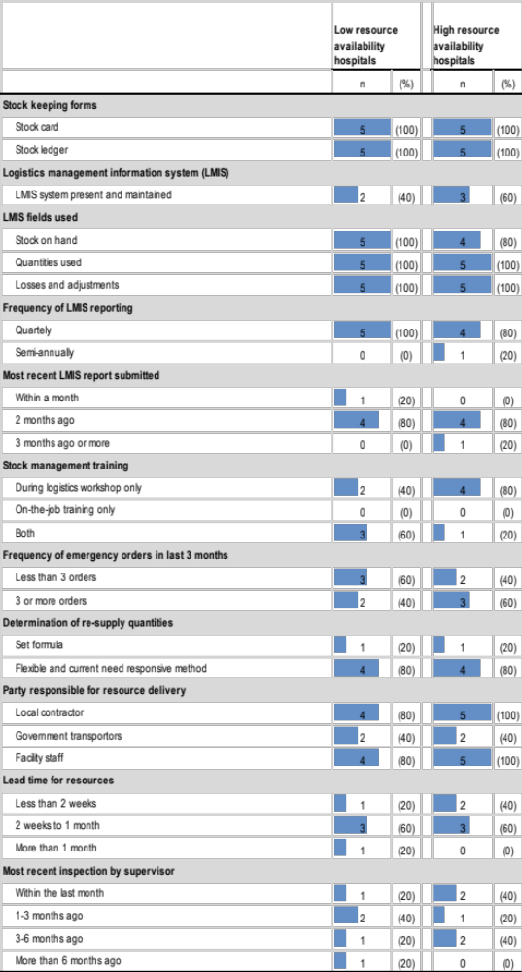

Table 2: Trauma resource availability and stock management at low and high resource availability hospitals in Ghana

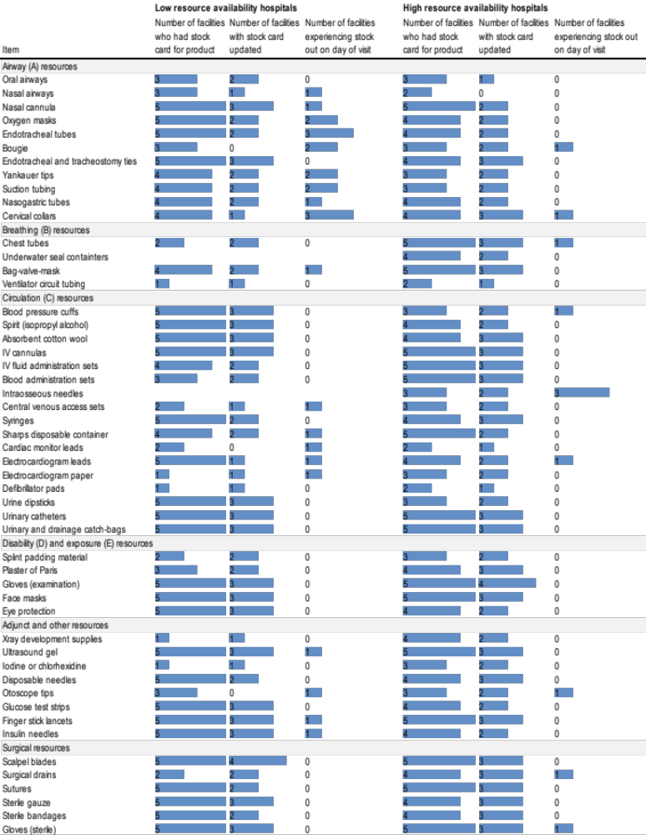

Table 3: Stock management and supply chain performance for trauma resources at low and high resource availability hospitals in Ghana

 | Low resource availability hospitals |  |  | High resource availability hospitals
 | median | (range) |  | median | (range) |  | p-value
Resources managed
Items managed (out of 51 trauma resources) | 40 | (34-51) |  | 47 | (35-51) |  | 0.09
Stock keeping
Stock cards available | 35 | (33-45) |  | 44 | (25-51) |  | 0.52
Stock cards updated | 24 | (0-45) |  | 31 | (0-45) |  | 0.83
Supply chain performance
Stock-out on day of visit | 4 | (2-14) |  | 1 | (0-5) |  | 0.05
Stock-out within 6 months | 9 | (3-16) |  | 2 | (0-7) |  | 0.07
Number of stock-outs within 6 months | 9 | (3-57) |  | 2 | (0-9) |  | 0.09
Number of days stock-out | 171 | (51-1,268) |  | 8 | (0-182) |  | 0.11

Table 4: Trauma care resource storage conditions at low and high resource availability hospitals in Ghana

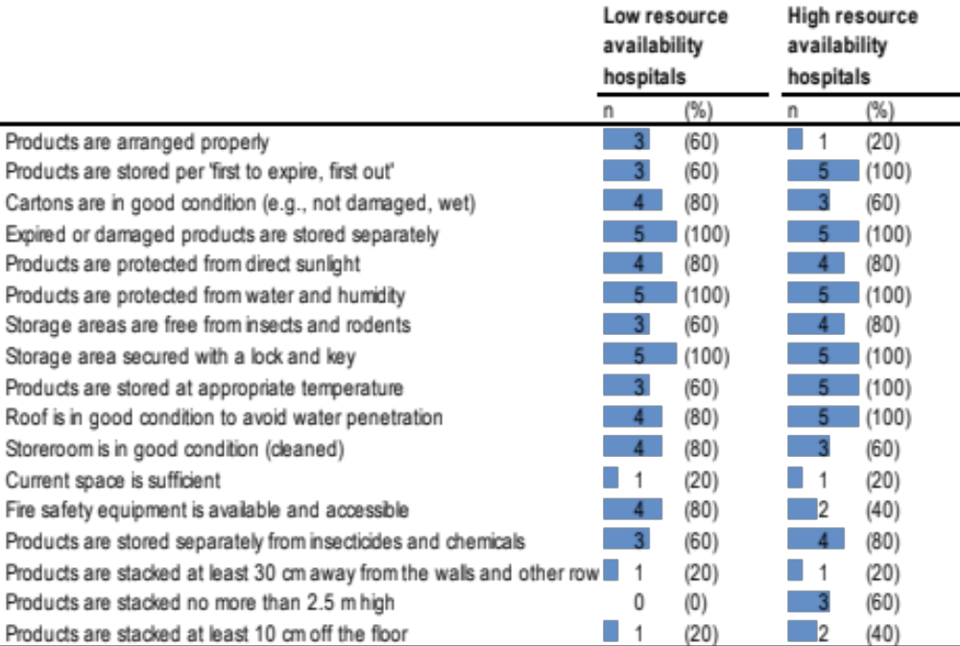

Table 5: Trauma resource stock-outs at low and high resource availability hospitals in Ghana

