Supplementary Information

Appendix S1. Emerald Ash Borer Spatiotemporal Management Prioritization Details

Decision context

Our optimization problem aims to minimize the impact of emerald ash borer (EAB) on street ash trees by identifying the best set of management actions to implement. To achieve this, we consider a set of discrete sites with host trees susceptible to pest attack and a set of discrete time periods. At a given point in time, each site could potentially have a management action implemented within it to control EAB. Specifically, we consider three possible management actions: (i) quarantining a site to limit entry of pests to the site, (ii) quarantining a site to limit the spread of pests from a site to other sites, and (iii) biological control of a site to reduce the pest population within the site. By strategically implementing particular actions within particular sites at particular points in time, our optimization model can identify optimal management plans for EAB.

Model description

Nonlinear formulation

Although we formulated our optimization problem using mixed integer programming (MILP) techniques (see below), we first describe a non-linear formulation to provide an intuitive understanding.

Sets

We consider a set of I sites which can be managed independently over a horizon of T planning periods, i ∈ I, t ∈ T. (Table S1). For simplicity in notation, we also use I and T to indicate the cardinalities of the sets. We also define an upper bound on the total budget available for EAB management, B at each planning period t $ϵ T$. (Table S1).

Constants

Each management action is characterized by an efficiency term that is defined as the proportional reduction of the total pest population in site i. Symbol $ε_{α}$ denotes the efficiency of an immigration-focused quarantine, which is the proportional reduction in immigration of propagules to site i; $ε_{β}$ is the efficiency of an emigration-focused quarantine (i.e., the proportional reduction in emigration of pest propagules from site i elsewhere), and $ε_{γ}$ is the efficiency of biological control actions, which is the proportional reduction in pest population size at a given site $i ϵ I$ after a biological control release of parasitoid wasps had achieved their maximal density in a period $t ϵ T$. We assumed a constant per-site cost of immigration- and emigration focused quarantines, $c_{α}$ and $c_{β}$, and biological control actions $c_{γ}$ (Table S2).
To approximate susceptible trees, let $V_{i}$denote the number of street ash (Fraxinus spp.) trees in site i $ϵ I$. The number of street trees was estimated using a street tree distributional model from Hudgins et al. (2022). For simplicity, we assumed that the EAB population in site i grows at a constant rate, $δ$. We assume that small EAB populations are subject to Allee effects and require some minimal density to persist (Tobin & Liebhold 2010). Once the EAB population size reaches the threshold size $ϕ$ in site i, we assume that EAB propagules can grow and spread from that site to other sites. Let $M_{i,j,t}$ be the proportion of dispersing propagules from a source site i,to a destination site j; i, j $ϵ I$in period t$ϵ T$. For example, a value of $M_{1,2,3}$= 0.3 means that 30% of the organisms in site 1 would be expected to disperse to site 2 during time period 3. We used the model from Hudgins et al. (2017; 2020) to define the values of M_{i,j,t}, $δ$ (i.e., 1.299 per 5-year time step), and $ϕ$(0.00054). The initial source cell of the EAB invasion was also taken from this model, and was denoted by s, which corresponded to cell i = 2951 of the matrix.
To describe parasitoid wasp dispersal between sites, let the binary parameter $A_{i,j}$ describe which sites $i ϵ I$ are adjacent to sites $j ϵ I$ (e.g. within $50km⋅\sqrt{2}$ of a given cell), i.e.:

$$A_{i,j} = \left\{\begin{aligned}1 if site i is adjacent to site j (1a) \\ 0 otherwise (1b)\end{aligned}\right.$$
Decision variables
We defined three sets of binary decision variables to select EAB management actions: $α$_{i,t} selects the quarantine limiting pest entries into site i in period t;,$β$_{i,t}, selects a quarantine limiting the pest spread from site i elsewhere, and $γ$_{i,t}, selects biological control at site i in period t, i,e,:.
$$α_{i,t}=\left\{\begin{aligned}if site i was selected for immigration- \\ 1 focused quarantines at time t (2a) \\ 0 otherwise \left(2b\right) \\ \end{aligned}\right.$$
$β_{i,t}=\left\{\begin{aligned}if site i was selected for emigration- \\ 1 focused quarantines at time t (2c) \\ 0 otherwise \left(2d\right) \\ \end{aligned}\right.$
$γ_{i,t}=\left\{\begin{aligned} if site i was selected for biological \\ 1 control at time t (2e) \\ 0 otherwise \left(2f\right) \\ \end{aligned}\right.$
We modelled the spatiotemporal distribution of EAB across the study system. This step was important so that our optimization process had the available information to strategically target particular sites at particular points in time to control EAB. Let the continuous decision variable $P_{i,t}$ denote the propagule pressure at sites $i ϵ I$ during time periods $t ϵ T$. Simulations of the published model by Hudgins et al. (2020) allowed us to predetermine the initial pest relative propagule pressure, $P_{i,1}$. The impact of known biological control releases prior to the start of the optimization time window that would have affected $P_{i,1 }$were simulated using data from the MapBioControl database (APHIS 2021) and the R analogues of the optimization problem (code and derived data available at https://anonymous.4open.science/r/eab_mgmt-D7C7/).
Our model also required the estimation of biological control organism (parasitoid wasp) dynamics. Let $G_{i,t}$ denote a simplified proxy of the parasitoid density in each cell $i ϵ I$ at each timestep $t ϵ T$. $G_{i,t}$ decision variable values were calculated as follows:

$G_{i,t}=\left\{\begin{aligned}if biological control release was done \\ 0.5 locally at the previous timestep or in a \\ neighbouring cell 2 timesteps ago \left(3a\right) \\ if biological control release was done \\ 1 locally two timesteps ago or in a \\ neighbouring cell 3 timesteps ago (3b) \\ 0 otherwise \left(3c\right)\end{aligned}\right.$
The impact of known biological control releases prior to the start of the optimization time window that would impact $G_{i,t}$during the optimization time window were incorporated as fixed, precalculated quantities. For example, if site i = 700 experienced a biological control release in 2015 (t = 0), based on eqn. 4,
$G_{700,1}=$0.5,$G_{700,2}=1, G_{A_{700,j},2}=0.5, G_{A_{700,j},3}=0.5=1 , ∀ j ϵ A_{700,j}=1$
Linearized decision variables
To make our problem solvable via MILP complete with its growth and dispersal components (Belotti et al. 2016), we performed a set of linearization steps to the relative propagule pressure $P_{i,t}$ across growth, dispersal, and management components. We denote these using the continuous decision variables $w_{i,t}$, $w'_{i,t}$, $w″_{i,t}$,${w_{i,t}}^{β}$,$w{'''}_{i,t}$, and$w{''''}_{i,t}$. To represent the linearization steps that were applied to each cell during the optimization, we relied on a set of binary indicator decision variables $θ_{i,t}$.
Initial pest densities at each timestep were calculated using a decision variable defined as follows:
$w_{i,1}=$ $\left\{\begin{aligned}1 for the initial source site (4a) \\ P_{i,1 } outside the initial source site (4b)\end{aligned}\right.$
The first form of management to be applied was biological control, which transformed $w_{i,t}$, into $w'_{i,t}$.
$w'_{i,t}=w_{i,t}*$ (1-$G_{i,t}$*efficiency of biological control) (5)
Before dispersal, pest densities were subjected to the growth threshold $ϕ$, which prevented sites where pest density was below this value from growing, being detected, and sending out propagules (Table S1-S2). This threshold was implemented using the following decision variables:
$$θ_{i,t}^{ϕ}=\left\{\begin{aligned}1 for all sites where w'_{i,t}is greater than the growth threshold (6a) \\ 0 for all sites where w'_{i,t}is less than the growth threshold (6b)\end{aligned}\right.$$
Before emigration, the effect of emigration quarantines was applied to calculate the density that can leave each cell $w^{β}$.
$w_{i,t}^{β}= {w″}_{i,t}(1-β_{i,t}$*efficiency of emigration quarantine) (7)
Note that emigration quarantines do not decrease local density, only the density that can leave a cell. As immigration is calculated, the effect of immigration quarantines is applied and transforms $w''$ to $w'''$:
$w‴_{i,t}=$ ${w″}_{i,t}$+ immigration*(1- $α_{i,t}$*efficiency of immigration quarantine) - emigration (8)
After dispersal, pest densities were once again checked against the growth threshold and were allowed to grow if they still met it, or were reset to this threshold if no management had taken place and they had been extirpated naturally.

$$w⁗_{i,t}=\left\{\begin{aligned}{w″'}_{i,t}*growth rate For non-initial source sites where the \\ growth threshold is still \\ reached after dispersal (9a) \\ {w″'}_{i,t}(no growth) For sites with no management where \\ the growth threshold was never met, \\ or for sites where management \\ has led to extirpation (9b) \\ growth threshold * growth rate For sites with no management \\ whose density has gone below \\ the growth threshold (9c) \\ 1 * growth rate For the initial source site (9d)\end{aligned}\right.$$
Finally, the density at the next timestep was calculated based on decision variables that checked whether the maximum density of 1 has been reached in a cell:

$w_{i,t+1}= \left\{\begin{aligned}{w″''}_{i,t} for sites where the maximum density was not exceeded (10a) \\ 1 for sites at or above the maximum density and the initial \\ source site (10b)\end{aligned}\right.$
$θ_{i,t}^{<1} =1,θ_{i,t}^{>1} =0$ If the site is below the maximum density (10c)
$θ_{i,t}^{>1} =1$, $θ_{i,t}^{<1} =0$ If the site is at or above the maximum density (10d)

Mathematical formulation
After defining the sets, constants, and decision variables employed, we now formulate the decision problem mathematically as a Mixed Integer Linear Program (MILP):

minimize $\sum_{iϵI}{\sum_{t∈T^{'}}{w_{i,t}\left(V_{i}+1\right)}}$ (11a)
subject to $α_{i,t}+β_{i,t}+γ_{i,t}≤1 ∀ i ∀ t : t≤6$ (11b)
$\sum_{iϵI}{α_{i,t}c_{α}+β_{i,t}c_{β}+γ_{i,t}c_{γ}≤B } ∀ i ∀ t :t≤6$ (11c)
$α_{i,t}+β_{i,t}+γ_{i,t}≤0 ∀ i ∀ t : t>6$ (11d)
$\sum_{iϵI}{α_{i,t}c_{α}+β_{i,t}c_{β}+γ_{i,t}c_{γ}≤0 } ∀ i ∀ t :t>6$ (11e)
$α_{i,t}, β_{i,t}, γ_{i, t }ϵ \{0,1\}$ (11f)
$γ_{i,t}=0$ $∀ i,t | P_{i,t}≤ 0.027$ (11g)

$w_{i,1}=$ $\left\{\begin{aligned} s ∀ t | i=s (12a) \\ P_{i,1} ∀ i,t | t=1 (12b)\end{aligned}\right.$
$0≤w_{i,t}≤1$ (12c)

$w'_{i,t}= (1-G_{i,t}ε_{γ})w_{i,t}$ $∀ i,∀ t$ (13a)
$0≤{w'}_{i,t}≤1$ (13b)
$G_{i,t}=$ $\left\{\begin{aligned}0.5 ∀i,t | γ_{i,t-1}+γ_{A_{i},t-2}≥1 ∧γ_{i,t-2}+γ_{A_{i},t-3}=0 (13c) \\ 1 ∀i,t | γ_{i,t-2}+γ_{A_{i},t-3}≥1 (13d) \\ 0 ∀i,t | γ_{i,t-1}+γ_{A_{i},t-2}+γ_{i,t-2}+γ_{A_{i},t-3}=0 (13e)\end{aligned}\right.$
$G_{i, t} ϵ \{0,0.5,1\}$ (13f)
$A_{i,t}ϵ \{0,1\}$ (13g)

$w″_{i,t}=$ $θ_{i,t}^{ϕ}w'$ $∀ i,∀ t$ (14a)
$θ_{i,t}^{ϕ}=$ $\left\{\begin{aligned}1 ∀ i,∀ t | w'_{i,t}≥ϕ (14b) \\ 0 ∀ i,∀ t | w'_{i,t}<ϕ (14c)\end{aligned}\right.$
$θ_{i,t}^{ϕ}≥\frac{w'_{i,t}-ϕ}{\frac{1}{ϕ}}$ (14d)
$0≤{w''}_{i,t}≤1$ (14e)
$θ_{i,t}^{ϕ}ϵ \{0,1\}$ (14f)

$w_{i,t}^{β}= w″(1-β_{i,t}ε_{β})$ (15a)
$0≤{w_{i,t}}^{β}≤1$ (15b)

$w‴_{i,t}=$ $w″+\sum_{j}{w_{j,t}^{β}M_{j,i,t}(1-{α_{i,t}ε}_{α})} -\sum_{j}{w_{i,t}^{β}M_{i,j,t}}$ (16a)
$0≤{w'''}_{i,t}≤1$ (16b)

$$w⁗_{i,t}=\left\{\begin{aligned}{w'″}_{i,t}δ ∀ i :i≠s,∀ t | θ_{i,t}^{ϕ_{2}}=1 (17a) \\ {w'″}_{i,t} ∀ i :i≠s,∀ t | θ_{i,t}^{ϕ_{2}}=0 ∧\left(G_{i,t}+α_{i,t}>0 ∨ θ_{i,t}^{ϕ}=0\right) (17b) \\ ϕδ ∀ i :i≠s,∀ t |θ_{i,t}^{ϕ_{2}}=0 ∧ θ_{i,t}^{ϕ}=1 ∧ G_{i,t}+α_{i,t}=0 (17c) \\ δ ∀ t | i=s (17d)\end{aligned} \right.$$

$w⁗_{i,t}≥w‴_{i,t}$ (17e)
$$θ_{i,t}^{ϕ_{2}}=\left\{\begin{aligned}1 ∀ i,∀ t | w{'''}_{i,t}≥ϕ (17f) \\ 0 ∀ i,∀ t | w{'''}_{i,t}<ϕ (17g)\end{aligned}\right.$$
$θ_{i,t}^{ϕ_{2}}≥\frac{w{'''}_{i,t}-ϕ}{\frac{1}{ϕ}}$ (17h)

$θ_{i,t}^{ϕ_{2}}ϵ \left\{0,1\right\}$ (17i)
$0≤{w''''}_{i,t}≤1$ (17j)

$$w_{i,t+1}= \left\{\begin{aligned}{w''″}_{i,t} ∀i: i≠s, ∀ t: t>1 | θ_{i,t}^{<1}=1 (18a) \\ 1 i=s, ∀i : i≠s, ∀ t:t>1 | θ_{i,t}^{>1}=1 (18b)\end{aligned} \right.$$
$θ_{i,t}^{<1} ≤ 1+\frac{1-w''''_{i,t}}{\frac{3}{ϕ}}$ (18c)
$θ_{i,t}^{>1} ≥ \frac{w''''_{i,t}-1}{\frac{3}{ϕ}}$ (18d)
$θ_{i,t}^{>1}+θ_{i,t}^{<1}=1$ (18e)
$θ_{i,t}^{>1},θ_{i,t}^{<1} ϵ \{0,1\}$ (18f)

The objective function (Eqn. 11a) minimizes the number of street ash trees exposed to EAB over a set of T planning periods (T = 8 in our study). We assume that the time horizon for possible management actions is shorter (6 periods out of 8 in our study) because some of the available management actions involve time delays. The objective minimizes the sum of the products of pest densities in each site i in period t, times the number of street ash trees in site i (Eqn. 11a). Note that we added one to the number of trees in each site i in period t to account for a possibility of that managing sites with no street ash trees would still benefit efforts to control EAB. Constraints (11b-c) ensure that only one management type can be applied to site i in period t (Eqn. 2b), and that the total cost of all management actions in a period is limited by the available budget B (Table 1, Eqn. 11c). Additional constraints (11d-e) restrict management action after 6 periods. We assumed that biological control could only be applied in sites where propagule pressure was above the chosen threshold, as managers tend to use the EAB population densities as a proxy indicator to guide the application of biological control measures. In our case, pest density in site i would have to be at least 2.7% of the modelled carrying capacity to qualify for biological control measures (Eqn. 11f), which corresponded to the mean predicted EAB density across all invaded sites in the US in 2020 by the underlying EAB spread model (Hudgins et al. 2022).
Eqns. 12-18 describe how management actions interact with spread, where biological control actions reduce the relative propagule pressure in a focal cell, quarantine measures targeted on immigration reduce propagule pressure flowing into a focal cell, and for quarantine measures targeted on emigration reduce propagule pressure leaving a focal cell, all in line with their respective efficiencies.
At the start of each timestep t, the linearized propagule pressure variable was set to the final linearized propagule pressure variable at the previous timestep t – 1 (Eqn. 12a, see also later Eqn. 18), except in the first timestep where it was set to the pre-calculated propagule pressure from Hudgins et al. (2020), and for the initial source location where it was fixed at 1 (Eqn. 12b).
The first nonlinear factor that impacted propagule pressure was biological control and its impact on parasitoid density in a site. Pest propagule pressure was reduced in line with the effectiveness and implementation status of biological control (Eqn. 13a) and the level of parasitoid density achieved in the cell (Eqn. 13c-e). In our model, five years after a biocontrol program began, the program could achieve 50% of its maximal efficiency (Eqn. 13c), followed by an achievement of 100% of the maximal efficiency after 2 timesteps (Eqn. 13d). Due to dispersal, adjacent cells became infested at a level of 50% maximal efficiency 1 timestep (5yr) after 50% effective density was achieved in a focal cell (i.e., 2 timesteps after initial parasitoid release) (Eqn. 13c). The adjacent sites were then analogously upped to 100% of the maximal biological control efficiency 3 timesteps after initial parasitoid release in their neighbouring cells (Eqn. 13d).
The next step was the implementation of the growth and dispersal threshold (Eqn. 14). We added a binary indicator variable activated by propagule pressure values above the growth threshold (Eqn. 14b-c). This indicator set the propagule pressure to zero if densities were below the growth threshold (Eqn. 14a). Comparing the difference between the propagule pressure and the threshold value and dividing by a big-M value ensured that this indicator constraint was appropriately selected (Eqn. 14d).
Next was the dispersal phase. First, we calculated the fraction of propagule pressure capable of performing emigration depending on whether an emigration-focused quarantine strategy was chosen, where the fraction would be reduced by the proportional efficiency of the quarantine if it was applied (Eqn. 15a). Along a similar vein, the resulting propagule pressure after immigration was calculated based on whether an immigration-focused quarantine strategy was chosen, where the proportional reduction in immigration to a site was equal to the efficiency of the immigration-focused quarantine when it was applied (Eqn. 16a).
Next was the growth phase. The effect of the growth phase was based on four cases of propagule pressure and management. In the first case, when the propagule pressure was above the detection threshold after the dispersal phase (Eqn. 17a), the site grew by the growth rate. If the site did not contain a detectable EAB population (i.e. above the growth and dispersal threshold) before or after the dispersal phase, it did not grow (Eqn. 17b). If the site had contained a detectable EAB population prior to the dispersal phase, but had become extirpated after the dispersal phase (i.e., propagule pressure had been reduced below the detection threshold), and had not been managed, we reset the propagule pressure to the detection threshold (Eqn. 17c). Finally, the source site grew to the maximum propagule pressure of 1 times the growth rate (Eqn. 17d). The creation of an indicator constraint, $θ_{i,t}^{ϕ_{2}},$ based on whether the propagule pressure was below or above $ϕ$(Eqn. 17f-j) helped to distinguish these cases. This indicator constraint was based on a big-M (relatively large constant) value of $\frac{1}{ϕ}$ (Eqn. 17f-g, Belotti et al. 2016).
Finally, the post-growth propagule pressure value allowed for the calculation of the starting propagule pressure at the next timestep, which had a maximum value of 1 (Eqn. 18a-b). The creation of indicator constraints, $θ_{i,t}^{>1}, θ_{i,t}^{<1}$helped to distinguish these cases (Eqn. 18c-e). These indicator constraints were based on a big-M (relatively large constant) value of 3 (Eqn. 18c-d, Belotti et al. 2016).

Efficiency and Budget Scenarios
Since uncertainty remains in the relative degree to which a given management action can control pest population dynamics, we examined a range of scenarios to examine the impact of different levels of management efficiency (defined as the proportional reduction in the pest population that can complete population growth or dispersal). For each scenario, we identified an optimal set of management actions needed to minimize impacts of EAB assuming a given level of management efficiency (Table S1).
We initially ran scenarios where the budget was optimally allocated among all three possible management actions. However, we also tested cases where the budget was forced to be allocated between site (biological control) and spread (quarantine) focused measures in a given proportion, where $ρ_{γ}$ and $ρ_{μ}$ were the proportion of the total budget $B$ allocated to the site and spread-focused management strategies, respectively. We tested 20% increments.
This caused eqn. 11c to be altered to the following equation:
$α_{i,t}c_{α}+β_{i,t}c_{β}≤Bρ_{μ};∀\{1,...,D\} γ_{i,t}c_{γ}≤Bρ_{γ};∀\{1,...,D\}$ (11g)
$ρ_{μ}$ , $ρ_{γ}$ $ϵ \{0\%,20\%,40\%,60\%,80\%,100\%\}$ (11h)
Additional Scenarios/Sensitivity Analysis
Given the imprecise nature of several estimates in our optimization, we tested the sensitivity of our framework to different parameter values. First, we tested sensitivity to our density threshold for biological control by allowing it to be selected at any propagule pressure value (not just those over 2.7%) by removing Eqn. 1lg. Second, we sped up parasitoid growth by replacing Eqn 13c-e. with:

$G_{i,t}=$ $\left\{\begin{aligned}0.5 ∀i,t | \sum_{jϵI}{γ_{A_{i,j},t-2}}≥1∧γ_{i,t-1}+γ_{A_{i},t-2}=0 (13c) \\ 1 ∀i,t |γ_{t-1} +\sum_{jϵI}{γ_{A_{i,j},t-3}}≥1 (13d) \\ 0 ∀ i,t | γ_{i,t-1}+\sum_{jϵI}{γ_{A_{i,j},t-2}}+\sum_{jϵI}{γ_{A_{i,j},t-3}}=0 (13e)\end{aligned} \right.$
Third, we sped up both growth and dispersal by replacing Eqn. 13c-e with the following equations:
$G_{i,t}=$ $\left\{\begin{aligned}1 ∀i,t | γ_{i,t-1}+\sum_{jϵI}{γ_{A_{i,j},t-2}}≥1 (13c) \\ 0 ∀i,t | γ_{i,t-1}+\sum_{jϵI}{γ_{A_{i,j},t-2}}=0 (13d)\end{aligned} \right.$

In sensitivity analyses examining the impact of different parasitoid dynamics on the optimized number of ash trees exposed to EAB, there was a positive but minimal effect of faster parasitoid dispersal on ash tree exposure, where more ash trees were exposed in low efficiency scenarios. However, there was very little spatial difference in the best management strategy across model formulations, indicating minimal sensitivity to misspecification (Table S2, Fig S2a-b). In other words, the fact there is uncertainty in parasitoid dispersal rates likely has minimal impact on the extent of mortality predicted. Similarly, the relaxation of the 2.7% threshold for parasitoid release resulted in solutions with slightly less exposure, but spatially similar patterning (Table S2, Fig. S2c). Again, this result was particularly pronounced at low efficiencies.
Rules-of-thumb
We compared our optimal solutions with common rules-of-thumb used for determining priority management sites. When determining quarantine locations, prioritizations often focus on controlling key sources, sinks and hubs contributing to the spread of an infestation (Yemshanov et al. 2015). A suitable graph theoretical metric to characterize these hubs controlling the propagule flow is degree centrality, which defines the number of shortest links in a graph connecting through a given node (Jentsch et al. 2020). Betweenness centrality is a similar metric that is frequently used for assessing the importance of nodes for the flow of propagules and can be useful for prioritizing quarantines. However, this metric is less straightforward to calculate because our pest dispersal model does not explicitly model spread paths through multiple cells at each time step. In our case, we defined the shortest link as the pair of cells associated with the greatest influx or outflux of propagules. Let N denote the network represented by the movement array $M_{i,j,t}$ at a given timestep t$ϵ T'$. N contains nodes i$ϵI$ and edges $\{i,j\},$ $i ϵ I,j ϵ I$. Let $φ^{α}$denote the shortest link for immigration to site i, and let and ${φ_{i}}^{β}$denote the shortest link for emigration from site i, i.e.:

${φ_{i}}^{α}=\{argmax_{jϵI} M_{j,i,t},i\}$ (19)
${φ_{i}}^{β}=\{i, argmax_{jϵI} M_{i,j,t}\}$ (20)

We further applied a weighting coefficient to the centrality metrics in Eqns. 19-20 to better quantify infestation risk. In the case of prioritizing immigration-focused quarantines preventing propagules from spreading into a site from any potential source cell, we weighted the degree centrality of each shortest link by the inverse of each destination node’s propagule pressure, and the number of street ash trees in each destination node. This rescaling quantifies how an increase in propagule pressure translates into increased tree exposure.

${ψ_{i}}^{α}=(1-P_{i})V_{i}P_{{φ_{i}}^{α}}$ (21)

This first rule of thumb follows the idea of the maximum expected coverage problem formulated in Yemshanov et al. (2015), which maximized the number of origin sites and potential sources of propagules to a destination site addressed by a pest management action. In our case, we have added a weighting scheme to each origin site which relates to its propagule pressure contribution and the number of susceptible trees in the recipient site (Eqn. 21). Thus, immigration quarantines are prioritized in sites that possess many street trees and presently have low propagule pressure, but receive a high propagule influx from many sites.
For emigration-focused quarantines preventing the spread of propagules out of a site i into other sites, we weighted each link between sites by the flow out of the shortest path, as well as the inverse of the propagule pressure and the host quantity in the destination.

${ψ_{i,t}}^{β}=(1-P_{{φ_{i,t}}^{α}})V_{{φ_{i,t}}^{α}}P_{i,t}$ (22)

Sites that are priorities for emigration-focused quarantines have high propagule pressure and send propagules to many sites with many street trees and low propagule pressure (Eqn. 22).

${ψ_{i,t}}^{γ}= \frac{P_{i,t}V_{i}}{c_{γ}}$ (23)

Biological control sites were prioritized based on their cost effectiveness, calculated as the potential reduction of trees exposed to EAB, divided by the cost of management (Yemshanov et al. 2017, Eqn. 23). This is also known as the first-best strategy, and can be thought of as a greedy algorithm analogue of our optimization objective function. Sites are prioritized for biocontrol sequentially starting from the sites with the highest metric value and proceeding towards sites with lower priority metric values until the entire budget is used. In the case where the remaining budget was not sufficient to manage another site with the focal management type, another management type was selected (i.e., we assumed that additional quarantine sites could be selected once the budget could not support additional biological control sites, even in the 100% biological control strategy). We ordered our management prioritization by selecting biological control sites first, followed by quarantine sites, due to the high cost and high EAB density requirements for biocontrol measures. All rules-of-thumb calculations were performed in R using scripts adapted from Hudgins et al. (2020).

Table S1. Constants and sets used within the optimization. See the main text for more details on calculation.
Set | Domain | Definition
I | {1,...,3060} | Vector of site indices i
T | {1,..,8} | Vector of 5-year timesteps indexed by t
Constant | Value | Definition
$$c_{γ}$$ | $50 000 | Per-cell cost of biological control
$$c_{α}$$ | $15 241 | Per-cell cost of Immigration quarantine
$$c_{β}$$ | $15 241 | Per-cell cost of Emigration quarantine
$$ε_{γ}$$ | {0.3,0.6,0.9} | Efficiency scenarios of biological control
$$ε_{α}$$ | {0.1,0.3,0.5} | Efficiency scenarios of Immigration quarantine
$$ε_{β}$$ | {0.3,0.6,0.9} | Efficiency scenarios of Emigration quarantine
A_{i,j} | [{0,1},{0,1}] | 3060 x 3060 matrix indicating which sites j (in columns) are immediately adjacent to site i (in rows)
$$B$$ | $1 650 000 | Total Annual Budget
$$δ$$ | 1.299 | EAB growth rate (per 5-year timestep)
$$ϕ$$ | 0.000538 | EAB detection threshold (relative to maximum $P_{i,t}$ of 1)

Table S2. Set, decision variable and parameter definitions
 | Sets
Symbol | Definition
I | Set of sites (1799)
$$T$$ | set of timesteps (spanning 40 years)

 | Decision variables
Symbol | Definition
$G$_{I,t} | Parasitoid growth and spread function, which consists of a step growth function and neighbourhood dispersal function, with speeds that vary across model reformulations
$P$_{I,t} | Pest relative propagule pressure, a value between 0 and 1, where 1 is the carrying capacity of a site, that serves as a proxy for the density of EAB in a site
$$θ_{i,t}^{ϕ}, θ_{i,t}^{ϕ_{2}}$$  $$θ_{i,t}^{<1},θ_{i,t}^{>1}$$ | Indicator constraint used in the MILP to transform SDK equations into linear equations as a function of w terms.
$$ψ_{i,t}$$ | Priority ranking of a site i at timestep t within a particular management strategy
$α$_{I,t} | Quarantine action directed at immigration
$β$_{I,t} | Quarantine action directed at emigration
$γ$_{I,t} | Biological control action, see Table 1
$$w_{i,t}, {w'}_{i,t},$$  $${w''}_{i,t},{w'''}_{i,t},$$  $${w''''}_{i,t}, w_{i,t}^{β}$$ | Propagule pressure terms following indicator and big-M constraint transformations used in the MILP formulation and passed to the optimizer

 | Parameters
Symbol | Definition
A_{i,j} | Adjacency matrix among sites, where ones indicate sites are immediately adjacent to one another
$$B$$ | Annual management budget level (assumed constant each year during a 5-year timestep)
$$c$$ | Management action cost per site per year
$$i$$ | focal site
$$j$$ | non-focal site
$$M_{i,j,t}$$ | Immigration/emigration matrix, which contains the proportion of propagule pressure at a site that emigrates and immigrates to other sites as a function of the Hudgins et al. 2020 dispersal model.
$$N_{i,j}$$ | graph representation of the movement array $M$ at a given timestep t
$$t$$ | timestep (5 years)
$$δ$$ | Multiplicative pest growth rate per timestep, fitted in Hudgins et al. 2020.
$$ε$$ | Efficiency, represented as the proportion of propagule pressure killed by a particular management action
$$ρ$$ | budget proportion allocated to a given management strategy {0, 0.2, 0.4, 0.6, 0.8, 1.0}, where subscript $γ$ is the biological control strategy and subscript $μ$ corresponds to quarantine strategies
$$ϕ$$ | Pest emigration, detection and growth threshold, fitted in Hudgins et al. 2020. Below this threshold, sites can receive immigrant propagules but cannot send emigrant propagules to other sites or grow
$$φ_{i,j}$$ | Shortest path between nodes i and j in N

Literature Cited
Animal and Plant Health Inspection Service (2021). Federal EAB Quarantine and Authorized
Transit as of January 4, 2021. https://www.aphis.usda.gov/plant_health/
plant_pest_info/emerald_ash_b/downloads/eab_quarantine_map.pdf
Belotti, P., Bonami, P., Fischetti, M., Lodi, A., Monaci, M., Nogales-Gómez, A., &
Salvagnin, D. (2016). On handling indicator constraints in mixed integer
programming. Computational Optimization and Applications, 65(3), 545-566.
Hudgins, E.J., Koch, F.H., Ambrose, M.J., & Leung, B. (2022) Hotspots of pest-induced US
urban tree death, 2020-2050. J Appl Ecol. https://doi.org/10.1111/1365-2664.14141/
Hudgins, E. J., Liebhold, A. M., & Leung, B. (2017). Predicting the spread of all invasive
forest pests in the United States. Ecol. Lett. 20(4), 426-435.
Hudgins, E. J., Liebhold, A. M., & Leung, B. (2020). Comparing generalized and customized
spread models for nonnative forest pests. Ecol. Appl., 30(1), e01988.
Jentsch, P. C., Bauch, C. T., Yemshanov, D., & Anand, M. (2020). Go big or go home: A
model-based assessment of general strategies to slow the spread of forest pests via
infested firewood. PloS one, 15(9), e0238979.
Liebhold, A. M., & Tobin, P. C. (2010). Exploiting the Achilles heels of pest invasions: Allee
effects, stratified dispersal and management of forest insect establishment and spread.
Yemshanov, D., Haight, R. G., Koch, F. H., Lu, B., Venette, R., Fournier, R. E., & Turgeon,
J. J. (2017). Robust surveillance and control of invasive species using a scenario
optimization approach. Ecological Economics, 133, 86-98.
Yemshanov, D., Haight, R. G., Koch, F. H., Lu, B., Venette, R., Lyons, D. B., ... & Ryall, K.
(2015). Optimal allocation of invasive species surveillance with the maximum
expected coverage concept. Diversity and Distributions, 21(11), 1349-1359.

Supplementary Tables

Table S3. Proportion of total budget spent on each management action in the optimal solution for each model scenario
Quarantine efficiency | Biocontrol efficiency | Quarantine in percent | Quarantine out percent | Biological control percent | Percent of total budget spent
30% | 10% | 49.3 | 42.1 | 8.5 | 99.5
 | 30% | 44.9 | 40.5 | 14.6 | 99.6
 | 50% | 46.7 | 36.7 | 16.6 | 97.7
60% | 10% | 58.8 | 35.8 | 5.5 | 99.3
 | 30% | 55.6 | 33.4 | 10.9 | 99.3
 | 50% | 57.2 | 31.2 | 11.6 | 99.4
90% | 10% | 72.2 | 21.1 | 6.7 | 99.2
 | 30% | 72.4 | 20.1 | 7.5 | 93.4
 | 50% | 64.8 | 22.3 | 12.8 | 99.1

Table S4. Objective function values across scenarios (thousands of exposed street ash trees). Biocontrol- and quarantine-only scenarios restrict management to one type; fast parasitoid growth scenario assumes results 100% parasitoid efficacy in the treated location within 5 years instead of 10 years; fast dispersal and growth scenarios assume 100% parasitoid efficacy in the treated site within 5 years and dispersal to adjacent sites occurring within 5 years; no biocontrol threshold scenario removes the minimum propagule pressure restriction on an application of biological control to managed sites; and +8hrs solving time scenario checks for better solutions to baseline scenario solves for an additional 8 hours when 1% optimality gap was not reached.
Quarantine efficiency | Biocontrol efficiency | Baseline scenario | Only Biocontrol | Only Quarantine | Fast  Growth | Fast Dispersal and Growth | No biocontrol Threshold | +8hrs solving time
30% | 10% | 591.04 | 1041.40 | 624.42 | 596.73 | 598.34 | 585.36 | 589.54
 | 30% | 516.37 | 818.00 | 599.53 | 534.31 | 536.40 | 508.50 | 516.36
 | 50% | 460.32 | 667.45 | 576.62 | 469.35 | 493.55 | 448.04 | 455.13
60% | 10% | 404.2 | 1041.40 | 419.57 | 408.84 | 412.95 | 399.18 | 404.04
 | 30% | 372.66 | 818.00 | 414.97 | 386.28 | 391.27 | 365.98 | 372.15
 | 50% | 342.8 | 667.45 | 410.16 | 365.14 | 370.19 | 336.17 | 342.60
90% | 10% | 338.89 | 1041.40 | 352.50 | 342.54 | 342.65 | 337.80 | NA
 | 30% | 316.19 | 818.00 | 350.67 | 330.07 | 330.12 | 314.82 | NA
 | 50% | 295.15 | 667.45 | 350.35 | 317.41 | 317.74 | 295.04 | NA

Table S5. Mean relative propagule pressure and standard error of sites selected for each management action in the quarantine efficiency scenarios.

Action | Quarantine Efficiency | Median relative propagule pressure (proportion of carrying capacity) | Standard error
Biocontrol | 0.3 | 0.027916 | 0.01500325
 | 0.6 | 0.027916 | 0.00027668
 | 0.9 | 0.027916 | 3.72E-17
None | 0.3 | 0 | 1.80E-06
 | 0.6 | 0 | 1.14E-06
 | 0.9 | 0 | 7.60E-07
Quarantine in | 0.3 | 0.00964234 | 0.00091035
 | 0.6 | 0.00246815 | 0.000597
 | 0.9 | 0.00020826 | 0.0004812
Quarantine out | 0.3 | 0.00425746 | 0.00584697
 | 0.6 | 0.0028119 | 0.00713032
 | 0.9 | 0.00094687 | 0.01126986

Supplementary Figures

Figure S1. Comparison between the effectiveness (the reduction of street tree exposure to EAB over time) of optimal solutions with flexible budget apportionment across management types in the baseline model scenarios (dashed lines) and three different slight reformulation scenarios (filled circles). Darker purple colors denote the scenarios with low management efficiency (30% for quarantines and 10% for biological control) and yellow colors denote the scenarios with high management efficiency (90% for quarantines and 50% for biological control). Model reformulations: a) Parasitoid growth reaches 100% within 5 years (one timestep); b) Parasitoid growth reaches 100% within 5 years and can disperse at maximal levels to neighbouring cells after 5 years; c) Biological control management can be enacted in any site, regardless of EAB density.
a.
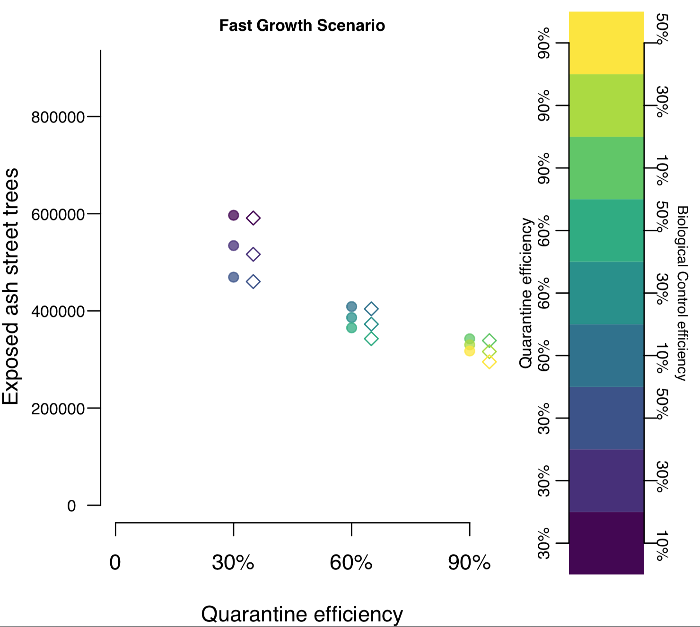
b.
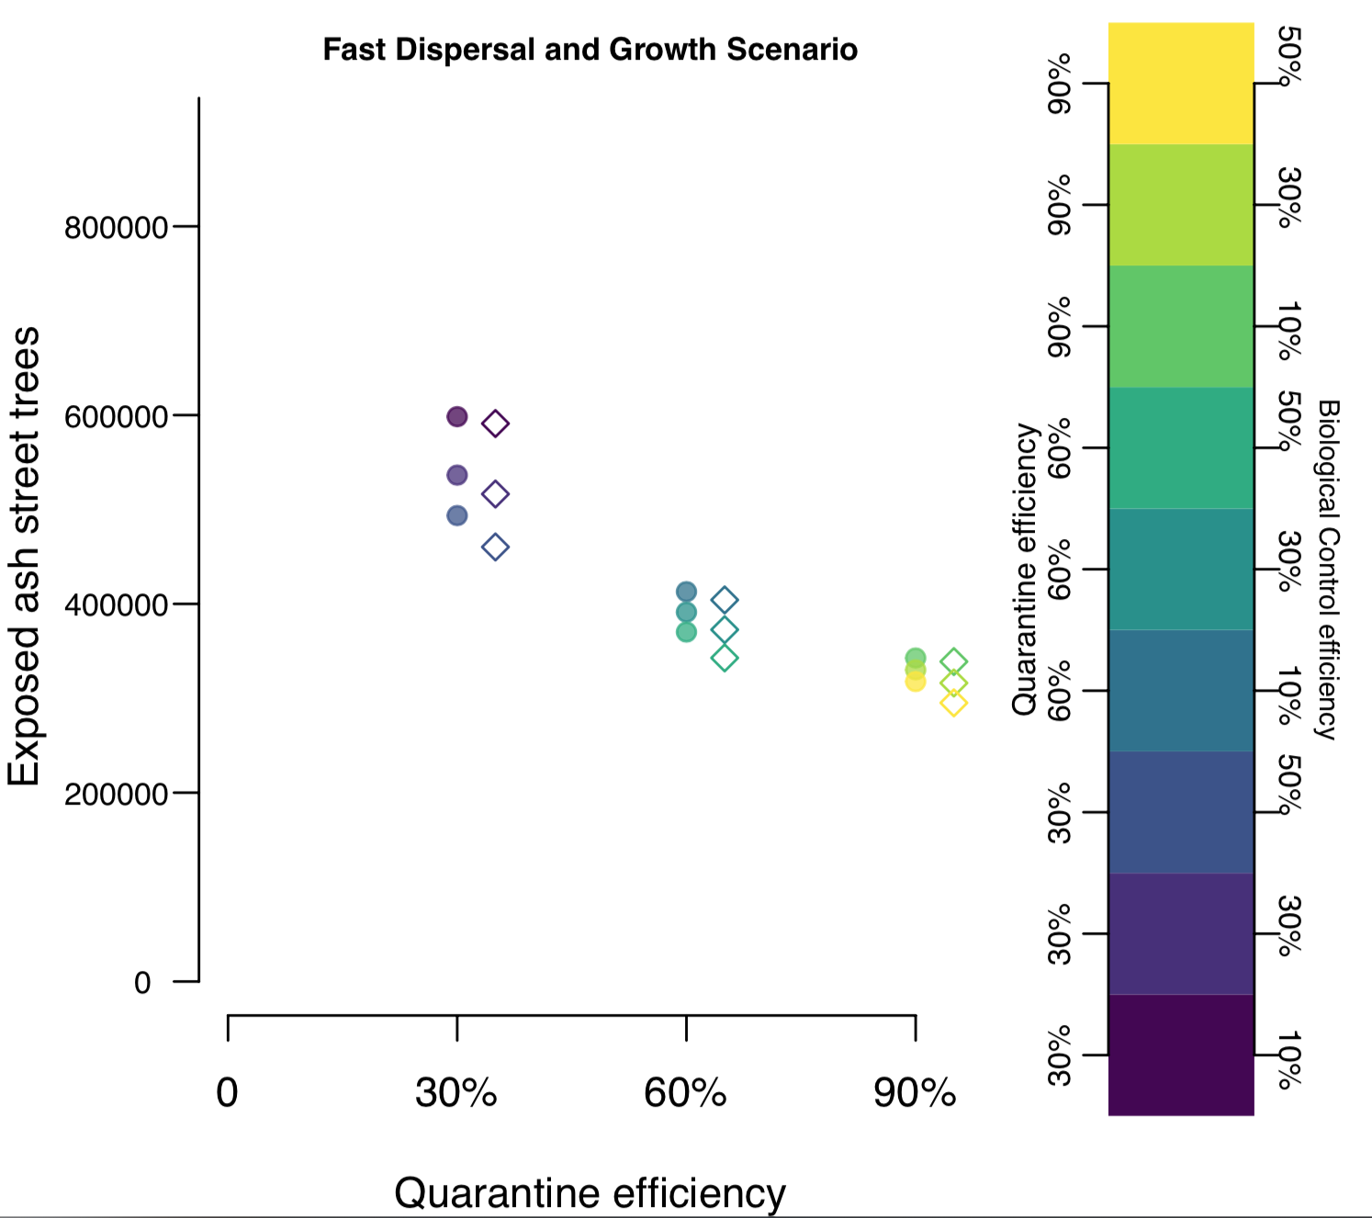
c.
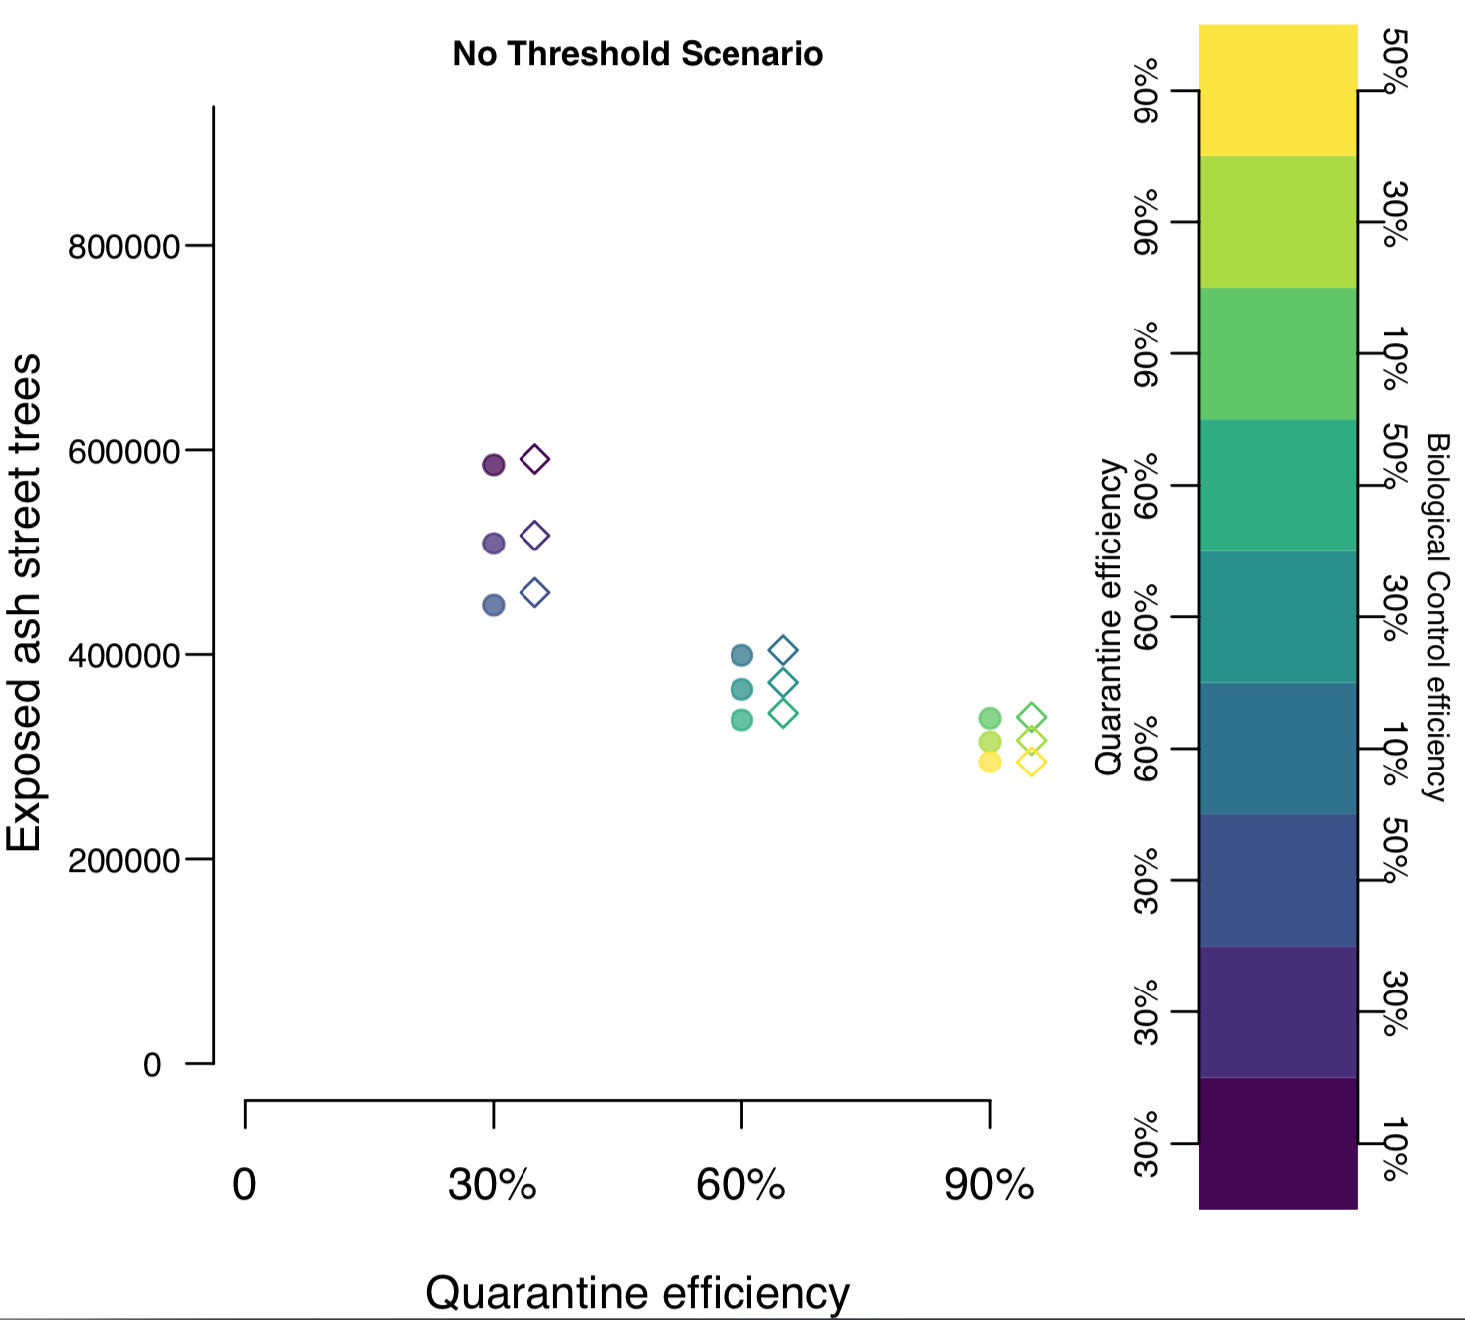
Figure S2. Relative propagule pressure in sites selected for each management action. (Y-axis is plotted in log scale, sites with zero density are not shown). Boxplots display median, 25% and 75% quartiles, 1.5x interquartile range (lines), and outliers (points) where appropriate. “None” corresponds to sites with no management actions. Sample size of sites where an action was taken at a given timestep per group was: Biological control = 155, None = 133263, Quarantine In = 2751, Quarantine Out = 1488.
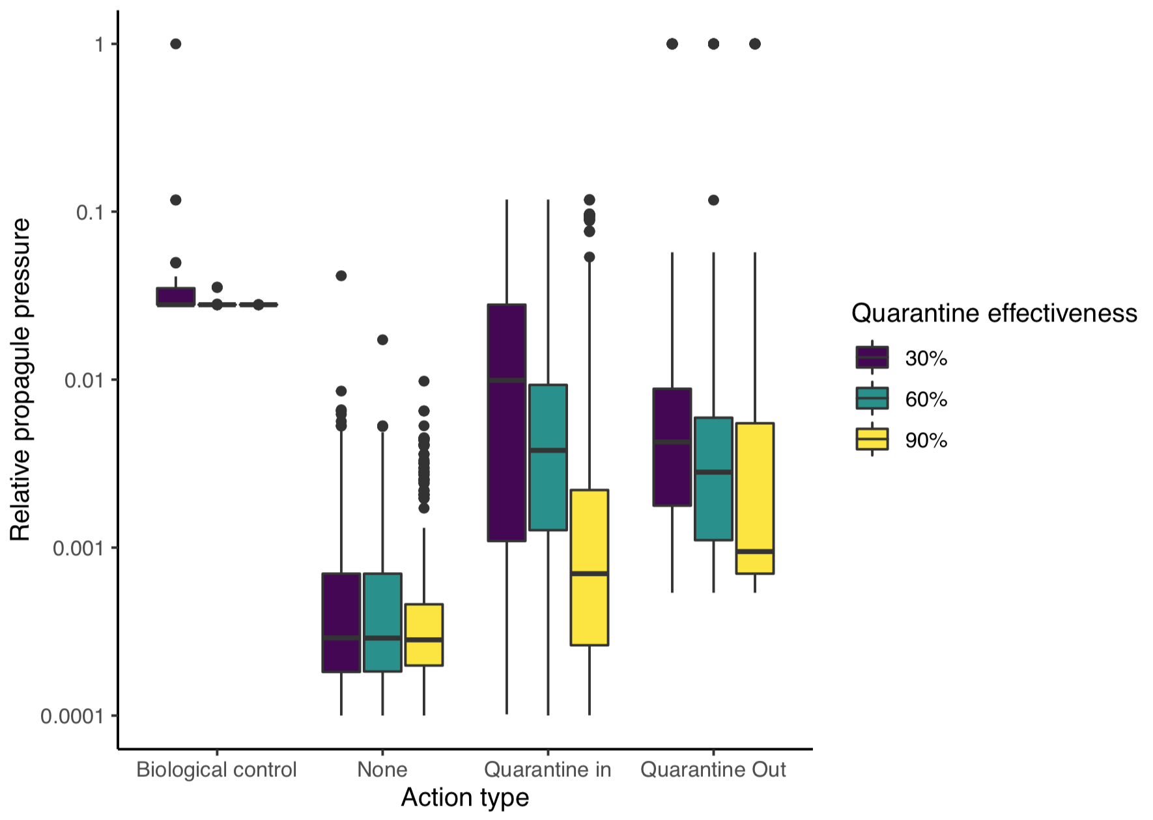

Figure S3. a. Estimated distribution of street ash trees in the United States in 2019 (based on data from [12] and b. Estimated number of exposed ash trees without EAB management action by 2045.
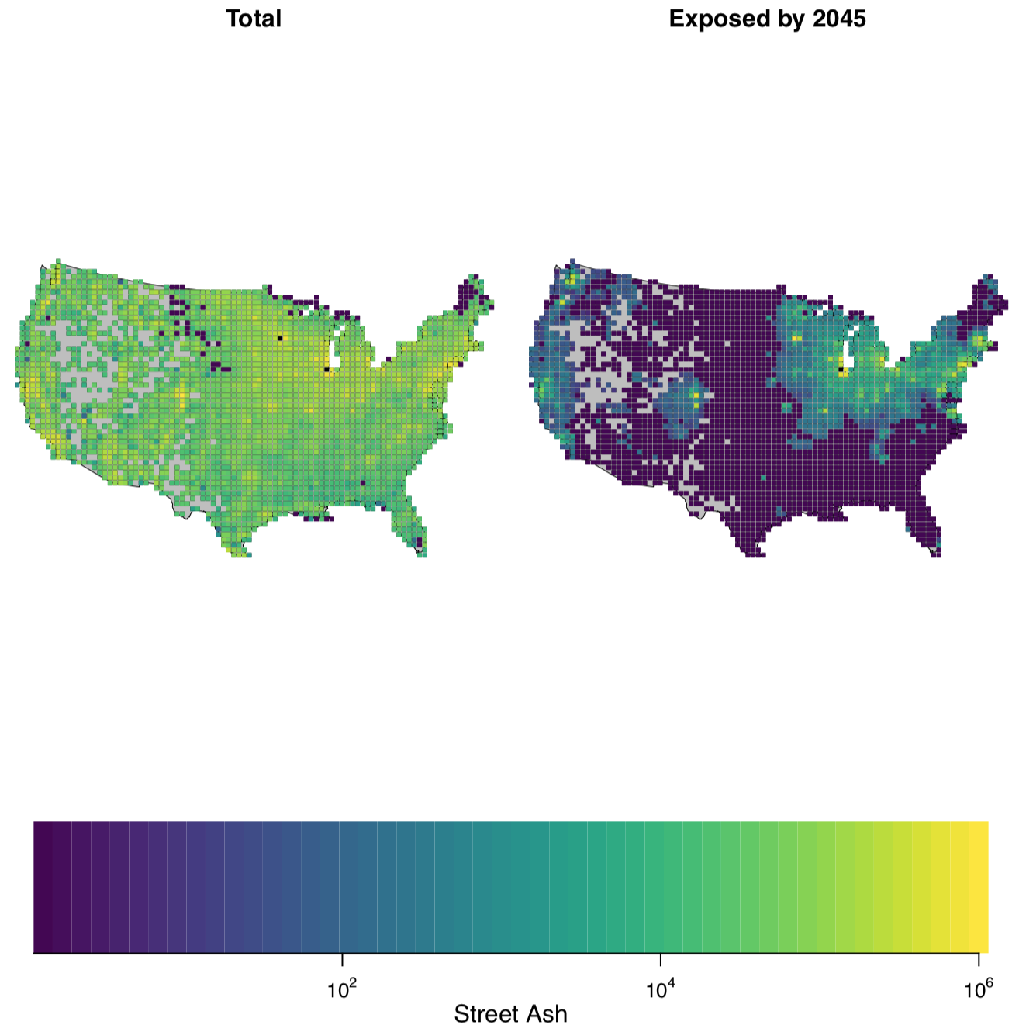
a.
b.

