Supplemental Figures
Figure S1. PCS component changes during the follow-up period before and after propensity score matching
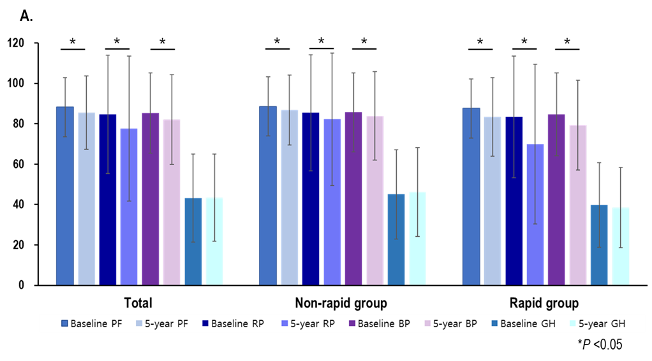
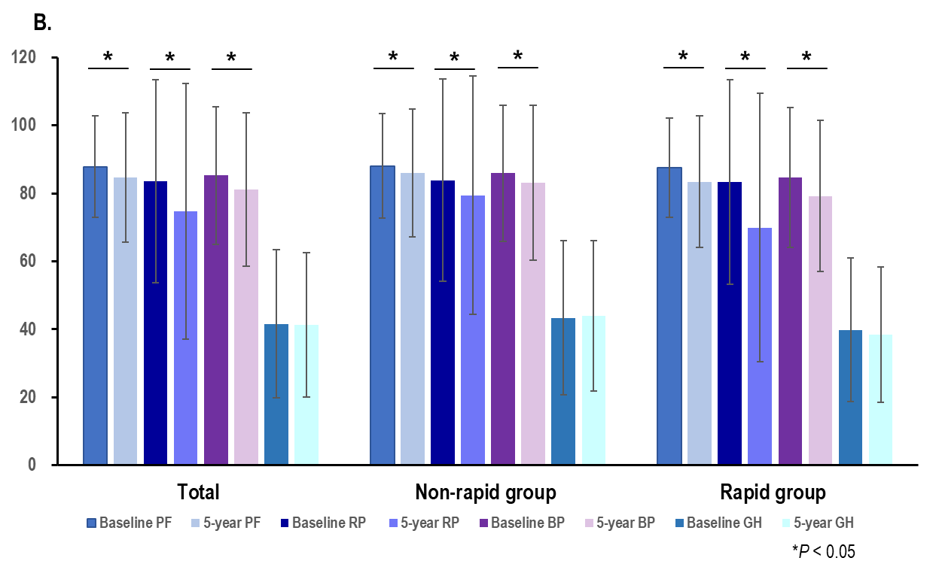
- Changes in PCS components before propensity score matching
- Changes in PCS components after propensity score matching
PCS, physical component summary; PF, physical function; RP, role-physical; BP, bodily pain; GH, general health

Figure S2. MCS component changes during the follow-up period before and after propensity score matching
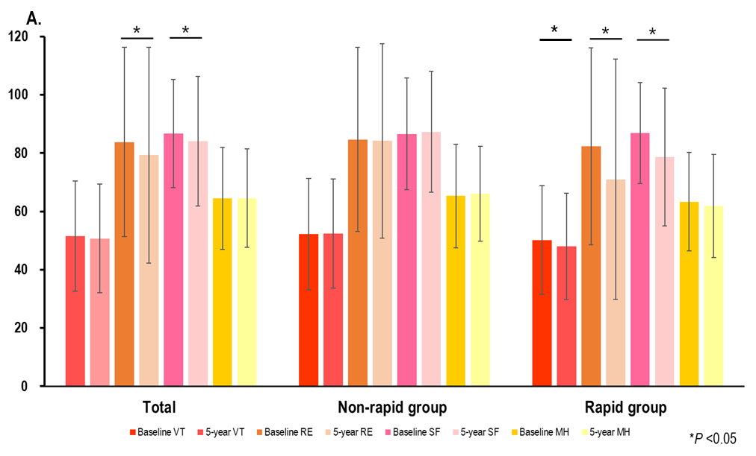
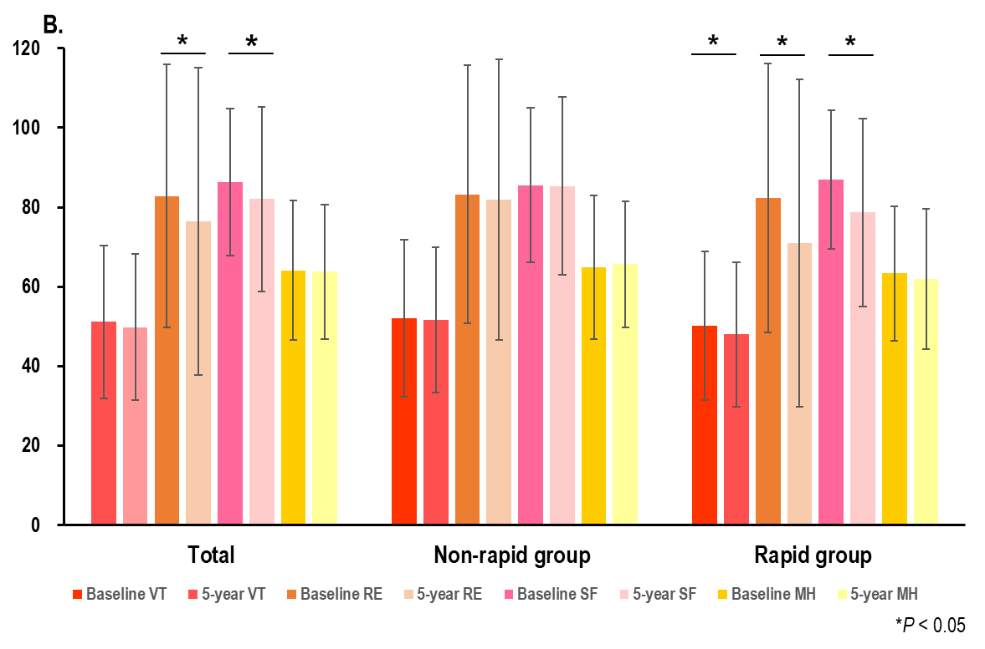
- Changes in MCS components before propensity score matching
- Changes in MCS components after propensity score matching
MCS, mental component summary; VT, vitality; RE, role-emotional; SF, social function; MH, mental health

Figure S3. Subgroup analysis for the association between the rapid kidney function decline and HRQOL deterioration using multivariable binary logistic regression model after propensity score matching
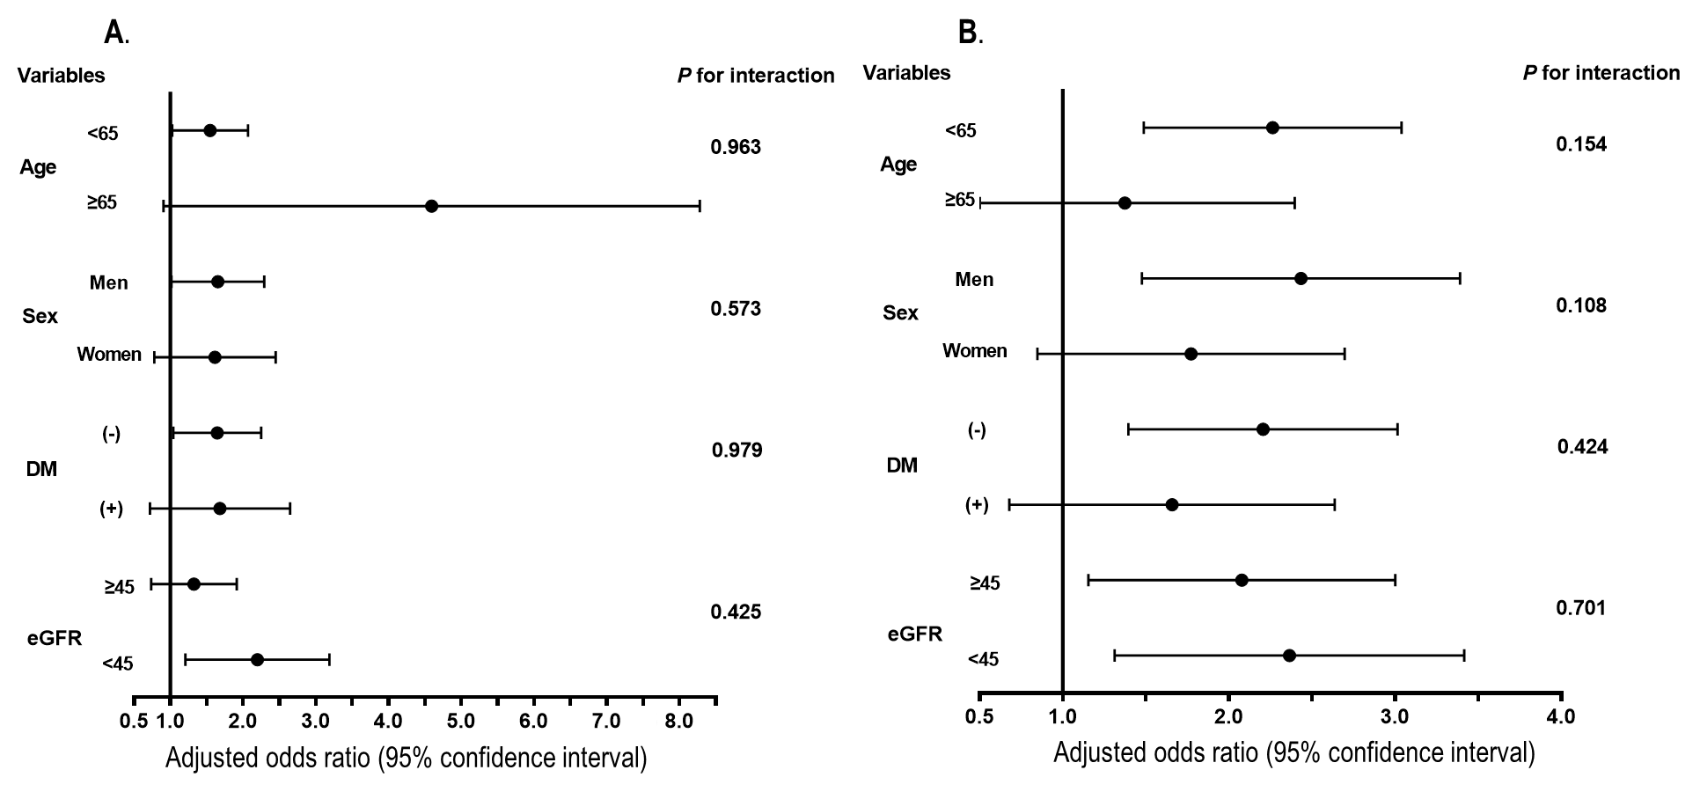
Odds ratio (OR) by subgroups adjusted for age, sex, HTN, DM, mean blood pressure, BMI, education, income, employment, hemoglobin, uric acid, albumin, total cholesterol, baseline eGFR, and logUPCR
A. ORs of PCS deterioration. The rapid decline of kidney function was a significant risk factor for the rapid deterioration of PCS in patients with eGFR <45 mL/min/1.73m², age <65, or men
B. ORs of MCS deterioration. The rapid decline of kidney function was a significant risk factor for the rapid deterioration of MCS in patients with both eGFR ≥45 and <45 mL/min/ overall health m², age <65, men, or patients without diabetes.
HRQOL, health-related quality of life; OR, odds ratio; PCS, physical component summary; MCS, mental component summary; DM, diabetes mellitus; HTN, hypertension; BMI, body mass index; eGFR, estimated glomerular filtration rate; UPCR, urine protein-creatinine ratio

