Triphosgene: an efficient chlorination reagent for synthesis of 5-chloro-2-pentanone from acetyl-n-propanol
Qianqian Xing ^{a,b} • Jiancheng Zhao ^{a,b} • Yulei Zhu ^{c,d} • Xianglin Hou ^{a,b} • Yingxiong Wang ^{a,b*}
ª Shanxi Engineering Research Center of Biorefinery, Institute of Coal Chemistry, Chinese Academy of Sciences, 27 South Taoyuan Road, Taiyuan 030001, China
^{b} Center of Materials Science and Optoelectronics Engineering, University of Chinese Academy of Sciences, Beijing 100049, China
^{c} State Key Laboratory of Coal Conversion, Institute of Coal Chemistry, Chinese Academy of Sciences, Taiyuan 030001, PR China
^{d} Synfuels China Co. Ltd, Taiyuan 030032, PR China
Corresponding Author: wangyx@sxicc.ac.cn

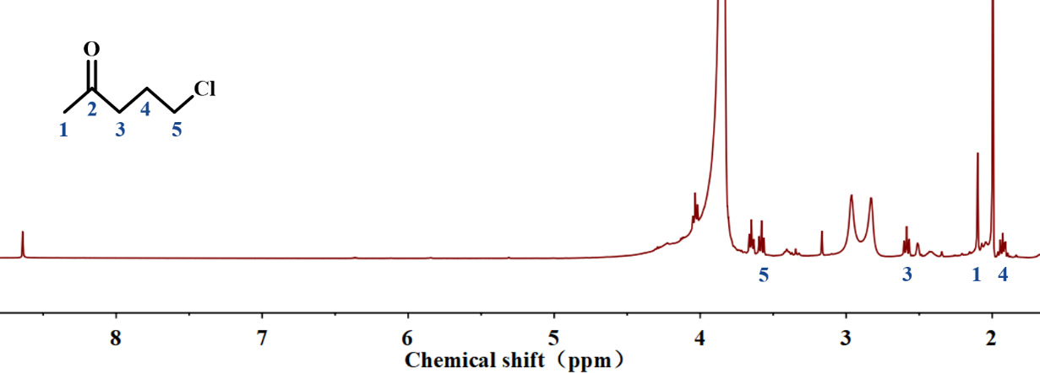
Fig. S1 ¹H NMR spectrum of reaction mixture in DMSO-d₆
Reaction conditions: 5 mmol acetyl-n-propanol, 2 mmol BTC, 10 mmol DMAC, 20 mL DCE, 80 °C

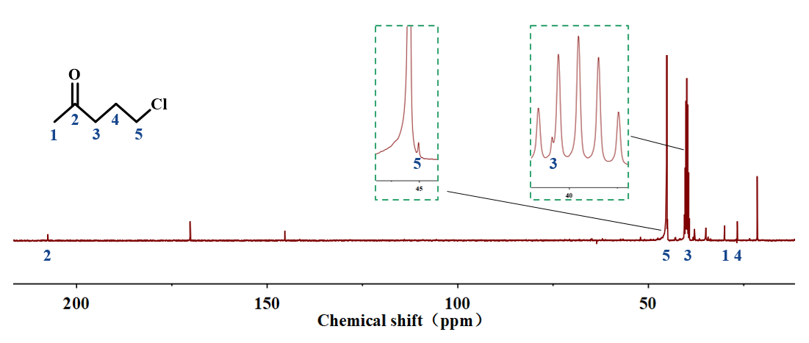
Fig. S2 ¹³C NMR spectrum of reaction mixture in DMSO-d₆
Reaction conditions: 5 mmol acetyl-n-propanol, 2 mmol BTC, 10 mmol DMAC, 20 mL DCE, 80 °C

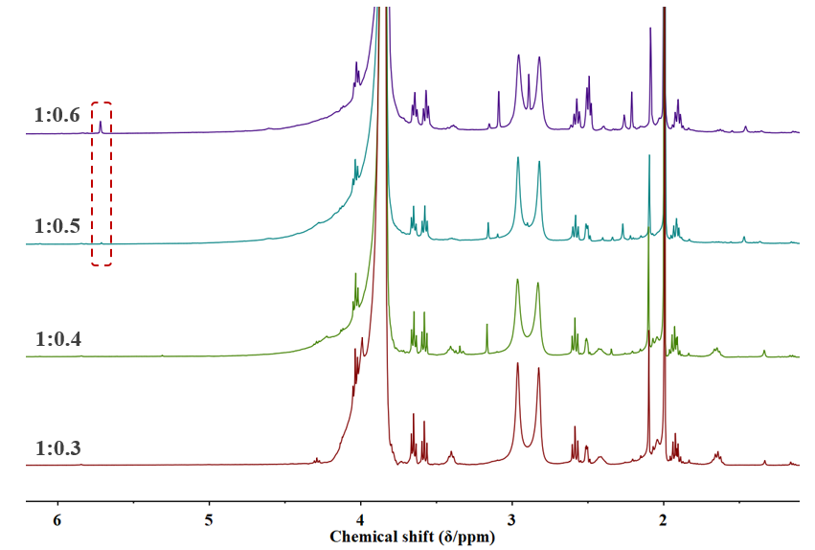
Fig. S3 ¹H NMR spectra of reaction mixture at different molar ratios in DMSO-d₆
Reaction conditions: 5 mmol acetyl-n-propanol, 10 mmol DMAC, 20 mL DCE, 2 h, 80 °C

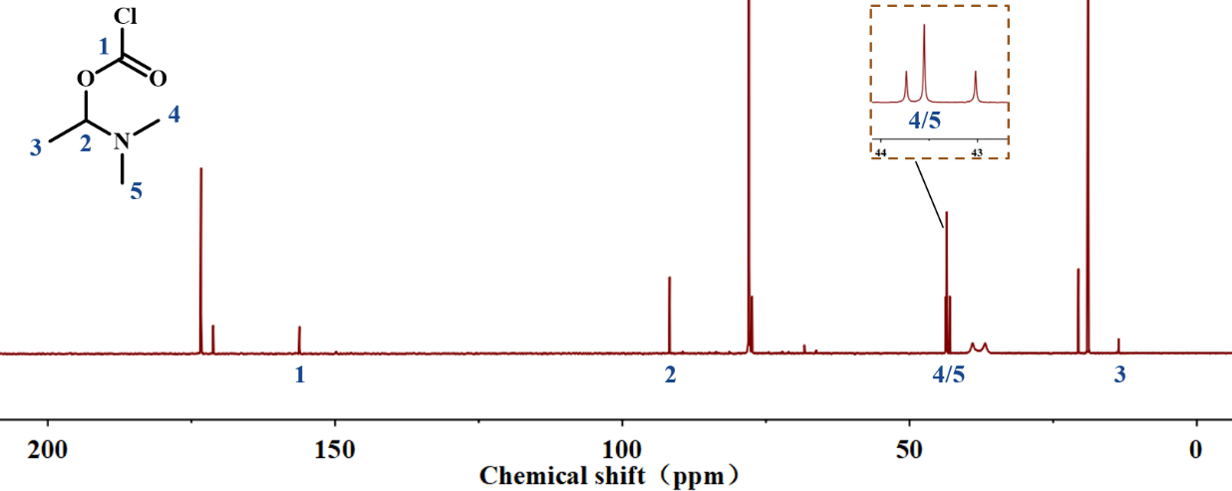
Fig. S4 The ¹³C NMR spectrum of reaction mixture in CDCl₃
Reaction conditions: 10 mmol DMAC, 2 mmol BTC, 10 mL CHCl₃, 1 h, 60 °C

