Appendix A
Instructional Video
 | Objectives | Extract from the script | Screenshot
Introduction | - Address the issue of the credibility of information found on the Internet and the need to assess its reliability | "To rely on true information, whether it's for a school assignment or to build your opinion on a given topic, you need to assess how much you can trust the different information you find.". | 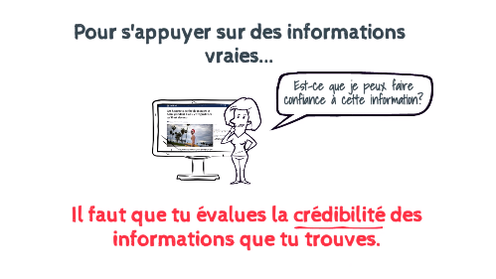
Part 1a: The concept of source | - Introduce the concept of information source | "The person (or media) who originates the information is called the "source of the information."  A first question to ask yourself to determine if you can trust information you find on the internet is "who is the source of this information?" | 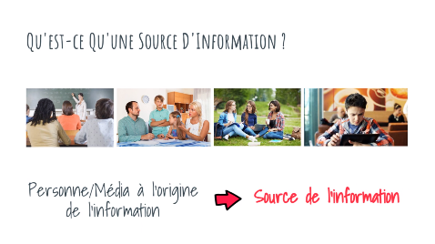
Part 1b:  How to identify the source | - Identify the source of information (author, editor in the case of articles; producer, people speaking on screen in the case of videos) | "When a person speaks on the screen, they are either presented verbally or with a banner at the bottom of the screen that gives information about who they are." | 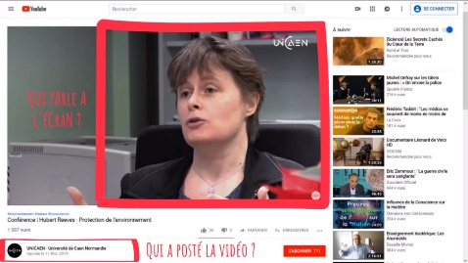
Part 2a: How to evaluate source credibility = Source Expertise | - Address possible criteria for assessing the credibility of a source  - Introduce the concept of source expertise | "A first criterion to determine if a person is well placed to give you information on a given subject is simply if he or she knows a lot about the subject, which is called his or her expertise on the subject. | 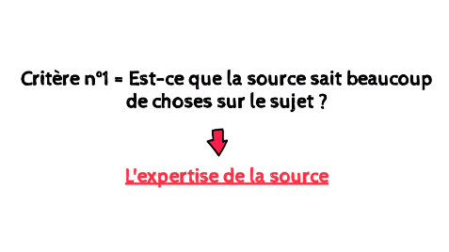
Part 2b = How to evaluate source credibility = Source’s Intentions | - Address the notion of source's intentions and that it may have other motivations than simply informing | "The second question to ask yourself to know if a source of information is trustworthy on the subject is "why is this source giving me this information?", i.e. "what is the source of this information trying to make me think or do by giving me this information?". | 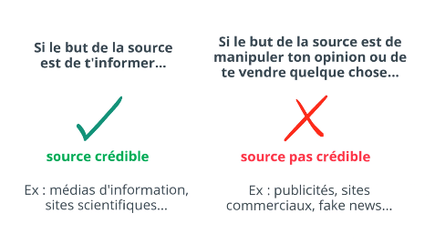
Conclusion | - Reminder of the points covered in the video | "To determine if a source of information is trustworthy, you can remember these 3 rules: [...] Make sure the source is really an expert on the subject you are looking for information on. Make sure the source is primarily trying to inform you about the topic, not influence you or get you to buy something." | 