Supplementary Information

For

Extraction of non-noble metal columbite-tantalite as a highly efficient electrocatalyst for water splitting

Patrick M. Bacirhonde et al.

Calculation of Turnover frequencies of Gas adsorption using BET surface area
The BET = 42.8963 m2g−1 for WOCT. For HER, η = 190.2 mV (V vs RHE) at 10 mA cm⁻². On the surface of WOCT (200), A(m²) = 1226.4 pm × 8430.9 pm = 1.03 × 10⁻¹⁸m² and we have 70 visibles atoms on the crystal structure (orthorhombic).
The total number of surface atoms = [70/ (1.03 × 10⁻¹⁸m²)] × (0.005g × 42.8963 m2g⁻¹) = 3.16 × 1019 atoms.
Turnover frequency of H2 production = [(10 mA/cm² × 0.001 × 0.87cm² × 6.022 × 1023 atoms/mol)] / [(96485.3 C/mol) (2) (3.16 × 1019 atoms)] = 0.87 sites s⁻¹.
For oxygen, TOF was calculated at η = 284.84 mV (current density at 10 mA cm⁻²) = [(10 mA cm⁻² × (0.001) × (0.89 cm²) × 6.022 × 1023 atoms/mol)] / [(96485.3 C/mol) (4)(3.16 × 1019 atoms)] = 0.44 sites s⁻¹.

SUPLLEMETARY TABLES
Supplementary Table 1: Representative compositions of the coltan ore using X-ray fluorescence spectroscopy measurements.
Major elements | Contents (%)
F | 0.939
Na₂O | 0.546
MgO | 1.46
Al₂O₃ | 6.71
SiO₂ | 15.7
P₂O₅ | 0.238
SO₃ | 0.0206
K₂O | 2.22
CaO | 5.46
TiO₂ | 3.21
MnO | 0.546
Fe₂O₃ | 8.44
Rb₂O | 0.275
SrO | 0.274
ZrO₂ | 0.514
Nb₂O₅ | 5.80
SnO2 | 7.44
BaO | 0.296
HfO₂ | 0.141
Ta₂O₅ | 38.7
PbO | 1.19
U₃O₈ | 0.683
Mass % | 100

Oxide form | Peaks positions and miller indices
Ta₂O₅ | 15θ (110), 24θ (020), 29θ (220), 30 θ (202), 35θ (022), 49θ (422), 53θ (004), 60θ (242).
Nb₂O₅ | 22θ (001), 29θ (100), 46θ (002) and 55θ (102)
MnO | 20θ (100), 22θ (110), 43θ (050), 53θ (201), 74θ (321)
Fe₂O₃ | 25θ (012), 34θ (104), 37θ (110), 51θ (024), 56θ (116)
Mn₂Ta | 24θ (101), 37θ (110), 44θ (112), 56θ (203)
Fe_{0.24}Mn_{0.76}Nb₂O₆ | 24θ (310), 30θ (311), 35θ (002), 51θ (330), 53θ (621), 60θ (313), 63θ (332)

Supplementary Table 2: Oxides forms and their peaks positions (hkl indices)

Supplementary Table 3: Calculated peaks, FWHM and d(spacing)
Peak position | FWHM | Miller indice | Theta (θ) | d (Spacing)
18.26331 | 0.37014 | 110 | 9.131655 | 4.853703
23.10498 | 4.86425 | 111 | 11.55249 | 3.846392
30.05942 | 0.62724 | 180 | 15.02971 | 2.970463
32.61318 | 0.30074 | 200 | 16.30659 | 2.743457
36.90606 | 0.60884 | 201 | 18.45303 | 2.433599
36.90606 | 2346.54001 | 202 | 18.45303 | 2.433599
56.95608 | 206544.3749 | 002 | 28.47804 | 1.615488
56.95608 | 0.39071 | 422 | 28.47804 | 1.615488
58.21814 | 0.35541 | 440 | 29.10907 | 1.583436
70.88718 | 58.32215 | 531 | 35.44359 | 1.32833
77.84268 | 0.39841 | 321 | 38.92134 | 1.226099
77.84268 | 136.11545 | 128 | 38.92134 | 1.226099

SUPPLEMETARY FIGURES

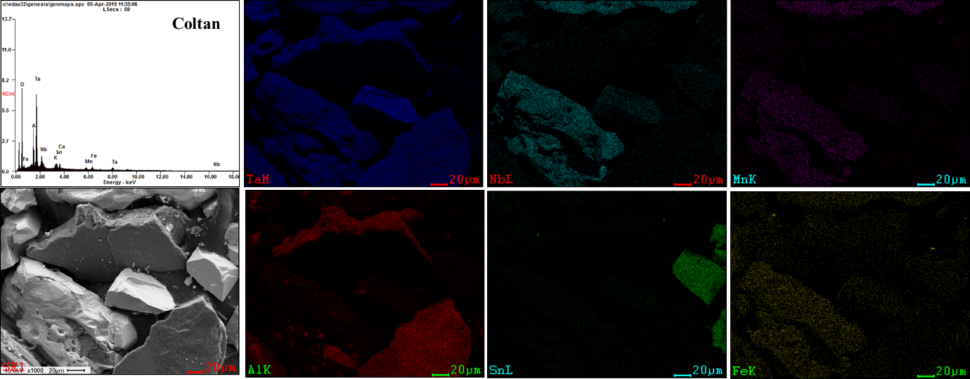
Supplementary Figure 1: Field emission scanning electron microscopy (FESEM) and mapping of coltan.

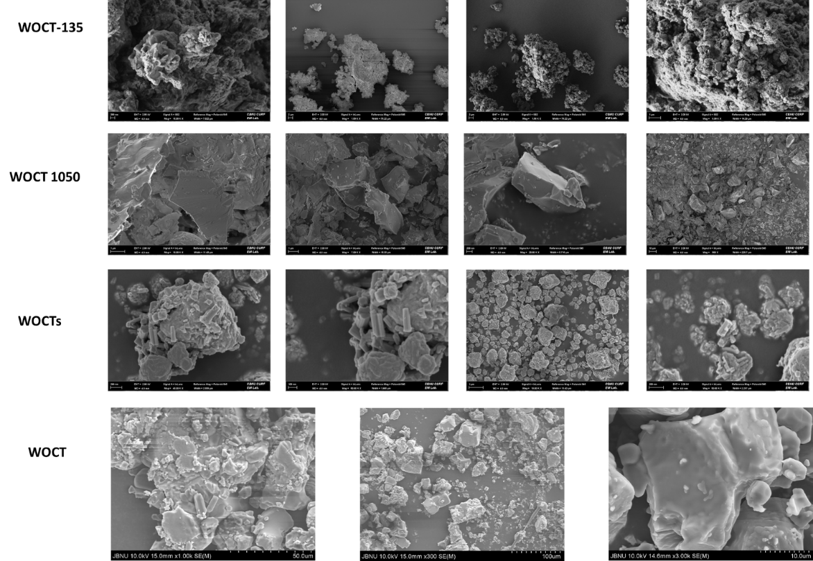

Supplementary Figure 2: SEM images of WOCT-135, WOCT-1050, WOCTs and WOCT

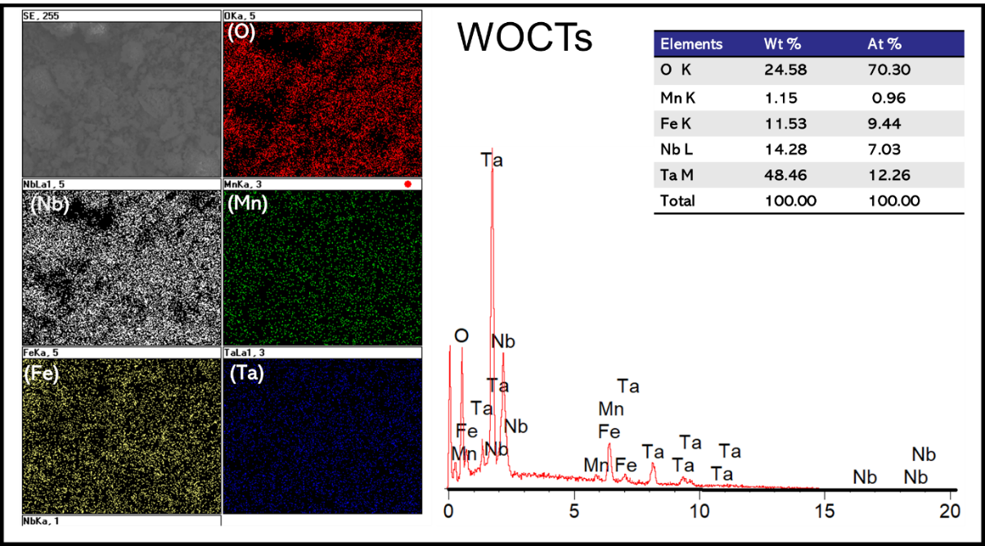

Supplementary Figure 3: SEM image, element mapping and Energy dispersive x-ray spectroscopy (EDS) analysis of WOCTs (hydrothermal synthesis)

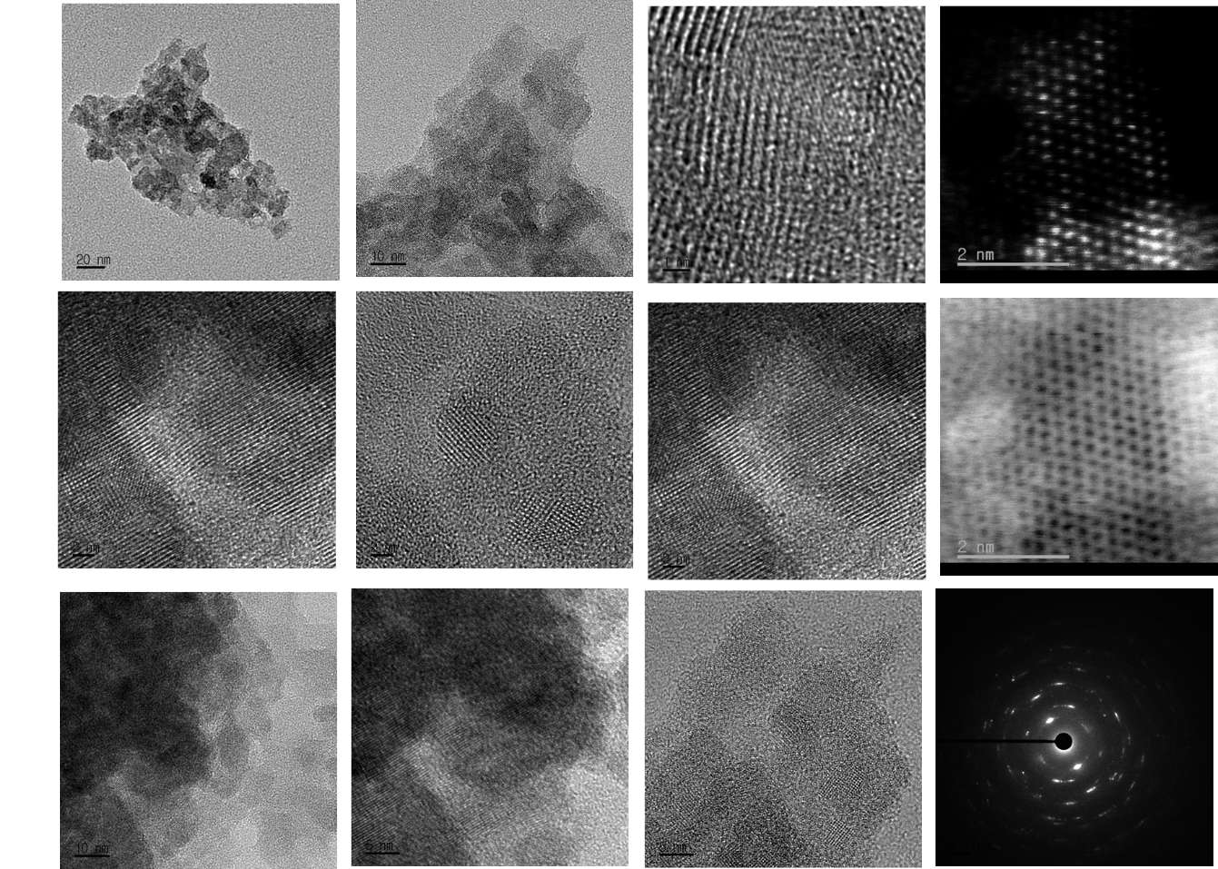
Supplementary Figure 4 Different HRTEM image taken from 20, 10, 5 and 2nm of WOCT

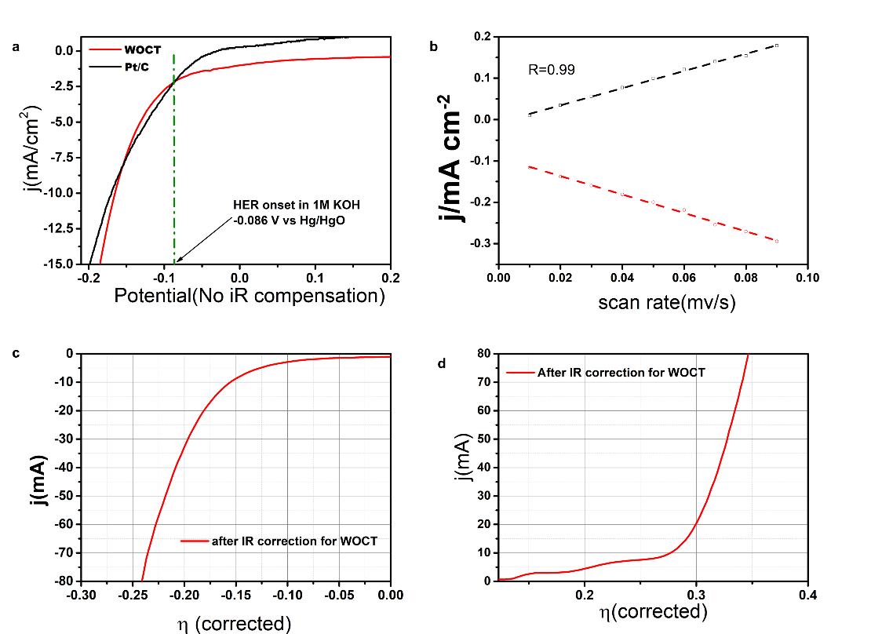

Supplementary Figure 5: (a) HER onset, b C_{dl} investigation c HER, d OER after IR correction

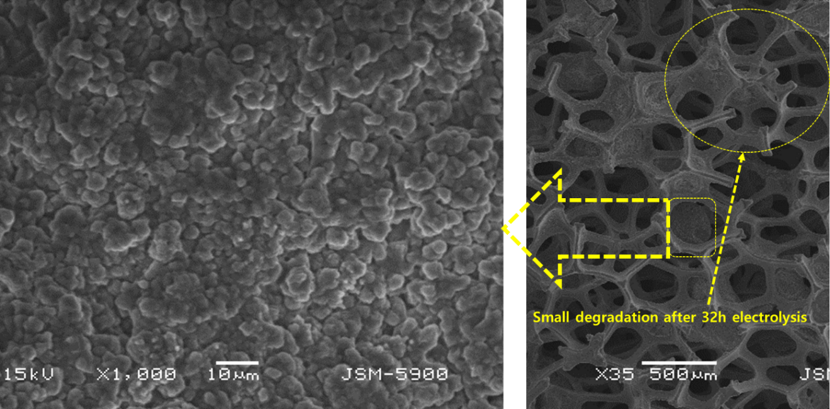
Supplementary Figure 6: SEM image of WOCT after 32 hours electrolysis

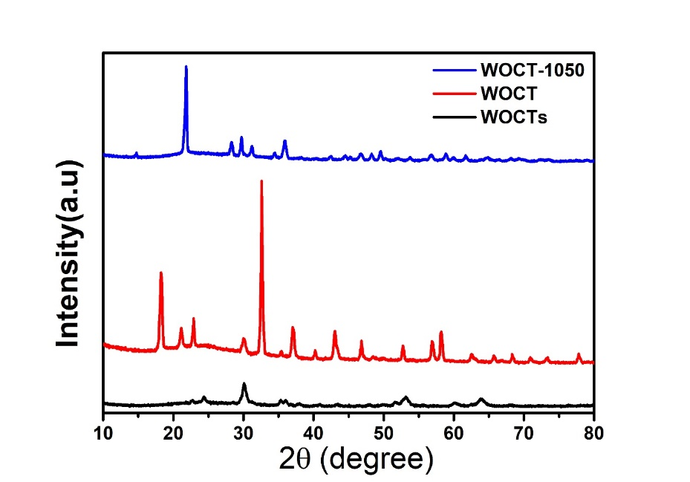
Supplementary Figure 7: XRD after electrolysis experiment

Supplementary Figure 8: Optimized bulk structure of (a) FeTa₂O₆ and (b) Fe_{0.75}Mn_{0.25}Ta_{1.875}Nb_{0.125}O₆ with their corresponding relaxed unit cell parameters.

Supplementary Figure 9: Optimized structure of (a) FeTa₂O₆(100) and (b) Fe_{0.75}Mn_{0.25}Ta_{1.875}Nb_{0.125}O₆(100) with surface used to model the HER and OER processes

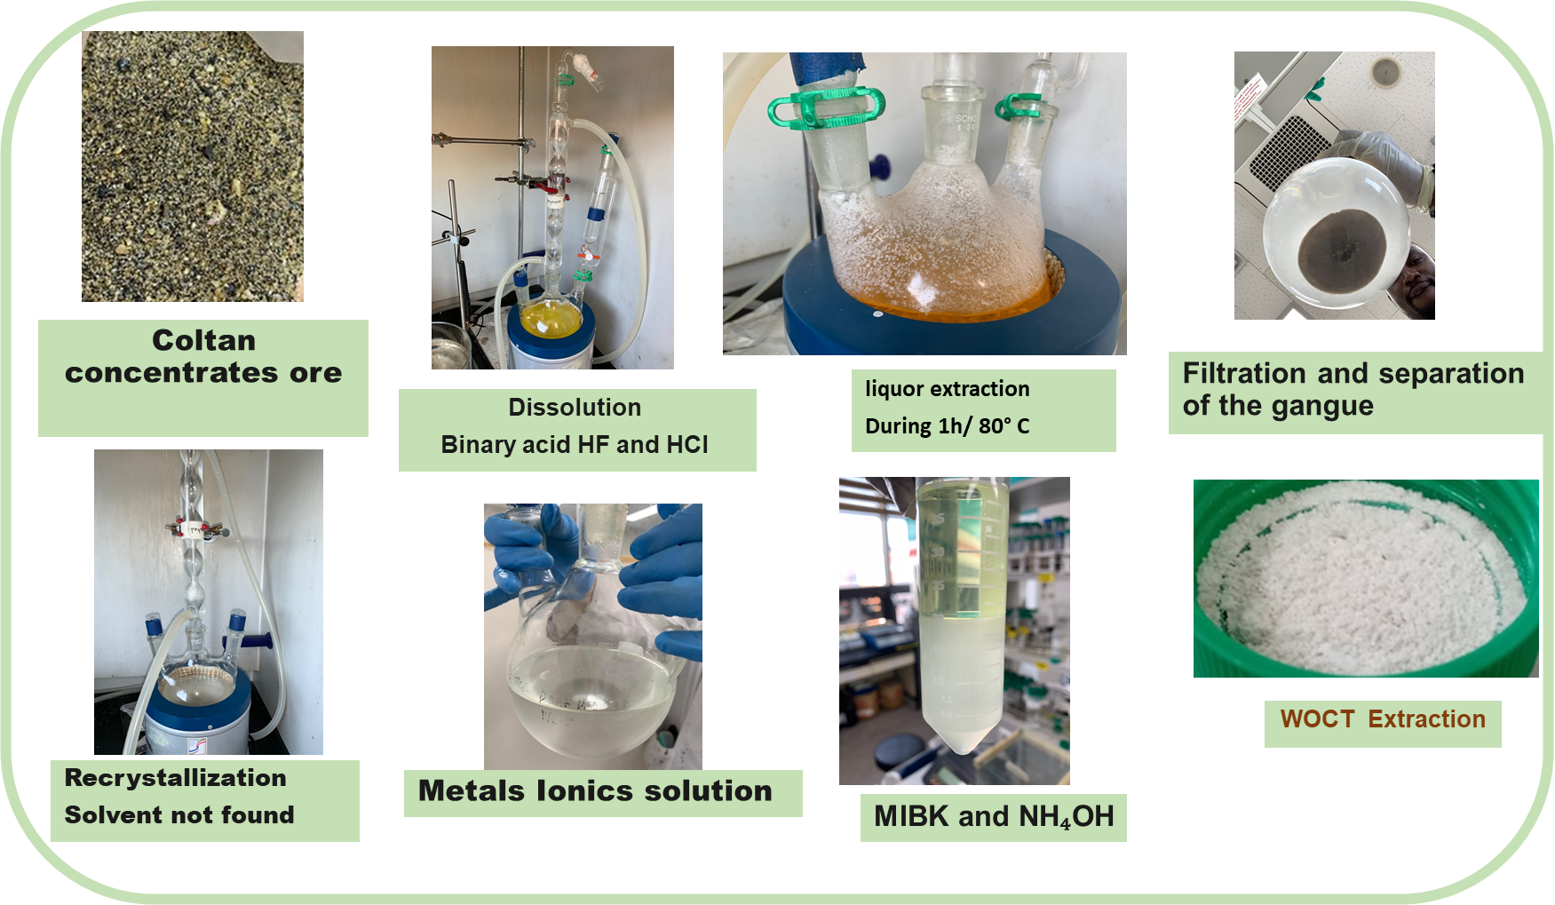
Supplementary Figure 10: illustration of extraction process

