[Extended Data for]
Partial-convolution-implemented
general adversarial network (GAN)
for global oceanic data assimilation

Yoo-Geun Ham^{1*}, Yong-Sik Joo¹, Jeong-Hwan Kim¹, Kang-Min Kim¹,
and Jeong-Gil Lee¹

1Department of Oceanography, Chonnam National University, Gwangju, South Korea

*Corresponding authors. Email: ygham@jnu.ac.kr
Product | Temporal resolution | Spatial resolution | Dimension | DA Method
OISST | 1982-2020 | 0.25°×0.25° | 2Dim | Optimal Interpolation
EN4.2.2 | 1980-2020 | 1°×1° | 3Dim | Optimal Interpolation
ORAS5 | 1982-2020 | 0.25°×0.25° | 3Dim | 3DVAR FGAT
COBE | 1980-2019 | 1°×1° | 2Dim | Optimal Interpolation
ECCO-v4 | 1992-2017 | 0.5° × 0.5° | 3Dim | 4DVAR
ECDA | 1980-2007 | 1°×1° | 3Dim | EnKF
GECCO2 | 1980-2016 | 1°×1° | 3Dim | 4DzVAR
OSTIA | 1982-2020 | 0.05°×0.05° | 2Dim | Optimal Interpolation
GODAS | 1982-2020 | 0.333° × 1.0° | 3Dim | 3DVAR
MERRA2 | 1982-2020 | 0.5° × 0.625° | 2Dim | 3DVAR
SODA.v2.2.4 | 1980-2010 | 0.25° × 0.40° | 3Dim | Optimal Interpolation
Extended Data Table 1. Global oceanic reanalysis database. The description of the 2D and 3D oceanic temperature reanalysis datasets used in this study.

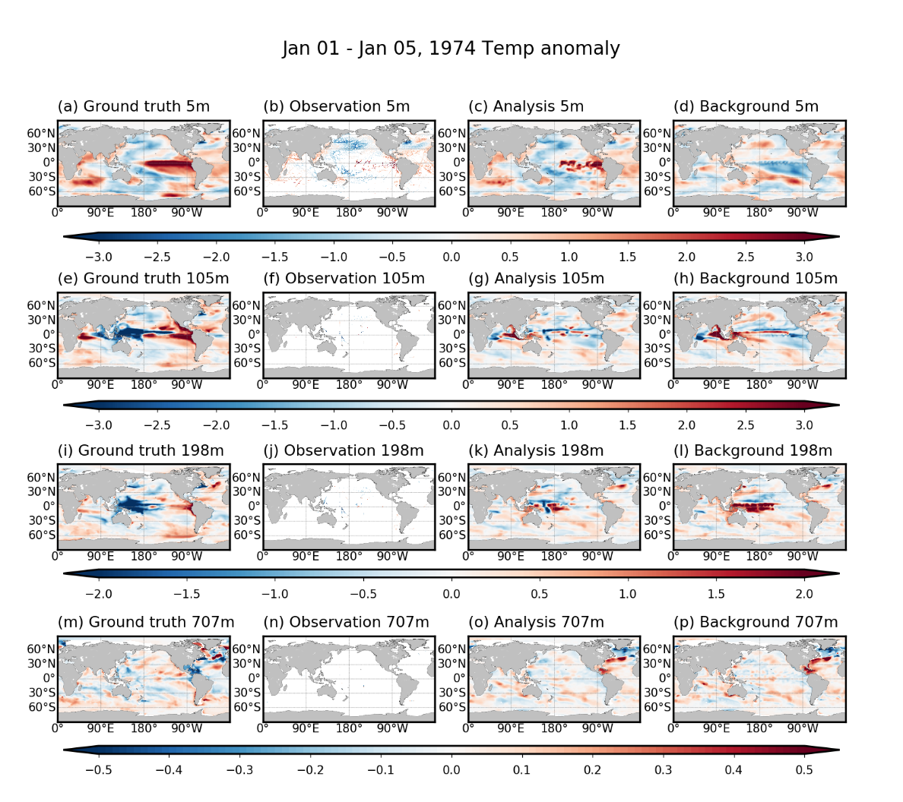
Extended Data Figure 1. Initial adjustment of DeepDA-produced subsurface temperature anomalies in the OSSEs. The temperature anomalies of the (a) ground truth, (b) observations, (c) analysis states, and (d) background states at 5 m at first data assimilation cycle in the Observing System Simulation Experiment (OSSEs). (e)-(h) same as (a)-(d), but for 105 m. (i)-(l) same as (a)-(d), but for 198 m. (m)-(p) same as (a)-(d), but for 707m.

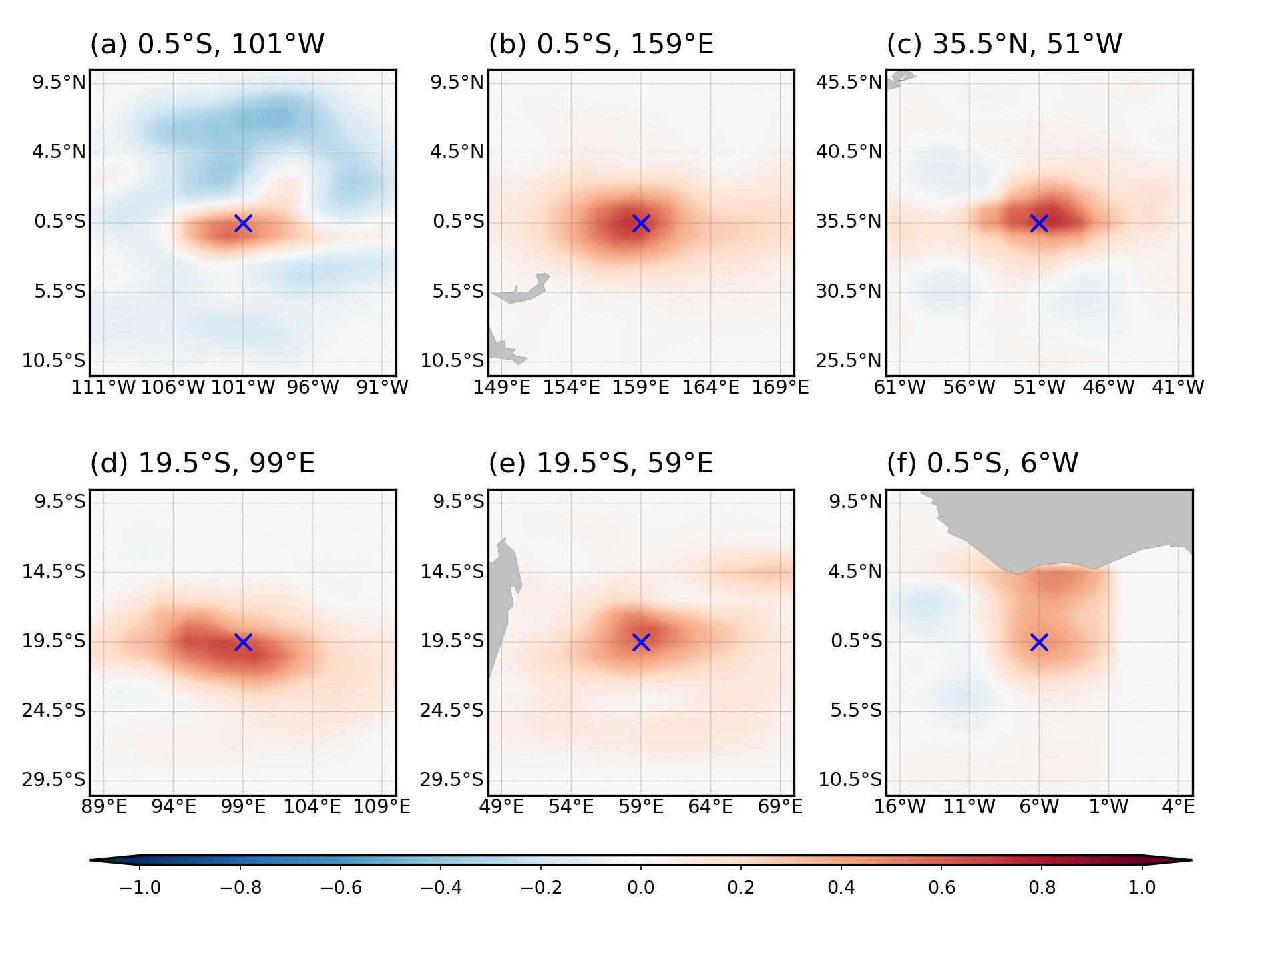
Extended Data Figure 2. Horizontal distribution of the analysis increment in the DeepDA system in the OSSEs. The analysis increment (i.e., analysis states minus background states) with a single observation at (a) 0.5ºS, 101ºW, (b) 0.5ºS, 159ºE, (c) 35.5ºN, 51ºW, (d) 19.5ºS, 99ºE, (e) 19.5ºS, 59ºE, and (f) 0.5ºS, 6ºW at January 1st 1997 in the OSSEs.

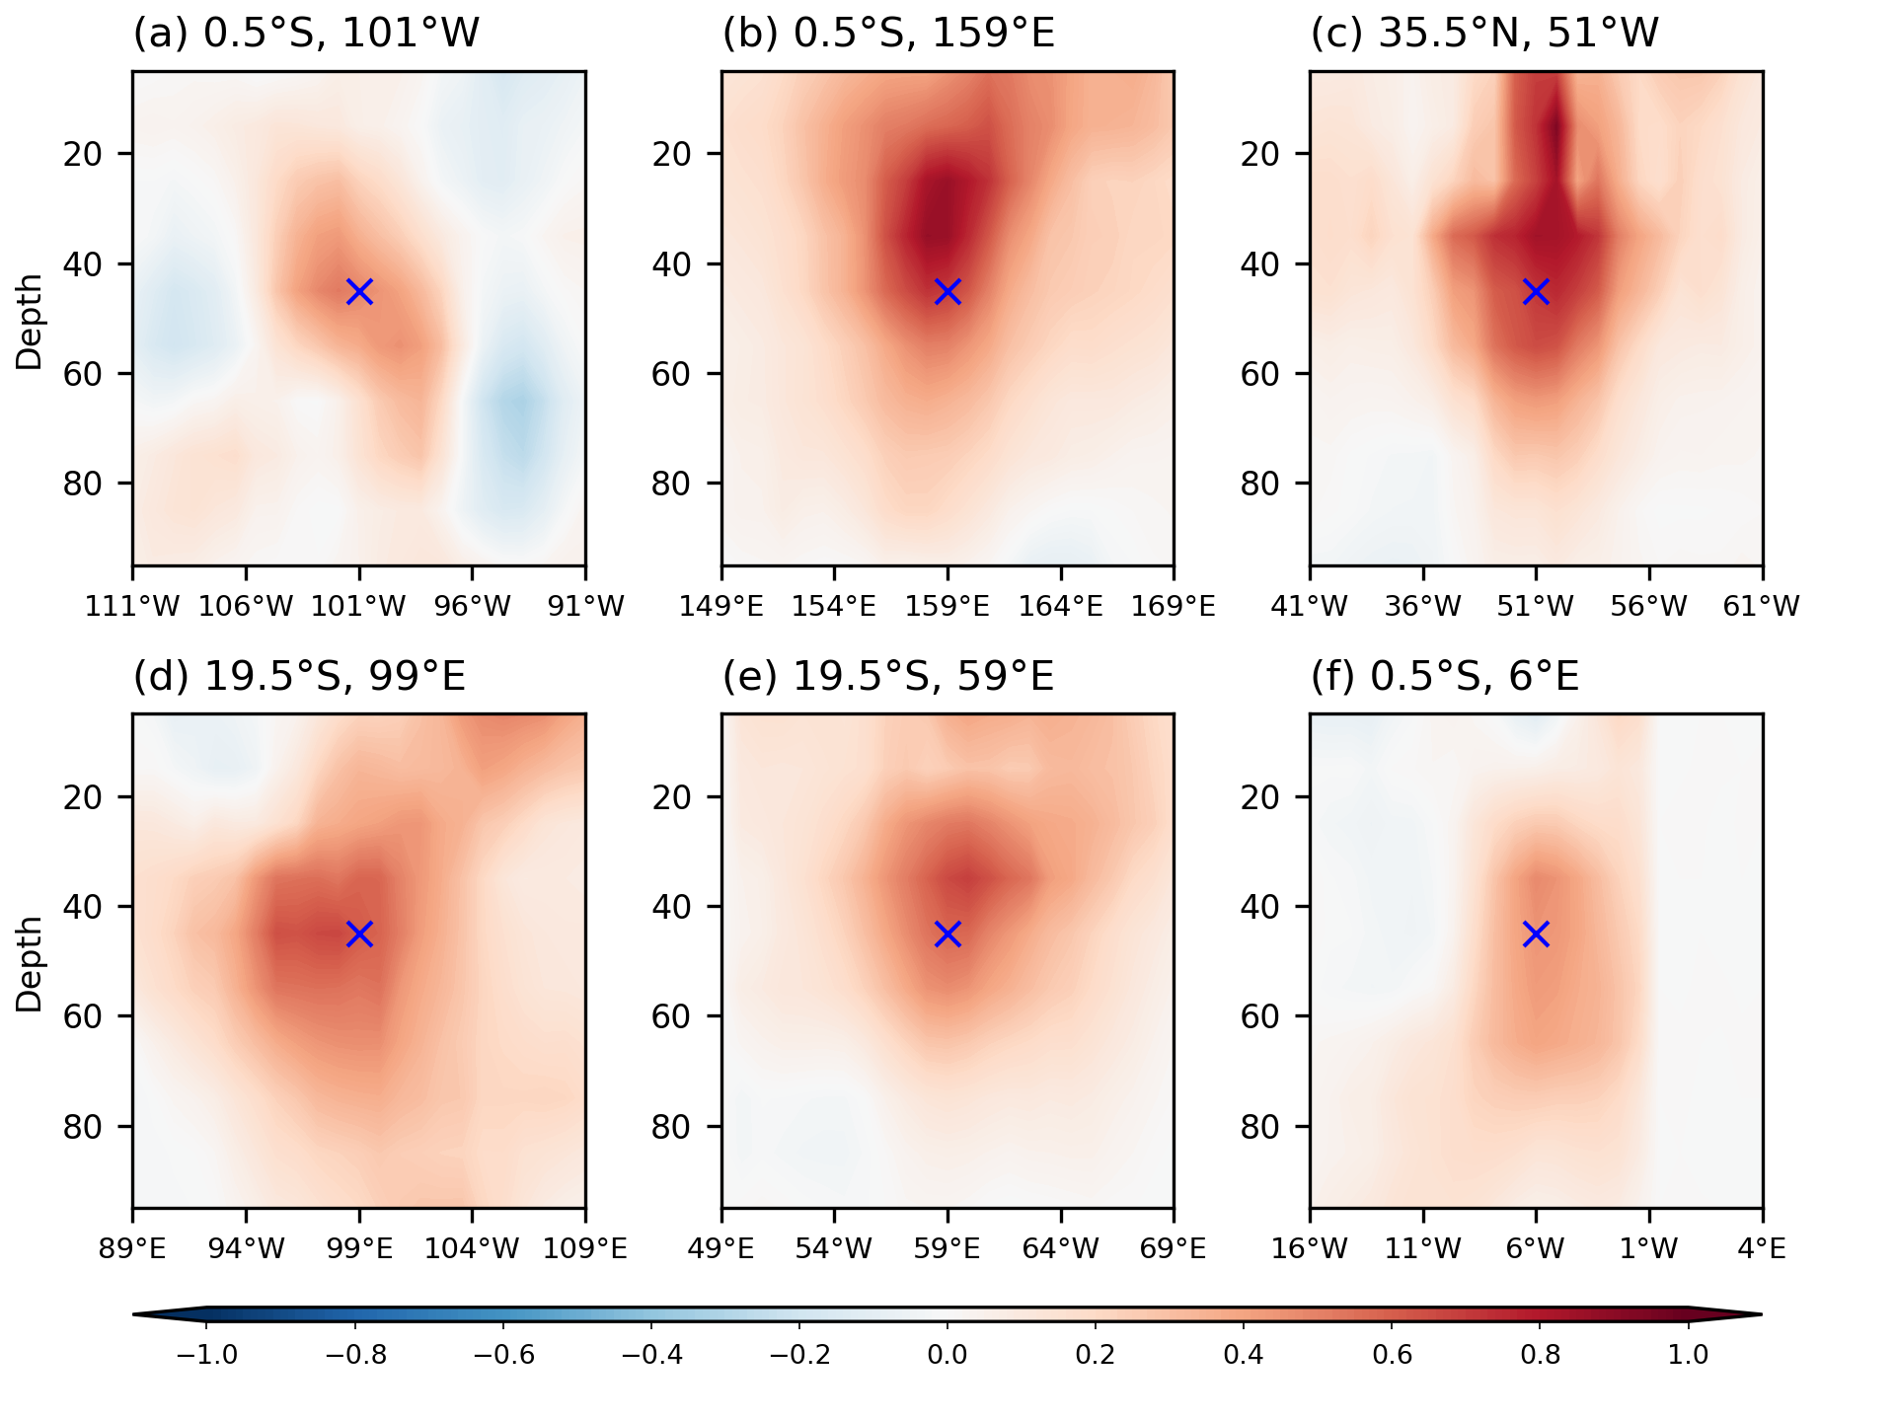
Extended Data Figure 3. Vertical distribution of the analysis increment in the DeepDA system in the OSSEs. Same as Extended Data Fig. 3, but for longitude-depth dimensions.

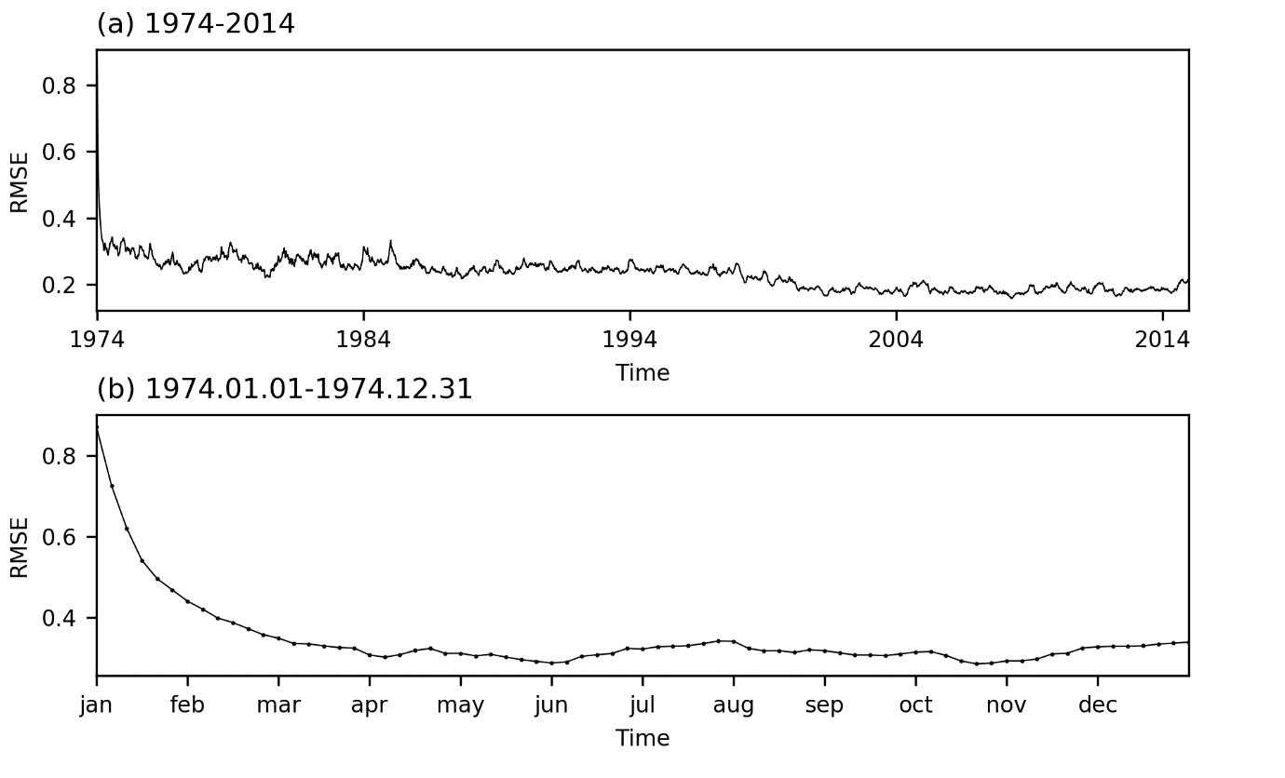
Extended Data Figure 4. Time-series of the RMSE of the analysis fields in the OSSEs. (a) Time-series of the globally- and vertically- (from 0 to 700 m) averaged root-mean-squared-errors (RMSEs) of the temperature anomalies in the analysis fields from the ground truth during 1974-2014 in the OSSEs. (b) Same as (a), but during January to December 1974. Black dots in panel (b) denotes each assimilation cycle.

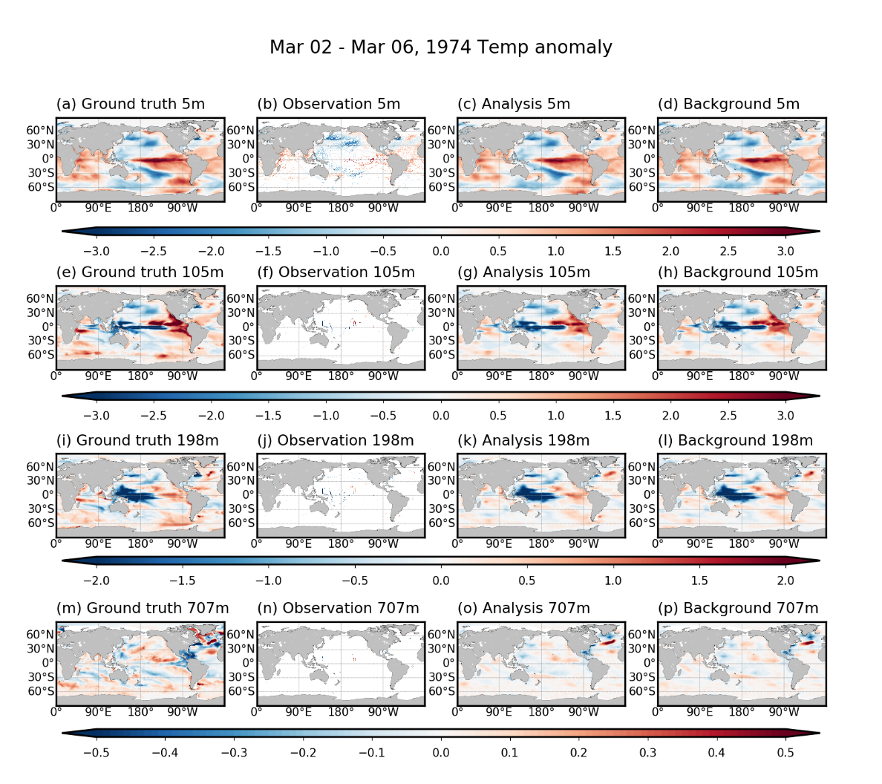
Extended Data Figure 5. The DeepDA-produced subsurface temperature anomalies in the OSSEs after 3-months spin-up. The temperature anomalies of the (a) ground truth, (b) observations, (c) analysis states, and (d) background states at the surface layer at 15th data assimilation cycle in the Observing System Simulation Experiments (OSSEs). (e)-(h) same as (a)-(d), but for 105 m. (i)-(l) same as (a)-(d), but for 198 m. (m)-(p) same as (a)-(d), but for 707 m.

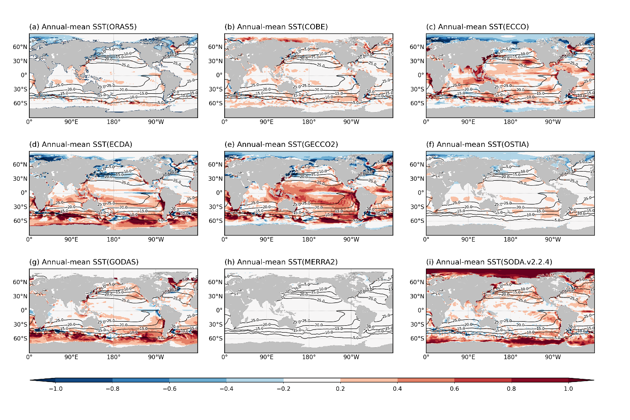
Extended Data Figure 6. The annual-mean SST in various oceanic reanalysis products. Annual-mean SST (contour), and the difference from the reference data (i.e., OISST V2) (shading) during 1980-2020 in (a) ORAS5, (b) COBE, (c) ECCO, (d) ECDA, (e) GECCO2, (f) OSTIA, (g) GODAS, (h) MERRA2, and (i) SODA V2.2.4.

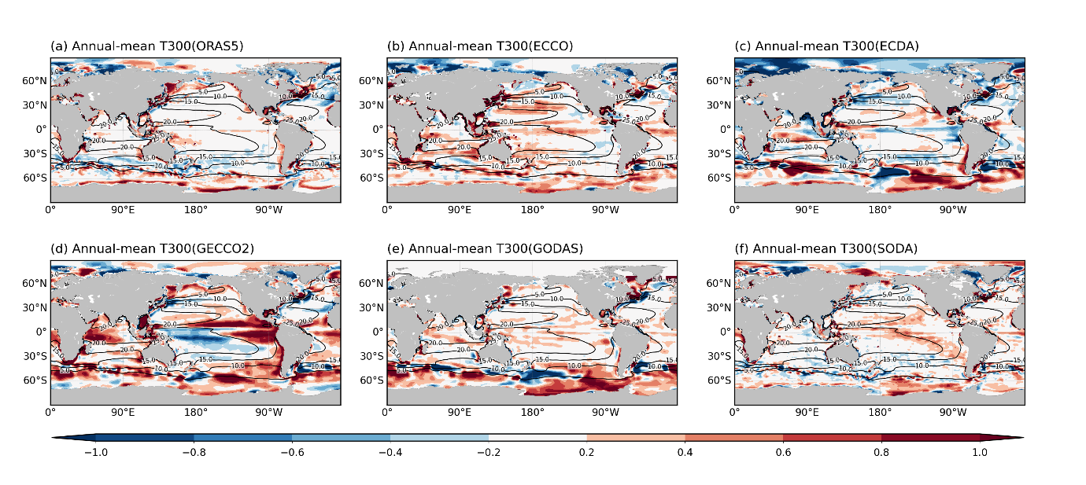
Extended Data Figure 7. The annual-mean T300 in various oceanic reanalysis products. Annual-mean temperature anomalies averaged from the surface to 300 m (T300 anomalies) (contour), and the difference from the reference data (i.e., EN4.2.2) (shading) during 1980-2020 in (a) ORAS5, (b) ECCO, (c) ECDA, (d) GECCO2, (e) GODAS, and (f) SODA V2.2.4.

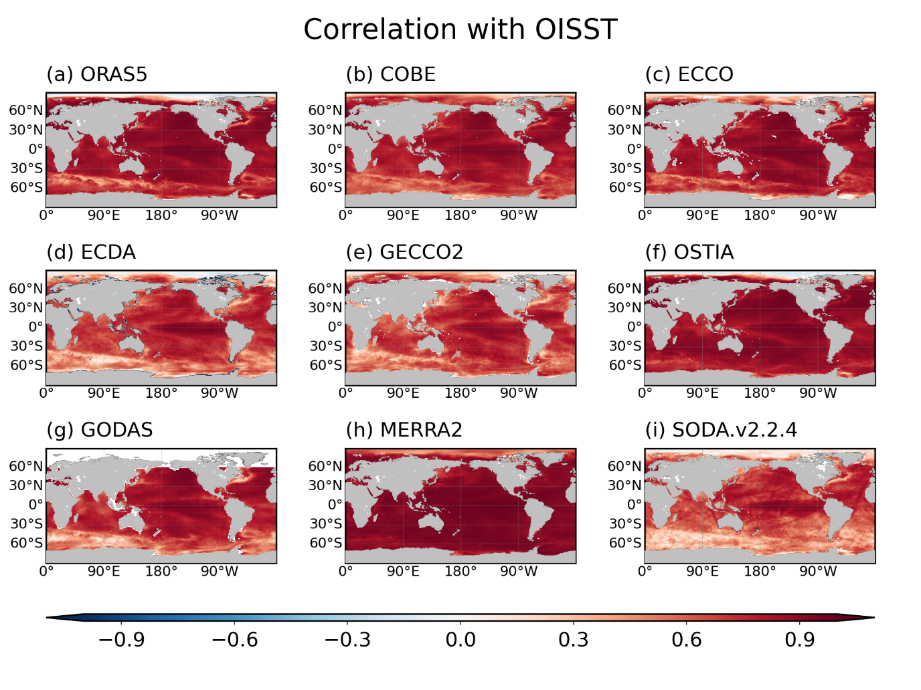
Extended Data Figure 8. The correlation skill of SST anomalies in various oceanic reanalysis products. The temporal anomaly correlation coefficients of the monthly SST anomalies between the OISST V2 and (a) ORAS5, (b) COBE, (c) ECCO, (d) ECDA, (e) GECCO2, (f) OSTIA, (g) GODAS, (h) MERRA2, or (i) SODA V2.2.4 during 1980-2020.

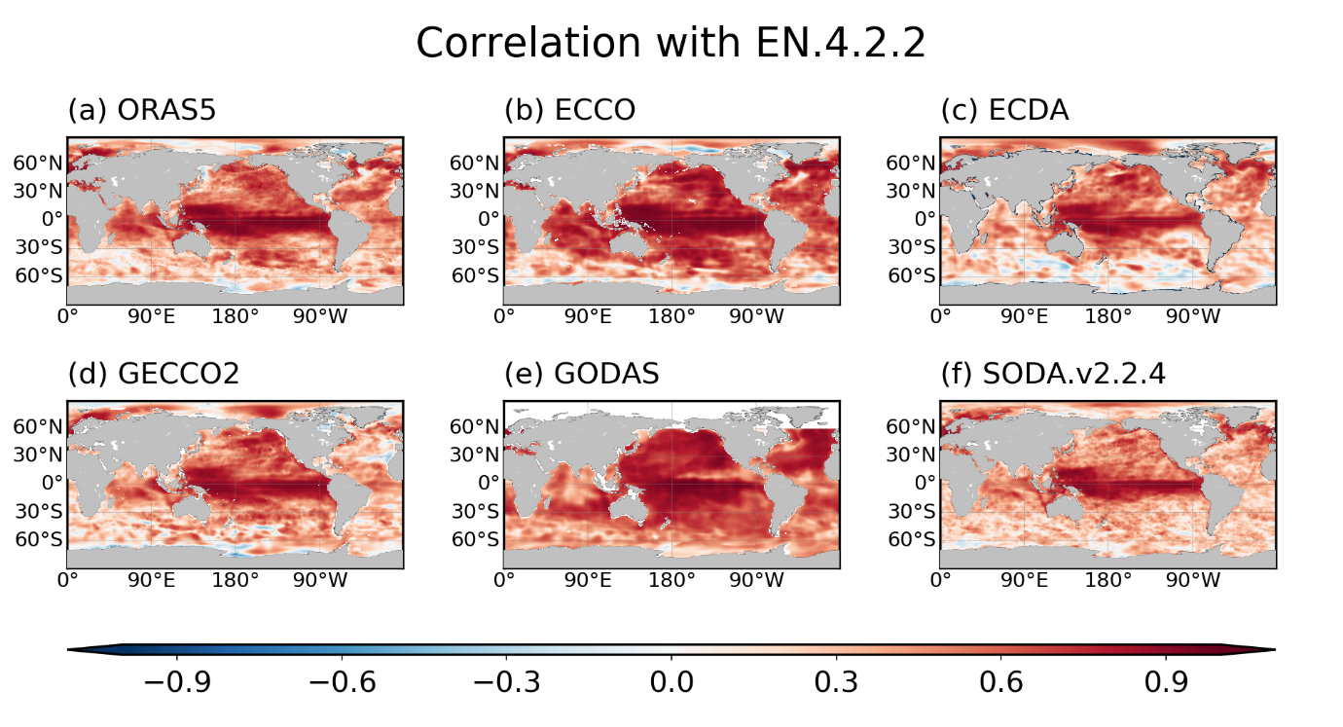
Extended Data Figure 9. The correlation skill of T300 anomalies in various oceanic reanalysis products. The temporal anomaly correlation coefficients of the monthly SST anomalies between the EN4.2.2 and (a) ORAS5, (b) ECCO, (c) ECDA, (d) GECCO2, (e) GODAS, or (f) SODA V2.2.4 during 1980-2020.

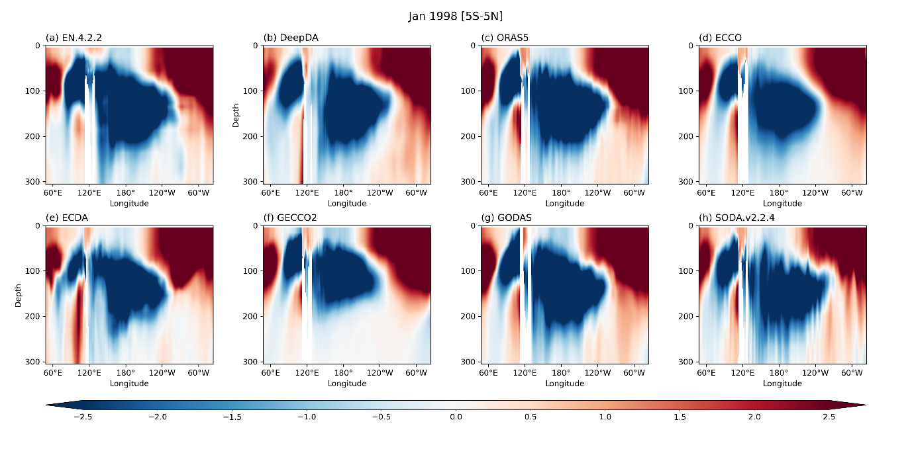
Extended Data Figure 10. The equatorial subsurface temperature anomalies during El Nino peak season. The equatorial temperature anomalies from surface to 300 m at January 1998 in (a) EN4.2.2, (b) DeepDA, (c) ORAS5, (d) ECCO, (e) ECDA, (f) GECCO2, (g) GODAS, and (h) SODA V2.2.4.

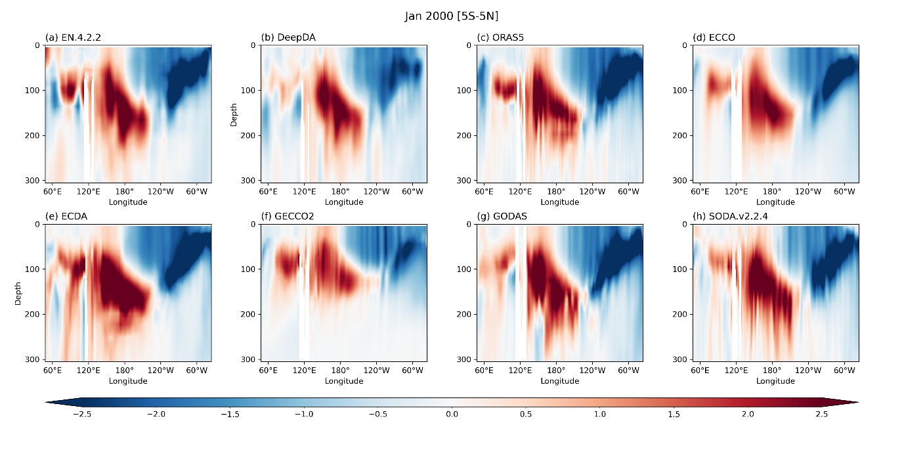
Extended Data Figure 11. The equatorial subsurface temperature anomalies during La Nina peak season. The equatorial temperature anomalies from surface to 300 m at January 2000 in (a) EN4.2.2, (b) DeepDA, (c) ORAS5, (d) ECCO, (e) ECDA, (f) GECCO2, (g) GODAS, and (h) SODA V2.2.4.

