Supplementary Information

Lysine-selective molecular tweezers are cell-penetrant and concentrate in lysosomes

Zizheng Li¹, Ibrar Siddique¹, Inesa Hadrović⁵, Ye Zhang^{2,3,4}, Frank-Gerrit Klärner⁵, Thomas Schrader⁵, and Gal Bitan^{1,3,4}

¹Department of Neurology, ²Department of Psychiatry and Biobehavioral Sciences,
David Geffen School of Medicine, ³Brain Research Institute, and ⁴Molecular biology Institute, University of California at Los Angeles, 635 Charles E. Young Drive South, Los Angeles, CA 90095, USA
⁵Institute of Chemistry, University of Duisburg-Essen, Universitätsstr. 7, 45117 Essen, Germany

Supplementary Movie 1. CLR16 is internalized in SH-SY5Y cells and forms bright puncta. SH-SY5Y cells were incubated with 5 µM CLR16 for 18 h, washed to remove CLR16 from the medium, and imaged by light and fluorescence microscopy. The 3D projection movie was created by combining Z-stacked images using the 3-D image viewer of BZ-X analyzer software.

Supplementary Movie 2. CLR16 colocalizes with lysosomes. SH-SY5Y cells were transiently transfected with GFP-actin, incubated with 5 µM CLR16 for 18 h, nuclei were stained with Hoechst, and lysosomes with LysoTracker™ (pseudo-colored cyan). The 3D projection movie was created by combining Z-stacked images using the 3-D image viewer of BZ-X analyzer software. Similar to Figure 4C, the diffuse red fluorescence of CLR16 is seen in the cell culture medium, whereas the movie shows that inside the cells nearly every cyan and red punctum overlap, demonstrating the colocalization of CLR16 with the lysosomes.

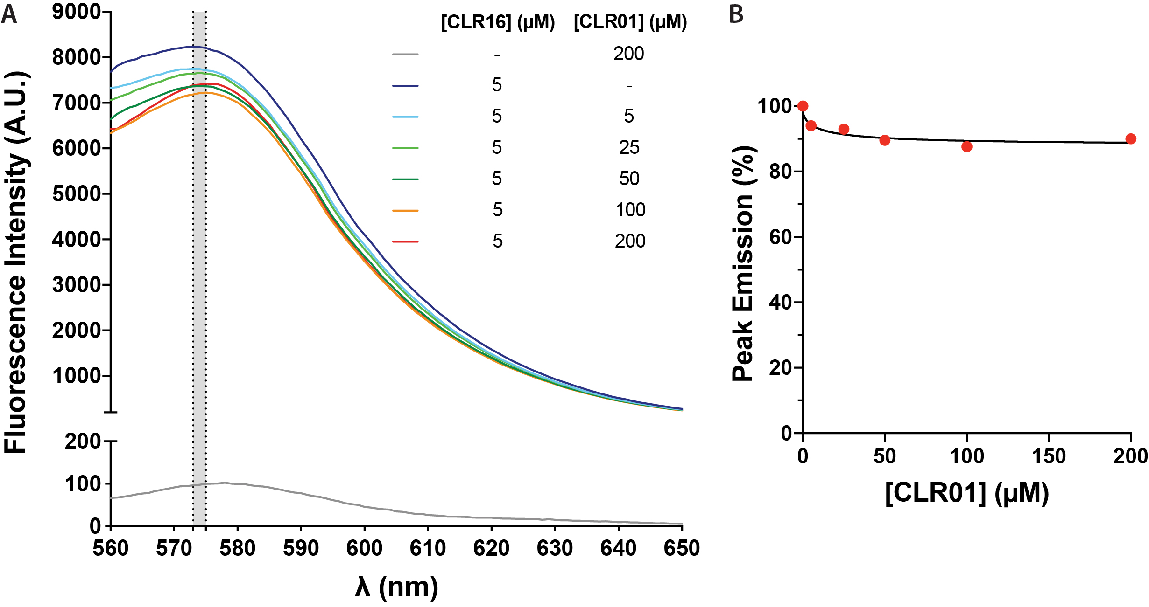
Supplementary Figure S1. CLR01 quenches CLR16 fluorescence weakly. A) 5 μM CLR16 was mixed with different concentrations of CLR01 in DMEM cell-culture medium and the fluorescence was measured between 560 and 650 nm. B) The maximum fluorescence, indicated by the gray area in panel A was plotted against CLR01 concentration.
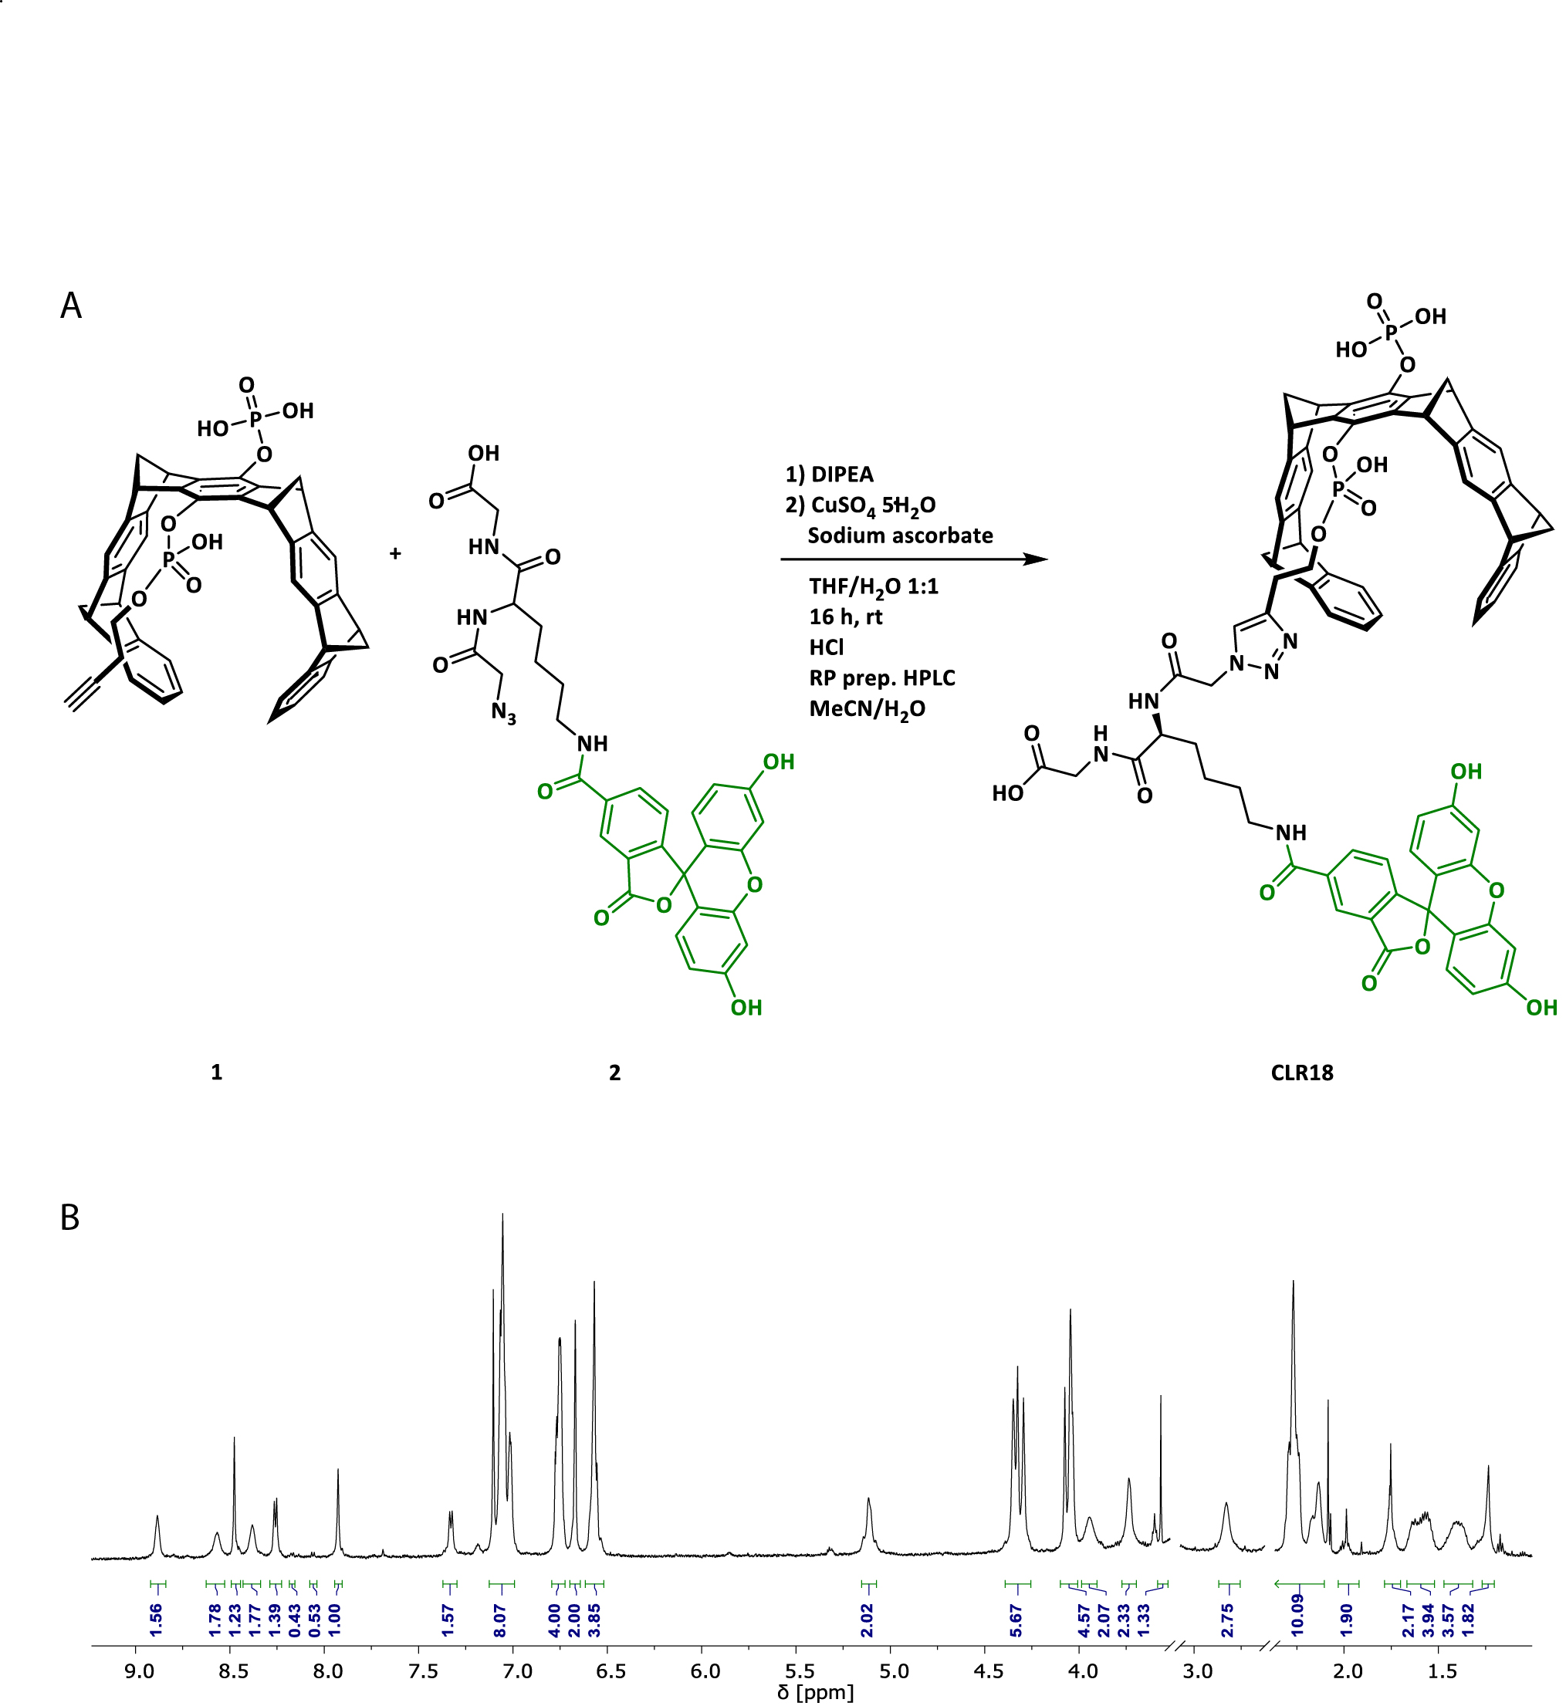
Supplementary Figure 2. Preparation of CLR18. A) Schematic of the reaction between the MT precursor 1 and FAM-azide 2 to yield CLR18. B) ¹H-NMR spectrum of the final product.

