Supporting Information

Effect of hydrophobic species on the oxygen reduction reaction on the high index planes of Pt₃Fe

Akane Suzuki, Masashi Nakamura, Nagahiro Hoshi*

Department of Applied Chemistry and Biotechnology, Graduate School of Engineering, Chiba University, Yayoi–cho–1–33, Inage–ku, Chiba, 263–8522, Japan

Corresponding author
Nagahiro Hoshi
hoshi@faculty.chiba–u.jp

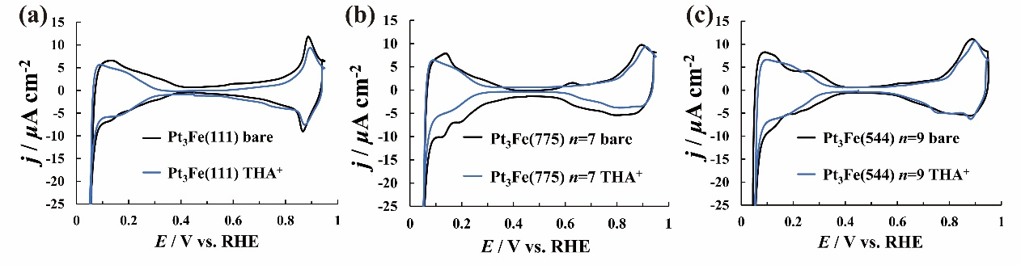
Fig. S1 CVs before and after THA⁺ modification in 0.1 M HClO₄ saturated with Ar.
Scanning rate: 0.010 V s⁻¹. (a) Pt₃Fe(111), (b) Pt₃Fe(775) = 7(111)–(111), (c) Pt₃Fe(544) = 9(111)–(100). Black line: without THA⁺, blue line: after THA⁺ modification.

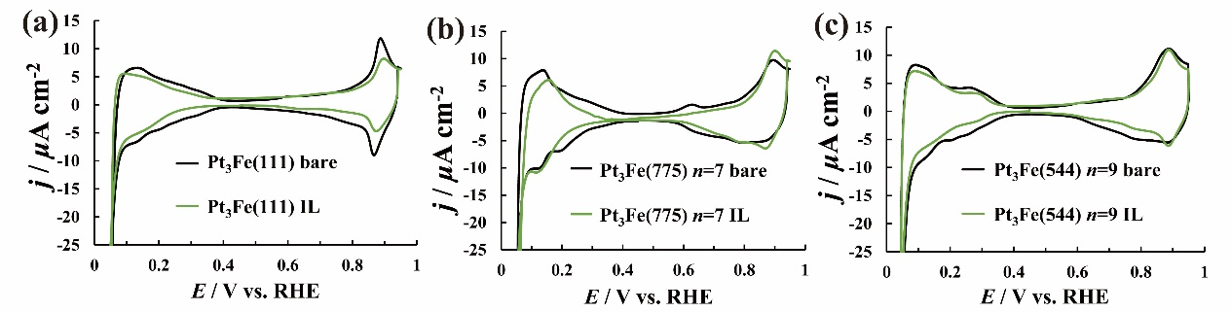
Fig. S2 CVs before and after IL modification in 0.1 M HClO₄ saturated with Ar.
Scanning rate: 0.010 V s⁻¹. (a) Pt₃Fe(111), (b) Pt₃Fe(775) = 7(111)–(111), (c) Pt₃Fe(544) = 9(111)–(100). Black line: without IL, green line: after IL modification.

Table S1. Values of the charge of adsorbed hydrogen region Q_{H} and the coverage of hydrophobic species θ of the low index planes of Pt₃Fe(111), Pt₃Fe(775) = 7(111)–(111), Pt₃Fe(544) = 9(111)–(100) before and after the modification with THA⁺, IL and melamine.
 |  | Q_{H}/μCcm⁻² | θ
Pt₃Fe(111) | bare | 111 | －
Pt₃Fe(111) | THA⁺ | 85.0 | 0.23
Pt₃Fe(111) | IL | 78.2 | 0.30
Pt₃Fe(111) | melamine– adsorbed | 86.7 | 0.22
Pt₃Fe(111) | melamine–added | 100 | 0.10
Pt₃Fe(775) | bare | 122 | －
Pt₃Fe(775) | THA⁺ | 74.9 | 0.38
Pt₃Fe(775) | IL | 84.2 | 0.31
Pt₃Fe(775) | melamine– adsorbed | 83.3 | 0.32
Pt₃Fe(775) | melamine–added | 90.4 | 0.26
Pt₃Fe(544) | bare | 116 | －
Pt₃Fe(544) | THA⁺ | 102 | 0.12
Pt₃Fe(544) | IL | 98.6 | 0.15
Pt₃Fe(544) | melamine– adsorbed | 105 | 0.095
Pt₃Fe(544) | melamine–added | 106 | 0.086

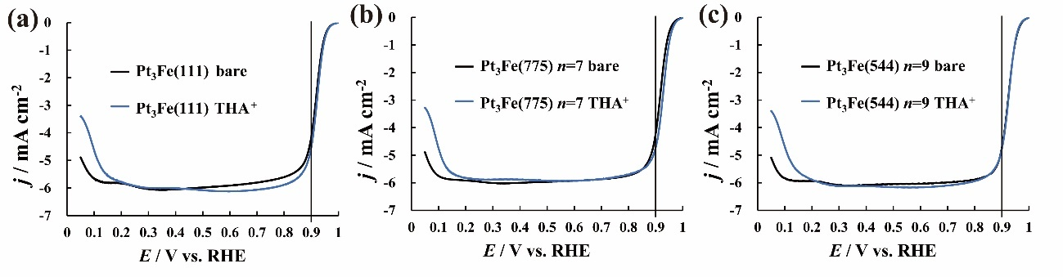 Fig. S3. LSVs before and after THA⁺ modification in 0.1 M HClO₄ saturated with O₂.
Scanning rate: 0.010 V s⁻¹. (a) Pt₃Fe(111), (b) Pt₃Fe(775) = 7(111)–(111), (c) Pt₃Fe(544) = 9(111)–(100). Black line : without THA⁺, blue line : after THA⁺ modification.

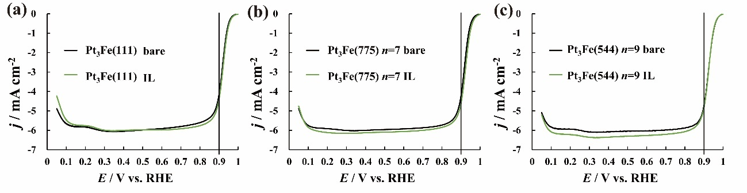
Fig. S4. LSVs before and after IL([MTBD][beti]) modification in 0.1 M HClO₄ saturated with O₂.
Scanning rate: 0.010 V s⁻¹. (a) Pt₃Fe(111), (b) Pt₃Fe(775) = 7(111)–(111), (c) Pt₃Fe(544) = 9(111)–(100). Black line: without IL, green line: after IL modification.

