Structure-based design of glycosylated oxytocin analogues
with improved selectivity and antinociceptive activity

Hannah J. Goodman,^{1#} Parthasadhireddy Tanguturi,^{2#} Lajos Z. Szabò,¹ Sarà Spröber,^{1,3} Chenxi Liu,¹
Fahad Al-Obeidi,¹ Vlad K. Kumirov,¹ M. Leandro Heien,^{1,4} John M. Streicher^{2,4} and *Robin Polt^{1,4}

¹Department of Chemistry & Biochemistry, The University of Arizona, Tucson, Arizona 85721
²Department of Pharmacology, College of Medicine, University of Arizona, Tucson, AZ 85724
³Visiting Student, Budapest University of Technology & Economics, 1111 Budapest,
Műegyetem rkp. 3. Hungary
⁴Comprehensive Pain and Addiction Center, University of Arizona, Tuscon, Arizona 85724
*Corresponding author: (520) 370-2654, polt@u.arizona.edu
#These authors contributed equally to the study.

Supporting Information on Methods.

Method Page Number
Chemical Structures of OT, OT-Agonists 1—8 2
Conformational Analysis 3 — 4
Chemical Synthesis 5 — 7
Compound Characterization 8 — 15
NMR Studies 16 — 20
Stability 21 — 23
BBB Penetration 23

Chemical Structures of OT, OT agonists 1—8

OT

1 | 2
3 | 4
5 | 6
7 | 8

Conformational Analysis of OT Backbones

To understand the source of enhancement of potency and metabolic stability of new analogues discovered in our lab relative to native oxytocin an in-Silico molding was applied. Our lab discovered that replacement of native oxytocin S-S bridge with lactam bridge (-CO-NH-) in oxytocin resulted in retention of activity and selectivity for OTR (Table 1). In addition, Gly⁹-NH₂ was replaced by Gly⁹-Ser¹⁰(O-beta-DGlucose)-NH₂. As prototype study three of the oxytocin analogues (Table 1), native oxytocin, compound 1 and compound 8 were studied by conformational search using LowModeMD method available in MOE software.¹ (Fig. 1 and Table X1 in Supplements).
Figure 1: Classes of intramolecular hydrogen bonds present in the macrocycle ring of the various analogues of oxytocin compounds.

The 4 atoms involvement HB labeled β-Type-I. Others with one HB (2 atoms) is labeled as β -Type-II if only Tyr²-CO and Asn⁵-NH are involved and β-Type-III if only Tyr²-NH and Asn⁵-CO are involved.
The main IMHB β-Type-I, which is conserved in native oxytocin structure and represent a bioactive conformation of the macrocycle structure of oxytocin. Based on active analogues of oxytocin, the highest population of β-Type-I and its intermediates β-Type-II and β- Type-III were used as a marker for potential bioactivity of compound under investigation. The potential contributions of the three IMHBs goes as β-Type-I> and β-II>> than β-Type-III.

Results of trajectory analyses of various analogues of oxytocin bridged by S-S or lactam groups are listed in Table I. All the 3 structures were studied by LowModeMD and their conformational structures of their macrocycles were analyzed for the population of the 3 types of IMHBs.
Entry (Table 1) | Compound | β-I % | β -II % | β -III % | Bridge | Ring size
1(OT) | Oxytocin | 13 | 7 | 4 | S-S | 20
2 (1) | Oxy-c[Asp¹-Dap⁶]-NH2 | 7 | 10 | 2 | Lactam | 20
3 (8) | OxySS-6-c[Glu¹-Dap⁶]-Pro⁷-Aib⁸-Gly⁹-Ser¹⁰(BDG)-NH₂ | 17 | 12 | 6 | Lactam | 21
Table 1: Structures and populations of IMHBs of compounds investigated in this study.
First compound (entry 1) was native oxytocin, and second compound (entry 2) is the active lactam version of oxytocin which was also reported in literature as active analogues of native oxytocin (¹). Compound in entry 2 showed low retention of conformational profile relative to oxytocin with about 50% less than oxytocin in β-Type-I and its bioactivity was less than native oxytocin (Table 1). These results indicated substitution of S-S-bridge of native oxytocin with lactam bridge and conserved ring size to 20 members resulted in some reduction in its conformational profile with decrease in β-Type-I and retention in other two HBs and these changes may be reflected on the biological potency (Table 1) of entry 1 compound.

The structure in entry 3 is discovered in our lab with super potent agonist oxytocin analogue with three new features including ring size of 21 members instead of classical 20 members of S-S bridge of oxytocin and substitution of Leu⁸-of native oxytocin with Aib⁸ (aminoisobutyric). In addition, the C-terminal was linked to Ser¹⁰(beta-D-Glucose). Intramolecular hydrogen bonds profile of entry 3 compound is higher than the native oxytocin with about more than 20% higher with β-Type-I compared to native oxytocin and about 2 times higher with β-Type-I compared to entry 2 compound. These high population of the IMHBs for entry 3 compound may be the source of super potency (Table 1).

The cyclic lactam family of compounds showed superior metabolic stability relative to native oxytocin, with adjustment of ring size to 21 members brought more population of IMHBs. The increase of population of IMHBs may act as a marker for prediction biological potency of newly designed compounds. The use of conformational search of newly designed compounds with retention of high populations of important conformation of the macrocyclic ring structures can be used to guide our future new designed analogues of oxytocin.
Synthesis of OT Agonists via Solid Phase Peptide Synthesis (SPPS)
Scheme 1: General solid phase peptide synthesis for oxytocin analogues.

OT Agonists 1-8 were synthesized on a Prelude® automated peptide synthesizer (Gyros Protein Technologies, Tucson, AZ, USA) using both automated and semi-manual loading, which requires loading reagents into the reaction vessels with a syringe. The vessels were mixed with a steady flow of argon. DMF and DCM washes were 2 min each.

Resin preparation
MBHA Rink amide resin (~1.2 g, loading 0.6 mmol.g⁻¹) was added to a 45 mL fritted reaction vessel, was swelled twice with DMF (10 mL, 10 min each). The Fmoc-protected resin was deprotected with a mixture of DBU (2% v/v) and piperidine (2% v/v) in DMF (10 mL) for 5 min, rinsed with DMF (10 mL) and then deprotected again for 7 min. The reaction vessels were washed with DMF 6 more times (10 mL, 2 min each).

Glycine or glycosyl amino acid loading
An equimolar mixture of 0.85 mmol (1 eq) Fmoc-Gly-OH, Fmoc-Ser(β-Glc(OAc)₄)-OH, or Fmoc-Ser(Lact(OAc)₇)-OH and Cl-HOBt (0.85 mmol, 1 eq) was dissolved in NMP (8 mL). DIC (0.85 mmol, 1 eq) was added to the solution after 15 min. The amino acid (AA) solution was manually added to the reaction vessel and stirred overnight. The mixture was diluted with DMF (10 mL) and drained before washing with DCM (10 mL). The mixture was drained and then washed with DMF (10 mL, 6 times). The vessel was then washed and stirred with DCM (8 mL, 4 times). The unreacted NH₂ sites on the resin were capped twice with a solution of N,N-diisopropylethylamine (DIEA, 10% v/v) and Ac₂O (10% v/v) in DCM (6 mL, 30 min each). After 1 h, the resin was washed with DCM (8 mL, 4 times) and then with DMF (8 mL, 4 times). The remaining amino acids were added via automated synthesis, except for those present at the cyclization site (Fmoc-Dap(Alloc), Fmoc-Asp(All), and Fmoc-Glu(All), vide infra).

Prelude® automated synthesis
AA solutions were prepared from an equimolar mixture (3 eq) of Fmoc-protected amino acids, chlorohydroxybenzotriazole (Cl-HOBt), and diisopropylcarbodiimide (DIC) and loaded to the synthesizer. Automated synthesis began with DMF washing (10 mL) followed by Fmoc deprotection achieved by two additions of a solution containing DBU (2% v/v) and piperidine (2% v/v) in DMF (10 mL, 4 min) followed by DMF washing (10 mL) after each addition. The AA solution was loaded (10 mL) along with (2-(1H-benzotriazol-1-yl)-1,1,3,3-tetramethyluronium hexafluorophosphate (HBTU, 0.375 M) in DMF and N-methylmorpholine (NMM, 3 M) in DMF and mixed (20 min). The vessels were then washed with DMF 5 times. The AA coupling reaction was repeated a second time but mixed for a longer duration (30 min).

Cyclization
All cyclization steps, including AA loading of the Fmoc-Dap(Alloc) and Fmoc-Asp(All) or Fmoc-Glu(All), were loaded semimanually. AA located at the site of cyclization are indicated by bold text in the sequences below. After the full AA sequence was assembled, the All and Alloc protecting groups were removed with PhSiH₃ (20 eq) in DCM (5 mL) and then Pd(PPh₃)₄ (0.1 eq) in DCM (3 mL). The resin was washed with DMF (10 mL, 6 times), with diethyldithiocarbamate (DEDTC, 0.5% w/w) in DMF (10 mL, 3 times), and DMF (10 mL, 6 times). The lactam ring was formed with PyClock (2.16 eq) and DIEA (4.32 eq) in NMP. The resin was washed with DMF (10 mL, 6 times), with diethyldithiocarbamate (DEDTC, 0.5% v/v) in DMF (10 mL, 3 times), and DMF (10 mL, 6 times).

Acetyl cleavage
Acetyl groups were removed from the sugar moieties with a solution of hydrazine-hydrate (NH₂NH₂⦁H₂O, 50%, 10 mL) was added to the resin and mixed overnight. This solution was drained and then added again (10 mL, 2 h). After draining, the resin was washed with DMF (10 mL, 8 times) and DCM (10 mL, 8 times) and dried.

Cleavage from the resin and global side chain deprotection
The dried resin was treated with an acidic cleavage cocktail containing trifluoroacetic acid (TFA) and triethylsilane (TES) (TFA/DCM/H₂O/TES/anisole, 90:10:2:3:0.5) and mixed (1 h). The solution was collected before repeating the cleavage step 2 more times (10 min each). The combined fractions were slowly evaporated with argon until the peptide began to crash out, at which point cold Et₂O was added to precipitate any remaining peptide. The mixture was centrifuged and the Et₂O layer decanted. This process was repeated twice more (for 3 total Et₂O additions) and the crude peptide was dried thoroughly and lyophilized before purification by preparative high performance liquid chromatography (HPLC).

HPLC purification and characterization of OT analogues
Compound purification was completed by reverse phase high performance liquid chromatography (RP-HPLC) using a semi-preparative (250x22 mm) C-18 column with a gradient eluent system (CH₃CN⦁H₂O with 0.1% TFA). The purity of products (typically 5-7 mg) was confirmed using analytical RP-HPLC (250x4.6 mm, C-18) and MS/MS with Collision Induced Decomposition (CID).
Compound Characterization
1 | Asp-Tyr-Ile-Gln-Asn-Dap-Pro-Leu-Gly-CONH₂ | 1
 | MW: 986.61, retention time t_{R} = 9.82 min.
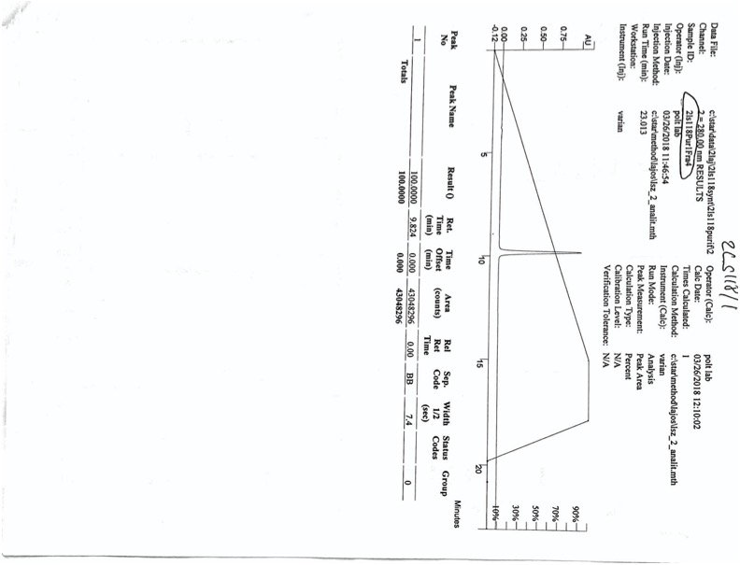

2 | Glu-Tyr-Ile-Gln-Asn-Dap-Pro-Leu-Gly-NH₂ | 1
 | MW: 1178.71, t_{R} = 9.29 min.
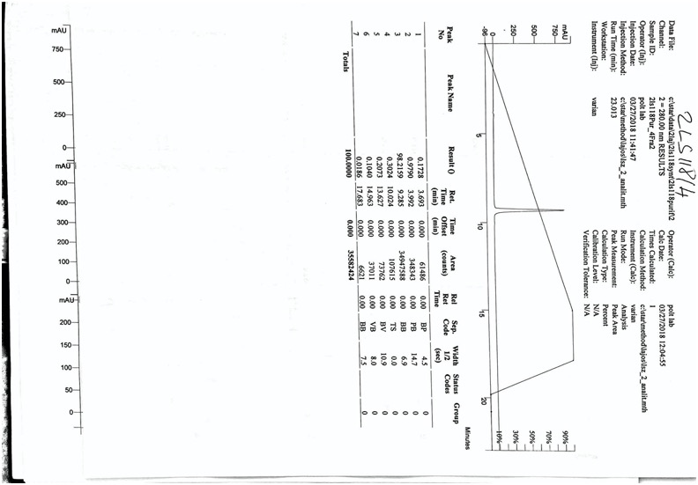
3 | Asp-Tyr-Ile-Gln-Asn-Dap-Pro-Leu-Ser(Lact)-NH₂ | 1
 | MW: 1340.76, t_{R} = 8.42 min.
4 | Asp-Tyr-Ile-Gln-Asn-Dap-Pro-Leu-Gly-SerLact-CONH₂ |  | 1
 |  | MW: 1398.69, t_{R} = 9.50 min.

5 | Asp-Tyr-Ile-Gln-Asn-Dap-Pro-Aib-SerGlc-CONH₂ | 1
 | MW: 1150.64, t_{R} = 8.85 min.

6 | Glu-Tyr-Ile-Gln-Asn-Dap-Pro-Leu-SerGlc-CONH₂ | 1
 | MW: 1197.72, t_{R} = 9.66 min.

7 | Glu-Tyr-Ile-Gln- Glu-Tyr-Ile-Gln-Asn-Dap-Pro-Aib-SerGlc-CONH₂ |  | 1
 |  | MW: 1164.67, t_{R} = 8.5 min.

8 | Glu-Tyr-Ile-Gln-Asn-Dap-Pro-Aib-Gly-SerGlc-CONH₂ | 1
 | MW: 1221.67, t_{R} = 8.74 min.
NMR Studies of OT Agonist 8
 |  | H δ (ppm) | C δ (ppm) |  |  | H δ (ppm) | C δ (ppm)
E1 |  |  |  | Dap6
 | CO | --- | 177.18 |  | NH | 7.853 | ---
 | αCH | 4.136 | 54.91 |  | αCH | 4.716 | 54.46
 | βCH₂ | 2.138, 2.253 | 29.36 |  | CO | --- | 174.61
 | γCH₂ | 2.256, 2.404 | 32.44 |  | βCH₂ | 3.246, 3.714 | 42.26
Y2 |  |  |  |  | δβNH₂ | 7.784 | ---
 | NH | 8.762 | --- | P7
 | CO | --- | 177.27 |  | CO | --- | 176.52
 | αCH | 4.719 | 58.46 |  | αCH | 4.396 | 63.63
 | βCH₂ | 2.983, 3.188 | 38.49 |  | βCH₂ | 1.934, 2.262 | 31.92
 | 1' | --- | 157.61 |  | γCH₂ | 2.002, 2.067 | 27.51
 | 2'6' | 7.200 | 133.10 |  | δCH₂ | 3.729 | 50.77
 | 3'5' | 6.865 | 118.50 | Aib8
 | 4' | --- | 130.69 |  | NH | 8.528 | ---
I3 |  |  |  |  | CO | --- | 180.66
 | NH | 8.023 | --- |  | αCH | --- | 59.92
 | CO | --- | 177.18 |  | βCH₂ | 1.468 | 26.68
 | αCH | 4.036 | 62.53 |  | β'CH₂ | 1.469 | 27.48
 | βCH₂ | 1.871 | 38.46 | G9
 | γCH₂ | 1.136, 1.375 | 27.56 |  | NH | 8.210 | ---
 | γ'CH₂ | 0.907 | 146.64 |  | CO | --- | 174.69
 | δCH₃ | 0.876 | 13.41 |  | αCH₂ | 3.939 | 45.89
Q4 |  |  |  | S10
 | NH | 8.266 | --- |  | NH | 8.228 | ---
 | CO | --- | 177.22 |  | CO | --- | 176.73
 | αCH | 4.106 | 57.92 |  | αCH | 4.616 | 56.2
 | βCH₂ | 2.011, 2.058 | 28.44 |  | βCH₂ | 3.925, 4.223 | 71.35
 | γCH₂ | 2.934 | 33.88 |  | CONH₂ | 7.235, 7.291 | 173.80
 | δCO | --- | 177.56 | Glc
 | δNH₂ | 6.741, 7.450 | --- |  | 1CH | 4.450 | 105.03
N5 |  |  |  |  | 2CH | 3.284 | 75.92
 | NH | 7.970 | --- |  | 3CH | 3.485 | 78.46
 | CO | --- | 176.36 |  | 4CH | 3.047 | 75.55
 | αCH | 4.819 | 52.74 |  | 5CH | 3.321 | 81.83
 | βCH₂ | 2.757, 2.853 | 38.42 |  | 6CH₂ | 3.710, 3.899 | 63.61
 | γCH₂ | --- | 176.71
 | γNH₂ | 6.919, 7.593
Table 2. Chemical shifts (δ) referenced to TSP. Data was acquired in 50 mM CD₃COONa buffer containing 0.45% NaCl and 0.05% NaN₃ at pH 5.2.

Residue | δ Hα | ¹H α range² | CSIª | δ Cα | ¹³Cα range³ | CSIª | δ CO | ¹³CO range³ | CSIª
Y2 | 4.719 | 4.60 ± 0.10 | 1 | 58.46 | 58.6 ± 0.7 | 0 | 177.27 | 175.7 ± 0.5 | 1
I3 | 4.036 | 3.95 ± 0.10 | 0 | 62.53 | 62.6 ± 0.7 | 0 | 177.18 | 176.9 ± 0.5 | 0
Q4 | 4.106 | 4.37 ± 0.10 | -1 | 57.92 | 56.2± 0.7 | -1 | 177.22 | 176.3 ± 0.5 | 1
N5 | 4.819 | 4.75 ± 0.10 | 0 | 52.74 | 53.6 ± 0.7 | -1 | 176.36 | 175.1 ± 0.5 | 1
P7 | 4.396 | 4.44 ± 0.10 | 0 | 63.63 | 62.9 ± 4.0 | 0 | 176.52 | 176.0 ± 4.0 | 0
G9 | 3.939ª | 3.97 ± 0.10 | 0 | 45.89 | 45.0 ± 0.7 | 1 | 174.69 | 173.6 ± 0.5 | 1
S10 | 4.616 | 4.50 ± 0.10 | 1 | 56.20 | 58.3 ± 0.7 | -1 | 176.73 | 173.7 ± 0.5 | 1
Table 3. Chemical-Shift Index (CSI) analysis for Hα, Cα, and backbone carbonyls of 8. Chemical shifts (δ) are reported in ppm) There is no evidence of secondary structure from the CSI analysis of this data, so the solution-phase peptide must be considered a random coil in solution. Nonnatural amino acids are omitted since they are not included in the CSI.
ªCSI calculation is based on the literature protocol.^{2,3}

Figure 2. ¹H-¹³C HSQC NMR spectrum with assignments used for Tables 1 and 2.

Figure 3. TOCSY (grey) and NOESY (red) spectral overlay showing assignments and NOEs for the amide peaks.

Dap6_{δβ}
Figure 4. ¹H-¹⁵N HSQC spectrum with assignments used to help with amide assignments in NOESY/TOCSY.

Dap6_{δβ}
Dap6_{δβ}
Dap6_{δβ}
Dap6_{δβ}
Dap6_{δβ}
Figure 5. VT ¹H NMR data used for TC calculations (Table 3, vide infra).

Temp | Y2 | I3 | Q4 | N5 | Dap6 | Aib8 | G9 | S10 | Dap6_{δβ}
293 | 8.890 | 8.160 | 8.401 | 8.088 | 7.884 | 8.584 | 8.243 | 8.275 | 7.820
298 | 8.867 | 8.129 | 8.370 | 8.069 | 7.864 | 8.544 | 8.217 | 8.243 | 7.801
303 | 8.843 | 8.089 | 8.339 | 8.049 | 7.845 | 8.504 | 8.192 | 8.213 | 7.782
308 | 8.820 | --- | 8.309 | 8.030 | 7.826 | 8.463 | 8.167 | 8.184 | 7.764
313 | --- | 8.424 | 8.279 | 8.011 | 7.807 | 8.424 | --- | 8.156 | 7.746
−ΔδNH/ΔK | 4.7 | 7.1 | 6.1 | 3.9 | 3.8 | 8.0 | 5.1 | 5.9 | 3.7

Table 4. VT ¹H NMR chemical shifts for amide peaks reported in ppm for each amino acid residue at each temperature. Some peaks were unable to be precisely determined (represented in the table as ---). TC (−ΔδNH/ΔK) for each amide was calculated by linear regression of plotted data.

Stability

Figure 6. Blood withdrawal and microdialysis sampling for serum and CSF sample collection.

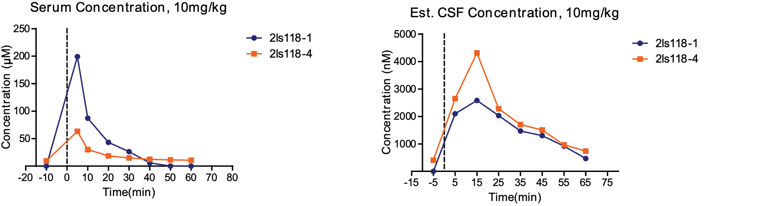
Oxy-NG-1
Oxy-G-4
Figure 7. Glycosylation of OXY-NG-1 with a glucose moiety led to a two-fold effect in vivo– increased excretion rates from serum

XIC assessment of glycosylation of OT agonists
Figure 8. Extracted ion chromatograms (XIC) for selected OT agonists. In the legend above, NG = no glycosylation, G = glycosylated.

Compound | Sequence | t_{1/2} (min)
Oxytocin | ^{C}[Cys-Tyr-Ile-Gln-Asn-Cys]-Pro-Leu-Gly-NH2 | 1.4 ± 0.6
Oxy-NG-1 | ^{C}[Asp-Tyr-Ile-Gln-Asn-Dap]-Pro-Leu-Gly-NH2 | 25.8 ± 9.2
Oxy-NG-2 | ^{C}[Glu-Tyr-Ile-Gln-Asn-Dap]-Pro-Leu-Gly-NH2 | 24.7 ± 11.0
Oxy-G-3 | ^{C}[Asp-Tyr-Ile-Gln-Asn-Dap]-Pro-Leu-Ser(β-Glc)-NH₂ | 34.5 ± 0.9
Oxy-G-4 | ^{C}[Asp-Tyr-Ile-Gln-Asn -Dap]-Pro-Leu-Gly-Ser(β-Glc)-NH₂ | 18.7 ± 8.4

Table 5. In vitro stability of OT and selected glycosylated and non-glycosylated OT agonists in rat serum, 37 °C (t_{1/2} = half-life). NG = no glycosylation, G = glycosylation.

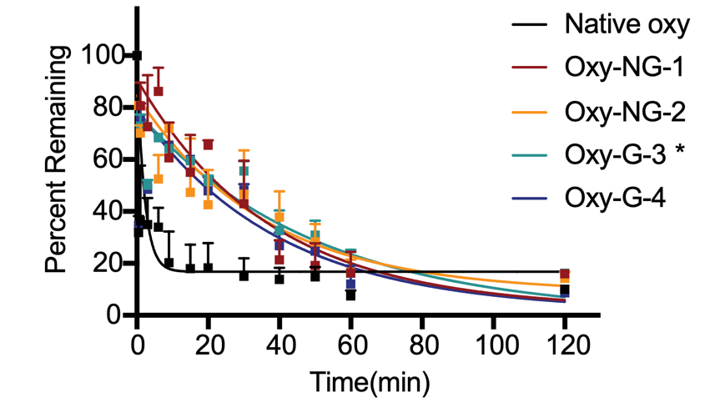
Figure 9. Stability of peptides in rat serum at 37 oC. An exponential non-linear fit was used for degradation curves. Oxy-NG-1 n=2, Oxy-NG-2, n=3, Oxy-G-3 n=2, Oxy-G-4 n=3, Native oxy n=4, one-way ANOVA (F(4,8) = 4.457, p = 0.0346) with Bonferroni post-hoc of Oxy-G-3 compared to Native oxytocin, p = 0.0492. data reported mean ± SEM.

Oxy-G-4
Oxy-NG-1
Figure 10. Stability of peptides and glycopeptides ex vivo in rat serum at 37°C as determined by HPLC-MS. An exponential non-linear fit was used to quantify the peptide structures. The stability amide-linked cyclic peptide Oxy-NG-1 (n=2), and the corresponding glucoside Oxy-G-4 (n=4), were compared to native oxytocin = OT (n=4), with a one-way ANOVA (F(4,8) = 4.457, p = 0.0346) compared to OT, p = 0.0492.
BBB Penetration
OXY-NG-1
OXY-G-4
Figure 11. Glycosylation of OXY-NG-1 with a glucose moiety led to a two-fold effect in vivo– increased excretion rates from serum, as well as increased BBB penetration rates following i.v. injection (10 mg/kg) into the tail vein of a rat.

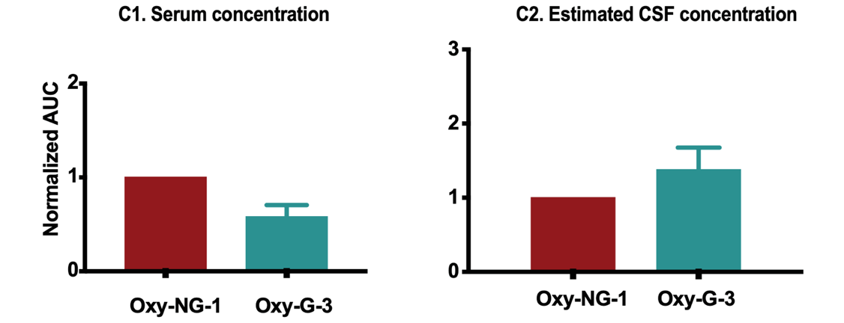
Figure 12. Area under the curve (AUC) of in vivo serum and CSF dialysate concentrations. AUCs were obtained by integrating serum and CSF dialysate pharmacokinetic profile concentration over time with starting point time = 0 to 60 minutes for serum, 65 minutes for CSF due to the time-averaging nature of dialysate collection. The data are then normalized to the non-glycosylated analogue. n=3, 10mg/kg. i.v. AUC reported by mean ± SEM. Asterisks denote statistical significance using repeated measures ANOVA, Dunnett’s multiple comparison test.

References

1 Moleular Operating Environment (MOE) v. 2019.01 (Chemical Computing Group ULC, Montreal, QC, Canada, 2019).
2 Wishart, D. S., Sykes, B. D. & Richards, F. M. The chemical shift index: a fast and simple method for the assignment of protein secondary structure through NMR spectroscopy. Biochemistry 31, 1647-1651, doi:10.1021/bi00121a010 (1992).
3 Wishart, D. S. & Sykes, B. D. The 13C chemical-shift index: a simple method for the identification of protein secondary structure using 13C chemical-shift data. J Biomol NMR 4, 171-180, doi:10.1007/bf00175245 (1994).

