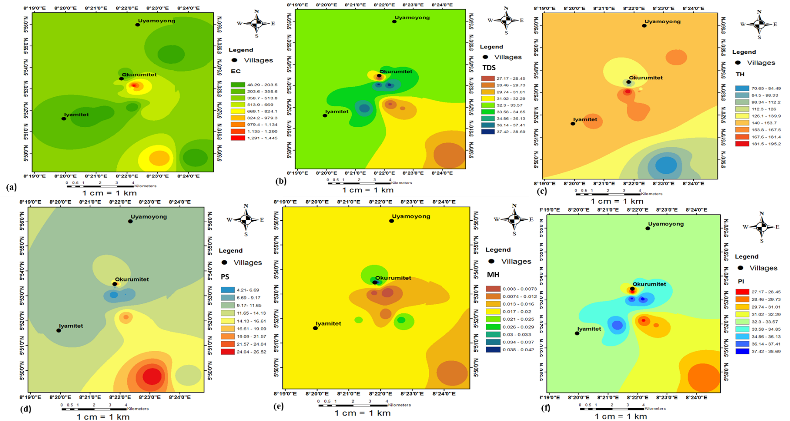
Fig. S1 Spatial maps of the various irrigational water parameters

