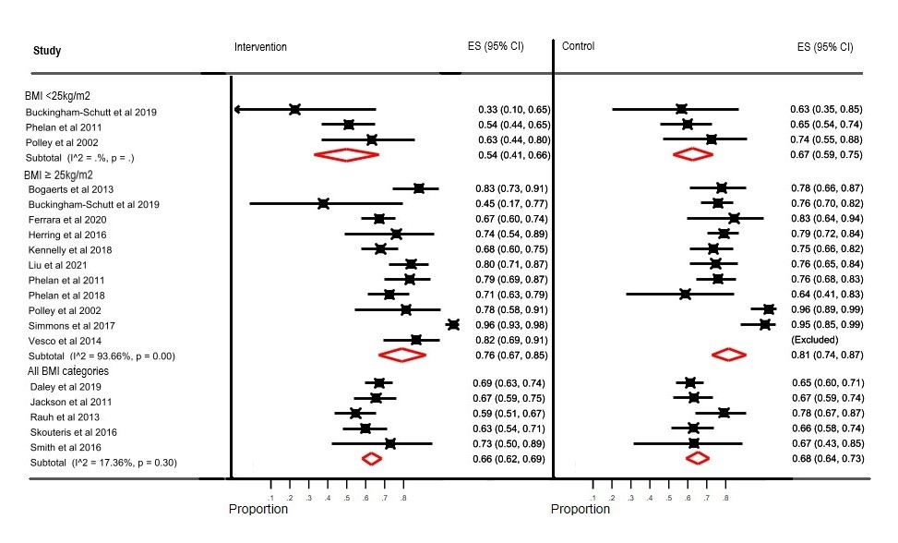
Additional figure 2 – proportion of participants with inappropriate GWG stratified by BMI category

