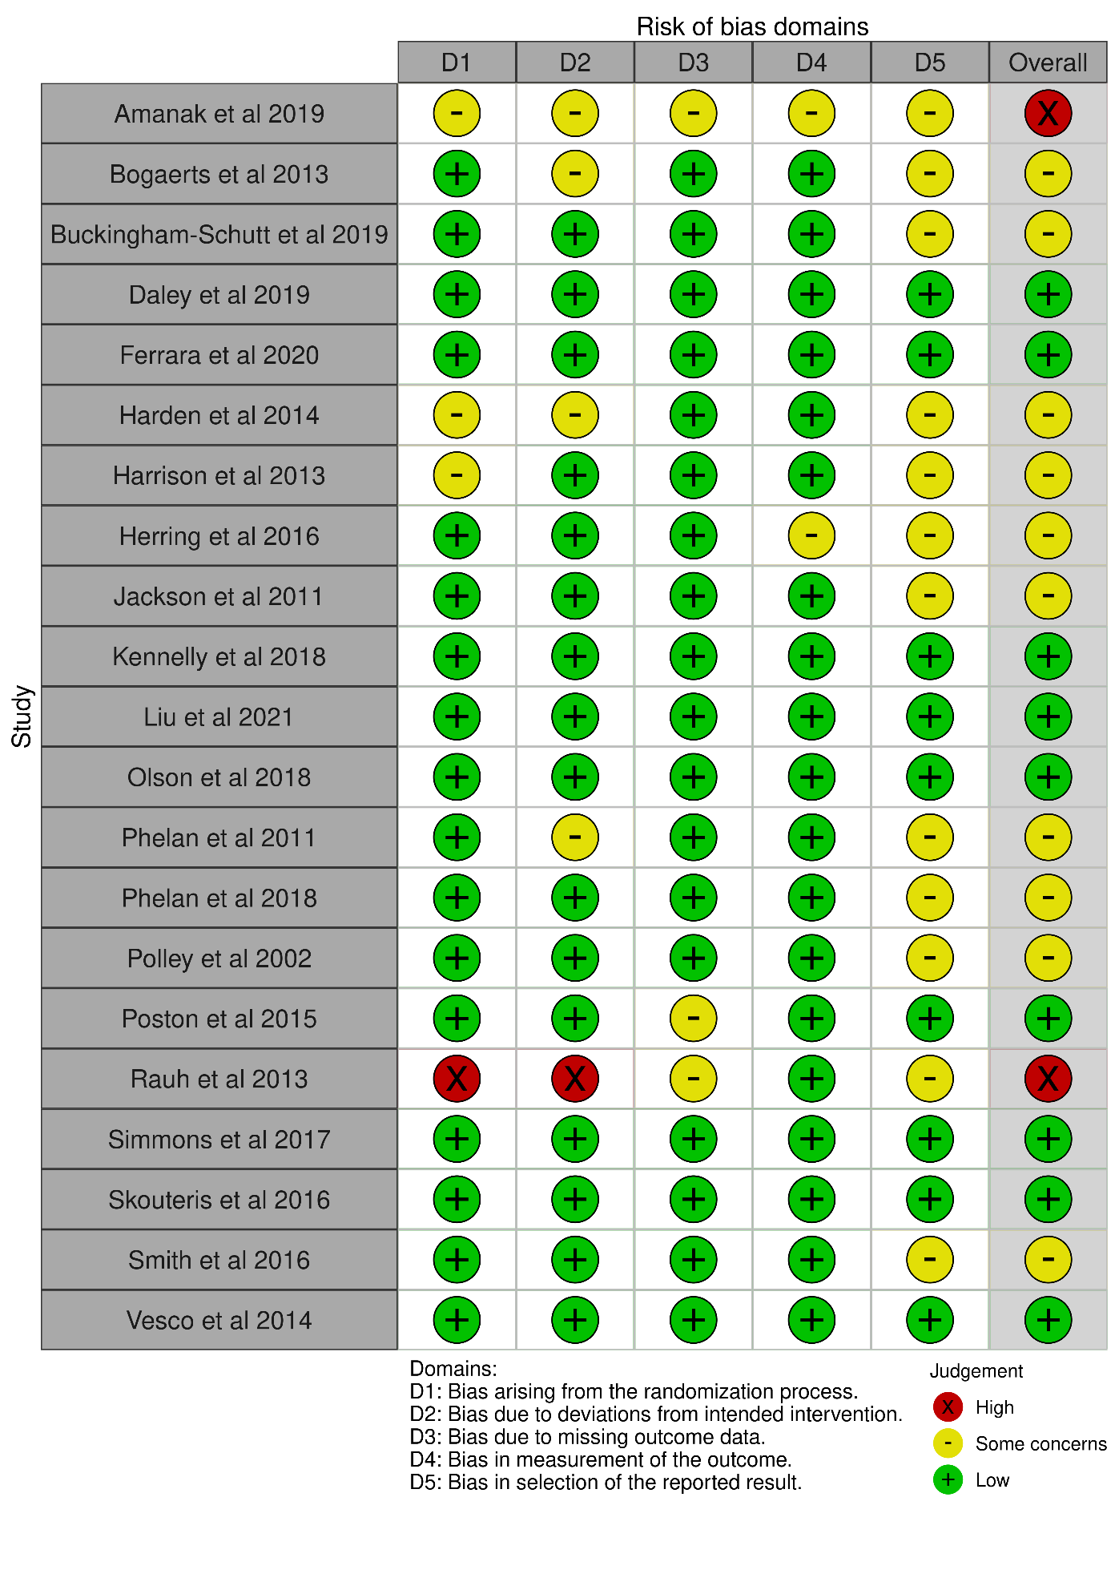
Additional figure 1 – summary of findings

