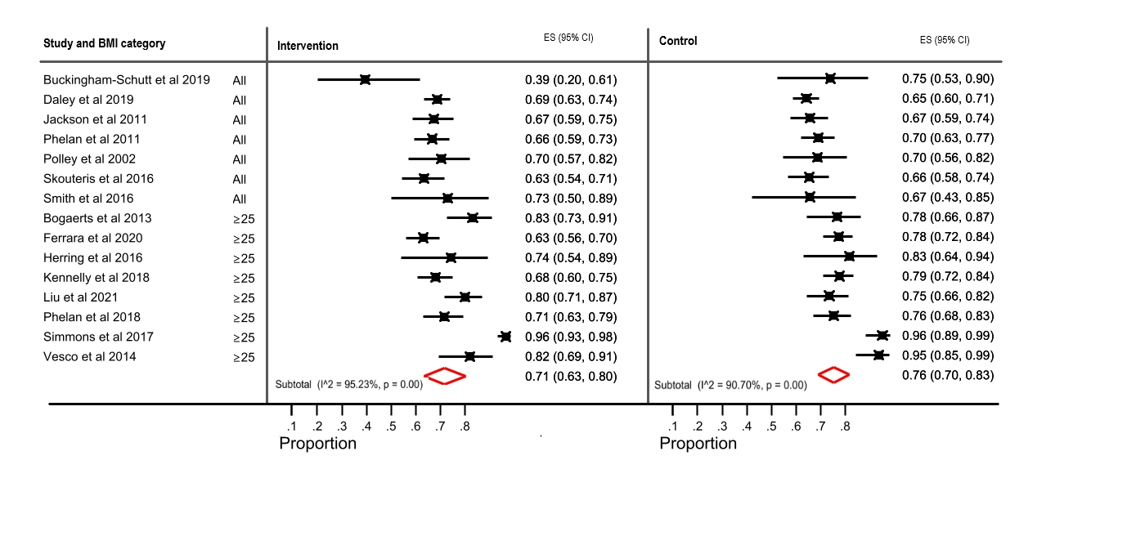
Additional figure 3 – sensitivity analysis

