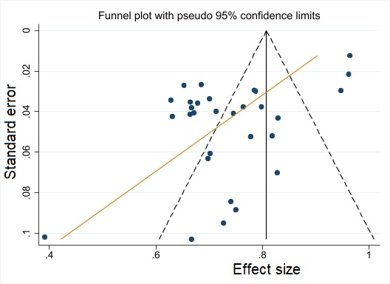
Additional figure 6 – Funnel plot

