Impact of proton therapy on antitumor immune response
Céline MIRJOLET (PhD)^{1,2}*, Anaïs NICOL³, Emeric LIMAGNE (PhD)^{2,4}, Carole MURA³, Corentin RICHARD (PhD)⁶, Véronique MORGAND¹, Marc ROUSSEAU (PhD)⁵, Romain BOIDOT (PhD)⁶, François GHIRINGHELLI (MD, PhD)^{2,4}, Georges NOEL (MD, PhD)^{5,7}, and Hélène BURCKEL (PhD)³

Table S1. List of the 68 genes differentially expressed between the un-irradiated control (NI) and 16.4 Gy irradiated tumors 3 days post-irradiation. s-value < 0.005. Groups contained 5-6 mice. (Excel document)

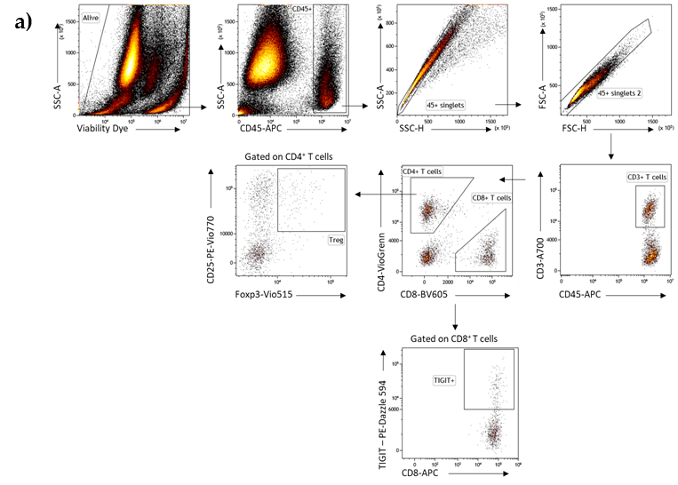

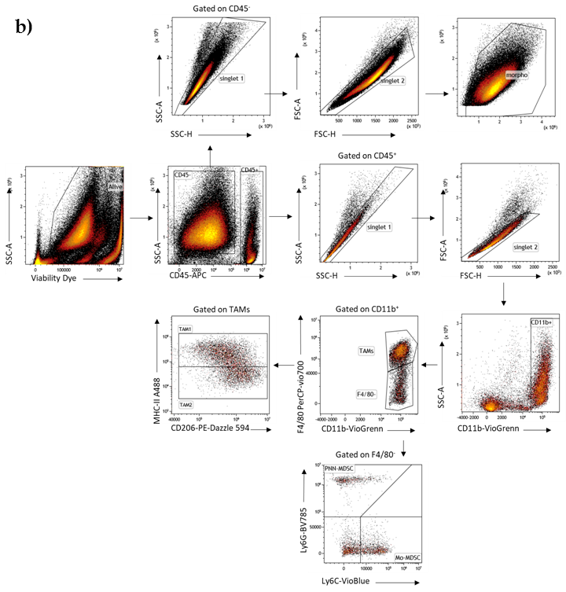

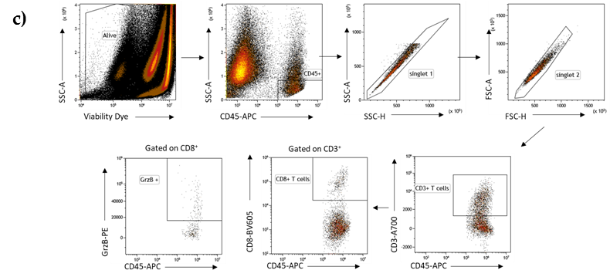
Figure S1. Gating procedures for flow cytometry. a) Gating strategy for lymphoid cells identification and quantification in tumor tissue. After CT26 tumor tissue dissociation, cells were stained with viability dye (eFluor 780), anti-CD45, anti-CD3, anti-CD4, anti-CD8, anti-CD25 and anti-Foxp3 antibodies and analyzed by flow cytometry. The frequency among CD45+ Tils of total T cells (CD45+ CD3+), CD8+ T cells (CD45+ CD3+ CD8+), CD4+ T cells (CD45+ CD3+ CD4+), NK Cells (CD45+CD3+NKP96+), and Treg (CD25high Foxp3+) were analyzed. b) Gating strategy for myeloid and tumor cells identification and quantification in tumor tissue. After CT26 tumor tissue dissociation, cells were stained with viability dye (eFluor 780), anti-CD45, anti-CD11b, anti-Ly6G, anti-Ly6C, anti-F4/80, anti-MHC-II and anti-CD206 antibodies and analyzed by flow cytometry. The frequency among CD45+ Tils of total myeloid cells (CD45+ CD11b+), TAM2 (CD45+ CD11b+ Ly6G- Ly6Clow F4/80+ MHC-II- CD206+), TAM1 (CD45+ CD11b+ Ly6G- Ly6Clow F4/80+ MHC-II- CD206+) were analyzed. c) Gating strategy for lymphoid cells functionality quantification in tumor tissue. After CT26 tumor tissue dissociation and stimulation with PMA/ionomycin for 4hrs, cells were stained with viability dye (eFluor 780), anti-CD45, anti-CD3, anti-CD8 and anti-GrzB antibodies and analyzed by flow cytometry. The frequency of GrzB+ CD8+ Tils (CD45+ CD3+ CD8+) and GrzB+ CD4+ Tils (CD45+ CD3+ CD4+) were analyzed.

Table S2. List of antibodies used for identification of myeloid and lymphoid cells and for the study of lymphoid function.
 | Marker | Fluorochrome | Clone
Myeloid panel | Ly-6C | VioBlue | 1G7.G10
Myeloid panel | CD11b | VioGreen | REA592
Myeloid panel | Ly-6G | Brilliant Violet 785 | 1A8
Myeloid panel | pan-MHC-II | Alexa Fluor 488 | M5/114.15.2
Myeloid panel | CD206 | PE-Dazzle594 | C068C2
Myeloid panel | F4/80 | PerCP-Vio700 | REA126
Myeloid panel | CD45 | APC | REA737
Myeloid panel | Fixable Viability Dye | eFluor 780 | x
 | Marker | Fluorochrome | Clone
Lymphoid panel | CD4 | VioGreen | REA604
Lymphoid panel | CD8 | BV605 | 53-6.7
Lymphoid panel | Foxp3 | vio BRIGHT 515 | REA788
Lymphoid panel | CD25 | PE-Vio770 | REA568
Lymphoid panel | CD45 | APC | REA737
Lymphoid panel | CD3 | A700 | 17A2
Lymphoid panel | Fixable Viability Dye | eFluor 780 | -
 | Marker | Fluorochrome | Clone
Function panel | CD4 | VioGreen | REA604
Function panel | CD8 | BV605 | 53-6.7
Function panel | Granz B | PE | REA226
Function panel | CD45 | APC | REA737
Function panel | CD3ε | Alexa 700 | 17A2
Function panel | Fixable Viability Dye | eFluor 780 | x

