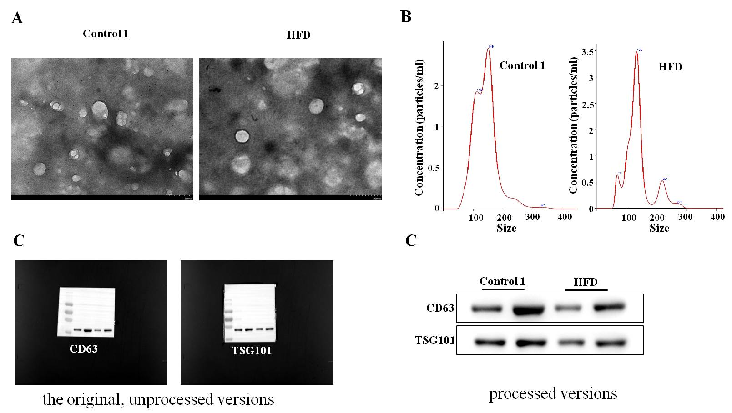
Supplementary figure S1 : Characterization of exosomes isolated from murine blood. Ultracentrifugation and subsequent TEM (A). The diameter of exosomes (B) and the exosomal surface markers of TSG101 and CD63 (C).

