Chemical composition of subcortical tissues of Quercus suber, the diet of the flathead oak borer Coraebus undatus (Coleoptera, Buprestidae)

Muñoz-Adalia, E.J., Haque, M.M.U., and Gemeno, C.

Supplementary material

Table S1. Models selected for the analysis of the 12 chemical parameters of the subcortical tissues of Q. suber trees. All are GLMs, except for model 10 which is a GLMM with "tree" as the random factor. The independent variables are tissue (phelloderm plus phloem or phellem) and infection with C. undatus larva. Four infected and 4 uninfected trees were analyzed. GLMM´s were run with the package “lme4” (https://cran.r-project.org/web/packages/lme4/index.html) in R (https://www.r-project.org/)

Model | Formula | Df | logLik | Deviance | AIC
M1 | Cellulose ~ tissue + infection | 4 | -38.33 | 76.66 | 84.66
M2 | Fiber-acid ~ tissue + infection | 4 | -44.73 | 89.47 | 97.47
M3 | Fiber-neutral ~ tissue + infection | 4 | -40.44 | 80.89 | 88.89
M4 | Fructose ~ tissue + infection | 4 | -89.85 | 179.70 | 187.70
M5 | Glucose ~ tissue + infection | 4 | -50.29 | 100.59 | 108.59
M6 | Hemicellulose ~ tissue + infection | 4 | -41.99 | 83.99 | 91.99
M7 | Lignin-acid ~ tissue + infection | 4 | -37.85 | 75.71 | 83.71
M8 | Moisture ~ tissue + infection | 4 | -60.23 | 120.47 | 128.47
M9 | Myo-Inositol ~ tissue + infection | 4 | -79.52 | 159.05 | 167.05
M10 | Organic matter ~ tissue + infection + (tree) | 4 | -25.20 | 50.39 | 58.39
M11 | Sucrose ~ tissue + infection | 4 | -142.28 | 284.56 | 292.56
M12 | Total proteins ~ tissue + infection | 4 | 0.91 | -1.82 | 6.1754

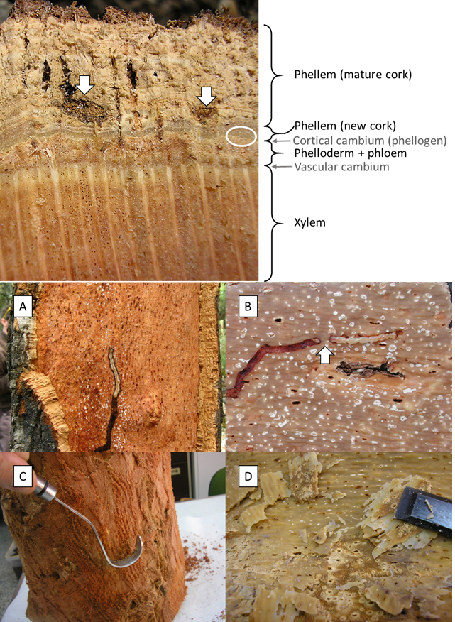
Fig. S1 Top: cross section of the trunk of a Q. suber tree. Different tissues are labelled on the right. The larva of C. undatus feeds on new phellem and phelloderm + phloem. The white ellipse indicates where the larva makes its gallery. White arrows indicate old galleries that are now in the cork due to the outward growth of phellem. Bottom: examples of fresh galleries of C. undatus with the larvae still on them: on the phelloderm + phloem (A), and on the new phellem (B). The arrow in B shows that the larva has bored exclusively on phellem just for a few mm. Collection of tissues for chemical analyses: phelloderm + phloem (C) and new phellem (D). A and B courtesy of J.M. Riba

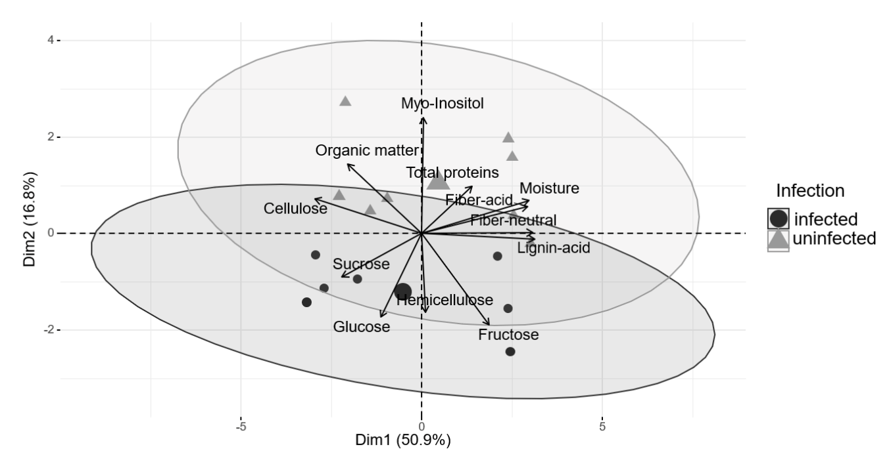
Fig. S2 PCA showing the relationship between the infection with C. undatus larvae and the chemical composition of the subcortical tissues of Q. suber on which it feeds. PC 2 (16.8% of the variability) separates the 4 infected and the 4 uninfected trees by the chemical composition their phelloderm + phloem and phellem samples (ellipses: 95% confidence interval level around the centroid). PCA was run with the package “factoextra” (https://cran.r-project.org/web/packages/factoextra/index.html) in R (https://www.r-project.org/)

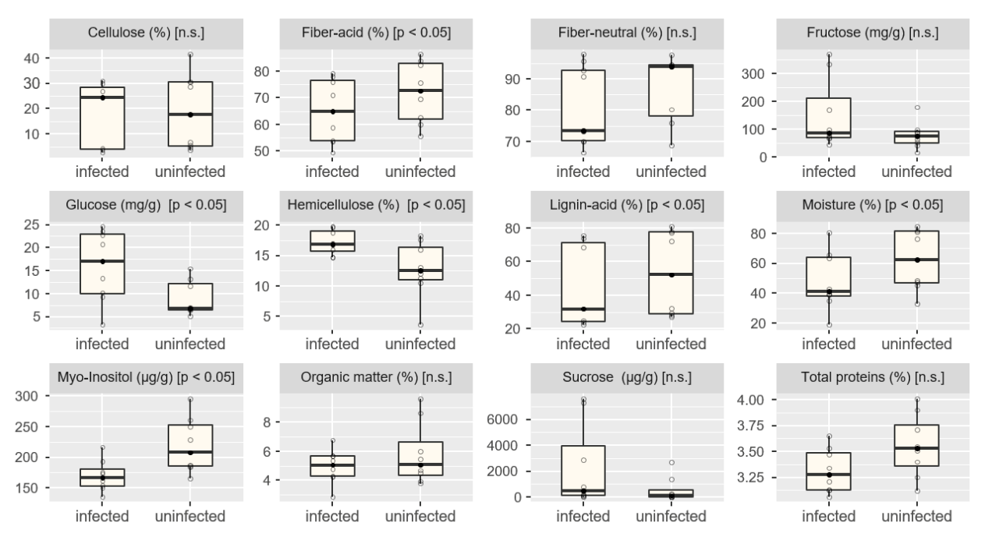
Fig. S3 Effect of infection with C. undatus larvae on the amount or percentage of 12 major chemical composition parameters of Q. suber subcortical tissues. Significant differences by GLM or GLMM are indicated (p < 0.05; n.s. = not significant, N = 8). The middle line is the median and the box limits show 25th and 75th quartiles. Lines reach minimum and maximum values and the dots outside are potential outliers. GLMM´s were run with the package “lme4” (https://cran.r-project.org/web/packages/lme4/index.html) in R (https://www.r-project.org/)

