Supporting Information
Experimental

- Resolution of crystal structures of OsOTUB1-cat and that in complex with Met1-diUb-DHA and with Ub-PA
1.1 Protein expression and purification
Recombinant 8×His-fusion proteins (in pET28a) were expressed in E. coli (BL21). Cultures were grown in LB media containing 50 µg/ml Kanamycin to an OD600 of 0.6-0.8. Protein expression was induced with 250 µM IPTG and cultures grown overnight at 30 °C. Harvested cells were resuspended in imidazole-lysis buffer (50 mM Tris-HCl pH 7.0, 1 M NaCl, 40 mM imidazole, 5 mM DTT, 1 mM PMSF) and lysed by sonication. Bacterial lysate was clarified by centrifugation at 30,000×g for 30 min and subsequently incubated with NTA resin (GE Healthcare) for 2 h at 4 °C. The resin bound proteins were washed extensively with imidazole-lysis buffer (no less than 15 folds of column volume). The 8×His tag was removed by overnight incubation with 3C protease at 4 °C. Proteins were further purified by size exclusion chromatography (Superdex 75 16/60, GE Healthcare) in Gel filtration buffer (50 mM Tris-HCl pH 7.0, 150 mM NaCl, 5 mM DTT). For the complexes, OsOTUB1 was incubated with 3 folds molar Met1-diUb-DHA and Ub-PA in 30 °C for 3 hours, after which the complexes were separated by MonoQ and further by size exclusion chromatography (Superdex 75 16/60) in Gel filtration buffer. The purified proteins were concentrated, flash frozen in liquid nitrogen and stored at -80 °C.

1.2 Acquisition of protein crystals
The initial crystal screening process was based on method of sitting-drop vapor diffusion. The OsOTUB1-cat (residues 74~324) with a concentration of 10 mg/mL was mixed with the crystallization reservoir at a volume ratio of 1:1 (1 μL: 1 μL), and crystals satisfying the diffraction requirement were finally obtained under the 95# condition of Hapton Index 49-96, which contained 0.1 M Potassium thiocyanate, 30% w/v Polyethylene glycol monomethyl ether 2,000. The OsOTUB1-cat~UbPA with a concentration of 7 mg/mL was mixed with the crystallization reservoir at a volume ratio of 1:1 (1 μL: 1 μL), and crystals satisfying the diffraction requirement were finally obtained under the 72# condition of Hapton Index 49-96, which contained 0.2 M Sodium chloride, 0.1 M HEPES pH 7.5, 25% w/v Polyethylene glycol 3,350. The OsOTUB1-cat~Met1-diUb-DHA with a concentration of 8 mg/mL was mixed with the crystallization reservoir at a volume ratio of 1:1 (1 μL: 1 μL), and crystals satisfying the diffraction requirement were finally obtained under the 70# condition of Hapton Index 49-96, which contained 0.2 M Sodium chloride, 0.1 M BIS-TRIS pH 5.5, 25% w/v Polyethylene glycol 3,350. Before collecting the diffraction data, the crystals were firstly cryo-protected with crystallization reservoir containing 30% glycerol.

1.3 Resolution of crystal structures
The diffraction data were initially collected at the Shanghai Synchrotron Radiation (SSRF) line stations 18U and 19U, and processed using HKL3000. The initial structure of OsOTUB1-cat was constructed by molecular replacement by CCP4, for which the template is the chain-sawed crystal structure of catalytic domain in hOTUB1 (2ZFY). Coot and PHENIX were used alternately for multiple rounds of refinement and model construction. For structures of OsOTUB1-cat~UbPA and OsOTUB1-cat~Met1-diUb-DHA, structures of OsOTUB1-cat and ubiquitin (1UBQ) were used as templates for molecular replacement by CCP4. Coot and PHENIX were used alternately for multiple rounds of refinement and model construction. All structural data were generated by Pymol (www.pymol.org).

- Preparation of Ub-PA
100 mg MesNa, 5 mg TCEP and 50 mg guanidine hydrochloride per mL was added to the supernatant of cell lysis after acid precipitation by perchloric acid, before which the pH was adjusted to 7.0. After exchanging most of the air with nitrogen, it was sealed with a plastic sealing film, tightly closed, and transferred to a heating shaker at 50 °C for 48 h. After chromatography and mass spectrometry analysis, it was confirmed that the reaction was completed, and then purified by HPLC and lyophilized.
After frozen-dried for several days, the sample was dissolved in 6 M guanidine hydrochloride at pH 2.3, transferred to an ice salt bath and stirred. After the temperature was lowered to -20 °C, sodium nitrite was added in 20-fold equivalent, and oxidation was completed for about 30 min which produced the intermediate product Ub-azide. Next, the pH of the solution is quickly adjusted to basic (usually 9.0 to 10.0) with propargylamine, in which case it is theoretically possible to convert all of the starting materials to Ub-PA probe. After confirming the reaction by chromatography and mass spectrometry, it was purified by HPLC and frozen-dried.
Because Ub-PA was mostly used in cross-linking experiments with DUB, it is necessary to refold the frozen-dried polypeptide. Thus we first dissolve it with guanidine hydrochloride buffer. Then in a low temperature environment (usually 4 °C) water or neutral pH buffer was gradually added, the ubiquitin is refolded by gradually diluting the concentration of guanidine hydrochloride. Finally Ub-PA which can be used for the crosslinking reaction was obtained by gel filtration.

- Preparation of Met1-diUb-DHA
Recombinant Met1-diUb mutant (Gly76 in distal Ub was mutated to Cys) containing N-terminal Avi tag (GLNDIFEAQKIEWHE) (Avi-Met1-diUb-76C) in pET22b was expressed in E. coli (BL21). After purification as mentioned in 1.1, in the concentrated Avi-Met1-diUb-76C (about 8 mg/mL), 1 μM BirA, 2 mM ATP, 10 μM Mg²⁺, 0.2 mM D-Biotin and 10 folds bisamide of the 1,4-dibromobutane were added simultaneously. After adjusting the pH to 9.5 by NaOH, the mixture was placed in 37℃ for about 10 h. The final reaction mixture was further purified by Superdex 75 16/60 in Gel filtration buffer.

- Deubiquitination assay
DUBs were diluted in Gel filtration buffer and incubated at 37 °C for 5 min. The DUB assays were subsequently carried out where 1 µM of DUB was incubated with 30 µM diUbs in Gel filtration buffer in a reaction volume of 25 µl. The reactions were incubated at 37 °C and 6 µl samples were taken at different time points and directly mixed with 4×SDS sample buffer to stop the reaction. The samples were separated on 4-12% SDS-PAGE gel (Life Technology) and stained by Coomassie brilliant blue G-250.

- Ub-PA crosslinking assay
DUBs were diluted in Gel filtration buffer and incubated at 37 °C for 5 min. The crosslinking assays were subsequently carried out where 20 µM of DUB was incubated with 100 µM Ub-PA in Gel filtration buffer in a reaction volume of 25 µL. The reactions were incubated at 37 °C and 6 µL samples were taken at different time points and directly mixed with 4×SDS sample buffer to stop the reaction. The samples were separated on 4-12% SDS-PAGE gel (Life Technology) and stained by Coomassie brilliant blue G-250.

- Ub-AMC hydrolysis essay
Ub-AMC was diluted in Gel filtration buffer to 40 nM. For each reaction 100 µL of diluted substrate in a black 96-well low volume plate (Corning) was mixed with 100 µL of 4 µM DUBs at room temperature. The rate of AMC generation was measured using a Synergy HT detector (Biotek). Fluorescent intensities were recorded following excitation at 340 nm and emission at 440 nm.

Table S1 Data Collection and Refinement Statistics
 | Apo-OsOTUB1 | OsOTUB1~UbPA | OsOTUB1~M1-diUb-DHA
PDB code | 6K9N | 6K9P | 6KBE
Data collection
Space group | P2₁2₁2₁ | P1 |  | P1
Cell dimensions
a, b, c (Å) | 59.69, 144.81, 155.85 | 48.90, 50.52, 75.34 |  | 57.40, 58.92, 112.40
α, β, γ (°) | 90.00, 90.00, 90.00 | 89.98, 90.01, 87.37 |  | 90.06, 89.98, 89.99
Resolution (Å) | 47.4-2.25  (2.29-2.25) | 41.94-2.047  (2.094-2.047) |  | 41.1-1.98  (2.01-1.98)
R_{merge} | 0.097(0.643) | 0.137(1.387) |  | 0.055(0.395)
I / σI | 18.8 (7.5) | 16.1 (2.1) |  | 18.6 (4.1)
Completeness (%) | 99.7 (99.7) | 97.0 (95.8) |  | 96.6 (95.0)
Redundancy | 10.8 (10.4) | 6.0 (3.3) |  | 3.6 (3.5)
Refinement
Resolution (Å) | 2.272 Å | 2.047 Å |  | 1.979 Å
No. reflections | 58983 | 41573 |  | 94184
R_{work} / R_{free} | 16.86 / 22.04 | 17.47 / 24.47 |  | 15.27 / 23.04
No. atoms
Protein | 8724 | 5276 |  | 14722
Ligand/ion | - | - |  | -
Water | 595 | 571 |  | 2053
Average B factors (Å²) | 42.32 | 47.71 |  | 23.122
r.m.s. deviations
Bond lengths (Å) | 0.0181 | 0.0162 |  | 0.0169
Bond angles (°) | 1.9609 | 1.8113 |  | 1.9767

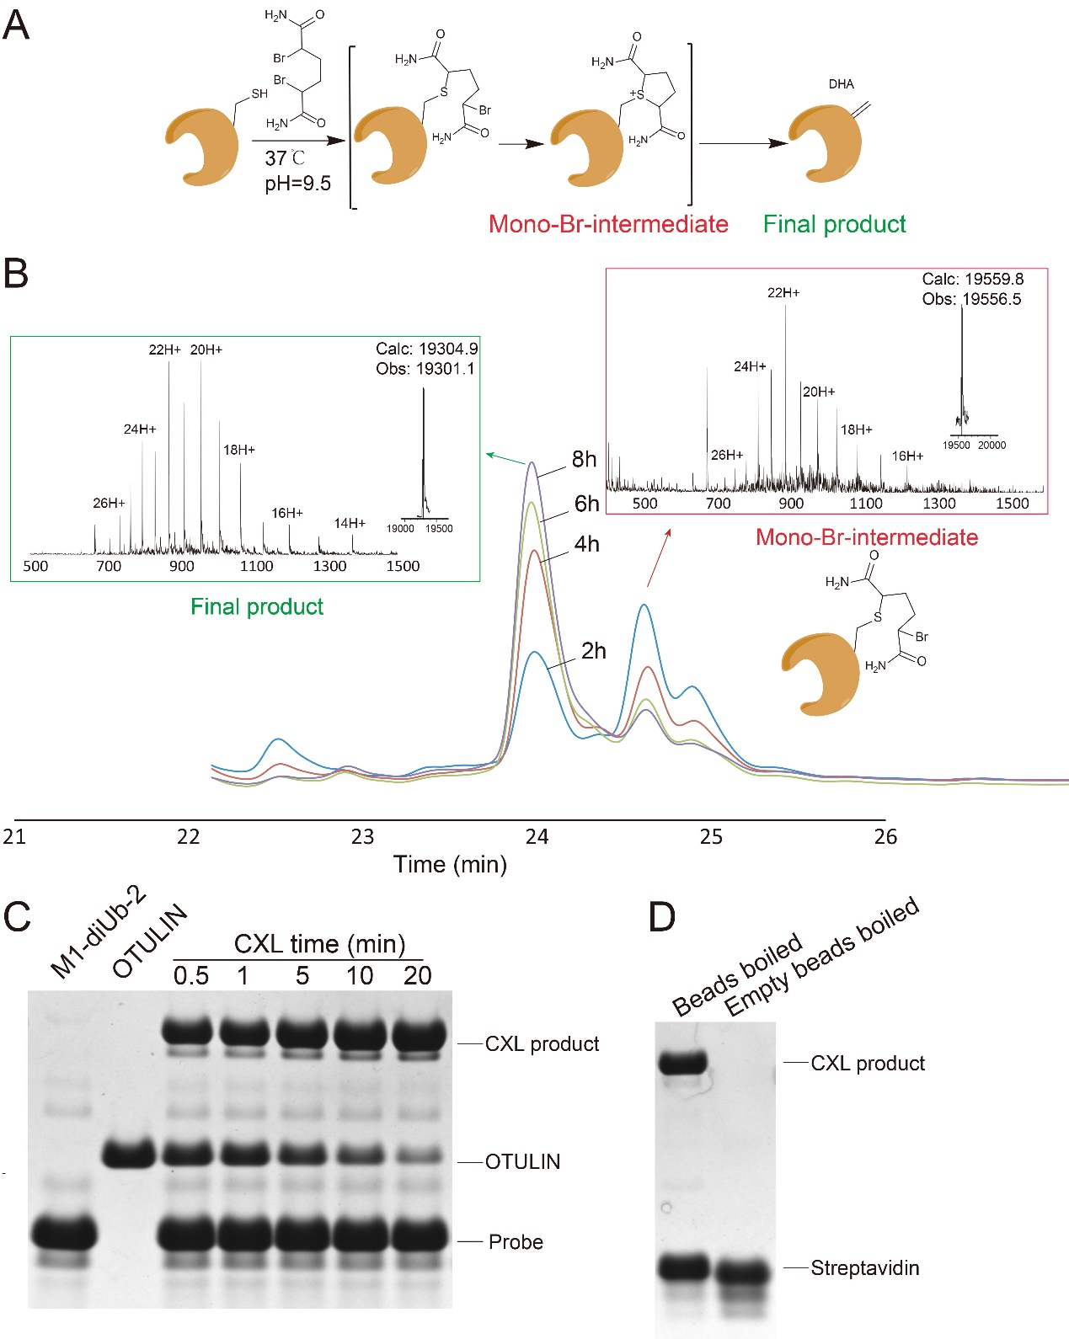
Fig. S1 One-pot synthesis of M1-diUb-2
A, Mechanism of desulfurization; B, Time scale tracing of one-pot synthesis of M1-diUb-2 by HPLC; C, Time scale investigation of crosslinking activity of M1-diUb-2 with OTULIN; D, Binding activity of M1-diUb-2 to Streptavidin beads. CXL: crosslink.

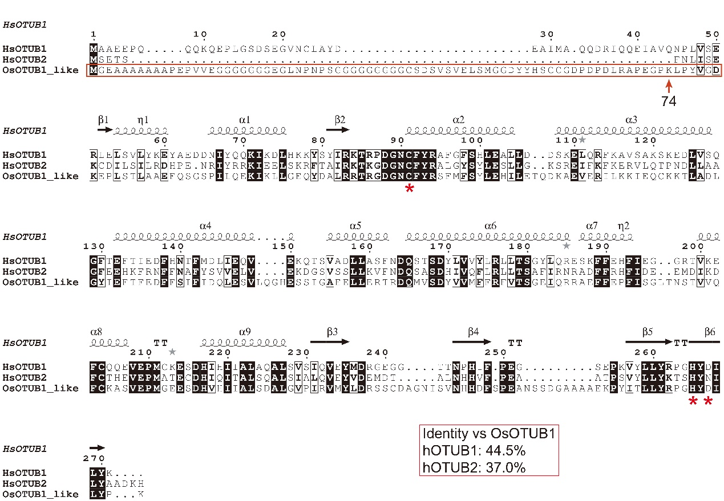
Fig. S2 Sequence alignment of OsOTUB1 with hOTUB1 and hOTUB2
Sequence included in the red frame indicates the unorganized region; red stars indicate the catalytic triad in OsOTUB1, hOTUB1 and hOTUB2; red frame contains the sequence identity of OsOTUB1 with hOTUB1 and hOTUB2.

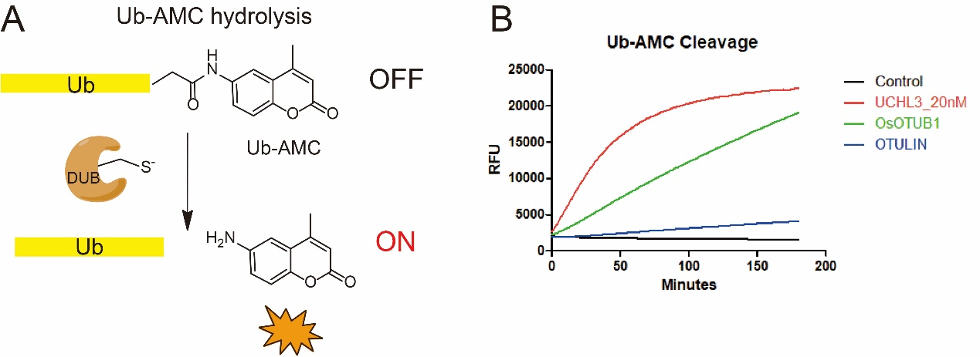
Fig. S3 Ub-AMC Digestion activities of UCHL3, OsOTUB1 and OTULIN.
A, Mechanism of DUB mediated Ub-AMC hydrolysis; B, Time scale hydrolysis activity of UCHL3, OsOTUB1 and OTULIN against Ub-AMC.

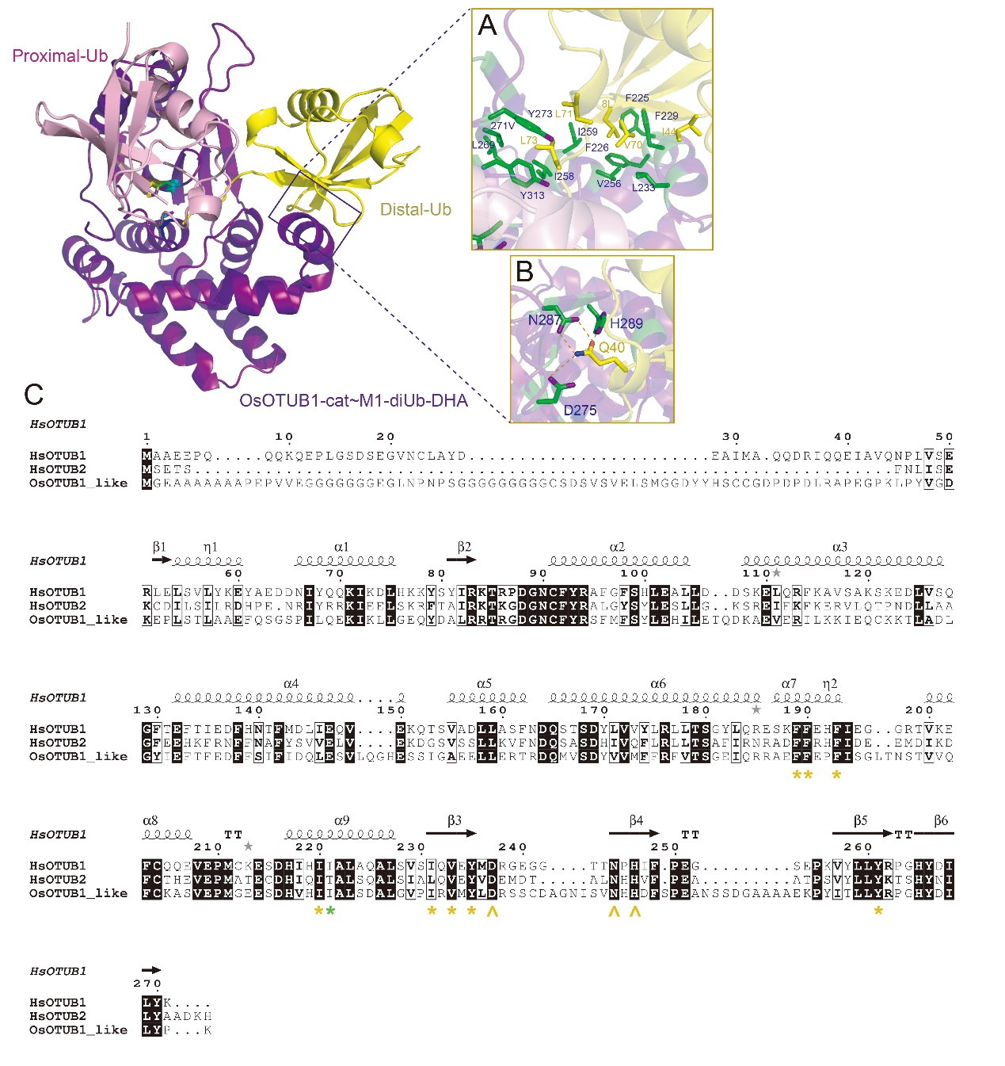
Fig. S4 Distal-Ub binding site of OsOTUB1 and the corresponding residues in hOUTB1 and hOTUB2
A, Hydrophobic interaction between OsOTUB1 and distal-Ub; B, Hydrogen bond between OsOTUB1 and distal-Ub; C, Mapping of residues in OsOTUB1 responsible for distal-Ub binding to hOUTB1 and hOTUB2.
Yellow stars indicate the conserved residues contributing hydrophobic interaction with distal-Ub. Green star indicate the non-conserved residue responsible for hydrophobic interaction with distal-Ub. Yellow up-arrows indicate the conserved residues contributing hydrogen bonds with distal-Ub.

