Supporting Information

A neutron diffraction investigation of high valent doped barium ferrite with super-wide tunable microwave absorption
Jun LI^{a,b, †,*}, Yang HONG^{c,†}, San HE^{a,b}, Weike LI^{a,b}, Han BAI^{a,b}, Yuanhua XIA^{d} Guangai SUN ^{d} and Zhongxiang ZHOU^{a,b,*}
ª School of Physics, Harbin Institute of Technology, Harbin 150001, China
^{b} Heilongjiang Provincial Key Laboratory of Plasma Physics and Application Technology, Harbin Institute of Technology, Harbin 150001, China
^{c} School of Chemistry and Chemical Engineering, Harbin Institute of Technology, Harbin 150001, China
^{d} Key Laboratory for Neutron Physics of CAEP, Institute of Nuclear Physics and Chemistry, Mianyang 621999, China
† Jun Li and Yang Hong contributed equally to this work.
* Corresponding author.
E-mail: lijuna@hit.edu.cn, zhouzx@hit.edu.cn

The XRD patterns of BFTO-x (x = 0.2, 0.4, 0.6, 0.8) are shown in Figure S1(a). It can be clearly seen that samples match the standard pattern of hexagonal barium ferrites (JCPDF No. 84-0757) with P63/mmc space group, and it also illustrates the superiority of the modified sol-gel method for preparing barium ferrite. At the same time, we can see from the detail figure (Figure S1(b)) that the peak position of samples firstly shifts to the right side relative to that of undoped M-type barium ferrite, and then to the left side when x increases. When x=0.8, it changes to the right shift again. This indicates that the lattice constants of the BFTO-x sample is smaller than that of undoped M-type barium ferrite first, then gradually become larger, and finally turn smaller again. We suppose that this is mainly the combination result of the different ionic radii and the doping concentration leading to the conversion of ferric iron to divalent iron. The Ti⁴⁺ ion radius is 0.0605 nm, the Fe³⁺ ion radius is 0.0645 nm, and the Fe²⁺ ion radius is 0.0780 nm. Because high-valence doping will convert some trivalent Fe³⁺ into divalent Fe²⁺, so when with a small amount of doping (x=0.2), the Ti⁴⁺ ionic radius is smaller than that of Fe³⁺, so the unit cell shrinks and the peak position shifts to the right; When x increasing, more and more trivalent Fe³⁺ are converted into divalent Fe²⁺. At this time, the larger radius of the divalent Fe²⁺ plays a major role, so that the characteristic peak position shifts to the left. When the doping concentration continues to increase, a large amount of Fe³⁺ ions have completed the valence state transition, and at this time, the smaller radius of Ti⁴⁺ ions begins to occupy a main role, and thus the characteristic peak position shifts to the right again.
Figure S1. (a) The XRD pattern of BFTO-x (x=0.2, 0.4, 0.6, 0.8) and (b) its partial enlarged detail.

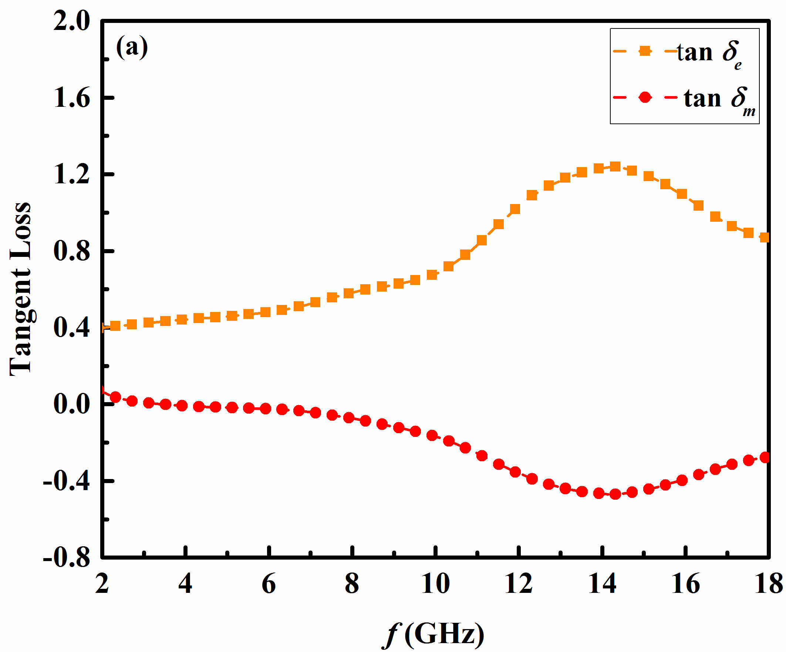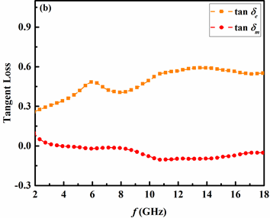
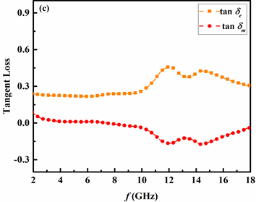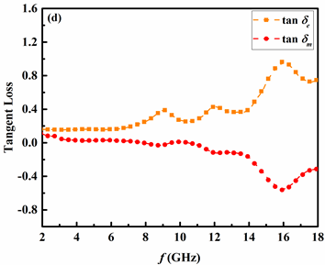
Figure S2. Dielectric and magnetic loss of PVA mixed BFTO-x ceramics with x = 0.2 (a), x = 0.4 (b), x = 0.6 (c), x = 0.8 (d).

