Electronic supplementary information
A Biomimetic Microfluidic Selection Platform Providing Improved Sperm Quality Metrics Compared to Swim-Up Steven A. Vasilescu¹, Lin Ding¹, Farin Yazdan Parast², Reza Nosrati², Majid Ebrahimi Warkiani^{1,3*}
Herein is a detailed description of aforementioned methods and details from the main text. This supplementary file includes:
- Image detailing the differences in workflow between swim up and microfluidic-based sperm selection methods.
- Image showing cross-sectional images of the device along different point of the device above a fluorescent top view of the device in action using live/dead sperm staining after 15 minutes incubation
- Supplementary video 1 description

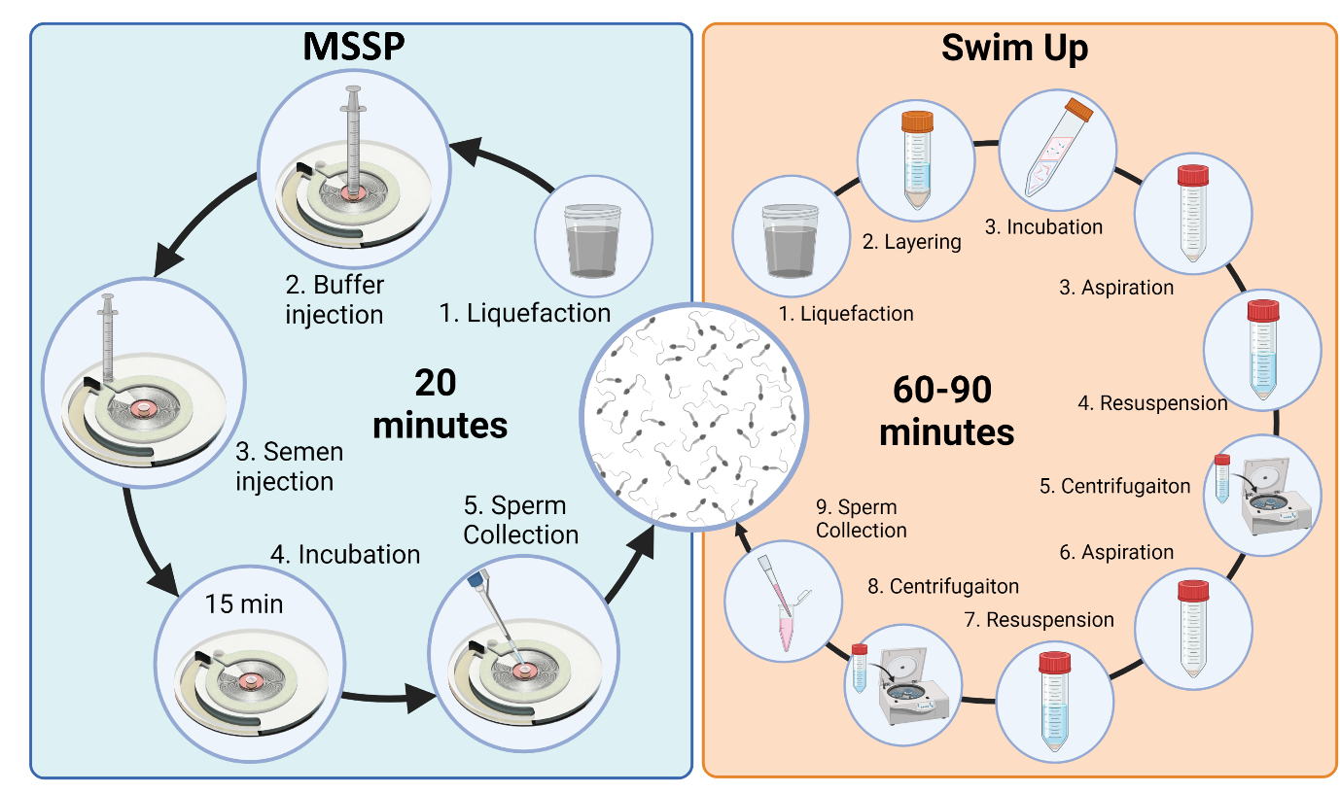
Figure 1. Schematic comparison of MSSP vs SU-based sperm selection methods by steps and time involved.

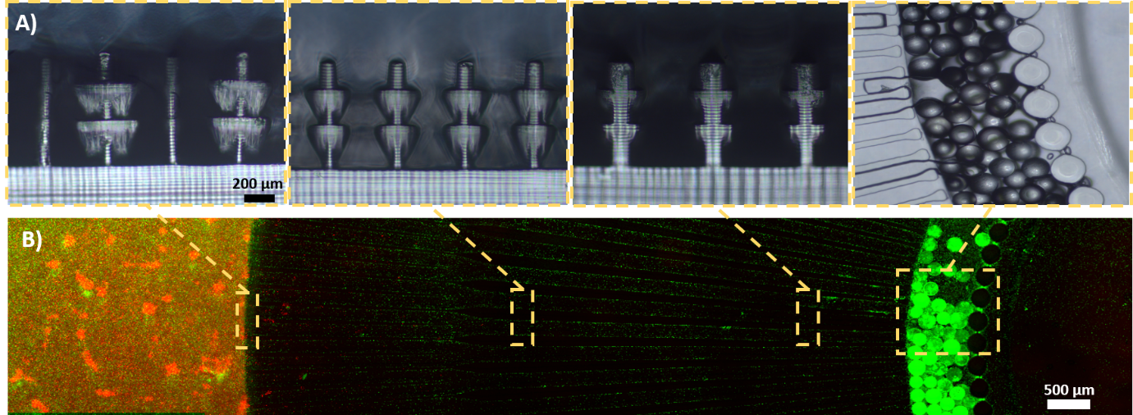
Figure 2. Microfluidic sperm selection device views. A) Cross-sectional views of the microchannels including 3D printed ridges for sperm guidance. B) Top view of the microfluidic device during sperm selection. Sperm are stained using a vitality kit to visualise the migration of live sperm from the semen containing dead and non-motile sperm

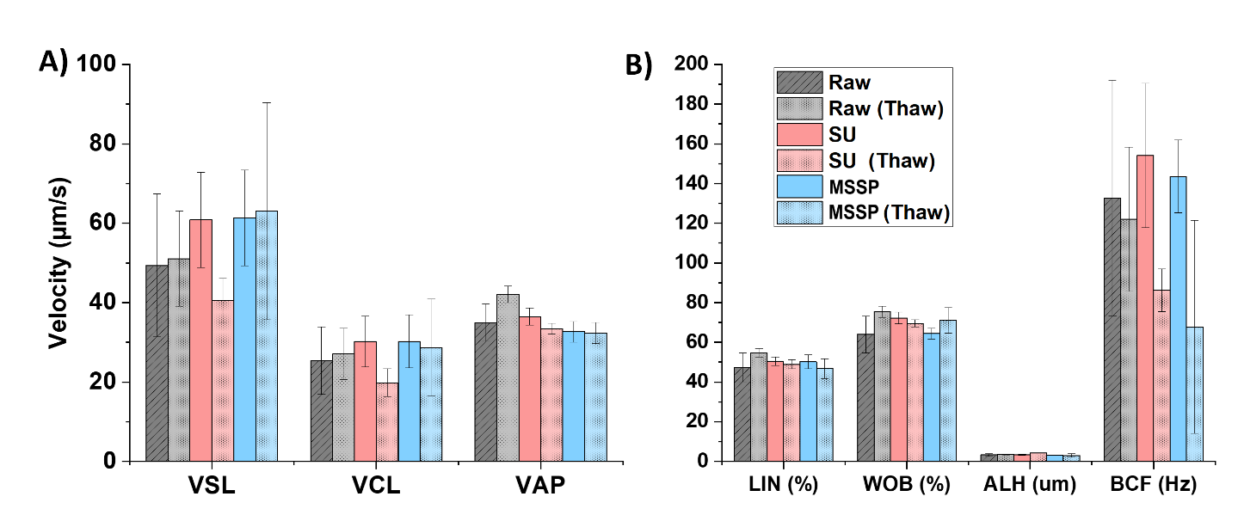
Figure 3. (A) Velocity parameters of sperm from Raw, SU and MSSP processed sperm before and after cryopreservation. (B) LIN, WOB, ALH, and BCF of sperm from the same aforementioned groups

Table 1 Motility parameters from OpenCASA for side-by-side sperm selection comparing SU and MSSP (at RT and 36C)
 | Raw | SD | Swim Up | SD | MSSP (36C) | SD |  | MSSP (RT) | SD
VSL | 28.17 | 3.78 | 30.178 | 2.47241 | 42.89233 |  | 3.08697 | 44.1554 | 10.4028
VCL | 59.47 | 3.68 | 73.7886 | 7.13269 | 85.37167 |  | 4.64605 | 73.2808 | 6.67
VAP | 41.48 | 4.67 | 46.1806 | 3.6065 | 61.16533 |  | 1.75904 | 54.1552 | 15.17356
LIN (%) | 47.55 | 3.9 | 42.1162 | 3.70987 | 51.87733 |  | 5.67975 | 64.295 | 10.57751
WOB (%) | 70.7 | 4.24 | 64.5406 | 2.43831 | 73.07833 |  | 1.5799 | 76.3498 | 6.75359
STR (%) | 66.56 | 4.06 | 64.4898 | 5.1623 | 70.34267 |  | 6.15784 | 83.0362 | 6.74328
ALH (um) | 1.9 | 0.43 | 2.4998 | 0.40618 | 2.477 |  | 0.01512 | 2.6746 | 1.34375
BCF (Hz) | 13.07 | 0.75 | 13.7292 | 1.09407 | 13.093 |  | 0.12741 | 12.1274 | 0.88149

Table 2. Motility parameters from OpenCASA for side-by-side sperm selection comparing SU and MSSP pre and post cryopreservation

 | RAW | SD | Thawed-RAW | SD | SU | SD | Thawed-SU | SD | MSSP | SD | MSSP | SD
VSL | 49.37 | 17.97377 | 51.04 | 11.99680402 | 60.85 | 11.996804 | 40.56 | 5.583970717 | 61.33 | 12.02289 | 63.01 | 27.33633
VCL | 25.37 | 8.472373 | 27.09 | 6.451746398 | 30.21 | 6.4517464 | 19.82 | 3.506737263 | 30.27 | 6.704059 | 28.66 | 12.22573
VAP | 34.95 | 4.686537 | 42.10 | 2.145997158 | 36.47 | 2.14599716 | 33.42 | 1.382114472 | 32.66 | 2.585936 | 32.40 | 2.640528
LIN | 47.28 | 7.253585 | 54.75 | 2.15648954 | 50.39 | 2.15648954 | 48.92 | 2.198550045 | 50.24 | 3.563692 | 46.70 | 5.000966
WOB | 63.96 | 9.309351 | 75.32 | 2.862864874 | 72.29 | 2.86286487 | 69.60 | 1.82834318 | 64.44 | 2.769509 | 71.06 | 6.531136
STR | 2.03 | 0.476723 | 2.05 | 0.181158072 | 2.23 | 0.18115807 | 1.66 | 0.070219409 | 1.99 | 0.137518 | 2.01 | 0.656295
ALH | 3.33 | 0.712525 | 3.48 | 0.289556792 | 3.42 | 0.28955679 | 4.22 | 0.140560342 | 3.12 | 0.141736 | 2.96 | 0.897917
BCF | 132.68 | 59.43637 | 122.00 | 36.29829526 | 154.20 | 36.2982953 | 86.20 | 10.79194478 | 143.56 | 18.28802 | 67.77 | 53.63571

Supplementary Video 1: Includes a before (left) and after (right) of sperm processed through the motility only MSSP.

