Supplementary Information
Endosomal acidification inhibitors broadly inhibit influenza virus and coronavirus in vivo
Hanjun Zhao, Hoiyan Lam, Xinxin Zhou, Zheng Peng, Jasper Fuk-Woo Chan, Ko-Yung Sit, Wing-Kuk Au, Richard Yi Tsun Kao, Kelvin K. W. To, Kwok-Yung Yuen

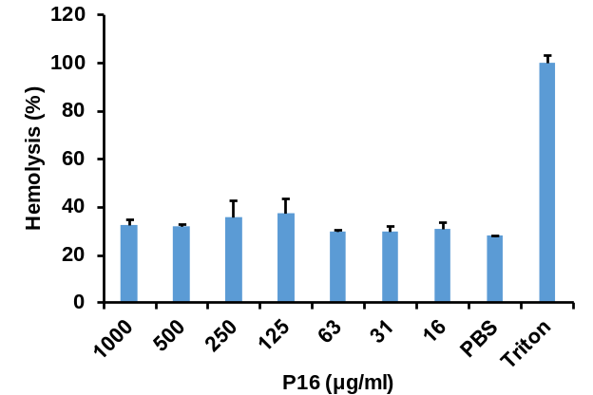

Figure 1. Hemolysis assay of P16 in turkey red blood cells (TRBC). TRBC were treated by the indicated concentration of P16. Hemolysis (%) was normalized to TRBC treated by Triton X-100. Data are presented as mean ±SD of three independent biological samples.
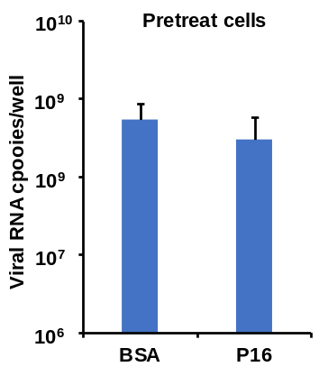

Figure 2. P16 did not inhibit viral infection when cells were treated before viral infection (n=4). MDCK cells were pretreated with P16 (25 μg ml⁻¹) for 1h and then cells were infected with A(H1N1) virus. Viral RNA copies in cell lysates were measured at 5h post infection. Data are presented as mean ±SD of four independent biological samples.

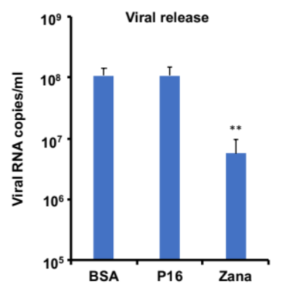
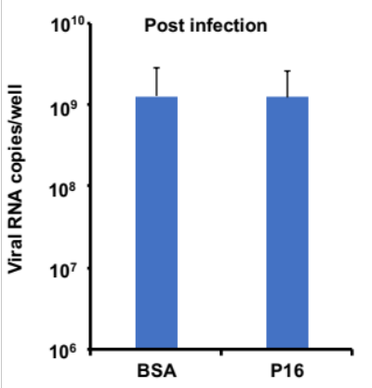
B
A

Figure 3. (A) P16 (25 μg ml⁻¹) did not inhibit viral replication when cells were treated by P16 after viral infection. H1N1 viral RNA copies in cell lysates were measured at 5h post infection (n=3). (B) P16 did not inhibit viral release when cells were treated by P16 after viral infection (n=3). Viral RNA copies in cell supernatants were measured at 8 h post infection. Data are presented as mean ±SD of independent biological samples. ** indicates P<0.01 when compared with BSA. P values were calculated by the two-tailed Student’s t test.

P9RS
P16
Triton

Figure 4. P16 did not disrupt H1N1 viral particles. A(H1N1) virus was pretreated by P16 (200 μg ml⁻¹), P9RS or Triton X-100. Virus was negatively stained for TEM analysis. Red triangles indicated intact H1N1 particles. Scale bar =200 nm. Experiments were repeated twice.

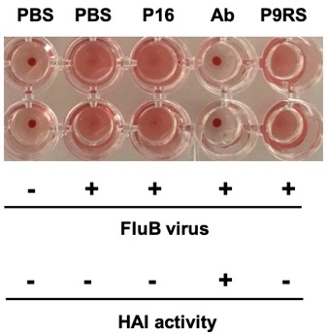
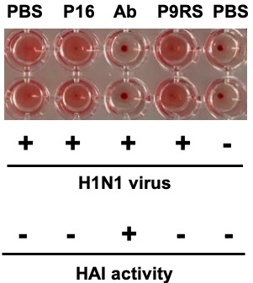

Figure 5. P16 did not show HAI activity on A(H1N1) and Flu B virus. A(H1N1) and FluB (8HA titer) virus were pretreated by P16 (100 μg ml⁻¹), P9RS (100 μg ml⁻¹), neutralization antibody (Ab), or PBS. TRBC cells were added to treated or untreated virus. Cell precipitates were recorded to show the HAI activity. Experiments were repeated twice.

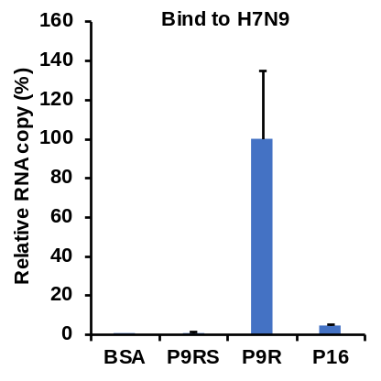

Figure 6. P16 did not bind to viral surface to capture H7N9 virus. P16, P9R (positive control), P9RS and BSA (negative control) were coated on ELISA plate, which was blocked by BSA. A(H7N9) virus was added to ELISA plate for binding. After washing the unbound virus, viral RNA copies were measured to indicate the bound virus. Data are presented as mean ±SD of three independent biological samples.

Virus+pH5.0+P16
Virus+pH5.0
Virus+pH7.4

Figure 7. P16 could inhibit cell fusion induced by FluB virus. MDCK cells were transfected with pGFP and infected with 1MOI of FluB virus. At 18 h post infection, infected cells were treated by P16 (500μg ml⁻¹) and then treated by pH5.0 or pH7.4. Infected cells treated by pH 7.4 were served as no fusion control and infected cells treated by pH5.0 were served as fusion control. Fusion pictures were taken at 4h post pH treatment. Scale bar=100 μm. Experiments were repeated twice.

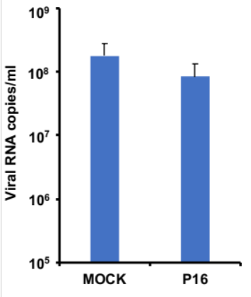

Figure 8. P16 did not effectively inhibit SARS-CoV-2 release. Vero-E6 cells were infected with SARS-CoV-2 virus. After 1 h post infection, infectious media were removed and fresh media with P16 (25 μg ml⁻¹) were added to infected Vero-E6 cells for viral culture. Viral RNA copies in cell supernatants were measured at 8 h post infection. Data are present as mean ±SD of four independent biological samples.

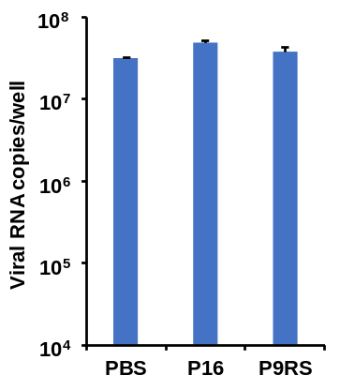

Figure 9. P16 did not inhibit SARS-CoV-2 attaching to cells. SARS-CoV-2 virus was pretreated by P16 (25 μg ml⁻¹), P9RS (peptide without antiviral activity) and PBS for 45 min and then attached to Vero-E6 at 4 °C for 1h. After washing, attached virus was measured by RT-qPCR. Data are present as mean ±SD of three independent biological samples.

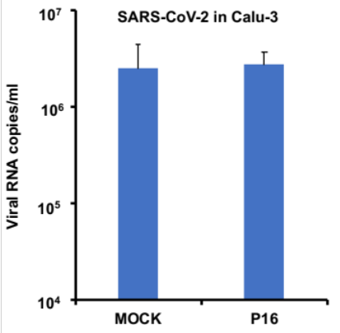

Figure 10. P16 did not inhibit SARS-CoV-2 replication in Calu-3 cells. SARS-CoV-2 (0.2 MOI) was pretreated by P16 (50 μg ml⁻¹) or DMEM-F12 (MOCK) for 1h and then infected Calu-3 cells. Viral RNA copies in supernatants were measured by RT-qPCR at 30 h post infection. Data are present as mean ±SD of four independent biological experiments.

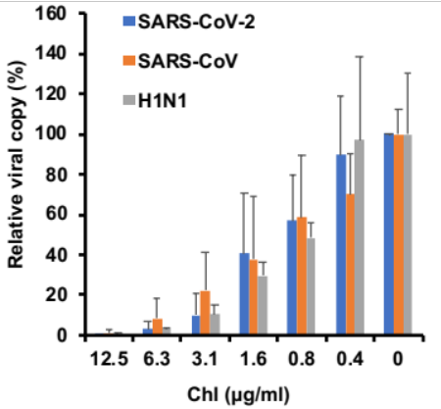

Figure 11. Chloroquine inhibited coronavirus and A(H1N1) virus replication in cells. SARS-CoV-2, SARS-CoV, or A(H1N1) virus (1000 FPU) infected cells at the presence of indicated chloroquine. At 24h post infection, viral RNA copies in the supernatants were measured by RT-qPCR. Relative viral copy was normalized to the virus without treatment. Data are present as mean ±SD of three independent biological samples.

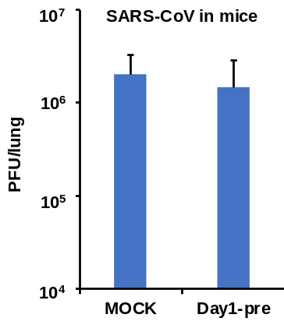
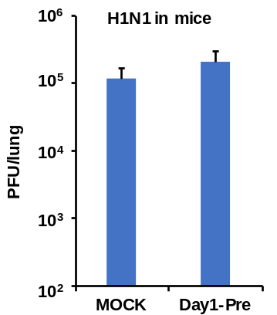

Figure 12. Chloroquine did not inhibit SARS-CoV and A(H1N1) virus replication when given to mice at one day before viral inoculation. One dose of chloroquine (2 mg kg⁻¹, Day1-Pre) or PBS (MOCK) was intranasally inoculated to mouse lungs one day before viral inoculation. SARS-CoV (5000 PFU) was intranasally inoculated to old BALB/c mouse lungs. A(H1N1) virus (200 PFU) was intranasally inoculated to young BALB/c mouse lungs. Viral loads in lungs were measured at day 2 (SARS-CoV) and day 1 (H1N1) post infection. Data are present as mean ±SD of four mice in each group.

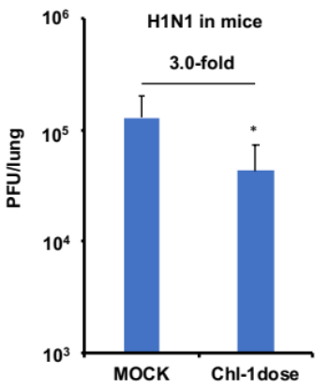
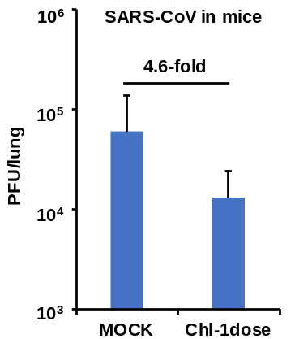

Figure 13. Chloroquine could inhibit SARS-CoV and A(H1N1) virus replication when given to mice before viral inoculation. One dose of chloroquine (Chl, 2 mg kg⁻¹) or PBS (MOCK) was intranasally inoculated to mouse lungs and then SARS-CoV (5000 PFU) or A(H1N1) virus were intranasally inoculated to mouse lungs. Viral loads in lungs (SARS-CoV, n=4 and H1N1, n=5) were measured at day 1 post infection. * indicates P<0.05 when compared with Mock. P values were calculated by the two-tailed Student’s t test. Data are present as mean ±SD of independent biological samples.

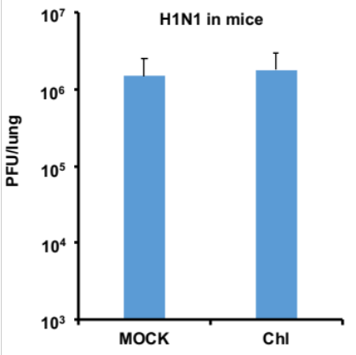

Figure 14. Chloroquine did not inhibit A(H1N1) viral replication in mouse lungs when administrated by oral. Chloroquine (Chl, 40 mg kg⁻¹) or PBS (MOCK) was orally inoculated to mice at 6 h post infection. Two more doses were given to mice in the following day. Viral loads in mouse lungs were measured at day 2 post infection. Data are present as mean ±SD of five mice.

Table 1. Primers for RT-qPCR
Virus | Primer | Oligonucleotide sequence (5' to3')
SARS-CoV-2 | S-F | CCTACTAAATTAAATGATCTCTGCTTTACT
 | S-R | CAAGCTATAACGCAGCCTGTA
SARS-CoV | NP-F | ACCAGAATGGAGGACGCAAT
 | NP-R | GCTGTGAACCAAGACGCAGTATTAT
H1N1 | M-F | CTTCTAACCGAGGTCGAAACG
 | M-R | GGC ATTTTGGACAAAKCGTCT A
H7N9 | M-F | CTTCTAACCGAGGTCGAAACG
 | M-R | GGC ATTTTGGACAAAKCGTCT A

