Supporting Information
Cellulose Derivatives Functionalized with Multidentate N‑Donor Atoms: Comparative Adsorption of Cadmium(II) and Lead(II) Ions from Water
Baohong Ding, Lu Yang, Hongtao Fan*, Nan You*
(College of Petrochemical Engineering, Liaoning Petrochemical University, Fushun 113001, China)
& The first two authors contributed equally to this paper
* Corresponding author
E-mail: httyf_77@163.com and younan_77@163.com

Preparation of aldehyde cellulose
The aldehyde cellulose was obtained by an oxidation reaction of microcrystalline cellulose by sodium metaperiodate which is a gentle oxidant and can oxidized hydroxide, methyl to aldehyde group. 4 g sodium metaperiodate was dissolved into 50 mL H₂O, and then 2 g of the microcrystalline cellulose was added. The resulting suspension mixture with the solution pH adjusted to 3 was stirred at 45 ◦C for 180 min. The main water-insoluble oxidized products were obtained by filtration, washed 5 times with deionized water, and freeze-dried for further grafting.
Determination of aldehyde content
The aldehyde content of aldehyde cellulose was determined by the hydroxylamine hydrochloride method. Excessive hydroxylamine hydrochloride solution (5 %) was added into a suspension with a known amount of aldehyde cellulose. The H⁺ concentration was released through a Schiff base reaction between the aldehyde groups of the aldehyde cellulose and the amino groups of hydroxylamine hydrochloride. The stoichiometry between H⁺ ion and aldehyde group is 1. The H⁺ concentration was determined by the consumption of the 0.0100 mol L⁻¹ of NaOH standard solution using methyl orange as indicator.
Calculation of adsorption capacity
q = (C₀ − C_{t}) V/m (S1)
where q (mg g⁻¹) is the adsorption capacity, C₀ (mg L⁻¹) is the initial concentration of metals, C_{t} (mg L⁻¹) is the remnant concentration of metals, V (mL) is the volume of solution and m (g) is the mass of the Schiff base functionalized cellulose.
Adsorption isotherms
The linearized equations of Langmuir (L), Freundlich (F) and Dubinin–Radushkevich (D–R) isotherm can be expressed as Eqs. (S3) and (S4), respectively.
C_{e}/q_{e}= 1/(q_{max} b) + C_{e}/q_{max} (S2)
log q_{e} = log k_{F} + (1/n) log C_{e} (S3)
ln q_{e} = ln q_{s} – k_{ad}ε² (S4)
where q_{e} (mg g⁻¹) is the amount of metals adsorbed per unit mass of the Schiff base functionalized cellulose at equilibrium; C_{e} (mg L⁻¹) is the concentration at equilibrium; q_{max} (mg g⁻¹) is the maximum adsorption at monolayer coverage; b (L mg⁻¹) is the adsorption equilibrium constant; K_{F} (L g⁻¹) is a Freundlich constant; n is a constant; k_{ad} (mol² kJ⁻²) is the D–R isotherm constant; q_{s} (mg g⁻¹) is the saturation capacity from D–R isotherm; ε is the Polanyi potential and calculated as follows:
ε= RT ln (1+1/C_{eq}) (S5)
where R (8.314 J mol⁻¹ K⁻¹) is universal gas constant; T (K) is the absolute temperature. C_{eq} (mol L⁻¹) is the equilibrium concentration of metal ions.
E (kJ mol⁻¹) is the change of free energy transforming 1 mol of metal ions from solution to the surfaces and is conducive to the estimation of adsorption reaction type, and is obtained from k_{ad} as follows:
E= –(2k_{ad}) ^{−1/2} (S6)
Kinetic analysis
The pseudo-first-order and pseudo-second-order rate expressions are linearly expressed as:
log(q_{e}−q_{t}) = log q_{e} − k₁t/2.303 (S7)
t/q_{t}= 1/k₂q_{e} ² + t/q_{e} (S8)
where k₁ (min⁻¹) is the rate constant of the pseudo-first-order adsorption. q_{e} and q_{t} (mg g⁻¹) are the adsorption capacity at equilibrium and the adsorption amount at time t (min), respectively. k₂ (g mg⁻¹ min⁻¹) is the rate constant of the pseudo-second-order equation.
Thermodynamic analysis
Thermodynamic parameters such as standard Gibbs free energy change (ΔG^{º}), enthalpy change (ΔH^{º}) and entropy change (ΔS^{º}) at equilibrium at different temperatures can be calculated from the constant (b, L mol⁻¹) of L isotherm equation as the following equations:
ΔGº = −RT lnb (S9)
In order to use b in the thermodynamic calculations, the value of b expressed in L mg⁻¹ in L isotherm equation can be multiplied by 1000 to convert the units in L g⁻¹, and then multiplied by the atom weight of the metals, to transform b in L mol⁻¹.
ΔH^{º} and ΔS^{º} were obtained from Eq.S11.
$\ln{b}=\frac{ΔS^{0}}{R}-\frac{ΔH^{0}}{RT}$ (S10)
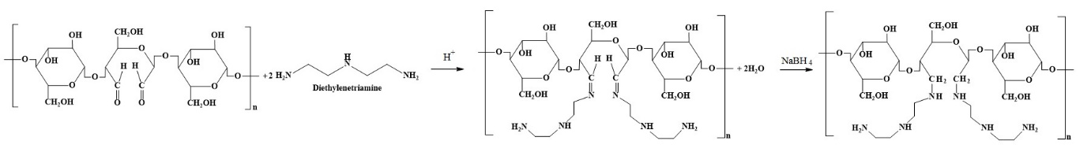
Scheme S1 Preparation process of the N₃-CL.
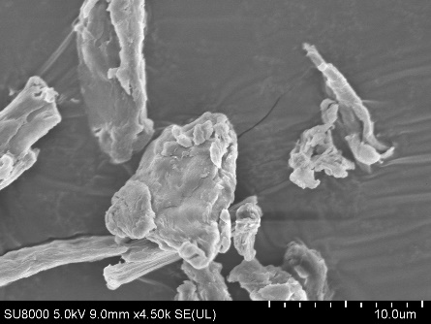
Figure S1 SEM images of the microcrystalline cellulose.
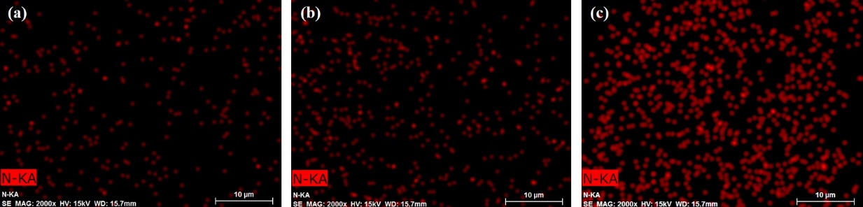
Figure S2 EDS mapping of the N elements in the N₂-CL, N₃-CL and N₄-CL 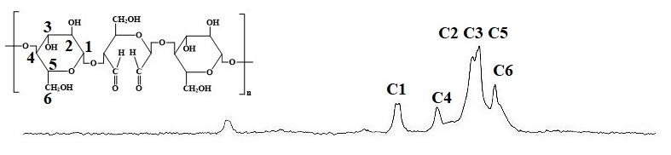
Figure S3 Solid state CNMR spectra of dialdehyde cellulose.

Table S1 The N contents of the N₃-CL at different experimental conditions
Molar ratios of aldehyde groups/primary amino groups | N Contents (wt%)
Molar ratios of aldehyde groups/primary amino groups | Element analysis | Kjeldahl method
1:0.5 | 2.76 | 2.57
1:1 | 4.43 | 4.37
1:2 | 4.31 | 4.39
Table S2 Isotherms parameters for the adsorption of both the ions by the N₂-CL
Ions | Temperature | Freundlich | Langmuir | D–R
Cd²⁺ |  | K_{F} = 60.4 L mg⁻¹ | q_{max} = 210.7 mg g⁻¹ | E = 14.7 mol kJ⁻¹
Cd²⁺ | 15°C | n = 4.63 | b = 0.0630 L mg⁻¹ | q_{s} = 338.0 mg g⁻¹
Cd²⁺ |  | R² = 0.951 | R² = 0.999 | R² = 0.975
Cd²⁺ |  | K_{F} = 67.4 L mg⁻¹ | q_{max} = 225.6 mg g⁻¹ | E = 15.0 mol kJ⁻¹
Cd²⁺ | 30°C | n = 4.71 | b = 0.0742 L mg⁻¹ | q_{s} = 359.3 mg g⁻¹
Cd²⁺ |  | R² = 0.953 | R² = 0.999 | R² = 0.978
Cd²⁺ |  | K_{F} = 71.7 L mg⁻¹ | q_{max} = 231.3 mg g⁻¹ | E = 15.2 mol kJ⁻¹
Cd²⁺ | 45°C | n = 4.79 | b = 0.0884 L mg⁻¹ | q_{s} = 370.6 mg g⁻¹
Cd²⁺ |  | R² = 0.944 | R² = 0.999 | R² = 0.974
Pb²⁺ |  | K_{F} = 59.6 L mg⁻¹ | q_{max} = 355.9 mg g⁻¹ | q_{s} = 947.3 mg g⁻¹
Pb²⁺ | 15°C | n = 2.95 | b = 0.0593 L mg⁻¹ | E = 11.9 mol kJ⁻¹
Pb²⁺ |  | R² = 0.885 | R² = 0.995 | R² = 0.919
Pb²⁺ |  | K_{F} = 64.3 L mg⁻¹ | q_{max} = 370.8 mg g⁻¹ | q_{s} = 1029.8 mg g⁻¹
Pb²⁺ | 30°C | n = 2.94 | b = 0.0700 L mg⁻¹ | E = 11.9 mol kJ⁻¹
Pb²⁺ |  | R² = 0.875 | R² = 0.998 | R² = 0.915
Pb²⁺ |  | K_{F} = 69.7 L mg⁻¹ | q_{max} = 376.9 mg g⁻¹ | q_{s} =1020.8 mg g⁻¹
Pb²⁺ | 45°C | n = 3.02 | b = 0.0765 L mg⁻¹ | E = 12.1 mol kJ⁻¹
Pb²⁺ |  | R² = 0.857 | R² = 0.997 | R² = 0.899

Table S3 Isotherms parameters for the adsorption of both the ions by the N₃-CL
Ions | Temperature | Freundlich | Langmuir | D–R
Cd²⁺ |  | K_{F} = 70.9 L mg⁻¹ | q_{max} = 233.7 mg g⁻¹ | E = 15.1 mol kJ⁻¹
Cd²⁺ | 15°C | n = 4.68 | b = 0.0910 L mg⁻¹ | q_{s} = 381.6 mg g⁻¹
Cd²⁺ |  | R² = 0.928 | R² = 0.999 | R² = 0.960
Cd²⁺ |  | K_{F} = 86.7 L mg⁻¹ | q_{max} = 248.9 mg g⁻¹ | E = 16.2 mol kJ⁻¹
Cd²⁺ | 30°C | n = 5.23 | b = 0.115 L mg⁻¹ | q_{s} = 377.6 mg g⁻¹
Cd²⁺ |  | R² = 0.947 | R² = 0.999 | R² = 0.973
Cd²⁺ |  | K_{F} = 93.3 L mg⁻¹ | q_{max} = 256.1 mg g⁻¹ | E = 17.1 mol kJ⁻¹
Cd²⁺ | 45°C | n = 5.45 | b = 0.124 L mg⁻¹ | q_{s} = 377.4 mg g⁻¹
Cd²⁺ |  | R² = 0.953 | R² = 0.999 | R² = 0.976
Pb²⁺ |  | K_{F} = 58.0 L mg⁻¹ | q_{max} = 400.0 mg g⁻¹ | q_{s} = 1305.2 mg g⁻¹
Pb²⁺ | 15°C | n = 2.63 | b = 0.0568 L mg⁻¹ | E = 11.2 mol kJ⁻¹
Pb²⁺ |  | R² = 0.819 | R² = 0.996 | R² = 0.863
Pb²⁺ |  | K_{F} = 71.8 L mg⁻¹ | q_{max} = 416.7 mg g⁻¹ | q_{s} = 1288.3 mg g⁻¹
Pb²⁺ | 30°C | n = 2.83 | b = 0.0723 L mg⁻¹ | E = 11.6 mol kJ⁻¹
Pb²⁺ |  | R² = 0.746 | R² = 0.996 | R² = 0.790
Pb²⁺ |  | K_{F} = 76.9 L mg⁻¹ | q_{max} = 420.5 mg g⁻¹ | q_{s} = 1275.9 mg g⁻¹
Pb²⁺ | 45°C | n = 2.89 | b = 0.0855 L mg⁻¹ | E = 11.8 mol kJ⁻¹
Pb²⁺ |  | R² = 0.801 | R² = 0.998 | R² = 0.849

