Supplementary Information for
First ancient DNA analysis of mummies from the post-Scythian Oglakhty cemetery in South Siberia

Artem V. Nedoluzhko ¹, Svetlana V. Pankova ^{1,2} , Ekaterina O. Vergasova ³, Nikolay A. Plotnikov ³, Anna A. Kim ³, Mikhail I. Shulpin ³, Natalia V. Nenasheva ³, Kim I. Adameyko ³, Andrei V. Poliakov ⁴, Nadezhda A. Pogodina ³, Alexander S. Rakitko ³, Anna Y. Ilinskaya ³, Valery V. Ilinsky ³

¹ European University at St. Petersburg, 6/1A Gagarinskaya st., 191187, Saint-Petersburg, Russia.
² State Hermitage Museum, Dvortsovaya nab. 34, 190000, Saint-Petersburg, Russia.
³ Genotek Ltd., Nastavnicheskiy Lane 17-1, 105120, Moscow, Russia.
⁴ Institute for the History of Material Culture, Russian Academy of Sciences, Dvortsovaya nab. 18, 191186, Saint-Petersburg, Russia.

Contents
Section | Pages
Supplementary Note 1: Description of Oglakhty cemetery and grave 4 | 3–4
Supplementary Note 2: Chronology of grave 4 of the Oglakhty cemetery | 5
Supplementary Note 3: Ancient DNA library preparation protocol for Oglakhty individuals | 6–8
Supplementary Note 4: Ancient DNA identification of animal leather and fur found in grave 4 (Oglakhty cemetery) | 9–10
Supplementary Figures | 11–14
Supplementary Tables | 15–26
References | 27–29

Supplementary Note 1: Description of Oglakhty cemetery and grave 4
The Oglakhty burial complex at Tashtyk archaeological culture is situated 40 km north of the city of Abakan (Republic of Khakassia, Russia). The cemetery site is located in a valley above the left bank of the Yenisei River, in the northern part of the Oglakhty mountain range (Altai–Sayan plateau).
The Oglakhty cemetery is one of the largest early Tashtyk culture burial complexes, comprising more than 300 graves. It is distinguished by an exceptional state of preservation of organic and human remains. Many artefacts have been discovered here, including painted gypsum funerary masks, fur and textile clothing, wooden houseware, models of weapons, horse tacking, Chinese silk decorations, and so on ¹⁻³. Moreover, well-preserved human mummies (one of them tattooed) have been found in Oglakhty cemetery, as well as unique mannequins; that is, full-size human-like figures made from leather and grass with cremains inside.
Oglakhty cemetery was discovered (1902) and investigated for the first time by Alexander Adrianov (1854–1920), who excavated a total of 17 graves across this archaeological site ³. The site was re-discovered and investigated in 1969–1973 by Leonid Kyzlasov (1924–2007), who excavated a further nine graves in the central and western cemetery plots ^{4,5}. Archaeological fieldwork was started again by the joint archaeological expedition of the Tomsk State University (Tomsk, Russia) and the State Hermitage Museum (Saint-Petersburg, Russia) in 2019–2022. Four grave excavations were carried out after high-resolution mapping and a detailed magnetometric survey ⁵.
Oglakhty cemetery has been attributed to the early stage of the Tashtyk culture (1–7 centuries AD) and dated within the 2nd to 4th centuries, according to the typology of the objects found. These dates have recently been confirmed by a series of accelerator mass spectrometry (AMS) radiocarbon dates ^{6,7}.
Numerous and well-preserved artefacts and human remains have been found in grave 4, which was excavated in 1969 by Leonid Kyzlasov. The remains of four adults and one child, which were buried in a wooden chamber made of larch and pine logs, were found here. Interestingly, the human individuals had been buried according to two different rituals. Two of the adults—a man (KE9609) and a woman (LC8544)—were buried by inhumation with trepanned skulls and painted gypsum funerary masks on their faces. The bodies of two other adults (both men) were cremated, and their cremains were enclosed into anthropomorphic leather mannequins ^{2,8}. A body of a child nearly 12 years old was placed at the feet of the adults. All adults were clothed in fur garments and accompanied by wooden utensils, pottery, and models of horse bridles. A model of a quiver edged with multi-colored Chinese silk was laid next to a mannequin.
The bodies of the two adults were preserved as dry mummies with soft tissues. Computed tomography (CT) scanning of the male mummy provided information on the age of the man (25–40 years old), his facial appearance, and craniometrical data. Post-mortem trepanation of his head and surgery seams on his face are considered to be the result of intentional head conservation ⁸. The man’s body was covered in tattoos ^{9,10}, and his fur clothes comprised two fur coats, a chest cover, mittens, and a cap, as well as trousers and boots, presenting the most complete outfit, compared to the other individuals from grave 4 ¹¹. The female mummy has not been studied in detail yet. Her preserved clothes include a fur coat and a woolen skirt made up of horizontal bands.

Supplementary Note 2: Chronology of grave 4 of Oglakhty cemetery
Grave 4 of Oglakhty cemetery has been typologically dated within the 2nd to 4th centuries, whereas the specificity of Chinese silks from the grave enable its dating to the 3rd to 4th centuries ¹². Due to the good preservation of organic materials, several efforts have been made to improve the age determination of this extraordinary complex through a series of radiocarbon dates of artefacts with different natures, associated with the burial construction and buried objects. Samples of two logs of the burial chamber have been analyzed using a wiggle-matching method, but, due to the peculiarity of the calibration curve of the period, each sample received two intervals, combined into 260–296 AD and 372–402 AD ¹³.
A total of 13 organic specimens (e.g., birch bark, grass, textiles, leather, and hairs) have been recently collected for AMS ¹⁴C dating. Two published ¹⁴C dates on the outermost rings of two tree-ring sequences from the burial chamber logs have been recycled for re-examination ². A Bayesian chronological model was set up for these dates, and a high-probability density range for grave 4 has been estimated as 254–306 AD, after calibration and analysis ⁷. Statistical calculations based on the Sum and Boundary functions made in OxCal v4.4.4 have been carried out for the same radiocarbon dates. The results indicated the 3rd century AD as the probable interval for the construction of grave 4 (Supplementary Fig. 1).

Supplementary Note 3: Ancient DNA library preparation protocol for Oglakhty individuals
The ancient DNA library preparation protocol consisted of uracil DNA glycosylase (UDG) treatment and end-repair of the DNA fragments, adapter ligation, followed by adapter fill-in with Bst polymerase (large fragment) and polymerase chain reaction with multiplexing.
Step 1. UDG treatment and end-repair of the DNA fragments were carried out on 30 ng of purified ancient DNA (elution volume, 38 µl), with:
- 3.5 µl FFPE DNA Repair Buffer (NEB, USA);
- 2 µl NEBNext FFPE DNA repair Mix (NEB, USA);
- 3.5 µl NEBNext quick blunting buffer (NEB, USA);
- 2 µl NEBNext quick blunting enzyme mix (NEB, USA);
- 6 µl dNTPs,100μM (Evrogen, Russia).
Each reaction was gently mixed by pipetting and was left at room temperature for 40 minutes. The reaction was followed by cleanup using 3X Agencourt AMPure XP beads (Beckman Coulter, USA).
Step 2. DNA adapter (P5 and P7) mix preparation. Adapters for DNA libraries were prepared using IS1_adapter.P5 (A*C*A*C*TCTTTCCCTACACGACGCTCTTCCG*A*T*C*T), IS2_adapter.P7 (G*T*G*A*CTGGAGTTCAGACGTGTGCTCTTCCG*A*T*C*T), and IS3_adapter.P5+P7 (A*G*A*T*CGGAA*G*A*G*C) oligonucleotides (where * indicates a PTO bond).
Adapter P5 contained a mix of 5 μl of 500 μM oligonucleotides IS1_adapt_P5 and IS3_ad_P5P7, and Adapter P7 contained a mix of 5 μl of 500 μM oligonucleotides IS2_adapt_P7 and IS3_ad_P5+P7.
Each adapter mix was incubated at 95 °C for 5 minutes, followed by cooling down at room temperature for 15 minutes. Then, adapters P5 and P7 were mixed together.
Step 3. For DNA adapter ligation, we used:
- 30 μl of purified DNA (after Step 1);
- 4 μl of 50% PEG-8000;
- 4 μl of 10X T4 ligase buffer (NEB, USA);
- 1 μl of T4 ligase (NEB, USA);
- 1 μl of adapter mix from step 2.
Each reaction was gently mixed and was left at room temperature for 30 minutes. The reaction was followed by cleanup using 1X Agencourt AMPure XP beads (Beckman Coulter, USA).
Step 4. Filling gaps with a large fragment of Bst polymerase, using:
- 34 μl of purified DNA (after Step 3);
- 4 μl of Bst buffer (Biolabmix, Russia);
- 0.5 μl of dNTPs, 100μM (Evrogen, Russia);
- 1.5 μl of Bst polymerase (Biolabmix, Russia).
Each reaction was gently mixed and was incubated at 37 °C for 20 minutes, followed by inactivation at 80 °C for 20 minutes.
Step 5. For Polymerase chain reaction (PCR), we used:
- 1 μl of Phusion Polymerase (Thermo Scientific, USA);
- 8 μl of Phusion buffer (Thermo Scientific, USA);
- 0.5 μl of dNTPs,100μM (Evrogen, Russia);
- 1 μl of index primer i5;
- 1 μl of index primer i7;
- the resulting volume from Step 4.
Each reaction was gently mixed before PCR.
PCR program:
- 95 °C for 2 min
17 cycles of
- 98 °C for 20 s;
- 65 °C for 30 s;
- 72 °C for 2 min.
Final elongation at 72 °C for 5 min. The reaction was followed by cleanup using 1X Agencourt AMPure XP beads (Beckman Coulter, USA). DNA libraries were quantified using a Bioanalyzer 2100 (Agilent Technologies, USA).

Supplementary Note 4: Ancient DNA identification of animal leather and fur found in grave 4 (Oglakhty cemetery)
Grave 4 has yielded not only well-preserved human mummies, but also fur and textile clothing (Supplementary Fig. 3B,C), human-like mannequins, wooden houseware, models of weapons, horse tacking, and Chinese silk decorations (Supplementary Fig. 3A). Objects made from animal skins provide a valuable resource for the species identification of domesticated and wild animals, which the Tashtyk people used in their daily life.
A fragment of leather from a human-like mannequin (stomach area; KN5672, Supplementary Fig. 3A), a fragment of fur coat trim from the male mummy (HD9839, Supplementary Fig. 3B), and a fragment of the inner layer of the fur coat collar from the female mummy (AD7085, Supplementary Fig. 3C) were used for animal species identification (Supplementary Table 4).
The following procedures were carried out:
- A mammal species list of the Republic of Khakassia (Russia) was developed (Supplementary Table 5).
- Conserved mtDNA loci with flanking nucleotide variable regions of mammalian species were identified (tRNA-Phe gene fragment).
- Universal DNA primers for the tRNA-Phe gene fragment were developed (Supplementary Table 6).
- Ancient DNA was extracted, as described in the main Methods section of the manuscript.
- PCR amplification was carried out using Thermo Scientific Phusion U Hot Start DNA Polymerase (Thermo Fisher Scientific, USA), according to the manufacturer’s protocol, and universal DNA primers (Supplementary Table 6).
- Amplicons were fluorescently labelled using a BigDye Terminator v3.1 Cycle Sequencing Kit (Thermo Fisher Scientific, USA), according to the manufacturer’s protocol. Sanger sequencing was performed on an ABI 3500xl (Thermo Fisher Scientific, USA), according to the manufacturer’s protocol.
- The ClustalW2 software tool (https://www.ebi.ac.uk/Tools/msa/clustalw2/) was used for sequence alignment and comparative analysis.
DNA analysis of animal skins from grave 4 demonstrated that leather from the human-like mannequin (KN5672), as well as the fur coat collar (AD7085) of the female mummy, came from cattle (Bos taurus), while the fur coat trim (HD9839) of the male mummy came from a wolf/domestic dog (Canis lupus). The latter result confirms the definition made in 1970, from the appearance of the then well-preserved fur (Supplementary Fig. 4), whereas former two identifications comprise completely new results.
Supplementary Figures
Supplementary Figure 1. Distribution of calibrated ¹⁴C dates (after Tarasov et al. ⁷) from grave 4 of Oglakhty cemetery using Sum and Boundary functions.
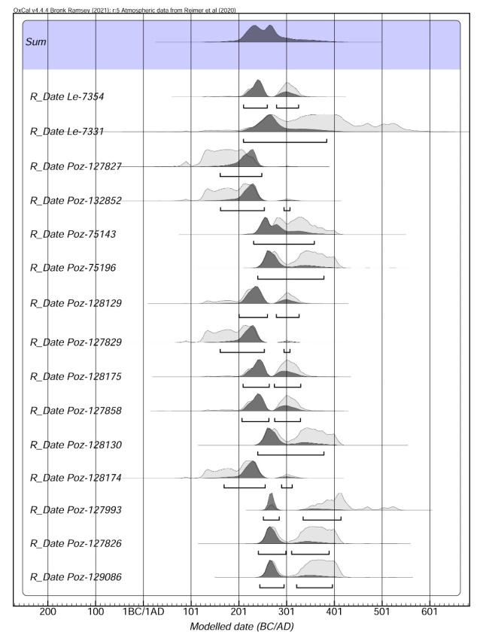

Supplementary Figure 2. Principal component analysis (PCA) of the two Oglakhty individuals (KE9609 and LC8544) in comparison to 1504 ancient and modern individuals who inhabited Eurasia (Supplementary Dataset 2). Modern genomes are represented by grey symbols, ancient genomes are colored. The Oglakhty human genomes analyzed in this study are shown by red circles: (A) PCA plot for 1504 ancient and modern individuals; and (B) PCA plot for two Oglakhty individuals and mostly genetically close ancient and modern individuals from the blue square in Fig 2A.
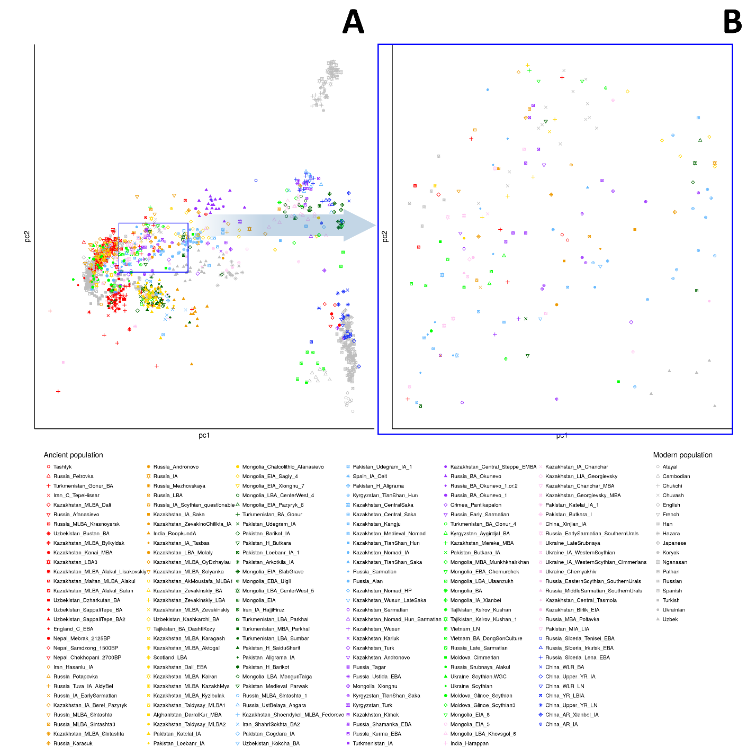
Supplementary Figure 3. Ancient DNA identification of animal leather and fur found in grave 4 (Oglakhty cemetery): (A) fragment of leather from human-like mannequin; (B) fragment of fur coat trim from the male mummy; and (C) fragment of the inner layer of the fur coat collar from the woman mummy. Figure courtesy of the State Hermitage Museum. Sampling spots are marked by red arrows.
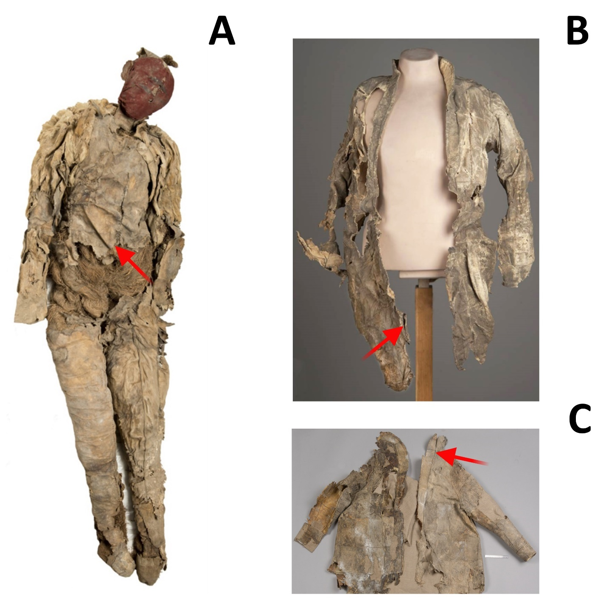

Supplementary Figure 4. Ancient DNA identification of animal leather and fur found in grave 4 (Oglakhty cemetery). A dendrogram of mammalian species (Supplementary Table 4) was reconstructed based on nucleotide sequences in tRNA-Phe gene fragment of mitochondrial DNA. Human-like mannequin (KN5672) and fur coat collar (AD7085) of the woman mummy are marked by red squares; the fur coat trim (HD9839) of the male mummy is marked by a yellow square.
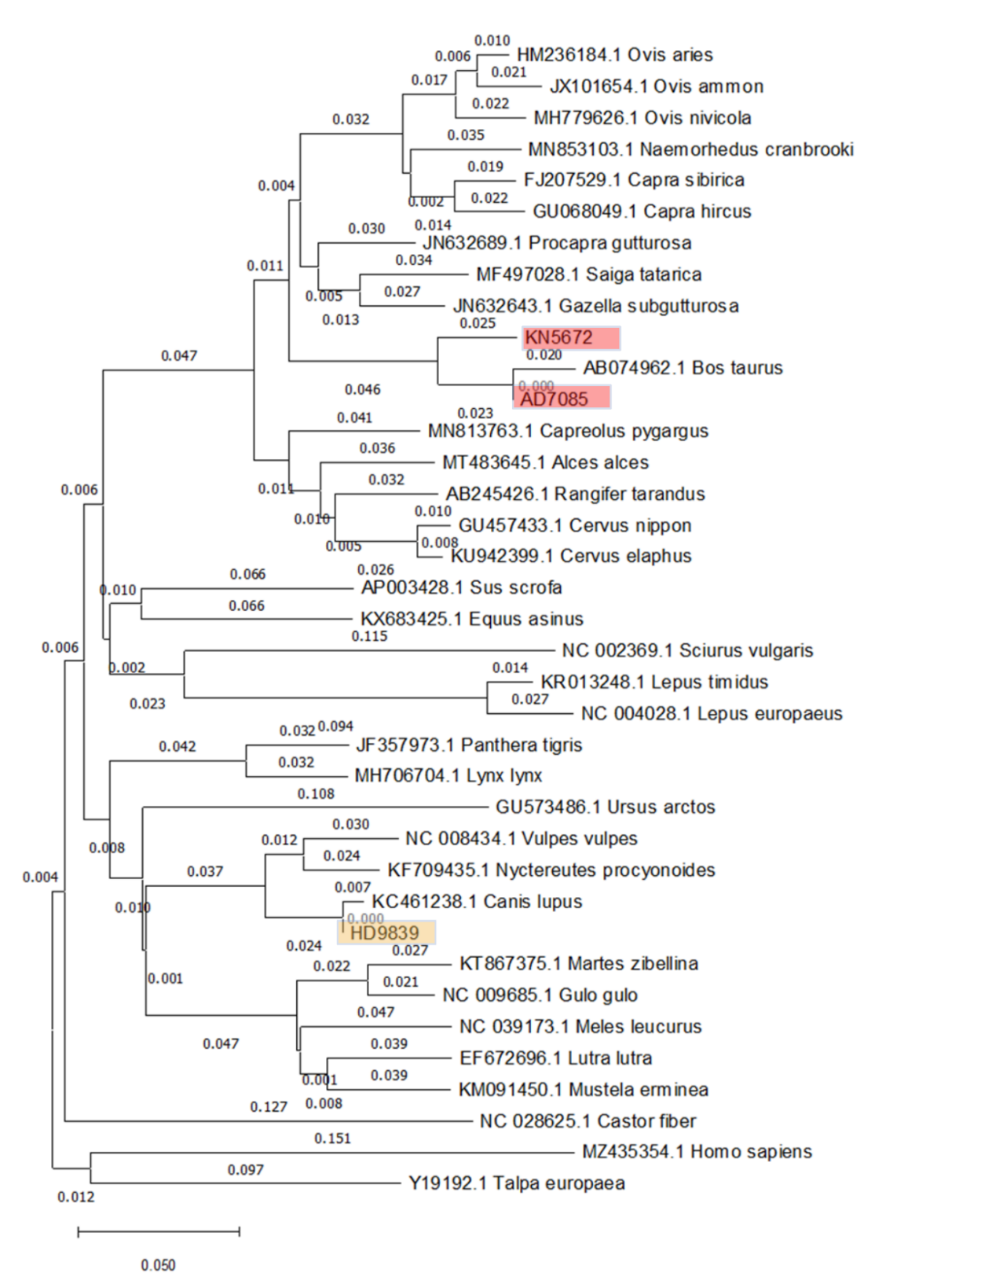
Supplementary Tables
Supplementary Table 1. Illumina-generated reads and number of mapped reads to human reference genome sequence (GRCh37.p13).
Library name | Total number of reads | Number of contaminant  reads | Total number of mapped reads | The ratio of mapped reads | Reads clonality | Coverage, fold | Breadth of coverage | Average merged read length
KE9609, male | 93,538,029 | 24,676,035 | 68,861,994 | 73.62 | 74.83 | 2.89 | 20.49 | 160
LC8544, female | 48,390,625 | 1,078,063 | 47,312,562 | 97.77 | 57.79 | 3.44 | 26.48 | 161
PI5222, child | 51,857 | - | - | - | - | - | - | 155.1
QR6400, child | 34,724 | - | - | - | - | - | - | 145.5

Supplementary Table 2. Mitochondrial DNA haplogroups of individuals from the Minusinsk Basin and adjacent regions (Bronze–Iron Ages).

Archaeological culture | Archaeological site | Mitochondrial haplogroup | Reference
Okunevo culture | All | A; A8; A8a; A8a1; A10; A12; C5; C5c; D4; D4b2a2a; H; H1bv1; H15b1; H6a; H6a1b; J; T2a1b; U5 | Allentoft et al., 2015; Damgaard et al., 2018; Hollard et al., 2018 ¹⁴⁻¹⁶
 | Okunev Ulus | A8a1; H6a | Damgaard et al., 2018 ¹⁵
 | Verkhni Askiz | A; A8a; H6a1b | Allentoft et al., 2015; Damgaard et al., 2018 ^{14,15}
 | Uybat V | A; A8a1; C5c; D4; H15b1 | Damgaard et al., 2018 ¹⁵
 | Syda 5 | C5c | Damgaard et al., 2018 ¹⁵
 | Krasny Kamen | C5; H1bv1 | Hollard et al., 2018 ¹⁶
 | Uibat-Charkov | A10; H1bv1; J; U5 | Hollard et al., 2018 ¹⁶
 | Itkol’ II | A8; A12; C5; D4b2a2a; H; T2a1b | Hollard et al., 2018 ¹⁶
Afanasievo/Afanasevo culture | All | C; H; H6a1b; G2a; H1bv1; H15b1; J2a2a; K1b2a; N1a1a1a1; R; T1a1; T2a1a; T2c1a2; U; U4b3; U4d1; U4d3; U5a1; U5a1a; U5a1a1; U5a1d2b; U5a1g1; U5a1g2; U5b2a1a; V1a | Allentoft et al., 2015; Hollard et al., 2018; Narasimhan et al., 2019; Jeong et al., 2020; Wang et al., 2021 ^{14,16-19}
 | Afanasieva Gora | J2a2a; T2c1a2; U5a1g2; V1a | Allentoft et al., 2015; Narasimhan et al., 2019 ^{14,18}
 | Kuyum River | U5a1a | Allentoft et al., 2015 ¹⁴
 | Lower Tyumechin 1 | T2a1a; U4d1; U5a1a1 | Narasimhan et al., 2019 ¹⁸
 | Minusinsk, Podsukhanika II | H15b1 | Narasimhan et al., 2019 ¹⁸
 | Inskoy Dol | U4d3 | Narasimhan et al., 2019 ¹⁸
 | Elo Bashi | U4b3; U5a1g1 | Narasimhan et al., 2019 ¹⁸
 | Elo 1 | T1a1; T2a1a | Narasimhan et al., 2019 ¹⁸
 | Karasuk III | U5a1d2b; U5b2a1a; U4b3; U5a1a1 | Narasimhan et al., 2019 ¹⁸
 | Ust'-Kuyum | H6a1b | Narasimhan et al., 2019 ¹⁸
 | Saldyar-1 | J2a2a; U | Hollard et al., 2018; Narasimhan et al., 2019 ^{16,18}
 | Kaminnaya Cave | K1b2a | Narasimhan et al., 2019 ¹⁸
 | Tytkesken-VI | R | Hollard et al., 2018 ¹⁶
 | Itkol’ II | C; H/U; H1bv1 | Hollard et al., 2018 ¹⁶
 | Shatar Chuluu | N1a1a1a1; U5a1 | Jeong et al., 2020 ¹⁷
 | Bayankhongor aimag | R; U5a1 | Wang et al., 2021 ¹⁹
 | Bayan-Ulgi aimag | G2a | Wang et al., 2021 ¹⁹
Andronovo culture | All | H; H2b; H2b34; H27; K1a; K1a4b; K2b; T1; T1a1; T2b; T2b34; T4; U2e1; U2e2; U2e; U2e1h; U2e2a1d; U4; U4a; U4a1; U4a1b; U4d1; U5a1; U5a2; U5b2b; U5b2c; W1c; Z | Keyser et al., 2009; Allentoft et al., 2015; Damgaard et al., 2018; Narasimhan et al., 2018 ^{14,15,18,20}
 | Tatarka cemetery | U4; Z | Keyser et al., 2009 ²⁰
 | Solenoozernaïa I | K2b; T4; U4 | Keyser et al., 2009 ²⁰
 | Solenoozernaïa IV | H; T1; U2e; | Keyser et al., 2009 ²⁰
 | Oust-Abakansty | U5a1 | Keyser et al., 2009
 | Kytmanovo | U2e1; U2e2; U4a1b; U4d1 | Allentoft et al., 2015 ¹⁴
 | Mitjurino | U2e1h | Damgaard et al., 2018 ¹⁵
 | Potroshilovo II | H2b; K1a; T1a1 | Narasimhan et al., 2018 ¹⁸
 | Ust-Bir IV | H2b34; K1a4b; T2b | Narasimhan et al., 2018 ¹⁸
 | Orak | H27; T1a1; T2b34; U2e2a1d; U4a; W1c; U4a1; U5a2; U5b2b; U5b2c | Narasimhan et al., 2018 ¹⁸
Karasuk culture | All | A; C4a1c; D4j1; H5a1; I4a1; T3; U4*; U5a1; U5a1a2a; U5a1d | Keyser et al., 2009; Allentoft et al., 2015 ^{14,20}
 | Oust-Abakansty | U5a1 | Keyser et al., 2009 ²⁰
 | Bogratsky | U4* | Keyser et al., 2009 ²⁰
 | Minoussinsk | T3 | Keyser et al., 2009 ²⁰
 | Bistraya | H5a1 | Allentoft et al., 2015 ¹⁴
 | Sabinka-2 | C4a1c; I4a1 | Allentoft et al., 2015 ¹⁴
 | Arban 1 | A; D4j1; U5a1a2a | Allentoft et al., 2015 ¹⁴
 | Podkuninskiy | U5a1d | Allentoft et al., 2015 ¹⁴
Tagar culture | All | A; A4; A8; A8a1; C; C4a2a; C5; D; F1b; F1b1b; G2a; H; H5; H5a1; HV*; HV6; I; I4; K; K1b1a; K1c2; N1a1a1a1; N9a9; T; T1; T2f7; T3; U*; U2e; U2e1h; U2e2; U4; U4a3; U5a; U5a1; U5a1h; W1c | Keyser et al., 2009; Unterländer et al., 2017; Damgaard et al., 2018; Pilipenko et al., 2018 ^{15,20-22}
 | Novosselovsky region | T3 | Keyser et al., 2009 ²⁰
 | Tchernogorsk | I4; T3 | Keyser et al., 2009 ²⁰
 | Oust-Abakansty | G2a | Keyser et al., 2009 ²⁰
 | Beysky region | C | Keyser et al., 2009 ²⁰
 | Bogratsky region | F1b; H | Keyser et al., 2009 ²⁰
 | Bogratsky region, Abakano-Pérévoz II | H5 | Keyser et al., 2009 ²⁰
 | Barsuchij Log | A4; C5; U2e2; U5a1 | Unterländer et al., 2017 ²²
 | Novaya chernaya-1 | A; C4a2a; G2a; T2f7; U*; U2e | Pilipenko et al., 2018 ²¹
 | Kichik-Kyuzyur | A8; C5; I; T1; U2e; U4; U4a3; U5a | Pilipenko et al., 2018 ²¹
 | Barsuchiha-1 | C; I; T1; T; U*; U2e | Pilipenko et al., 2018 ²¹
 | Barsuchiha-6 | A8; D; F1b1b; U5a1h | Pilipenko et al., 2018 ²¹
 | Barsuchiha-7 | C; D; HV*; T1; T | Pilipenko et al., 2018 ²¹
 | Podgornoe ozero | A8; G2a; H; HV6; K1b1a; K1c2; T1; U*; U2e; U4 | Pilipenko et al., 2018 ²¹
 | Tepsej-3 | HV6; U4a3; | Pilipenko et al., 2018 ²¹
 | Tepsej-8 | A8; C4a2a; K; T1 | Pilipenko et al., 2018 ²¹
 | Tepsej-9 | F1b; H; T2f7; U4a3 | Pilipenko et al., 2018 ²¹
 | Sovetskaya Hakasiya | D | Pilipenko et al., 2018 ²¹
 | Perevozinskij | D; H | Pilipenko et al., 2018 ²¹
 | Dolgij Kurgan | HV6 | Pilipenko et al., 2018 ²¹
 | Ulug-Kyuzyur | K1b1a; U4a3; U5a1 | Pilipenko et al., 2018 ²¹
 | Grishkin Log 1 | A8a1; F1b1b; H5a1; N1a1a1a1; N9a9; U2e1h; U2e2; W1c | Damgaard et al., 2018 ¹⁵
Tashtyk culture | All | C; H; HV; I4a1; N9a; T1 | Keyser et al., 2009 ²⁰; This study
 | Abakano-Pérévoz I | C; H; HV; N9a; T1 | Keyser et al., 2009 ²⁰
 | Oglakhty | I4a1 | This study
Aldy Bel culture | All | A; A4; A8; C4; C4a1a3; C4d; C5b1; D4b1a2a; D4j7; F1b1b; G; G2a; H; H14b2; HV14a; HV6; T1a; U4a1a; U4a3; U5a1d2b; U5a1f1; U5a2a; Y1 | Unterländer et al., 2017; Mary et al., 2019 ^{22,23}
 | Arzhan 2 | A; A4; A8; C4; C5b1; D4b1a2a; G; G2a; H; T1a; U4a3; U5a1d2b; U5a1f1; Y1 | Unterländer et al., 2017 ²²
 | Eki-Ottug 2 | H14b2; D4j7; H; F1b1b; C4d; HV6 | Mary et al., 2019 ²³
 | Eerbek | HV14a | Mary et al., 2019 ²³
 | Bai-Dag | C4a1a3; U4a1a; U5a1f1; U5a2a | Mary et al., 2019 ²³
The Tarim basin’s people | All | B; C4; C5; D; G2a; H; K; M5; R*; R1b1; T; U2e; U5; U7 | Li et al., 2015; Zhang et al., 2021 ^{24,25}
 | Xiaohe | B; C4; C5; D; G2a; H; K; M5; R*; R1b1; T; U2e; U5; U7 | Li et al., 2015; Zhang et al., 2021 ^{24,25}
 | Beifang | C4 | Zhang et al., 2021 ²⁵
Xiongnu | All | A; A16; A23; B4d3a; B5b4; C; C4a1; C4a1a; C4a2c; C4b6; C5b1b; D4; D4a6; D4b2b2b; D4b2b4; D4f; D4j7; D4j8; D4q; G2a; G2a1d2; G3a3; H2a1; H5a1; H7b; H47; J1d5; J2a1a1; J2b1a2a; N9a; N9a2a; T1a1; T2b3; U2e1; U2e2a1; U5a1; U5a1a1; X2b4a; Y1 | Kim et al., 2010; Damgaard et al., 2018; Pilipenko et al., 2018; Keyser et al., 2021 ^{15,26-28}
 | Acaj-2 | D4; Y1 | Pilipenko et al., 2018 ²⁸
 | Enhor | A16; B5b4; C; D4 | Pilipenko et al., 2018 ²⁸
 | Il’movaya pad’ | A; C; D4; G2a; N9a | Pilipenko et al., 2018 ²⁸
 | Nizhneivolginskij | C5b1b | Pilipenko et al., 2018 ²⁸
 | Hovsgol | D4b2b4; G3a3 | Damgaard et al., 2018 ¹⁵
 | Omnogobi | D4b2b2b; D4a6 | Damgaard et al., 2018 ¹⁵
 | Arkhangai | N9a2a | Damgaard et al., 2018 ¹⁵
 | Duurlig Nars | U2e1 | Kim et al., 2010 ²⁷
 | Tamir Ulaan Khoshuu | A23; B4d3a; C4a1; C4a1a; C4a2c; C4b6; D4f; D4j7; D4j8; D4q; G2a1d2; H2a1; H5a1; H7b; H47; J1d5; J2a1a1; J2b1a2a; T1a1; T2b3; U2e2a1; U5a1; U5a1a1; X2b4a | Keyser et al., 2021 ²⁶

Supplementary Table 3. Y-chromosome haplogroups of individuals from the Minusinsk Basin and adjacent regions (Bronze–Iron Ages).
Archaeological culture | Archaeological site | Y-chromosome DNA haplogroup | Reference
Okunevo culture | All | NO1; Q1a; Q1a1b1; Q1a2; Q1a2a1; Q1a2a1с; Q1a2b; Q1b; Q1b1a; R1b1a2a2 | Damgaard et al., 2018; Hollard et al., 2018 ^{15,16}
 | Uibat- Charkov | NO1; Q1b; R1b1a1a2a | Hollard et al., 2018 ¹⁶
 | Itkol’ II | NO1; Q1b1a; Q1b1a | Hollard et al., 2018 ¹⁶
 | Okunev Ulus | Q1a2a1; Q1a2a1с | Damgaard et al., 2018 ¹⁵
 | Verkhni Askiz | Q1a; Q1a2; Q1a2b | Damgaard et al., 2018 ¹⁵
 | Uybat V | Q1a1b1; R1b1a2a2 | Damgaard et al., 2018 ¹⁵
 | Syda 5 | Q1a2a1с | Damgaard et al., 2018 ¹⁵
Afanasievo/Afanasevo culture | All | C2a1a1; J1a; J1a2; R1b1a1a; R1b1a1a2a; R1b1a1a2a2; R1b1a1b; Q1a2 | Hollard et al., 2018; Narasimhan et al., 2018; Jeong et al., 2020; Wang et al., 2021 ¹⁶⁻¹⁹
 | Itkol’ II | R1b1a1a2a | Hollard et al., 2018 ¹⁶
 | Tytkesken-VI | R1b1a1a | Hollard et al., 2018 ¹⁶
 | Afanasieva Gora | R1b1a1a2a2 | Narasimhan et al., 2018 ¹⁸
 | Minusinsk, Podsukhanika II | R1b1a1a2a2 | Narasimhan et al., 2018 ¹⁸
 | Karasuk III | Q1a2; R1b1a1a2a2 | Narasimhan et al., 2018 ¹⁸
 | Shatar Chuluu | J1a; R1b1a2a1a | Jeong et al., 2020 ¹⁷
 | Bayankhongor aimag | J1a2; R1b1a1b | Wang et al., 2021 ¹⁹
 | Bayan-Ulgi aimag | C2a1a1 | Wang et al., 2021 ¹⁹
Andronovo culture | All | R; R1a1; R1a1a1b; R1a1a1b1a2b1; R1a1a1b2; R1a1a1b2a; R1a1a1b2a2a; Q1a2; | Keyser et al., 2009; Narasimhan et al., 2018 ^{18,20}
 | Solenoozernaïa IV | R1a1 | Keyser et al., 2009 ²⁰
 | Oust-Abakansty | R1a1 | Keyser et al., 2009 ²⁰
 | Potroshilovo II | R; R1a1a1b; R1a1a1b2a2a | Narasimhan et al., 2018 ¹⁸
 | Ust-Bir IV | R1a1a1b | Narasimhan et al., 2018 ¹⁸
 | Orak | R1a1a1b; R1a1a1b2a; R1a1a1b1a2b1; R1a1a1b2; Q1a2 | Narasimhan et al., 2018 ¹⁸
Karasuk culture | All | Q1a1b1; R1a1a1; R1a1a1b2a | Allentoft et al., 2015 ¹⁴
 | Sabinka 2 | Q1a1b1; R1a1a1 | Allentoft et al., 2015 ¹⁴
 | Arban 1 | R1a1a1b2a | Allentoft et al., 2015 ¹⁴
Tagar culture | All | R1; R1a1 | Keyser et al., 2009; Damgaard et al., 2018 ^{15,20}
 | Tchernogorsk | R1a1 | Keyser et al., 2009 ²⁰
 | Oust-Abakansty | R1a1 | Keyser et al., 2009 ²⁰
 | Beysky region | R1a1 | Keyser et al., 2009 ²⁰
 | Bogratsky region | R1a1 | Keyser et al., 2009 ²⁰
 | Abakano-Pérévoz II | R1a1 | Keyser et al., 2009 ²⁰
 | Grishkin Log 1 | R1 | Damgaard et al., 2018 ¹⁵
Tashtyk culture | All | R1a1; R1a1a | Keyser et al., 2009 ²⁰; This study
 | Abakano-Pérévoz I | R1a1 | Keyser et al., 2009 ²⁰
 | Oglakhty | R1a1a | This study
Aldy Bel culture | All | N; R1a; R1a1a1b2; Q1b1a | Mary et al., 2019 ²³
 | Eki-Ottug 2 | R1a; R1a1a1b2 | Mary et al., 2019 ²³
 | Eerbek | N | Mary et al., 2019 ²³
 | Bai-Dag | Q1b1a; R1a1a1b2 | Mary et al., 2019 ²³
The Tarim basin’s people | All | R1; R1b1c | Zhang et al., 2021 ²⁵
 | Xiaohe | R1b1c | Zhang et al., 2021 ²⁵
 | Beifang | R1 | Zhang et al., 2021 ²⁵
Xiongnu | All | O3a; O3a3b2; N; R1a; R1a1; R1b | Kim et al., 2010; Damgaard et al., 2018; Keyser et al., 2021 ^{15,26,27}
 | Hovsgol | R1b | Damgaard et al., 2018 ¹⁵
 | Omnogobi | O3a; O3a3b2 | Damgaard et al., 2018 ¹⁵
 | Arkhangai | R1 | Damgaard et al., 2018 ¹⁵
 | Duurlig Nars | R1a1 | Kim et al., 2010 ²⁷
 | Tamir Ulaan Khoshuu | N; R1a | Keyser et al., 2021 ²⁶

Supplementary Table 4. Ancient DNA identification of animal leather and fur found in grave 4 (Oglakhty cemetery).
Object | Sample description | Laboratory code | Figure | Species name
Oglakhty cemetery, grave 4, human-like mannequin | Fragment of leather | KN5672 | Supplementary Fig. 3A | Bos taurus
Oglakhty cemetery, grave 4, male mummy (KE9609) | Fragment of fur coat trim | HD9839 | Supplementary Fig. 3B | Canis lupus
Oglakhty cemetery, grave 4, female mummy (LC8544) | Fragment of the inner layer of the fur coat collar | AD7085 | Supplementary Fig. 3C | Bos taurus

Supplementary Table 5. List of mammalian species which were used for animal coat and leather object identification from grave 4 (Oglakhty cemetery)
# | Animal species | Latin species name | NCBI accession number
1 | Domestic cattle | Bos taurus | AB074962.1
2 | Stoat | Mustela erminea | KM091450.1
3 | Brown bear | Ursus arctos | GU573486.1
4 | Moose | Alces alces | MT483645.1
5 | Gray wolf | Canis lupus | KC461238.1
6 | Domestic goat | Capra hircus | GU068049.1
7 | Siberian ibex | Capra sibirica | FJ207529.1
8 | Siberian roe deer | Capreolus pygargus | MN813763.1
9 | Eurasian beaver | Castor fiber | NC028625.1
10 | Red Deer | Cervus elaphus | KU942399.1
11 | Sika deer | Cervus nippon | GU457433.1
12 | Domestic asinus | Equus asinus | KX683425.1
13 | Goitered gazelle | Gazella subgutturosa | JN632643.1
14 | Wolverine | Gulo | NC009685.1
15 | European hare | Lepus europaeus | NC004028.1
16 | Mountain hare | Lepus timidus | KR013248.1
17 | Eurasian otter | Lutra lutra | EF672696.1
18 | Lynx | Lynx lynx | MH706704.1
19 | Sable | Martes zibellina | KT867375.1
20 | Asian Badger | Meles leucurus | NC039173.1
21 | Goral | Naemorhedus cranbrooki | MN853103.1
22 | Common raccoon dog | Nyctereutes procyonoides | KF709435.1
23 | Argali | Ovis ammon | JX101654.1
24 | Domestic sheep | Ovis aries | HM236184.1
25 | Snow sheep | Ovis nivicola | MH779626.1
26 | Amur tiger | Panthera tigris | JF357973.1
27 | Mongolian gazelle | Procapra gutturosa | JN632689.1
28 | Reindeer | Rangifer tarandus | AB245426.1
29 | Saiga antelope | Saiga tatarica | MF497028.1
30 | Red squirrel | Sciurus vulgaris | NC002369.1
31 | Domestic pig | Sus domesticus | AP003428.1
32 | European mole | Talpa europaea | Y19192.1
33 | Red fox | Vulpes vulpes | NC008434.1
34 | Human* | Homo sapiens | MZ435354.1
* Human mtDNA sequence was also included in the alignment, in order to control for contamination of samples

Supplementary Table 6. Universal DNA primers used for the identification of animal leather and fur found in grave 4 (Oglakhty cemetery).
Primer name | Primer sequence 5′-3’ | Primer direction
MTCH 590F | AA ATA TAT TAA AGC AAG GCA CTG AAA ATG C | Forward
MTCH 845R | GTT TAT GGC TTA ATT TTT ATC ACT GCT GT | Reverse
MTCH 796F | TWA GCC ACA CCC CCA CGG GA | Forward
MTCH 1085R | GGG GTA TCT AAT CCC AGT TTG G | Reverse

References
1 Nikolaev, N. N. & Pankova, S. V. After the Scythians. Scythians: Warriors of Ancient Siberia, 322-351 (2017).
2 Pankova, S. V. in Masters of the Steppe: the Impact of the Scythians and Later Nomad Societies of Eurasia. Proceedings of a Conference Held at the British Museum, 27-29 October 2017 (eds S.V. Pankova & St.J. Simpson) 373-396 (2020).
3 Tallgren, A. The South Siberian cemetery of Oglakty from the Han period. Eurasia Septentrionalis Antiqua 11, 69-90 (1937).
4 Kyzlasov, L. R. Ocherki po istorii Sibiri i Tsentral’noi Azii. (Krasnoyarsk University Press, 1992).
5 Vodyasov, E. V., Pankova, S. V., Zaitceva, O. V. & Vavulin, M. V. The Oglakhty Burial Ground: History of Discovery, Planigraphy, and Current State. Siberian Historical Research 3, 6-23, doi:10.17223/2312461X/33/1 (2021).
6 Pankova, S. V., Makarov, N. P., Simpson, S. J. & Cartwright, C. R. New radiocarbon dates and environmental analyses of finds from 1903 excavations in the eastern plot of the Tashtyk cemetery of Oglakhty. Siberian Historical Research 3, 24-59 (2021).
7 Tarasov, P. E. et al. New results of radiocarbon dating and identification of plant and animal remains from the Oglakhty cemetery provide an insight into the life of the population of southern Siberia in the early 1st millennium CE. Quaternary International, doi:10.1016/j.quaint.2021.12.004 (2021).
8 Pankova, S. V. & Shirobokov, I. G. Burial mannequin with cremains from the Grave 4 of the Oglakhty burial ground (excavations by L.R. Kyzlasov, 1969). Siberian Historical Research 3, 60-96 (2021).
9 Pankova, S. V. One more culture with ancient tattoo tradition in southern Siberia: tattoos on a mummy from the Oglakhty Burial Ground, 3rd-4th century AD. Zurich Studies in Archaeology 9, 75-86 (2013).
10 Pankova, S. V. in Ancient Ink: the Archaeology of Tattooing (eds L. Krutak & A. Deter-Wolf) 65-84 (University of Washington Press, 2017).
11 Pankova, S. V. in Pamyatniki arkheologii v issledovaniyah i fotografiyah (pamyaty G.V. Dluzhnevskoy) (ed N.Yu. Smirnov) 132-139 (Institute for the History of Material Culture, Russian Academy of Sciences, 2018).
12 Pankova, S. V. & Mikolaichuk, E. A. in The Art of Ancient Textiles. Archaeology of China and East Asia Vol. 7 (ed M. Wagner I.I. Elkina, P.E. Tarasov ) 108-141 (Nünnerich-Asmus Verlag & Media, 2019).
13 Pankova, S. V., Vasiliev, S. S., Dergachev, V. A. & Zaitseva, G. I. Radiocarbon dating of Oglakhty grave using a wiggle matching method. Archaeology, Ethnology and Anthropology of Eurasia 38, 46-56, doi:10.1016/j.aeae.2010.08.007 (2010).
14 Allentoft, M. E. et al. Population genomics of Bronze Age Eurasia. Nature 522, 167-172, doi:10.1038/nature14507 (2015).
15 Damgaard, P. B. et al. 137 ancient human genomes from across the Eurasian steppes. Nature 557, 369-374, doi:10.1038/s41586-018-0094-2 (2018).
16 Hollard, C. et al. New genetic evidence of affinities and discontinuities between bronze age Siberian populations. Am J Phys Anthropol 167, 97-107, doi:10.1002/ajpa.23607 (2018).
17 Jeong, C. et al. A Dynamic 6,000-Year Genetic History of Eurasia's Eastern Steppe. Cell 183, 890-904 e829, doi:10.1016/j.cell.2020.10.015 (2020).
18 Narasimhan, V. M. et al. The formation of human populations in South and Central Asia. Science 365, doi:10.1126/science.aat7487 (2019).
19 Wang, C.-C. et al. Genomic insights into the formation of human populations in East Asia. Nature 591, 413-419, doi:10.1038/s41586-021-03336-2 (2021).
20 Keyser, C. et al. Ancient DNA provides new insights into the history of south Siberian Kurgan people. Hum Genet 126, 395-410, doi:10.1007/s00439-009-0683-0 (2009).
21 Pilipenko, A. S. et al. Maternal genetic features of the Iron Age Tagar population from Southern Siberia (1st millennium BC). PLoS One 13, e0204062, doi:10.1371/journal.pone.0204062 (2018).
22 Unterlander, M. et al. Ancestry and demography and descendants of Iron Age nomads of the Eurasian Steppe. Nat Commun 8, 14615, doi:10.1038/ncomms14615 (2017).
23 Mary, L. et al. Genetic kinship and admixture in Iron Age Scytho-Siberians. Hum Genet 138, 411-423, doi:10.1007/s00439-019-02002-y (2019).
24 Li, C. X. et al. Analysis of ancient human mitochondrial DNA from the Xiaohe cemetery: insights into prehistoric population movements in the Tarim Basin, China. Bmc Genetics 16, doi:10.1186/s12863-015-0237-5 (2015).
25 Zhang, F. et al. The genomic origins of the Bronze Age Tarim Basin mummies. Nature 599, 256-261, doi:10.1038/s41586-021-04052-7 (2021).
26 Keyser, C. et al. Genetic evidence suggests a sense of family, parity and conquest in the Xiongnu Iron Age nomads of Mongolia. Hum Genet 140, 349-359, doi:10.1007/s00439-020-02209-4 (2021).
27 Kim, K. et al. A Western Eurasian Male Is Found in 2000-Year-Old Elite Xiongnu Cemetery in Northeast Mongolia. Am J Phys Anthropol 142, 429-440, doi:10.1002/ajpa.21242 (2010).
28 Pilipenko, A. S. et al. Mitochondrial DNA diversity in a Transbaikalian Xiongnu population. Archaeol Anthrop Sci 10, 1557-1570, doi:10.1007/s12520-017-0481-x (2018).

