Characterization of Heterorhabditis indica (Nematoda: Rhabditida) and their efficacy against insect pests by using regression probit analysis model: Implication on biological control of pest management
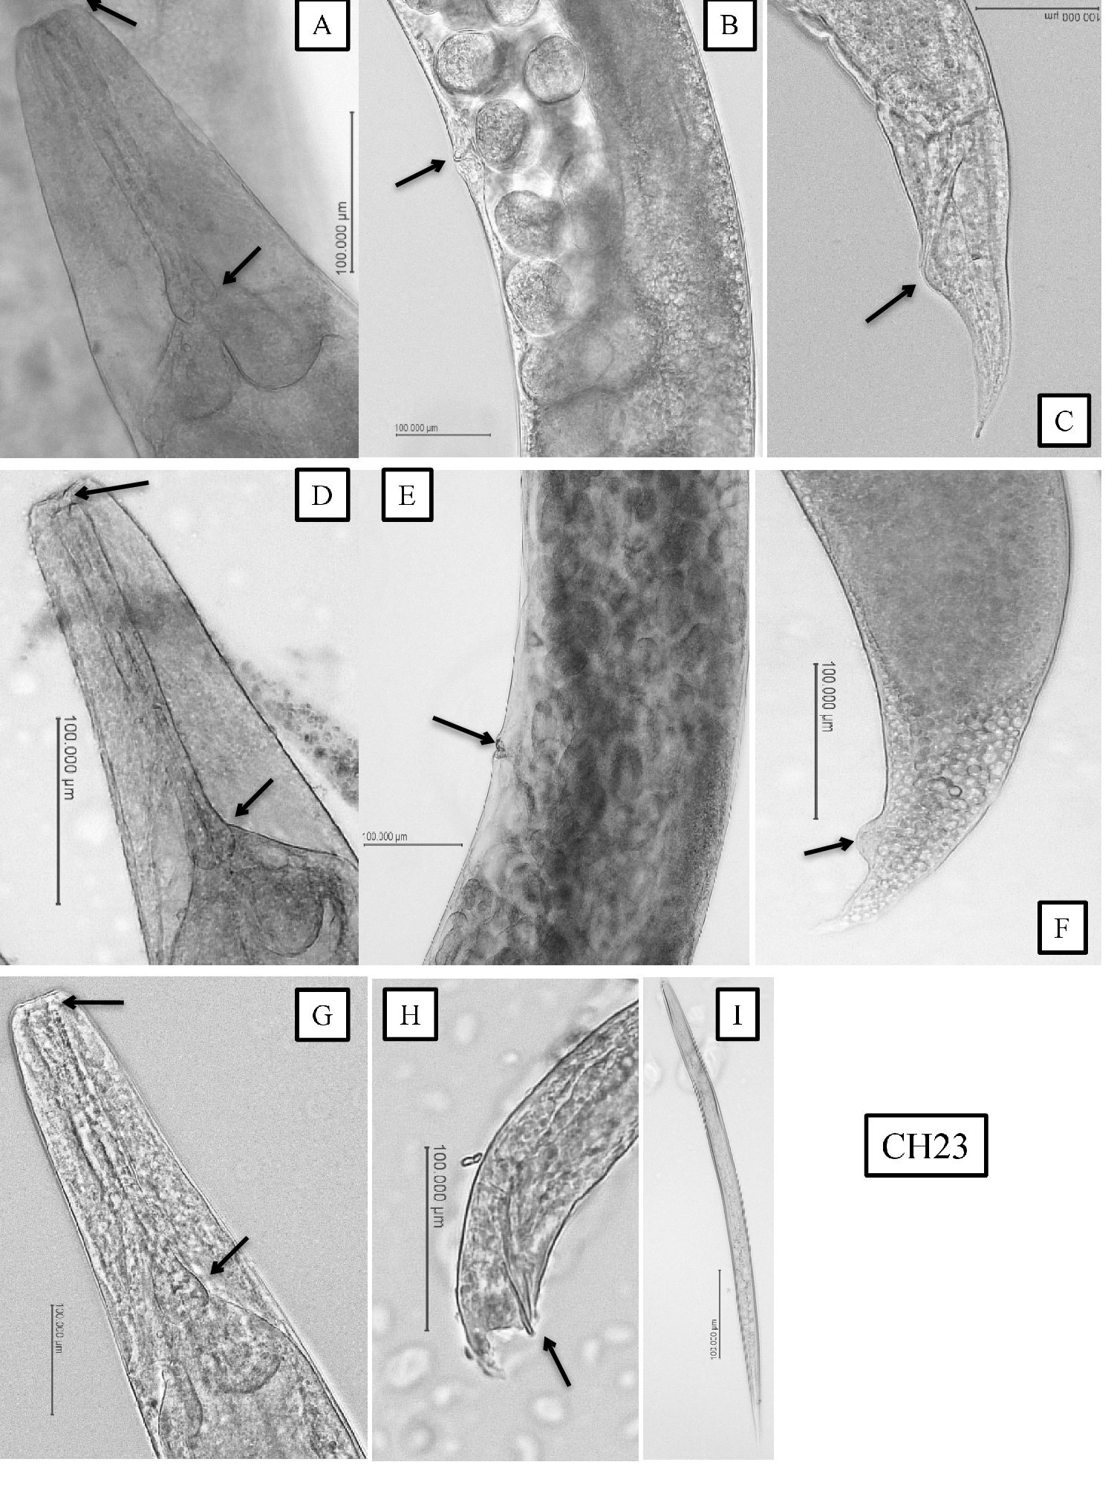
Supplementary Figure 1.Photomicrographs of H. indica CH23. Hermaphrodite: A: Anterior region; B: Vulval region; C: Anal region, Amphimictic Female D: Anterior region E: Vulval region; F: Anal region, Male: G: Anterior region; H: Posterior region, Infective Juvenile: I: Whole body. The arrows indicate the anterior and pharyngeal region (A, D, G), vulval region of hermaphroditic and amphimictic females (B, E), anal region (C, F) and spicule (H).

