SUPPLEMENTARY DATA
An efficient synthesis of some new pyrimidine derivatives bearing 1,3,5- triazine nucleus as potential anti-microbial agents
Ramkumar P. Dongre*
Arvindbabu Deshmukh Mahavidyalaya Bharsingi, Tal-Narkhed, Dist-Nagpur (M.S.) India 441305
ramdongre341@gmail.com
Corresponding author: Ramkumar Dongre, E-mail: ramdongre341@gmail.com

MATERIALS AND METHODS
Experimental
Melting points were determined in open capillaries and are uncorrected.IR spectra were recorded using Perkin –Elmer spectrometer.1H NMR spectra were recorded on Brucker Advance II 400 spectrometer in DMSO by using TMS as internal standard. Thin layer chromatography was performed with E. Merk precoated TLC plates, silica gel 60F254 with thickness of 0.25mm and spots were visualized by irradiation with ultraviolet light (254 nm).
General procedure for the synthesis of 1-(4-(4,6-dichloro-1,3,5-triazin-2-yl amino) phenyl) ethanone (3)
4-Amine acetophenone (0.01 mole) was added slowly to cyanuric chloride (0.01 mole) in acetone (30 ml) with constant stirring over a period of 4 hr at 0 to 5⁰ C. Then, sodium carbonate (0.005 mole) dissolved in water (10 ml) was added drop wise to neutralize HCl evolved during the reaction. Finally, the contents were poured into crushed ice. The solid was separated out by filtration and washed with water. The product is dried, recrystallized from alcohol to give the product (3).
General procedure for the synthesis of 1-(4-(4,6-diethoxy-1,3,5-triazin-2-ylamino) phenyl) ethanone (4)
1-(4-(4,6-dichloro-1,3,5-triazin-2-yl amino)phenyl)ethanone (3) (0.01 mole) was added slowly to sodiumethaoxide (0.02 mole) with constant stirring in DMF: H₂O (9: 1 ml) over a period of 4 hrs. At room temperature and refluxed for 4 hrs. at 80 ⁰C. The contents were poured onto ice cold water and filtered. The product 4 was obtained and recrystallized from DMF.
General procedure for the synthesis of substituted 1-(4-(4,6-diethoxy-1,3,5-triazin-2-yl amino) phenyl)-3-phenylprop-2-en-1-one (Chalcone) (6a-h)
Compound 4 (0.01 mole) was dissolved in DMF (25 ml) and substituted benzaldehyde (5a-h) (0.01mole) was added with constant stirring at room temperature for 30 minute, then sodium hydroxide (40% w/v) was added to reaction mixture which was again stirred at R.T. for 24 hrs. The progress of reaction was monitored by TLC. After completion of the reaction, crushed ice was added in the reaction mixture and neutralized with HCl. The product separated was filtered, washed with water, dried and recrystallized from DMF to get pure product (Chalcone) (6a-h).
General procedure for the synthesis of substituted N-(4-(2-amino-6-(phenyl)pyrimidin-4-yl) phenyl)-4,6-diethoxy-1,3,5-triazin-2-amine (7a-h)
A mixture of substituted (E)-1-(4-(4,6-diethoxy-1,3,5-triazin-2-ylamino) phenyl)-3-(phenyl)prop-2-en-1-one (Chalcone) (6a-h) ,Guanidine Hydrochloride (0.01 mole) ,and KOH (alc) in 25 mL DMF was refluxed for 12 hrs. After completion of reaction (checked by TLC), the reaction mixture was cooled and poured into ice cold water. The separated solid product was filtered, washed with cold water, dried and then recrystallized from DMF.
Spectral data of synthesized compounds
(6g): 1-(4-(4,6-diethoxy-1,3,5-triazin-2-ylamino)phenyl)-3-(4-chlorophenyl)prop-2-en-1-one
Yield 75%; m.p. 237 0C: Elemental analysis Calcd for (C₂₂H₂₁ClN₄O₃); C, 62.19; H, 4.98; N, 13.19; found: C, 62.15; H, 4.80; N, 13.14%; IR (KBr pellets Cm‐1): 3316 (N-H), 1650 (>C=O), 1606 (CH=CH), 843 (C‐Cl): 1H NMR (DMSO, 400 MHz), δ 10.56 (br. s, 1H, N-H), 8.14 (dd, 1H>C=CH_{B}), 7.98-7.22 (m, 8H, Ar-H), 7.52 (dd, 1H, CH_{A}=C<), 3.43-3.19 (q, 4H, -CH2-CH3) , 3.12-2.52 (t,6H, CH3-CH2-) MS: m/z 424.88 (M+1).
(7a) N-(4-(2-amino-6-p-tolylpyrimidin-4-yl)phenyl)-4,6-diethoxy-1,3,5-triazin-2-amine
Yield 77%; M.P. 195°C: Elemental analysis Calcd for (C₂₄H₂₅N₇O₂) C, 65.00; H, 5.68; N, 22.11 found C, 64.98; H, 5.64; N, 22.08 ; IR (KBr pellets cm‐1): 3309.30 cm-1 (NH) , 3200.33 cm-1 (Ar C-H str.), 1670.20 cm-1( C=N str), and 1578.16 cm-1 (Ar C=C). 1H NMR (DMSO-d6, 400 MHz): δ 10.44 (br. s, 1H, N-H) 9.29 (d, 2H, N-H) 8.18-6.36 (m, 8H, Ar‐H), 7.54 (s, 1H, -CH- pyrimidine), 3.32-2.91 (q, 4H, -CH2-CH3) , 2.76 (s, 3H, Ali-CH3) 2.52-2.26 (t,6H, CH3-CH2-) . 13C NMR (DMSOd6,400 MHz) δ: 187.1 (2C, triazine ring),165.1 (1C, triazine ring), 164.4 (1C, pyrimidine ring), 163.8 (1C, pyrimidine ring), 162.2 (1C, pyrimidine ring), , 143.1 (1C, aromatic) , 140.2 (1C, aromatic), 140.2 (1C, aromatic), 134.7 (2C, aromatic), 131.1 (2C, aromatic), 128.6 (1C, aromatic), 127.2 (2C, aromatic), 119.2 (2C, aromatic), 100.6 (1C, pyrimidine ring) 35.7 (2C, CH3-CH2), 30.6 (1C, Ali-CH3) ,20.96 (2C, CH2-CH3) . MS: m/z 443 (M+1).

(7b)N-(4-(2-amino-6-(4-methoxyphenyl)pyrimidin-4-yl)phenyl)-4,6-diethoxy-1,3,5-triazin-2-amine
Yield 80%; M.P. 187°C: Elemental analysis Calcd for (C₂₄H₂₅N₇O₃) C, 62.73; H, 5.48; N, 21.34; found C, 62.70; H, 5.45; N, 21.30; . IR (KBr pellets cm‐1): 3309.32 cm-1 (NH) , 3200.35 cm-1 (Ar C-H str.), 1670.22 cm-1( C=N str), and 1578.18 cm-1 (Ar C=C). ). 1H NMR (DMSO-d6, 400 MHz): δ 10.46 (br. s, 1H, N-H) 9.30 (d, 2H, N-H) 8.19-6.37 (m, 8H, Ar‐H), 7.55 (s, 1H, -CH- pyrimidine), 3.33-2.92 (q, 4H, -CH2-CH3) , 2.85 (s, 3H, Ali-OCH3) 2.53-2.27 (t,6H, CH3-CH2-) . 13C NMR (DMSOd6,400 MHz) δ: 187.2 (2C, triazine ring),165.2 (1C, triazine ring), 164.5 (1C, pyrimidine ring), 164.1 (1C, pyrimidine ring), 162.3 (1C, pyrimidine ring), , 143.2 (1C, aromatic) , 140.3 (1C, aromatic), 140.3 (1C, aromatic), 134.8 (2C, aromatic), 131.2 (2C, aromatic), 128.7 (1C, aromatic), 127.3 (2C, aromatic), 119.3 (2C, aromatic), 100.8 (1C, pyrimidine ring) 35.8 (2C, CH3-CH2), 34.8 (1C, Ali-OCH3) ,20.98 (2C, CH2-CH3) . MS: m/z 459 (M+1).
(7c) N-(4-(2-amino-6-(2,3,4-trimethoxyphenyl)pyrimidin-4-yl)phenyl)-4,6-diethoxy-1,3,5-triazin-2-amine
Yield 70%; M.P. 205°C: Elemental analysis Calcd for (C₂₆H₂₉N₇O₅) C, 60.11; H, 5.63; N, 18.87; found C, 60.10; H, 5.60; N, 18.85 IR (KBr pellets cm‐1): 3309.35 cm-1 (NH) , 3200.37 cm-1 (Ar C-H str.), 1670.24 cm-1( C=N str), and 1578.21 cm-1 (Ar C=C). ). 1H NMR (DMSO-d6, 400 MHz): δ 10.47 (br. s, 1H, N-H) 9.31 (d, 2H, N-H) 8.20-6.38 (m, 6H, Ar‐H), 7.56 (s, 1H, -CH- pyrimidine), 3.34-2.94 (q, 4H, -CH2-CH3) , 2.86 (s, 9H, Ali-OCH3) 2.54-2.28 (t,6H, CH3-CH2-) . 13C NMR (DMSOd6,400 MHz) δ: 187.3 (2C, triazine ring),165.4 (1C, triazine ring), 164.4 (1C, pyrimidine ring), 164.2 (1C, pyrimidine ring), 162.4 (1C, pyrimidine ring), , 143.3 (1C, aromatic) , 140.5 (1C, aromatic), 140.4 (1C, aromatic), 134.9 (2C, aromatic), 131.3 (2C, aromatic), 128.8 (1C, aromatic), 127.4 (2C, aromatic), 119.4 (2C, aromatic), 100.9 (1C, pyrimidine ring) 35.9 (2C, CH3-CH2), 34.7 (1C, Ali-OCH3) ,20.94 (2C, CH2-CH3) . MS: m/z 519(M+1).

(7d)N-(4-(2-amino-6-(3,4,5-trimethoxyphenyl)pyrimidin-4-yl)phenyl)-4,6-diethoxy-1,3,5-triazin-2-amine
Yield 70%; M.P. 205°C: Elemental analysis Calcd for (C₂₆H₂₉N₇O₅) C, 60.11; H, 5.63; N, 18.87; found C, 60.09; H, 5.60; N, 18.84; IR (KBr pellets cm‐1): 3309.39 cm-1 (NH) , 3200.40 cm-1 (Ar C-H str.), 1670.28 cm-1( C=N str), and 1578.25 cm-1 (Ar C=C). ). 1H NMR (DMSO-d6, 400 MHz): δ 10.48 (br. s, 1H, N-H) 9.32 (d, 2H, N-H) 8.21-6.39 (m, 6H, Ar‐H), 7.57 (s, 1H, -CH- pyrimidine), 3.35-2.95 (q, 4H, -CH2-CH3) , 2.86 (s, 9H, Ali-OCH3) 2.55-2.29 (t,6H, CH3-CH2-) . 13C NMR (DMSOd6,400 MHz) δ: 187.4 (2C, triazine ring),165.5 (1C, triazine ring), 164.5 (1C, pyrimidine ring), 164.3 (1C, pyrimidine ring), 162.5 (1C, pyrimidine ring), , 143.4 (1C, aromatic) , 140.4 (1C, aromatic), 140.3 (1C, aromatic), 134.7 (2C, aromatic), 131.4 (2C, aromatic), 128.9 (1C, aromatic), 127.5 (2C, aromatic), 119.5 (2C, aromatic), 100.7 (1C, pyrimidine ring) 35.7 (2C, CH3-CH2), 34.8 (1C, Ali-OCH3) ,20.8 (2C, CH2-CH3) . MS: m/z 519(M+1).
(7e) N-(4-(2-amino-6-(4-fluorophenyl)pyrimidin-4-yl)phenyl)-4,6-diethoxy-1,3,5-triazin-2-amine
Yield 72%; M.P. 203°C: Elemental analysis Calcd for (C₂₃H₂₂FN₇O₂) C, 61.74; H, 4.96; N, 21.91; found C, 61.71; H, 4.94; N, 21.89; . IR (KBr pellets cm‐1): 3309.43 cm-1 (NH) , 3200.44 cm-1 (Ar C-H str.), 1670.32 cm-1( C=N str), and 1578.29 cm-1 (Ar C=C). 1H NMR (DMSO-d6, 400 MHz): δ 10.43 (br. s, 1H, N-H) 9.28 (d, 2H, N-H) 8.17-6.35 (m, 8H, Ar‐H), 7.53 (s, 1H, -CH- pyrimidine), 3.31-2.90 (q, 4H, -CH2-CH3) , 2.51-2.25 (t,6H, CH3-CH2-) . 13C NMR (DMSOd6,400 MHz) δ: 187.1 (2C, triazine ring),165.0 (1C, triazine ring), 164.3 (1C, pyrimidine ring), 163.7 (1C, pyrimidine ring), 162.1 (1C, pyrimidine ring), 143.0 (1C, aromatic) , 140.1 (1C, aromatic), 140.1 (1C, aromatic), 134.6 (2C, aromatic), 131.0 (2C, aromatic), 128.5 (1C, aromatic), 127.1 (2C, aromatic), 119.1 (2C, aromatic), 100.5 (1C, pyrimidine ring) 35.6 (2C, CH3-CH2) ,20.94 (2C, CH2-CH3) . MS: m/z 447 (M+1).
(7f) N-(4-(2-amino-6-(2-chlorophenyl)pyrimidin-4-yl)phenyl)-4,6-diethoxy-1,3,5-triazin-2-amine
Yield 75%; M.P. 182°C: Elemental analysis Calcd for (C₂₃H₂₂ClN₇O₂) C, 59.55; H, 4.78; N, 21.13; found C, 59.53; H, 4.74 N, 21.10. . IR (KBr pellets cm‐1): 3309.51 cm-1 (NH) , 3200.53 cm-1 (Ar C-H str.), 1670.42 cm-1( C=N str), and 1578.41 cm-1 (Ar C=C). 1H NMR (DMSO-d6, 400 MHz): δ 10.42 (br. s, 1H, N-H) 9.27 (d, 2H, N-H) 8.16-6.34 (m, 8H, Ar‐H), 7.52 (s, 1H, -CH- pyrimidine), 3.30-2.89 (q, 4H, -CH2-CH3) , 2.50-2.24 (t,6H, CH3-CH2-) . 13C NMR (DMSOd6,400 MHz) δ: 187.0 (2C, triazine ring),164.9 (1C, triazine ring), 164.2 (1C, pyrimidine ring), 163.6 (1C, pyrimidine ring), 162.0 (1C, pyrimidine ring), 142.9 (1C, aromatic) , 140.0 (1C, aromatic), 140.0 (1C, aromatic), 134.5 (2C, aromatic), 130.9 (2C, aromatic), 128.4 (1C, aromatic), 127.0 (2C, aromatic), 119.0 (2C, aromatic), 100.4 (1C, pyrimidine ring) 35.5 (2C, CH3-CH2) ,20.92 (2C, CH2-CH3) . MS: m/z 463 (M+1).
(7g) N-(4-(2-amino-6-(4-chlorophenyl)pyrimidin-4-yl)phenyl)-4,6-diethoxy-1,3,5-triazin-2-amine
Yield 72%; M.P. 200°C: Elemental analysis Calcd for (C₂₃H₂₂ClN₇O₂) C, 59.55; H, 4.78; N, 21.13; found C, 59.53; H, 4.75; N, 21.11; IR (KBr pellets cm‐1): 3309.46 cm-1 (NH) , 3200.49 cm-1 (Ar C-H str.), 1670.37 cm-1( C=N str), and 1578.36 cm-1 (Ar C=C). 1H NMR (DMSO-d6, 400 MHz): δ 10.41 (br. s, 1H, N-H) 9.26 (d, 2H, N-H) 8.15-6.33 (m, 8H, Ar‐H), 7.51 (s, 1H, -CH- pyrimidine), 3.29-2.88 (q, 4H, -CH2-CH3) , 2.49-2.23 (t,6H, CH3-CH2-) . 13C NMR (DMSOd6,400 MHz) δ: 187.1 (2C, triazine ring),164.8 (1C, triazine ring), 164.1 (1C, pyrimidine ring), 163.5 (1C, pyrimidine ring), 162.1 (1C, pyrimidine ring), 142.8 (1C, aromatic) , 140.1 (1C, aromatic), 140.1 (1C, aromatic), 134.4 (2C, aromatic), 130.8 (2C, aromatic), 128.3 (1C, aromatic), 127.1 (2C, aromatic), 119.2 (2C, aromatic), 100.3 (1C, pyrimidine ring) 35.4 (2C, CH3-CH2) ,20.91 (2C, CH2-CH3) . MS: m/z 463 (M+1).
(7h) N-(4-(2-amino-6-(2,4-dichlorophenyl)pyrimidin-4-yl)phenyl)-4,6-diethoxy-1,3,5-triazin-2-amine
Yield 72%; M.P. 200°C: Elemental analysis Calcd for (C₂₃H₂₁Cl₂N₇O₂) C, 55.43; H, 4.25;N, 19.67;found C, 55.41; H, 4.23; N, 19.65; . IR (KBr pellets cm‐1): 3309.51 cm-1 (NH) , 3200.54 cm-1 (Ar C-H str.), 1670.43 cm-1( C=N str), and 1578.41 cm-1 (Ar C=C). ). 1H NMR (DMSO-d6, 400 MHz): δ 10.40 (br. s, 1H, N-H) 9.25 (d, 2H, N-H) 8.14-6.32 (m, 7H, Ar‐H), 7.50 (s, 1H, -CH- pyrimidine), 3.28-2.87 (q, 4H, -CH2-CH3) , 2.48-2.22 (t,6H, CH3-CH2-) . 13C NMR (DMSOd6,400 MHz) δ: 187.2 (2C, triazine ring),164.7 (1C, triazine ring), 164.3 (1C, pyrimidine ring), 163.4 (1C, pyrimidine ring), 162.2 (1C, pyrimidine ring), 142.7 (1C, aromatic) , 140.2 (1C, aromatic), 140.2 (1C, aromatic), 134.3 (2C, aromatic), 130.7 (2C, aromatic), 128.2 (1C, aromatic), 127.2 (2C, aromatic), 119.3 (2C, aromatic), 100.2 (1C, pyrimidine ring) 35.5 (2C, CH3-CH2) ,20.90 (2C, CH2-CH3) . MS: m/z 498(M+1).
Mass spectra (4) : 1-(4-(4,6-diethoxy-1,3,5-triazin-2-ylamino)phenyl)ethanone

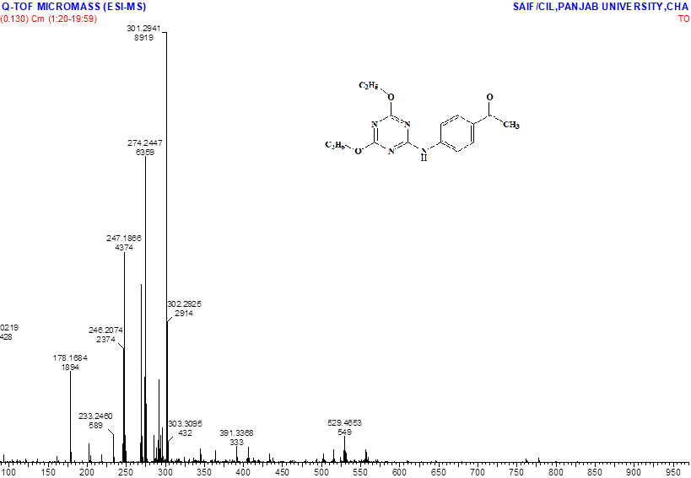

¹H NMR (4) : 1-(4-(4,6-diethoxy-1,3,5-triazin-2-ylamino)phenyl)ethanone
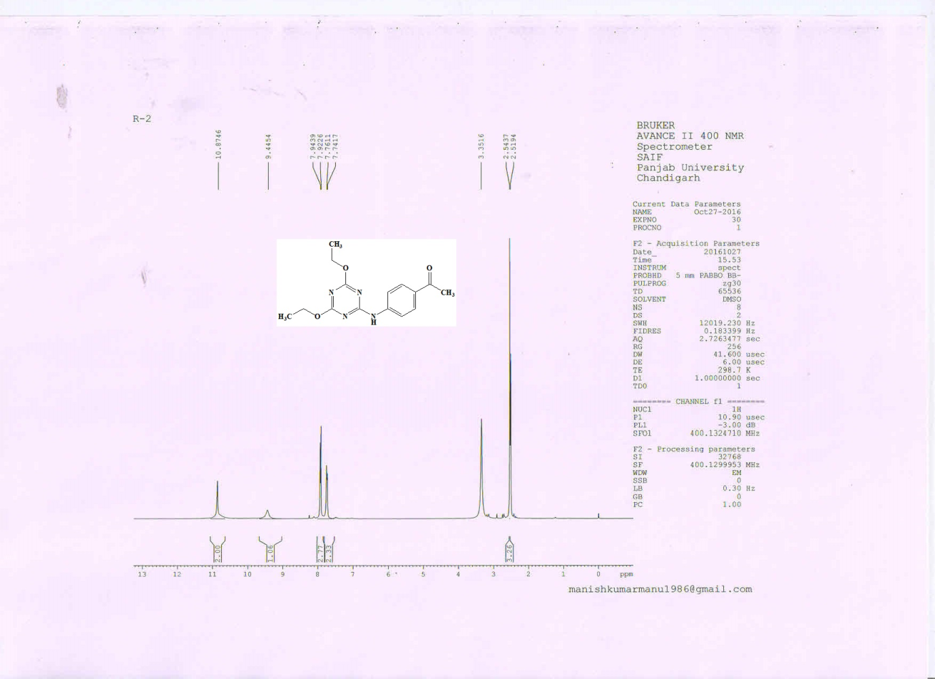

Spectra: IR (6g): 1-(4-(4,6-diethoxy-1,3,5-triazin-2-ylamino)phenyl)-3-(4-chloro phenyl) prop-2-en-1-one
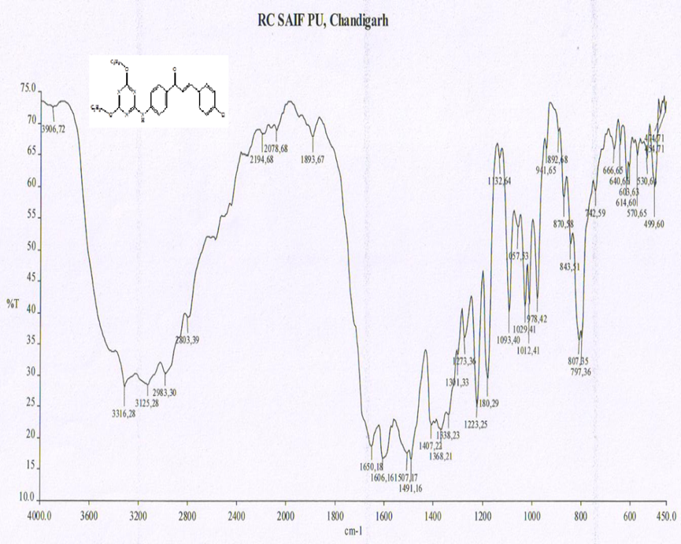

¹H NMR (6g): 1-(4-(4,6-diethoxy-1,3,5-triazin-2-ylamino)phenyl)-3-(4-chloro phenyl) prop-2-en-1-one
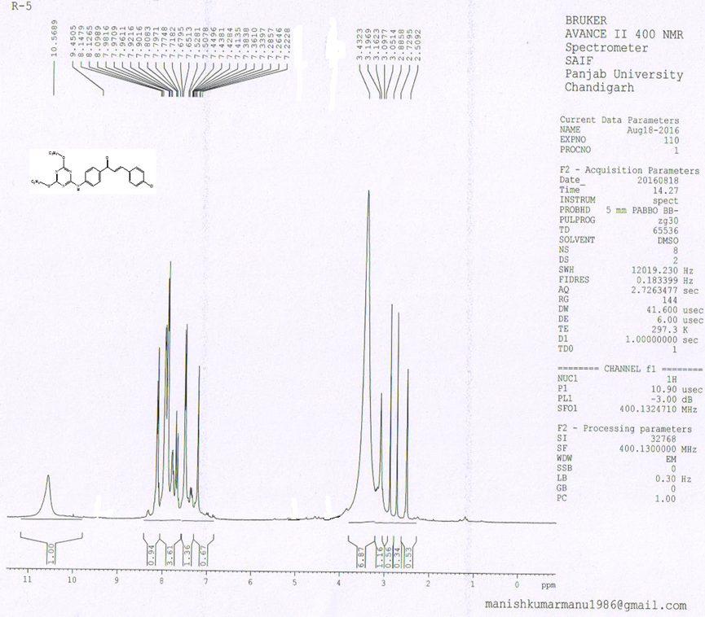

Mass (6g): 1-(4-(4,6-diethoxy-1,3,5-triazin-2-ylamino)phenyl)-3-(4-chloro phenyl) prop-2-en-1-one
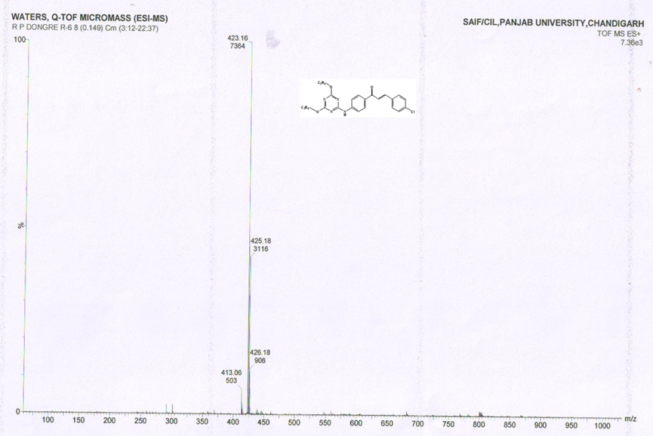

Spectra: IR (7a) N-(4-(2-amino-6-p-tolylpyrimidin-4-yl)phenyl)-4,6-diethoxy-1,3,5-triazin-2-amine
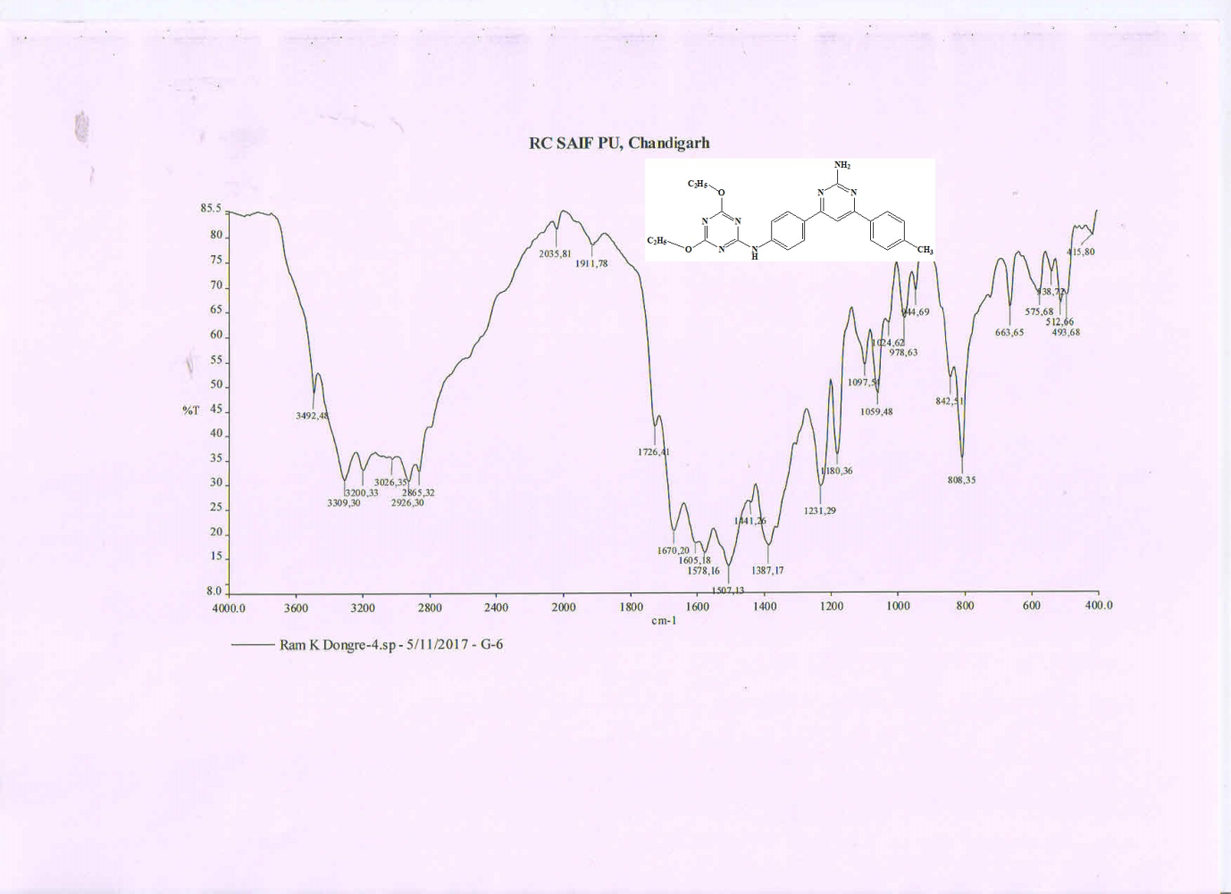

Spectra: ¹H NMR (7a) N-(4-(2-amino-6-p-tolylpyrimidin-4-yl)phenyl)-4,6-diethoxy-1,3,5-triazin-2-amine
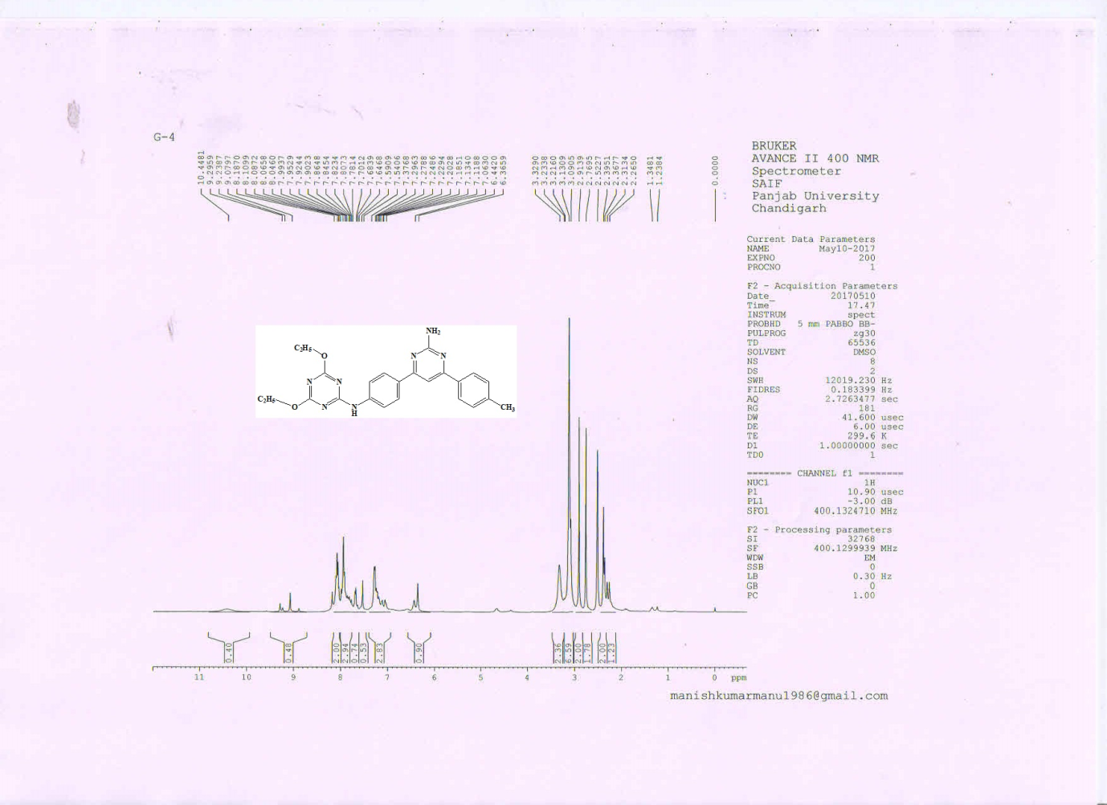

Spectra: ¹³C NMR (7a) N-(4-(2-amino-6-p-tolylpyrimidin-4-yl)phenyl)-4,6-diethoxy-1,3,5-triazin-2-amine
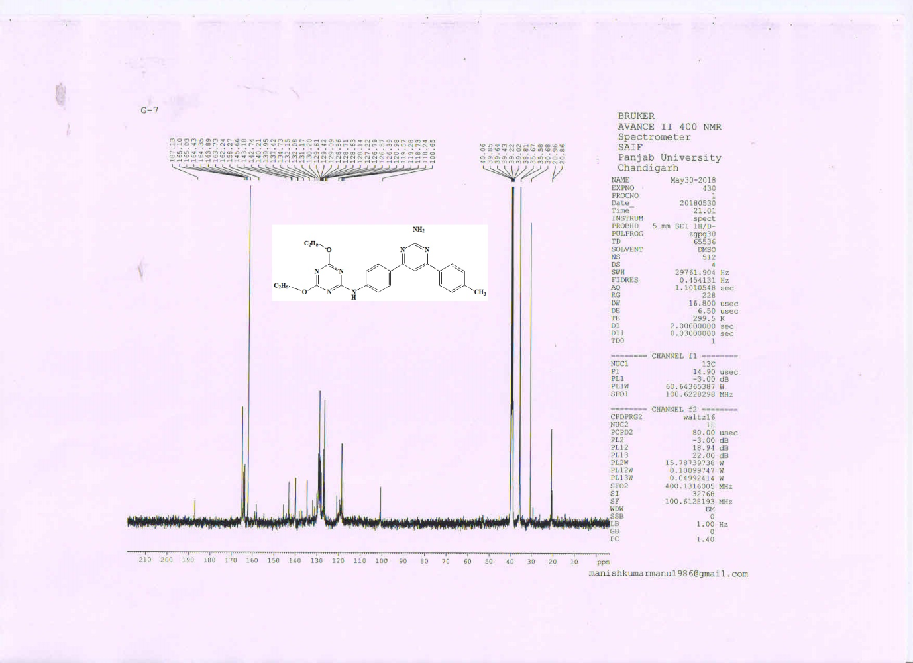

Spectra: Mass (7a): N-(4-(2-amino-6-p-tolylpyrimidin-4-yl)phenyl)-4,6-diethoxy-1,3,5-triazin-2-amine
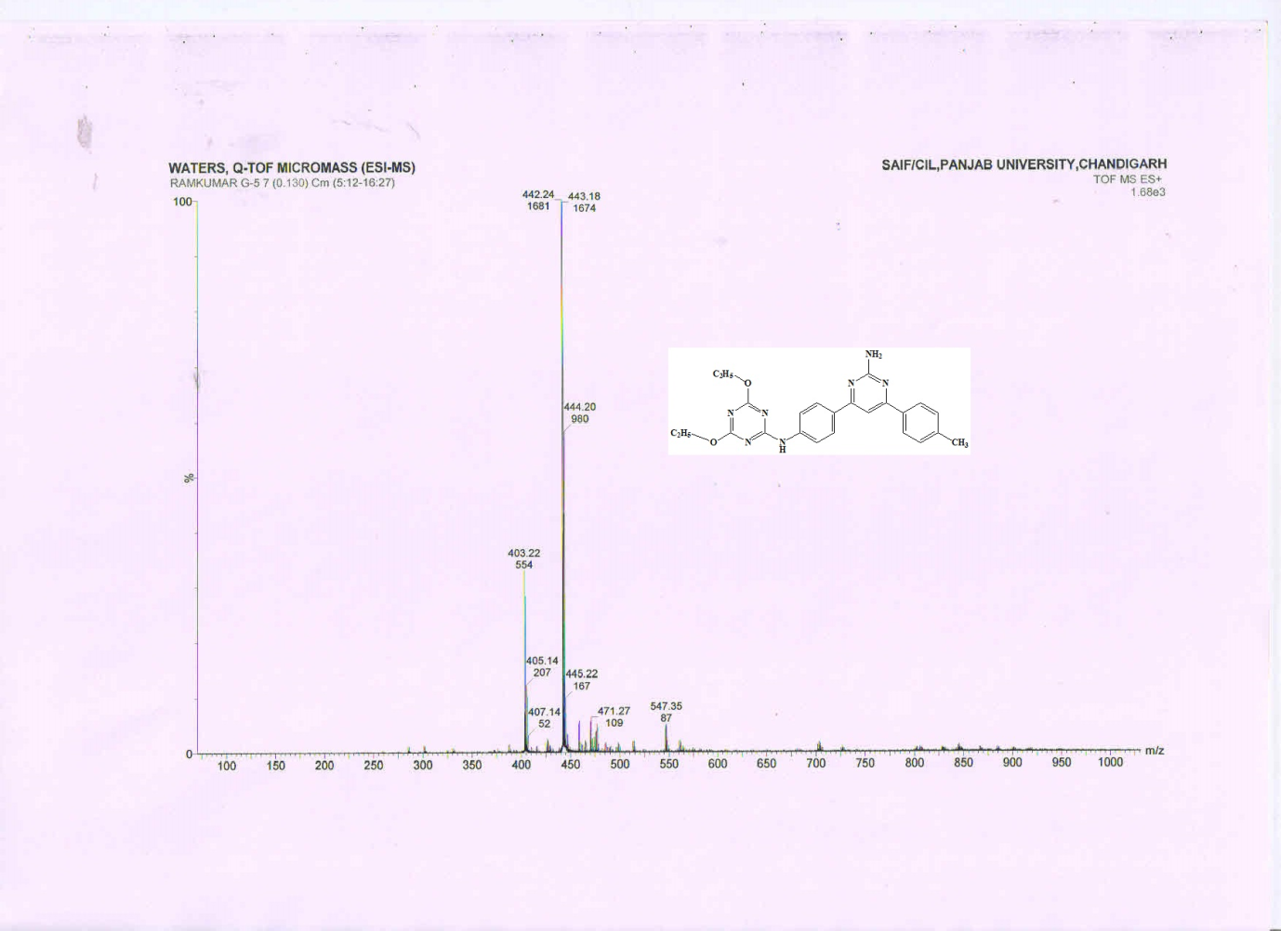

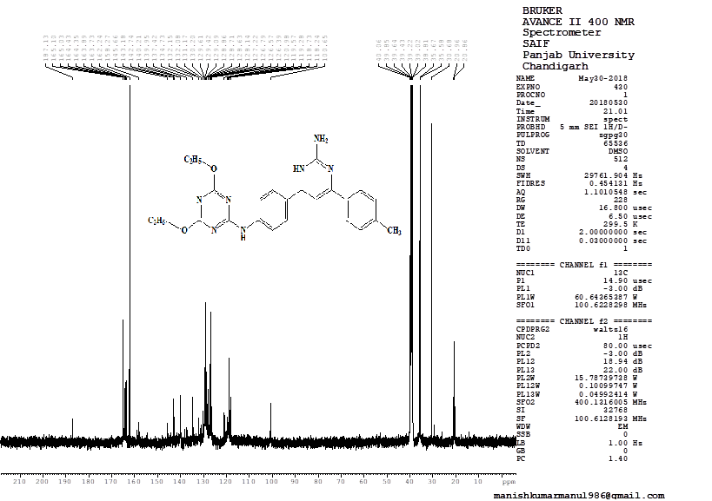

Biological activity
Antimicrobial activity
The newly synthesized compounds were screened for anti-bacterial activity against the species like E. coli, Salmonella typhi and Staphylococcus aureus the method used was disc diffusion method for antibacterial activity. the standard drugs used was Penicillin and anti-fungal activity has done against by using species like Aspergillus niger, Aspergillus flavus, Penicillium chrysogenum.the method used was poison plate method using Griseofulvin as a standard drugs and solvent was DMSO. The anti-bacterial study shows that very few of the compounds were shows significant property while majority of the compounds shows the moderately active. The study of anti-fungal activity shows that some of the compounds have promising activity while some of them show no antifungal activity.
Table 1: Antibacterial screening results of the compounds (7a-7h).
S. No. | Compounds | E. coli | Salmonella typhi | Staphylococcus aureus
1 | 7a | 12 | 14 | 16
2 | 7b | 17 | 18 | 17
3 | 7c | 19 | 17 | 27
4 | 7d | 17 | 19 | 30
5 | 7e | 19 | 20 | 31
6 | 7f | 15 | 16 | 21
7 | 7g | 14 | 15 | 19
8 | 7h | 20 | 21 | 26
9 | Penicillin | 22 | 25 | 35
10 | DMSO | -ve | -ve | -ve
Table 2: Antifungal screening results of the compounds (7a-7h).
S. No. | Compounds | Aspergillus niger | Aspergillus flavus | Penicillium chrysogenum
1 | 7a | +ve | RG | +ve
2 | 7b | -ve | -ve | -ve
3 | 7c | -ve | -ve | -ve
4 | 7d | -ve | -ve | -ve
5 | 7e | -ve | -ve | -ve
6 | 7f | RG | +ve | RG
7 | 7g | +ve | -ve | -ve
8 | 7h | -ve | -ve | -ve
9 | Greseofulvin | -ve | -ve | -ve
10 | DMSO | +ve | +ve | +ve
-ve: No growth Antifungal activity present; +ve: Growth Antifungal activity absent; RG: Reduced growth

