Effect of different alkaline activators on geopolymers
Fig. 1 shows the compressive strength of VA-BFS based geopolymers activated with various combinations of Na₂SiO₃ and NaOH, with 50% BFS. When only 0.5 M Na₂SiO₃, the high compressive strength of the geopolymers at 55.60 MPa was obtained. While with only 0.5 M NaOH, the geopolymers obtained a lower compressive strength of 10.26 MPa. The compressive strength of 50% BFS geopolymer system decreases with increasing alkaline activator NaOH, which indicates the irreplaceable role of Na₂SiO₃ in alkaline activator. The mechanical properties of geopolymers are related to the type and amount of alkaline-based initiator.
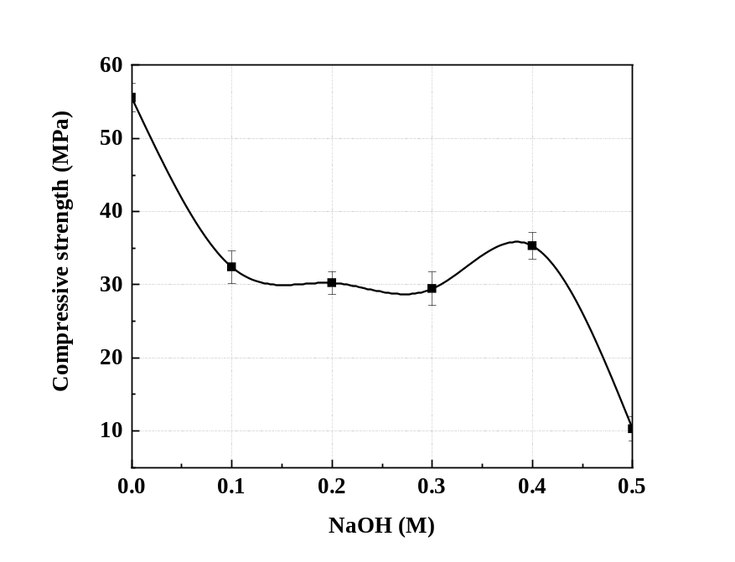
Fig. 1. Compressive strength of VA-BFS based geopolymers activated with various combinations of Na₂SiO₃ and NaOH (No. 9–14).
Fig. 2 shows the SEM images of VA-BFS based geopolymers synthesized by activation with different combinations of Na₂SiO₃ and NaOH, with 50% BFS. In the presence of alkaline activator of 0.5 M NaOH, the presence of unreacted particle agglomerates and increased pores were observed, which suggests the formation of less geopolymer gel, and results in low compressive strength. With 0.5 M Na₂SiO₃ as activator, geopolymers was observed the surface relatively smooth, and trace amounts of unreacted particles on the geopolymers gel, indicating that Na₂SiO₃ plays a role in the dissolution of the raw aluminosilicate (Fig. 7). Compared with geopolymer synthesized with different amounts of Na₂SiO₃ and NaOH as activator (Fig. 7), Na₂SiO₃ was found to play a role in geopolymer gel formation and aluminosilicate dissolution in in activating VA-BFS raw materials.
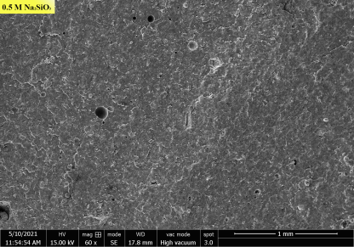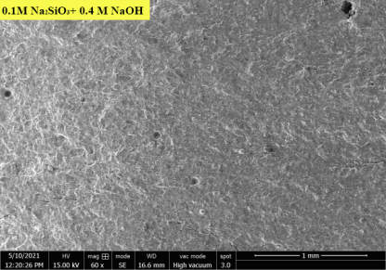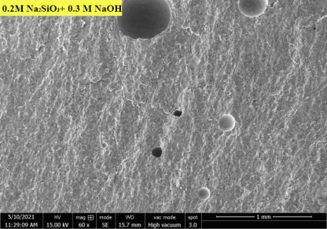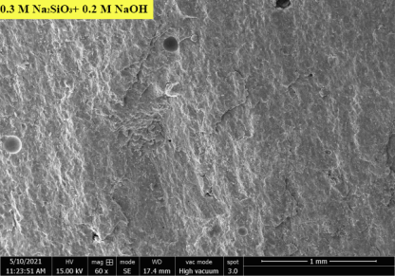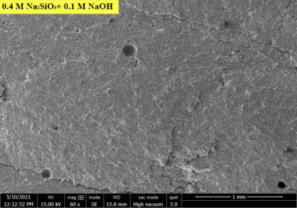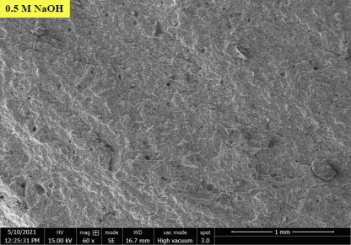
Fig. 2. SEM images of the geopolymers activated with various Na₂SiO₃ and NaOH.

Effect of different water content on geopolymers
Fig. 3 shows the compressive strength of VA-BFS based geopolymers synthesized with different water content. The minimum water content for inducing sufficient mixing during synthesis was 4 M. When the water content was increased to 6 M, the compressive strength of the geopolymer was optimum. As the water content continues to increase, the compressive strength of the geopolymers decreased. Geopolymers could not be formed when the water content of 9 M. Proper water content was conducive to the formation of gel, which was consistent with the fact that the optimal water-solid ratio is conducive to the formation of geopolymer gel.
Fig. 4 shows the SEM images of VA-BFS based geopolymers synthesized with water contents of 4~8 M. Homogeneous geopolymer gels were observed at water content of 6 M, but cracks were observed at water contents of 4 and 5 M, which may be attributed to the shrinkage effect of the hardening process of geopolymers with low water content. When the water content increased to 7 and 8 M, it was observed a small amount of cracks and unreacted particles, which may be attributed to the evaporation of residual water. Therefore, water content affects the formation of VA-based geopolymers, as it in small or excessive amounts leads to the formation of cracks and porous structures and lowers the compressive strength. This is consistent with the report that water content affects the formation of gel precursors in geopolymers and effect the mechanical properties and microstructure.
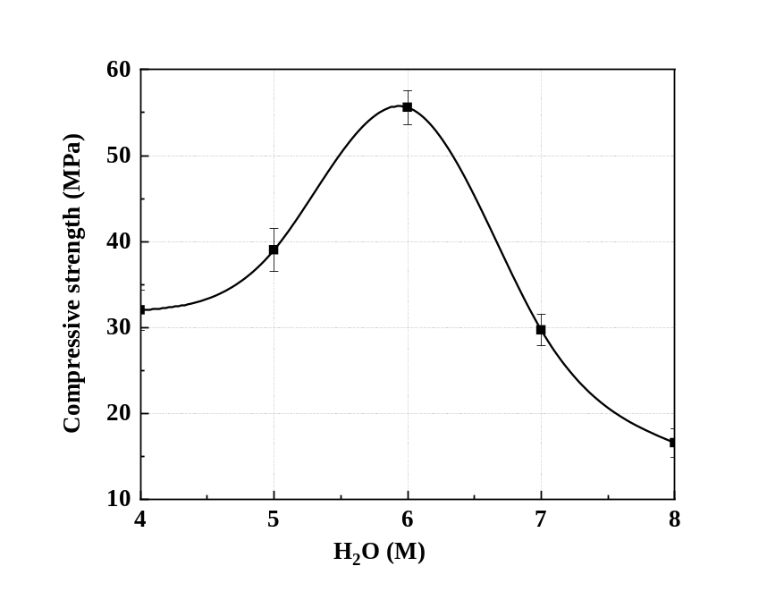
Fig. 3. Compressive strength of VA-BFS based geopolymers synthesized with water contents of 4~8 M (No.17–21).

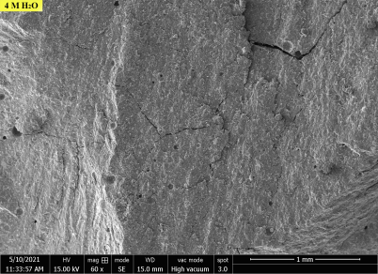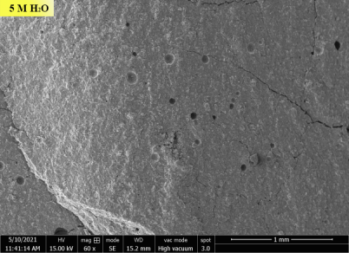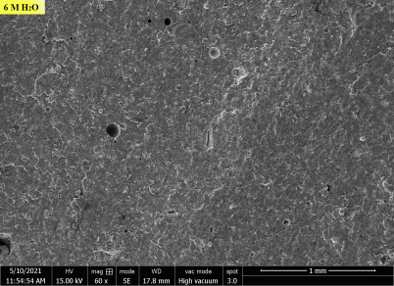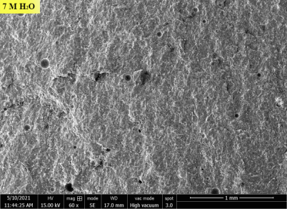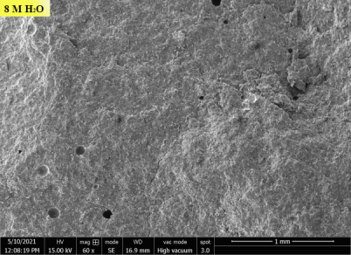
Fig. 4. SEM images of VA-BFS based geopolymers synthesized with water contents of 4~8 M.

