Supplementary Information for

Novel inhibition of AKR1C3 and androgen receptor axis by PTUPB synergizes enzalutamide treatment in advanced prostate cancer

Joy C. Yang, Pengfei Xu, Shu Ning, Logan J. Wasielewski, Hans Adomat, Sung Hee Hwang, Christophe Morissea, Martin Gleave, Eva Corey, Allen C. Gao, Primo Lara, Christopher P. Evans, Bruce D. Hammock, Chengfei Liu*

*Corresponding author: Chengfei Liu
Email: cffliu@ucdavis.edu

This PDF file includes:
Figures S1 to S6
Tables S1 to S2

Figure S1

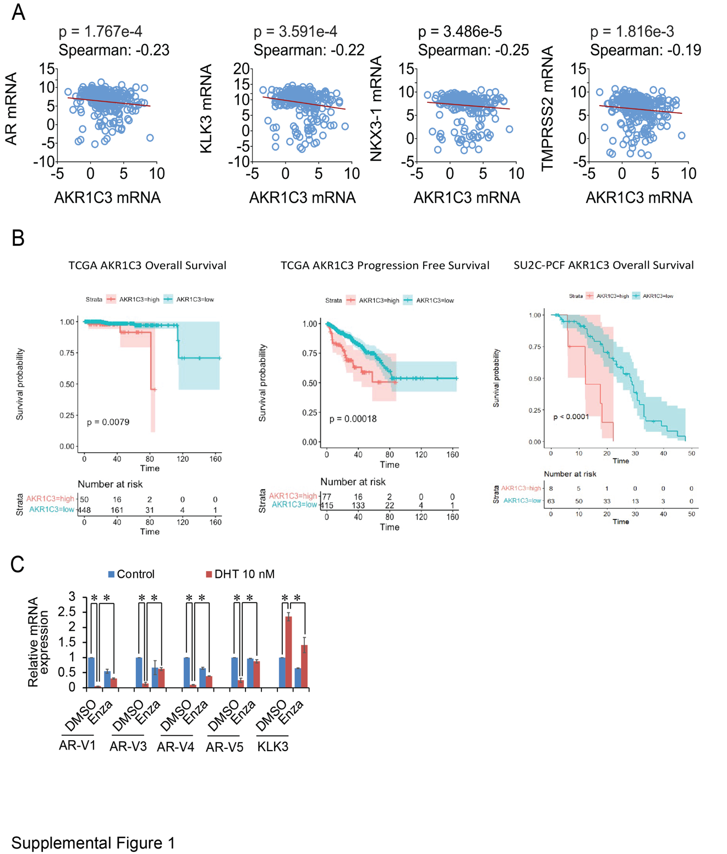

Figure S1. AR negative regulates AKR1C3 expression. A. The gene expression data from SU2C-PCF database was extracted and AR, KLK3, NKX3-1, TMPRSS2 and AKR1C3 correlations were determined by Spearman correlation. B. Kaplan-Meier analysis of AKR1C3 for the overall survival or progression free survival in TCGA and SU2C-PCF cohorts. C. VCaP cells were treated with 10 nM DHT, with or without 20 M Enza for 5 days, and mRNA expression of AR-V1, AR-V3, AR-V4, AR-V5 and KLK3 were examined by qRT-PCR. * p<0.05

Figure S2

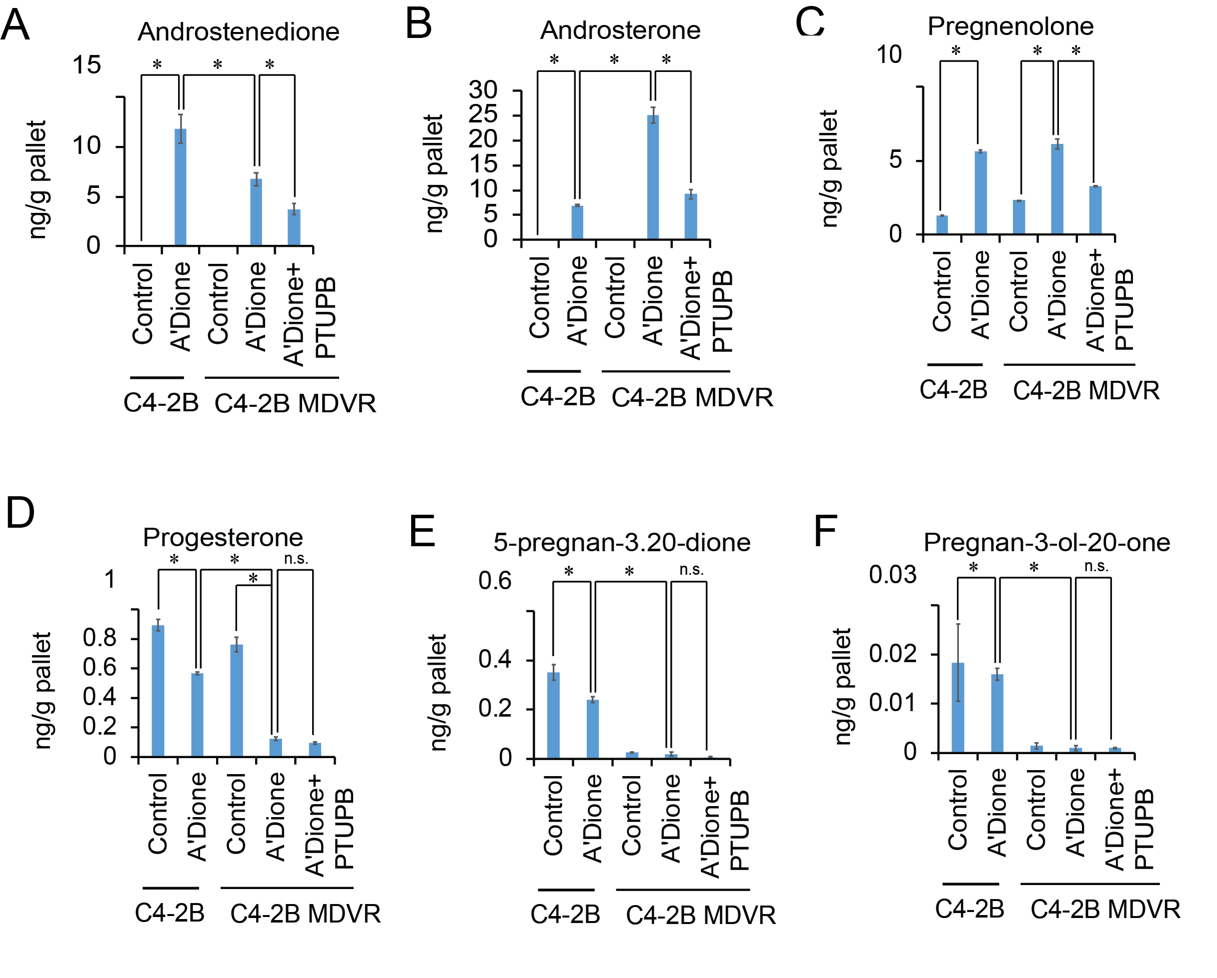

Figure S2. PTUPB affects intracrine steroid biosynthesis. A-F. The represented steroid metabolites (A’Dione, androsterone, Pregnenolone, Progesterone, 5-pregnan-3,20-dione and Pregnan-3-ol-20-one) between C4-2B parental and C4-2B MDVR cells were measured by LC-MS and quantified by Quanlynx. *p<0.05

Figure S3

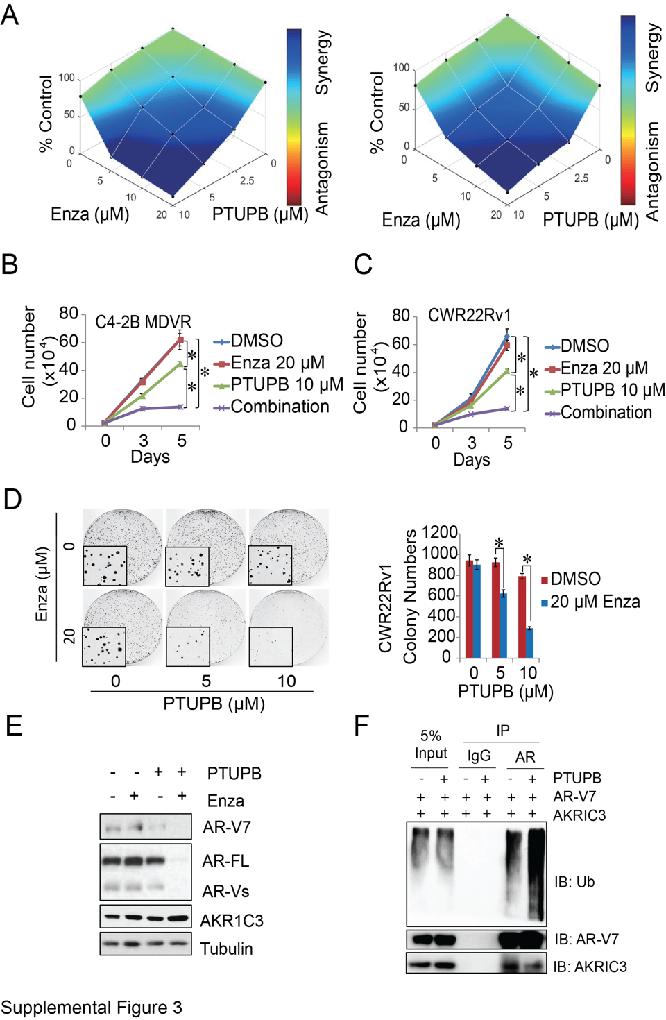

Figure S3. PTUPB synergizes enzalutamide treatment. A. CWR22Rv1 and C4-2B AbiR cells were treated with different concentrations of PTUPB with or without different concentrations of Enza; the drug synergy distribution map was generated by Combenefit. B. C4-2B MDVR cells were treated with 10 µM PTUPB with/without 20 µM Enza. Total cell numbers were determined at 3 and 5 days. C. CWR22Rv1 cells were treated with 10 µM PTUPB with/without 20 µM Enza. Total cell numbers were determined at 3 and 5 days. D. CWR22Rv1 cells were treated with DMSO, PTUPB (5 and 10 µM) with/without 20 µM Enza, the colony formation ability was examined by clonogenic assay, and the colony numbers were determined. E. CWR22Rv1 cells were treated with DMSO, 20 µM PTUPB with/without 20 µM Enza, then whole cell lysate was extracted and subjected to western blot. F. AR-V7 and AKR1C3 plasmids were transfected in 293 cells and then treated using 20 µM PTUPB with MG132 overnight. Total cell lysates were immunoprecipitated with anti-AR antibody (441) and immunoblotted with anti-Ub, AKR1C3 and AR-V7 antibodies. Enza: enzalutamide * p<0.05

Figure S4

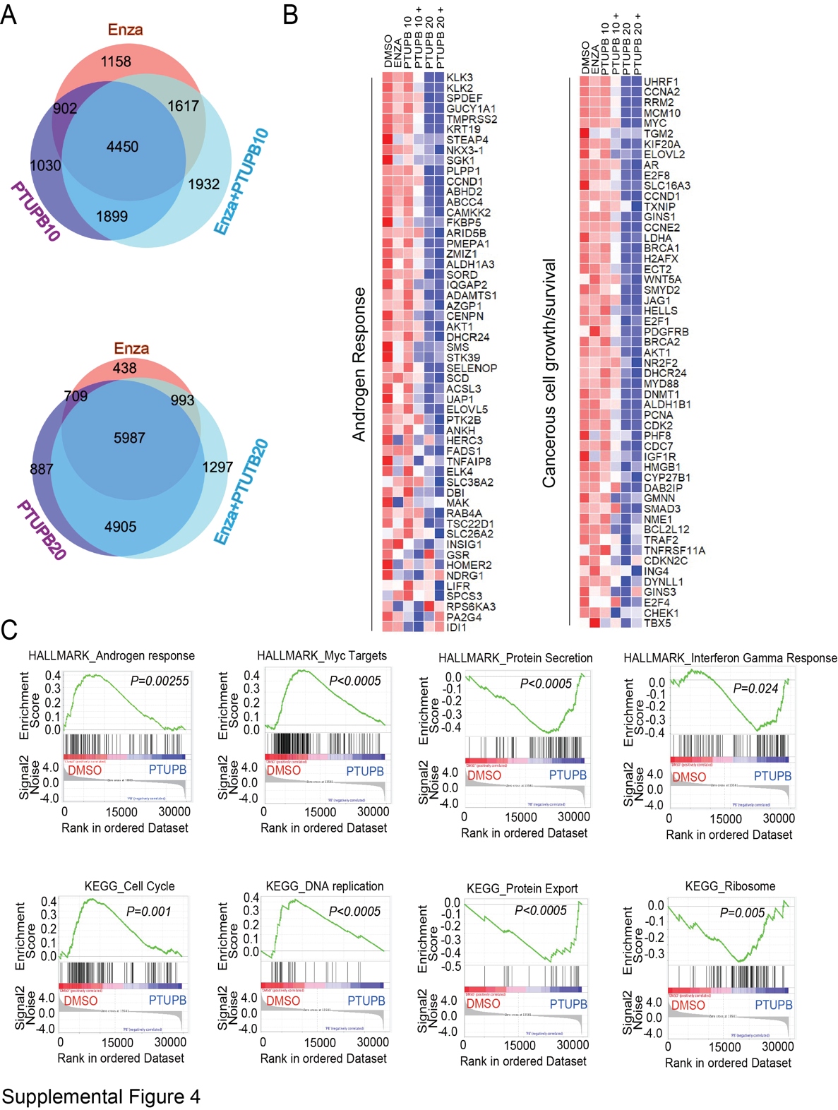

Figure S4. PTUPB and Enza combination treatment synergizes gene signature regulation. A. Venn diagram of total regulated gene numbers analyzed from RNA sequence data by three comparisons: PTUPB (10 µM or 20 µM) vs. DMSO, Enza vs. DMSO, and PTUPB+Enza vs. DMSO in C4-2B MDVR cells (FPKM>1 and fold change>1.2). B. Androgen response genes and cell growth/survival genes that were altered in expression are displayed. C. Top regulated Hall Mark and KEGG gene signature plots in C4-2B MDVR cells treated with PTUPB were analyzed by GSEA.

Figure S5

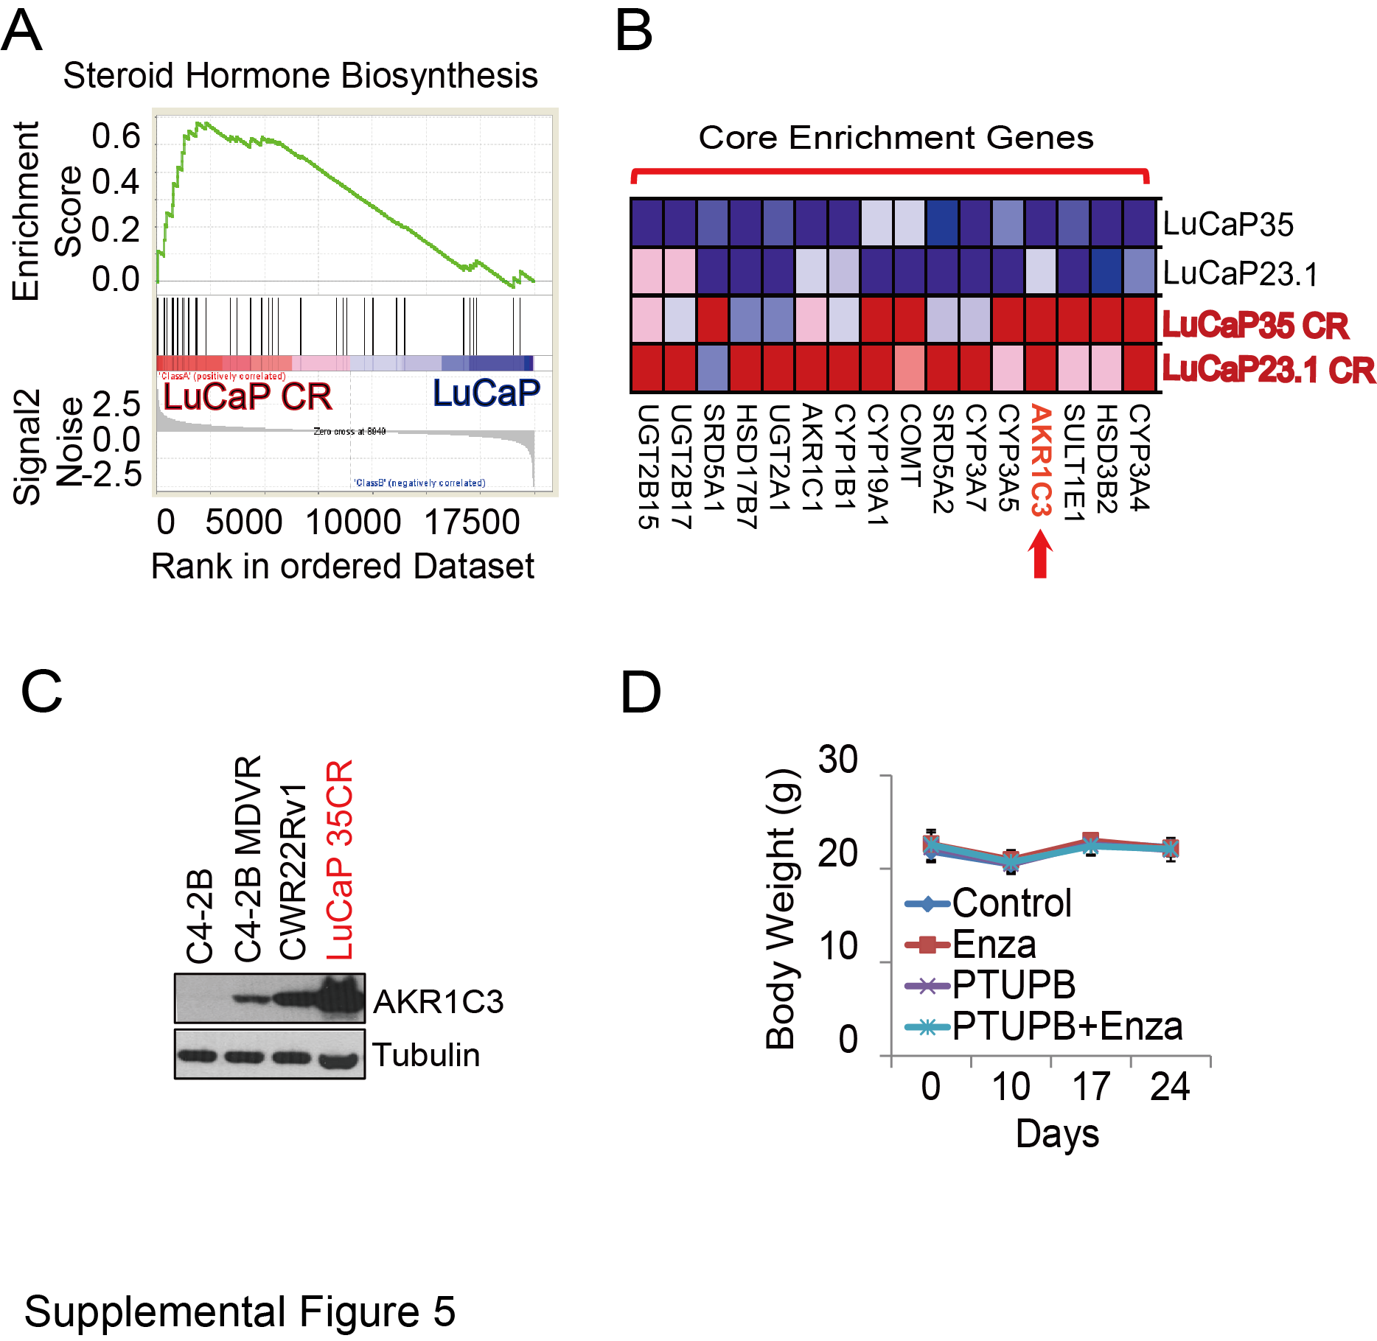

Figure S5. AKR1C3 in LuCaP35CR model. A. Gene expression data from LuCaP23.1, LuCaP35, LuCaP23.1CR and LuCaP35CR were analyzed, and steroid hormone biosynthesis gene set was enriched by GSEA. B. The Core enrichment genes in steroid hormone biosynthesis gene set. C. Whole cell lysates from C4-2B, C4-2B MDVR, CWR22Rv1 cells and LuCaP35CR tumor were extracted and subjected to western blot. D. Body weight from VCaP tumor buried mice was calculated.

Figure S6

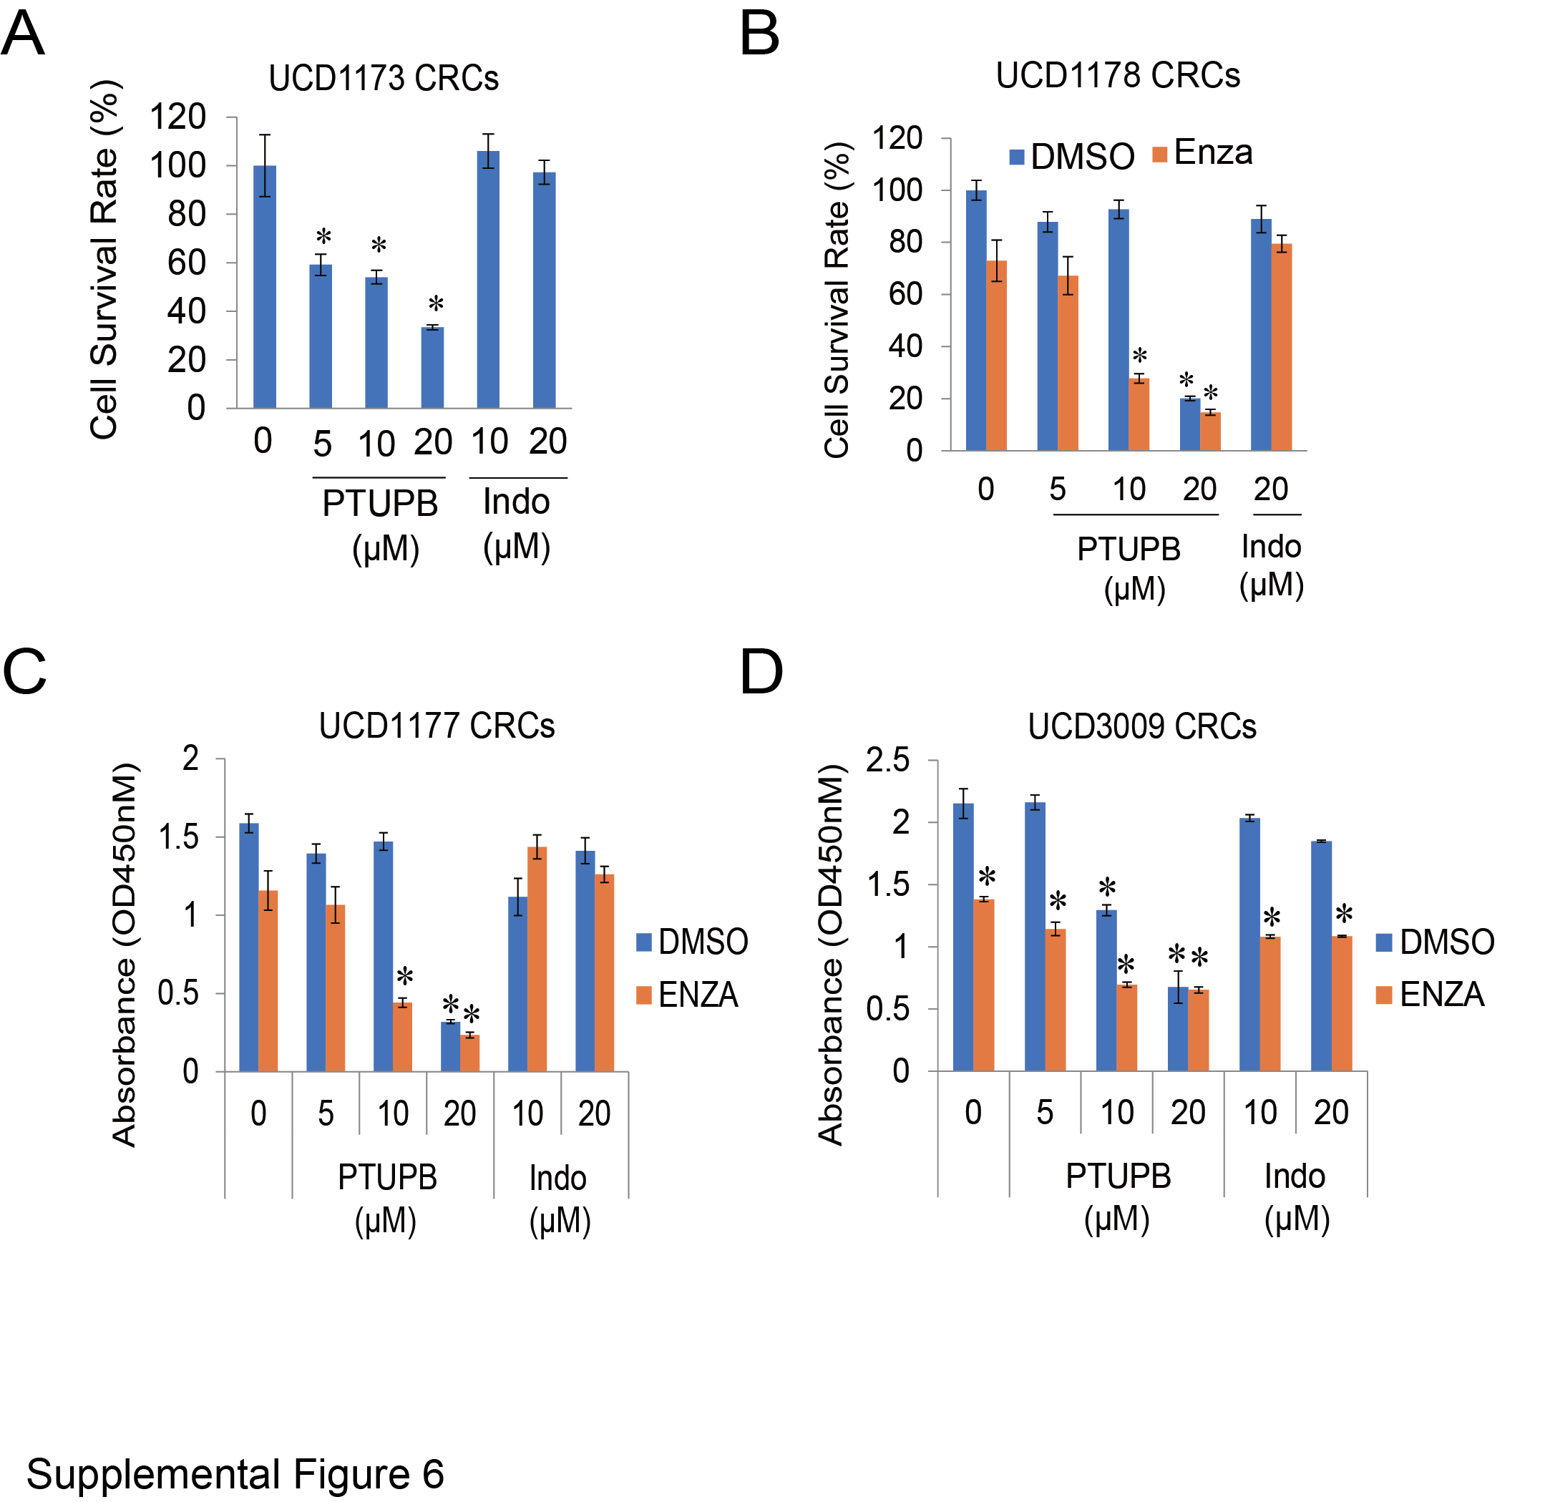

Figure S6. PTUPB suppresses the growth of patient derived xenograft tumor cells. A. UCD1173 CRC cells were treated with different concentrations of PTUPB or Indocin for 3 days. The cell survival rate was determined. B-C. UCD1177, UCD1178 and UCD3009 CRC cells were treated with different concentrations of PTUPB or Indocin with/without Enza for 3 days. The cell survival rate was determined. Indocin: indomethacin, Enza: enzalutamide * p<0.05.

Table S1. Dosage inhibitory effects of both PTUPB and Enzalutamide (Enza) on the proliferation of drug resistant cells
Cell line | PTUPB (μM) | Enza (μM) | Growth inhibitory effect |  |  | CDI | CI
Cell line | PTUPB (μM) | Enza (μM) | PTUPB | Enza | PTUPB+Enza | CDI | CI
 | 0 | 0 | 1.00 | 1.00 | 1.00 | 1.00 | 1.00
C4-2B MDVR | 2.5 | 5 | 0.93 | 1.00 | 0.84 | 0.90 | 0.67
C4-2B MDVR | 2.5 | 10 | 0.93 | 0.94 | 0.68 | 0.77 | 0.59
C4-2B MDVR | 2.5 | 20 | 0.93 | 0.91 | 0.62 | 0.73 | 0.95
C4-2B MDVR | 5 | 5 | 0.86 | 1.00 | 0.68 | 0.79 | 0.53
C4-2B MDVR | 5 | 10 | 0.86 | 0.94 | 0.54 | 0.67 | 0.56
C4-2B MDVR | 5 | 20 | 0.86 | 0.91 | 0.39 | 0.50 | 0.78
C4-2B MDVR | 10 | 5 | 0.76 | 1.00 | 0.22 | 0.29 | 0.22
C4-2B MDVR | 10 | 10 | 0.76 | 0.94 | 0.18 | 0.25 | 0.33
C4-2B MDVR | 10 | 20 | 0.76 | 0.91 | 0.14 | 0.20 | 0.56
C4-2B AbiR | 2.5 | 5 | 0.97 | 1.00 | 0.81 | 0.83 | 0.43
C4-2B AbiR | 2.5 | 10 | 0.97 | 0.99 | 0.63 | 0.66 | 0.39
C4-2B AbiR | 2.5 | 20 | 0.97 | 0.98 | 0.57 | 0.60 | 0.59
C4-2B AbiR | 5 | 5 | 0.91 | 1.00 | 0.63 | 0.69 | 0.42
C4-2B AbiR | 5 | 10 | 0.91 | 0.99 | 0.50 | 0.56 | 0.43
C4-2B AbiR | 5 | 20 | 0.91 | 0.98 | 0.33 | 0.37 | 0.49
C4-2B AbiR | 10 | 5 | 0.79 | 1.00 | 0.19 | 0.24 | 0.24
C4-2B AbiR | 10 | 10 | 0.79 | 0.99 | 0.15 | 0.19 | 0.27
C4-2B AbiR | 10 | 20 | 0.79 | 0.98 | 0.12 | 0.16 | 0.37
CWR 22Rv1 | 2.5 | 5 | 0.93 | 0.96 | 0.58 | 0.65 | 0.15
CWR 22Rv1 | 2.5 | 10 | 0.93 | 0.87 | 0.53 | 0.65 | 0.21
CWR 22Rv1 | 2.5 | 20 | 0.93 | 0.82 | 0.33 | 0.44 | 0.18
CWR 22Rv1 | 5 | 5 | 0.90 | 0.96 | 0.51 | 0.60 | 0.15
CWR 22Rv1 | 5 | 10 | 0.90 | 0.87 | 0.35 | 0.44 | 0.12
CWR 22Rv1 | 5 | 20 | 0.90 | 0.82 | 0.28 | 0.38 | 0.15
CWR 22Rv1 | 10 | 5 | 0.82 | 0.96 | 0.38 | 0.48 | 0.12
CWR 22Rv1 | 10 | 10 | 0.82 | 0.87 | 0.26 | 0.37 | 0.10
CWR 22Rv1 | 10 | 20 | 0.82 | 0.82 | 0.16 | 0.24 | 0.09

Table S2. Primer list for q-PCR

 | Forward | Reverse
AR-V1 | AACAGAAGTACCTGTGCGCC | TGAGACTCCAAACACCCTCA
AR-V3 | TGGATGGATAGCTACTCCGG | GTTCATTCTGAAAAATCCTTCAGC
AR-V4 | AACAGAAGTACCTGTGCGCC | TTCTGTCAGTCCCATTGGTG
AR-V7 | AACAGAAGTACCTGTGCGCC | TCAGGGTCTGGTCATTTTGA
AR-V9 | TGCGCCAGCAGAAATGATTG | GCAGCTGCTCAGGTAAGTTG
AR-FL | AAGCCAGAGCTGTGCAGATGA | TGTCCTGCAGCCACTGGTTC
KLK3 | GCCCTGCCCGAAAGG | GATCCACTTCCGGTAATGCA
FKBP5 | GGGAAGATAGTGTCCTGGTTAG | GCAGTCTTGCAGCCTTATTC
NKX3-1 | CCGAGACGCTGGCAGAGACC | GCTTAGGGGTTTGGGGAAG
UBE2C | TGGTCTGCCCTGTATGATGT | AAAAGCTGTGGG GTTTTTCC
ACTIN | AGAACTGGCCCTTCTTGGAGG | GTTTTTATGTTCCTCTATGGG
AKR1C3 Enhancer set1 | AGCTTGAGTGACTGAGCAATAA | TCTCTGCTGTATTAGAGACATTTCC
AKR1C3 Enhancer set2 | GGCAAGGAACTGCAGAACTA | CACCTGGCTCTGTTGGTTTA
AKR1C3 Enhancer set3 | AGTTCCTTGCCAAGCTTCA | TGGGACAACTTGGAAACCTG

