Supplementary Materials for

Immunobiology of a rationally-designed AAV2 capsid following intravitreal delivery in mice

Michael Whitehead*, Andrew Sage, Andrew Osborne, Patrick Yu-Wai-Man and Keith R Martin

*Corresponding author. Email: michael1993whitehead@gmail.com

Fig. S1.

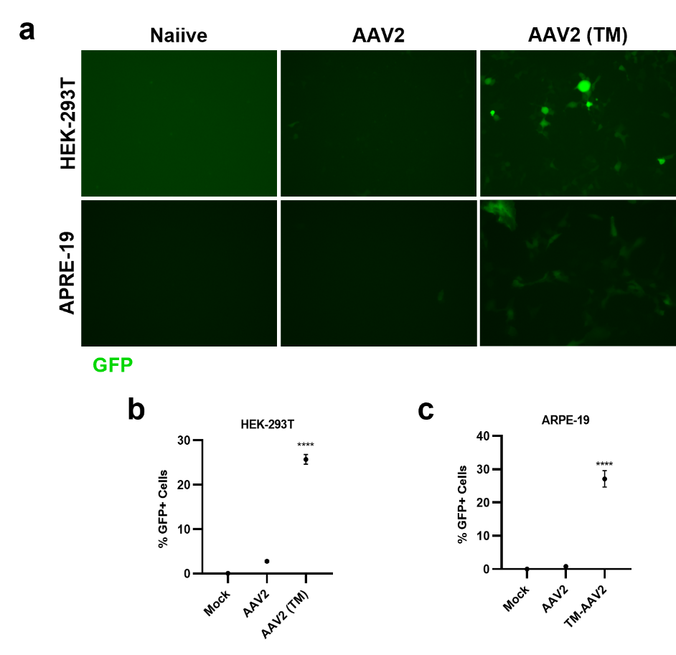

Fig. S1 - Transduction of AAV2 (TM) in vitro. (a) Representative images of GFP expression levels following a 24h incubation with the triple phosphodegron mutant AAV2 and WT AAV2 and Mock (DMEM-only). Here, 5E7 VP/mL was used for the HEK-293T cell line, 2E8 VP/mL for the ARPE-19 cell line. (b & c) Flow cytometry analysis of GFP expression in (b) HEK-293T cells and (c) ARPE-19 cells. A two-tailed Student’s t-test was used to assess statistical significance between groups. **** = p < 0.0001.
Fig. S2

Fig. S2.
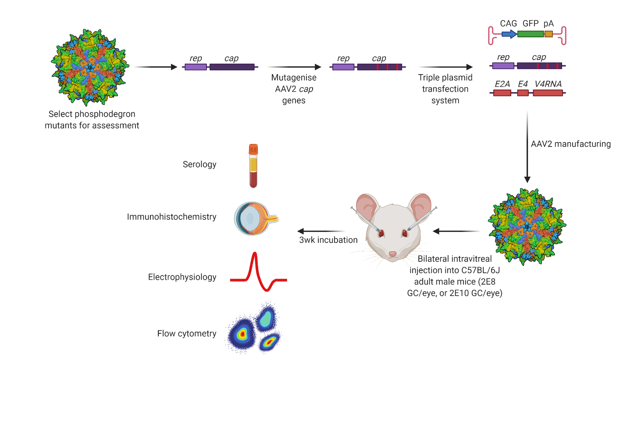
Fig. S2 – Phosphodegron mutations were selected for assessment and introduced into AAV2 capsids. Mice were injected bilaterally with 2E8 VG/eye. After three weeks, samples were collected for assessment after ERG.

