Figures and Tables

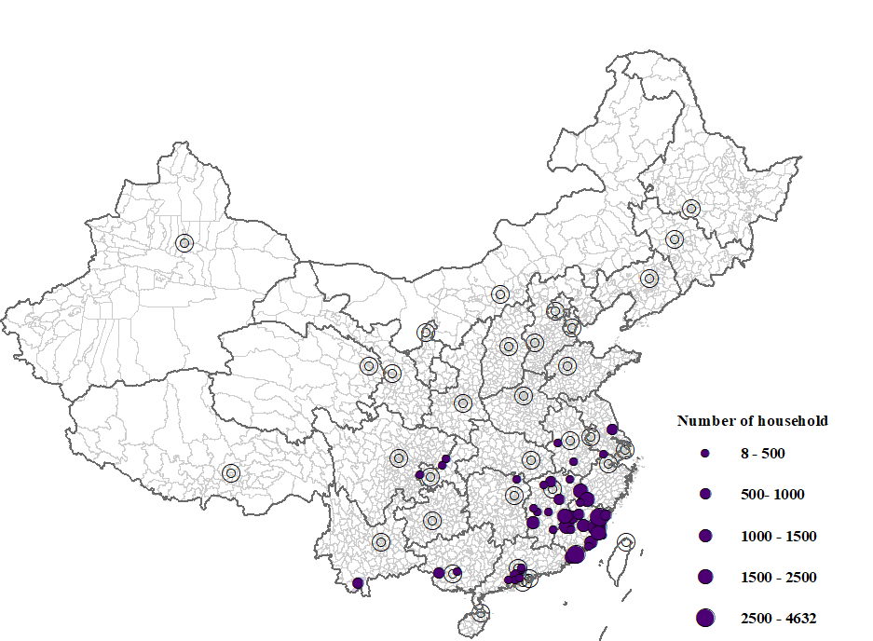

Figure 1: Location of households in dataset

Notes: The represented provinces are Anhui, Chongqing, Fujian, Guangdong, Guangxi, Hunan, Jiangsu, Jiangxi, Zhejiang, Yunnan.

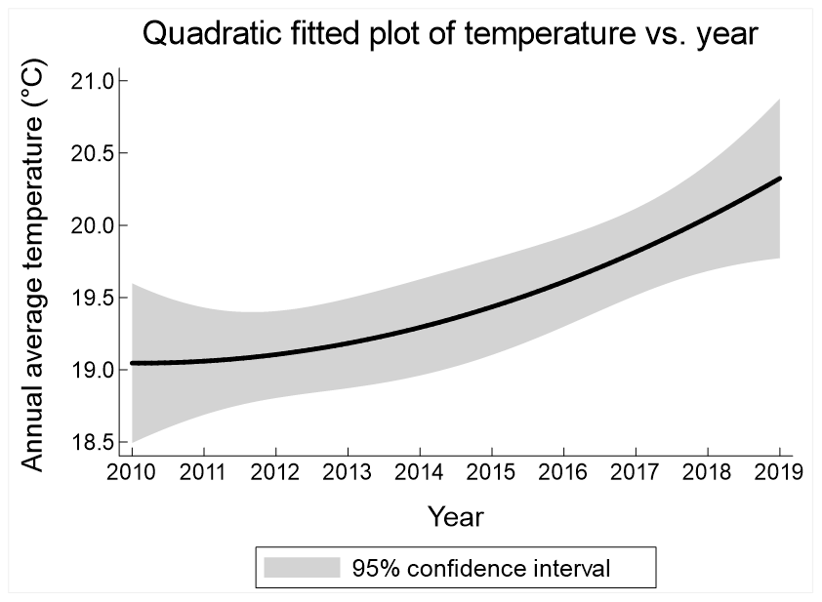
(a)
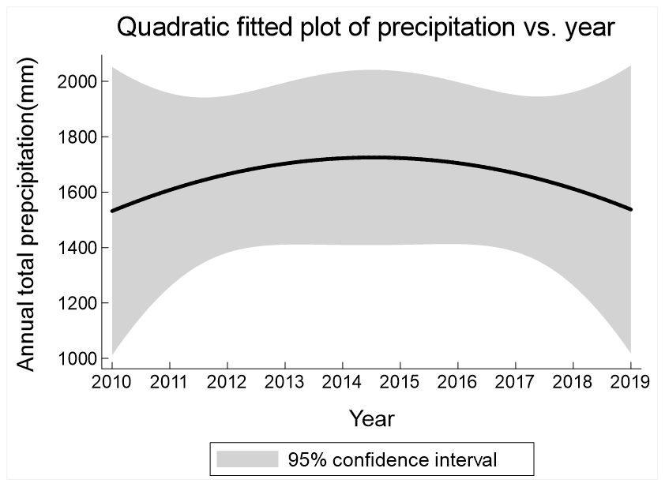
(b)

Figure 2: Quadratic fitted plots of weather variables against year (panel (a) for temperature and panel(b) for precipitation)

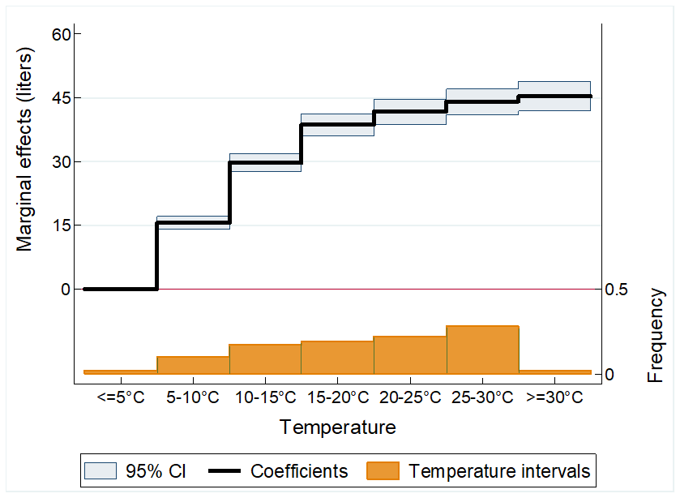

Figure 3: Baseline results of temperature intervals with respect to household water usage

Notes: This figure shows the estimated coefficients and their 95% confidence bars of each temperature interval on water usage. The omitted temperature interval is <5 °C, and so that the estimated coefficients of other temperature intervals are interpreted in relation to this omitted reference group (Full results in Table S1).

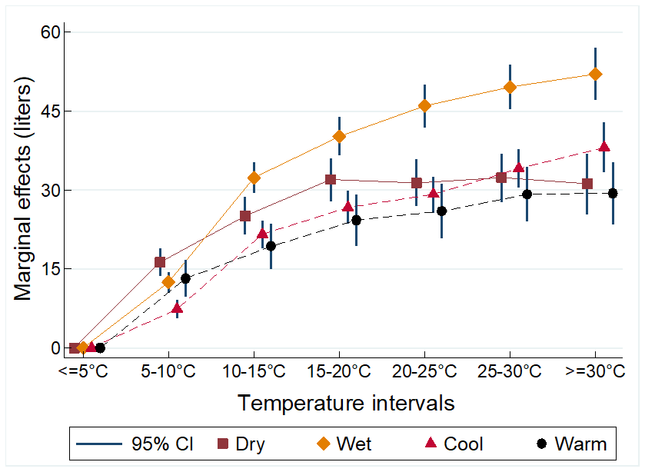

Figure 4: Heterogeneity results of temperature intervals with respect to household water usage (by underlying climatic conditions)

Notes: This figure shows the estimated coefficients and their 95% confidence bars of each temperature interval on water usage. The omitted temperature interval is <5 °C, and so that the estimated coefficients of other temperature intervals are interpreted in relation to this omitted reference group (full results in Table S3). For easier comparisons, the two solid lines represent “Dry” and “Wet” cities whereas the two dotted lines represent “Cool” and “Warm”.

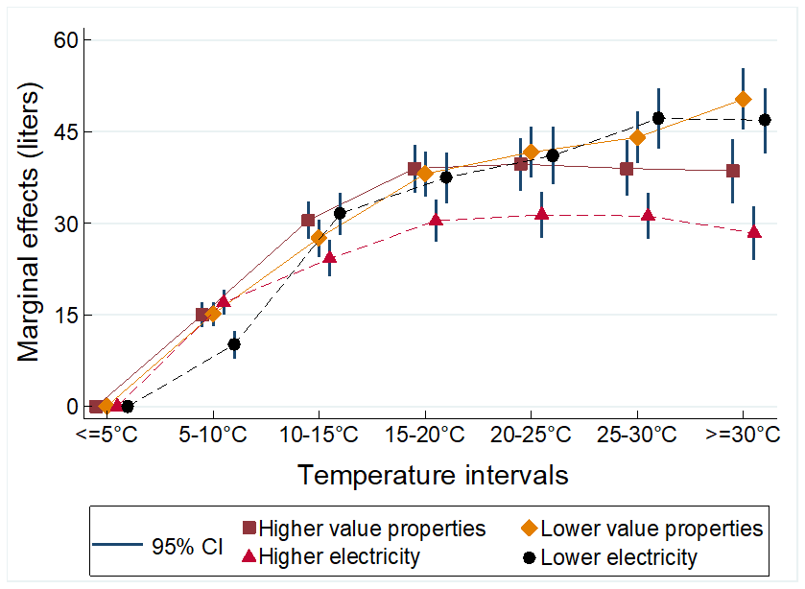

Figure 5: Heterogeneity results of temperature intervals with respect to household water usage (by underlying socioeconomic conditions)

Notes: This figure shows the estimated coefficients and their 95% confidence bars of each temperature interval on water usage. The omitted temperature interval is <5 °C, and so that the estimated coefficients of other temperature intervals are interpreted in relation to this omitted reference group (full results in Table S3). For easier comparisons, the two solid lines separates cities by property values whereas the two dotted lines separate cities by household electricity usage.

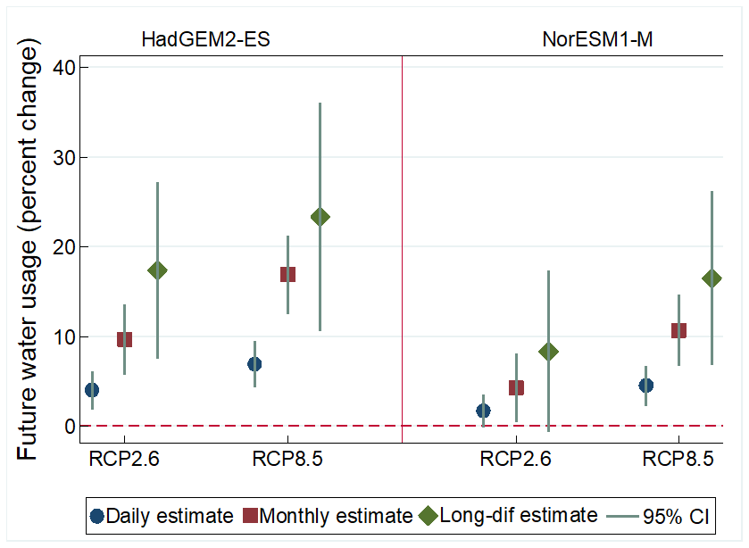
- Mid-term projection (2040-2060)
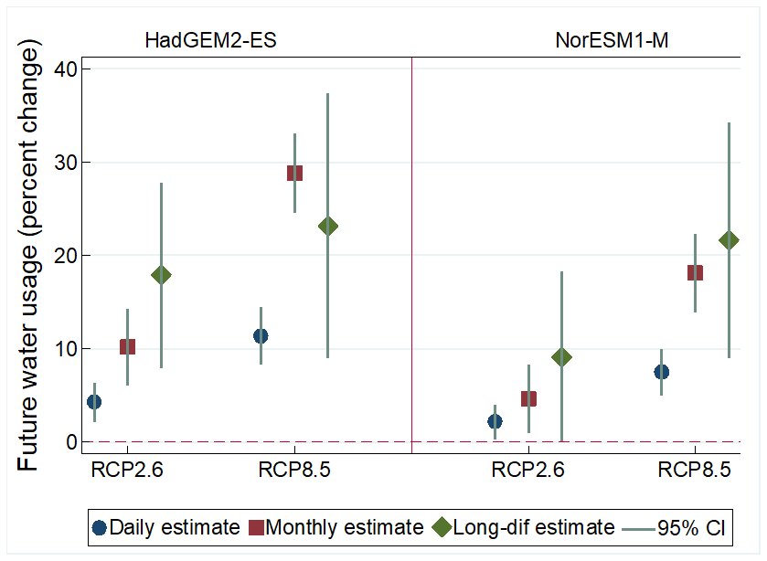
- Long-term projection (2070-2099)

Figure 6: Projected impacts of future warming on water usage

Notes: This figure depicts the predicted percentage changes in water usage under either HadGEM2-ES model or NorESM1-M model, based on mid-term (Panel A) or long-term prediction (Panel B). The solid scatter, square, and diamond represent the projections based on daily estimates, monthly estimates, and long-difference estimates, respectively, while the vertical-line represent their 95% confidence intervals.

Table 1: Summary statistics
Variable | Mean | SD | Min | Max
Daily water usage (m³) | 0.45 | 0.29 | 0.002 | 5
Temperature interval (<5°C) | 0.02 | 0.15 | 0 | 1
Temperature interval (5-10°C] | 0.10 | 0.30 | 0 | 1
Temperature interval (10-15°C] | 0.17 | 0.38 | 0 | 1
Temperature interval (15-20°C] | 0.19 | 0.39 | 0 | 1
Temperature interval (20-25°C] | 0.22 | 0.41 | 0 | 1
Temperature interval (25-30°C] | 0.28 | 0.45 | 0 | 1
Temperature interval (>30°C) | 0.02 | 0.14 | 0 | 1
Heatwaves (days) | 0.06 | 0.58 | 0 | 27
Cold-waves (days) | 0.08 | 0.76 | 0 | 38
Relative humidity (%) | 78.60 | 10.55 | 25.28 | 99.97
Daily precipitation (mm) | 4.64 | 10.73 | 0.00 | 316.41
Daily hours of sunlight | 4.46 | 3.80 | 0.00 | 13.08
Sea pressure (Pa) | 990.83 | 23.52 | 791.74 | 1040.19
Wind speed (m/second) | 2.00 | 1.03 | 0.02 | 11.60

Note: Number of observations = 28,122,387. Daily water usage is observed at the household level. The remaining weather-related variables are observed at the county-level. Heatwaves count the number of days of a heatwave event, which in turn refers to an event where average temperature is at least 30°C for three consecutive days. Cold-waves are defined in similar manner, except for days where average temperature is below 5°C. Days without heatwave or cold-wave are given a value of 0.

Table 2: Results from regression analyses at different temporal scales

 | (1) | (2) | (3) | (4) | (5) | (6) | (7)
 | Daily | Weekly | Bi-weekly | Monthly | Long-difference | 2014 and before | After 2014
Tem. interval (5-10°C] | 0.0155*** | 0.0154*** | 0.0196*** | 0.0220*** | 0.0428 | 0.0131*** | 0.0174***
 | (0.0007) | (0.0006) | (0.0009) | (0.0014) | (0.0348) | (0.0009) | (0.0010)
Tem. interval (10-15°C] | 0.0297*** | 0.0154*** | 0.0246*** | 0.0355*** | 0.0142 | 0.0250*** | 0.0329***
 | (0.0011) | (0.0006) | (0.0008) | (0.0012) | (0.0345) | (0.0013) | (0.0013)
Tem. interval (15-20°C] | 0.0387*** | 0.0233*** | 0.0296*** | 0.0343*** | 0.0682 | 0.0291*** | 0.0450***
 | (0.0013) | (0.0007) | (0.0009) | (0.0014) | (0.0428) | (0.0016) | (0.0015)
Tem. interval (20-25°C] | 0.0418*** | 0.0275*** | 0.0337*** | 0.0517*** | 0.0706** | 0.0289*** | 0.0507***
 | (0.0015) | (0.0008) | (0.0010) | (0.0016) | (0.0295) | (0.0018) | (0.0017)
Tem. interval (25-30°C] | 0.0441*** | 0.0355*** | 0.0451*** | 0.0652*** | 0.0923*** | 0.0278*** | 0.0559***
 | (0.0015) | (0.0009) | (0.0011) | (0.0019) | (0.0321) | (0.0019) | (0.0017)
Tem. interval (>30°C) | 0.0454*** | 0.0451*** | 0.0565*** | 0.0801*** | 0.1315*** | 0.0315*** | 0.0546***
 | (0.0018) | (0.0011) | (0.0015) | (0.0024) | (0.0477) | (0.0022) | (0.0021)
HH-Year Fixed effects (FEs) | Y | Y | Y | Y | N | Y | Y
Month-of-year FEs | N | Y | Y | Y | N | N | N
Calendar Date FEs | Y | N | N | N | N | Y | Y
Observations | 28,122,387 | 7,532,535 | 3,746,336 | 1,925,286 | 38,646 | 14,650,725 | 12,134,335
Adj R-square | 0.3039 | 0.6255 | 0.6570 | 0.6887 | 0.0188 | 0.3090 | 0.3053
Notes: Dependent variable is daily water usage. The following weather variables and their quadratic terms are also included: relative humidity, precipitation, sunlight duration, sea pressure, wind speed. Standard error clustered by household-id in parentheses; *** p<0.01, ** p<0.05, * p<0.1.

Table S1: Baseline results

 | (1) | (2)
 | Overall | Heatwaves and cold-waves
Tem. interval (5-10°C] | 0.0155***
 | (0.0007)
Tem. interval (10-15°C] | 0.0297***
 | (0.0011)
Tem. interval (15-20°C] | 0.0387***
 | (0.0013)
Tem. interval (20-25°C] | 0.0418***
 | (0.0015)
Tem. interval (25-30°C] | 0.0441***
 | (0.0015)
Tem. interval (>30°C) | 0.0454***
 | (0.0018)
Heatwave |  | 0.0009***
 |  | (0.0002)
Cold-wave |  | -0.0023***
 |  | (0.0002)
Observations | 28,122,387 | 27,759,123
Adj R-square | 0.3039 | 0.3041
Notes: Dependent variable is daily water usage. Heatwave counts the number of days of a heatwave event, which in turn refers to an event where average temperature is at least 30°C for three consecutive days. Cold-wave is defined in similar manner, except for days where average temperature is below 5°C. All models estimated with the following explanatory variables: calendar date fixed effects (FEs), household-by-year FEs. The following weather variables and their quadratic terms are also included: relative humidity, precipitation, sunlight duration, sea pressure, wind speed. Standard error clustered by household-id in parentheses; *** p<0.01, ** p<0.05, * p<0.1.

Table S2: Robustness checks

 | (1) | (2) | (3) | (4) | (5) | (6) | (7) | (8) | (9)
 | Baseline | With air quality | Without  air quality | Different  cutoffs | Days unoccupied<31/year | Include no water usage | Without  household-by-year FE | Different clusters  for standard error
Tem. interval (5-10°C] | 0.0155*** | 0.0130*** | 0.0132*** | 0.0145*** | 0.0187*** | 0.0151*** | 0.0166*** | 0.0155*** | 0.0155***
 | (0.0007) | (0.0008) | (0.0008) | (0.0008) | (0.0009) | (0.0007) | (0.0008) | (0.0027) | (0.0006)
Tem. interval (10-15°C] | 0.0297*** | 0.0246*** | 0.0249*** | 0.0277*** | 0.0358*** | 0.0302*** | 0.0319*** | 0.0297*** | 0.0297***
 | (0.0011) | (0.0012) | (0.0012) | (0.0011) | (0.0013) | (0.0010) | (0.0011) | (0.0036) | (0.0009)
Tem. interval (15-20°C] | 0.0387*** | 0.0328*** | 0.0331*** | 0.0360*** | 0.0480*** | 0.0412*** | 0.0414*** | 0.0387*** | 0.0387***
 | (0.0013) | (0.0015) | (0.0015) | (0.0014) | (0.0016) | (0.0013) | (0.0014) | (0.0038) | (0.0010)
Tem. interval (20-25°C] | 0.0418*** | 0.0357*** | 0.0362*** | 0.0389*** | 0.0556*** | 0.0476*** | 0.0460*** | 0.0418*** | 0.0418***
 | (0.0015) | (0.0017) | (0.0017) | (0.0015) | (0.0018) | (0.0014) | (0.0016) | (0.0042) | (0.0012)
Tem. interval (25-30°C] | 0.0441*** | 0.0372*** | 0.0379*** | 0.0419*** | 0.0638*** | 0.0546*** | 0.0499*** | 0.0441*** | 0.0441***
 | (0.0015) | (0.0018) | (0.0018) | (0.0015) | (0.0018) | (0.0015) | (0.0017) | (0.0046) | (0.0013)
Tem. interval (>30°C) | 0.0454*** | 0.0386*** | 0.0395*** | 0.0430*** | 0.0716*** | 0.0592*** | 0.0526*** | 0.0454*** | 0.0454***
 | (0.0018) | (0.0020) | (0.0020) | (0.0018) | (0.0022) | (0.0017) | (0.0020) | (0.0052) | (0.0015)
PM_{2.5} |  | -0.0001***
 |  | (0.0000)
HH-Year FEs | Y | Y | Y | Y | Y | Y | N | Y | Y
HH FEs | N | N | N | N | N | N | Y | N | N
Std error cluster | Household | Household | Household | Household | Household | Household | Household | Household-Year | Calendar date
Observations | 28,122,387 | 22,031,851 | 22,031,851 | 32,027,588 | 17,495,040 | 30,491,040 | 28,122,387 | 28,122,387 | 28,122,387
Adj R-square | 0.3039 | 0.3028 | 0.3028 | 0.4037 | 0.3246 | 0.3908 | 0.2630 | 0.3039 | 0.3039
Notes: Dependent variable is daily water usage. The dataset is trimmed at the 1st and 99th percentile level in Column (4). The dataset excludes household-year with more than 30 days of no water usage in a year in Column (5). The dataset includes observations with no water usage in Column (6). All models estimated with the additional explanatory variables: indicator for no water usage (only for Column (6)) and calendar date fixed effects (FEs). The following weather variables and their quadratic terms are also included: relative humidity, precipitation, sunlight duration, sea pressure, wind speed. Standard error in parentheses; *** p<0.01, ** p<0.05, * p<0.1.

Table S3: Heterogeneity analyses

 | (1) | (2) | (3) | (4) | (5) | (6) | (7) | (8)
 | Below-median precipitation | Above-median  precipitation | Below-median  temperature | Above-median  temperature | Below-median  housing value | Above-median  housing value | Below-median  residential electricity usage | Above-median  residential electricity usage
Tem. interval (5-10°C] | 0.0163*** | 0.0125*** | 0.0074*** | 0.0132*** | 0.0151*** | 0.0150*** | 0.0101*** | 0.0170***
 | (0.0013) | (0.0010) | (0.0009) | (0.0018) | (0.0010) | (0.0011) | (0.0012) | (0.0010)
Tem. interval (10-15°C] | 0.0251*** | 0.0324*** | 0.0216*** | 0.0193*** | 0.0276*** | 0.0305*** | 0.0316*** | 0.0242***
 | (0.0018) | (0.0015) | (0.0013) | (0.0022) | (0.0016) | (0.0016) | (0.0018) | (0.0015)
Tem. interval (15-20°C] | 0.0320*** | 0.0402*** | 0.0267*** | 0.0243*** | 0.0381*** | 0.0390*** | 0.0375*** | 0.0304***
 | (0.0021) | (0.0019) | (0.0016) | (0.0025) | (0.0019) | (0.0020) | (0.0021) | (0.0018)
Tem. interval (20-25°C] | 0.0314*** | 0.0460*** | 0.0292*** | 0.0260*** | 0.0417*** | 0.0397*** | 0.0411*** | 0.0314***
 | (0.0023) | (0.0021) | (0.0018) | (0.0027) | (0.0021) | (0.0022) | (0.0024) | (0.0019)
Tem. interval (25-30°C] | 0.0324*** | 0.0496*** | 0.0341*** | 0.0292*** | 0.0441*** | 0.0390*** | 0.0472*** | 0.0312***
 | (0.0024) | (0.0021) | (0.0019) | (0.0027) | (0.0021) | (0.0023) | (0.0025) | (0.0019)
Tem. interval (>30°C) | 0.0312*** | 0.0521*** | 0.0381*** | 0.0294*** | 0.0504*** | 0.0386*** | 0.0469*** | 0.0284***
 | (0.0029) | (0.0025) | (0.0024) | (0.0030) | (0.0026) | (0.0027) | (0.0027) | (0.0023)
Observations | 12,134,335 | 15,988,052 | 13,263,940 | 14,858,447 | 14,988,793 | 13,133,594 | 9,564,277 | 18,558,110
Adj R-square | 0.3053 | 0.3092 | 0.3017 | 0.3076 | 0.3152 | 0.2959 | 0.2992 | 0.3108
Notes: Dependent variable is daily water usage. All models estimated with the following explanatory variables: calendar date fixed effects (FEs), household-by-year FEs. The following weather variables and their quadratic terms are also included: relative humidity, precipitation, sunlight duration, sea pressure, wind speed. Standard error clustered by household-id in parentheses; *** p<0.01, ** p<0.05, * p<0.1.

