Appendix I. Comprehensive scores and ranking of regional innovation (following the factor analysis)
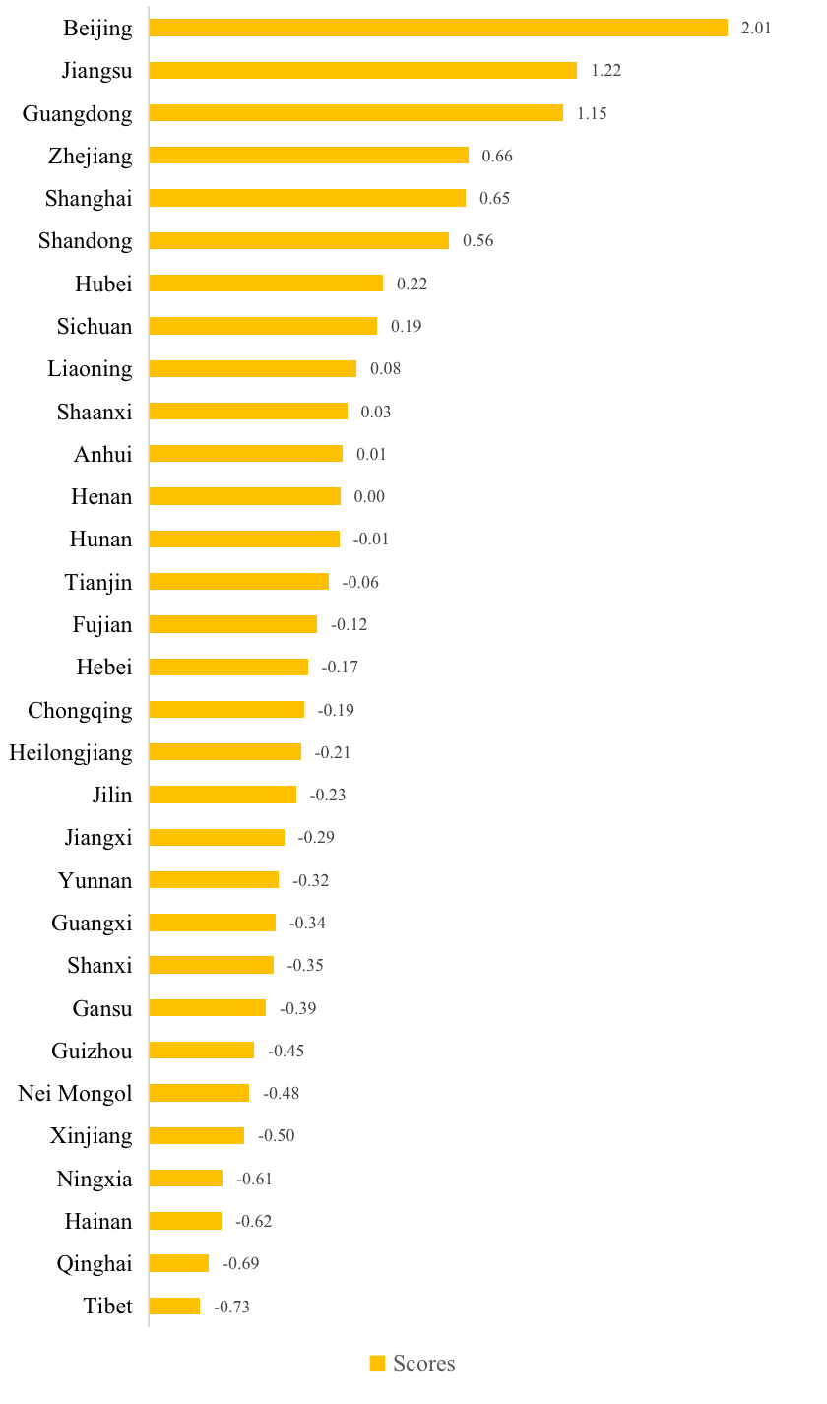

NOTE: The comprehensive score indicates the relative position of the region to the average level. The higher the comprehensive score, the higher the Province’s innovation capability. The function is as follows: Factor=0.40437Factor1+0.35198Factor2+0.15012Factor3
Appendix II. Some descriptive statistics of variables used in the analysis

Descriptive Statistics on Patent Citations in China.
 | N | Mean | Std. dev. | Min | Max.
Total sample of citation links | 961 | 28.22 | 317.05 | 0 | 6439
inter-province citation links | 930 | 7.11 | 44.61 | 0 | 762
Positive inter-province citation links | 243 | 27.22 | 84.08 | 0 | 762
Intra-province citation links | 31 | 661.52 | 1625.41 | 0 | 6439

Degree Centrality and Intra-province citation of the network, 1995–2019.
Region | Abbreviation | Indegree | Outdegree | Total citation | Intra-province citation | Proportion of intra province Citation (%)
Guangdong | G.D. | 1744 | 2263 | 8183 | 6439 | 78.69
Beijing | B.J. | 1269 | 1193 | 7181 | 5912 | 82.33
Shanghai | Sh.H. | 1202 | 1016 | 4938 | 3736 | 75.66
Zhejiang | Zh.J. | 647 | 512 | 2238 | 1591 | 71.09
Jiangsu | J.S. | 661 | 622 | 2138 | 1477 | 69.08
Fujian | F.J. | 223 | 158 | 779 | 556 | 71.37
Hubei | Hu.B. | 292 | 115 | 411 | 119 | 28.95
Sichuan | S.C. | 134 | 279 | 270 | 136 | 50.37
Shandong | Sh.D. | 96 | 148 | 207 | 111 | 53.62
Shaanxi | Sh.X. | 53 | 23 | 133 | 80 | 60.15
Tianjin | T.J. | 42 | 42 | 123 | 81 | 65.85
Liaoning | L.N. | 40 | 26 | 99 | 59 | 59.60
Hebei | He.B | 9 | 24 | 77 | 68 | 88.31
Jiangxi | J.X. | 43 | 10 | 68 | 25 | 36.76
Hunan | Hu.N. | 30 | 32 | 49 | 19 | 38.78
Anhui | A.H. | 35 | 40 | 48 | 13 | 27.08
Chongqing | Ch.Q. | 23 | 27 | 31 | 8 | 25.81
Henan | He.N | 13 | 18 | 24 | 11 | 45.83
Guangxi | G.X. | 11 | 14 | 23 | 12 | 52.17
Shanxi | S.X. | 20 | 7 | 23 | 3 | 13.04
Gansu | G.S. | 7 | 6 | 15 | 8 | 53.33
Heilongjiang | H.L.J. | 3 | 8 | 13 | 10 | 76.92
Jilin | J.L. | 3 | 22 | 13 | 10 | 76.92
Xinjiang | X.J. | 2 | 1 | 12 | 10 | 83.33
Nei Mongol | N.M.G. | 4 | 2 | 7 | 3 | 42.86
Ningxia | N.X. | 2 | 0 | 7 | 5 | 71.43
Guizhou | G.Zh. | 3 | 4 | 3 | 0 | 0.00
Yunnan | Y.N. | 2 | 1 | 3 | 1 | 33.33
Hainan | Hai.N. | 1 | 1 | 2 | 1 | 50.00
Qinghai | Q.H. | 0 | 0 | 0 | 0 | 0.00
Tibet | T.B. | 0 | 0 | 0 | 0 | 0.00

Citation Received and Citation Made Lag Distribution by 4-Year Sub-periods
 | Grant Years of Cited-Backward Patents.
 | 1996-99 | 2000-03 | 2004-07 | 2008-11 | 2012-15 | 2016-19
Lag(years)
0 | 7.7 | 6.7 | 4.3 | 5.8 | 3.6 | 4.4
1 | 46.2 | 20.0 | 26.3 | 28.5 | 21.0 | 21.7
2 | 30.8 | 21.3 | 26.0 | 21.9 | 23.1 | 21.0
3 | 15.4 | 22.7 | 13.9 | 17.5 | 15.8 | 14.7
4 | 0.0 | 18.7 | 13.2 | 11.4 | 11.2 | 10.4
5 | 0.0 | 9.3 | 9.6 | 6.7 | 7.6 | 8.3
6 | 0.0 | 0 | 3.6 | 3.2 | 6.2 | 6.0
7+ | 0.0 | 1.3 | 3.2 | 4.9 | 11.4 | 13.6
Total | 100.0 | 100.0 | 100.0 | 100.0 | 100.0 | 100.0
(ii) Mean and Standard Deviation of the Lag, in Years.
Mean | 1.54 | 2.61 | 2.67 | 2.66 | 3.37 | 3.52
s.d. | 0.84 | 1.50 | 1.77 | 2.08 | 2.61 | 2.87

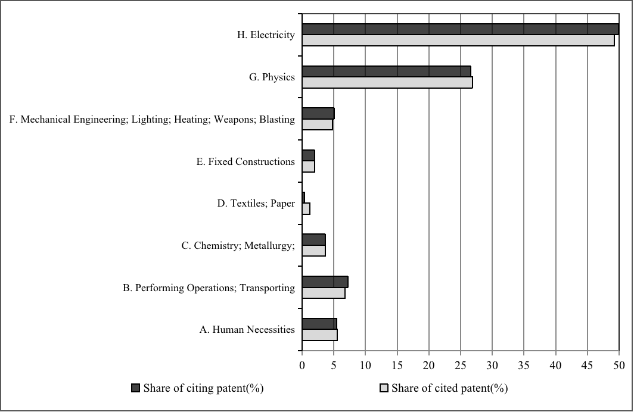
Distribution of citations by technological field (IPC).

Technology Proximity Distribution of Patent Citation in China.
Year | S_{ij}<0.8 | 0.8<S_{ij} <0.899 | S_{ij} >0.9 | Sum
1995 | 0 | 0 | 0 | 0
1996 | 0 | 0 | 3 | 3
1997 | 0 | 0 | 6 | 6
1998 | 2 | 0 | 18 | 20
1999 | 2 | 1 | 19 | 22
2000 | 3 | 1 | 27 | 31
2001 | 3 | 3 | 38 | 44
2002 | 1 | 4 | 67 | 72
2003 | 1 | 7 | 89 | 97
2004 | 3 | 5 | 167 | 175
2005 | 4 | 8 | 474 | 486
2006 | 6 | 31 | 494 | 531
2007 | 8 | 40 | 633 | 681
2008 | 11 | 34 | 947 | 992
2009 | 7 | 51 | 1218 | 1276
2010 | 16 | 115 | 1378 | 1509
2011 | 12 | 94 | 1356 | 1462
2012 | 12 | 150 | 1347 | 1509
2013 | 13 | 152 | 1595 | 1760
2014 | 24 | 191 | 2129 | 2344
2015 | 35 | 284 | 2613 | 2932
2016 | 24 | 275 | 3334 | 3633
2017 | 16 | 329 | 3747 | 4092
2018 | 16 | 151 | 2281 | 2448
2019 | 3 | 63 | 927 | 993
Sum | 222 | 1989 | 24907 | 27118

Geographic Distribution of Patent Citation in China.
Year | Citation <1000km | Citation of 1000-1500km | Citation >1500km | Sum
1995 | 0 | 0 | 0 | 0
1996 | 3 | 0 | 0 | 3
1997 | 6 | 0 | 0 | 6
1998 | 20 | 0 | 0 | 20
1999 | 22 | 0 | 0 | 22
2000 | 28 | 0 | 3 | 31
2001 | 41 | 1 | 2 | 44
2002 | 62 | 7 | 3 | 72
2003 | 90 | 5 | 2 | 97
2004 | 168 | 3 | 4 | 175
2005 | 469 | 13 | 4 | 486
2006 | 485 | 38 | 8 | 531
2007 | 625 | 41 | 15 | 681
2008 | 930 | 44 | 18 | 992
2009 | 1183 | 65 | 28 | 1276
2010 | 1334 | 132 | 43 | 1509
2011 | 1247 | 144 | 71 | 1462
2012 | 1247 | 168 | 94 | 1509
2013 | 1413 | 228 | 119 | 1760
2014 | 1846 | 282 | 216 | 2344
2015 | 2310 | 376 | 246 | 2932
2016 | 2863 | 459 | 311 | 3633
2017 | 3429 | 377 | 286 | 4092
2018 | 2067 | 221 | 160 | 2448
2019 | 860 | 71 | 62 | 993
Sum | 22748 | 2675 | 1695 | 27118

Appendix III. Regression results without co-inventor as independent variable

Estimation results of Chinese patent citations (Dependent variable: Patent Citation).
 | (1) | (2) | (3) | (4) | (5) | (6)
 | Tobit | Tobit | Negative binomial | Negative binomial | Generalised negative | Generalised negative
 | ln(C_{ij}) | ln(C_{ij}) | C_{ij} | C_{ij} | C_{ij} | C_{ij}
Co-patenting
ln(P_{i}*P_{j}) | 0.774*** | 0.719*** | 0.712*** | 0.741*** | 0.718*** | 0.771***
 | (6.39) | (7.80) | (10.58) | (13.12) | (12.72) | (17.04)
S_{ij} | 2.885*** | 2.326*** | 3.245*** | 3.005*** | 3.243*** | 3.092***
 | (3.49) | (3.73) | (6.82) | (6.29) | (7.34) | (6.94)
ln(d_{ij}) | -0.551*** | -0.492*** | -0.375*** | -0.375*** | -0.287*** | -0.331***
 | (-2.59) | (-3.02) | (-2.88) | (-3.13) | (-3.58) | (-4.11)
F1_{i} | 0.309** |  | 0.201** |  | 0.211***
 | (2.25) |  | (2.31) |  | (3.36)
F2_{i} | 0.178 |  | 0.162 |  | 0.239***
 | (0.94) |  | (1.59) |  | (2.91)
F1_{j} | 0.341** |  | 0.258*** |  | 0.225***
 | (2.46) |  | (3.89) |  | (3.96)
F2_{j} | 0.315* |  | 0.243*** |  | 0.178**
 | (1.67) |  | (2.64) |  | (2.07)
F1_{i} × F1_{j} |  | 0.239*** |  | 0.168*** |  | 0.137***
 |  | (3.40) |  | (3.72) |  | (4.49)
F2_{i} × F2_{j} |  | 0.131** |  | 0.101*** |  | 0.066***
 |  | (2.52) |  | (3.70) |  | (3.94)
Traffic_{i} | 0.184 | 0.146* | 0.120 | 0.103** | 0.154** | 0.080**
 | (1.22) | (1.76) | (1.42) | (2.04) | (2.53) | (2.02)
Traffic_{j} | 0.275* | 0.155* | 0.241*** | 0.166*** | 0.165** | 0.126***
 | (1.78) | (1.83) | (3.16) | (2.92) | (2.57) | (3.18)
Constant | -6.226* | -5.636** | -7.296*** | -7.661*** | -8.556*** | -8.646***
 | (-1.87) | (-2.20) | (-4.01) | (-4.41) | (-7.01) | (-7.04)
Observations | 930 | 930 | 930 | 930 | 930 | 930
Geographical position | Control | Control | Control | Control | Control | Control
lambda | 1.810*** | 1.382***
 | (4.95) | (4.74)
ln(P_{i}*P_{j}) |  |  |  |  | -0.579*** | -0.587***
 |  |  |  |  | (-9.45) | (-9.21)
S_{ij} |  |  |  |  | 2.943** | 3.586**
 |  |  |  |  | (2.30) | (2.52)
ln(d_{ij}) |  |  |  |  | 0.520** | 0.510**
 |  |  |  |  | (2.17) | (2.25)
Robust z-statistics in parentheses *** p<0.01, ** p<0.05, * p<0.1

Estimation results of Chinese patent citations (Dependent variable: Patent Citation).
 | (1) | (2) | (3)
 | Tobit | Negative binomial | Generalised negative binomial
 | ln(C_{ij}) | C_{ij} | C_{ij}
Co-patenting
ln(P_{i}*P_{j}) | 0.770*** | 0.720*** | 0.720***
 | (5.08) | (10.60) | (12.73)
S_{ij} | 2.759*** | 3.150*** | 3.219***
 | (3.07) | (5.99) | (6.93)
ln(d_{ij}) | -0.481** | -0.292** | -0.221**
 | (-2.16) | (-2.22) | (-2.55)
F1_{i} | 0.367** | 0.260*** | 0.272***
 | (2.41) | (2.93) | (4.16)
F2_{i} | 0.153 | 0.159 | 0.236***
 | (0.75) | (1.52) | (2.88)
F1_{j} | 0.403*** | 0.318*** | 0.285***
 | (2.61) | (4.57) | (5.22)
F2_{j} | 0.302 | 0.226** | 0.183**
 | (1.49) | (2.50) | (2.48)
D1 | -0.116 | -0.123 | -0.023
 | (-0.29) | (-0.72) | (-0.15)
D2 | 0.971** | 0.783*** | 0.590***
 | (2.41) | (4.23) | (3.34)
D3 | -0.0003 | -0.109 | -0.171
 | (-0.00) | (-0.71) | (-1.19)
Traffic_{i} | 0.281* | 0.224*** | 0.241***
 | (1.65) | (2.58) | (3.28)
Traffic_{j} | 0.380** | 0.344*** | 0.259***
 | (2.13) | (4.36) | (3.76)
Constant | -7.265* | -8.581*** | -9.593***
 | (-1.91) | (-4.52) | (-7.60)
Observations | 930 | 930 | 930
Geographical position | Control | Control | Control
lambda | 1.892***
 | (4.94)
ln(P_{i}*P_{j}) |  |  | -0.584***
 |  |  | (-8.48)
S_{ij} |  |  | 3.680**
 |  |  | (2.45)
ln(d_{ij}) |  |  | 0.479**
 |  |  | (2.01)
Robust z-statistics in parentheses *** p<0.01, ** p<0.05, * p<0.1

