Supplementary Methods:
Search Strategy
Search terms comprised of two categories: 1) cannabis, marijuana, marihuana, CBD, cannabidiol and 2) fMRI, functional magnetic resonance, imaging, magnetic resonance, MRI, single photon emission tomography, SPECT, positron emission tomography, PET, perfusion, blood flow, ASL. Boolean Operators were used to combine the categories. The search was restricted to titles and abstracts across studies in humans.
The literature search and data extraction were conducted independently by two researchers. In the instance of any discrepancies, a senior investigator was consulted. The final literature search was conducted on 21/07/21.
Eligibility Criteria
Studies that investigated functional connectivity or brain chemistry (e.g., Magnetic Resonance Spectroscopy) were excluded. Studies that investigated the effects of a sustained dose of CBD, that is a non-acute dose, were also excluded along with those that primarily assessed psychological effects without neuroimaging. The results of studies that reported the effects of CBD using different cognitive paradigms on the same group of subjects were treated as independent and were included.
Data analysis
A map of Q_{H} statistics, created from standard z values derived from a chi-square distribution, was overlaid on the map of the main findings for visual inspection of overlapping areas of heterogeneity. Egger’s test was conducted for all significant clusters to assess the asymmetry of funnel plots to examine for potential publication bias (Egger et al., 1997). This was conducted to evaluate the effect-sizes of small or imprecise studies. While large studies are likely to be published even with negative findings, small studies with negative results may be less likely to be published. Jack-knife leave-one-out sensitivity analysis was conducted to evaluate whether each cluster remained statistically significant in the absence of one study, repeated across all studies. Coordinates are reported using MNI coordinates examined using a human brain atlas(Adams, 1978).
Whole brain correlation with FAAH, DRD2, HTR1A and CNR1 gene expression
The Allen Human Brain Atlas contains mRNA microarray expression data from six neurotypical adult human brains distributed across cortical, subcortical, brainstem and cerebellar regions (Hawrylycz et al., 2012). The atlas contains 3,702 spatially distinct tissue samples, quantifying the expression of more than 20,000 genes. In the data processing we followed the recommendations put forward by Arnatkevic̆iūtė et al. (Arnatkevic̆iūtė, Fulcher and Fornito, 2019) and utilised the package abagen (Markello et al., 2020) to conduct a reproducible workflow.
First, transcriptional gene expression data from microarray probes were downloaded from the Allen Human Brain Atlas database. Microarray probe-to-gene re-annotation was conducted with information from Arnatkevic̆iūtė et al., 2019 (Arnatkevic̆iūtė, Fulcher and Fornito, 2019). Probes that could not be reliably matched to genes were discarded. We then performed intensity-based filtering of probes to remove those that did not exceed background noise using a threshold of 0.5 (i.e., probes must exceed background noise in 50% of all tissue samples). Following this, representative probes, with the highest differential stability (i.e., the probe with the most consistent spatial pattern across the donor brains) in indexing the mRNA for receptor genes of interest were selected. Microarray samples were then matched to 78 cortical regions, parcellated across the Desikan–Killiany brain atlas(Desikan et al., 2006). For precise sample to region matching, we initially determined if the microarray sample fell directly within a region of the atlas. If the sample did not, they were assigned to a region within a distance of 2mm of the Desikan-Killiany parcels. In cases where there were multiple nearby regions, the closest region was determined by calculating the centre-of-mass of the abutting regions. We then transformed expression values for the genes across samples, for each donor, using a scaled robust sigmoid normalisation function. Finally, expression values for microarray samples, assigned to each region of the Desikan-Killiany atlas, were averaged independently for each donor and then averaged across donors.
Using SDM, we extracted the effect-size estimates of the voxel of the centroid for each of the 78 regions of the Desikan-Killiany (Desikan et al., 2006) atlas from our main imaging meta-analysis with all participants.
Linear regression analysis was then conducted where the SDM effect-size estimates for brain regions in the Desikan-Killiany (Desikan et al., 2006) atlas were considered as the dependent variable and the corresponding average FAAH, DRD2, HTR1A and CNR1 gene expression values derived from the Allen Human Brain Atlas were considered as the predictor variables. Regression diagnostics were first conducted using the Companion to Applied Regression (car) package in R (Fox, 2021). QQ plots were used to assess normal distribution of the residuals. Variance inflation factor was used to test for multicollinearity, and a spread-level plot was used to assess heteroskedasticity. We then carried out multiple linear regression analysis using Python 3.7.9(Python Software Foundation, 2016).

Supplementary Results:
Jack-Knife Leave One Out Analysis Matrix And Funnel Plots For Clusters In Core Analysis With Egger’s Test For Asymmetry And
The funnel plots below depict Hedge’s g effect size estimates from individual studies (x axis) against the standard error (SE) (y axis). Larger, more powerful studies are placed at the top of the funnel plot. The effect size estimates from smaller studies are distributed at the bottom of the plot, with the spread narrowing among larger studies (Begg and Berlin, 1988). In the absence of bias and between study heterogeneity, the scatter should arise from variations in sampling shown by a symmetrical inverted funnel (Sterne et al., 2011). Present within the triangle should be 95% of the studies if there is no bias and the fixed effect assumption is true (the true effect of CBD is the same in each study). Factors that may cause asymmetry in the funnel plot may be heterogeneity, reporting bias, choice of statistics being plotted, and chance (Sterne et al., 2011). Egger’s test is a statistical test that was used to quantitatively asses the asymmetry of funnel plots (Egger et al., 1997). The Egger’s test suggested potential publication bias for 2 clusters: the left cerebellum lobule IV / V (CBD>PLB; Egger’s test P= 0.026; peak coordinates -18, -34, -20) and the right precentral gyrus (CBD<PLB; Egger’s test P= 0.002; peak coordinates 64, 2, 24).

Supplementary Table 1. Jack-knife leave-one-out sensitivity analysis, each analysis was repeated excluding 1 single study at a time to establish whether each cluster remained statistically significant. 80% of all clusters survived this analysis, as indicated with dots. Crosses indicate regions where clusters did not survive.
 | R middle orbital frontal gyrus | L cerebellum crus II | R inferior temporal gyrus | R middle temporal gyrus | L cerebellum lobule IV / V | L supplementary motor area | R inferior temporal gyrus | R precentral gyrus | L superior temporal pole | R median / paracingulate gyri
Bhattacharyya(Fusar-Poli et al., 2009) | • | • | × | × | • | • | × | • | • | •
Bhattacharyya(Bhattacharyya et al., 2012) | • | • | • | × | • | • | • | • | • | •
Bhattacharyya(Bhattacharyya et al., 2018) | • | • | • | • | • | × | • | • | • | ×
Borgwardt(Borgwardt et al., 2008) | • | • | • | • | • | • | • | • | • | •
Crippa(Crippa et al., 2004) | • | • | × | • | • | • | • | • | • | •
Crippa(Crippa et al., 2011) | • | × | • | • | • | • | • | × | • | ×
Davies(Davies et al., 2020) | × | • | • | • | • | • | • | × | • | •
Fusar-Poli(Fusar-Poli et al., 2009) | • | • | • | × | • | • | • | • | × | ×
O’Neill(O’Neill et al., 2021) | • | • | • | • | • | • | × | × | • | •
Lawn(Lawn et al., 2020) | • | • | • | • | • | • | • | • | • | •
Wilson(Wilson et al., 2019) | • | × | × | × | • | × | × | • | × | •
Winton-Brown(Winton-Brown et al., 2011) | • | • | • | × | • | • | • | • | • | •

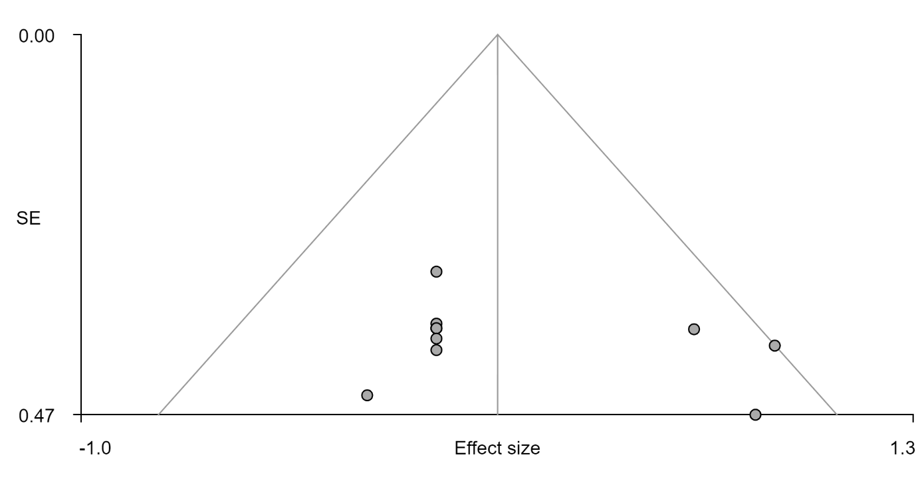
Supplementary Figure 1. CBD>placebo, right middle orbital frontal gyrus, Egger’s test, bias= 2.69, t: 1.07, df: 10, p: 0.31
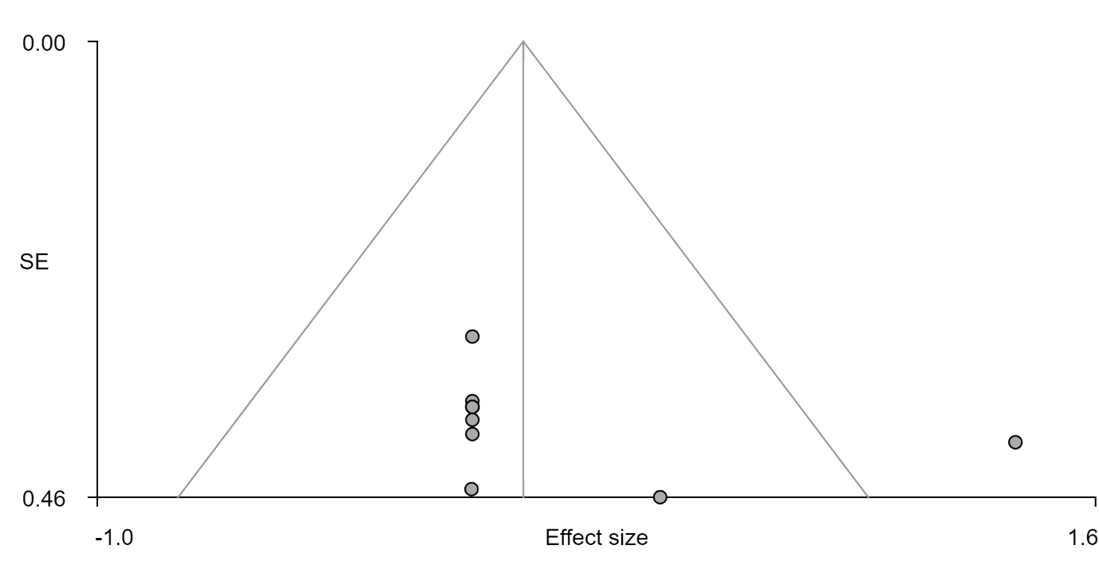
Supplementary Figure 2. CBD>placebo, left cerebellum crus II, Egger’s test, bias= 3.25, t: 1.19, df: 10, p: 0.26
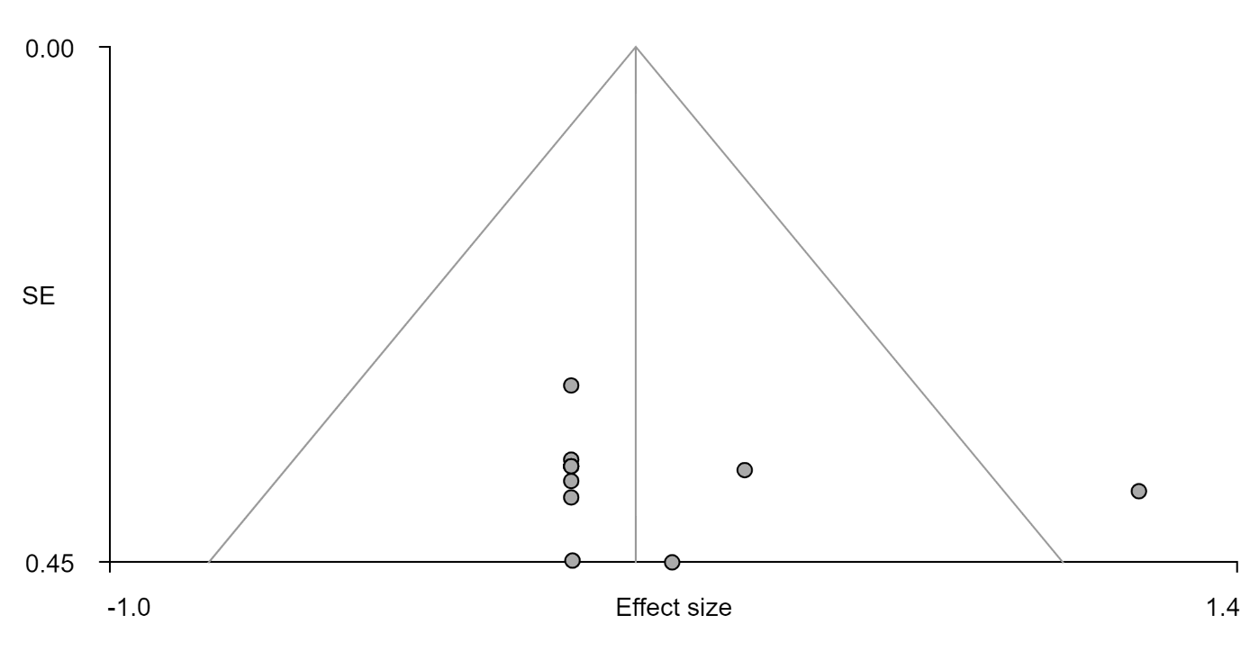
Supplementary Figure 3. CBD>placebo, right interior temporal gyrus, Egger’s test, bias= 1.60, t: 0.63, df: 10, p: 0.54
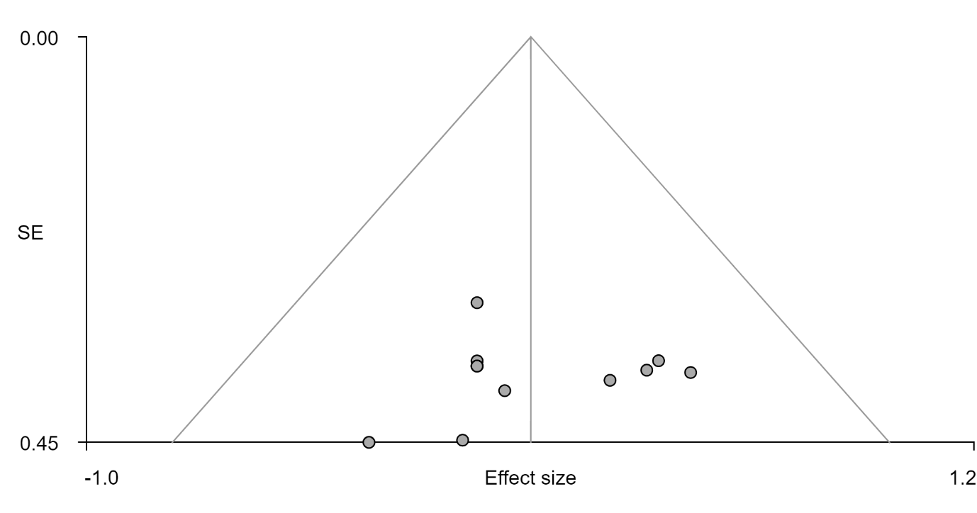
Supplementary Figure 4. CBD>placebo, right middle temporal gyrus, Egger’s test, bias= -0.74, t: -0.41, df: 1, p: 0.69
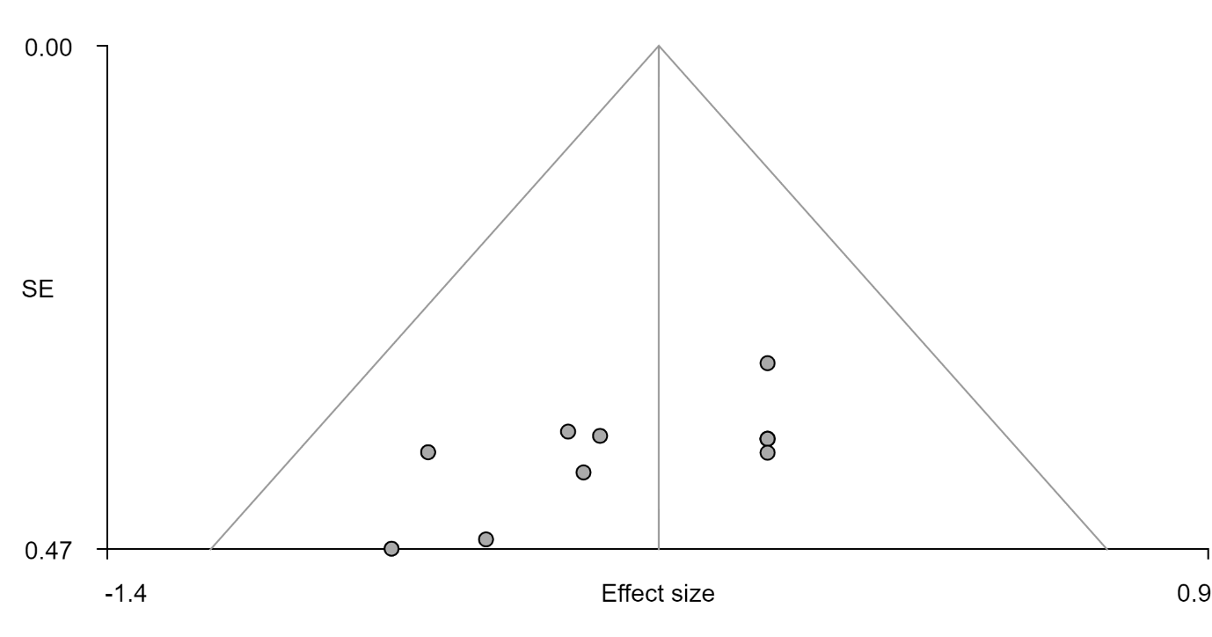
Supplementary Figure 5. CBD<placebo, left cerebellum lobule IV/V, Egger’s test, bias= -4.13, t: -2.60, df: 10, p: 0.026
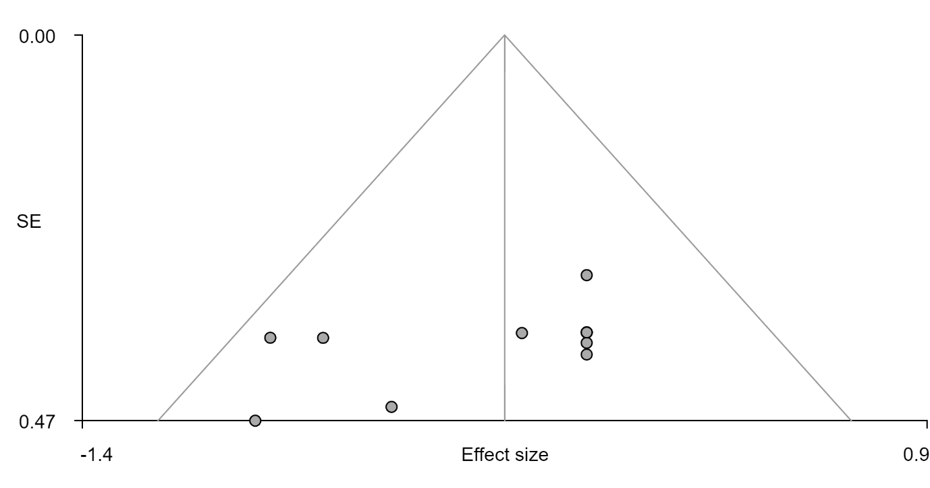
Supplementary Figure 6. CBD<placebo, left supplementary motor area, Egger’s test, bias= -4.10, t: -1.91, df: 10, p: 0.086
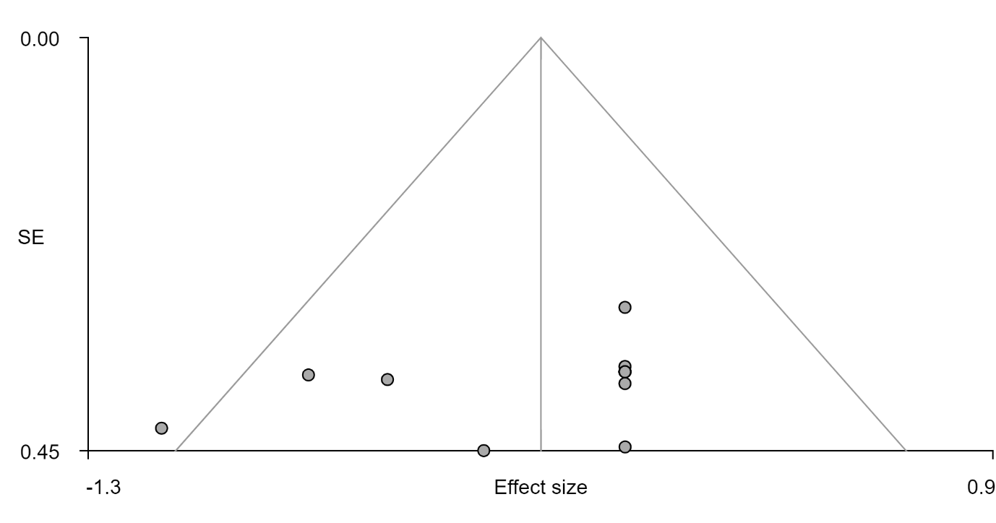
Supplementary Figure 7. CBD<placebo, right inferior temporal gyrus, Egger’s test, bias= -3.25, t: -1.31, df: 10, p: 0.22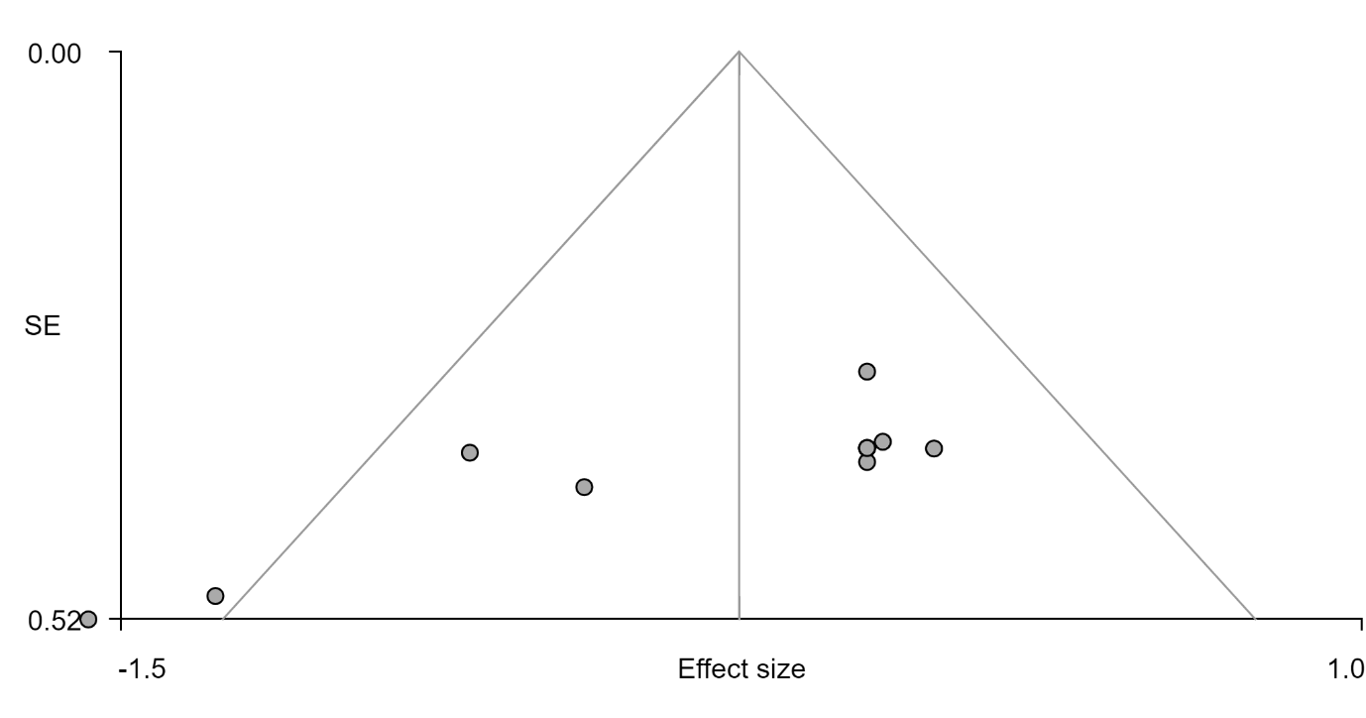Supplementary Figure 8. CBD<placebo, right precentral gyrus, Egger’s test, bias= -7.08, t: -4.20, df: 10, p: 0.002

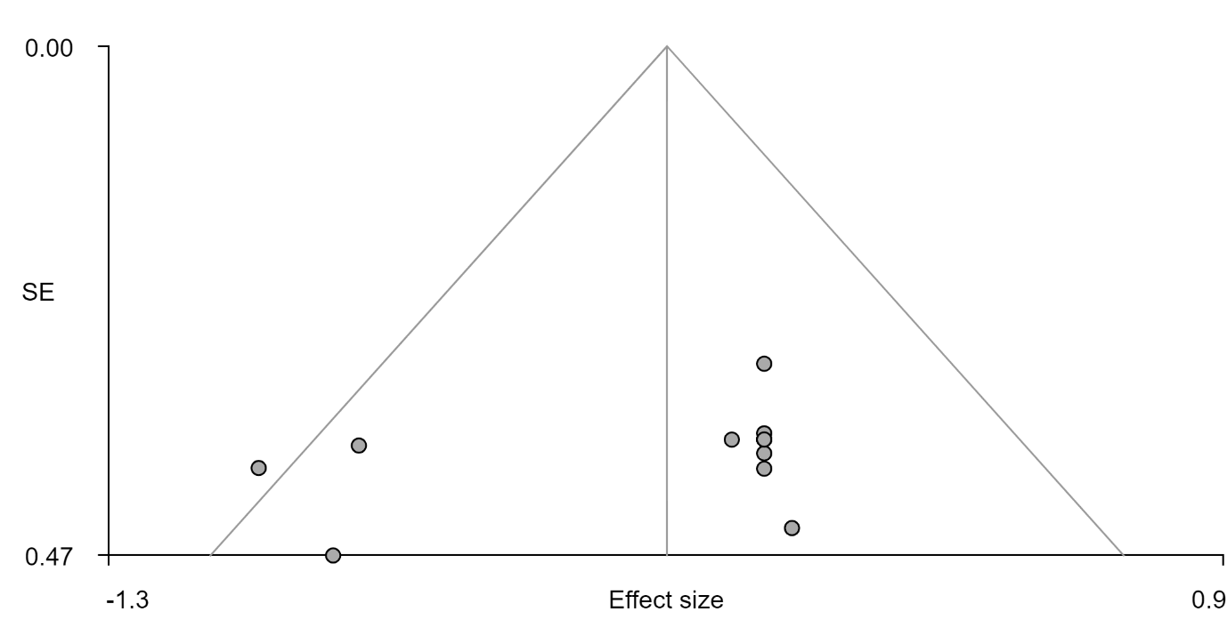
Supplementary Figure 9. CBD<placebo, left superior temporal pole, Egger’s test, bias= -3.37, t: -1.29, df: 10, p: 0.23
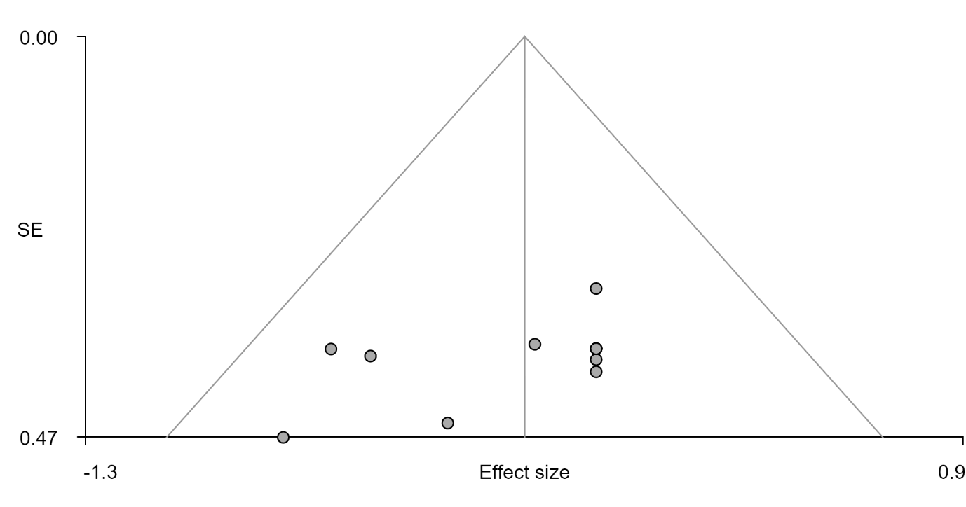
Supplementary Figure 10. CBD<placebo, right median/ paracingulate gyri, Egger’s test, bias= -3.40, t: -1.84, df: 10, p: 0.1

Regression Diagnostics For Hedge’s g Effect Size Estimate and FAAH, DRD2, HTR1A and CNR1 Gene Expression Values
Regression diagnostics are methods used to assess a regression model in its ability to adequately represent the data (Fox, 2009). Visual inspection of the QQ plots indicated that the data was normally distributed (Supplementary Figure 11). The Spread-Level plot suggested that heteroskedasticity was not present among the data (Supplementary Figure 12). Variance inflation factor was used to assess multicollinearity where a cut off 5 is commonly applied (Sheather, 2009). The variance inflation factor for the genes investigated were: FAAH= 1.22, DRD2= 1.92, HTR1A= 2.11, CBR1= 1.86. This indicated minimal multicollinearity between the independent variables.
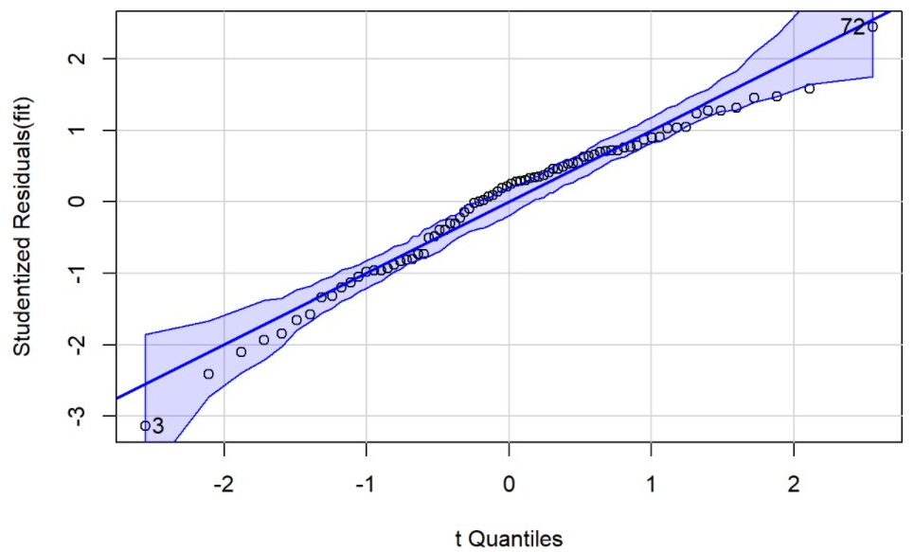
Supplementary Figure 11. QQ plot indicating normal distribution

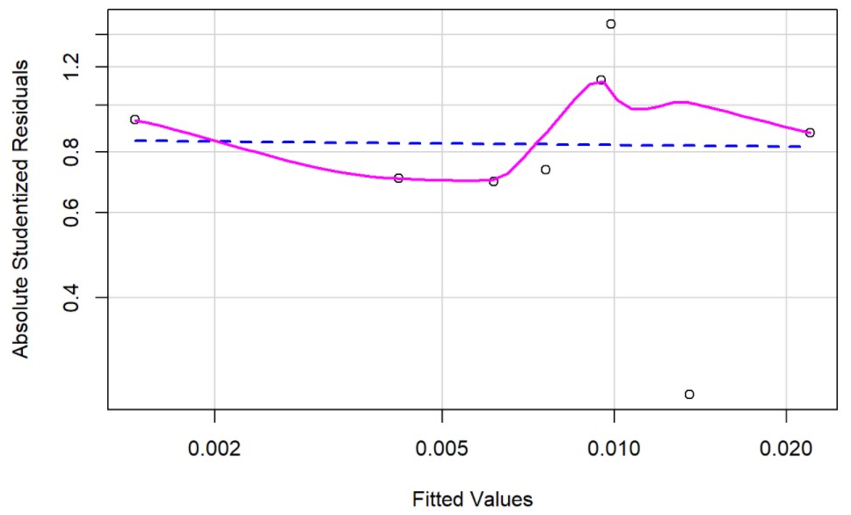
Supplementary Figure 12. Spread-level plot indicating an absence of heteroskedasticity

Supplementary References
Adams, H. (1978) Atlas of the Human Brain. 3rd edn, Journal of Neurology, Neurosurgery & Psychiatry. 3rd edn. Amsterdam: Elsevier Academic Press. doi: 10.1136/jnnp.41.10.960-b.
Arnatkevic̆iūtė, A., Fulcher, B. D. and Fornito, A. (2019) ‘A practical guide to linking brain-wide gene expression and neuroimaging data’, NeuroImage, 189(July 2018), pp. 353–367. doi: 10.1016/j.neuroimage.2019.01.011.
Begg, C. B. and Berlin, J. A. (1988) ‘Publication Bias: A Problem in Interpreting Medical Data’, Journal of the Royal Statistical Society. Series A (Statistics in Society). JSTOR, 151(3), p. 419. doi: 10.2307/2982993.
Bhattacharyya, S. et al. (2012) ‘Induction of psychosis by Δ9-tetrahydrocannabinol reflects modulation of prefrontal and striatal function during attentional salience processing’, Archives of General Psychiatry, 69(1), pp. 27–36. doi: 10.1001/archgenpsychiatry.2011.161.
Bhattacharyya, S. et al. (2018) ‘Effect of Cannabidiol on Medial Temporal, Midbrain, and Striatal Dysfunction in People at Clinical High Risk of Psychosis: A Randomized Clinical Trial’, JAMA Psychiatry. American Medical Association, 75(11), pp. 1107–1117. doi: 10.1001/jamapsychiatry.2018.2309.
Borgwardt, S. J. et al. (2008) ‘Neural Basis of Δ-9-Tetrahydrocannabinol and Cannabidiol: Effects During Response Inhibition’, Biological Psychiatry, 64(11), pp. 966–973. doi: 10.1016/j.biopsych.2008.05.011.
Crippa, J. A. et al. (2004) ‘Effects of Cannabidiol (CBD) on Regional Cerebral Blood Flow’, Neuropsychopharmacology, 29(2), pp. 417–426. doi: 10.1038/sj.npp.1300340.
Crippa, J. A. et al. (2011) ‘Neural basis of anxiolytic effects of cannabidiol (CBD) in generalized social anxiety disorder: A preliminary report’, Journal of Psychopharmacology, 25(1), pp. 121–130. doi: 10.1177/0269881110379283.
Davies, C. et al. (2020) ‘A single dose of cannabidiol modulates medial temporal and striatal function during fear processing in people at clinical high risk for psychosis’, Translational Psychiatry. Springer Nature, 10(1), pp. 1–12. doi: 10.1038/s41398-020-0862-2.
Desikan, R. S. et al. (2006) ‘An automated labeling system for subdividing the human cerebral cortex on MRI scans into gyral based regions of interest’, NeuroImage. Neuroimage, 31(3), pp. 968–980. doi: 10.1016/j.neuroimage.2006.01.021.
Egger, M. et al. (1997) ‘Bias in meta-analysis detected by a simple, graphical test’, British Medical Journal. BMJ Publishing Group, 315(7109), pp. 629–634. doi: 10.1136/bmj.315.7109.629.
Fox, J. (2009) Regression Diagnostics. Available at: https://socialsciences.mcmaster.ca/jfox/Courses/Brazil-2009/index.html (Accessed: 15 September 2021).
Fox, J. (2021) ‘Companion to Applied Regression [R package car version 3.0-11]’. Comprehensive R Archive Network (CRAN). Available at: https://cran.r-project.org/package=car (Accessed: 15 September 2021).
Fusar-Poli, P. et al. (2009) ‘Distinct effects of A9-Tetrahydrocannabinol and cannabidiol on neural activation during emotional processing’, Archives of General Psychiatry, 66(1), pp. 95–105. doi: 10.1001/archgenpsychiatry.2008.519.
Hawrylycz, M. J. et al. (2012) ‘An anatomically comprehensive atlas of the adult human brain transcriptome’, Nature. Nature Publishing Group, 489(7416), pp. 391–399. doi: 10.1038/nature11405.
Lawn, W. et al. (2020) ‘The acute effects of cannabidiol on the neural correlates of reward anticipation and feedback in healthy volunteers’, Journal of Psychopharmacology. SAGE Publications, 34(9), pp. 969–980. doi: 10.1177/0269881120944148.
Markello, R. D. et al. (2020) ‘abagen: A toolbox for the Allen Brain Atlas genetics data’, Zenodo, p. Available from: https://doi.org/10.5281/zenodo.372. doi: 10.5281/ZENODO.4091537.
O’Neill, A. et al. (2021) ‘Normalization of mediotemporal and prefrontal activity, and mediotemporal-striatal connectivity, may underlie antipsychotic effects of cannabidiol in psychosis’, Psychological Medicine, 51(4), pp. 596–606. doi: 10.1017/S0033291719003519.
Python Software Foundation (2016) Welcome to Python.org. Available at: https://www.python.org/about/ (Accessed: 26 January 2021).
Sheather, S. J. (2009) ‘A Modern Approach to Regression with R’, in, pp. 1–14. doi: 10.1007/978-0-387-09608-7_1.
Sterne, J. A. C. et al. (2011) ‘Recommendations for examining and interpreting funnel plot asymmetry in meta-analyses of randomised controlled trials’, BMJ (Online). British Medical Journal Publishing Group, 343(7818). doi: 10.1136/bmj.d4002.
Wilson, R. et al. (2019) ‘Cannabidiol attenuates insular dysfunction during motivational salience processing in subjects at clinical high risk for psychosis’, Translational Psychiatry. Nature Publishing Group, 9(1), p. 203. doi: 10.1038/s41398-019-0534-2.
Winton-Brown, T. T. et al. (2011) ‘Modulation of auditory and visual processing by delta-9- tetrahydrocannabinol and cannabidiol: An fMRI study’, Neuropsychopharmacology. Nature Publishing Group, 36(7), pp. 1340–1348. doi: 10.1038/npp.2011.17.

