Schematic demonstration of the structural evolution of ZIF-8 incubated in humoral environment for inducing bone regeneration. Detailed mineralized procedure of ZIF-8 in humoral milieu. Calcium attack triggered degradation of ZIF-8, which provides calcium-phosphorus binding sites and leads to apatite deposition. b) ZIF-8/PCL scaffold with mineralization capability fabricated by melt electrowritten (MEW) printing was implanted into a rat calvarial defect to evaluate its ability to enhance bone regeneration. c) Hypothetical chemical reaction equations of the mineralization of ZIF-8.

Figure 2. The characterization of the mineralization process induced by ZIF-8. a) SEM and TEM-EDS mapping images, showing a typical rhombic dodecahedral structure and zinc-nitrogen skeleton elements of ZIF-8 particles. b). quantitative data of corresponding elemental mapping of mineralized ZIF-8 in panel e. c) XRD patterns showing the pure phase of the as-synthesized ZIF-8 (red line). Part of ZIF-8 particles gradually collapsed in SBF over time, and the appearance of new diffraction peaks indicates the formation of new crystal structures. d) As shown in the comparative FTIR spectroscopic analysis of the ZIF-8 particles before and after the incubation process in SBF (day 21), the degradation process of ZIF-8 involves the release of the ligand with a change in the coordination environment of ions. e) TEM-EDS mapping images of ZIF-8 particles showing the morphology and component changes in SBF over time. Mineralized ZIF-8 contains calcium, phosphorus and zinc elements with obvious agglomeration. f) The particle size of ZIF-8 after mineralization (day 21) was found much larger than compare to their original size. g) Zeta potential and distribution of ZIF-8 changed from negative to positive after mineralization (day 21). h) Concentration of Zn²⁺ and Ca²⁺ in SBF demonstrate the release of zinc ions and the binding of calcium ions during the incubation process. i) Quantitative determination of 2-methylimidazole concentration in SBF demonstrate the protonation release of the ligand.
Figure 3. In vitro osteogenesis assays using rBMSCs cultured with mineralized ZIF-8 in regular medium without osteogenic induction solution. a) Representative digital images rBMSCs incubated with mineralized ZIF-8 showing the distinct mineralization extracellular matrix containing mineralized crystalloid after 14 days, compare to rBMSCs incubated in regular medium (Alizarin red S staining.) b) Gene expression of early markers (Runx2/Alp) and late markers (Ocn/Opn) of osteogenesis in rBMSCs increased significantly at day 5,14 in rBMSCs incubated with mineralized ZIF-8. c, d) Western blot images and summarized data revealed the same increasing trend of the protein levels of RUNX2/ALP/ OCN /OPN RUNX2. ** p < 0.01, *** p < 0.001, ns: no significance (n = 3).

Figure 4. Characterization of mineralization properties and mechanical properties of ZIF-8/PCL. Flake-like PCL and ZIF-8/PCL molded in a cylindrical mould. a) SEM images showing the abundant crystal deposition on the flake-like ZIF-8/PCL after the incubation process in SBF at low and high magnifications. b) The elements mapping of ZIF-8/PCL indicates that the crystal deposition contains Ca, P and Zn elements. c) The images of 3D micro-CT reconstructions of the flake-like ZIF-8/PCL showed deposits of bone-like apatite crystals and increased with time. d) quantitative analysis of the apatite volume/total volume ratio obtained from the stereograms. e) Comparison of Young’s modulus between PCL and ZIF-8/PCL showing no significant difference, but there was a certain trend of PCL to become flexible after mixing with ZIF-8. f) Static water contact angle measurement demonstrated the addition of ZIF-8 increased the surface roughness of PCL, and became rougher after 7 days mineralization. g) Images of AFM illustrated changes in roughness at the nanoscale after 24 h mineralization. *** p < 0.001, ns: no significance (n = 4)

Figure 5. Characterization of morphology and mineralization properties of MEW printed ZIF-8/PCL. a) Schematic of fabrication of PCL, ZIF-8/PCL scaffold via MEW printing. b) SEM images showing the thick layers of crystal deposition on the surface of MEW printed ZIF-8/PCL scaffold after the incubation process in SBF, which were not observed on the surface of MEW printed PCL. c) The elements mapping indicates that the crystal deposition contains Ca, P and Zn elements. d) The images of 3D micro-CT reconstructions showed obvious deposits of bone-like apatite crystals and increased with time. e) quantitative analysis of the apatite volume/total volume ratio obtained from the stereograms. f) The calcium quantitative assay of different groups at day 28 confirmed the presence of calcium in the deposit on the surface of MEW printed ZIF-8/PCL scaffold. g) The LSCM images of the surface of MEW printed PCL and ZIF-8/PCL showing the roughness variation before and after mineralization in the micro-scale. *** p < 0.001 (n = 4)

Figure 6. Initial spread, cytoskeletal arrangement, cell proliferation and the expression of actin in rBMSCs cultured on printed ZIF-8/PCL. a) CLSM images of rBMSCs seeded on PCL and ZIF-8/PCL for 3, 7 d with further staining with Calcein-AM/PI. As shown, ZIF-8/PCL showed a better cell affinity. b) Cell cytotoxicity profile of rBMSCs co-incubated on these two groups showed no significant differences compare to the control group. c) Contrast of morphology and quantity of rBMSCs after 3 d, 7 d of culturing. Red represents the actin filaments, and blue represents the cell nuclei. d) Cell viability profile showing a higher proliferating ability of rBMSCs co-cultured with ZIF-8/PCL. e) The rBMSCs seeded on the ZIF-8/PCL after 3 h, 24 h of culturing exhibit a highly degree of the cytoskeletal development with thick stress fibers formation and larger cell spreading areas. f) Cytomorphometric evaluations based on the images presented in panel c. g-i) Image analysis-based actin expression. Levels of actin expression per cell and per cell area were evaluated by densitometry using the confocal microscopic images presented in panel e. *p < 0.05, **p < 0.01, *** p < 0.001 (n = 6).

Figure 7. In vitro osteogenesis assays of osteo-induced rBMSCs cultured with printed ZIF-8/PCL scaffolds. a) Gross view and microscopic view of PCL, ZIF-8/PCL after cultured with rBMSCs in osteogenic induction medium in Von kossa staining at day 14. Right-most panels: the mineralization extracellular matrix of rBMSCs cultured with the leaching solutions of different scaffolds in von Kossa staining at day 14. More mineralized nodules were observed in ZIF-8/PCL group in both kinds of experiments. b) Gene expression of RUNX2 and ALP in rBMSCs at day 5 after cultured with ZIF-8/PCL and the gene expression of OCN and OPN in rBMSCs at day 14 were increased significantly compare to PCL group. c, d) Representative Western Blot images and summarized data showing the higher expression of RUNX2 and ALP at day 5, the expression of OCN and OPN at day 14 in ZIF-8/PCL group. **p < 0.01, ***p <0.001 (n = 6).

Figure 8. In vivo evaluation of the scaffolds using the critical-sized defect. a) Gross view of implantation area during the surgery. b) Micro-CT 3D reconstruction images of cranium bone defects implanted with PCL and ZIF-8/PCL for 4 weeks and 12 weeks. The initial boundary of the cranial defect was marked by the purple lines. More newly formed bone was grown into the ZIF-8/PCL group compared to the other groups. Quantification of c) bone volume (BV), d) bone volume/total volume ratio (BV/TV) and e) bone mineral density (BMD) from micro-CT analysis. * p < 0.05, ** p < 0.01, *** p < 0.001, ns: no significance (n = 4).

Figure 9. Histological and Immunohistochemical analysis of new bone formation conducted after scaffolds implantation. Representative histological analysis of new bone formation conducted after scaffolds implantation images of a) H&E staining and b) Masson’s trichrome staining. magnification images indicated by black dotted rectangle. S: scaffold. c) Immunohistochemical staining of OCN after scaffold implantation for 4 weeks and 12 weeks.

Figure S1. The initial compressive stress-strain curves of PCL and ZIF-8/PCL. The slope of the initial linear portion of the stress-strain curves were calculated to obtain the elastic modulus.

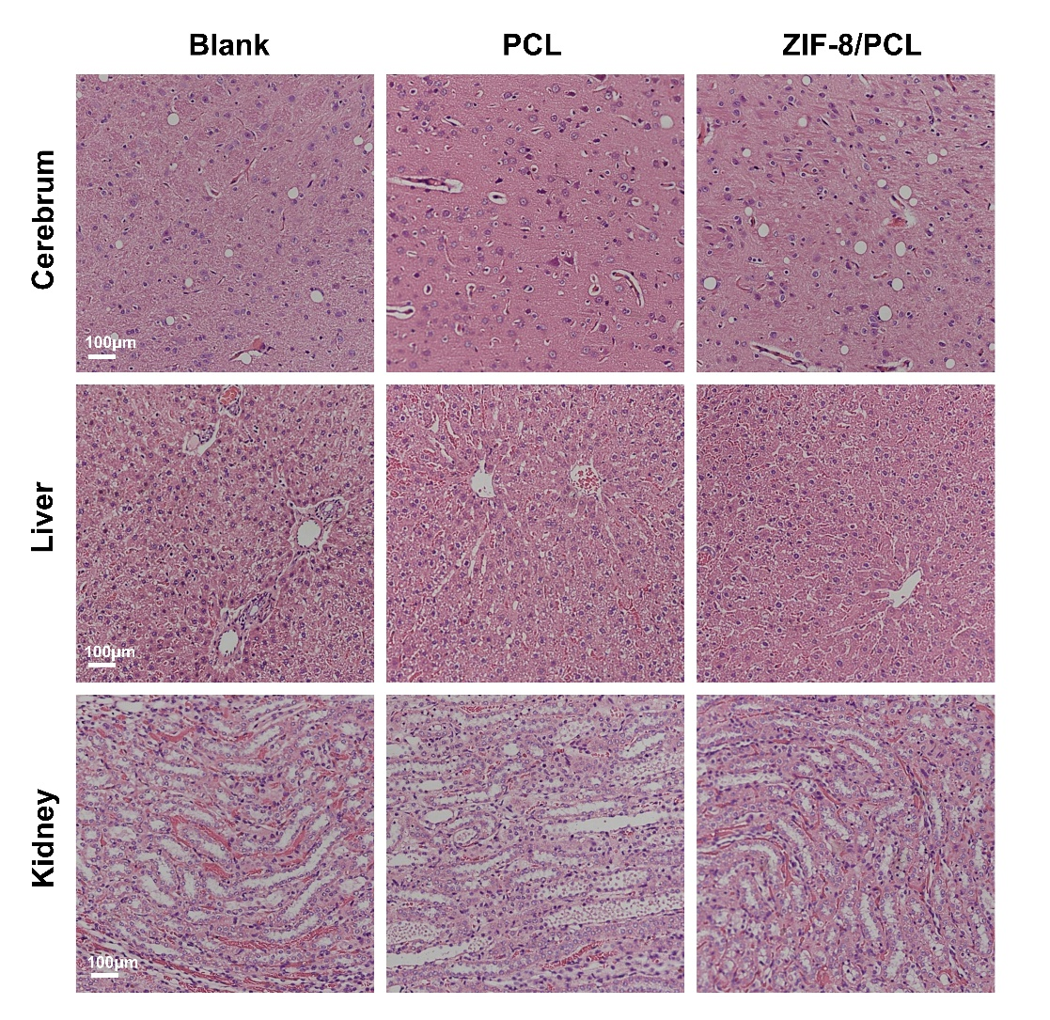

Figure S2. Histological analysis on major organs. Cerebrum, liver and kidney sections of the ZIF-8/PCL treated rats appeared histologically normal with no significant pathological changes.

Figure S3. Characterization of mineralization properties of ZIF-8/PLA. ZIF-8 was synthesized with PLA by electrospinning. a) SEM images showing mineral deposition on the surface of ZIF-8/PLA electrospun fibers after the 7 days incubation process in SBF, and the diameter of the fibers were increased. b) The elements mapping indicates that the deposition contains Ca, P and Zn elements.

Figure S4. Characterization of mineralization properties of PCL combined with other subtypes MOFs. The mineralization properties were all studied in simulated body fluid (SBF) over a total period of 7 days. a) No noticeable surface topography changes were observed in SEM images, suggesting that MIL-100, UIO-66 do not exhibit mineralization ability. b) The elements mapping indicates that the there was no mineral deposition.

