Supporting Information

Electrochemical Reduction of Carbon Dioxide to Methanol on Defective Graphene Supported Cu Based Single-Atom Catalysts: A First Principles Approach
Liu Jing¹, Jun Zhao^{1*}, Yang Li¹, Chuangwei Liu², Mohamed E. Zayed^{1,3}
( ¹ Tianjin University, Key Laboratory of Efficient Utilization of Low and Medium Grade Energy
, Ministry of Education, China, Tianjin 300350).
( 2 Department of Energy Conversion and Storage, Technical University of Denmark, 2800 Kgs. Lyngby, Denmark).
(3 Mechanical Power Engineering Department, Faculty of Engineering, Tanta University, Tanta 31521, Egypt).

Table S1 DFT electronic energy (𝐸_{DFT}), zero point energy correction (ZPE), and entropy contribution (–TS) of Cu-G3/4 surface systems. All data are given in eV.
(S1-t)
 | E（ev） | ZPE（ev） | TS（ev）-
CO2 | -23 | 0.8 | 0.67
H2 | -6.77 | 0.3 | 0.4
H2O | -14.23 | 1.34 | 0.67
CH4 | -24.07 | 1.91 | 0.6
CH3OH | -30.44 | 1.89 | 0.79
Cu-G3 | -153.77 | 2.66 | 0.37
(S1-a)
Cu-G3-HCOO | E (ev) | ZPE (ev) | T (ev) | Free energy G | ΔG
*+CO2+6(H++e-） | -193.55 | 1.7 | 1.87 | -193.72 | 0
*HCOO+5(H++e-） | -196.81 | 4.09 | 1.52 | -194.24 | -0.52
*HCOOH+4(H++e-） | -197.36 | 4.29 | 1.32 | -194.39 | -0.15
*CHO+3(H++e-） | -197.35 | 4.39 | 1.17 | -194.13 | 0.26
CH2O*+2(H++e-）+H2O | -198.19 | 5.27 | 1.46 | -194.38 | -0.25
CH3O*+1(H++e-）+H2O | -198.9 | 5.29 | 1.4 | -195.01 | -0.63
*+CH3OH+H2O | -198.42 | 3.23 | 1.46 | -196.65 | -1.64
(S1-b)
Cu-G3-COOH | E (ev) | ZPE (ev) | T (ev) | Free energy G | ΔG
*+CO2+6(H⁺+e⁻） | -193.55 | 1.7 | 1.87 | -193.72 | 0
*COOH+5(H⁺+e⁻） | -196.12 | 4.09 | 1.54 | -193.57 | 0.15
*CO+4(H++e-)+H2O | -196.85 | 4.85 | 1.97 | -193.97 | -0.4
*CHO+3(H++e-)+H2O | -196.39 | 4.97 | 1.85 | -193.27 | 0.7
*CH2O+2(H++e-）+H2O | -197.21 | 4.82 | 1.56 | -193.95 | -0.68
*CH3O+1(H++e-）+H2O | -198.94 | 5.29 | 1.4 | -195.05 | -1.1
*+CH3OH+H2O | -198.46 | 3.23 | 1.46 | -196.69 | -1.64
(S1-c)
Cu-G4-HCOO | E（ev） | ZPE（ev） | TS（ev） | G=E+ZPE-TS | ΔG
*+CO2+6(H⁺+e⁻） | -184.13 | 1.7 | 1.87 | -184.3 | 0
*HCOO+5(H++e-） | -186.17 | 3.94 | 1.57 | -183.8 | 0.5
*HCOOH+4(H⁺+e⁻） | -185.68 | 4.01 | 1.33 | -183 | 0.8
*CHO+3(H⁺+e⁻） | -184.5 | 3.74 | 1.29 | -182.05 | 0.95
*CH2O+2(H++e-）+H2O | -185.81 | 4.97 | 1.51 | -182.35 | -0.3
*CH3O+1(H++e-）+H2O | -187.1 | 5.15 | 1.4 | -183.35 | -1
*+CH3OH+H2O | -186.76 | 3.23 | 1.46 | -184.99 | -1.64
(S1-d)
Cu-G4-COOH | E（ev） | ZPE（ev） | TS（ev） | G=E+ZPE-TS | ΔG
*+CO2+6(H++e-） | -184.13 | 1.7 | 1.87 | -184.3 | 0
*COOH+5(H++e-） | -185.77 | 3.95 | 1.46 | -183.28 | 1.02
*CO+4(H++e-)+H2O | -186.53 | 4.71 | 2.09 | -183.91 | -0.63
*CHO+3(H++e-)+H2O | -186.74 | 4.92 | 1.69 | -183.51 | 0.4
*OCH2+2(H++e-）+H2O | -187.68 | 4.98 | 1.31 | -184.01 | -0.5
*OCH3+1(H++e-）+H2O | -188.6 | 5.08 | 1.49 | -185.01 | -1
*+CH3OH+H2O | -188.42 | 3.23 | 1.46 | -186.65 | -1.64

Table S2 Charge per atom of Cu-G3. MIN DIST = Minimum distance from nucleus to basin boundary
 | X | Y | Z | CHARGE | MIN DIST | ATOMIC VOL
1 | 3.689066 | 6.449756 | 1.272905 | 3.851373 | 0.578938 | 28.417112 | 0.148627
2 | 1.183737 | 0.680924 | 1.352342 | 4.077504 | 0.601546 | 23.496492 | -0.0775
3 | 6.177465 | 2.130504 | 1.28145 | 3.819937 | 0.550823 | 28.388627 | 0.180063
4 | -0.071675 | 2.857742 | 1.34751 | 4.047599 | 0.510561 | 23.28571 | -0.0476
5 | 4.949696 | 4.299452 | 1.30352 | 3.979063 | 0.523316 | 25.494648 | 0.020937
6 | 1.295424 | 5.010578 | 1.29465 | 3.847781 | 0.585258 | 28.180694 | 0.152219
7 | 1.296555 | 6.440083 | 1.310588 | 4.116217 | 0.519216 | 27.421594 | -0.11622
8 | 3.683077 | 0.687624 | 1.327333 | 3.844417 | 0.563642 | 22.275951 | 0.155583
9 | 1.072796 | 2.067442 | 1.53085 | 4.201467 | 0.518736 | 24.605946 | -0.20147
10 | 0.059024 | 4.292682 | 1.316491 | 4.072258 | 0.542902 | 27.135329 | -0.07226
11 | 1.18957 | 5.015504 | 1.318227 | 3.827346 | 0.56113 | 22.344312 | 0.172654
12 | 1.204137 | 6.4497 | 1.271702 | 4.061655 | 0.554341 | 29.305814 | -0.06166
13 | 6.174343 | 0.696825 | 1.289191 | 4.061405 | 0.554914 | 29.469597 | -0.0614
14 | 3.79102 | 2.080771 | 1.448615 | 4.207745 | 0.610291 | 28.109484 | -0.20775
15 | 4.94999 | 2.862237 | 1.317689 | 4.137945 | 0.578167 | 22.904024 | 0.13795
16 | 2.44919 | 4.410884 | 1.441962 | 4.1126 | 0.532154 | 25.253958 | -0.1126
17 | 3.706421 | 5.021557 | 1.312905 | 4.246681 | 0.612587 | 23.114806 | -0.24668
18 | 2.454531 | 2.867108 | 2.51091 | 10.486979 | 0.768158 | 144.149227 | 0.513021

The valence of carbon atoms is positive 4. We can see that the valence of carbon atoms from 1 to 17 is about 4. The change of valence is caused by copper atoms. The atomic serial number is identified in Figure S1. No. 17 is a copper atom
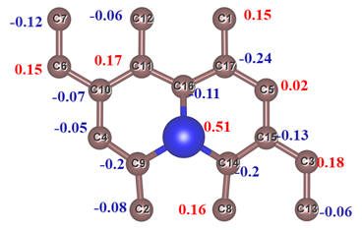
Fig. S1 The atomic serial number of Cu-G3
Table S3 Charge per atom of Cu-G4. MIN DIST = Minimum distance from nucleus to basin boundary
 | X | Y | Z | CHARGE | MIN DIST | ATOMIC VOL
1 | 3.846754 | 6.218992 | 2.299594 | 4.127713 | 0.56325 | 24.955536 | -0.12771
2 | 1.257219 | 0.737307 | 2.299392 | 3.927144 | 0.615299 | 24.632589 | 0.072856
3 | 6.390755 | 2.024589 | 2.299266 | 4.053457 | 0.552077 | 23.97812 | -0.05346
4 | 0.075506 | 2.760596 | 2.30072 | 4.276621 | 0.523468 | 24.278204 | -0.27662
5 | 2.496358 | 4.196488 | 2.301916 | 3.905929 | 0.537056 | 22.31337 | 0.094071
6 | 1.285876 | 4.931259 | 2.300048 | 3.785293 | 0.499931 | 22.324802 | 0.214707
7 | 2.551784 | 0.065314 | 2.300056 | 4.033009 | 0.527623 | 23.933822 | FALSE
8 | 3.847229 | 0.736691 | 2.30011 | 3.94453 | 0.554003 | 24.574001 | 0.05547
9 | 1.182927 | 2.142609 | 2.298709 | 4.273949 | 0.458805 | 29.385344 | -0.27395
10 | 0.075224 | 4.196808 | 2.298042 | 4.008803 | 0.493751 | 22.176189 | -0.0088
11 | 1.183395 | 4.815475 | 2.300178 | 4.118183 | 0.55702 | 28.4608 | -0.11818
12 | 1.256797 | 6.218542 | 2.299915 | 3.777037 | 0.573012 | 23.305075 | 0.222963
13 | 6.390822 | 0.616429 | 2.299603 | 3.964879 | 0.534357 | 23.760917 | 0.035121
14 | 3.921039 | 2.141063 | 2.300959 | 4.264234 | 0.654637 | 29.040962 | -0.26423
15 | 5.179919 | 2.759404 | 2.29842 | 4.107765 | 0.542563 | 23.060721 | -0.10777
16 | 3.921902 | 4.815002 | 2.299502 | 4.064047 | 0.507448 | 28.323619 | -0.06405
17 | 2.55285 | 3.477905 | 2.299839 | 10.367425 | 0.771276 | 40.475581 | 0.632575
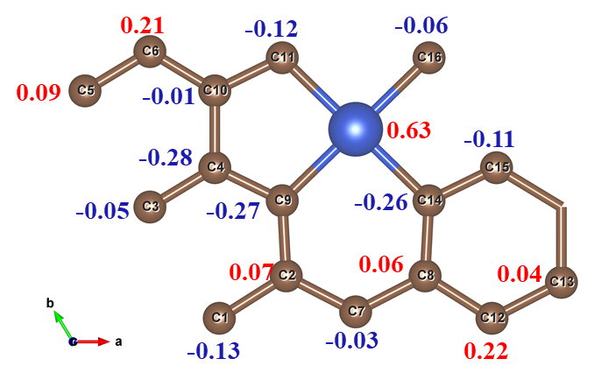
Fig. S2 The atomic serial number of Cu-G4

