Supplementary Figure 1. Study patient flow chart

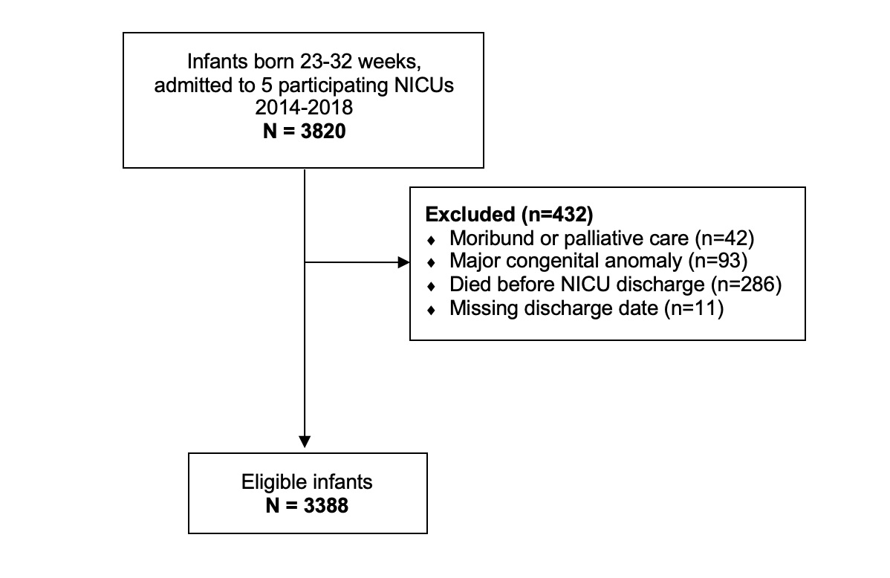

Supplementary Table 1. Infant characteristics according to discharge destination
Variables | Home | Other unit | P-value
Variables | N=1883 | N=1504 | P-value
Infant characteristics
Gestational age, weeks | 29 [27-31] | 30 [29-32] | <0.01
Gestational age group |  |  | <0.01
23-25 weeks | 289 (15) | 102 (7)
26-28 weeks | 586 (31) | 268 (18)
29-30 weeks | 429 (23) | 393 (26)
31-32 weeks | 579 (31) | 741 (49)
Birth weight, grams | 1190 [900-1570] | 1480 [1160-1780] | <0.01
Male sex | 989 (53) | 820 (55) | 0.25
Small for gestational age | 207 (11) | 130 (9) | 0.03
Multiple births | 529 (28) | 431 (29) | 0.75
Caesarean birth | 1289 (69) | 969 (65) | 0.02
Apgar at 5 min <7 | 583 (31) | 385 (26) | <0.01
SNAP-II score >20 | 250 (13) | 150 (10) | <0.01
Discharge characteristics
Length of stay, days | 69 [45-97] | 30 [15-56] | <0.01
Corrected gestational age at discharge, weeks | 39 [37-41] | 35 [33-37] | <0.01
Readmitted to a Level 3 NICU | 64 (3) | 58 (4) | 0.54
Data presented as n (%) for categorical variables and median [IQR] for continuous variables
Abbreviations: NICU, neonatal intensive care unit; SNAP-II, Score for Neonatal Acute Physiology version II
P-values derived from the Chi-square test for categorical variables and Wilcoxon Rank sum test for continuous variables

Supplementary Table 2. Standardized ratios with 95% confidence intervals for probability of discharge according to NICU occupancy quintiles among infants born <33 weeks stratified by NICU

Quintile | Quintile bounds | Observed number of discharges | Expected number of discharges | Standardized ratio (95% CI)
NICU 1
1 | [60-83] | 133 | 127 | 1.05 (0.87, 1.23)
2 | (83-88] | 116 | 127 | 0.92 (0.75, 1.08)
3 | (88-91] | 104 | 127 | 0.82 (0.66, 0.98)
4 | (91-95] | 129 | 127 | 1.02 (0.84, 1.19)
5 | (95-127] | 151 | 127 | 1.19 (1.00, 1.38)
NICU 2
1 | [71-86] | 156 | 192 | 0.81 (0.68, 0.94)
2 | (86-90] | 174 | 192 | 0.91 (0.77, 1.04)
3 | (90-93] | 197 | 192 | 1.02 (0.88, 1.17)
4 | (93-96] | 162 | 192 | 0.84 (0.71, 0.97)
5 | (96-107] | 272 | 192 | 1.42 (1.25, 1.58)
NICU 3
1 | [57-77] | 115 | 141 | 0.81 (0.67, 0.96)
2 | (77-82] | 121 | 141 | 0.86 (0.70, 1.01)
3 | (82-87] | 146 | 141 | 1.03 (0.87, 1.20)
4 | (87-92] | 128 | 141 | 0.91 (0.75, 1.06)
5 | (92-110] | 196 | 141 | 1.39 (1.19, 1.58)
NICU 4
1 | [65-85] | 117 | 140 | 0.84 (0.69, 0.99)
2 | (85-90] | 160 | 140 | 1.15 (0.97, 1.32)
3 | (90-94] | 161 | 140 | 1.15 (0.98, 1.33)
4 | (94-97] | 113 | 140 | 0.81 (0.66, 0.96)
5 | (97-106] | 147 | 140 | 1.05 (0.88, 1.22)
NICU 5
1 | [30-61] | 36 | 78 | 0.46 (0.31, 0.61)
2 | (61-71] | 55 | 78 | 0.71 (0.52, 0.89)
3 | (71-81] | 93 | 78 | 1.19 (0.95, 1.43)
4 | (81-90] | 89 | 78 | 1.14 (0.90, 1.38)
5 | (90-124] | 117 | 78 | 1.50 (1.23, 1.77)

Supplementary Table 3. Standardized ratios with 95% confidence intervals for probability of discharge according to NICU nurse-to-patient ratio quintiles among infants <33 weeks stratified by NICU in the 4 sites with nursing data (n=2325)

Quintile | Observed number of discharges | Expected number of discharges | Standardized ratio (95% CI)
1 | 475 | 465 | 1.02 (0.93, 1.11)
2 | 433 | 465 | 0.93 (0.84, 1.02)
3 | 486 | 465 | 1.05 (0.95, 1.14)
4 | 490 | 465 | 1.06 (0.96, 1.15)
5 | 438 | 465 | 0.94 (0.85, 1.03)

Supplementary Table 4. Negative binomial regression analysis for association of length of stay and NICU occupancy quintile among infants born <33 weeks and among gestational age subgroups
Variables | Rate ratios, days (95% CI)*
 | All infants born <33 weeks | Subgroup of infants  born <29 weeks | Subgroup of infants  born 29-32 weeks
Gestational age (1 week increase) | 0.81 (0.80, 0.81) | 0.87 (0.86, 0.88) | 0.75 (0.73, 0.77)
Male sex | 0.97 (0.94, 1.00) | 1.01 (0.97, 1.04) | 0.94 (0.90, 0.99)
Small for gestational age | 1.39 (1.32, 1.47) | 1.29 (1.21, 1.37) | 1.44 (1.33, 1.56)
Multiplicity | 1.03 (0.99, 1.07) | 1.08 (1.04, 1.12) | 1.00 (0.95, 1.06)
Occupancy quintile
Quintile 1 (lowest) | Reference | Reference | Reference
Quintile 2 | 0.99 (0.94, 1.05) | 1.00 (0.95, 1.06) | 0.99 (0.91, 1.07)
Quintile 3 | 0.96 (0.91, 1.01) | 0.97 (0.92, 1.02) | 0.96 (0.88, 1.04)
Quintile 4 | 0.97 (0.92, 1.02) | 0.97 (0.92, 1.03) | 0.97 (0.90, 1.05)
Quintile 5 (highest) | 0.88 (0.84, 0.93) | 0.97 (0.92, 1.02) | 0.84 (0.78, 0.91)
*Adjusted for gestational age (weeks), sex, small for gestational age status, multiple births and occupancy quintile

