Additional file 2:
Distribution of b-value in the central and southern Ryukyu: Is the low b-value in the rift-axis of the Okinawa Trough accurate?
Mamoru Nakamura

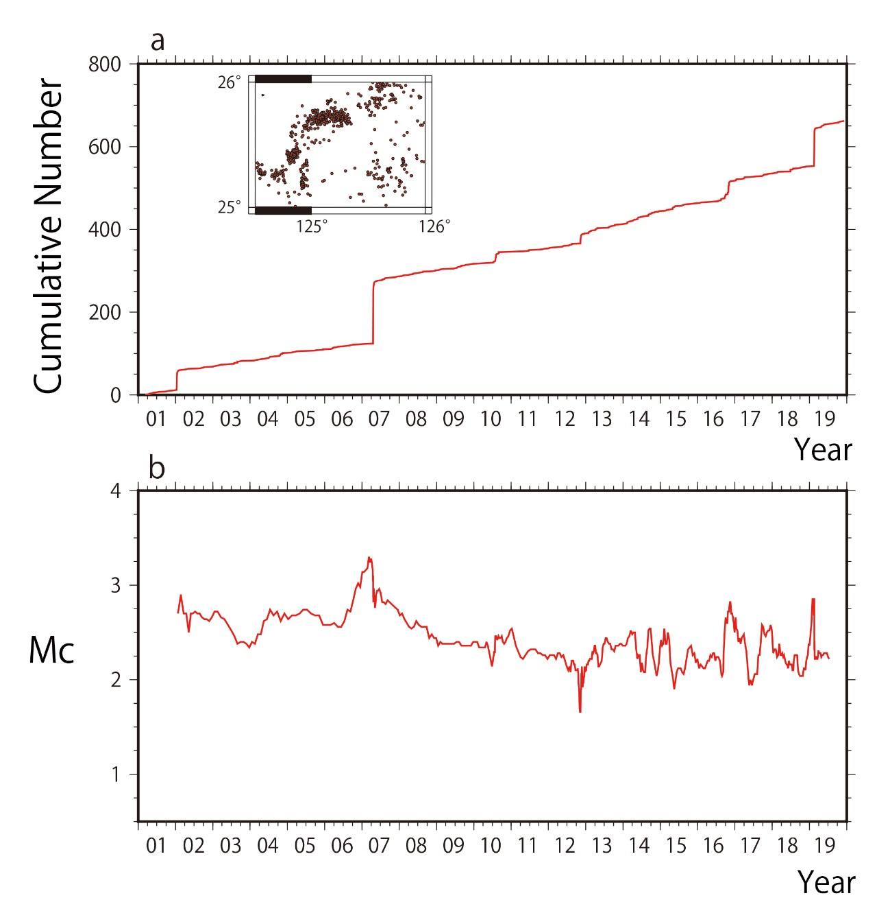
Figure S1. Time variation of M_{C} in the MI. a Cumulative number of earthquakes (M_{V} ≥ 3.0). The inset shows the calculation area. Red circles indicate hypocenters. b Time variation of M_{C}. The M_{C} was calculated using Zmap7, shifting by 5% for every 100 earthquakes on the time axis.
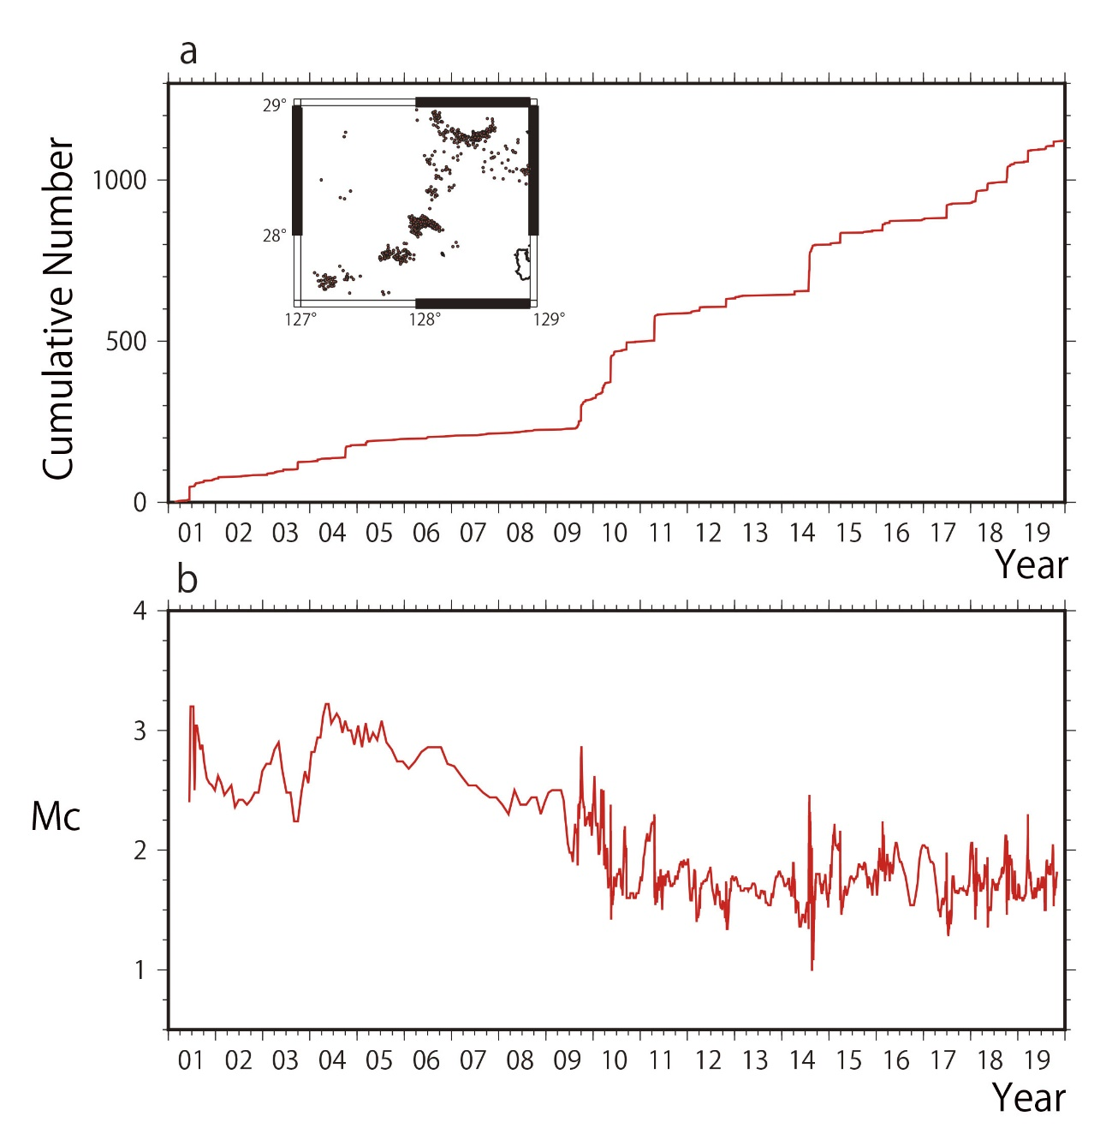
Figure S2. The same as Figure S1 but in the AM.
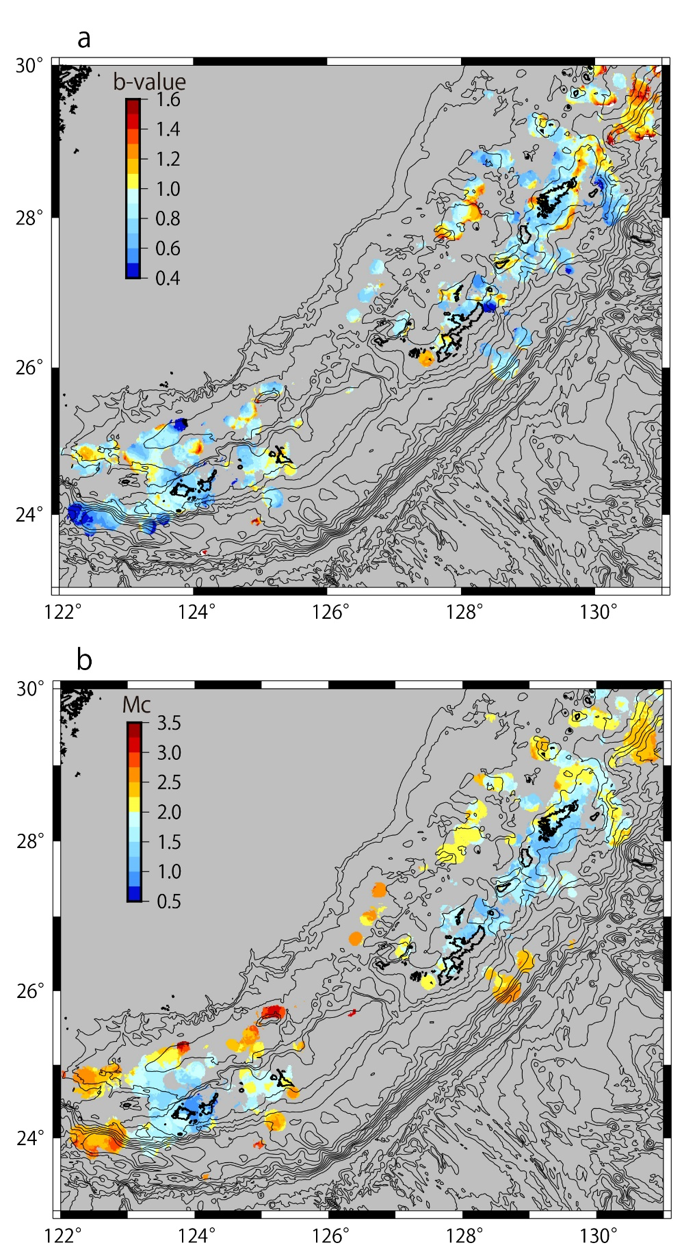
Figure S3. Distribution of b-values and M_{C} in the south-central part of the Ryukyu determined by M_{J}. a Distribution of b-values. b Distribution of M_{C}.

