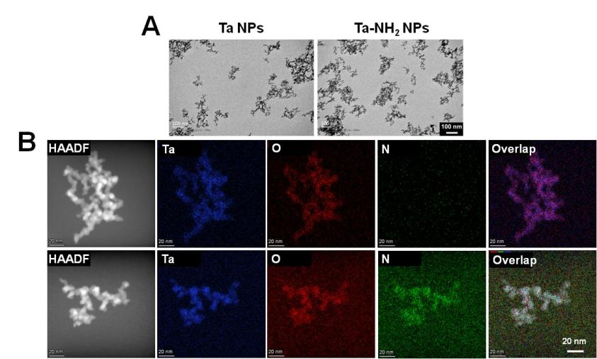Figure S1. (A) TEM images of Ta NPs and Ta-NH₂ NPs. (B) Dark-field TEM image of Ta NPs and Ta-NH₂ NPs and corresponding TEM elemental mappings.
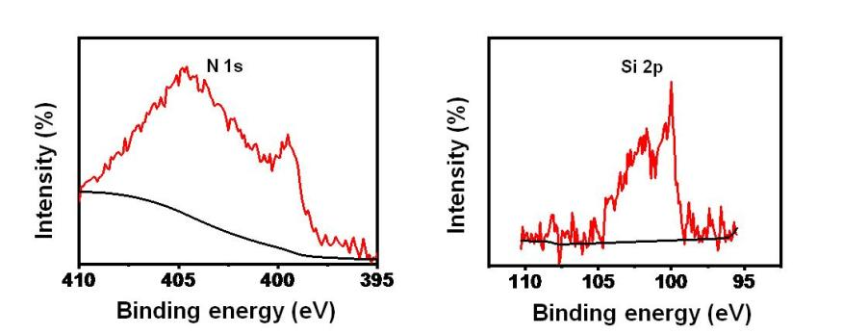
Figure S2. High resolution XPS spectra of N 1s and Si 2p.
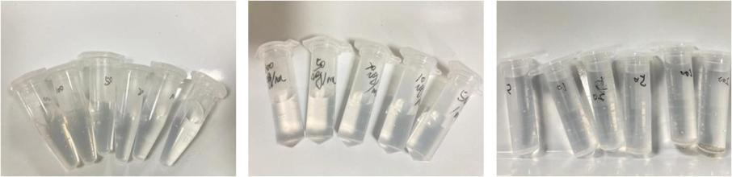
Figure S3. Bubbles were generated after adding Ta-NH₂ NPs into H₂O₂ solution
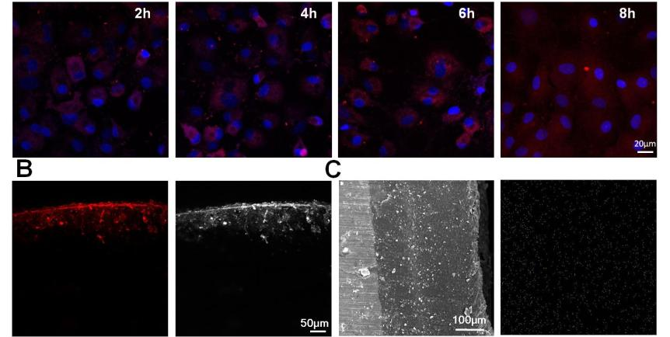
Figure S4. (A) Cy5.5-labeled Ta-NH₂ NPs were phagocytosed by chondrocytes. (B) The affinity of Ta-NH₂ NPs to articular cartilage was observed by confocal microscope and (C) the distribution of tantalum in cartilage was observed by scanning electron microscope
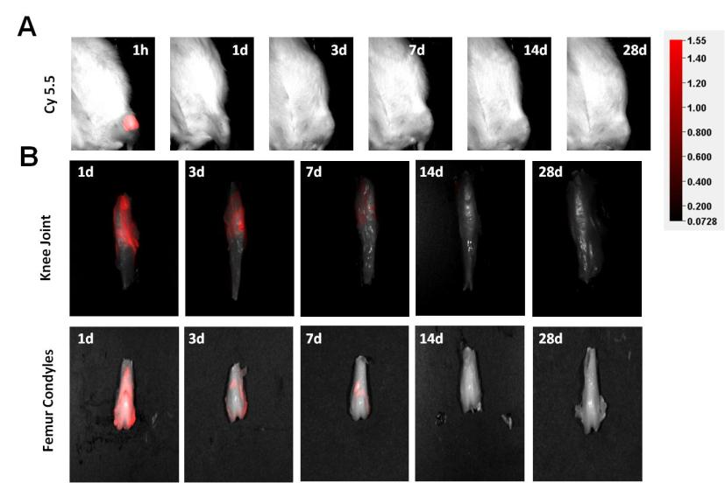
Figure S5. (A) In vivo detection in fluorescence intensity of cy5.5 in rat knee joints for 28 d. (B) Knee and femoral condyle fluorescence reimaging of cy5.5 labeled CAT at 1-28 d.
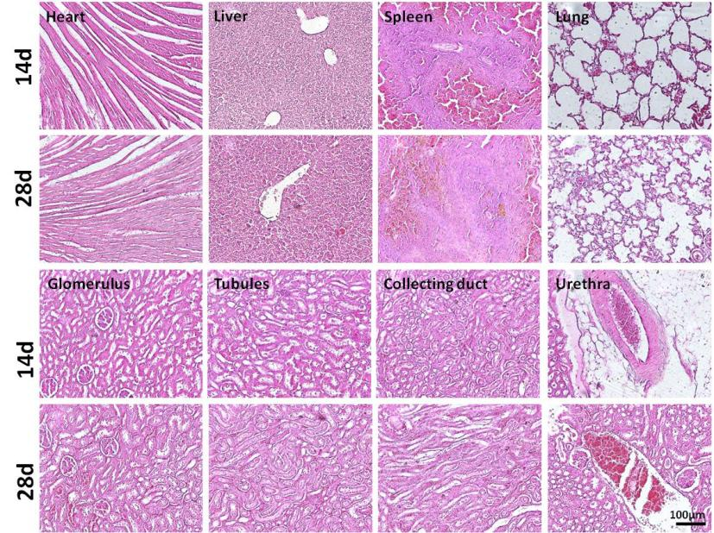
Figure S6. Evaluation of in vivo toxicity of Ta-NH₂ NPs to major organs (heart, liver, spleen, and lung) at 14d and 28d post single intra-articular injection.

