Supporting information

Bacterial Outer Membrane Vesicle Based Versatile Nanosystem Boosts the Efferocytosis Blockade Triggered Tumor-Specific Immunity
Wan-Ru Zhuang¹, Yunfeng Wang¹, Weidong Nie¹, Yao Lei¹, Chao Liang¹, Jiaqi He¹, Liping Zuo¹, Li-Li Huang², Hai-Yan Xie^{1,}*

¹ School of Life Science, Beijing Institute of Technology, Beijing 100081, P.R. China
² School of Medical Technology, Beijing Institute of Technology, Beijing 100081, P.R. China
E-mail: hyanxie@bit.edu.cn

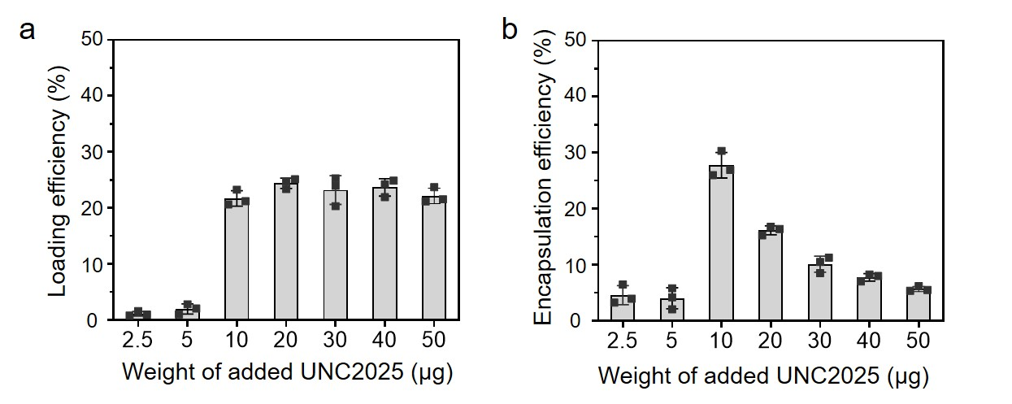
Supplementary Figure 1 Loading efficiency (a) and encapsulation efficiency (b) of UNC2025 in OMVs. Different amounts of UNC2025 were individually incubated with the same amount of OMVs (10 µg). The loading was saturated when 10 µg UNC2025 was added. Data are presented as mean ± s.d. (n = 3).

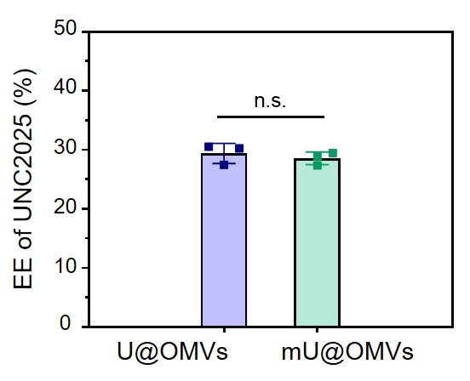
Supplementary Figure 2 Encapsulation efficiency (EE) of UNC2025 after functionalizing U@OMVs with Mal as quantified by UV-vis spectrum. Data are presented as mean ± s.d. (n = 3). Statistically significant differences between groups were identified by one-way ANOVA. n.s., not significant.

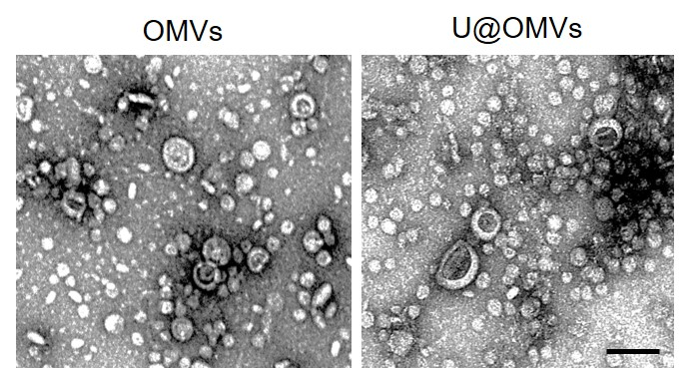
Supplementary Figure 3 TEM images of OMVs and U@OMVs. Scale bar: 100 nm.

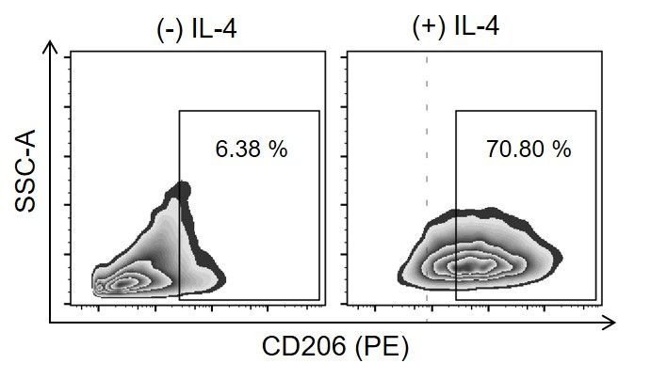
Supplementary Figure 4 Flow cytometry analysis of phenotype transformation of macrophages. 70.80 % of RAW264.7 cells were CD206 positive after the incubation with interleukin-4 (IL-4) for 48 h, indicating the efficient transformation of M0 to M2.

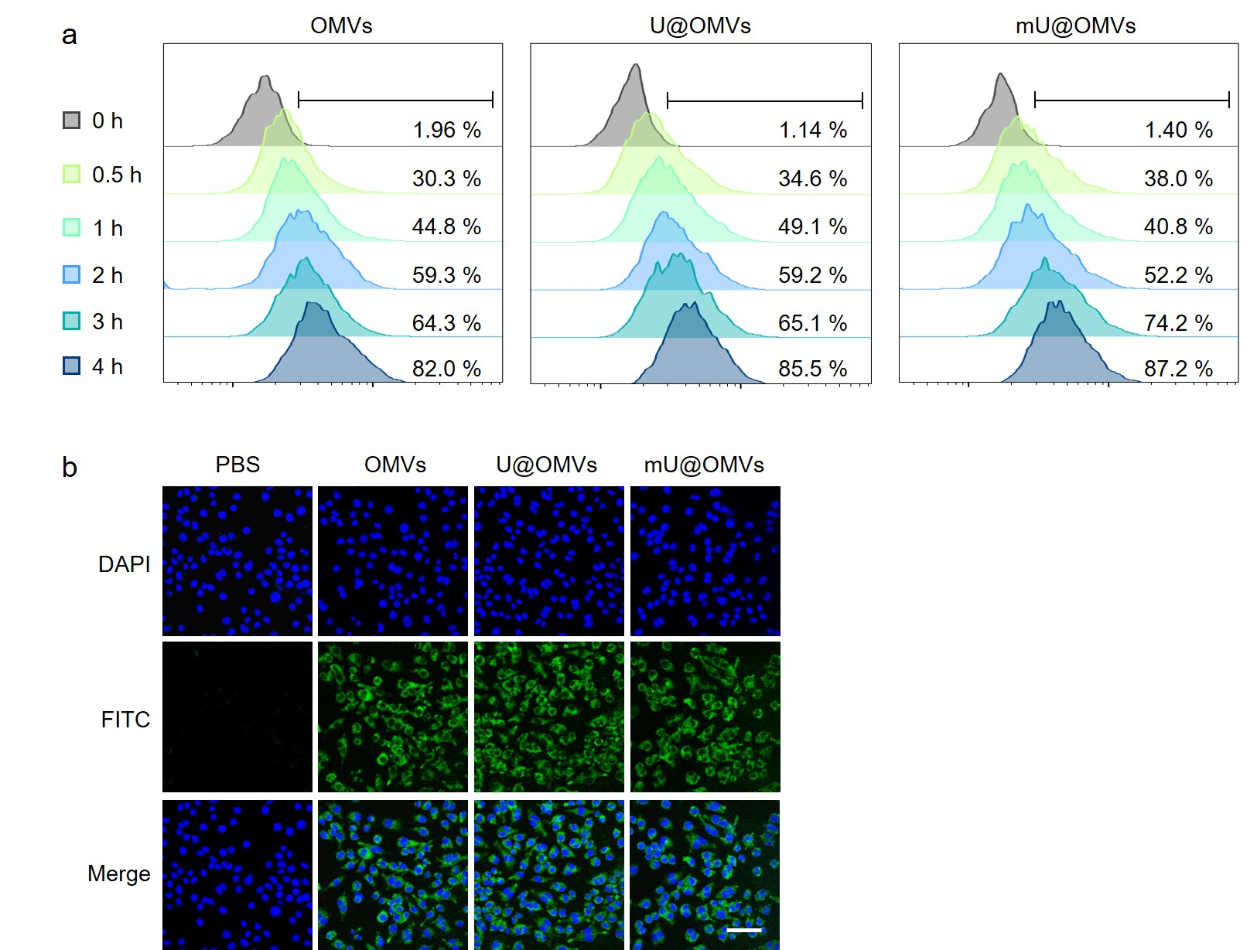
Supplementary Figure 5 Cellular uptake of OMVs, U@OMVs and mU@OMVs in M2 macrophages. a Representative flow cytometry plots of different vesicles at different time points. b Confocal image of cell uptake of different vesicles after incubation for 4 h. Vesicles (FITC-conjugated anti-E. coli LPS labeled, green); cell nucleus (Hoechst 33342, blue). Scale bar: 50 μm.

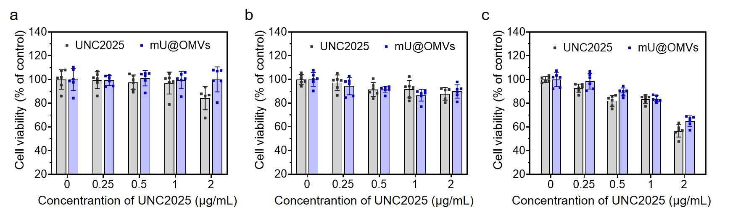
Supplementary Figure 6 Viabilities of RAW264.7 (a), B16F10 (b) and CT26 (c) cells after the incubation with different concentrations of UNC2025 and mU@OMVs for 24 h. Data are presented as mean ± s.d. (n = 6).

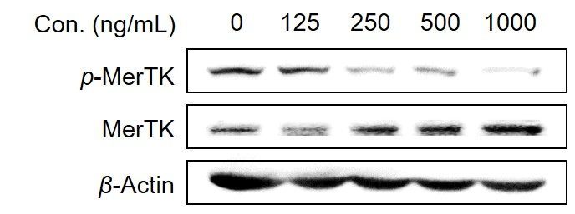
Supplementary Figure 7 Western blot analysis of phosphorylation of MerTK in M2 macrophages after the treatment with different concentrations of free UNC2025 for 2 h.

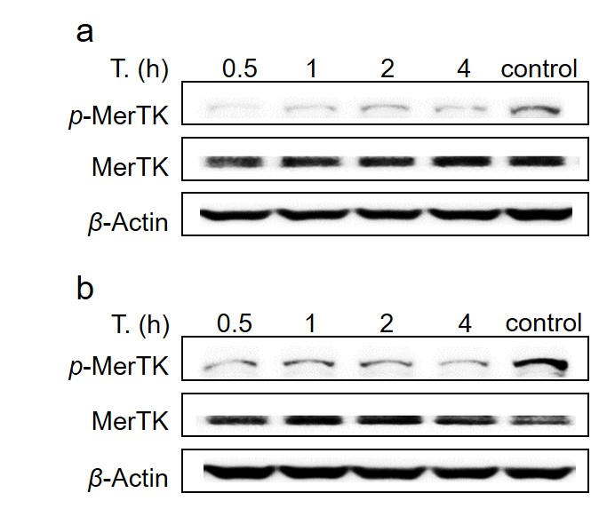
Supplementary Figure 8 Western blot analysis of phosphorylation of MerTK in M2 macrophages after 1000 ng/mL free UNC2025 (a) or mU@OMVs (containing 1000 ng/mL UNC2025) (b) treatment for different incubation time.

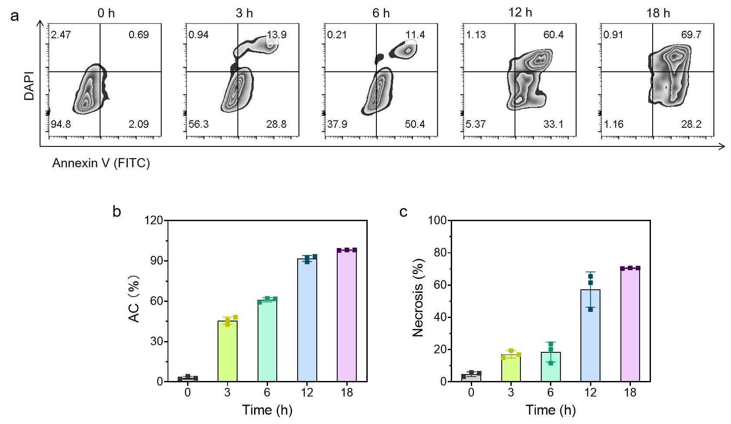
Supplementary Figure 9 Flow cytometry analysis of cell apoptosis by Annexin V-FITC/DAPI double staining in B16F10 melanoma cells treated with 5 μM doxorubicin for 0, 3, 6 h, 12 h, or 18 h. a Representative flow cytometry plots. b Quantification of apoptotic tumor cells (AC) at the indicated time points (Annexin V⁺ tumor cells). c Quantification of necrotic tumor cells at the indicated time points (DAPI⁺ tumor cells). Therefore, the final apoptotic tumor cells were obtained by adding 5 μM doxorubicin to B16F10 cells for 6 h, since around 60 % of B16F10 cells exposed PtdSer on the surface along with little necrosis (< 20 %) at this timepoint. Data are presented as mean ± s.d. (n = 3).

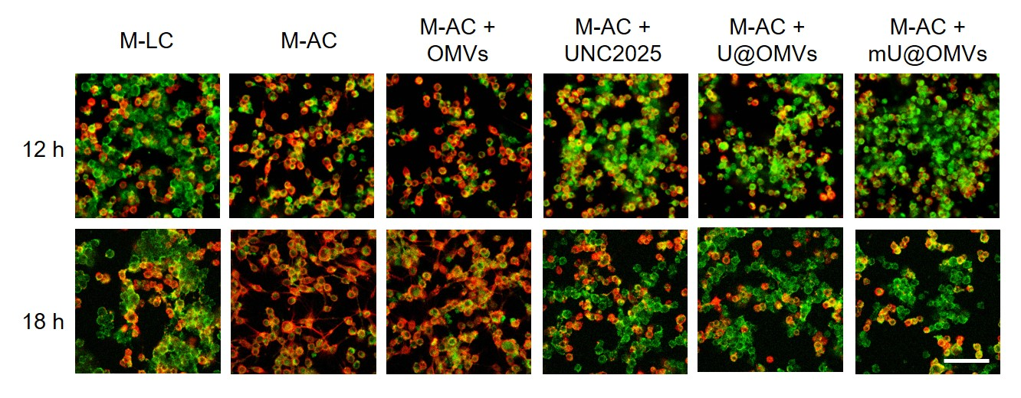
Supplementary Figure 10 CLMS imaging of the phagocytosis of AC (carboxyfluorescein succinimidyl ester (CFSE)-labeled, green) by macrophages (APC-conjugated anti-CD11b labeled, red) after a 12-hour or 18-hour incubation. M: M2 macrophages; LC: living B16F10 cells; AC: apoptotic B16F10 cells. Scale bar: 50 μm.

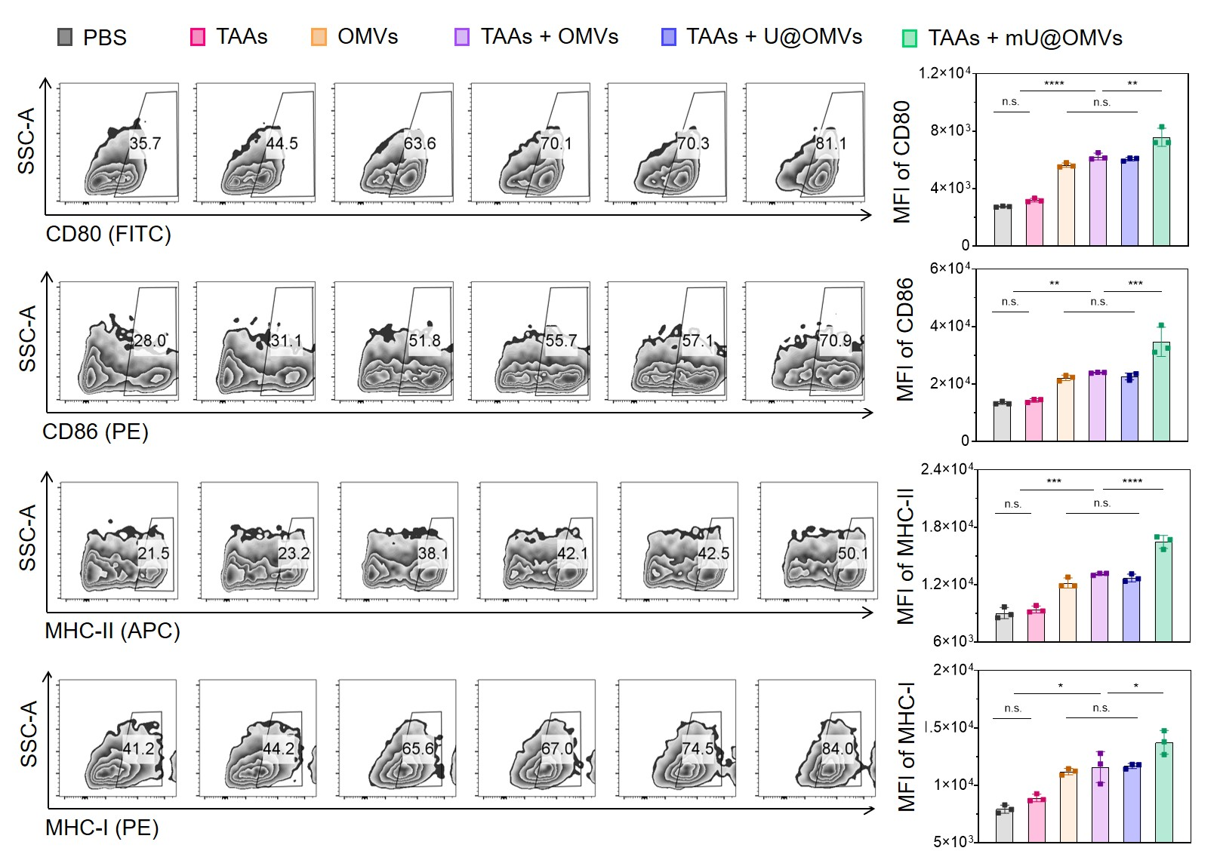
Supplementary Figure 11 Representative flow cytometry plots of CD80, CD86, MHC-II or MHC-I positive cells (gated on CD11c⁺ cells) of BMDCs after different treatments. Data are presented as mean ± s.d. (n = 3).

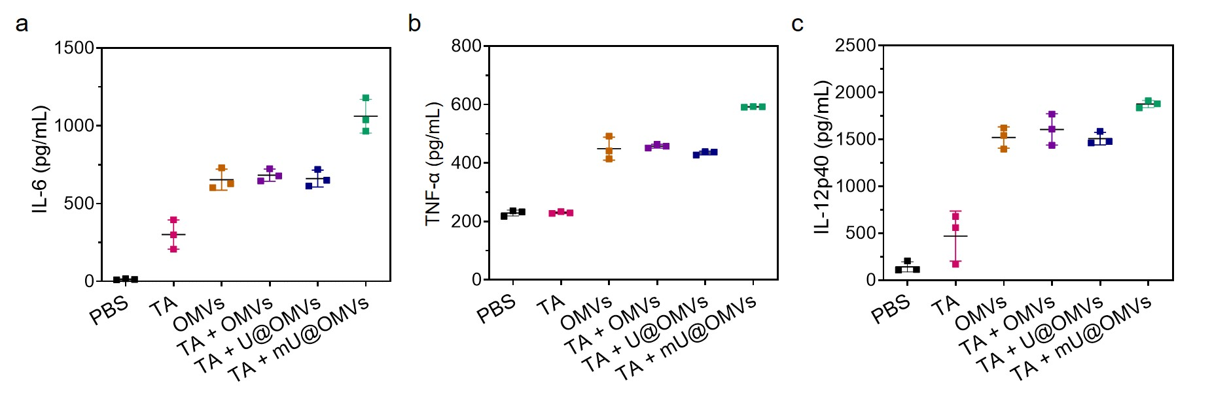
Supplementary Figure 12 Secretion of IL-6 (a), TNF-α (b), and IL-12p40 (c) by BMDCs determined by ELISA. Data are presented as mean ± s.d. (n = 3).

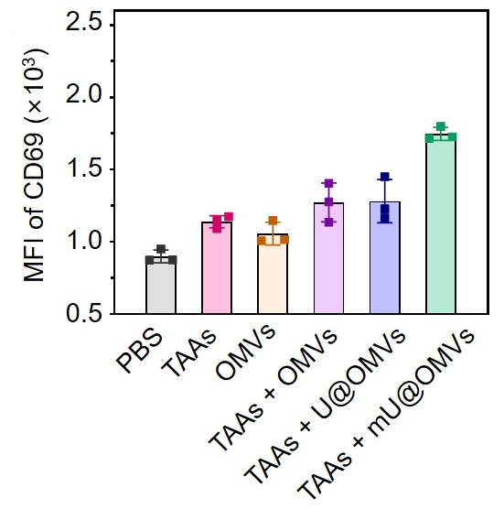
Supplementary Figure 13 Naive T cells are isolated from the spleens of C57BL/6 mice and co-cultured with BMDCs for 24 h. MFI of CD69 (a costimulatory molecule for T cell activation) expressed on T cells were analyzed by flow cytometry (gated on CD8⁺ cells). Data are presented as mean ± s.d. (n = 3).

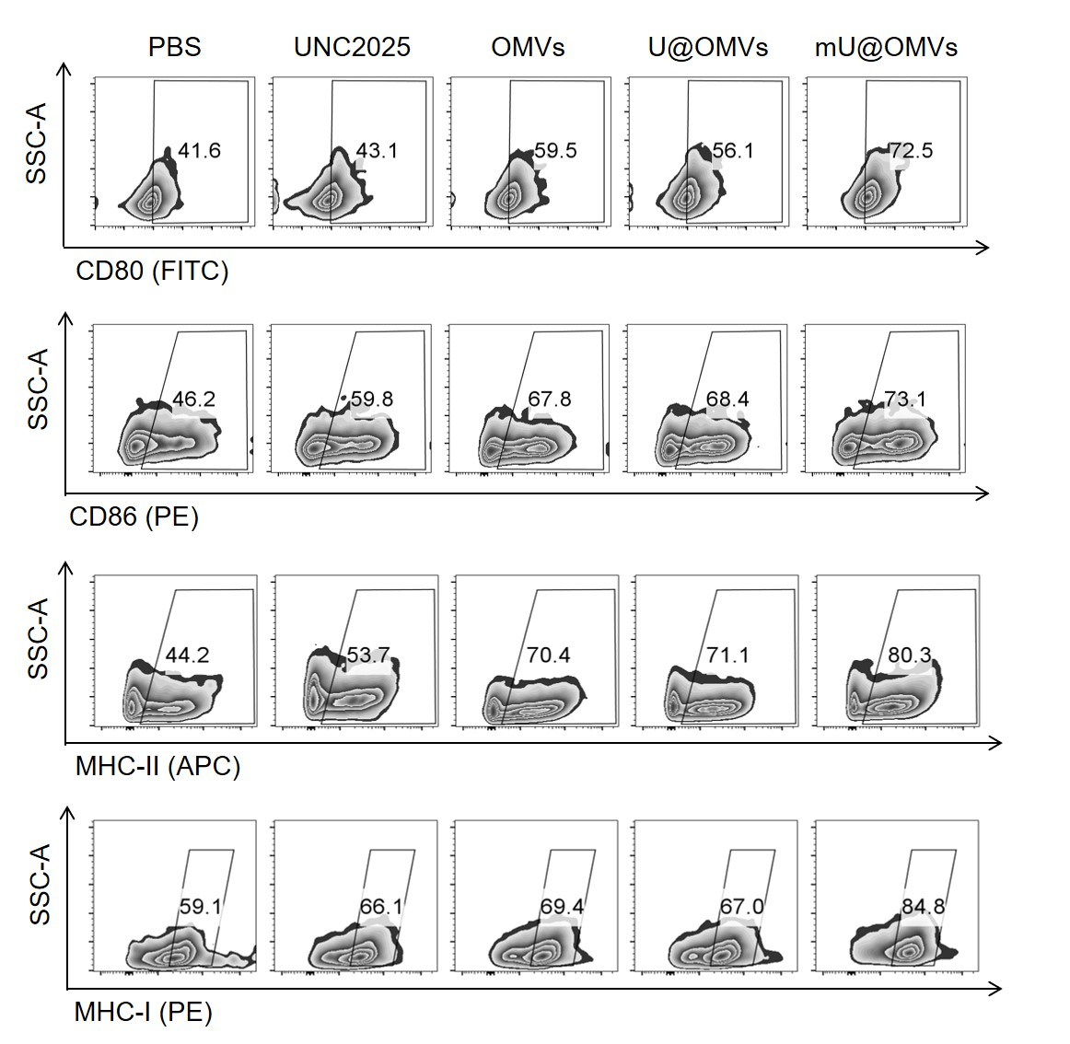
Supplementary Figure 14 Representative flow cytometry plots of CD80⁺, CD86⁺, MHC-II⁺ or MHC-I⁺ cells (gated on CD11c⁺ cells) from different treatment groups in DLNs.

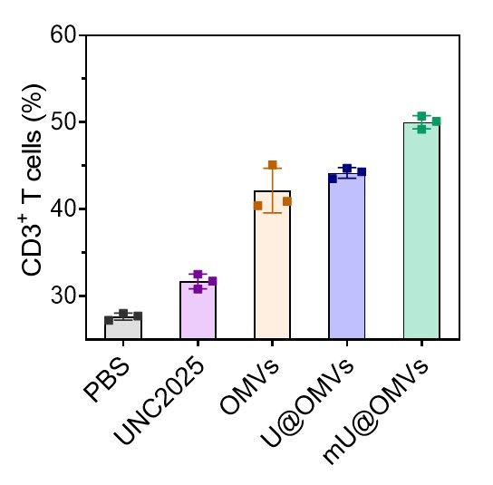
Supplementary Figure 15 The percentages of CD3⁺ T cells from different treatment groups in spleens. Data are presented as mean ± s.d. (n = 3).

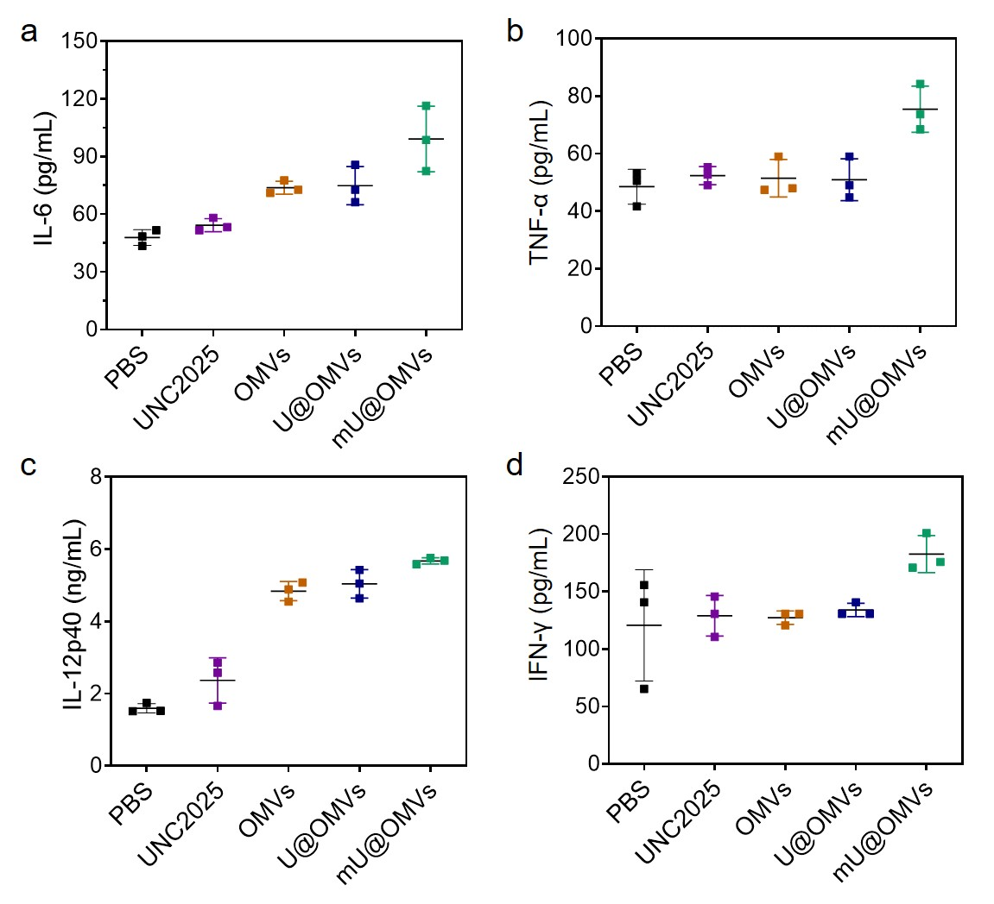
Supplementary Figure 16 The serum levels of proinflammatory cytokines, including IL-6 (a), TNF-α (b), IL-12p40 (c) and IFN-γ (d) from different groups after 48 h administration. Data are presented as mean ± s.d. (n = 3).

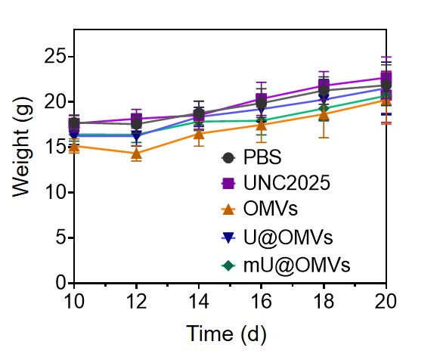
Supplementary Figure 17 Body weight during antitumor experiment against B16F10. Data are presented as mean ± s.d. (n = 9).

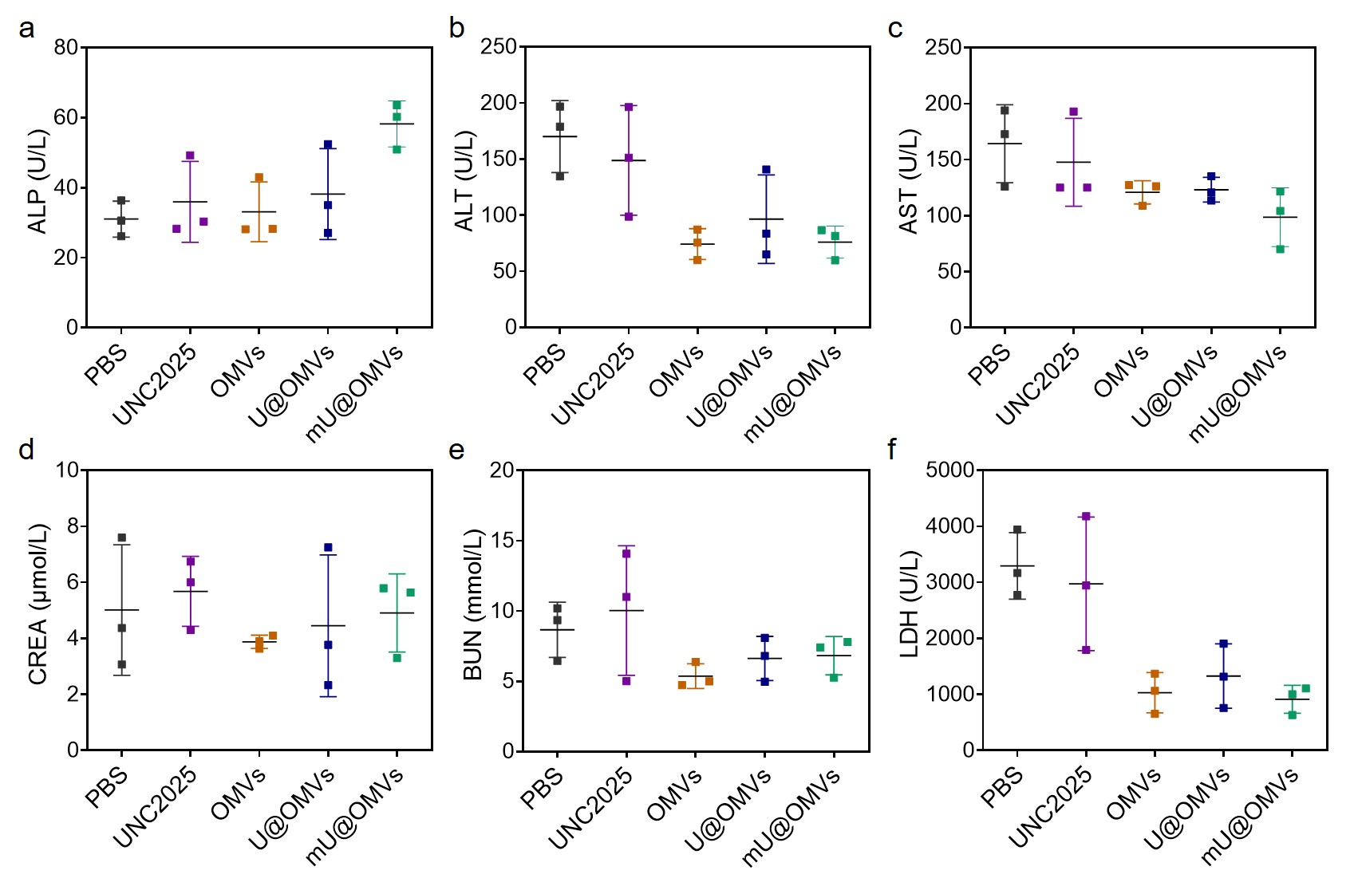
Supplementary Figure 18 Serum biochemical indexes of ALP (a), ALT (b), AST (c), CREA (d), BUN (e) and LDH (f) in different groups at the endpoint of the antitumor experiment against B16F10. Data are presented as mean ± s.d. (n = 3).

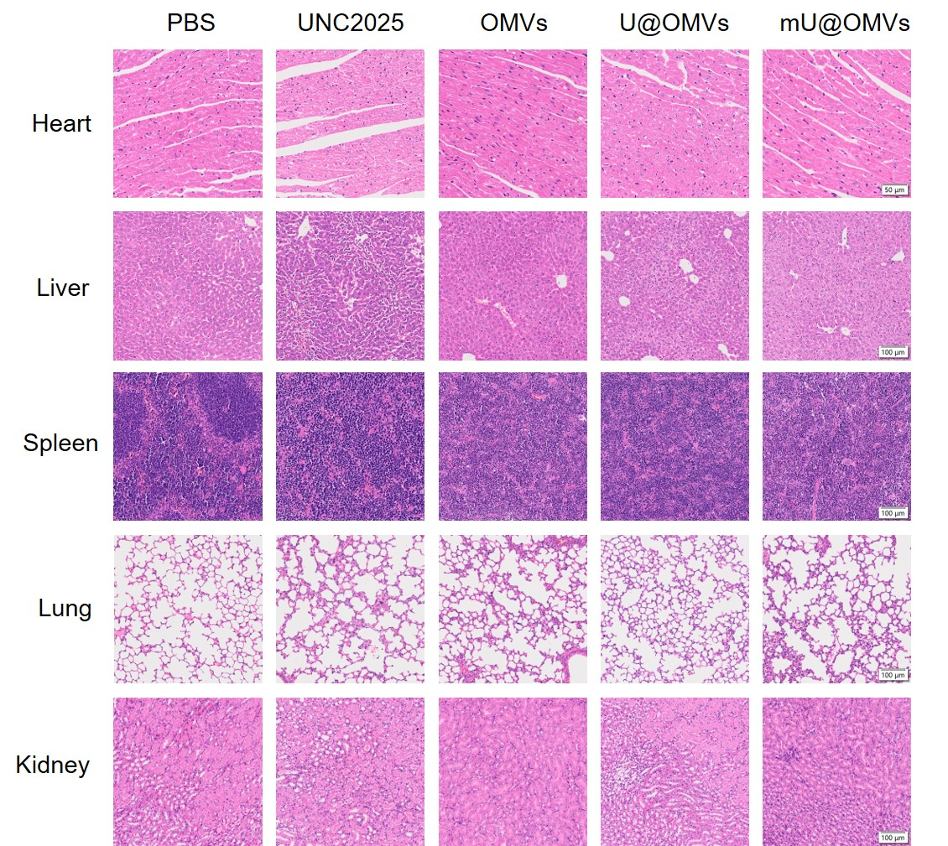
Supplementary Figure 19 H&E staining of major organs at the endpoint of the antitumor experiment against B16F10.

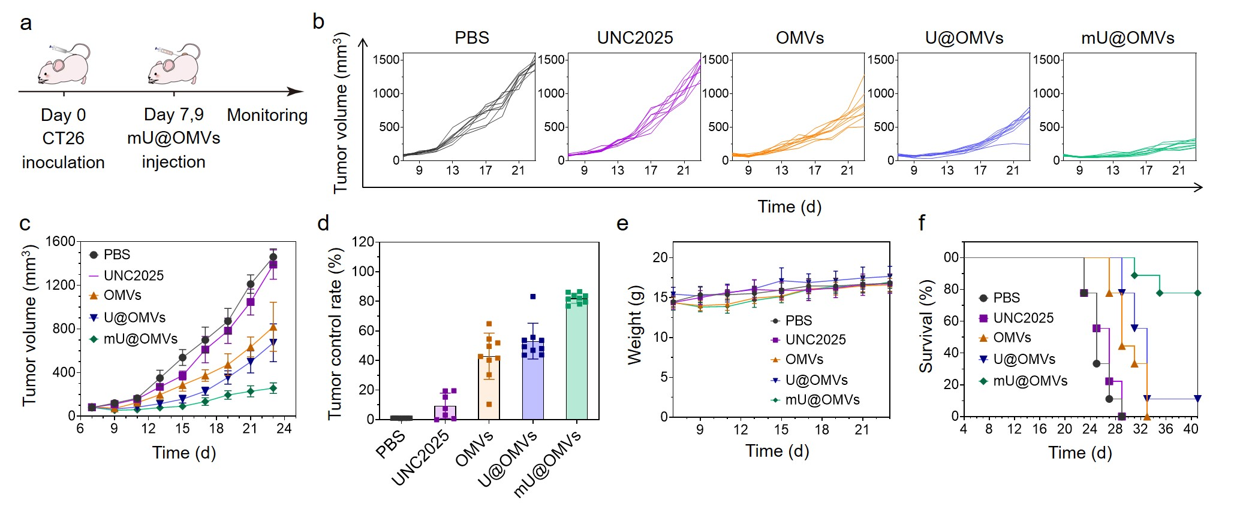
Supplementary Figure 20 The antitumor effect of mU@OMVs to inhibit CT26 tumors. a Schematic illustration. b Individual tumor growth kinetics were recorded every three days. c Tumor volumes. d Tumor control rate. e Body weight during antitumor experiment. f Survival curve of each group. Data are presented as mean ± s.d. (n = 9).

